**PowerPoint Activities**

**Purpose of Activities:**

1. Insert Slide - Inserting a new slide in the existing PowerPoint Presentation.
2. Insert Picture – Inserting a picture in a slide.
3. Delete Slide- Deleting the slide in the existing PowerPoint Presentation.

**Properties of Insert Slide:**

1. File Path – PowerPoint file full path.

**Properties of Insert Picture:**

1. File Path – PowerPoint file full path.
2. Image Path – Image path to insert into the PowerPoint Slide.
3. Picture Size – Using this property , cable to fix the position and height, width
4. Slide Index – Which slide that it goes to insert the image .

**Technical Specification:**

It is developed by C#.net. It is using the **Microsoft.Office.Interop.PowerPoint.dll.**

**Screen shot of Activity:**

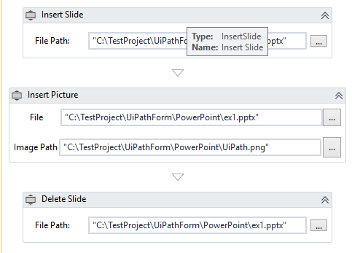

**Real-time:**

* I have uploaded this package in UiPath Gallery (<https://bit.ly/2nRbJ6y>). It exists in the namespace of “**BalaReva.PowerPoint.Activities**”.
* In the Community form can also see the reviews <https://bit.ly/2MDf1YX>