ASSIGNMENT-1
Name:- Ipshita Patel
Sec:- 3SB
Uni. Roll no.:- 2415000699 (27)
- Explain the difference between frontend, backend, and full-stack development with suitable real-world examples.
Ans.
Frontend Development:- Frontend development handles the interactive part of a website or application. Frontend developers are responsible for designing the appearance and interactive elements of a website such as buttons, page layouts, menus, images, etc.
Core skills required for frontend development are javascript, HTML and CSS.
For example, let’s consider a college or university website. The website contains many things like menu, navigation bar, admission forms, login page, images, announcements, etc. Suppose a student fills out an admission form or clicks on a button to move from one page to another, the frontend controls how these elements look and respond to the user’s actions.

Backend Development:- Backend development handles the server-side operations. It controls how the website works like managing databases, processing user requests and maintaining application security. It connects frontend with databases and APIs to make the website actually functional.
Core skills required for backend development are Python, Java, Node.js, SQL and REST APIs.
For example, let’s consider the college website again. When the student enters their login credentials, the backend collects these details and checks them against the information stored in the database. If the credentials are correct, it allows the student to access their profile, attendance, marks, etc.

Full-stack Development:- It refers to working with both, frontend and backend development. A full-stack developer is responsible for the working of a website or application as well as how it looks and interacts with the user.
Core skills required for full-stack development are HTML, CSS, JavaScript, Python, Java and Node.js.
2. Create a simple diagram showing how the client-server model
works in web architecture.
Ans.
Web Browser
(User)
Web Server
Application
HTTP Request
HTTP Response
CLIENT
SERVER

Working:- The client (user) sends a HTTP request to the server when the user requests some information or performs an action. The server receives and processes the request and sends an HTTP response to the client. The browser then displays the received information to the user.

3. Describe how a browser requests and displays a web page
from a web server.
Ans. The browser and web server communicate using the client-server model. The browser sends an HTTP request through the internet to the web server. The server processes the request and sends back the requested files. The browser receives these files and renders the webpage for the user.

4. Identify and list the tools required to set up a web development
environment. Explain the purpose of each.
Ans. The following tools are required to set up a web development environment:-
1. Code editor- used to write and edit web development code. For example:- VS code
2. Web browser with developer tool- used to view, test, inspect and debug web pages.
3. Git- a version control system used to track changes in source code and manage different versions of a project.
4. GitHub- used to host git repositories online and collaborate with other developers.
5. Node.js- a JavaScript runtime that allows JavaScript to run outside the web browser and can be used to create web servers.
6. NPM- a package manager that comes with Node.js and is used to install and manage project packages and dependencies.
7. Local Development Server- used to run and test a website locally during development. Example:- VS code live server.

5. Explain what a web server is and give examples of commonly
used servers.
Ans. A web server is a computer system or software that stores website files and delivers them to user browsers over the internet using HTTP or HTTPS.
Some commonly used web servers are:
- Apache HTTP Server
- Nginx
- Microsoft IIS
- LiteSpeed Web Server
- Caddy

6. Define the roles of a frontend developer, backend developer, and
database administrator in a project.
Ans.
Frontend Developer- develops the visual and interactive part of the application that users see and interact with. They recreate responsive interfaces using technologies such as HTML, CSS, etc.
Backend Developer- develops the server-side logic of the application. They process user requests, create APIs, handle authentication and security and connect the frontend with the database. Common technologies include python, java, node.js.
Database Administrator- manages and maintains the database of the application. They ensure that data is stored properly, remains secure, is backed up and can be retrieved efficiently. They commonly work with databases such as mysql and mongodb.

7. Install VS Code and configure it for HTML, CSS, and JavaScript
development. Take a screenshot of the setup.
Ans.
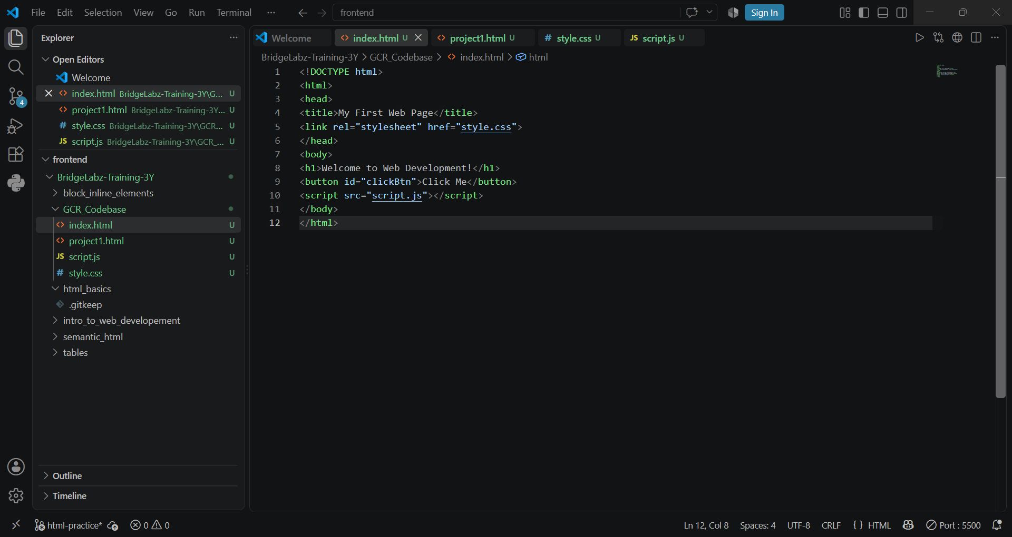

8. Explain the difference between static and dynamic websites.
Provide an example of each.
Ans.
Static Website | Dynamic Website
Content is mostly fixed | Content can change dynamically
Same content for most users | Content may differ for each user
Usually simpler and faster | More complex and interactive
Often uses HTML, CSS, JavaScript | Often uses frontend, backend and databases
Ex:- personal portfolio | Ex:- university student portal

9. Research and list five web browsers. Explain how rendering
engines differ between them.
Ans.
Web browser | Rendering engine | Explanation
Google Chrome | Blink | Chrome is based on chromium and uses blink to process and render web content
Mozilla Firefox | Gecko | Firefox uses Mozilla’s gecko engine which handles HTML, CSS, layout and graphics
Apple Safari | WebKit | Safari uses webkit to render webpages and implement web technologies.
Microsoft Edge | Blink | Modern edge is based on chromium so its webpage rendering is largely based on the same technology as chrome.
Opera | Blink | Modern opera is chromium-based and uses the blink rendering engine.

10. Draw a labeled diagram showing the basic web architecture flow
— client, server, database, and APIs.
Ans.
CLIENT
(Web Broswer)
SERVER
(Web Server)
APIs
External/Service
DATABASE
Stores Data
SERVER
CLIENT
(Web Broswer)
HTTP Request
API Request
Read/Write datat
HTTP Response

