This is the first page right now
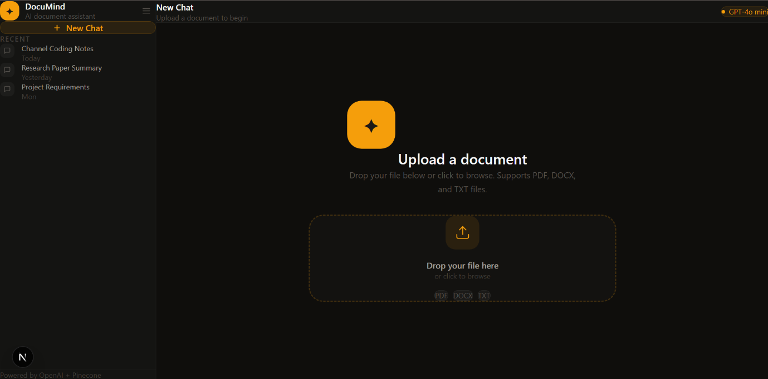
Later on after the doc is uploaded it goes to the chat interface
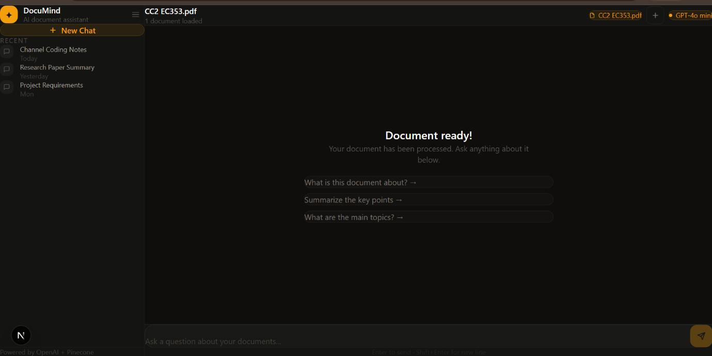
On the left sidebar, you can see the new chat option and I m planning to store chat history in supabase so that one can go back to previous chats or docs.

