HEALTHCARE DATA VISUALIZATION PLAN
From raw data to decision-ready dashboards and reports for non-technical stakeholders

Prepared by: Ipshita Verma
Jaipur, Rajasthan, India
Date: October 24, 2026
GitHub: https://github.com/ipshitav71-wq/healthcare-data-visualization-plan

Executive Summary
Healthcare organisations collect large volumes of data, yet the people who must act on it (executives, ward managers, quality leads, public-health officers) are rarely data specialists. This plan describes how raw healthcare data would be turned into visuals that these people can read in seconds, trust, and act on. It covers the metrics worth visualising, the tools chosen and why, the step-by-step process from raw file to published dashboard, the chart types best suited to each kind of question, and annotated mock-ups of three dashboards and one printable report. Every design choice is tied to a decision it supports or a problem it helps detect. User-centred design and accessibility (colour-blind-safe colour, redundant shape cues, screen-reader support, plain-language headlines) are treated as core requirements rather than finishing touches.
All charts in the mock-ups use synthetic, clearly labelled illustrative data. They demonstrate layout, chart choice and communication design; they do not represent any real hospital or population.

1. Purpose, Audiences and Design Principles

1.1 Purpose
The goal is to shorten the distance between a data point and a decision. A good healthcare visual answers three questions quickly: what is happening, is it a problem, and what should be done next. Where a visual cannot answer one of those, it is redesigned or removed.

1.2 Stakeholder Personas
Design starts from the people who will use the output. Four personas guide every mock-up in this plan.
Persona | Key decisions | What they need from visuals | Preferred format
Hospital executive (e.g., chief operating officer) | Where to allocate staff, beds and budget; which problems to escalate | A one-screen overview, clear status against targets, trends over months, no jargon | Dashboard on laptop or tablet; monthly PDF briefing
Ward or nurse manager | Daily staffing, discharge planning, bed management | Current-week detail by ward and shift, easy comparison to benchmark | Dashboard on desktop; printed daily huddle sheet
Quality and patient-safety lead | Whether a change is real or random; which care steps fail | Statistical signals (control charts), process drop-off views, drill-down to detail | Interactive dashboard with exportable tables
Public-health officer or policy maker | Where to target campaigns and resources; which groups are left behind | Geographic and demographic comparison, change over time, uncertainty shown honestly | Dashboard plus report with plain-language summary

1.3 Design Principles
- Answer first: every chart title states the finding (for example, “Readmissions have risen for three months in a row”), not just the topic.
- Overview first, then zoom and filter, then details on demand (Shneiderman, 1996). Executives see the summary; analysts can drill down.
- Show comparison: a number without a target, benchmark or prior period has no meaning to a non-specialist.
- Reduce clutter: remove 3-D effects, heavy gridlines and decoration so that attention goes to the data (Tufte, 2001; Few, 2013).
- Be honest: bar charts start at zero, uncertainty is displayed, small counts are suppressed, and data currency is always stamped on the page.
- Be inclusive: design for colour-vision deficiency, screen readers, small screens and low statistical literacy from the first sketch.

2. Key Healthcare Metrics to Visualise
Metrics were selected by working backwards from decisions: a metric is included only if someone can name an action they would take if it moved. They are grouped into operations, clinical quality and population health, and each is paired with a visual form.
Metric | Definition (short) | Decision it supports | Visual form
30-day readmission rate | Share of discharges followed by an unplanned return within 30 days | Review of discharge planning and follow-up care | Line chart with target line and annotation
Average length of stay (LOS) | Mean days from admission to discharge, by department | Bed capacity, discharge efficiency | Ranked bar of difference from benchmark
ED median wait time | Median minutes from arrival to first clinician contact, by hour | Staffing patterns by time of day | Column chart by hour with limit line
Bed occupancy | Occupied beds divided by staffed beds, by ward and day | Surge planning, step-down capacity | Heat map (ward by weekday)
Hospital-acquired infection rate | Infections per 1,000 patient-days | Infection-control interventions | Control chart (SPC) with limits
Care-bundle compliance (e.g., sepsis) | Percentage completing each required step on time | Which step of a pathway fails | Funnel or step-down bar chart
Safety events | Falls with harm, pressure injuries, medication errors per 1,000 bed-days | Targeted safety programmes | Status table with target and symbols
Patient experience score | Share of patients rating care positively (survey-based) | Service improvement priorities | Diverging bar by survey domain
Appointment no-show rate | Missed appointments divided by booked, by clinic and day | Reminder and overbooking strategy | Small multiples by clinic
Vaccination coverage | Percent of eligible population vaccinated, by region and group | Targeting of campaigns | Tile map, dot plot, line with confidence band
Disease incidence | New cases per 100,000 population, by age group and period | Outbreak detection, resource planning | Line chart, small multiples by age group
Data completeness | Percentage of expected fields populated, by source | Whether the data can be trusted | Small status indicator on every page

The last row is deliberate. Showing data completeness and refresh date beside the results builds trust and prevents decisions based on stale or partial data, a recurring problem in routinely collected health data (Weiskopf & Weng, 2013).

3. Tool Selection and Justification

3.1 Selection Criteria
- Accessibility features: alt text, keyboard tab order, high-contrast themes, screen-reader support.
- Security: row-level access control and suitability for sensitive health data.
- Connectivity: works with CSV/Excel, SQL databases and public APIs.
- Cost and learning curve: usable by a small team or individual analyst without paid infrastructure.
- Statistical capability: supports charts such as control charts and confidence intervals, or can be extended to.
- Sharing: stakeholders can view results without installing software.

3.2 Tool Comparison
Tool | Strengths | Limitations | Role in this plan
Microsoft Power BI | Free desktop authoring; strong data modelling and DAX measures; row-level security; built-in alt text, tab order and high-contrast support; wide connector library | Control charts and confidence bands need custom visuals or extra modelling; sharing in the service needs a licence | Primary dashboard tool
Python (pandas, matplotlib, Plotly) | Full control over cleaning and statistical charts (control charts, funnel plots, uncertainty bands); reproducible scripts | Less convenient for non-technical consumers; needs hosting to be interactive | Data preparation, statistical visuals, static report figures, wireframe generation
PostgreSQL | Reliable, open source; enforces constraints; handles joins across large tables | Not a visual tool | Storage and modelling layer feeding the dashboards
Tableau | Excellent exploratory visuals and polish; large community | Cost; the free public version publishes data openly, so it is unsuitable for patient-level data | Considered alternative
Excel | Universal familiarity; fast for ad hoc checks | Weak governance, manual refresh, limited accessibility control | Quick validation only
Looker Studio | Free, web-based, simple sharing | Limited modelling and accessibility controls | Not selected

3.3 Justification
Power BI is chosen as the main dashboard environment because it combines a free authoring tool, a proper semantic model (so that a metric such as readmission rate is defined once and reused everywhere), row-level security for sensitive data, and the most complete set of built-in accessibility controls among the tools compared. Python complements it where business-intelligence tools are weak: statistical process control charts, funnel plots and confidence bands are straightforward to script and are the visuals that quality leads rely on to separate real change from noise (Benneyan, Lloyd & Plsek, 2003). PostgreSQL provides a governed, queryable store between raw files and visuals. The same stack is also realistic for a small team and for portfolio work with public datasets, which keeps the plan feasible and replicable.

4. Process: Converting Raw Data into Visual Formats
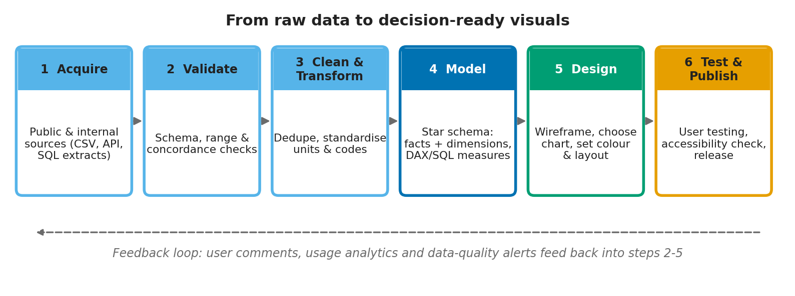
Figure 1. End-to-end workflow from raw data to published visuals
Stage | Activities | Tools | Quality gate before moving on
1. Acquire | Pull data from public portals (e.g., national health statistics, hospital quality datasets) or internal extracts; log source, version and date | Python requests/pandas, SQL extracts | Source, licence and refresh date recorded
2. Validate | Check schema, data types, ranges (e.g., age 0-120), cross-field logic (discharge not before admission), duplicate keys | pandas, Great Expectations or pandera | All critical rules pass or exceptions are documented
3. Clean and transform | Standardise units and codes, handle missing values by documented rule, derive fields (length of stay, age group, 30-day return flag) | Python, SQL | Row counts reconcile with raw data; cleaning log saved
4. Model | Build a star schema: fact tables (admissions, ED visits, appointments) and dimensions (date, ward, patient group, region); define measures once | PostgreSQL, Power BI model and DAX | Measures tested against hand-calculated values
5. Design | Sketch wireframes on paper, choose chart types from the guide in Section 5, apply palette and layout grid, write headline titles | Paper, Python/Figma for mock-ups, Power BI | Each visual linked to a named decision
6. Test and publish | Usability test with representative users, accessibility checklist, performance check, role-based access, release with refresh schedule | Power BI service, screen reader, contrast checker | Test targets met (Section 8); sign-off by data owner

Two design habits make this process dependable. First, measures are defined in one place so that two dashboards cannot report different readmission rates. Second, each stage has an explicit gate, so a problem found late (for example, a unit mismatch) is traced back to the stage that should have caught it and the rule is added there.

5. Visualization Techniques and Chart Selection Guide
Charts are chosen by the question being asked, using research on how accurately people read visual encodings: position along a common scale is read most precisely, while angle, area and colour intensity are read less accurately (Cleveland & McGill, 1984). That is why this plan favours lines, bars and dots over pies and gauges.
Question | Recommended chart | Why | Avoid
How has a measure changed over time? | Line chart with target line and annotated events | Shows direction and pace; target gives context | Dual axes; 3-D lines
Is a change real or random variation? | Control chart (SPC) with centre line and limits | Separates special-cause signals from normal variation | Reacting to single-month movements
Which units are better or worse than benchmark? | Ranked horizontal bar or dot plot of difference from benchmark | Easy sorting and reading of labels | Pie charts; unsorted bars
Where in a pathway do patients drop out? | Step-down bar (funnel) chart | Makes the largest loss obvious | Tables of percentages only
When are pressures highest? | Heat map (day by hour or ward by day) with values printed in cells | Reveals patterns across two dimensions | Rainbow colour scales
How do regions compare? | Equal-sized tile map plus ranked list | Avoids large, sparsely populated areas dominating the view | Choropleth only, without a list
How big are gaps between groups? | Dot plot (lollipop) sorted by value | Shows distance between groups clearly | Stacked bars across many groups
Is a small hospital really worse? | Funnel plot with control limits by volume | Accounts for small-number variation (Spiegelhalter, 2005) | League tables without uncertainty
What is the exact value? | Large number tile with status symbol and comparison | Fast scanning for executives | Gauges and speedometers

5.1 Honest Visual Communication
- Bar charts start at zero; line charts may use a trimmed axis but the axis range is labelled.
- Rates are shown with denominators or confidence intervals where counts are small.
- Counts below a minimum cell size (for example, fewer than 11) are suppressed to protect privacy, a convention used in public health reporting.
- Outcomes that depend on patient mix (mortality, readmissions) are labelled as risk-adjusted or unadjusted.
- Colour carries meaning consistently across all pages: blue for on target, orange for watch, vermillion for action needed.

6. Dashboard and Report Mock-ups
Three dashboards and one printable report are presented. Numbered circles on each mock-up correspond to the tables beneath it, which explain what each visual shows, what problem it helps identify, and what decision it supports. The mock-ups were drawn with Python and illustrate how the final Power BI pages would be laid out.

6.1 Dashboard 1: Hospital Operations Overview (executives and ward managers)
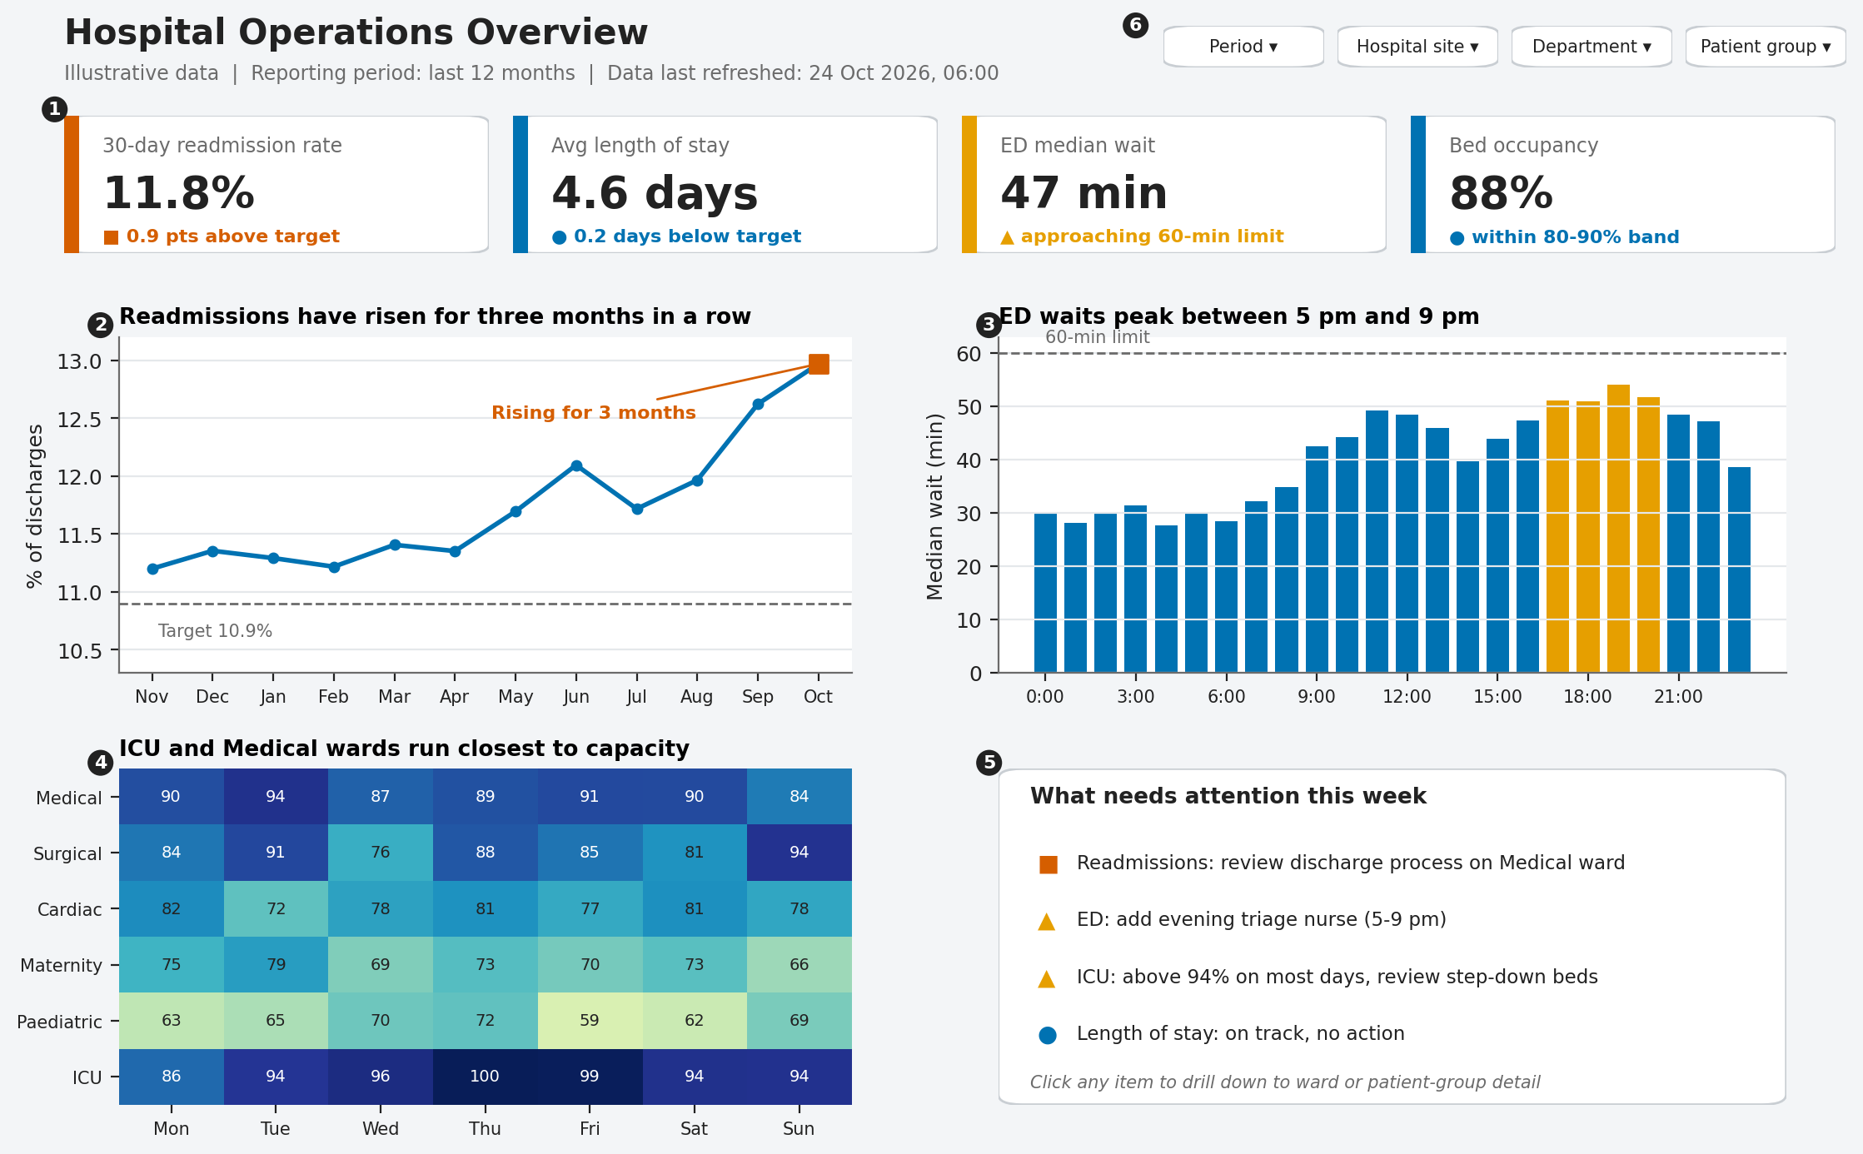
Figure 2. Operations dashboard mock-up (illustrative data)
# | Element | Problem it helps identify | Decision supported
1 | KPI tiles with status symbol and comparison text | Which of the four headline measures is off target, at a glance | Where to direct attention first in a short meeting
2 | Readmission trend with target line | A sustained upward drift that a single monthly number would hide | Commission a review of discharge planning on the wards driving the rise
3 | ED wait by hour with 60-minute limit | Predictable evening peak in waiting time | Shift staffing or add a triage nurse during 5-9 pm
4 | Ward by weekday occupancy heat map | Wards running near capacity on specific days | Plan step-down beds and elective scheduling
5 | What-needs-attention list | Translates the charts into a prioritised action list for non-analysts | Assign owners and track follow-up
6 | Filters (period, site, department, patient group) | Whether a problem is local or hospital-wide | Targeted rather than blanket interventions

6.2 Dashboard 2: Clinical Quality and Patient Safety (quality leads and clinicians)
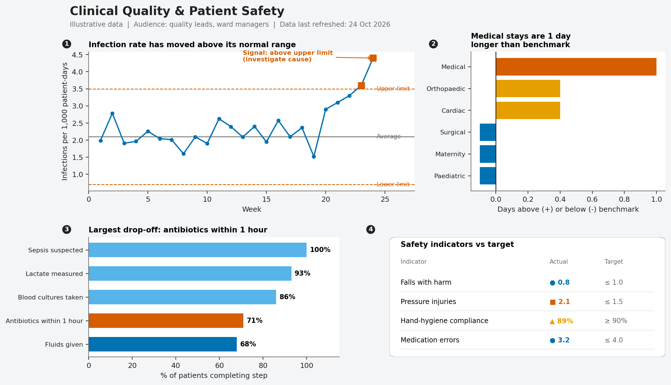
Figure 3. Quality and safety dashboard mock-up (illustrative data)
# | Element | Problem it helps identify | Decision supported
1 | Control chart of infection rate with limits | Whether a rise is a genuine signal or normal variation | Trigger a root-cause investigation only when a signal appears
2 | LOS difference from benchmark, ranked | Departments with unusually long stays | Prioritise discharge-process review where the gap is largest
3 | Sepsis bundle step-down chart | The single care step with the biggest drop-off | Focus training and protocol change on that step
4 | Safety indicator table with symbols | Indicators missing targets (e.g., pressure injuries) | Assign improvement projects and monitor against target

6.3 Dashboard 3: Population Health (public-health officers and policy makers)
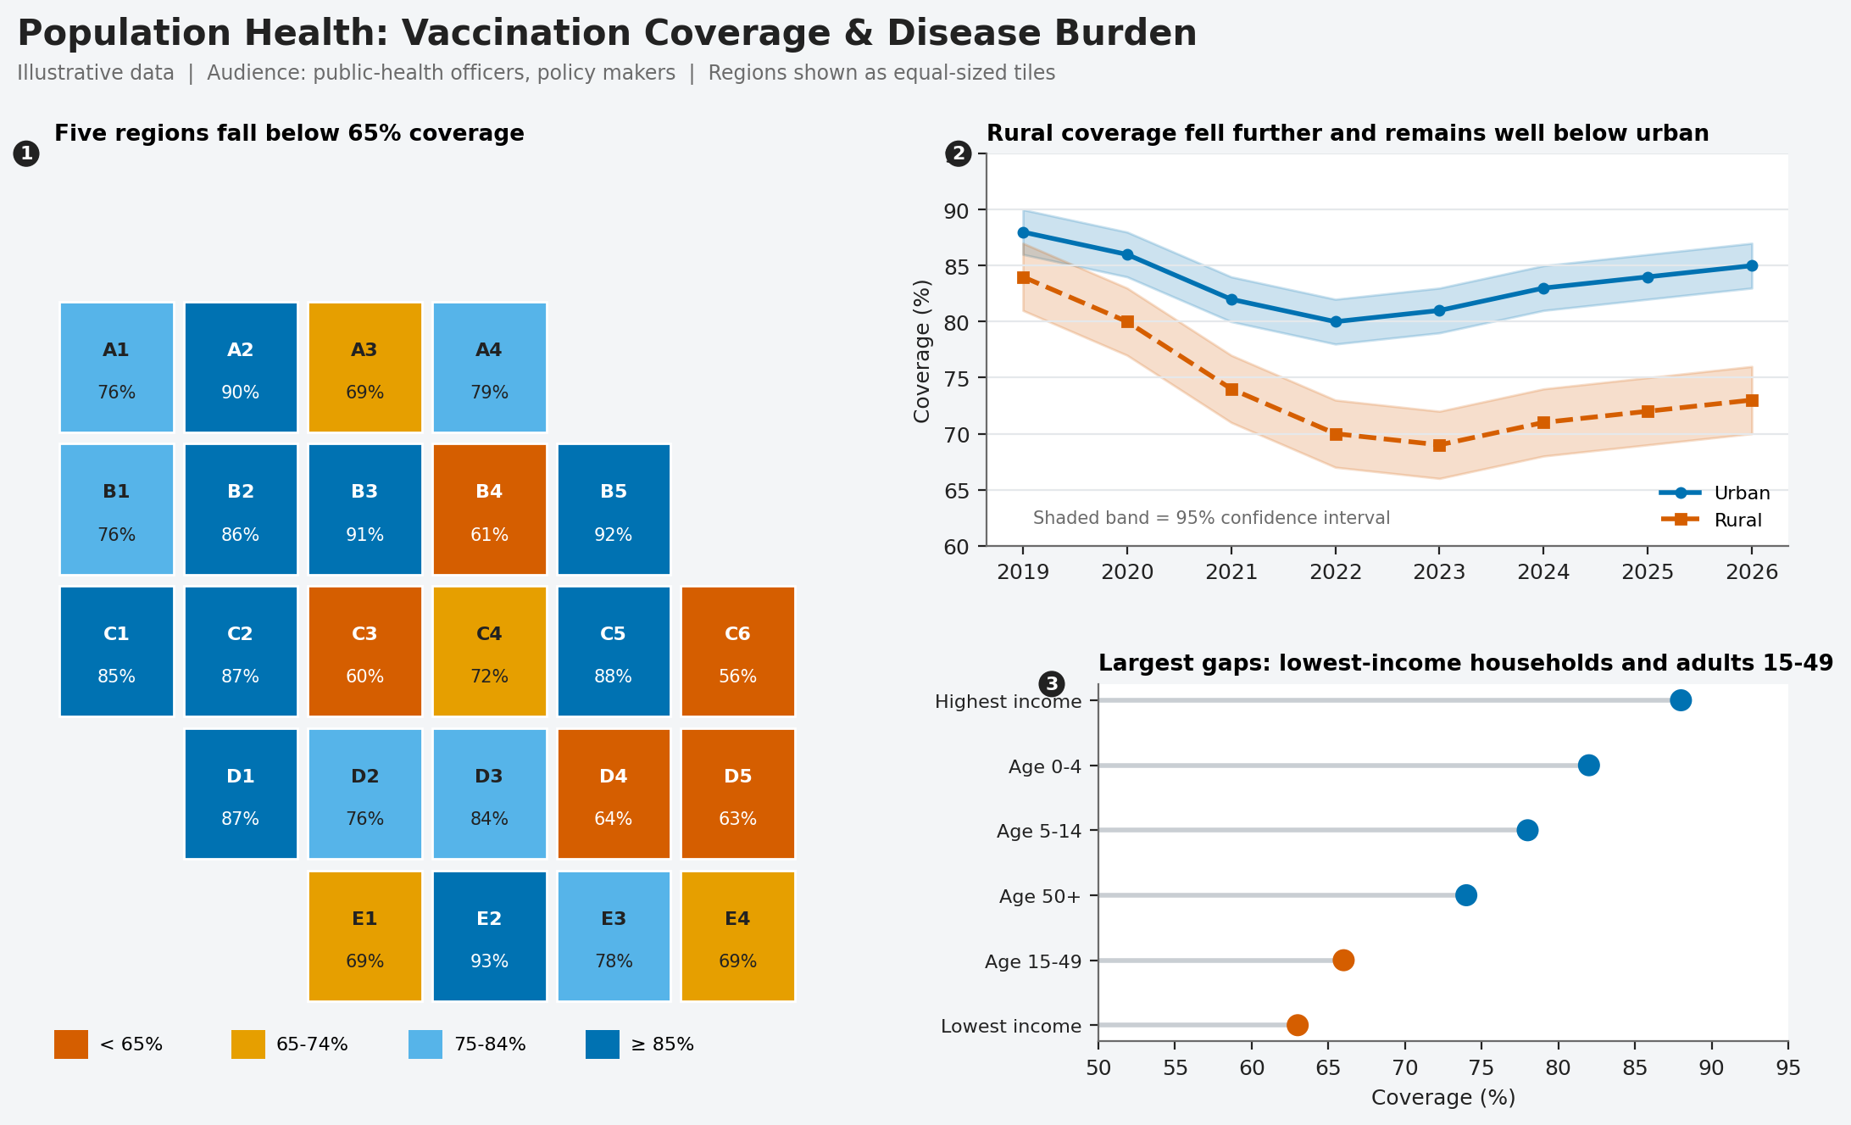
Figure 4. Population health dashboard mock-up (illustrative data)
# | Element | Problem it helps identify | Decision supported
1 | Tile map with value labels and legend | Regions below the coverage threshold, without large areas dominating | Choose regions for outreach and mobile clinics
2 | Urban vs rural lines with confidence bands | A persistent rural gap and whether it is statistically meaningful | Allocate resources to rural delivery
3 | Dot plot by age and income group | Groups with the lowest coverage | Design targeted messaging and subsidies

6.4 Report Wireframe: One-Page Monthly Briefing
Not every stakeholder opens a dashboard. A one-page briefing, produced from the same data model and distributed as an accessible PDF, serves executives and committees. The layout puts the conclusion first and the evidence second.
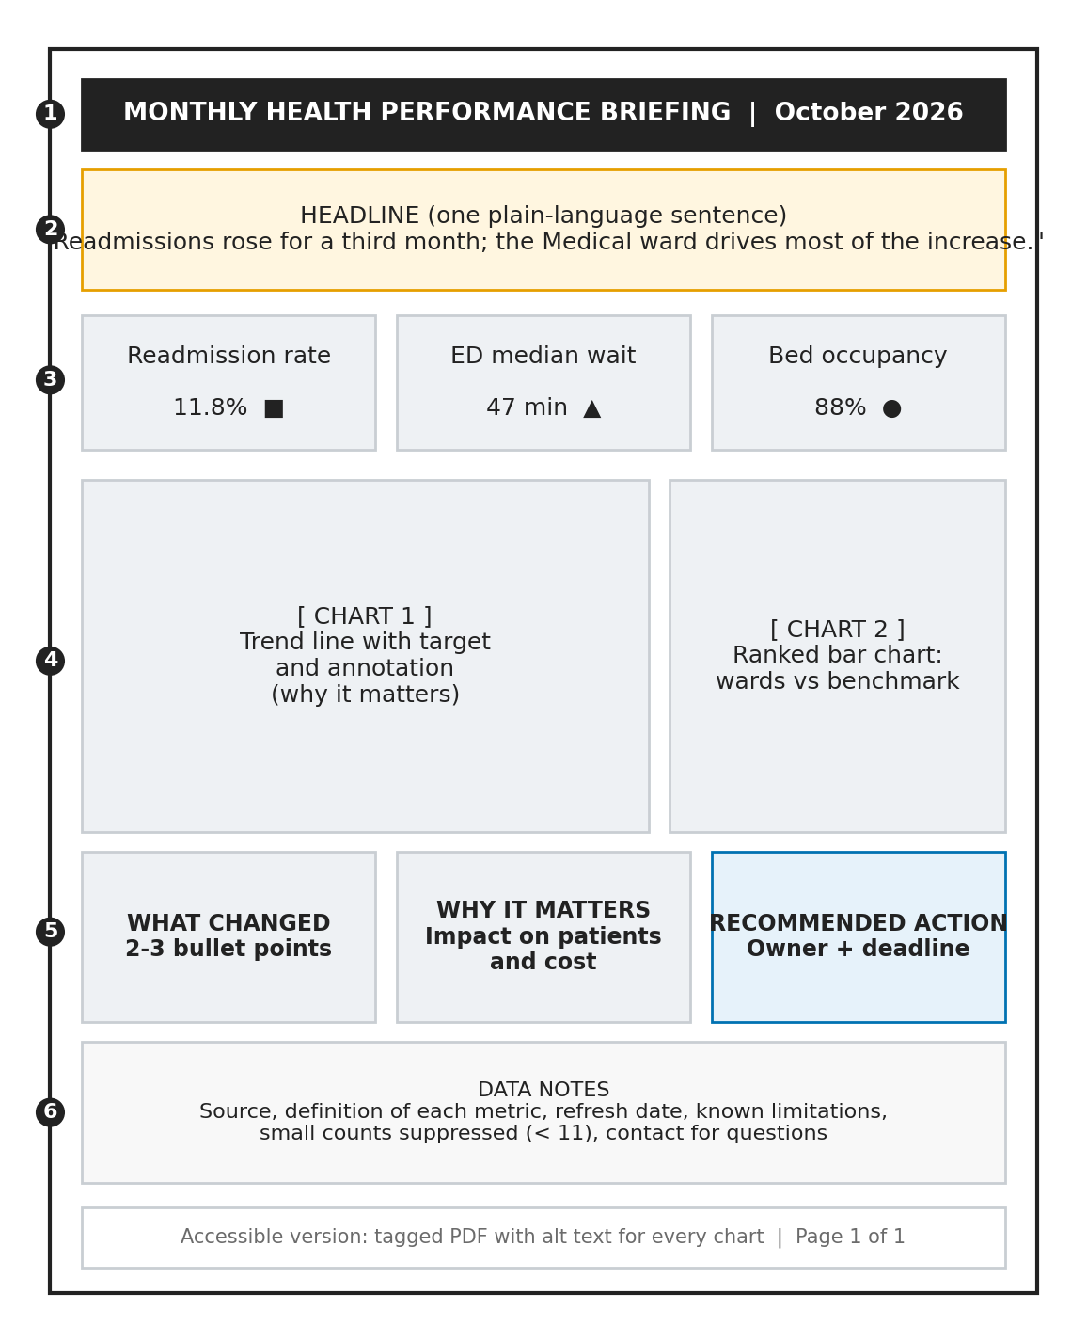
Figure 5. Wireframe of the one-page monthly briefing
# | Section | Purpose
1 | Title bar | Names the report and period
2 | Headline sentence | States the single most important finding in plain language
3 | Three key measure tiles | Immediate status of the most important indicators
4 | Charts (trend and ranked comparison) | Evidence for the headline, each with an annotated takeaway
5 | What changed / Why it matters / Recommended action | Moves the reader from information to a named owner and deadline
6 | Data notes | Source, definitions, refresh date, suppression rules and a contact point, supporting trust and reproducibility

7. User-Centric Design and Accessibility

7.1 Design with Users, Not for Them
- Interview two to three representatives of each persona to list the decisions they make and the questions they ask, in their own words.
- Draw paper wireframes and run short walk-throughs: users point to where they would look to answer a question.
- Build a Power BI prototype with realistic data and run task-based usability sessions with about five participants per persona.
- Measure success with task completion, time to find the answer, errors, and a System Usability Scale (SUS) score (Brooke, 1996); revise and repeat.
- After release, review usage statistics and collect feedback monthly; retire visuals nobody uses.

7.2 Accessibility Requirements
The requirements below follow the Web Content Accessibility Guidelines (WCAG) 2.1, level AA, and the colour-universal-design approach of Okabe and Ito (2008).
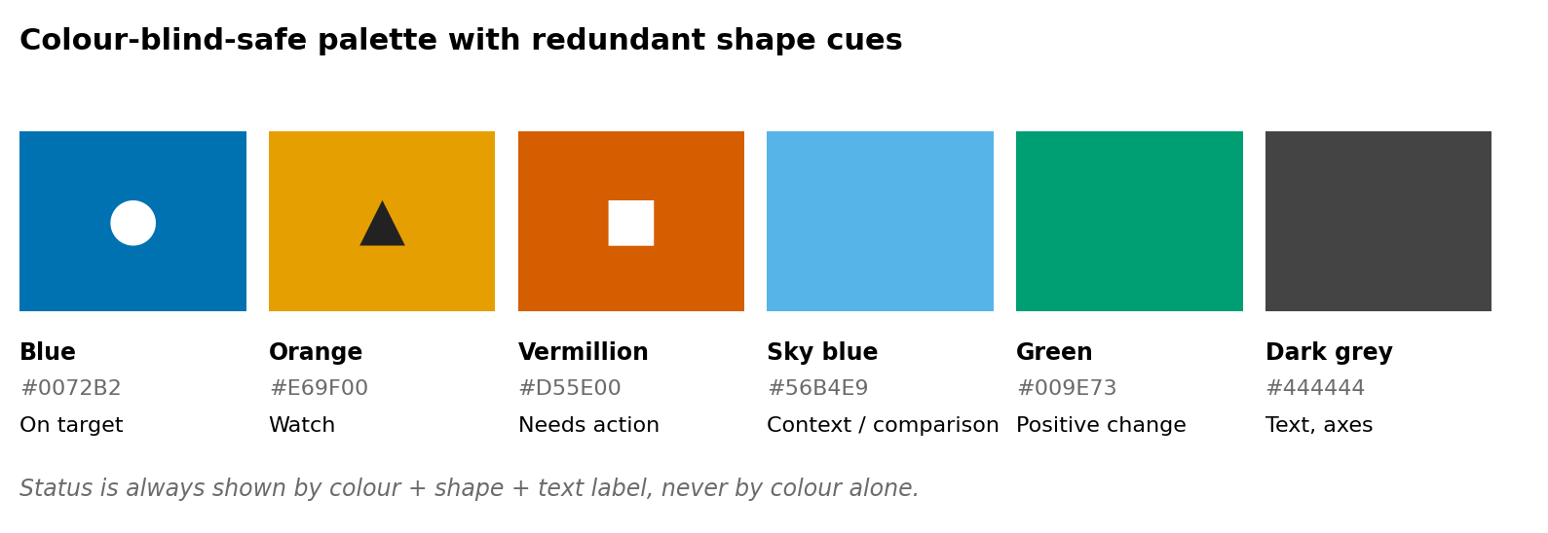
Figure 6. Colour-blind-safe palette with redundant shape cues
Requirement | How it is met in this plan
Do not rely on colour alone (WCAG 1.4.1) | Status is shown by colour, shape (circle, triangle, square) and text label; lines differ by dash style and marker
Text contrast of at least 4.5:1 (WCAG 1.4.3) | Dark text on white or very light grey; white text only on dark blue or vermillion fills; contrast verified with a checker
Graphics contrast of at least 3:1 (WCAG 1.4.11) | Palette chosen for distinct luminance; chart lines at least 2 pt; gridlines kept light but never the only cue
Colour-blind-safe palette | Okabe-Ito colours; no red-green pairings; sequential scales use a single-hue blue ramp
Screen-reader access | Alt text on every visual describing the finding; meaningful reading order and tab order; a ‘show as table’ view for each chart
Keyboard operation | All filters and drill-downs reachable without a mouse; visible focus indicator
Readable text | Minimum 12 pt body text on dashboards; titles in sentence case; no text embedded in images
Plain language | Headline titles state the finding; abbreviations spelled out on first use; glossary link for each metric
Responsive layout | Mobile view with KPI tiles stacked first; fewer, larger visuals on small screens
Reduced motion | No auto-playing animation; transitions off by default
Accessible documents | Briefings exported as tagged PDFs with alt text, headings and a logical reading order

8. Communication Plan for Non-Technical Stakeholders

8.1 Storytelling Structure
Each dashboard page and report follows the same narrative sequence, adapted from guidance on storytelling with data (Knaflic, 2015): context (what are we looking at and for which period), finding (what changed), meaning (why it matters for patients, safety or cost), and action (what to do, who owns it, by when). The headline sentence, annotation and action panel in the mock-ups implement this sequence.

8.2 Worked Example
Raw data: a table of discharges with admission and discharge dates, ward and a readmission flag. After cleaning and modelling, the 30-day readmission rate is calculated monthly and compared with a target. Instead of a table of 12 percentages, the executive sees a line chart titled “Readmissions have risen for three months in a row,” a dashed target line, and a highlighted final point. The attention panel adds “Review discharge process on the Medical ward.” A ward manager clicks through and sees which discharge days and patient groups account for the rise. The insight moves from a number to a named problem to an assigned action without anyone writing a query.

8.3 Delivery Channels
- Interactive dashboard for regular use, with role-based views.
- One-page monthly briefing (accessible PDF) for committees.
- Short walk-through session at launch and a one-page ‘how to read this dashboard’ guide.
- Alerts or subscriptions for metrics crossing a threshold, so users are not required to check daily.

9. Data Governance, Privacy and Risk Considerations
Risk | Mitigation in the visualization design
Re-identification from small numbers or detailed filters | Aggregate by default; suppress small cells; restrict patient-level views to authorised roles through row-level security
Misleading charts leading to wrong decisions | Chart guide (Section 5); peer review of every new visual; uncertainty shown; definitions linked from each metric
Stale or incomplete data presented as current | Refresh timestamp and completeness indicator on every page; alerts when feeds fail
Inconsistent metric definitions across teams | Single governed semantic model; metric glossary with owner for each measure
Alert fatigue or dashboard overload | Limit each page to about six visuals; thresholds agreed with users; usage review to retire unused visuals
Exclusion of users with disabilities | Accessibility checklist as a release gate; testing with assistive technology
Use of public visual platforms with sensitive data | Only de-identified or public data in public tools; patient-level data stays in governed, access-controlled environments

Applicable regulations (for example HIPAA in the United States, the Digital Personal Data Protection Act, 2023 in India, and GDPR in Europe) are reviewed before any patient-level data is used, and only data cleared for the purpose is loaded.

10. Implementation Roadmap and Evaluation
Phase | Activities | Output
1. Discover | Persona interviews, decision mapping, metric definitions | Signed-off metric list and glossary
2. Prototype | Paper and digital wireframes, user walk-throughs | Validated layouts for three dashboards and one report
3. Build | Data pipeline, model and measures; Power BI pages; Python statistical visuals | Working minimum viable dashboards on public or de-identified data
4. Test | Usability and accessibility testing; performance and security review | Issue log resolved; release approval
5. Launch and learn | Training, monthly feedback and usage review, iterate | Adoption and impact report

Success will be judged against four measures: adoption (share of target users opening the dashboard monthly), speed (time for a new user to answer a defined set of questions), accessibility (all items on the checklist passed and assistive-technology testing completed), and impact (documented decisions or interventions that cite the dashboard). A SUS score of 68 or above, the commonly cited average, is the minimum acceptable usability result, with a higher score targeted after the first iteration.

11. Project Work Breakdown
The table records the planning, research and design effort behind this document.
Task | Hours
Stakeholder and persona research; mapping decisions to data needs | 4.0
Identifying and defining key healthcare metrics | 4.0
Tool evaluation and justification | 3.0
Designing the raw-data-to-visual process and quality gates | 4.0
Researching visualization techniques; building the chart selection guide | 3.0
Wireframing and mock-up design (three dashboards, one report) | 7.0
Accessibility and user-centred design review | 3.0
Communication and storytelling plan | 2.0
Governance, privacy and risk notes | 1.0
Documentation, quality review and referencing | 2.0
Total estimated effort: approximately 33 hours.

12. Conclusion
Effective healthcare visualization is less about elaborate graphics than about disciplined choices: defining metrics around decisions, building from trustworthy, validated data, choosing the simplest chart that answers the question honestly, and designing for the real people who will use it, including those with disabilities. The dashboards and report in this plan translate that approach into concrete layouts, each element tied to a problem it detects and a decision it informs. Because the workflow, chart guide and accessibility checklist are documented, the plan can be repeated for other datasets and extended as users' needs change.
Supporting files (mock-up images and the Python script that generates them) are available in the project repository:
https://github.com/ipshitav71-wq/healthcare-data-visualization-plan

References
Benneyan, J. C., Lloyd, R. C., & Plsek, P. E. (2003). Statistical process control as a tool for research and healthcare improvement. Quality and Safety in Health Care, 12(6), 458–464. https://doi.org/10.1136/qhc.12.6.458
Brooke, J. (1996). SUS: A quick and dirty usability scale. In P. W. Jordan, B. Thomas, B. A. Weerdmeester, & I. L. McClelland (Eds.), Usability evaluation in industry (pp. 189–194). Taylor & Francis.
Cleveland, W. S., & McGill, R. (1984). Graphical perception: Theory, experimentation, and application to the development of graphical methods. Journal of the American Statistical Association, 79(387), 531–554. https://doi.org/10.1080/01621459.1984.10478080
Few, S. (2013). Information dashboard design: Displaying data for at-a-glance monitoring (2nd ed.). Analytics Press.
Knaflic, C. N. (2015). Storytelling with data: A data visualization guide for business professionals. Wiley.
Okabe, M., & Ito, K. (2008). Color universal design (CUD): How to make figures and presentations that are friendly to colorblind people. https://jfly.uni-koeln.de/color/
Shneiderman, B. (1996). The eyes have it: A task by data type taxonomy for information visualizations. Proceedings of the IEEE Symposium on Visual Languages, 336–343. https://doi.org/10.1109/VL.1996.545307
Spiegelhalter, D. J. (2005). Funnel plots for comparing institutional performance. Statistics in Medicine, 24(8), 1185–1202. https://doi.org/10.1002/sim.1970
Tufte, E. R. (2001). The visual display of quantitative information (2nd ed.). Graphics Press.
Weiskopf, N. G., & Weng, C. (2013). Methods and dimensions of electronic health record data quality assessment: Enabling reuse for clinical research. Journal of the American Medical Informatics Association, 20(1), 144–151. https://doi.org/10.1136/amiajnl-2011-000681
World Wide Web Consortium. (2018). Web Content Accessibility Guidelines (WCAG) 2.1. https://www.w3.org/TR/WCAG21/

