STATISTICAL ANALYSIS AND PREDICTIVE MODELING FRAMEWORK FOR HEALTHCARE
A methodological plan for analysing trends, forecasting outcomes and deriving actionable, ethical insights

Prepared by: Ipshita Verma
Jaipur, Rajasthan, India
Date: October 24, 2026

Executive Summary
This document sets out a complete, replicable plan for using statistical analysis and predictive modeling in a healthcare setting. It does not report numerical results; its purpose is to describe, step by step and with justification, how an analyst would move from a clinical or operational question to a validated, fair and responsibly deployed model. The plan covers common statistical techniques and when each is appropriate, an eleven-step modeling workflow (problem framing, cohort definition, data segmentation, pre-processing, variable selection, model selection, evaluation, validation, bias auditing, documentation and monitoring), the pitfalls that most often invalidate healthcare models, and a stage-by-stage ethical framework. A running example, predicting unplanned 30-day hospital readmission, is used throughout to make each decision concrete.
Three principles shape the whole plan. First, start from the decision the model will inform, not from the algorithm. Second, treat evaluation honestly: keep test data untouched, check calibration and clinical usefulness, and audit performance across patient groups. Third, treat ethics as a design requirement present at every stage rather than a review at the end.

1. Scope, Objectives and Running Example

1.1 Objectives
- Analyse trends in healthcare data using appropriate descriptive and inferential methods.
- Forecast outcomes: individual patient risk (classification), time to an event (survival), and service demand (time series).
- Convert model output into actions that clinicians and managers can take, with the limits of the model clearly stated.
- Identify and reduce bias, and document the ethical basis for using the model at all.

1.2 Types of Analytical Question
Question type | Example in healthcare | Typical method family | Output
Describe and compare | Do readmission rates differ between wards? | Descriptive statistics, hypothesis tests, confidence intervals | Effect sizes with uncertainty
Explain association | Which factors are associated with longer stay after adjusting for age and diagnosis? | Linear, logistic, Poisson and multilevel regression | Adjusted estimates
Predict a binary outcome | Which discharged patients are at high risk of 30-day readmission? | Penalised logistic regression, tree ensembles | Calibrated risk probability
Predict time to event | How long until a patient with heart failure is readmitted or dies? | Kaplan-Meier, Cox regression, competing-risk models | Survival curves, hazard ratios
Forecast demand | How many emergency admissions next week? | Exponential smoothing, ARIMA, regression with seasonality | Forecast with prediction interval
Discover groups | Are there distinct patient phenotypes in a chronic-disease clinic? | Clustering, latent class analysis | Segments to be clinically validated

1.3 Running Example
To keep the framework concrete, one example is followed throughout: a model that estimates, at the time of discharge, each patient's probability of unplanned readmission within 30 days, so that a limited follow-up service (phone call, early clinic slot) can be offered to those most likely to benefit. Suitable public data include the UCI Diabetes 130-US Hospitals dataset (Strack et al., 2014), which records roughly one hundred thousand inpatient encounters with a readmission label, and the MIMIC-IV critical-care database (Johnson et al., 2023), which is available to credentialed researchers. In a real deployment the same steps would be applied to the hospital's own electronic health record extract.

2. Overview of Statistical Techniques for Healthcare Data
Predictive modeling sits on top of sound statistical practice. The table lists the techniques most often needed, what each answers, and the main cautions. Choosing the simplest technique that answers the question, and checking its assumptions, is preferable to defaulting to a complex algorithm.
Technique | Use in healthcare | Key assumptions and cautions
Descriptive statistics and visual exploration | Summarise age, length of stay, lab values; spot errors, skew and missingness | Report median and interquartile range for skewed data such as length of stay; always show missing counts
t-test, Mann-Whitney, ANOVA, Kruskal-Wallis | Compare a measure between two or more groups | Check distribution and independence; report effect size and confidence interval, not only the p-value (Wasserstein & Lazar, 2016)
Chi-square and Fisher exact tests | Compare proportions (e.g., readmitted or not, by sex) | Expected cell counts must be adequate; use Fisher for small counts
Correlation (Pearson, Spearman) | Screen relationships between continuous measures | Association is not causation; Spearman for monotonic, non-normal data
Linear regression | Continuous outcomes such as length of stay or blood pressure | Linearity, constant variance, independent residuals; transform skewed outcomes or use alternative models
Logistic regression | Binary outcomes such as readmission or death; baseline for risk prediction | Adequate events per variable; linearity of log-odds; check calibration (Hosmer et al., 2013)
Poisson and negative binomial regression | Counts such as infections or falls per patient-day, with exposure offset | Overdispersion often present; negative binomial handles it
Multilevel (mixed-effects) models | Patients nested within wards or hospitals | Ignoring clustering understates uncertainty; random effects capture between-unit variation
Kaplan-Meier and Cox regression | Time to readmission, relapse or death with censoring | Proportional hazards (check Schoenfeld residuals); competing risks (e.g., death) need dedicated methods (Fine & Gray, 1999)
Time-series methods (ETS, ARIMA, seasonal decomposition) | Forecast admissions, bed demand, seasonal infection | Trend and seasonality; validate with rolling-origin evaluation (Hyndman & Athanasopoulos, 2021)
Multiple-testing control | When many subgroups or variables are tested | Bonferroni or Benjamini-Hochberg false discovery rate (Benjamini & Hochberg, 1995)
Propensity-score and causal methods | Estimating treatment effects from observational data | Needed when the aim is causal; a prediction model must not be read as showing cause (Rosenbaum & Rubin, 1983)
Penalised regression (LASSO, ridge, elastic net) | Prediction with many correlated variables | Shrinks coefficients to reduce overfitting (Tibshirani, 1996); standardise predictors first

2.1 Prediction Versus Explanation
A model built to predict readmission may use variables (for example, number of prior admissions) because they are informative, whether or not they cause readmission. Statements such as “reducing this variable will reduce risk” are causal claims and are not supported by a prediction model. Where the question is causal, the plan switches to causal-inference designs (directed acyclic graphs, propensity-score methods, or trial emulation). Keeping this distinction explicit prevents a common misuse of predictive output.

3. Step-by-Step Plan for Building a Predictive Model
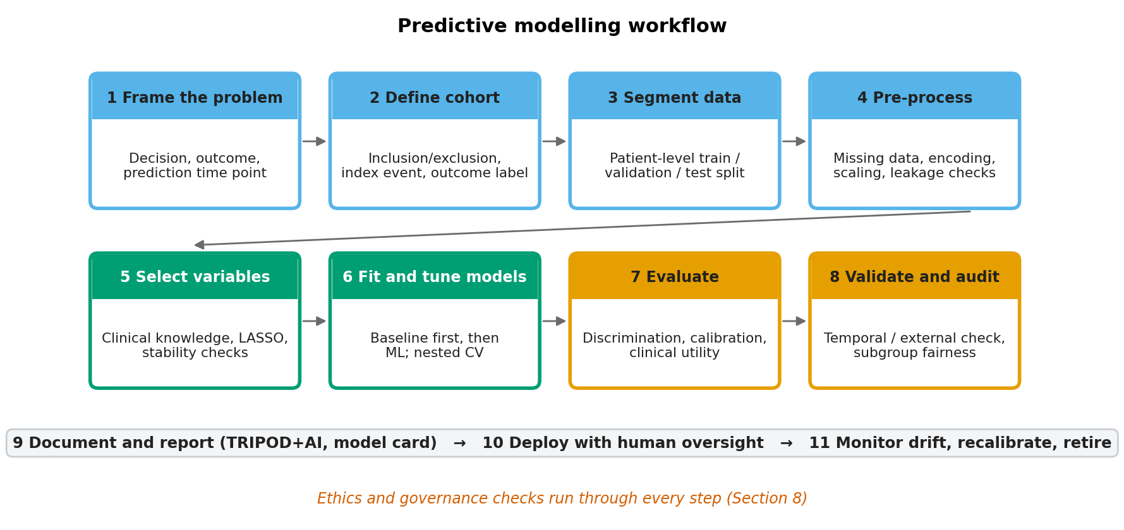
Figure 1. Predictive modeling workflow

Step 1. Frame the Problem and Link It to a Decision
- State the decision: for example, “which discharged patients should receive a follow-up call within 48 hours?”
- State the capacity: if staff can call only 50 patients a day, the model must rank patients and the threshold is a resource decision, not just a statistical one.
- Define the prediction time point: only information available at discharge may be used (see leakage, Section 6).
- Agree success criteria with clinicians before modeling, including the cost of a missed high-risk patient versus an unnecessary call.

Step 2. Define the Cohort and the Outcome
Element | Specification for the readmission example
Unit of analysis | Index hospital discharge (one row per discharge), with a patient identifier retained for grouping
Inclusion | Adult inpatients discharged alive to home or community care
Exclusion | In-hospital death, discharge to hospice, planned readmissions, transfers to another acute hospital, records with unusable key fields
Outcome | Unplanned readmission within 30 days of discharge (binary); for survival analysis, days to readmission with censoring at 30 days
Predictors | Demographics, diagnosis and procedure groups, comorbidity index, prior admissions in 12 months, length of stay, key lab and medication information, discharge disposition
Prevalence check | Report outcome prevalence; imbalance affects metrics and threshold choice

Step 3. Data Segmentation (Splitting and Stratifying)
“Segmentation” is used here in two senses: dividing data for training and testing, and dividing patients into meaningful groups for analysis.

3a. Splitting data for development and testing
- Split at the patient level, never the row level. If one patient has several admissions, all of them stay in the same partition; otherwise the model is tested on patients it has already seen and performance is inflated.
- Prefer a temporal split when dates exist: train on earlier years, tune on a later year, test on the most recent period. This mimics real use, where the model predicts the future.
- When dates are unavailable, use stratified, patient-grouped splits so that outcome prevalence is similar in each partition.
- Lock the test set. It is used once, after all choices have been made. Looking at it earlier turns it into a validation set and the final estimate becomes optimistic.
- Check sample size before modeling using criteria for prediction models that consider shrinkage, optimism and precision (Riley et al., 2020), rather than relying only on the older rule of ten events per variable.

3b. Segmenting patients for analysis
- Pre-specified clinical strata (age bands, sex, principal diagnosis group, ward type, insurance or income category) are used for descriptive comparison and for the fairness audit in Step 9.
- Exploratory clustering (k-means, hierarchical clustering or latent class analysis) can reveal patient phenotypes. Clusters are judged by stability across resamples and by clinical meaning, and are treated as hypotheses, not diagnoses.
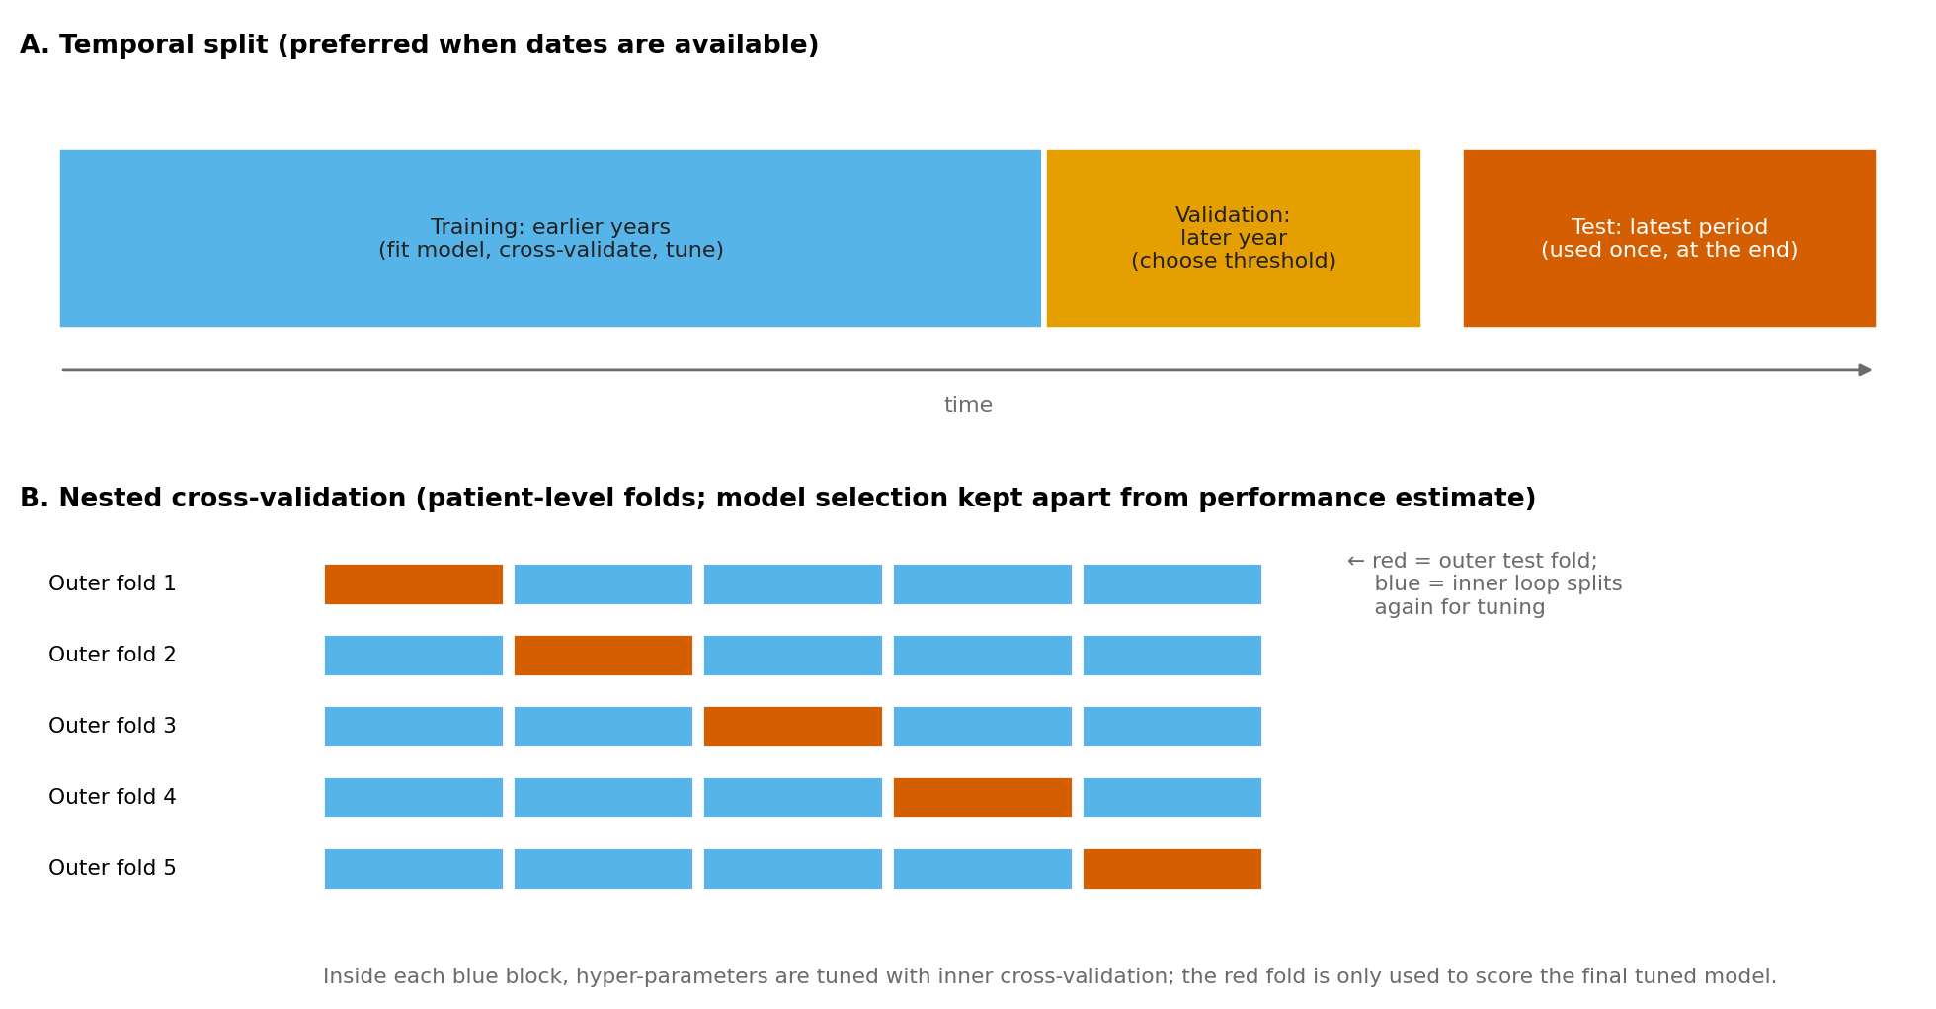
Figure 2. Temporal split and nested cross-validation design

Step 4. Data Pre-processing
Task | Method | Reasoning and safeguards
Data audit | Profile every field: type, range, missing percentage, duplicates, impossible values; compare against the data dictionary | Early detection of errors; documents data quality (Weiskopf & Weng, 2013)
Missing data | Diagnose mechanism (completely at random, at random, or not at random). Use median/mode with a missing-indicator for simple cases, or multiple imputation by chained equations for key variables (Little & Rubin, 2019) | Missingness in health data is often informative (a test not ordered). Fit imputation inside each training fold only
Outliers and errors | Clinical range rules (e.g., plausible heart rate), winsorising or log-transform for skewed values; review rather than delete | Real extreme values can be clinically important
Categorical encoding | One-hot encoding; group rare categories; map diagnosis codes to clinically meaningful groups | Prevents sparse, unstable columns
Scaling | Standardise continuous variables for penalised and distance-based models; not required for tree models | Penalties treat all variables equally only after scaling
Feature engineering | Prior admissions in 12 months, comorbidity index, medication count, trend of a lab value, length of stay | Use only information available at the prediction time point
Class imbalance | Start with class weights and appropriate metrics; use resampling only inside training folds | Resampling such as SMOTE (Chawla et al., 2002) can distort predicted probabilities, so recalibrate afterwards
Leakage control | Run a time-stamp audit on every predictor; remove any variable created after discharge or derived from the outcome | Leakage is the most common reason a model looks excellent in development and fails in practice (Kaufman et al., 2012)

All pre-processing steps are packaged in a single pipeline object so that each transformation is learned from training data only and then applied unchanged to validation and test data. This is the practical way to prevent leakage during cross-validation.

Step 5. Variable Selection
- Start from clinical knowledge and the literature: list candidate predictors with clinicians, including variables known to matter even if they are not significant in the sample.
- Remove variables that are unavailable at the prediction time, unreliable, or ethically inappropriate (see Section 8).
- Check collinearity with correlation matrices and variance inflation factors; combine or drop redundant variables.
- Avoid selection by univariable p-values, which discards variables that matter only in combination and inflates optimism (Steyerberg, 2019; Harrell, 2015).
- Use embedded selection: LASSO or elastic net for regression models, with the penalty strength chosen by cross-validation; examine stability by repeating selection on bootstrap samples and keeping variables chosen consistently.
- For tree ensembles, use permutation importance on validation data and SHAP values (Lundberg & Lee, 2017) to understand contribution, not to claim causation.
- Prefer a smaller model that performs nearly as well: fewer inputs are easier to collect, audit and explain.

Step 6. Model Selection and Justification
Candidate model | Why consider it | Limitations | Role
Logistic regression (baseline) | Transparent, well understood, good calibration, works with modest data | Needs manual handling of interactions and non-linearity | Mandatory benchmark
Penalised logistic regression (LASSO / elastic net) | Handles many correlated predictors; built-in selection | Coefficients are shrunk, so interpret with care | Main interpretable candidate
Random forest | Captures non-linearity and interactions; robust to scaling (Breiman, 2001) | Probabilities may need recalibration; less transparent | Flexible candidate
Gradient boosting (e.g., XGBoost) | Often the highest accuracy on tabular data (Chen & Guestrin, 2016) | Many hyper-parameters; risk of overfitting; needs explanation tools | High-performance candidate
Cox regression / survival forest | Uses time and censoring, not only a yes/no label | Proportional-hazards assumption; competing risks | When timing matters
ETS / ARIMA / seasonal regression | Forecast counts over time with trend and seasonality | Assume pattern continues; sensitive to sudden shocks | Demand forecasting

The selection rule is principled rather than competitive: a more complex model is adopted only if it improves discrimination, calibration or net benefit by a meaningful margin over the logistic baseline in nested cross-validation, and only if it can be explained to clinicians well enough to be trusted and audited. If the gain is small, the simpler model is chosen.

Step 7. Training and Hyper-parameter Tuning
- Define a small, pre-specified search grid or random search for each model; record the random seed and software versions.
- Tune with inner cross-validation and estimate performance with an outer loop (nested cross-validation) so that model selection does not contaminate the performance estimate (Cawley & Talbot, 2010; Varma & Simon, 2006).
- Use early stopping for boosting and regularisation for logistic models to limit overfitting.
The outline below shows how the pipeline would be organised in Python. It is an illustrative structure, not executed code.
# Illustrative outline (scikit-learn style)
preprocess = ColumnTransformer([
('num', Pipeline([('impute', SimpleImputer(strategy='median', add_indicator=True)),
('scale', StandardScaler())]), numeric_cols),
('cat', Pipeline([('impute', SimpleImputer(strategy='most_frequent')),
('onehot', OneHotEncoder(handle_unknown='ignore'))]), categorical_cols)])

model = Pipeline([('prep', preprocess),
('clf', LogisticRegression(penalty='elasticnet', solver='saga',
class_weight='balanced', max_iter=5000))])

# patient-level folds: GroupKFold(groups=patient_id) for outer and inner loops
# inner loop: GridSearchCV over C and l1_ratio, scored by log-loss or AUROC
# outer loop: record AUROC, AUPRC, Brier score and calibration slope per fold
# after selection: refit on training + validation data, evaluate once on locked test set

Step 8. Interpretation and Explanation
- For regression models, report odds ratios with confidence intervals.
- For ensembles, use SHAP summary and dependence plots, partial-dependence plots and individual-patient explanations to check that the model relies on clinically sensible factors.
- Review explanations with clinicians. If the model relies on an implausible or administrative variable, investigate for leakage or proxy effects.

Step 9. Evaluation, Validation and Bias Audit
Evaluation is described fully in Section 4 and bias auditing in Sections 5 and 6.

Step 10. Documentation, Deployment and Step 11. Monitoring
- Document using the TRIPOD+AI reporting guideline (Collins et al., 2024) and a model card describing intended use, data, performance, subgroup results and limitations (Mitchell et al., 2019).
- Deploy first in “silent mode,” generating predictions that are not shown to staff, to compare predictions with real outcomes, then as a pilot with human oversight.
- Monitor input distributions, calibration and subgroup performance monthly; define triggers for recalibration, retraining or withdrawal.

4. Model Evaluation and Validation

4.1 Metrics
Aspect | Metric | Interpretation and cautions
Discrimination | AUROC (c-statistic) | Probability a random patient with the event is ranked above one without; 0.5 is chance. Can look good even when probabilities are poor
Discrimination under imbalance | AUPRC (precision-recall) | More informative when events are rare (Saito & Rehmsmeier, 2015); compare against prevalence
Calibration | Calibration slope and intercept, calibration plot, Brier score | Slope near 1 and intercept near 0 mean predicted risks match observed risks; poor calibration misleads clinical use (Van Calster et al., 2019; Brier, 1950)
Classification at a threshold | Sensitivity, specificity, positive and negative predictive value, F1 | Depend on threshold and prevalence; chosen from capacity and cost of errors, on the validation set
Clinical usefulness | Decision curve analysis (net benefit) | Net benefit = TP/n − (FP/n) × pt/(1 − pt), where pt is the threshold probability; shows whether acting on the model beats treating all or none (Vickers & Elkin, 2006)
Survival models | Concordance index, time-dependent AUC, calibration at fixed times | Account for censoring
Forecasts | MAE, RMSE, MASE and prediction-interval coverage | Compare with a naive or seasonal-naive benchmark (Hyndman & Koehler, 2006)
Uncertainty | Bootstrap 95% confidence intervals for every metric | Avoids over-reading small differences between models

Accuracy alone is not used. If 12% of patients are readmitted, a model that predicts “no readmission” for everyone is 88% accurate yet useless. The metric set above is chosen so that a model must be well ranked, well calibrated and useful at a realistic threshold.
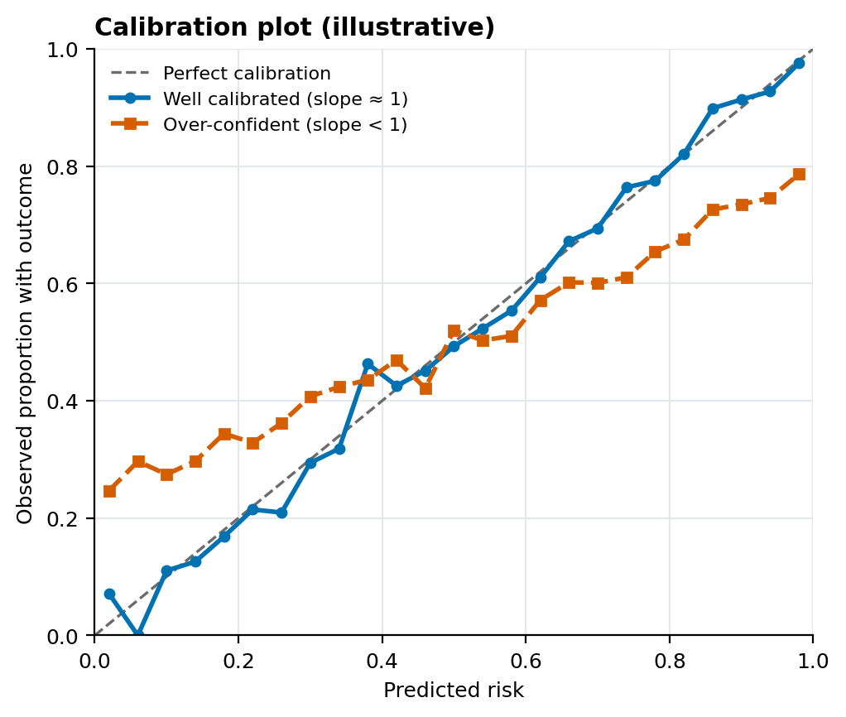
Figure 3. Calibration plot (illustrative)

4.2 Validation Strategies
Strategy | How it works | When to use | Cautions
Hold-out split | Fixed training and test partitions | Large datasets | Single split can be unstable; keep test set untouched
k-fold cross-validation (k = 5 or 10) | Rotate which fold is held out; average results | Moderate datasets; model comparison | Fit pre-processing within each fold
Stratified k-fold | Keeps outcome proportion equal in folds | Imbalanced outcomes | Still needs patient grouping
Grouped k-fold | Keeps all rows of a patient (or hospital) together | Repeated admissions per patient | Essential to prevent leakage
Repeated cross-validation | Repeats k-fold with different shuffles | Small datasets | Increases computation
Nested cross-validation | Inner loop tunes, outer loop estimates performance | Whenever tuning or choosing between models | Avoids optimistic selection bias
Bootstrap optimism correction | Refit on resamples; subtract average optimism (Harrell, 2015) | Small samples, regression models | Repeat the full modeling process in each resample
Rolling-origin evaluation | Train on past, forecast the next period, move forward | Time-series forecasts | Never use random folds for time series
Temporal validation | Test on a later period | Any model meant for future use | Reveals drift
External validation | Test in a different hospital or population | Before wider use | Often shows lower performance; recalibration may be needed
Leave-one-site-out | Hold out each hospital in turn | Multi-site data | Tests transportability

4.3 Model Comparison and Threshold Choice
- Compare models on identical folds and report differences in metrics with bootstrap intervals; adopt a more complex model only when the improvement is meaningful (Step 6).
- Choose the decision threshold on the validation set from clinical capacity (for example, the top 50 risks per day) and the relative cost of false negatives and false positives; then report test-set performance at that fixed threshold.
- If calibration is poor but ranking is good, recalibrate (Platt scaling or isotonic regression) on the validation data.

4.4 Evaluation Checklist
- Test set untouched until the end; pre-processing learned in training only.
- Metrics reported with confidence intervals; calibration and decision-curve analysis included.
- Comparison with a simple baseline and, where one exists, an existing clinical score.
- Temporal or external validation completed or its absence stated as a limitation.
- Subgroup performance reported (Section 5).

5. Bias, Fairness and Subgroup Auditing
A model can have excellent overall performance and still work poorly for particular groups. The audit therefore reports every main metric separately for pre-specified groups (age, sex, ethnicity or caste where lawfully and ethically recorded, rural or urban residence, income or insurance category, language, disability, hospital site).
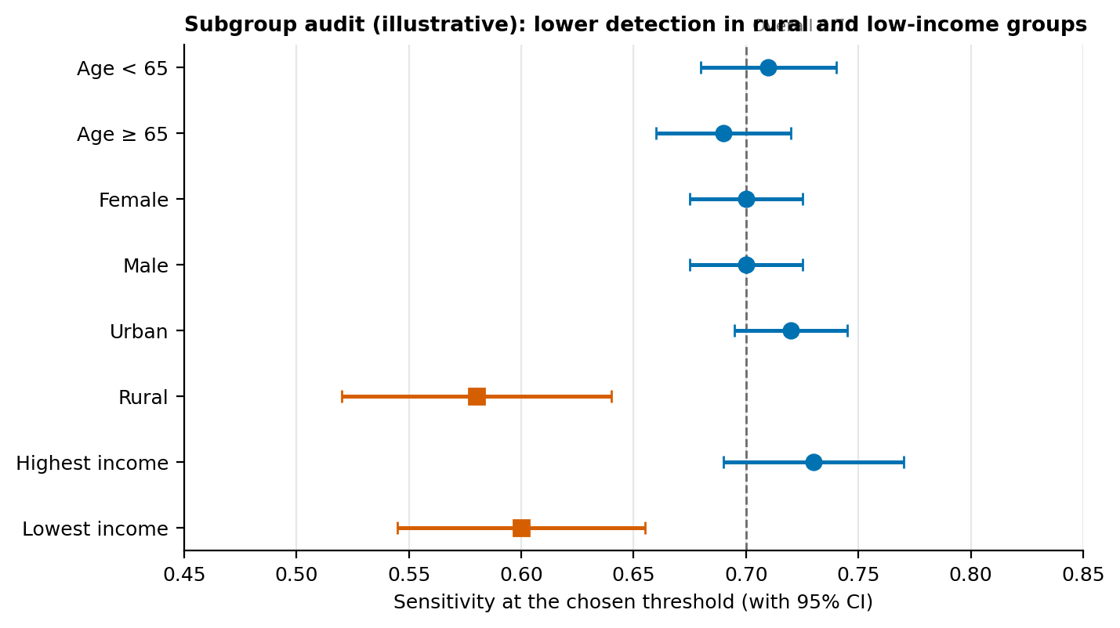
Figure 4. Subgroup audit (illustrative data)
Fairness notion | Definition | Use and caution
Equal opportunity | Equal sensitivity across groups (Hardt et al., 2016) | Appropriate when missing a high-risk patient is the main harm
Equalised odds | Equal sensitivity and equal false-positive rate | Stricter; may reduce overall accuracy
Calibration within groups | Predicted risk means the same thing in every group | Essential when risk scores guide treatment intensity
Demographic parity | Equal share flagged in each group | Can be inappropriate when true risk differs between groups

These criteria cannot all be satisfied at once when groups differ in underlying outcome rates (Chouldechova, 2017), so the choice of criterion is itself an ethical decision recorded with its reasons, made with clinicians and patient representatives, and revisited after deployment.

6. Potential Pitfalls and Mitigation Strategies
Pitfall | How it arises | Mitigation
Data leakage | Predictors recorded after the prediction time (e.g., discharge summary text, later lab results); same patient in training and test sets; pre-processing fitted on all data | Time-stamp audit; patient-grouped splits; pipelines fitted inside folds; clinician review of top predictors
Label bias (proxy outcomes) | Using a convenient proxy such as healthcare cost to represent health need under-served groups who use less care; a widely cited algorithm underestimated the needs of Black patients for this reason (Obermeyer et al., 2019) | Examine what the label truly measures; compare label with clinical need; test alternative labels
Selection and sampling bias | Data come from one hospital, insured patients, or those who reach care; groups under-represented | Describe the population; weight or collect more data for under-represented groups; limit claims of generalisability
Measurement bias | Devices or documentation differ in accuracy by group; for example, pulse oximeters can overestimate oxygen saturation in patients with darker skin (Sjoding et al., 2020) | Review measurement validity by subgroup; avoid or adjust unreliable inputs
Missing not at random | Tests are ordered for sicker patients, so missingness carries information | Missing indicators; sensitivity analysis; avoid naive complete-case analysis
Historical and structural bias | Past under-treatment is recorded as lower need (Gianfrancesco et al., 2018; Rajkomar et al., 2018) | Fairness audit; involve clinicians and community representatives; avoid using proxies for protected attributes without justification
Overfitting | Too many variables for the number of events; tuning on the test set; repeated peeking | Sample-size calculation; regularisation; nested cross-validation; locked test set
Class imbalance | Rare outcomes make accuracy misleading | Use AUPRC, calibration and decision curves; class weights; recalibrate after resampling
Dataset shift and drift | Coding changes, new treatments, population change, pandemics reduce performance over time; a widely deployed sepsis model performed far worse than reported when externally evaluated (Wong et al., 2021) | Temporal and external validation; scheduled monitoring; recalibration or retraining triggers
Confounding and causal misreading | Reading predictor associations as causes | Label output as prediction only; use causal designs for causal questions
Multiple comparisons | Many subgroups, variables or models tested until one looks significant | Pre-specify analyses; control false discovery rate
Immortal-time and survivorship bias | Follow-up window includes time in which the outcome could not have occurred | Define time zero carefully; use time-dependent methods
Automation bias and alert fatigue | Staff over-trust or ignore the tool | Human oversight, appropriate thresholds, clear explanation, user training, audit of overrides
Poor reproducibility | Untracked data versions, random seeds and code | Version control, fixed seeds, environment files, data dictionary, documented decisions

7. Tools and Reproducible Workflow
Purpose | Tools
Data extraction and storage | SQL (PostgreSQL), pandas; versioned data snapshots with checksums
Statistical analysis | Python (statsmodels, SciPy, lifelines for survival) or R as an alternative
Machine learning | scikit-learn pipelines, XGBoost; calibration utilities
Explanation and fairness | SHAP for explanation; Fairlearn for subgroup metrics and mitigation
Forecasting | statsmodels (ETS, ARIMA) with rolling-origin evaluation
Reproducibility | Git, environment files, fixed random seeds, notebooks plus scripts, a data dictionary and a decision log
Reporting | TRIPOD+AI checklist; PROBAST for risk-of-bias review (Wolff et al., 2019); model card

8. Ethical Considerations in Predictive Analytics
Ethical analysis is organised around four widely used principles of biomedical ethics: respect for autonomy, beneficence, non-maleficence and justice (Beauchamp & Childress, 2019), together with transparency and accountability, as emphasised in international guidance on artificial intelligence in health (World Health Organization, 2021; Indian Council of Medical Research, 2023).
Ethical issue | Key questions | Actions in this framework
Legitimate purpose and benefit | Is a prediction model the right response? Who benefits and who might be harmed? Is there an effective action to take once someone is flagged? | Define the intervention before modeling; no model without a defined, available benefit; clinical and patient input at the design stage
Privacy and data protection | Is the data lawfully obtained and minimised? Can individuals be re-identified? | De-identification; minimum necessary data; access control and audit logs; compliance review under applicable law (e.g., India's Digital Personal Data Protection Act, 2023; HIPAA; GDPR); no re-identification attempts
Consent and governance | Is secondary use of health data covered by consent or an approved waiver? | Ethics committee or institutional review board approval; data-use agreements; follow national research-ethics guidance (ICMR, 2017; ICMR, 2023)
Fairness and equity | Does performance and benefit differ by group? Does the model entrench past disparities? | Subgroup audit (Section 5); documented fairness criterion; remediation (re-weighting, group-specific thresholds or calibration where justified); equity review of who receives the intervention
Use of sensitive attributes | Should race, caste, religion or gender be model inputs? | Decide case by case with clinical justification; test performance with and without; never use them to ration care; keep them available for auditing even if excluded from the model
Transparency and explainability | Can clinicians and patients understand why a risk was given? | Prefer interpretable models where performance is similar; explanation tools for complex models; plain-language model card; disclose use of the tool
Accountability | Who is responsible if the model is wrong? | Named model owner and clinical safety lead; documented approval; clinicians retain final judgement; incident reporting and appeal route
Safety and harm balance | What are the consequences of false negatives and false positives? | Threshold set from harm analysis; silent-mode and pilot testing; stopping rules if harm or drift is detected
Autonomy and communication | Are patients told that algorithms inform their care? Can they question results? | Patient information, a human point of contact, and a way to contest decisions
Over-reliance and deskilling | Will staff follow the tool blindly? | Training; presenting risk as uncertainty, not certainty; periodic review of overrides
Security | Could the model or data be misused or attacked? | Secure storage, role-based access, monitoring of unusual use
Lifecycle responsibility | What happens when the model ages? | Monitoring plan, scheduled revalidation, retirement criteria, and public documentation of changes

8.1 Ethics Checkpoints by Stage
Stage | Required check
Design | Purpose, benefit and harm assessment; stakeholder consultation; legal and ethics approval
Data preparation | Representativeness review; label-validity review; privacy safeguards
Development | Variable review for proxies and sensitive attributes; leakage audit
Validation | Subgroup performance and calibration; external or temporal validation; clinical review of explanations
Deployment | Human oversight design; staff training; patient communication; silent-mode pilot
Monitoring | Drift and fairness dashboards; incident log; scheduled ethical re-review

9. Applying the Framework: Readmission Example Summary
Component | Plan
Decision | Offer a 48-hour follow-up call to the highest-risk discharged patients, within staff capacity
Cohort and outcome | Adult live discharges; unplanned readmission within 30 days; planned readmissions and deaths excluded
Splits | Patient-grouped, temporal where dates exist; locked test set
Pre-processing | Median imputation with missing indicators, diagnosis grouping, one-hot encoding, scaling inside the pipeline
Variable selection | Clinically chosen candidates; elastic net with stability check; collinearity review
Models | Logistic baseline, elastic net, random forest, gradient boosting
Tuning and estimate | Nested grouped cross-validation
Metrics | AUROC, AUPRC, calibration slope and Brier score, sensitivity and PPV at the capacity threshold, net benefit
Validation | Temporal test; external site if available; bootstrap intervals
Bias audit | Sensitivity, calibration and false-positive rates by age, sex, residence and income; documented fairness criterion
Explanation | Odds ratios or SHAP; clinician review of top predictors
Governance | Ethics approval, model card, silent-mode pilot, monthly monitoring, retirement criteria

10. Replication Checklist and Project Timeline
Phase | Activities | Deliverable
1. Prepare | Frame decision, secure approvals, extract data, write data dictionary | Protocol and approvals; analysis plan
2. Understand | Data audit, cohort definition, exploratory analysis, subgroup description | Data quality report; cohort flow diagram
3. Build | Splits, pipeline, variable selection, models, nested cross-validation | Candidate models and selection record
4. Prove | Locked-test evaluation, calibration, decision curves, temporal or external validation, bias audit | Validation report with subgroup tables
5. Explain and approve | Interpretation, clinical review, TRIPOD+AI and model card, ethics sign-off | Documented model ready for pilot
6. Deploy and monitor | Silent mode, pilot, monitoring dashboards, scheduled review | Monitoring reports and update decisions

The analysis plan is written and dated before the test data are examined, and any later change is recorded with its reason, so that another analyst can repeat the study and reach the same results from the same data.

11. Project Work Breakdown
Task | Hours
Literature review on healthcare statistics, prediction models and ethics | 6.0
Mapping statistical techniques to healthcare questions | 3.0
Designing the modeling workflow and the readmission running example | 5.0
Designing data segmentation, pre-processing and variable-selection methods | 4.0
Model selection, evaluation and validation design | 5.0
Bias, pitfalls and mitigation analysis | 3.0
Ethical framework and governance checkpoints | 3.0
Creating figures and tables | 2.0
Writing, referencing and quality review of the document | 2.0
Total estimated effort: approximately 33 hours.

12. Conclusion
A healthcare prediction model is only as trustworthy as the process that produced it. This framework puts the decision first, defines the cohort and outcome precisely, protects the test data, chooses models by evidence and explainability, evaluates discrimination, calibration and usefulness together, and examines performance for every patient group. Ethical review is built into each stage so that privacy, fairness, transparency and accountability are addressed before harm occurs rather than after. Because every step, tool and decision rule is documented, the plan can be replicated on other datasets and adapted to other clinical questions.

References
Beauchamp, T. L., & Childress, J. F. (2019). Principles of biomedical ethics (8th ed.). Oxford University Press.
Benjamini, Y., & Hochberg, Y. (1995). Controlling the false discovery rate: A practical and powerful approach to multiple testing. Journal of the Royal Statistical Society: Series B, 57(1), 289–300.
Breiman, L. (2001). Random forests. Machine Learning, 45(1), 5–32. https://doi.org/10.1023/A:1010933404324
Brier, G. W. (1950). Verification of forecasts expressed in terms of probability. Monthly Weather Review, 78(1), 1–3.
Cawley, G. C., & Talbot, N. L. C. (2010). On over-fitting in model selection and subsequent selection bias in performance evaluation. Journal of Machine Learning Research, 11, 2079–2107.
Chawla, N. V., Bowyer, K. W., Hall, L. O., & Kegelmeyer, W. P. (2002). SMOTE: Synthetic minority over-sampling technique. Journal of Artificial Intelligence Research, 16, 321–357.
Chen, T., & Guestrin, C. (2016). XGBoost: A scalable tree boosting system. Proceedings of the 22nd ACM SIGKDD International Conference on Knowledge Discovery and Data Mining, 785–794.
Chouldechova, A. (2017). Fair prediction with disparate impact: A study of bias in recidivism prediction instruments. Big Data, 5(2), 153–163.
Collins, G. S., Moons, K. G. M., Dhiman, P., et al. (2024). TRIPOD+AI statement: Updated guidance for reporting clinical prediction models that use regression or machine learning methods. BMJ, 385, e078378.
Fine, J. P., & Gray, R. J. (1999). A proportional hazards model for the subdistribution of a competing risk. Journal of the American Statistical Association, 94(446), 496–509.
Gianfrancesco, M. A., Tamang, S., Yazdany, J., & Schmajuk, G. (2018). Potential biases in machine learning algorithms using electronic health record data. JAMA Internal Medicine, 178(11), 1544–1547.
Hardt, M., Price, E., & Srebro, N. (2016). Equality of opportunity in supervised learning. Advances in Neural Information Processing Systems, 29.
Harrell, F. E. (2015). Regression modeling strategies (2nd ed.). Springer.
Hosmer, D. W., Lemeshow, S., & Sturdivant, R. X. (2013). Applied logistic regression (3rd ed.). Wiley.
Hyndman, R. J., & Athanasopoulos, G. (2021). Forecasting: Principles and practice (3rd ed.). OTexts. https://otexts.com/fpp3/
Hyndman, R. J., & Koehler, A. B. (2006). Another look at measures of forecast accuracy. International Journal of Forecasting, 22(4), 679–688.
Indian Council of Medical Research. (2017). National ethical guidelines for biomedical and health research involving human participants. ICMR.
Indian Council of Medical Research. (2023). Ethical guidelines for application of artificial intelligence in biomedical research and healthcare. ICMR.
Johnson, A. E. W., Bulgarelli, L., Shen, L., et al. (2023). MIMIC-IV, a freely accessible electronic health record dataset. Scientific Data, 10, 1.
Kaufman, S., Rosset, S., Perlich, C., & Stitelman, O. (2012). Leakage in data mining: Formulation, detection, and avoidance. ACM Transactions on Knowledge Discovery from Data, 6(4), 15.
Little, R. J. A., & Rubin, D. B. (2019). Statistical analysis with missing data (3rd ed.). Wiley.
Lundberg, S. M., & Lee, S.-I. (2017). A unified approach to interpreting model predictions. Advances in Neural Information Processing Systems, 30.
Mitchell, M., Wu, S., Zaldivar, A., et al. (2019). Model cards for model reporting. Proceedings of the Conference on Fairness, Accountability, and Transparency, 220–229.
Obermeyer, Z., Powers, B., Vogeli, C., & Mullainathan, S. (2019). Dissecting racial bias in an algorithm used to manage the health of populations. Science, 366(6464), 447–453.
Rajkomar, A., Hardt, M., Howell, M. D., Corrado, G., & Chin, M. H. (2018). Ensuring fairness in machine learning to advance health equity. Annals of Internal Medicine, 169(12), 866–872.
Riley, R. D., Ensor, J., Snell, K. I. E., et al. (2020). Calculating the sample size required for developing a clinical prediction model. BMJ, 368, m441.
Rosenbaum, P. R., & Rubin, D. B. (1983). The central role of the propensity score in observational studies for causal effects. Biometrika, 70(1), 41–55.
Saito, T., & Rehmsmeier, M. (2015). The precision-recall plot is more informative than the ROC plot when evaluating binary classifiers on imbalanced datasets. PLoS ONE, 10(3), e0118432.
Sjoding, M. W., Dickson, R. P., Iwashyna, T. J., Gay, S. E., & Valley, T. S. (2020). Racial bias in pulse oximetry measurement. New England Journal of Medicine, 383(25), 2477–2478.
Steyerberg, E. W. (2019). Clinical prediction models: A practical approach to development, validation, and updating (2nd ed.). Springer.
Strack, B., DeShazo, J. P., Gennings, C., et al. (2014). Impact of HbA1c measurement on hospital readmission rates: Analysis of 70,000 clinical database patient records. BioMed Research International, 2014, 781670.
Tibshirani, R. (1996). Regression shrinkage and selection via the lasso. Journal of the Royal Statistical Society: Series B, 58(1), 267–288.
Van Calster, B., McLernon, D. J., van Smeden, M., Wynants, L., & Steyerberg, E. W. (2019). Calibration: The Achilles heel of predictive analytics. BMC Medicine, 17, 230.
Varma, S., & Simon, R. (2006). Bias in error estimation when using cross-validation for model selection. BMC Bioinformatics, 7, 91.
Vickers, A. J., & Elkin, E. B. (2006). Decision curve analysis: A novel method for evaluating prediction models. Medical Decision Making, 26(6), 565–574.
Wasserstein, R. L., & Lazar, N. A. (2016). The ASA statement on p-values: Context, process, and purpose. The American Statistician, 70(2), 129–133.
Weiskopf, N. G., & Weng, C. (2013). Methods and dimensions of electronic health record data quality assessment: Enabling reuse for clinical research. Journal of the American Medical Informatics Association, 20(1), 144–151.
Wolff, R. F., Moons, K. G. M., Riley, R. D., et al. (2019). PROBAST: A tool to assess the risk of bias and applicability of prediction model studies. Annals of Internal Medicine, 170(1), 51–58.
Wong, A., Otles, E., Donnelly, J. P., et al. (2021). External validation of a widely implemented proprietary sepsis prediction model in hospitalized patients. JAMA Internal Medicine, 181(8), 1065–1070.
World Health Organization. (2021). Ethics and governance of artificial intelligence for health: WHO guidance. WHO.

