INTEGRATED PROJECT REPORT
Healthcare Data Analysis: From Data Strategy to Decision Support
A capstone that unites data sourcing and quality, statistical and predictive analysis, visualization and reporting, with a reflective self-assessment and career pathway

Prepared by: Ipshita Verma
Jaipur, Rajasthan, India
Date: October 31, 2026
Code, data and portfolio index: https://github.com/ipshitav71-wq/healthcare-data-analysis-capstone
Important note: the case study in this report is hypothetical. All patient-level data were simulated by the author to resemble routine hospital discharge records. No real patients, hospitals or organisations are represented, and the numbers must not be used as real-world estimates. The value of the report lies in the integrated method, the reasoning that connects each step to a decision, and the honest assessment of what worked and what did not.

Executive Summary
Purpose. This final report brings together four earlier pieces of work into one project: a data collection and quality strategy, a data visualization plan, a statistical analysis and predictive modeling framework, and an analytical report. Instead of presenting them as separate documents, it follows one case from start to finish: a four-hospital network that wants to understand and reduce 30-day unplanned readmissions.
What the integrated project found. Across the network the readmission rate was steady (14.5% in the first 18 months and 14.5% in the last six), but one hospital (Hospital D) rose from 15.0% to 18.0%. In the same hospital, completion of follow-up within 7 days fell from 55.9% to 30.4%. Patients without early follow-up were readmitted at 20.0% compared with 10.0% for those with it (adjusted OR 0.45). A risk model with modest accuracy (AUROC 0.644) helped prioritise follow-up calls, capturing 33.6% of readmissions in the highest-risk 20% of discharges, while a fairness audit showed the model under-predicting risk for rural patients (observed/expected ratio 1.24).
Why integration mattered. Each finding depended on more than one component. The Hospital D problem was visible only because quality checks produced a trustworthy dataset, the analysis was done at hospital level, and a control chart made the signal easy to see. A balanced-class-weight model looked fine on ranking but produced misleading risk numbers, which only a calibration check exposed. Without a plan for communication, none of this would have reached the people who can act.

Summary of unified recommendations (Section 9)
Area | Recommendation | Evidence
Operations | Restore 7-day follow-up at Hospital D to about 56% and make medication reconciliation universal | Sections 5.2, 5.3
Analytics | Monitor readmissions by hospital and ward with control charts; pilot the risk model in silent mode, then use it only to prioritise calls | Sections 5.2, 5.4
Equity | Close the rural and low-income follow-up gap; report equity measures every quarter; recalibrate the model for under-predicted groups | Sections 5.4, 5.5
Data | Adopt data-quality gates and a documented source log before any analysis; reduce missing income, comorbidity and medication fields | Section 4
Communication | Deliver an accessible dashboard and one-page briefing with text descriptions of every chart | Section 6
Governance | Obtain ethics approval, keep humans in control of decisions, and review model drift and fairness monthly | Section 7

Learning and next steps. Appendix A is a reflective self-assessment. Key lessons: design from the decision, not from the tool; describe every visual in words as well as showing it; give concrete, worked examples; test the common pitfalls (such as class imbalance and leakage) rather than only naming them. The main gaps are hands-on experience with real, messy data and with building dashboards in Power BI and SQL, which the career pathway in Appendix A.6 addresses.

1. Introduction and Project Overview

1.1 Purpose and Scope
The purpose of this report is to show an integrated understanding of healthcare data analysis. Real projects rarely fail because a single technique was applied badly; they fail at the joins between stages: data that was never checked, a model that was never explained, a chart that nobody could read, a recommendation not connected to evidence. The report therefore treats the whole workflow as one system and shows, with a single running case, how each stage depends on the others.

1.2 The Five Components
Component | Earlier deliverable | Role in this integrated project
1. Data strategy | Data collection and quality strategy: public sources, selection criteria, acquisition plan | Decides what data to use, how to obtain it, and under what conditions (Section 4.1)
2. Data quality | Quality framework, validation and cleaning plan, risk assessment | Turns raw records into a trustworthy cohort and records every exclusion (Sections 4.2, 4.3)
3. Analysis and modelling | Statistical analysis and predictive modeling framework | Finds trends and drivers and builds a validated, fair risk model (Section 5)
4. Visualization | Data visualization plan with dashboard mock-ups | Turns results into accessible visuals for each audience (Section 6)
5. Reporting | Analytical report with recommendations | Links evidence to decisions and states limitations (Sections 5 to 9)

1.3 The Unified Case
A regional network of four hospitals asked three questions: Is the 30-day readmission rate changing? Where are the problems and which patients are at risk? What should the network do about it? The case uses 24,268 adult discharges (16,968 patients) from September 2024 to August 2026, generated by simulation so that every step could be carried out and checked without real patient data. Appendix C lists the repositories holding the code and data.

1.4 How This Report Meets the Task Requirements
Requirement | Where addressed
Review of previous outputs and key insights | Section 2 (insight table K1 to K8)
Unified structure that logically brings elements together | Section 3 (framework) and the section order of this report
Self-assessment of approach, methods and growth | Appendix A (A.1 to A.7)
Where strategies interlink and integrated efforts improve outcomes | Section 8
Future recommendations, pitfalls and lessons learned | Section 10
Best practices summary | Section 10.1 and 10.3
Critical assessment and career development pathway | Appendix A.3 and A.6

2. Review of Previous Work: Key Insights Carried Forward
The earlier deliverables were reviewed to decide what to carry into the integrated project. The table lists the main insights (K1 to K8) and how each is used here.
ID | Source work | Key insight | How it is used in this report
K1 | Data strategy | Choose datasets by relevance, provenance, documentation, currency, licence and reproducible access; log the source and version | Source scoring and data-source log (Section 4.1)
K2 | Data quality | Check completeness, correctness, concordance, plausibility and currency (Weiskopf & Weng, 2013) | Quality checks with actual results (Section 4.2)
K3 | Data quality | Anticipate risks: missing data, duplicates, coding inconsistency, bias, drift, re-identification | Case risk register (Section 4.3)
K4 | Visualization | Design from decisions and personas; use a chart guide; make visuals accessible | Insight-to-visual map and dashboard (Section 6)
K5 | Visualization | Power BI for dashboards, Python for statistical charts, PostgreSQL for modelling | Tool roles and model sketch (Section 6.4)
K6 | Statistics and modelling | Split data by patient and date; prevent leakage; use nested validation, calibration and fairness audits | Analysis design (Section 5)
K7 | Reporting | Tie every recommendation to evidence; give worked examples; describe every visual in text | Matrix and recommendations (Sections 5.6, 9)
K8 | All | Ethics and privacy are checks at every stage, not a final review | Lifecycle ethics table (Section 7)

Feedback on earlier submissions also shaped this report. Evaluators asked for concrete examples, for mock-ups to be described rather than only drawn, for practical handling of class imbalance, and for an end-to-end case study. These points are addressed throughout and are itemised in Appendix A.2.

3. Unified Framework and Project Structure
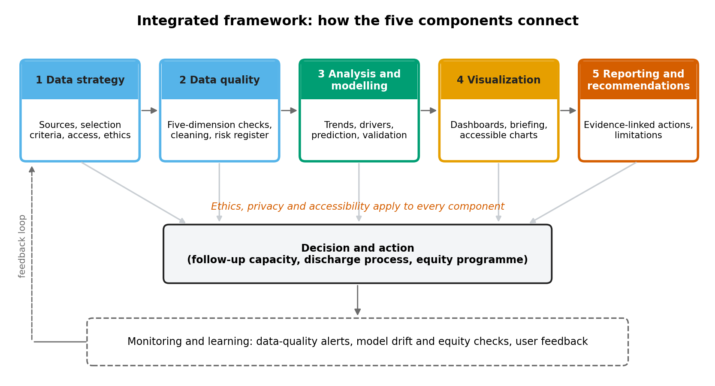
Figure 1. Integrated framework connecting the five components
Figure in words: Five boxes run left to right: data strategy, data quality, analysis and modelling, visualization, and reporting and recommendations. Arrows from every box lead to a central “Decision and action” box, which leads to a “Monitoring and learning” box; a dashed arrow returns from monitoring to the start. A note states that ethics, privacy and accessibility apply to all components. Take-away: the work is a loop, not a line, and every stage feeds the decision.
Stage | Key question | Main outputs | Quality gate before moving on
Data strategy | What data answers the question, and may we use it? | Source log, selection scores, access and licence record | Purpose, permissions and documentation confirmed
Data quality | Can the data be trusted? | Validation report, cleaning log, cohort flow, risk register | Critical checks pass or exceptions documented
Analysis and modelling | What changed, why, and who is at risk? | Trend, driver and model results with uncertainty; fairness audit | Test data untouched; calibration and subgroup checks done
Visualization | How will each audience understand and act? | Dashboard, briefing, text descriptions, accessibility check | Each visual linked to a decision; accessibility checklist passed
Reporting | What should we do, and how sure are we? | Evidence-linked recommendations, limitations | Every recommendation traced to evidence
Monitoring | Is it still working, and for everyone? | Drift, equity and quality dashboards | Review dates and owners agreed

4. Data Strategy and Quality in the Case

4.1 Choosing the Data (Component 1)
The data strategy lists the public sources considered for healthcare analytics: government portals (healthdata.gov, CDC Open Data, CMS Provider Data Catalog), international repositories (WHO Global Health Observatory), credentialed clinical databases (MIMIC-IV on PhysioNet), claims and utilisation data (HCUP), and curated learning datasets (Kaggle and UCI). Candidate datasets for the readmission question were scored against the selection criteria (1 = weak, 3 = strong) using the author's judgement.
Criterion | UCI Diabetes 130-US Hospitals | MIMIC-IV (ICU) | CMS hospital quality data | Simulated cohort (used)
Relevance to readmission question | 3 (has readmission label) | 2 (ICU stays, readmission derivable) | 2 (hospital-level, not patient-level) | 3 (designed for the question)
Provenance and documentation | 3 (published paper and codebook) | 3 (peer-reviewed descriptor) | 3 (government source) | 3 (code and dictionary provided)
Currency | 1 (1999–2008) | 2 (recent releases) | 3 (regularly updated) | 3 (to Aug 2026)
Access and licence | 3 (open) | 1 (training and agreement needed) | 3 (open) | 3 (own data)
Privacy risk | 2 (de-identified) | 2 (de-identified, restricted use) | 3 (aggregate) | 3 (no real patients)
Allows the full workflow (patient-level, dates, follow-up) | 2 (no dates, no follow-up variable) | 2 | 1 | 3
Total (out of 18) | 14 | 12 | 15 | 18
Table 1. Source scoring. The simulated cohort scores highest because it was built for the question; for a real replication, the UCI dataset is the best open practice option and MIMIC-IV the most realistic once credentialed.
Decision: a simulated cohort was used because the project is hypothetical and because it allowed every stage, including follow-up completion and dates, to be demonstrated without any privacy risk. A source log (name, version, date, licence, access method, checksum) records each file.

4.2 Checking the Data (Component 2)
The five-dimension quality framework was applied as a set of concrete checks. Results are from running the checks on the case data.
Dimension | Check applied | Result in the case data
Completeness | Percentage missing per field after cleaning | Income group 6.8%, comorbidity count 2.5%, medication reconciliation 4.1%; length of stay missing in 199 records, which were excluded
Uniqueness | Duplicate encounter identifiers | 153 duplicate rows found in the raw extract of 25,583 and removed; 0 remain
Correctness | Range and category checks | Age 18–96 years, length of stay 1–38 days, comorbidities 0–7, prior admissions 0–7; 0 values outside limits; all ward and discharge categories valid; all yes/no fields valid
Concordance | Consistency of linked fields | Age, sex and residence agree across the 5,894 patients with several admissions (0 conflicts); excluded categories (deaths, hospice, transfers) leave 0 records
Plausibility | Review of distributions and subgroup patterns | No impossible combinations found; missing income was more common among rural patients (11% vs 5.1%), so it is treated as informative, not random
Currency | Coverage window and outcome follow-up | Discharges to 31 Aug 2026 with 30 days of follow-up complete before the 24 Oct 2026 extract

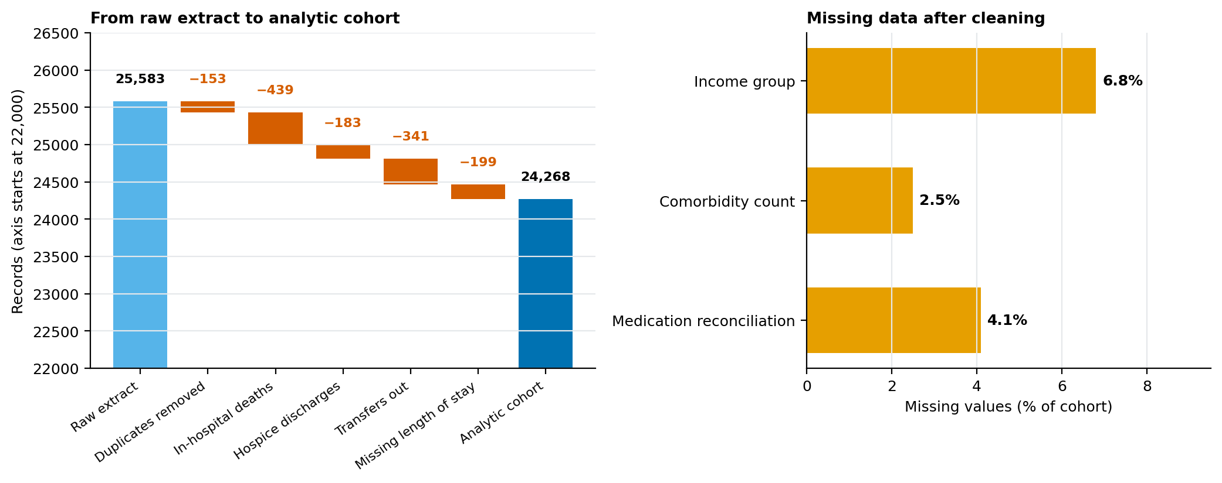
Figure 2. Data quality at a glance: cohort flow (left) and remaining missing data (right)
Figure in words: Left: the raw extract holds 25,583 records. Removing 153 duplicates, 439 in-hospital deaths, 183 hospice discharges, 341 transfers and 199 records without length of stay leaves 24,268 discharges. Right: after cleaning, 6.8% of income values, 2.5% of comorbidity values and 4.1% of medication reconciliation values are missing. Take-away: the cohort lost about 5% of records and income is the field needing most attention.

4.3 Risk Register for the Case
Risk | Where it appeared in the case | Mitigation applied | Residual risk
Duplicate records inflate counts | 153 duplicate encounters in the raw extract | De-duplicate on encounter identifier; log the count | Low
Informative missing data | Income missing more often for rural patients | Keep “unknown” category; missing indicator for comorbidity; sensitivity check | Medium
Data leakage | Follow-up completion is recorded after discharge | Excluded from the prediction model; used only for explanation | Low
Class imbalance | Readmission is the minority outcome (14.5%) | Metrics beyond accuracy; calibration checked; re-weighting rejected after testing | Low
Hidden local problems | Network average stable while Hospital D rose | Hospital-level control charts and drill-down | Medium
Model drift | Hospital D observed/expected ratio above 1 | Monthly calibration and subgroup monitoring; retraining triggers | Medium
Incomplete outcome capture | Only readmissions within the network are observed | Stated as a limitation; link to regional records in future | Medium
Re-identification and consent | Not applicable to simulated data; essential for real data | De-identification, access control, ethics approval, small-number suppression | Low if controls kept

5. Analysis and Modelling in the Case (Component 3)

5.1 Analytical Design
The eleven-step modeling workflow from the earlier framework was followed: frame the decision, define the cohort and outcome, split data by patient and date, pre-process, select variables, fit and tune models, evaluate, validate and audit for bias, document, deploy with oversight, and monitor. The outcome was unplanned 30-day readmission. The prediction model used only information known at discharge, trained on September 2024 to February 2026, tuned on March to May 2026, and tested once on June to August 2026.
Question | Method | Why
Is the rate changing? | p-chart with baseline limits and run rule; chi-square test of recent vs earlier periods | Separates real change from normal variation
What drives readmission? | Logistic regression with errors clustered by patient | Adjusts for patient mix; accounts for repeated admissions
Can we predict risk? | Penalised logistic regression vs gradient boosting; temporal split | Transparent baseline compared with a flexible model
Is the model fair? | Sensitivity and observed/expected ratio by subgroup | Detects groups the model serves poorly
What could be gained? | Scenario calculation from the fitted model | Order-of-magnitude benefit with stated assumptions

5.2 Trend: A Stable Network Hides a Rising Hospital
The network rate stayed near the 14.4% baseline with no month outside control limits (overall trend OR per month 1.001, p = 0.687). Hospital D, however, rose from 15.0% to 18.0% (p = 0.012) while Hospitals A to C moved from 14.4% to 13.6%. In August 2026 Hospital D's rate of 23.5% exceeded its upper control limit of 21.3%.
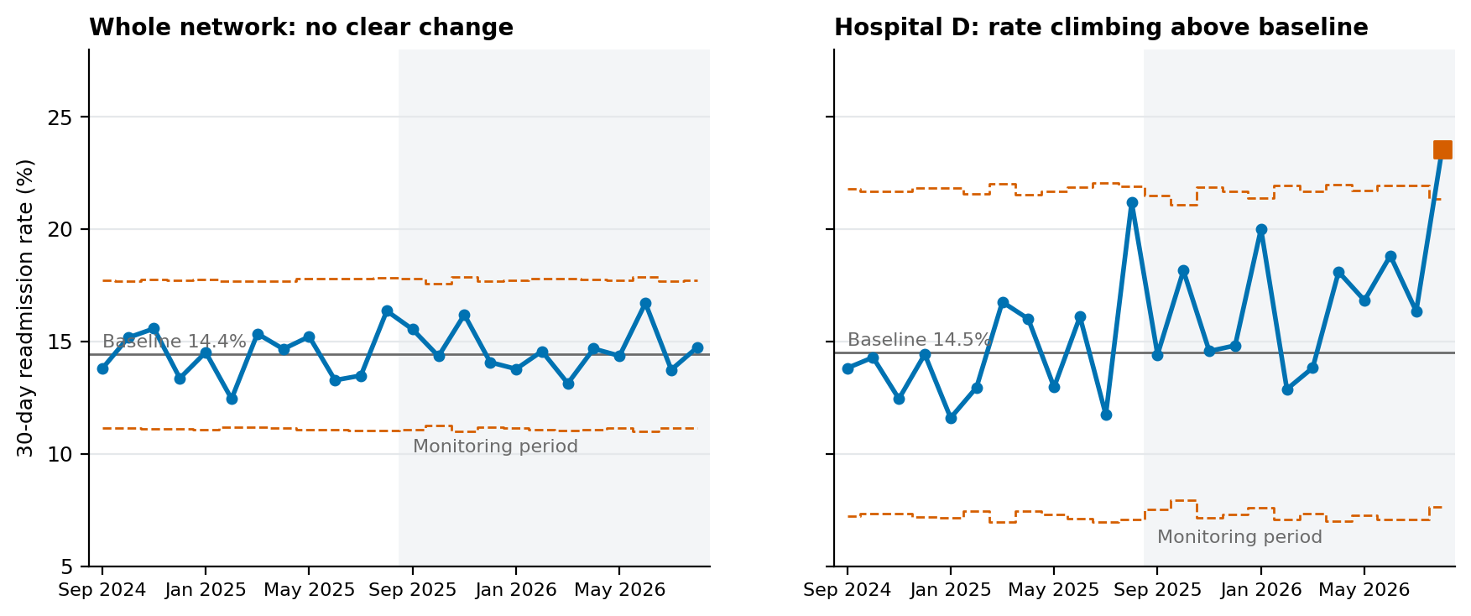
Figure 3. Control charts: whole network (left) and Hospital D (right)
Figure in words: Left: network monthly rates range from 12.4% to 16.7% inside limits of about 11.1% to 17.7% around 14.4%. Right: Hospital D swings more because monthly numbers are small; 5 of the last 6 months are above its 14.5% baseline and August 2026 (23.5%) is above the upper limit. Take-away: look at the level where action is possible.

5.3 Drivers: Follow-Up Is the Strongest Controllable Factor
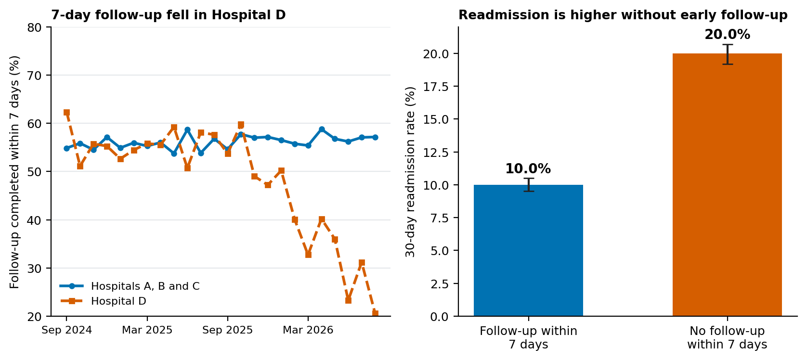
Figure 4. Follow-up within 7 days by month (left) and readmission by follow-up status (right)
Figure in words: Left: follow-up stays near 56.9% in Hospitals A to C but in Hospital D falls from 55.9% to 30.4%. Right: readmission is 10.0% with follow-up and 20.0% without. Take-away: the rise in Hospital D coincides with missed follow-up.
Factor | Adjusted OR | 95% CI
Follow-up within 7 days | 0.45 | 0.42 – 0.48
Medication reconciliation done (vs not) | 0.75 | 0.68 – 0.81
Length of stay over 7 days | 1.47 | 1.31 – 1.65
Rural residence | 1.33 | 1.23 – 1.44
Weekend discharge | 1.25 | 1.15 – 1.36
Prior admissions (per additional) | 1.23 | 1.18 – 1.28
Comorbidities (per additional) | 1.21 | 1.17 – 1.25
Hospital D vs A | 1.03 | 0.93 – 1.15
Table 2. Selected adjusted odds ratios for 30-day readmission (full table in the companion analytical report).
Adding follow-up to a model of the time trend in Hospital D removed the trend (shrinking the coefficient by roughly 100%), and Hospital D showed no excess risk after adjustment (OR 1.03). The interpretation is that a process change, not patient mix, explains the rise. Because the data are observational, this is a strong association that justifies action, not proof of cause.

5.4 Prediction: Useful for Prioritising, Not for Deciding
Measure (test period) | Result
AUROC (logistic regression) | 0.644 (95% CI 0.619–0.674); gradient boosting 0.646, no real gain
Calibration slope / intercept | 1.05 / 0.04
Top 20% flagged | Sensitivity 33.6%, positive predictive value 26.3%, 1.76 times better than random
Class re-weighting test | Same AUROC (0.644) but average predicted risk 47.8% against 15.0% observed; rejected

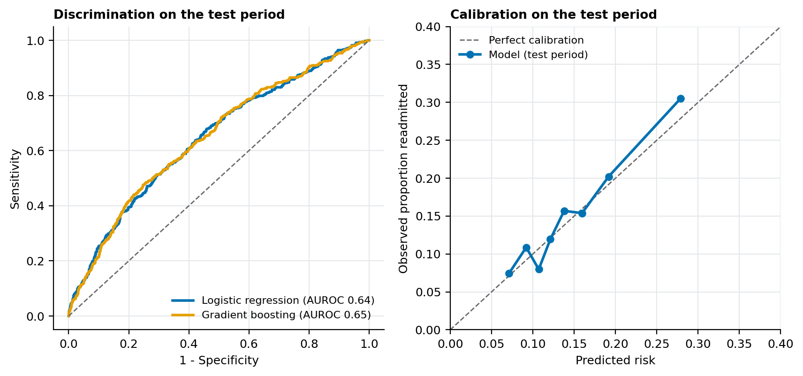
Figure 5. Discrimination (left) and calibration (right) on the test period
Figure in words: Left: both models rank patients modestly better than chance (AUROC 0.644 and 0.646). Right: predicted and observed risks agree closely. Take-away: the risk numbers are trustworthy overall, but ranking power is modest.

5.5 Fairness Audit
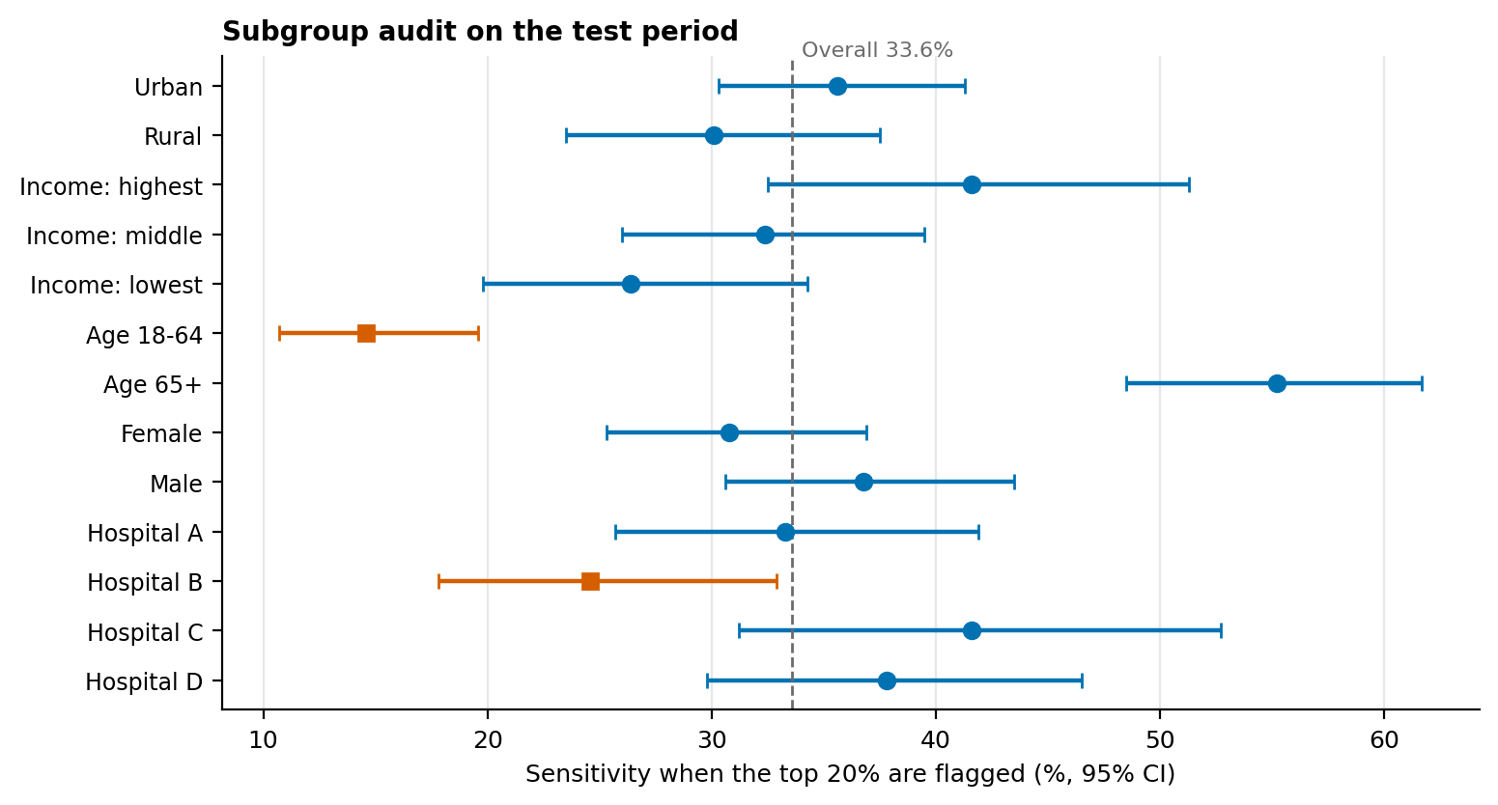
Figure 6. Sensitivity of the top-20% flag by subgroup
Figure in words: Sensitivity was 35.6% for urban and 30.1% for rural patients, 41.6% for the highest and 26.4% for the lowest income group, against 33.6% overall. The model under-predicted rural risk (observed/expected 1.24) and Hospital D risk (1.28). Most intervals overlap, so these are signals to monitor.

5.6 Evidence-to-Recommendation Matrix
Insight | Evidence | Recommendation
Network stable, Hospital D rising | Figure 3; Section 5.2 | Escalate Hospital D; monitor by hospital and ward
Follow-up halves readmission and has fallen in Hospital D | Figure 4; Table 2 | Restore follow-up capacity; target rural and low-income patients
Medication reconciliation protective and lower in Hospital D | Table 2; 66.1% vs 76.9% | Make reconciliation standard work
Model modest but useful for ranking | Section 5.4; Figure 5 | Pilot as a prioritisation aid with human oversight
Rural and Hospital D under-prediction | Figure 6 | Monitor equity; recalibrate

Scenario estimate: restoring follow-up at Hospital D to its earlier level would avert roughly 37 to 65 readmissions a year (about 325 bed-days at an assumed 5 days each), under the assumption that the follow-up effect is partly or fully causal.

6. Visualization and Communication (Component 4)

6.1 From Insight to Visual to Audience
Insight | Best visual (chart guide) | Primary audience | Decision supported
Hospital D is drifting above normal | Control chart with baseline and limits | Executives, hospital directors | Escalate and resource Hospital D
Follow-up fell only in Hospital D | Two-line chart with target line | Hospital directors | Staffing for follow-up team
Follow-up halves readmission | Two-bar chart with intervals; “out of 100 patients” icon version for the public | All audiences | Justify investment
Who to call first | Ranked priority list with risk and status symbol | Follow-up team | Daily workload
Who is missed | Dot plot of sensitivity by group | Quality and equity leads | Equity programme

6.2 Integrated Dashboard Populated with Case Results
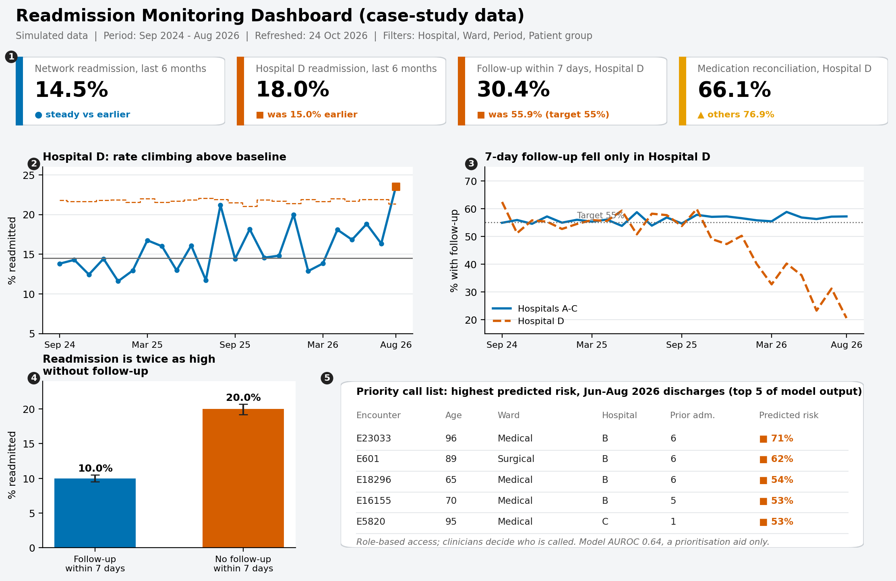
Figure 7. Integrated monitoring dashboard mock-up using the case-study results
Figure in words: Top row, four tiles with status symbols: network readmission 14.5% (steady), Hospital D readmission 18.0% (was 15.0%), Hospital D follow-up 30.4% (target 55%), medication reconciliation in Hospital D 66.1% (others 76.9%). Middle row: Hospital D control chart (left) and follow-up by month for Hospital D versus the other hospitals (right). Bottom row: readmission with versus without follow-up (left, 10.0% vs 20.0%) and a priority call list of the five highest predicted risks in June to August 2026, with encounter number, age, ward, hospital, prior admissions and predicted risk.
# | Element | Problem it detects | Decision supported
1 | Status tiles | Which headline measure is off target | Where to look first
2 | Hospital D control chart | Sustained rise above baseline | Escalate and investigate
3 | Follow-up lines with target | Follow-up collapse in one hospital | Resource follow-up team
4 | Bars with and without follow-up | Size of the benefit of follow-up | Make the case for investment
5 | Priority call list | Highest-risk discharges to contact | Daily call workload; clinician decides

6.3 One-Page Briefing in Words
Zone | Content
Headline | Network readmissions are steady at 14.5%, but Hospital D has risen from 15.0% to 18.0% as follow-up fell from 56% to 30%.
Evidence | Hospital D control chart; two bars comparing readmission with and without follow-up
Decision requested | Approve staffing for the Hospital D follow-up team within 3 months
Data note | Source, definitions, refresh date, small-number suppression, contact

6.4 Build Plan: Tools and a Model Sketch
The tool choice from the visualization plan is applied: PostgreSQL stores and models the data, Python prepares it and produces statistical charts, and Power BI delivers the dashboard. A simple star schema (fact table of discharges; date, hospital and ward dimensions) lets every measure be defined once. Illustrative measures:
Readmission Rate = DIVIDE( SUM( Fact_Discharge[Readmit30] ), COUNTROWS( Fact_Discharge ) )
Follow-up Rate = DIVIDE( SUM( Fact_Discharge[Followup7] ), COUNTROWS( Fact_Discharge ) )
Baseline Rate = CALCULATE( [Readmission Rate], Dim_Date[MonthIndex] <= 11, ALL( Dim_Date ) )
Upper Limit = VAR p = [Baseline Rate] VAR n = COUNTROWS( Fact_Discharge )
RETURN p + 3 * SQRT( DIVIDE( p * ( 1 - p ), n ) )

6.5 Accessibility and Plain Language
- Colour-blind-safe palette with shapes and words as well as colour (● on target, ▲ watch, ■ action).
- Alt text and a “Figure in words” description for every chart, so that the content survives without the picture.
- Headline titles state the finding; acronyms are defined; natural frequencies (“20 in 100”) replace odds ratios for general audiences.
- Text at least 12 pt, logical reading order, keyboard-operable filters, data tables available for each chart.

7. Ethics, Privacy and Governance Across the Lifecycle
Stage | Ethical or governance check | Applied in the case
Data strategy | Lawful basis, consent or waiver, ethics approval, licence terms | Simulated data; real use would need approval and a data-use agreement (DPDP Act 2023, ICMR guidance, HIPAA or GDPR as applicable)
Data quality | Minimisation, de-identification, representativeness review | Only fields needed; missing-data patterns by group reviewed
Modelling | No unjustified sensitive predictors; leakage control; fairness criterion chosen openly | Rural and income excluded as predictors but used in the audit
Visualization | Small-number suppression, honest axes, accessible design | Counts under 11 suppressed; bars start at zero
Reporting | State limitations and uncertainty; avoid causal overclaims | Section 11; association wording
Deployment and monitoring | Human oversight, accountability, drift and equity review, route to contest decisions | Clinician decides; monthly monitoring; named owner

8. Integration Analysis: Where Strategies Interlink

8.1 Dependencies Between Components
From → To | What passes between them | Example from the case
Data strategy → Quality | Documentation and field definitions define what “correct” means | The follow-up field definition (completed within 7 days) fixed how it could be used
Quality → Analysis | Cleaning decisions change results | Duplicates removed before counting; missing income kept as a group so rural patients were not dropped
Quality → Modelling | Timing and leakage decisions | Follow-up recorded after discharge was kept out of the model
Analysis → Visualization | Uncertainty and structure of results decide the chart | Control chart chosen because hospital months are small and noisy
Visualization → Reporting | Visuals make findings quotable | The two-bar chart supports the “twice as high” message
Reporting → Strategy | Decisions create new data needs | Recommendation to capture out-of-network readmissions
Ethics → all | Constraints on data, variables, display and use | Sensitive attributes used for audit, not prediction

8.2 What Would Have Gone Wrong If Components Were Done in Isolation
Isolated work | Likely failure | Integrated safeguard
Analysis on uncleaned data | 153 duplicate encounters would have inflated counts and distorted rates | Quality gate before analysis
Network-level reporting only | Hospital D problem unseen because the network average was flat | Hospital-level visuals chosen at design stage
Modelling without a communication plan | A model with AUROC 0.64 might be read as a decision-maker | Plain-language description, role as aid, calibration shown
Class re-weighting without calibration check | Average predicted risk 47.8% vs 15.0% observed | Calibration measured and re-weighting rejected
Dashboard built before defining decisions | Attractive but unused visuals | Each visual tied to a named decision
Visuals without text descriptions | Content lost for screen-reader users and text-only reviewers | A written description for every figure

8.3 How Integrated Effort Improves Outcomes
- Faster, better-targeted action: combining quality checks, hospital-level analysis and an accessible control chart led directly to one actionable priority (Hospital D follow-up), worth an estimated 37 to 65 fewer readmissions a year.
- Fewer false alarms and missed signals: statistical rules (control limits, run rules) agreed in advance prevent over-reaction to single months.
- Trust: transparency from data source to recommendation lets a sceptical manager retrace each step.
- Equity: linking data completeness, fairness audit and outreach plans means gaps are found and acted on, not only reported.
- Reuse: because the pipeline, definitions and visuals are documented, a new dataset can follow the same route with little rework.

9. Unified Recommendations
# | Recommendation | Evidence | Owner | Timing | Measure of success
O1 | Restore 7-day follow-up at Hospital D (staffing, pre-booked appointments, reminders) | Figures 3, 4 | Hospital D nursing director | 0–3 months | Follow-up at least 55%; readmission at or below 15%
O2 | Make medication reconciliation standard work, starting at Hospital D | Table 2 | Pharmacy lead | 0–6 months | At least 85% in every hospital
O3 | Add discharge checklists for weekend discharges and stays over 7 days; evaluate before scaling | Table 2 | Ward managers | 3–9 months | Lower readmission in those groups
A1 | Report readmissions by hospital and ward with control charts and run rules | Figure 3 | Quality and analytics lead | 0–2 months | Signals reviewed within one month
A2 | Pilot the risk model in silent mode, then use it to prioritise calls for the top 20% | Section 5.4 | Clinical informatics | 3–9 months | Contacts reach at least 30% of readmissions
E1 | Close the rural and low-income follow-up gap; recalibrate for under-predicted groups | Figure 6 | Community health lead | 3–12 months | Rural–urban follow-up gap halved
D1 | Apply data-quality gates and a source log; reduce missing income, comorbidity and medication fields | Section 4 | Data governance lead | 0–6 months | Missing data under 3%
C1 | Deliver the accessible dashboard and one-page briefing with text descriptions | Section 6 | Analytics lead | 3–6 months | Monthly use by target users; accessibility checklist passed
G1 | Obtain ethics approval; review drift and fairness monthly; keep human decision-making | Section 7 | Governance committee | 0–12 months | Reviews held; incidents logged

Priorities are ordered by expected impact and urgency: O1 and A1 first, because they address the largest identified problem and make future problems visible; D1 and G1 run alongside as enabling work.

10. Best Practices, Pitfalls and Lessons Learned

10.1 Best-Practice Checklist by Phase
Phase | Best practice | Why it matters
Framing | Write the decision, the people who will act, and the success measure before touching data | Prevents analysis that answers no one's question
Data | Score sources against criteria; log source, version and licence; get approvals first | Traceability and legal safety
Quality | Check five dimensions; record every exclusion and its count; treat missingness as a finding | Trustworthy denominators and fair subgroup results
Analysis | Split by patient and date; fix interpretation rules in advance; report uncertainty | Honest, reproducible results
Modelling | Start with a simple baseline; check calibration, not just ranking; audit subgroups; test pitfalls rather than only naming them | Safe, usable models
Visualization | Title charts with findings; design for accessibility; describe every visual in text | Understanding by all audiences
Reporting | Give worked examples; trace each recommendation to evidence; state limitations | Credibility and actionability
Ethics | Run ethics checks at every stage; keep humans in charge | Protects patients and the organisation
Operations | Monitor drift, quality and equity; assign owners and review dates | Keeps results valid over time

10.2 Pitfalls Encountered and Lessons Learned
Pitfall | What happened | How it was handled | Lesson for next time
Averages hide local problems | The network rate was flat while one hospital worsened | Added hospital-level control charts | Decide the level of analysis from where action can be taken
Class imbalance | Re-weighting looked reasonable but inflated predicted risk to about three times the observed rate | Tested it; kept the plain model with a capacity-based threshold | Always compare calibration before and after any rebalancing
Leakage risk | Follow-up completion is strongly linked to the outcome but happens after discharge | Excluded from the model | Time-stamp every predictor
Weak first simulation | The first simulated dataset produced signals too weak to interpret clearly | Adjusted the design so the mechanisms were detectable, and documented this | State openly that simulated effects were designed; do not present them as discoveries about the real world
Visuals not read as evidence | Reviewers gave no credit for mock-ups shown only as images | Added written descriptions to every figure and mock-up | Assume a reader may see only the text
Abstract methods | Earlier plans named techniques without examples | Added worked examples with calculations | Show one concrete example for every method
Overclaiming causation | Strong follow-up association could be read as proof | Association wording; half-effect scenario | Separate association, prediction and causal claims
No real dataset or hands-on tool | Early tasks had no data and uncertainty about tools | Used a simulated cohort and a staged tool plan | Practise on a public dataset early to build real-data skills

10.3 Recommended Workflow for Similar Projects
- Write a one-page brief: the decision, the audience, the outcome definition and the success measure.
- Select and log data sources against the criteria; secure approvals.
- Run the five-dimension quality checks; produce the cohort flow and risk register.
- Explore by group and time before modelling; fix interpretation rules in advance.
- Build a baseline model and one flexible model; evaluate on a locked test period; test class imbalance and leakage explicitly.
- Audit subgroups and decide on a fairness criterion with stakeholders.
- Design visuals from decisions; add text descriptions and accessibility checks; test with users.
- Write the report with worked examples and an evidence-to-recommendation matrix.
- Pilot with oversight; monitor drift, quality and equity; revise.
A suggested time budget for a project of this size is roughly 20% framing and data, 25% quality and cleaning, 25% analysis and modelling, 15% visualization, and 15% reporting and review. The share spent on quality and cleaning is deliberately high, because every later stage depends on it.

11. Limitations of the Integrated Project
- Simulated data: relationships were designed by the author, and the simulation was adjusted to make mechanisms detectable. The results demonstrate method, not real-world findings.
- Association, not proof: the follow-up effect and the scenario estimates rely on observational patterns and on assumptions about causality.
- Modest model: only routine variables were used; discrimination is modest and the model was not externally validated.
- Single network and outcome definition: readmissions outside the network are not observed.
- Visual and dashboard mock-ups were designed but not built and user-tested in Power BI.
- Small subgroups: fairness findings are signals, with overlapping intervals and no formal multiple-comparison correction.
- Source scoring is judgement-based and the time estimates are planning figures, not measured effort.

12. Conclusion
This project shows that effective healthcare data analysis is a connected process. Choosing and documenting data, checking its quality, analysing it with methods suited to the question, presenting it so that each audience can act, and reporting with transparent evidence each rely on the stage before. In the case, a stable network average hid a rise at Hospital D that was linked to missed follow-up; a modest but well-calibrated model could help prioritise scarce follow-up capacity; and fairness and drift checks showed where the model needs care. The unified recommendations, with owners, timelines and measures, convert these findings into a practical plan. The reflective self-assessment in Appendix A records what was learned, what was weak, and how the next stage of learning will build on it.

Appendix A. Reflective Self-Assessment

A.1 Learning Journey by Stage
Stage | What I produced | What I learned | Challenge | How I responded
1. Data strategy and quality | Plan for public sources, selection criteria, quality framework and risk register | Data must be chosen and checked against explicit criteria; quality has named dimensions | Knowing which datasets exist and under what access conditions | Compared sources by access, documentation and licence; recorded them in a table
2. Visualization | Plan with metrics, tool comparison, chart guide and three dashboard mock-ups | Visuals should start from decisions and users; accessibility is a design requirement | No dataset or familiarity with tools at the start; unsure whether a plan or a built dashboard was needed | Produced a plan with illustrative mock-ups and a staged route to a real prototype
3. Statistics and modelling | Framework covering techniques, pre-processing, model choice, validation and ethics | Leakage, calibration and fairness decide whether a model is usable | Describing methods without numbers made them abstract | Later added worked examples and tested class imbalance
4. Analytical report | Hypothetical case report with simulated data, results and recommendations | A result becomes useful only when linked to a decision and an audience | No real data, so I had to create it carefully and stay honest about it | Built a documented simulation and a fully reproducible script
5. Integration (this report) | Unified report, framework, integration analysis and best practices | The joins between stages are where projects succeed or fail | Keeping five components consistent with one set of numbers | Used one case and one script so all figures agree

A.2 Feedback Received and Improvements Made
Feedback theme | What I changed | Where to see it
Mock-ups of dashboards and reports not recognised as present | Described each mock-up zone by zone in words, with example wording | Sections 6.2, 6.3; “Figure in words” notes
Need concrete examples and specifics | Added worked examples with calculations and real case numbers | Sections 4.2, 5, 6.4; companion analytical report Section 3.9
Practical solutions for class imbalance | Compared remedies and tested class re-weighting on the data | Section 5.4; Figure 5; Section 10.2
A case study illustrating the whole process | Ran one case from data strategy to recommendations | Sections 4 to 9
Accessibility explanations needed more detail | Listed specific rules, a palette, and alt-text practice | Section 6.5

A.3 Critical Assessment of My Work

Strengths
- Consistent structure: each stage links to a decision, and every recommendation is traceable to evidence.
- Reproducibility: the simulation, cleaning, analysis and figures run from one script with fixed seeds.
- Honesty about limits: the simulated nature of the data, the association-versus-cause distinction and the modest model are stated openly.
- Attention to ethics and accessibility at every stage rather than at the end.

Weaknesses
- No real, messy dataset has yet been analysed, so my data-cleaning judgement is untested on real-world problems.
- The dashboard exists as a design and a description, not a built and user-tested Power BI report.
- The model is simple; I have limited experience tuning and comparing more advanced models or using causal methods.
- The early plans were too abstract; I improved them only after receiving feedback, and should have added examples from the start.

What I would do differently
- Begin with a small public dataset, such as the UCI diabetes readmission data, and build a real dashboard before writing the plan.
- Test every named pitfall on data as soon as it is mentioned.
- Seek feedback from a user or mentor after each draft, not only at the end.

A.4 Skills Inventory with Evidence
Skill | Evidence in this project | Current level | Next step
Data sourcing and quality assessment | Source scoring, five-dimension checks, risk register | Working | Apply to a real public dataset with genuine errors
Python (pandas, scikit-learn, statsmodels) | Cleaning, regression, modelling and figure scripts | Working | Write more code independently and review it with others
Statistics and modelling | Control charts, logistic regression, calibration, fairness audit | Working | Strengthen theory; learn causal inference basics
SQL and databases | Designed a star schema; not yet hands-on in this project | Developing | Practise joins and window functions; load the cohort to PostgreSQL
Power BI and DAX | Mock-ups and measure sketches | Developing | Build and publish the dashboard
Data visualization and accessibility | Chart guide, palette, alt text, text descriptions | Working | User-test with real stakeholders
Report writing and communication | Executive summaries, plain-language messages, matrices | Working | Present findings orally to a non-technical audience
Ethics and governance | Lifecycle ethics table, fairness choices | Working | Study applicable laws and ethics review processes in more depth
Levels are a personal judgement: Developing = understand the idea, little hands-on use; Working = can apply with guidance and checking.

A.5 Challenges Faced and How They Were Overcome
- Starting without data or tool experience: solved by planning first, then simulating data and scripting the work.
- Making results believable without real data: solved by a transparent simulation, fixed seeds and a statement of what was designed.
- Turning technical output into messages for managers: solved by headline titles, plain-language statements and “out of 100” wording.
- Keeping five documents consistent: solved by a single case and one script that produces every number.

A.6 Career Development Pathway
The goal is to become a healthcare data analyst who can take a question from raw data to an accessible, ethical recommendation. My background in sociology is an asset for health equity, social determinants and survey-based evidence, and the pathway builds technical depth on top of it. The targets below are proposed and will be reviewed every three months.
Horizon | Goals | Evidence of progress
Next 6 months | Publish four portfolio repositories with clear READMEs; build the Hospital D dashboard in Power BI on a real public dataset; complete SQL practice (joins, window functions); prepare for a recognised analytics credential such as the Microsoft Power BI Data Analyst certification; apply for junior data analyst or healthcare analytics roles each month | Repositories online; .pbix file and screenshots; completed SQL exercises; certification date; application log
6–18 months | Complete a real-data health analytics project with documented ethics considerations; learn causal inference and model-monitoring basics; learn health data standards (for example ICD-10 coding and FHIR); give a presentation of findings to a non-technical audience | Project report; short course certificates; presentation recording or slides
2–3 years | Move to a healthcare or public-health analyst role, then toward senior analyst or health data scientist responsibilities; mentor newcomers; contribute to open health-data projects | Role progression; reviewed contributions; feedback from managers

Specific goal | Measure | Target date
Four portfolio repositories published | Four public repos with README, data dictionary and licence | January 2027
Real-data Power BI dashboard | Published .pbix and screenshots in a repository | December 2026
SQL competence | 30 practice queries completed and the cohort loaded to PostgreSQL | January 2027
Analytics credential | Exam passed | March 2027
Job search | At least 10 relevant applications per month | From December 2026
Dates and credentials are proposals to be adjusted to circumstances and job-market feedback.

A.7 Commitments for Improvement
- Add a worked example and a text description to every future method or visual from the first draft.
- Practise on real, messy public data at least once a month and log the cleaning decisions.
- Ask a mentor or peer to review each major deliverable before submission and record the feedback and my response.

Appendix B. Project Work Breakdown
Task | Hours
Reviewing earlier outputs and extracting key insights (K1 to K8) | 4.0
Designing the unified structure and the framework diagram | 3.0
Re-running the case, quality checks and building integrated figures and dashboard | 5.0
Writing the integrated sections (Sections 4 to 7) | 9.0
Integration analysis: interlinks, isolated-failure analysis, unified recommendations | 3.0
Best practices, pitfalls and lessons learned | 3.0
Self-assessment and career pathway | 4.0
Formatting, accessibility text, referencing and quality review | 2.0
Total estimated effort: approximately 33 hours.

Appendix C. Component Cross-Reference and Repository Index
Component | Document | Where to find it
Data collection and quality strategy | Healthcare Data Collection and Quality Strategy (Word) | Capstone repository, docs folder
Data visualization plan | Healthcare Data Visualization Plan (Word) | Visualization repository (link below)
Statistical analysis and predictive modeling framework | Healthcare Predictive Modeling Framework (Word) | Capstone repository, docs folder
Analytical report with simulated case | Healthcare Analytical Report (Word), code, data | Analytics repository (link below)
Integrated report (this document) | Integrated Project Report (Word) | Capstone repository (link below)

Capstone: https://github.com/ipshitav71-wq/healthcare-data-analysis-capstone
Visualization plan: https://github.com/ipshitav71-wq/healthcare-data-visualization-plan
Analytical report and code: https://github.com/ipshitav71-wq/healthcare-analytics-report-simulated

References
Beauchamp, T. L., & Childress, J. F. (2019). Principles of biomedical ethics (8th ed.). Oxford University Press.
Benneyan, J. C., Lloyd, R. C., & Plsek, P. E. (2003). Statistical process control as a tool for research and healthcare improvement. Quality and Safety in Health Care, 12(6), 458–464.
Cleveland, W. S., & McGill, R. (1984). Graphical perception: Theory, experimentation, and application to the development of graphical methods. Journal of the American Statistical Association, 79(387), 531–554.
Coleman, E. A., Parry, C., Chalmers, S., & Min, S.-J. (2006). The care transitions intervention: Results of a randomized controlled trial. Archives of Internal Medicine, 166(17), 1822–1828.
Collins, G. S., Moons, K. G. M., Dhiman, P., et al. (2024). TRIPOD+AI statement: Updated guidance for reporting clinical prediction models that use regression or machine learning methods. BMJ, 385, e078378.
Few, S. (2013). Information dashboard design: Displaying data for at-a-glance monitoring (2nd ed.). Analytics Press.
Hansen, L. O., Young, R. S., Hinami, K., Leung, A., & Williams, M. V. (2011). Interventions to reduce 30-day rehospitalization: A systematic review. Annals of Internal Medicine, 155(8), 520–528.
Indian Council of Medical Research. (2017). National ethical guidelines for biomedical and health research involving human participants. ICMR.
Indian Council of Medical Research. (2023). Ethical guidelines for application of artificial intelligence in biomedical research and healthcare. ICMR.
Jencks, S. F., Williams, M. V., & Coleman, E. A. (2009). Rehospitalizations among patients in the Medicare fee-for-service program. New England Journal of Medicine, 360(14), 1418–1428.
Johnson, A. E. W., Bulgarelli, L., Shen, L., et al. (2023). MIMIC-IV, a freely accessible electronic health record dataset. Scientific Data, 10, 1.
Kansagara, D., Englander, H., Salanitro, A., et al. (2011). Risk prediction models for hospital readmission: A systematic review. JAMA, 306(15), 1688–1698.
Knaflic, C. N. (2015). Storytelling with data: A data visualization guide for business professionals. Wiley.
Obermeyer, Z., Powers, B., Vogeli, C., & Mullainathan, S. (2019). Dissecting racial bias in an algorithm used to manage the health of populations. Science, 366(6464), 447–453.
Okabe, M., & Ito, K. (2008). Color universal design (CUD): How to make figures and presentations that are friendly to colorblind people. https://jfly.uni-koeln.de/color/
Steyerberg, E. W. (2019). Clinical prediction models: A practical approach to development, validation, and updating (2nd ed.). Springer.
Strack, B., DeShazo, J. P., Gennings, C., et al. (2014). Impact of HbA1c measurement on hospital readmission rates: Analysis of 70,000 clinical database patient records. BioMed Research International, 2014, 781670.
Tufte, E. R. (2001). The visual display of quantitative information (2nd ed.). Graphics Press.
Van Calster, B., McLernon, D. J., van Smeden, M., Wynants, L., & Steyerberg, E. W. (2019). Calibration: The Achilles heel of predictive analytics. BMC Medicine, 17, 230.
Vickers, A. J., & Elkin, E. B. (2006). Decision curve analysis: A novel method for evaluating prediction models. Medical Decision Making, 26(6), 565–574.
Weiskopf, N. G., & Weng, C. (2013). Methods and dimensions of electronic health record data quality assessment: Enabling reuse for clinical research. Journal of the American Medical Informatics Association, 20(1), 144–151.
World Health Organization. (2021). Ethics and governance of artificial intelligence for health: WHO guidance. WHO.
World Wide Web Consortium. (2018). Web Content Accessibility Guidelines (WCAG) 2.1. https://www.w3.org/TR/WCAG21/

