ANALYTICAL REPORT
Reducing 30-Day Hospital Readmissions: A Data-Driven Analysis for Healthcare Strategy
A hypothetical case study using simulated data for a regional hospital network (four hospitals, September 2024 – August 2026)

Prepared by: Ipshita Verma
Jaipur, Rajasthan, India
Date: October 24, 2026
Code and data: https://github.com/ipshitav71-wq/healthcare-analytics-report-simulated
Important note: this is a hypothetical project. All data in this report were simulated by the author to resemble routine hospital discharge records. No real patients, hospitals or organisations are represented, and the figures must not be used as real-world estimates. The purpose is to demonstrate a complete analytical workflow, from data to recommendation.

Executive Summary
Background. A regional network of four hospitals asked whether its 30-day unplanned readmission rate, an important indicator of care quality and cost, was changing, where problems were concentrated, and what the network could do about them. This report analyses 24,268 adult discharges (16,968 patients) from September 2024 to August 2026.
Headline finding. Across the whole network the readmission rate looked stable (14.5% in the first 18 months and 14.5% in the last six). That stability was misleading. In Hospital D the rate rose from 15.0% to 18.0% (p = 0.012) while the other hospitals combined were flat or slightly lower (14.4% to 13.6%). Averaging across hospitals hid a local problem.
Likely explanation. Completion of a follow-up visit or call within 7 days of discharge fell sharply in Hospital D, from 55.9% to 30.4% in the latest six months, while it stayed near 56.9% elsewhere. Patients who had no follow-up within 7 days were readmitted twice as often (20.0% versus 10.0%; adjusted OR 0.45). After accounting for follow-up, the time trend in Hospital D disappeared, which suggests that missed follow-up explains most of the rise. Because the data are observational, this is an association that points to a likely cause rather than proof of one.
Who is most at risk. Risk rose with number of prior admissions, comorbidities, long stays (over 7 days), weekend discharge and rural residence, and was lower when medication reconciliation was completed. Rural and lower-income patients were less likely to receive early follow-up (45.6% rural versus 58.2% urban), which creates an equity concern.
Can prediction help? A risk model built on information available at discharge had modest accuracy (AUROC 0.644, 95% CI 0.619–0.674), typical of readmission models. It is well calibrated overall but not accurate enough to make decisions alone. Used to prioritise follow-up calls, flagging the top 20% of discharges reached 33.6% of readmissions, about 1.76 times better than random selection.

Key recommendations (detailed in Section 5)
# | Recommendation | Evidence in this report | Expected effect
1 | Restore 7-day follow-up at Hospital D to its earlier level of about 56% | Follow-up fell from 55.9% to 30.4%; readmissions rose 15.0% to 18.0% | About 37–65 fewer readmissions per year (scenario estimate)
2 | Monitor readmissions by hospital and ward every month using control charts, not only network averages | Network average hid the Hospital D rise | Earlier detection of local problems
3 | Use the risk model to prioritise follow-up calls for the highest-risk 20% of discharges, starting with a silent pilot | Top 20% captured 33.6% of readmissions; 3.8 patients flagged per readmission captured | Efficient use of limited follow-up capacity
4 | Close the follow-up gap for rural and lower-income patients (telephone or telehealth, transport support, community health workers) | Follow-up 45.6% rural vs 58.2% urban; readmission 17.9% vs 13.1% | Fairer access and fewer readmissions in under-served groups
5 | Make medication reconciliation at discharge universal, starting with Hospital D | Done for 66.1% in Hospital D vs 76.9% elsewhere; OR 0.75, 95% CI 0.68–0.81 | Lower readmission risk for all patients
6 | Add discharge planning checks for weekend discharges and stays over 7 days, and evaluate them before scaling | OR 1.25, 95% CI 1.15–1.36; OR 1.47, 95% CI 1.31–1.65 | Targeted reduction in higher-risk discharges

1. Introduction

1.1 Background
Unplanned readmission within 30 days of discharge is widely used as a measure of care quality and coordination. It is costly for health systems, burdensome for patients and families, and in several countries is linked to hospital performance monitoring (Jencks et al., 2009). Some readmissions are unavoidable, but others follow gaps in discharge planning, medication management or follow-up care. Hospitals therefore need analytical answers to practical questions: is the rate changing, where is it highest, which patients are most at risk, and which actions are most likely to help?

1.2 Objectives and Analytical Questions
The objective is to show how routine hospital data can be turned into evidence for strategy and policy decisions. Five questions guide the analysis.
# | Question | Decision it informs
Q1 | Is the 30-day readmission rate changing over time, overall and by hospital? | Whether to escalate and where
Q2 | Which wards and patient groups have the highest rates? | Where to focus improvement effort
Q3 | Which factors are associated with readmission, including actions the hospital controls? | Which interventions to design or fix
Q4 | Can a risk model identify patients to prioritise for follow-up, and is it fair across groups? | Whether and how to use prediction
Q5 | What might be gained by acting on the main finding? | How to prioritise and justify resources

1.3 Nature and Scope of This Report
This is a hypothetical case study. A synthetic dataset was generated to resemble routine discharge data, including realistic imperfections such as duplicate records and missing values (Appendix B explains how). Every number in this report was produced by running the analysis on that dataset, using the code in the project repository, so each result can be traced and reproduced. The scope covers adult inpatient discharges to the community; planned readmissions, in-hospital deaths, hospice discharges and transfers to other acute hospitals are excluded.

1.4 How to Read This Report
Section 2 explains the methods, Section 3 presents results, Section 4 interprets them, and Section 5 turns them into recommendations, each linked to specific evidence. Section 6 shows how the findings would be communicated to non-technical audiences. Limitations and future research follow in Sections 7 and 8. Readers short of time should read the Executive Summary and Section 5.

1.5 How This Report Meets the Task Requirements
Requirement | Where it is addressed
Structured executive summary with key insights and recommendations | Executive Summary (headline findings and recommendation table)
Introduction, methodology, results, discussion, conclusion | Sections 1, 2, 3, 4 and 10
How the data was interpreted to produce actionable insights | Section 2.7 (decision rules), Section 3.9 (five worked examples with calculations), Section 4.1 (data-to-decision table)
Communication for non-technical stakeholders: clear language and visualization ideas | Section 6 (plain-language messages, text descriptions of mock-ups, accessibility rules); a “Figure in words” note under every figure
Limitations of the approach and further research | Sections 7 and 8
Recommendations that are evidence-based and tied to insights | Section 5, including the evidence-to-recommendation matrix (Section 5.1)
No ambiguity about how insights were derived | Fixed rules (Section 2.7), reproducible code and data (repository link on the title page), appendices A and B

2. Methodology

2.1 Data Source
The dataset contains one row per hospital discharge for a four-hospital network. After cleaning, it holds 24,268 discharges of 16,968 patients (some patients were admitted more than once). Hospitals A, B, C and D account for 30.2%, 28.4%, 20.1% and 21.2% of discharges. Five adult wards are included: Medical, Surgical, Cardiac, Respiratory and Orthopaedic. The 24-month window runs from September 2024 to August 2026, which allows a full 30 days of follow-up for every discharge.

2.2 Outcome and Key Definitions
Term | Definition used
Index discharge | A live discharge of an adult inpatient to home, home with services, or a care facility
Outcome: 30-day readmission | Unplanned admission to any hospital in the network within 30 days of the index discharge (1 = yes, 0 = no)
Follow-up within 7 days | A completed clinic visit, home visit or telephone follow-up within 7 days of discharge (recorded after discharge)
Medication reconciliation | Documented review of the patient's medicines at discharge
Baseline period | September 2024 – August 2025 (first 12 months), used to set normal ranges for monitoring
Recent period | March – August 2026 (last 6 months), compared with the earlier 18 months

2.3 Data Preparation and Quality Checks
Raw data were checked before analysis. The steps below were applied in order, and the number of records affected at each step is shown.
Step | Records affected | Records remaining
Raw extract | – | 25,583
Remove duplicate encounter records | 153 | 25,430
Exclude in-hospital deaths | 439 | 24,991
Exclude discharges to hospice | 183 | 24,808
Exclude transfers to another acute hospital | 341 | 24,467
Exclude records with missing length of stay | 199 | 24,268

Missing data were handled by simple, documented rules. Income group was missing for 1,662 records (6.8%), and was kept as a separate “unknown” category, since missing income was more common among rural patients. Comorbidity count was missing for 596 records (2.5%); the median value was used and a missing indicator was added. Medication reconciliation status was missing for 995 records (4.1%) and was kept as an “unknown” category. Values were checked against plausible ranges (for example, age 18–96 years, length of stay 1–40 days).

2.4 Analytical Methods and Why They Were Chosen
Question | Method | Reason for choice
Q1: change over time | Control chart (p-chart) with limits at three standard errors around the baseline rate, plus a run rule (eight consecutive months above baseline); chi-square test comparing recent and earlier periods; logistic regression trend | Control charts separate real change from month-to-month variation and are standard in quality improvement (Benneyan et al., 2003); a simple test gives a clear yes/no signal for a manager
Q2: where | Readmission rates with 95% Wilson confidence intervals by ward and hospital; chi-square tests | Intervals show whether differences are larger than chance
Q3: drivers | Multivariable logistic regression with standard errors that allow for repeated admissions of the same patient (clustered by patient); results as adjusted odds ratios | Adjusting for age, illness and ward avoids mistaking patient mix for a hospital effect (Hosmer et al., 2013)
Q3: role of follow-up in the Hospital D rise | Compare the time trend in Hospital D with and without follow-up in the model | Shows how much of the rise is statistically accounted for by follow-up
Q4: prediction | Penalised logistic regression and gradient boosting using only information known at discharge; temporal train/validation/test split | A transparent baseline is compared with a flexible model; a temporal split mimics real use (Steyerberg, 2019)
Q4: fairness | Sensitivity, flag rate and observed-to-expected ratio by rural/urban, income, age, sex and hospital | A model can work well on average and poorly for a group (Obermeyer et al., 2019)
Q5: impact | Scenario calculation using the fitted regression: expected readmissions in Hospital D if follow-up were restored to its earlier level | Gives decision makers an order of magnitude; assumptions stated in Section 3.8

2.5 Predictive Model Design
- Data split by date: training from September 2024 to February 2026 (18,254 discharges, 2,650 readmissions), validation from March to May 2026 (3,001 discharges), and a locked test period from June to August 2026 (3,013 discharges, 452 readmissions, 15.0% rate).
- Predictors available at the time of discharge: age, sex, comorbidity count, prior admissions in the last 12 months, length of stay, discharge destination, ward, hospital, weekend discharge, and medication reconciliation status.
- Follow-up within 7 days was deliberately excluded because it happens after discharge and would not be known when the prediction is needed (using it would be data leakage). Rural residence and income were deliberately not used as predictors; they were used only to audit fairness.
- Two model types were compared on the validation period by log-loss: penalised logistic regression and gradient boosting. The simpler model was preferred unless the flexible model was clearly better.
- The decision threshold was set from the validation period so that the highest-risk 20% of discharges are flagged, reflecting a follow-up team able to contact about one in five patients (threshold risk 0.189).
- Performance was reported on the untouched test period: AUROC (ranking ability), calibration slope and intercept, Brier score, sensitivity, positive predictive value, lift and net benefit (Van Calster et al., 2019; Vickers & Elkin, 2006).

2.6 Handling Class Imbalance
Readmissions are the minority outcome (about 14.5% of discharges), so a model can look accurate by predicting “no readmission” for almost everyone. Several practical remedies exist; each was considered and a decision recorded.
Option | What it does | Risk | Decision in this project
Choose the right metrics | Report AUROC, average precision, calibration and net benefit instead of accuracy | None | Used
Class weights (“balanced”) | Counts each rare event more heavily during training | Predicted probabilities become too high | Tested; rejected (Section 3.9, Example E)
Oversampling or SMOTE in training folds | Adds copies or synthetic cases of the rare class | Distorts probabilities; can overfit | Not used; would need recalibration
Undersampling the majority class | Discards many non-events | Throws away information | Not used
Move the decision threshold | Flags the highest-risk share (here 20%) to match team capacity | Threshold must be revisited as capacity changes | Used
Recalibrate after any re-weighting | Rescales predicted probabilities to match observed rates | Needs validation data | Fallback if re-weighting were needed

2.7 Decision Rules Used to Interpret the Results
To avoid ambiguity, the rules below were fixed in advance and applied to every result. They are conventional choices that a real organisation would agree with its clinicians.
Question | Rule applied | Meaning for a manager
Is a difference real or chance? | p < 0.05 and a 95% confidence interval that excludes “no difference”; size of the difference is also considered, not only p | A small p-value alone is not enough; the gap must also be big enough to matter
Has a measure moved outside normal variation? | One monthly point beyond the 3-standard-error limits, or eight consecutive months on the same side of the baseline | Signals a change worth investigating; a single ordinary fluctuation is not a signal
Is a factor practically important? | Adjusted odds ratio at or above 1.2 or at or below 0.8, with an interval excluding 1 | Filters out statistically significant but trivial effects
Is the model usable as an aid? | Lower confidence bound of AUROC above 0.6; calibration slope between 0.8 and 1.2; positive net benefit over treating everyone | Good enough to rank patients, not good enough to decide alone
Is there a fairness concern? | Observed/expected ratio outside 0.8–1.2, or a sensitivity interval wholly below the overall value | Flags groups to monitor and review
Which action comes first? | Highest expected readmissions avoided, then feasibility and cost | Resources go where gain is largest and delivery is realistic

2.8 Tools and Reproducibility
The analysis used Python (pandas, SciPy, statsmodels, scikit-learn and matplotlib). Random seeds are fixed, and the simulation, cleaning, analysis and figure code are provided in a single script, so anyone can regenerate every table and chart in this report from scratch.

3. Results

3.1 Who Was Discharged
The analytic cohort comprised 24,268 discharges, of which 3,524 (14.5%) were followed by an unplanned readmission within 30 days. Patients who were readmitted were older, had more comorbidities and prior admissions, and were more often rural, lower-income and discharged at weekends. They were also much less likely to have had follow-up within 7 days (Table 1).
Characteristic | All (n = 24,268) | Readmitted (n = 3,524) | Not readmitted (n = 20,744) | p-value
Age, years: mean (SD) | 60.0 (16.7) | 64.0 (16.4) | 59.3 (16.7) | <0.001
Male | 47.6% | 49.0% | 47.4% | 0.093
Rural residence | 29.8% | 36.8% | 28.6% | <0.001
Lowest income group | 31.1% | 34.4% | 30.5% | <0.001
Comorbidities: mean (SD) | 1.2 (1.2) | 1.6 (1.4) | 1.1 (1.1) | <0.001
Admissions in prior 12 months: mean (SD) | 0.6 (0.9) | 0.9 (1.0) | 0.6 (0.8) | <0.001
Length of stay, days: median (IQR) | 4 (2-5) | 4 (2-5) | 3 (2-5) | <0.001
Weekend discharge | 21.5% | 24.9% | 20.9% | <0.001
Discharged to facility | 5.4% | 7.7% | 5.0% | <0.001
Follow-up completed within 7 days | 54.5% | 37.3% | 57.4% | <0.001
Medication reconciliation done | 74.6% | 70.3% | 75.3% | <0.001
Table 1. Characteristics of discharges by readmission status (simulated data). p-values: t-test or Mann-Whitney test for numbers, chi-square test for percentages.

3.2 Q1: Is the Readmission Rate Changing?
At network level the answer is no. The monthly rate stayed close to the 14.4% baseline, with no month outside the control limits (Figure 1, left). The rate was 14.5% in the first 18 months and 14.5% in the last six, and the overall time trend was negligible (odds ratio per month 1.001, 95% CI 0.996–1.006, p = 0.687).
Hospital D tells a different story (Figure 1, right). Its rate rose from 15.0% in the first 18 months to 18.0% in the last six (chi-square p = 0.012), and 5 of the last 6 months were above its baseline of 14.5%. In August 2026 the rate reached 23.5%, beyond the upper control limit. Monthly numbers for a single hospital are small, so individual months fluctuate widely and the period comparison is the more reliable signal. Over the same period, Hospitals A, B and C combined moved from 14.4% to 13.6%.
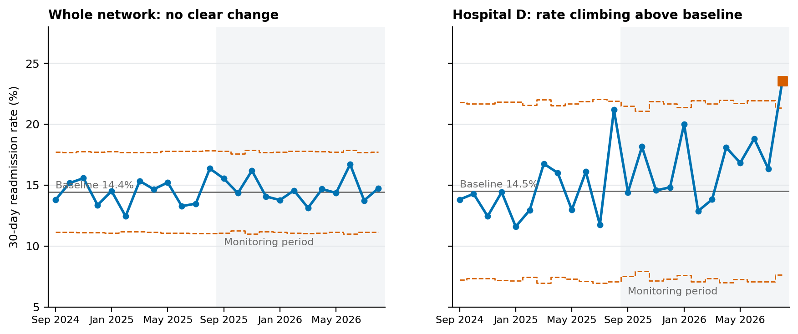
Figure 1. Monthly 30-day readmission rate with control limits: whole network (left) and Hospital D (right). Shaded area marks the monitoring period; square markers fall outside the limits.
Figure in words: Two line charts show the monthly readmission rate from September 2024 to August 2026. Left (whole network): the rate moves between 12.4% and 16.7%, always inside the control limits (about 11.1% to 17.7%), around a baseline of 14.4%. Right (Hospital D): the baseline is 14.5% and the line swings more because each month has few patients; 5 of the last 6 months lie above baseline and August 2026 (23.5%) is above the upper limit of 21.3%. Take-away: the network looks stable, Hospital D does not.
Insight: a stable network average can hide a deteriorating hospital. Monitoring should be done at the level where action is possible.

3.3 Q2: Where Are Readmissions Concentrated?
Rates differed by ward (chi-square p <0.001). The Medical ward had the highest rate at 15.8% (95% CI 15–16.6), followed closely by Respiratory at 15.7%; the Orthopaedic ward had the lowest at 10.2%. Readmission also rose steeply with age (from 9.6% at ages 18–44 to 21.4% at 80 and over) and with prior admissions (11.6% for patients with none, 28.7% for those with three or more, who made up 3.6% of discharges).
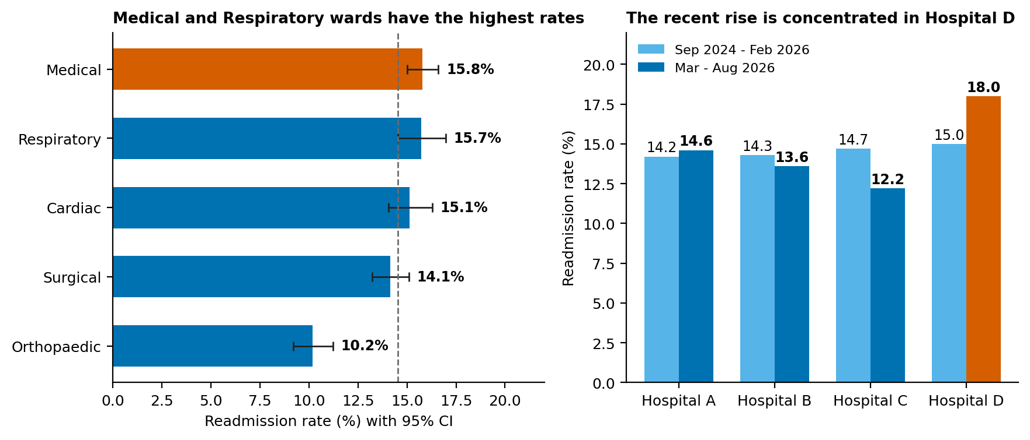
Figure 2. Readmission rate by ward (left) and change by hospital between the earlier 18 months and the latest 6 months (right).
Figure in words: Left: readmission rates by ward are Medical 15.8%, Respiratory 15.7%, Cardiac 15.1%, Surgical 14.1% and Orthopaedic 10.2%. Right: between the earlier 18 months and the latest 6 months the rate changed from 14.2% to 14.6% in Hospital A, 14.3% to 13.6% in B, 14.7% to 12.2% in C and 15% to 18% in D. Take-away: Medical and Respiratory wards need most attention, and only Hospital D worsened.

3.4 Q3: What Is Associated with Readmission?
Table 2 and Figure 3 show adjusted odds ratios from the multivariable model. An odds ratio above 1 means higher odds of readmission, and below 1 means lower odds, holding the other factors constant.
Factor | Adjusted odds ratio | 95% CI | p-value
Follow-up within 7 days | 0.45 | 0.42 – 0.48 | <0.001
Medication reconciliation done (vs not) | 0.75 | 0.68 – 0.81 | <0.001
Length of stay over 7 days | 1.47 | 1.31 – 1.65 | <0.001
Rural residence | 1.33 | 1.23 – 1.44 | <0.001
Weekend discharge | 1.25 | 1.15 – 1.36 | <0.001
Prior admissions (per additional) | 1.23 | 1.18 – 1.28 | <0.001
Comorbidities (per additional) | 1.21 | 1.17 – 1.25 | <0.001
Discharge: facility vs home | 1.23 | 1.06 – 1.42 | 0.007
Discharge: home with services vs home | 1.15 | 1.04 – 1.28 | 0.008
Income: lowest vs highest | 1.11 | 1 – 1.23 | 0.046
Ward: Medical vs Surgical | 1.11 | 1 – 1.23 | 0.042
Ward: Respiratory vs Surgical | 1.13 | 1 – 1.28 | 0.059
Ward: Orthopaedic vs Surgical | 0.7 | 0.61 – 0.8 | <0.001
Age (per 10 years) | 1.1 | 1.07 – 1.13 | <0.001
Male sex | 1.08 | 1.01 – 1.17 | 0.034
Hospital D vs A | 1.03 | 0.93 – 1.15 | 0.541
Table 2. Adjusted odds ratios for 30-day readmission (logistic regression, standard errors clustered by patient). Reference groups: highest income, home discharge, Surgical ward, Hospital A, medication reconciliation not done.
Three points matter for decisions. First, follow-up within 7 days had the strongest association (adjusted OR 0.45), and medication reconciliation was also protective (OR 0.75); both are things the hospital controls. Second, several risk factors point to identifiable groups: long stays (OR 1.47), rural residence (OR 1.33), weekend discharge (OR 1.25) and patients with many prior admissions. Third, once these factors were accounted for, there was no remaining difference between hospitals (Hospital D versus A: OR 1.03, CI 0.93–1.15), which again points to process differences such as follow-up rather than to the hospital itself.
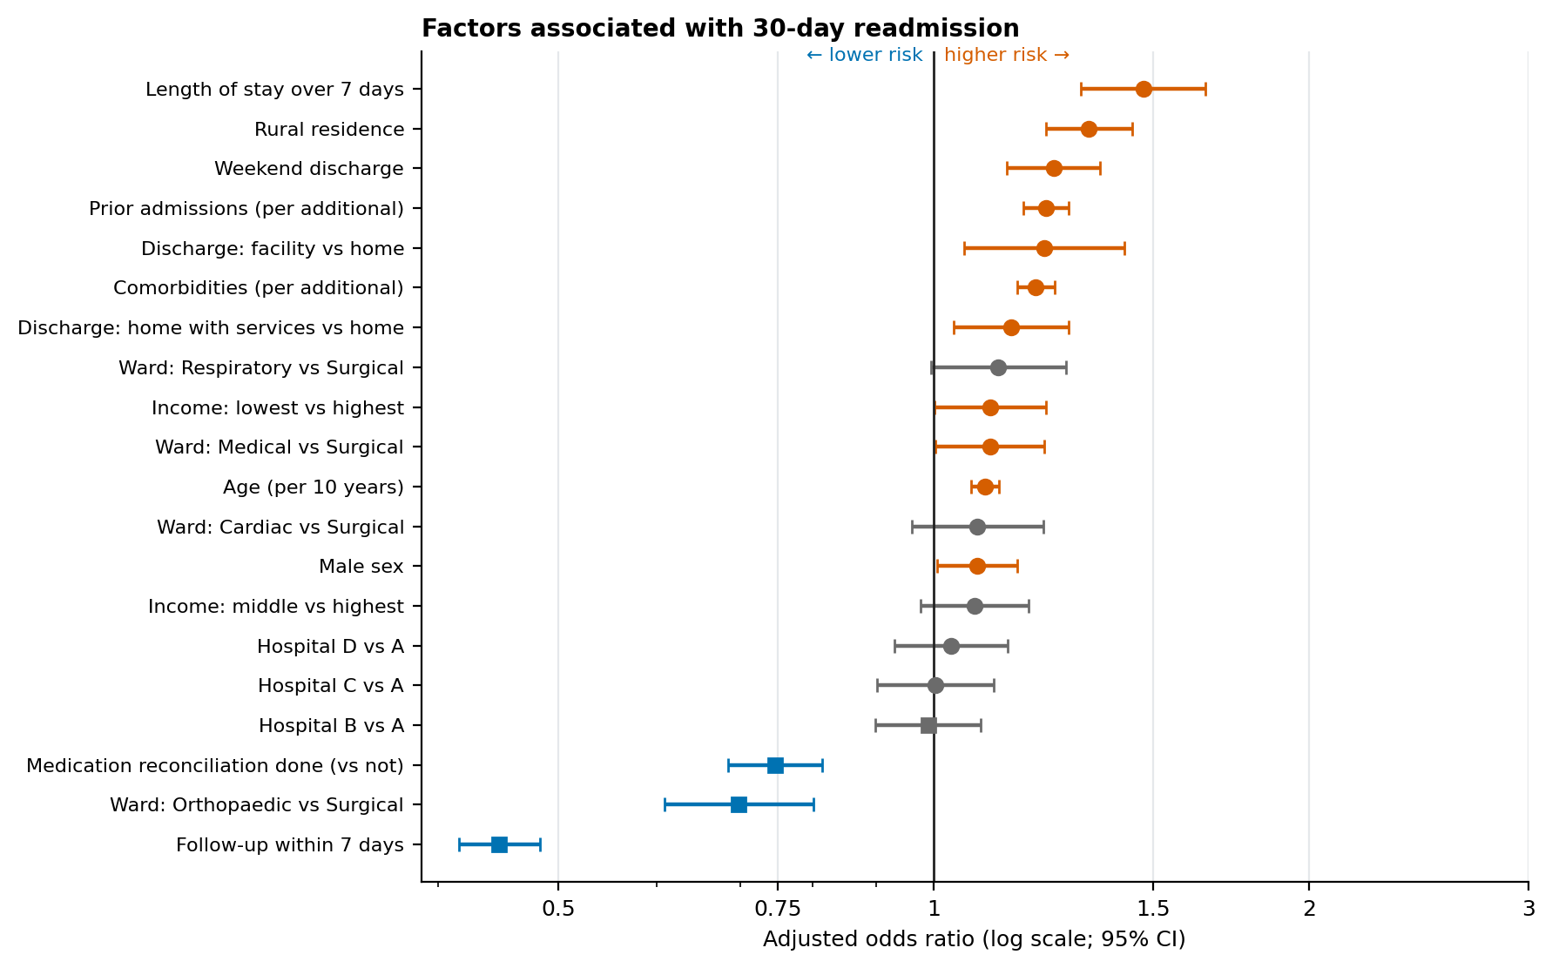
Figure 3. Adjusted odds ratios with 95% confidence intervals. Orange marks higher risk, blue marks lower risk, grey marks no clear difference.
Figure in words: Each row is one factor, with a dot for its adjusted odds ratio and a line for its 95% confidence interval. Rows to the right of the vertical line at 1 raise the odds of readmission: long stay (1.47), rural residence (1.33), weekend discharge (1.25), prior admissions (1.23 per admission) and comorbidities (1.21 each). Rows to the left lower the odds: follow-up within 7 days (0.45) and medication reconciliation (0.75). Take-away: the strongest levers the hospital controls are follow-up and medication reconciliation.

3.5 The Follow-Up Finding in Detail
Patients without follow-up within 7 days were readmitted at 20.0% (95% CI 19.2–20.7), compared with 10.0% (9.5–10.5) for those with follow-up (Figure 4, right). Follow-up completion held steady near 56.9% in Hospitals A–C, but in Hospital D it dropped from 55.9% before November 2025 to 30.4% in the latest six months and 24.8% in the final three (Figure 4, left).
The statistical link between the two trends is strong. When follow-up was added to a model of the time trend within Hospital D, the trend coefficient shrank by roughly 100%, meaning that follow-up accounts for essentially all of the rise that could be explained by the measured variables. Two other differences are consistent with a process problem in Hospital D: medication reconciliation was completed for only 66.1% of its discharges, compared with 76.9% elsewhere.
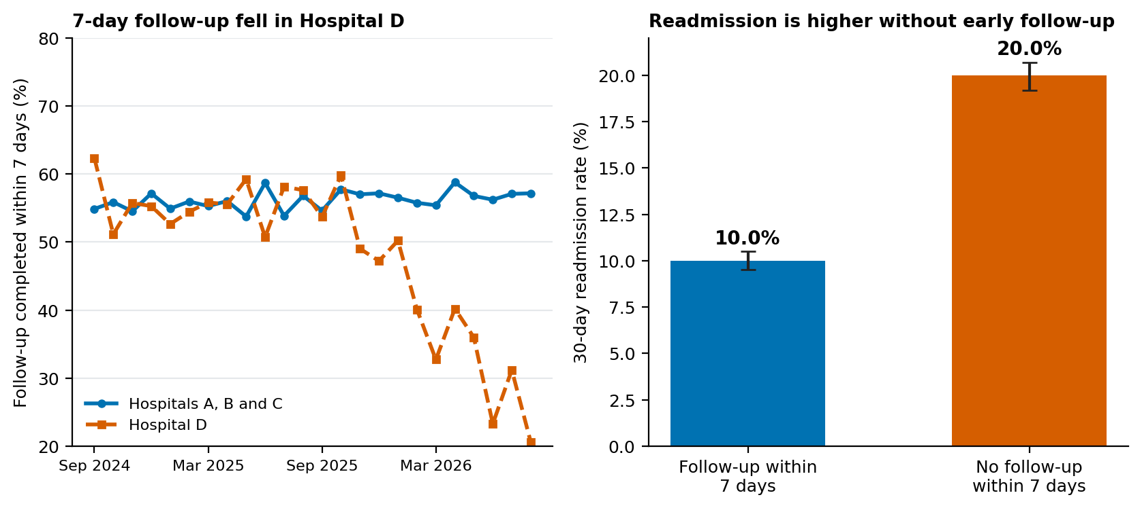
Figure 4. Follow-up within 7 days by month (left) and readmission rate by follow-up status (right).
Figure in words: Left: the share of patients with follow-up within 7 days stays near 56.9% in Hospitals A to C but in Hospital D falls from 55.9% (before November 2025) to 30.4% (last six months) and 24.8% (last three). Right: readmission is 10.0% with follow-up and 20.0% without. Take-away: when follow-up fell in Hospital D, readmissions rose.
Access to follow-up was uneven. Completion was 45.6% for rural patients versus 58.2% for urban patients, and 47.4% in the lowest income group versus 61.2% in the highest. Correspondingly, readmission was 17.9% in rural and 13.1% in urban patients, and 16.1% for the lowest income group versus 12.8% for the highest.

3.6 Q4: Can a Risk Model Help Target Follow-Up?
Both candidate models performed similarly on the locked test period: logistic regression reached an AUROC of 0.644 (95% CI 0.619–0.674) and gradient boosting 0.646 (0.622–0.673). Because the flexible model brought no real gain, the logistic regression was chosen for its transparency. Discrimination in this range is modest but consistent with published readmission models, which commonly fall between 0.6 and 0.7 (Kansagara et al., 2011).
Measure (test period) | Result | How to read it
AUROC | 0.644 (0.619–0.674) | Probability that a readmitted patient is ranked above a non-readmitted one; 0.5 is chance
Average precision (AUPRC) | 0.258 | Compare with the 15.0% readmission rate (value for random ranking)
Brier score | 0.1224 (no-skill 0.1275) | Lower is better; model beats a model that predicts the average for everyone
Calibration slope | 1.05 (0.85–1.25) | Close to 1 means predicted risks match observed risks
Calibration intercept | 0.04 | Close to 0 means no overall over- or under-prediction
Observed-to-expected ratio | 1.04 | Observed readmissions divided by those predicted; 1 is ideal
Flagging the top 20% (threshold 0.189) | Sensitivity 33.6%, specificity 83.4%, positive predictive value 26.3% | About 3.8 flagged patients per readmission captured; lift 1.76 times random
Net benefit at 15% threshold | 0.0316 (treat all: 0) | Positive and higher than treating everyone or no one
Table 3. Performance of the selected logistic regression model on the test period (June–August 2026).
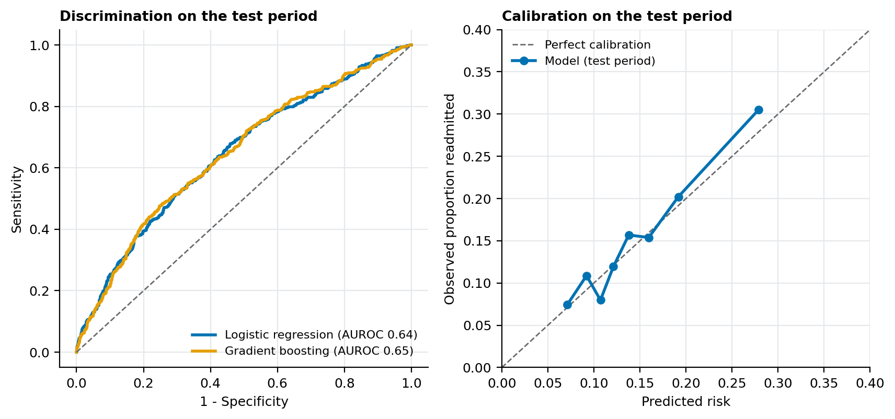
Figure 5. Discrimination (left) and calibration (right) on the test period.
Figure in words: Left: the ROC curves for both models sit modestly above the diagonal chance line, with areas of 0.644 (logistic regression) and 0.646 (gradient boosting). Right: predicted risks track observed risks closely (calibration slope 1.05). Take-away: the model ranks patients modestly well and its risk numbers can be trusted overall.
Table 4 shows what a follow-up team would gain at different capacity levels. Ranking all test-period patients, the highest-risk 20% contained about a third of all readmissions, with a positive predictive value of about one in four.
Share of discharges contacted | Patients | Readmissions captured | Readmission rate in group | Lift vs average | Patients contacted per readmission
5% | 150 | 10.8% | 32.7% | 2.18 | 3.1
10% | 301 | 19.9% | 29.9% | 1.99 | 3.3
20% | 602 | 36.1% | 27.1% | 1.80 | 3.7
30% | 903 | 47.1% | 23.6% | 1.57 | 4.2
Table 4. Gains table on the test period (patients ranked by predicted risk).
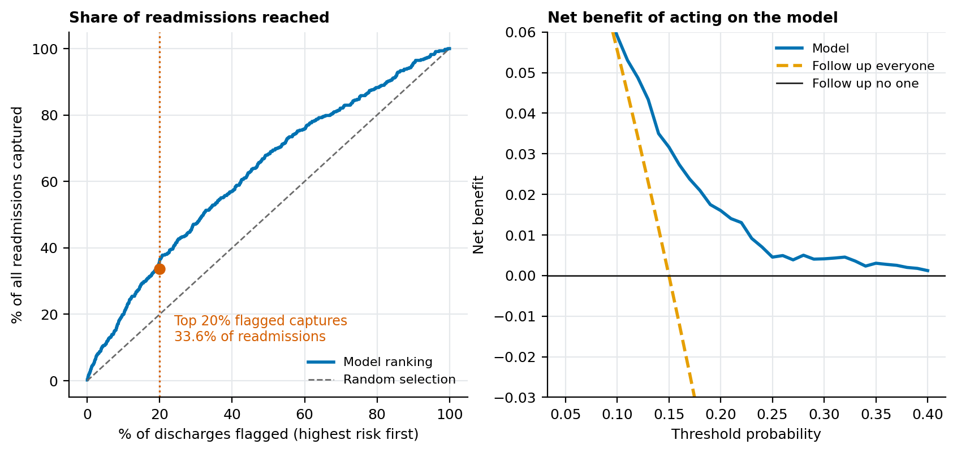
Figure 6. Share of readmissions reached by contacting the highest-risk patients (left) and decision curve (right).
Figure in words: Left: if the follow-up team contacts the highest-risk 20% of discharges it reaches about 36.1% of all readmissions (random selection would reach 20%). Right: across threshold probabilities from 10% to 40% the model's net benefit stays above both “follow up everyone” and “follow up no one” (at a 15% threshold 0.0316 versus 0). Take-away: using the model to prioritise calls is better than calling everyone or no one.
The most influential predictors (by loss in AUROC when shuffled on the validation period) were prior admissions, comorbidities, age and ward, which match the regression results and clinical expectation.

3.7 Q4 (continued): Is the Model Fair Across Groups?
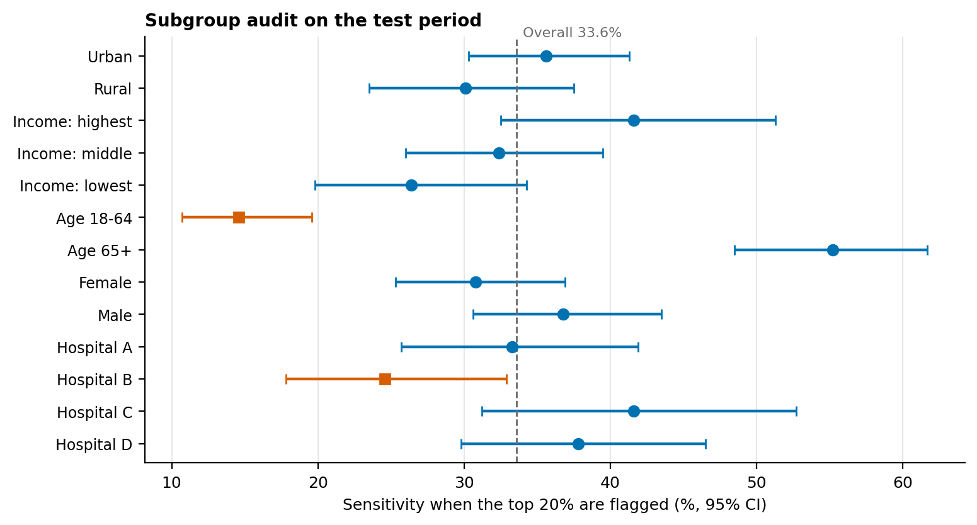
Figure 7. Sensitivity of the top-20% flag by subgroup, with 95% confidence intervals.
Figure in words: Each row shows the share of readmissions caught (sensitivity) for one group, with its 95% interval, against an overall value of 33.6%: urban 35.6%, rural 30.1%, highest income 41.6%, lowest income 26.4%, age 18–64 14.6%, age 65+ 55.2%. Take-away: the model catches fewer readmissions in rural, lower-income and younger groups, but most intervals overlap, so these are signals to monitor.
Group | Discharges | Readmissions | Flagged (%) | Sensitivity (%) | 95% CI | AUROC | Observed/ expected
Urban | 2,103 | 289 | 19.2 | 35.6 | 30.3–41.3 | 0.659 | 0.95
Rural | 910 | 163 | 19.1 | 30.1 | 23.5–37.5 | 0.618 | 1.24
Income: highest | 769 | 101 | 21.5 | 41.6 | 32.5–51.3 | 0.652 | 0.88
Income: middle | 1,107 | 182 | 18.8 | 32.4 | 26–39.5 | 0.646 | 1.15
Income: lowest | 944 | 140 | 16.4 | 26.4 | 19.8–34.3 | 0.633 | 1.05
Age 18-64 | 1,808 | 240 | 7.7 | 14.6 | 10.7–19.6 | 0.612 | 1.1
Age 65+ | 1,205 | 212 | 36.3 | 55.2 | 48.5–61.7 | 0.674 | 0.97
Female | 1,584 | 240 | 19.1 | 30.8 | 25.3–36.9 | 0.637 | 1.06
Male | 1,429 | 212 | 19.2 | 36.8 | 30.6–43.5 | 0.655 | 1.01
Hospital A | 887 | 126 | 17.8 | 33.3 | 25.7–41.9 | 0.667 | 1.01
Hospital B | 861 | 122 | 15.8 | 24.6 | 17.8–32.9 | 0.621 | 1.02
Hospital C | 623 | 77 | 19.3 | 41.6 | 31.2–52.7 | 0.659 | 0.84
Hospital D | 642 | 127 | 25.4 | 37.8 | 29.8–46.5 | 0.62 | 1.28
Table 5. Subgroup audit on the test period. Observed/expected above 1 means the model under-predicts risk for that group.
Three patterns need attention. (1) Rural patients had an observed-to-expected ratio of 1.24, meaning the model under-predicted their risk, and lower sensitivity (30.1% versus 35.6% for urban patients), although the intervals overlap. (2) Sensitivity was lowest in the lowest-income group (26.4%) and highest in the highest-income group (41.6%), again with overlapping intervals but a consistent direction. (3) Hospital D had an observed-to-expected ratio of 1.28: the model was built before most of the follow-up decline and does not know about it, an example of drift. Lower sensitivity among adults under 65 (14.6%) mainly reflects their lower baseline risk under a single threshold, but should be reviewed clinically. Group sizes are small, so these differences are signals to monitor, not firm conclusions.

3.8 Q5: What Might Be Gained by Acting?
In the latest six months Hospital D had 1,272 discharges. Using the fitted regression, about 226 readmissions would be expected at the observed follow-up rate. If follow-up completion were restored to its earlier level (55.9%), which means reaching about 37% of the patients who currently miss follow-up, the expected number would fall to about 193, roughly 33 fewer per six months or 65 per year. If the true protective effect of follow-up were only half as large as estimated, the figure would be about 37 per year. At an assumed 5 days per readmission, 65 fewer readmissions would free about 325 bed-days a year at Hospital D. These are scenario estimates built on assumptions (Section 7), not forecasts.

3.9 Worked Examples: How the Numbers Were Derived
Five short examples show, step by step, how key results were calculated and interpreted, so that a reader can check the reasoning without any special software.

Example A: Deciding whether August 2026 is a real signal at Hospital D
- Baseline readmission rate for Hospital D (first 12 months): 14.5% (0.145).
- Discharges in August 2026: 238; readmissions: 56; rate = 56 ÷ 238 = 23.5%.
- Normal variation for a month this size: 3 × √(0.145 × 0.855 ÷ 238) is about 6.8 percentage points, so the upper control limit is 14.5% + 6.8 = 21.3%.
- Interpretation: 23.5% is above 21.3%, so August is outside normal variation and triggers a review. Because one month can be chance, the decision also uses the period comparison (15.0% to 18.0%, p = 0.012).

Example B: What an odds ratio means in plain terms
- Without follow-up, 20.0 in 100 patients are readmitted. Odds = 20.0 ÷ 80.0 = 0.250.
- Adjusted odds ratio for follow-up = 0.45. New odds = 0.250 × 0.45 = 0.113.
- Converted back to a risk: 0.113 ÷ (1 + 0.113) = 10.1%, which matches the observed 10.0% with follow-up.
- Interpretation: follow-up is associated with roughly halving readmission risk. Because the data are observational, this is a strong association, not proof of cause.

Example C: From patient details to a predicted risk
The model turns the information known at discharge into a probability. Three illustrative patients were run through the final model (flag threshold 0.189, equal to 18.9%):
Illustrative patient | Predicted risk | Flagged for follow-up call?
Patient 1: 74-year-old man, Medical ward, Hospital D, 4 comorbidities, 3 prior admissions, 9-day stay, weekend discharge with home services, no medication reconciliation | 49.1% | Yes
Patient 2: 58-year-old woman, Surgical ward, Hospital A, 2 comorbidities, 1 prior admission, 5-day stay, weekday discharge home, medication reconciliation done | 14.3% | No
Patient 3: 36-year-old woman, Orthopaedic ward, Hospital B, no comorbidities, no prior admissions, 3-day stay, discharged home, medication reconciliation done | 4.8% | No
Table 6. Predicted readmission risk for three illustrative patients (final model, test-period settings).
Interpretation: Patient 1 has several risk factors at once, including prior admissions, comorbidities, a long stay, a weekend discharge and no medication reconciliation, and is flagged. Patient 3 has none of them. Staff would see the risk and the main reasons, then use judgement.

Example D: From risk score to follow-up workload
- Suppose the team can contact 20 out of every 100 discharges.
- Choosing 20 patients at random reaches about 20 × 0.150 = 3.0 patients who will be readmitted.
- Choosing the 20 highest-risk patients reaches about 20 × 0.263 = 5.3 such patients, which is 2.3 more per 100 discharges.
- Over a year the network has about 12,134 discharges, so prioritising calls with the model reaches roughly 274 more patients who go on to be readmitted, giving the team a chance to intervene early.

Example E: Class imbalance and why re-weighting was rejected
Readmission is the minority outcome (15.0% in the test period), a ratio of about 5.9 non-events to 1 event. The standard remedy of “balanced” class weights was compared with the plain model on the same test data.
Approach | AUROC | Average predicted risk | Observed rate | Brier score (lower is better) | Calibration intercept (ideal 0)
Plain logistic regression (used) | 0.644 | 14.5% | 15.0% | 0.1224 | 0.04
Balanced class weights | 0.644 | 47.8% | 15.0% | 0.2325 | -1.73
Table 7. Effect of class re-weighting on test-period performance.
Interpretation: re-weighting did not improve ranking (AUROC 0.644 against 0.644) but pushed the average predicted risk to 47.8%, more than three times the observed 15.0%. A manager reading “48% risk” would badly overestimate the true chance. The practical solution adopted was to keep the plain model, judge it by ranking and calibration measures, and set the threshold from team capacity (Section 2.6).

4. Discussion

4.1 From Data to Insight to Decision
The table below shows how each result was interpreted and what decision followed, so that the reasoning behind every recommendation is visible.
What the data showed | How it was interpreted | Decision implication
Network rate flat at 14.5%, Hospital D up from 15.0% to 18.0% | Averages can mask local deterioration; the rise is real at the 5% significance level in a single hospital | Report and act at hospital and ward level; add control charts to routine reporting
Follow-up in Hospital D fell from 55.9% to 30.4%; readmission doubles without follow-up | Timing matches the rise, the effect is large, and the trend vanishes once follow-up is accounted for; plausible mechanism (missed problems after discharge) | Treat follow-up capacity at Hospital D as the first priority
Hospital D has no excess risk after adjustment | The difference is explained by process, not by patient mix | Fix the process rather than restricting admissions or blaming case mix
Medication reconciliation done for 66.1% in Hospital D vs 76.9% elsewhere; protective OR 0.75 | A second process gap in the same hospital | Include reconciliation in the Hospital D discharge improvement plan
Rural and low-income patients: less follow-up, higher readmission, model under-predicts rural risk | Access barriers create inequity and a model blind spot | Targeted outreach and monitoring of equity measures
Model AUROC 0.644, top 20% captures 33.6% | Useful for prioritisation, not for individual decisions | Use as an aid with clinical judgement, pilot first, monitor drift

4.2 Fit with Existing Evidence
The findings are consistent with broader literature, though the simulated data cannot confirm it. Reviews of readmission-reduction programmes find that post-discharge support and better transitions of care are the most promising areas, but that no single intervention is consistently effective and that multi-component approaches work best (Hansen et al., 2011). A randomised trial of a coaching-based transition intervention reported fewer rehospitalisations (Coleman et al., 2006). Reviews of risk-prediction models report moderate discrimination, usually between 0.6 and 0.7, matching the model here (Kansagara et al., 2011). This is why the recommendations pair follow-up and discharge process improvement with prediction used only to prioritise.

4.3 Strategic and Policy Implications
- Governance: quality dashboards should show hospital-level control charts, with a named owner for each signal.
- Resource allocation: protecting post-discharge capacity (follow-up clinics, telephone teams) is likely to be more valuable than adding inpatient capacity to cope with avoidable readmissions.
- Equity: payment and performance frameworks that use average readmission rates may overlook under-served groups; equity should be reported alongside averages.
- Analytics: prediction should be introduced as a supervised pilot with ongoing monitoring of calibration and subgroup performance.

5. Recommendations
Each recommendation is tied to evidence in Section 3. They are ordered by expected impact and urgency. Owners and timelines are suggestions for a real organisation to adapt.

5.1 Evidence-to-Recommendation Matrix
Insight | Evidence | Leads to | Decision it informs
I1. Network rate is stable but Hospital D is rising | Figure 1; Section 3.2; Example A | Recs 1, 2 | Escalate Hospital D; monitor by hospital and ward
I2. Follow-up halves readmission risk and has fallen in Hospital D | Figure 4; Table 2; Section 3.5; Example B | Recs 1, 4 | Fund and protect follow-up capacity
I3. Medication reconciliation is protective and lower in Hospital D | Table 2; Section 3.5 | Rec 5 | Make reconciliation standard work
I4. Long stays, weekend discharges and many prior admissions raise risk | Table 2; Figure 3 | Recs 3, 6 | Discharge checklists; prioritised calls
I5. The model ranks risk modestly but usefully | Tables 3, 4, 6, 7; Figures 5, 6; Example D | Rec 3 | Use as an aid; pilot first
I6. Rural, lower-income and Hospital D groups show equity and drift signals | Sections 3.5, 3.7; Table 5 | Recs 4, 7 | Equity monitoring; recalibration

5.2 Recommendations in Detail
# | Recommendation and key actions | Evidence | Owner | Timing | Success measure
1 | Restore 7-day follow-up at Hospital D. Review staffing of the discharge clinic and call team; book appointments before discharge; use reminders; target at least 55% completion. | Sections 3.2, 3.5, 3.8; follow-up 55.9% → 30.4% | Hospital D director of nursing | 0–3 months | Follow-up completion ≥ 55%; readmission back to ≤ 15%
2 | Add control-chart monitoring by hospital and ward to the monthly quality report; apply run rules; agree escalation steps when a signal appears. | Section 3.2 | Quality and analytics lead | 0–2 months | Signals detected and reviewed within one month
3 | Pilot the risk model in silent mode for 3 months, then use it to prioritise follow-up calls for the highest-risk 20% of discharges, with clinician override. | Section 3.6; sensitivity 33.6%, lift 1.76 | Clinical informatics and ward managers | 3–9 months | Contacts reach ≥ 30% of readmissions; monitored calibration within 0.8–1.2
4 | Reduce the rural and low-income follow-up gap using telephone or video follow-up, transport support and community health workers; report equity measures every quarter. | Sections 3.5, 3.7 | Community health lead | 3–12 months | Gap in follow-up between rural and urban reduced by half
5 | Make medication reconciliation at discharge standard work, beginning with Hospital D. | Section 3.4; 66.1% vs 76.9% | Pharmacy lead | 0–6 months | Completion ≥ 85% in every hospital
6 | Add checklists for weekend discharges and stays over 7 days (medicines, follow-up booked, patient education), and evaluate before extending. | Section 3.4; weekend 16.8% vs 13.9%; long stay 20.4% vs 13.9% | Ward managers | 3–9 months | Lower readmission in those groups compared with baseline
7 | Strengthen data quality (income, comorbidity, medication fields) and set up monthly model monitoring with retraining triggers. | Sections 2.3, 3.7 | Data governance lead | 0–6 months | Missing data under 3%; drift checks reported

5.3 Implementation Roadmap
Phase | Actions | Review point
Months 0–3 | Recommendations 1, 2 and 5 start; baseline measures agreed; model silent pilot begins | Monthly control charts; Hospital D review at month 3
Months 3–9 | Prioritised follow-up calls (rec. 3); equity programme (rec. 4); discharge checklists (rec. 6) | Quarterly equity and calibration report
Months 9–12 | Evaluate impact; retrain and recalibrate model; decide on scale-up | Annual evaluation with comparison to baseline

5.4 Risks to Delivery
- Staffing constraints: restoring follow-up requires people; the case should be made with the scenario figures in Section 3.8.
- Alert fatigue or over-reliance on the model: use a fixed daily capacity and keep clinicians in control.
- Unintended inequity: if the model replaces universal follow-up, groups under-predicted by the model (rural patients) could be disadvantaged; keep universal follow-up standards for high-need groups.

6. Communicating the Findings to Non-Technical Stakeholders

6.1 Plain-Language Key Messages
- “Overall, readmissions are steady at about 14.5 in every 100 patients, but at Hospital D they have risen from 15.0 to 18.0 in every 100.”
- “Patients who do not get a follow-up contact within a week come back to hospital twice as often (20.0 in 100 compared with 10.0 in 100).”
- “At Hospital D, follow-up has dropped from about 56 in 100 patients to about 30 in 100. Fixing this is our biggest opportunity: roughly 37 to 65 fewer readmissions a year.”
- “People in rural areas and lower-income households get less follow-up and are readmitted more often. We should close that gap.”
- “A computer risk score can help us decide whom to call first, but it is only a guide; staff judgement stays in charge.”

6.2 Visualization Plan by Audience
Audience | Main visuals | Design choices that aid understanding
Hospital board and executives | One-page briefing: headline sentence, three status tiles (network rate, Hospital D rate, follow-up completion), hospital control charts (Figure 1), action table | Findings as titles; target and baseline lines; status shown by colour, shape and word; one recommended action per finding
Hospital directors and ward managers | Interactive dashboard with hospital and ward filters; Figures 2 and 4; weekly follow-up completion list | Drill-down from network to ward; thresholds highlighted; refresh date shown
Quality and clinical leads | Forest plot (Figure 3), calibration and gains charts (Figures 5, 6), subgroup audit (Figure 7) | Confidence intervals shown; short notes explaining how to read each chart
Community health and equity teams | Follow-up and readmission by rural/urban and income; subgroup audit | Gap shown as paired bars; small numbers flagged
Patients and public (summary) | Simple icon-based “out of 100 patients” graphic comparing readmission with and without follow-up | Natural frequencies rather than percentages or odds ratios

Visual design follows common guidance: state the finding in the title, remove clutter, use position along a common scale rather than angle or area, start bar charts at zero, and keep colours consistent (Few, 2013; Knaflic, 2015; Tufte, 2001). All charts use a colour-blind-safe palette, with shape and text as well as colour, and each carries a short text description for screen readers (World Wide Web Consortium, 2018).

6.3 Plain-Language Glossary
Term | Meaning in plain language
30-day readmission | A patient is admitted again as an emergency within 30 days of going home
Control chart | A chart showing the usual range of a measure from month to month, so that unusual changes stand out
Odds ratio | How many times higher (above 1) or lower (below 1) the chance of readmission is for one group compared with another, after allowing for other differences
Confidence interval | The range in which the true value probably lies; a narrow range means more certainty
AUROC | A score from 0.5 (no better than chance) to 1 (perfect) showing how well a model ranks patients by risk
Calibration | Whether a predicted risk of 20% really means about 20 in 100 patients are readmitted
Sensitivity | The share of patients who were readmitted that the model flagged in advance
Drift | When a model becomes less accurate because circumstances have changed

6.4 Mock-ups in Words
Because the audience will meet these visuals as a briefing page and a dashboard, both are described here zone by zone, with example wording, so they can be built in any tool.

(a) One-page monthly briefing
Zone | Content | Example wording from this report
1. Title bar | Report name, period, data refresh date | Readmissions Briefing – August 2026 (data to 30 Sep 2026)
2. Headline | One sentence stating the main finding | Network readmissions are steady at 14.5%, but Hospital D has risen from 15.0% to 18.0% as follow-up fell from 56% to 30%.
3. Three status tiles | Network rate, Hospital D rate, follow-up completion, each with a target and a symbol | ● Network 14.5% ■ Hospital D 18.0% ■ Follow-up (D) 30.4%
4. Chart 1 (left) | Hospital D control chart with baseline and limits; August point labelled | Title: Hospital D readmissions are above their normal range
5. Chart 2 (right) | Two bars: readmission with and without follow-up | 10.0% with follow-up vs 20.0% without
6. Decision box | Action, owner and deadline | Approve follow-up team staffing for Hospital D within 3 months (Director of Nursing)
7. Data notes | Definitions, source, small-number rule, contact | Simulated data; counts under 11 are suppressed; contact: analytics team

(b) Network monitoring dashboard layout
Position on screen | Visual | Interaction | Question answered
Top strip | Filters: hospital, ward, date range, patient group | Dropdowns; selections carry to all visuals | Where and when?
Row 1 | Four tiles: readmission rate, follow-up completion, medication reconciliation, average stay | Click a tile to filter the page | Are we on target?
Row 2, left | Control chart of monthly readmission rate (hospital selected by filter) | Hover shows number of discharges | Is the change real?
Row 2, right | Bar chart of follow-up completion by hospital with 55% target line | Click a bar to drill to ward | Who is below target?
Row 3, left | Ward ranking with confidence intervals | Sort and drill-down | Where are rates highest?
Row 3, right | Priority patient list (top 20% predicted risk) for the follow-up team | Role-based access; export | Whom to call first?
Footer | Data refresh date, completeness, definitions link | None | Can I trust the data?

6.5 Accessibility: Specific Rules and Examples
Requirement | Specific rule | How it is checked | Example from this report
Colour contrast | Text at least 4.5:1 and chart elements at least 3:1 against their background (WCAG 2.1 AA) | Automated contrast checker on the final palette | Near-black text on white; lines at least 2 pt wide
Colour-blind safety | Okabe-Ito palette (blue #0072B2, orange #E69F00, vermillion #D55E00); no red-green pairs | View charts with a colour-blindness simulator | Higher-risk bars in vermillion, others in blue
Not colour alone | Status uses shape plus word plus colour; lines differ by dash style; values written on bars | Print the page in greyscale and re-read it | ● on target, ▲ watch, ■ action needed
Text alternatives | Every chart has alt text stating the finding and key numbers | Screen-reader walkthrough | See example below
Reading order | Headline, tiles, charts, action box; headings in logical order | Tab through the page | Same order as the briefing zones
Readable text | At least 12 pt; sentence-case titles; no text inside images | Visual check at 200% zoom | Findings written as chart titles
Plain language | Short sentences, acronyms defined on first use, glossary provided | Read aloud to a non-specialist colleague | Glossary in Section 6.3
Data table alternative | Each chart can be viewed as a table | Confirm table view exists | Tables 1–7 mirror the charts

Example alt text for Figure 4 (right): “Bar chart of 30-day readmission rate. Patients with a follow-up within 7 days: 10.0%. Patients without follow-up: 20.0%. Readmission is twice as high without follow-up.”
Example alt text for Figure 1 (right): “Control chart for Hospital D. Baseline 14.5%. Monthly rates fluctuate between about 12% and 21%, with most of the last six months above baseline and August 2026 at 23.5%, above the upper limit of 21.3%.”

7. Limitations
- Simulated data. All numbers come from a synthetic dataset created by the author, including the relationships between variables. The report demonstrates method and communication, not real-world findings. Effect sizes should not be quoted as evidence about real hospitals.
- Association, not proof of cause. The regression and scenario results show associations adjusted for measured factors. Unmeasured factors (for example, severity of illness at discharge, social support, patient choice) could influence both follow-up and readmission. The scenario estimates assume the follow-up effect is causal; a half-strength case is shown to reflect this uncertainty.
- Small numbers at hospital level. Monthly counts for a single hospital are small, so month-to-month variation is large; period comparisons are more reliable than single months.
- Limited outcome definition. Only readmissions to hospitals in the network are counted, which would under-count patients who go elsewhere in a real setting.
- Modest model accuracy. The model uses only routine variables available at discharge. It lacks laboratory results, medication detail, social circumstances and clinical notes, and discrimination is modest.
- Fairness analysis is limited. Subgroups are few and small, intervals overlap, and many comparisons were made without formal correction; findings are signals to monitor. Race, caste or ethnicity were not available.
- Unexplained variation. The fall in Hospital C's rate (from 14.7% to 12.2%) was not investigated and may be chance.
- Assumptions in the impact estimate. The calculation assumes follow-up could be restored for 37% of patients who currently miss it, that every readmission lasts 5 days, and excludes the cost of delivering extra follow-up.
- Single time window. Seasonality and external events (for example, outbreaks, changes in coding or staffing) were not modelled.

8. Suggestions for Further Research
- Test the follow-up intervention in a pilot or stepped rollout across hospitals, so that effects can be estimated more causally than with observational data.
- Apply causal methods (propensity scores, difference-in-differences comparing Hospital D with other hospitals) to estimate the effect of follow-up more rigorously.
- Enrich the model with clinical, medication and social-needs data, and with free-text discharge summaries, and validate it externally in another network.
- Study why follow-up fell in Hospital D through staff interviews and workflow review (qualitative research), and explore patient experience, especially among rural and low-income patients.
- Evaluate cost-effectiveness: cost of follow-up delivery versus savings from avoided readmissions.
- Use time-to-event methods that treat death as a competing risk, and extend to 60- and 90-day outcomes.
- Develop and test fairness-aware recalibration for rural and low-income groups and monitor it over time.

9. Ethics and Governance
Because the data are simulated, no patient privacy or consent issues arose in this project. In a real application the following would be required before analysis: approval from an ethics committee or institutional review board; compliance with applicable data-protection law (for example India's Digital Personal Data Protection Act, 2023, HIPAA or GDPR) and national health-research guidance (Indian Council of Medical Research, 2017, 2023); de-identified, access-controlled data; and small-number suppression in published tables.
Several ethical choices were built into the design: rural residence and income were not used as predictors, so the model does not rely on them to ration care, but were used to audit fairness; the model is positioned as an aid with human oversight rather than a decision maker; subgroup results are reported openly; and a monitoring plan covers calibration, drift and equity after deployment (Collins et al., 2024; Obermeyer et al., 2019).

10. Conclusion
This report shows how a routine analysis can move from data to decision. A stable network-wide readmission rate concealed a rise at Hospital D, which was closely linked to a fall in 7-day follow-up. Patients without follow-up were readmitted about twice as often, and gaps in follow-up and medication reconciliation affected Hospital D, rural and lower-income patients most. A modest risk model can help target scarce follow-up capacity but needs careful monitoring for drift and fairness. Restoring follow-up at Hospital D, monitoring performance at the level where action is possible, and closing equity gaps form a practical, evidence-linked strategy, with an estimated 37–65 readmissions avoided per year in the scenario analysed. Because the data are simulated, the numbers illustrate the approach; the method, the communication and the transparency of the reasoning are the contribution.

Appendix A. Variable Dictionary
Variable | Type | Description
readmit30 | Binary (outcome) | Unplanned readmission within 30 days (1 = yes)
age, male | Number, binary | Age in years at discharge; male sex
rural | Binary | Rural residence (not used as a model predictor)
income | Category | Lowest, middle, highest or unknown household income group (not used as a model predictor)
comorb | Count (0–7) | Number of chronic conditions recorded
prior_adm | Count | Admissions in the previous 12 months
los | Days | Length of stay
dest | Category | Discharge destination: home, home with services, facility
ward, hospital | Category | Ward (5 types) and hospital (A–D) of the index stay
weekend | Binary | Discharged on a Saturday or Sunday
medrec | Binary/unknown | Medication reconciliation completed at discharge
followup7 | Binary | Follow-up contact completed within 7 days (recorded after discharge; excluded from the prediction model)
month | Integer 0–23 | Month of discharge (0 = September 2024)

Appendix B. How the Simulated Data Were Generated
The author wrote a script that creates patients (age, sex, residence, income, comorbidity) and hospital stays (hospital, ward, prior admissions, length of stay, discharge destination, weekend discharge, medication reconciliation). Readmission was generated from a logistic model in which risk increases with age, comorbidity, prior admissions, long stays, weekend discharge, facility or service-supported discharge, rural residence and lower income, differs by ward, and decreases with 7-day follow-up and medication reconciliation. Follow-up completion depends on residence and income, and from November 2025 it declines steadily at Hospital D only. A random patient-level factor makes repeated admissions of the same patient similar. The overall readmission rate was calibrated to about 14.5%. Realistic data problems were added: about 0.6% duplicate records, missing income (higher in rural patients), comorbidity, medication reconciliation and length of stay, and in-hospital deaths, hospice discharges and transfers that must be excluded. Fixed random seeds make every run identical. The script, simulated data and results are in the project repository (https://github.com/ipshitav71-wq/healthcare-analytics-report-simulated).
Because the relationships were designed by the author, the analysis “rediscovers” known mechanisms. This is intentional: it lets the reader check that the methods work and that the interpretation follows from the numbers. A real dataset would be messier and the conclusions less clear.

Appendix C. Project Work Breakdown
Task | Hours
Defining the case, analytical questions and report structure | 3.0
Literature review (readmission, quality improvement, prediction and fairness) | 4.0
Designing and building the simulation, including realistic data problems | 5.0
Data cleaning, quality checks and descriptive analysis | 3.0
Trend, subgroup and regression analysis | 4.0
Predictive model development, validation and fairness audit | 5.0
Scenario analysis and interpretation of results | 2.0
Designing figures and tables | 2.0
Writing recommendations and communication plan | 3.0
Writing, referencing, formatting and quality review | 2.0
Total estimated effort: approximately 33 hours.

References
Benneyan, J. C., Lloyd, R. C., & Plsek, P. E. (2003). Statistical process control as a tool for research and healthcare improvement. Quality and Safety in Health Care, 12(6), 458–464.
Coleman, E. A., Parry, C., Chalmers, S., & Min, S.-J. (2006). The care transitions intervention: Results of a randomized controlled trial. Archives of Internal Medicine, 166(17), 1822–1828.
Collins, G. S., Moons, K. G. M., Dhiman, P., et al. (2024). TRIPOD+AI statement: Updated guidance for reporting clinical prediction models that use regression or machine learning methods. BMJ, 385, e078378.
Few, S. (2013). Information dashboard design: Displaying data for at-a-glance monitoring (2nd ed.). Analytics Press.
Hansen, L. O., Young, R. S., Hinami, K., Leung, A., & Williams, M. V. (2011). Interventions to reduce 30-day rehospitalization: A systematic review. Annals of Internal Medicine, 155(8), 520–528.
Hosmer, D. W., Lemeshow, S., & Sturdivant, R. X. (2013). Applied logistic regression (3rd ed.). Wiley.
Indian Council of Medical Research. (2017). National ethical guidelines for biomedical and health research involving human participants. ICMR.
Indian Council of Medical Research. (2023). Ethical guidelines for application of artificial intelligence in biomedical research and healthcare. ICMR.
Jencks, S. F., Williams, M. V., & Coleman, E. A. (2009). Rehospitalizations among patients in the Medicare fee-for-service program. New England Journal of Medicine, 360(14), 1418–1428.
Kansagara, D., Englander, H., Salanitro, A., et al. (2011). Risk prediction models for hospital readmission: A systematic review. JAMA, 306(15), 1688–1698.
Knaflic, C. N. (2015). Storytelling with data: A data visualization guide for business professionals. Wiley.
Obermeyer, Z., Powers, B., Vogeli, C., & Mullainathan, S. (2019). Dissecting racial bias in an algorithm used to manage the health of populations. Science, 366(6464), 447–453.
Steyerberg, E. W. (2019). Clinical prediction models: A practical approach to development, validation, and updating (2nd ed.). Springer.
Tufte, E. R. (2001). The visual display of quantitative information (2nd ed.). Graphics Press.
Van Calster, B., McLernon, D. J., van Smeden, M., Wynants, L., & Steyerberg, E. W. (2019). Calibration: The Achilles heel of predictive analytics. BMC Medicine, 17, 230.
Vickers, A. J., & Elkin, E. B. (2006). Decision curve analysis: A novel method for evaluating prediction models. Medical Decision Making, 26(6), 565–574.
World Wide Web Consortium. (2018). Web Content Accessibility Guidelines (WCAG) 2.1. https://www.w3.org/TR/WCAG21/

