## 1. Project Introduction

In this project we are working on the development of an Office Management System which will help to create profile of different group of people, and let them perform various actions on available data like collect, store, and update, present and calculate, even if user is not at office campus. System will help employees to efficiently compute office related data in order to accomplish the specified task. Apart from this the system will also record the user activities. Here our approach is to use responsive layout development. The responsive layout will make the system easily accessible from any device. During implementation phase, time to time training for the user will be also required; such training will help users to easily adapt to the changing environment. From the beginning stage, development of training manual and training schedule will be carried out simultaneously.

This application has two major parts: first part begins with login & registration which helps to maintain role based accessibility and provide profile management facilities. On the other hand this application facilitates Task management & Documents management. The Task management part helps user to keep & track record of various tasks related to him. One can add new task, assign tasks to other employees, update task, view task summary. The other major part is Documents management which helps users to add/upload and search documents.

## 2. Proposed System

The proposed system enables user’s login & registration facility based on different group of login user, these different group will help to define the role for users, like user with admin role etc. These role based user login will help to make a hierarchy for the validation of data, accessibility for task, documents etc. The functionality of deleting, uploading & updating documents will be based on group of login user. These will be key steps for dealing with accessibility control & security. The other major component is task management. Here system will have an option where one can make the task and assign it to other employees based on the group of login user. While there should be an interface where employee can enter the details of work, he/she has performed against the specified task. One can also view the task of own or others, according to the metadata supplied based on the group of login user.

## 3. Feasibility Study

Feasibility study is an important part of system development process and is carried out to select the superlative system that fulfills recital necessities. The main aim of the feasibility study is to conclude whether it would be economically and technically feasible to develop the system

"The project is economically feasible because all development tools are open source, freely available so there are no extra licensing costs involved. The project is technically feasible because it is easy to acquire resources for developing and maintaining the application.

## 3. Platform Introduction

HTML, CSS will be used for frontend while for the purpose of validation both server side and client side JavaScript and PHP will be used. MySQL as database service with the help of PHP language will be used in backend. Following sections describe the main features of technology platform.

## 3.1 Introduction to HTML/CSS JavaScript

The PHP stands for Hypertext Preprocessor: a web based programming language used for both client and server side validation. Few major features of PHP are given below:

## 3.2 Introduction to PHP

The PHP stands for Hypertext Preprocessor: a web based programming language used for both client and server side validation. Few major features of PHP are given below:

* PHP is a server side scripting language used for creating and managing server side dynamic web content, web based database and session handling.
* The execution with PHP is very easy. The MySQL server, once started, executes even very complex queries with huge result sets in record-setting time [3].
* PHP supports a large number of key protocols such as POP3, IMAP, and LDAP. It also supports for Java and distributed object architectures (COM and CORBA) [3].

## 3.3 Introduction to MYSQL

We have used MySQL as database for developing our application. MySQL is an open source, SQL Relational Database Management System (RDBMS). It is fast and easy-to-use and is being used in various applications for data storage. MySQL is developed by a Swedish company MySQL AB. MySQL is popular because of many good reasons, such as

* Client/ Server Architecture: MySQL provides a facility by which user can develop client server architecture software.
* Large Database: MySQL supports large database to make efficient use of database.
* Concurrent Processing: MySQL supports concurrent execution of a program. Concurrent execution means that two or more than two users can access program simultaneously.
* High Transaction Processing Performance: MySQL offer its user high degree of whole system performance.
* Manageable Security: Security is the protection against unauthorized database access. MySQL has a facility to create so many users and give them specific privileges. So, MySQL can manage security among their users
* Portability: It is ported for different operating system. Application developed in MySQL can be ported to any operating system through minute or no modification.
* Compatibility: MySQL software is compatible with industry standards. Including most industry standard system application developed for oracle can be used in any system.
* Replicated environments: MySQL software lets you replicate group of table and their supporting object to multiple sites
* Integrity: MySQL supports data integrity business rule that maintain the standards for acceptable data as a result. Integrity pr events wrong entries in database.
* MySQL is supported by Oracle Corporation
* MySQL is released under an open-source license. So you have nothing to pay to use it.

## 4. System design

Design is the first step in the development phase for any product or system. The designer’s goal is to produce a model or representation of an entity that will later be built. The three technical activities i.e. design-code and tests are required to build, and verify the software. The importance of design can be stated with a single word “Quality”. Design is the place where quality is fostered in software development. Design offers us representations of end user product that can assess for quality. By design we can accurately transform a customer’s interpretation into a complete and finished software product or system. Without a strong and effective design we risk structure an unstable product, that seems to be difficult to test, or whole quality cannot be measured until the last stage of development including testing.

During design, progressive refinement of the data structure, program structure, and the procedural details are developed, reviewed and documented. System design can be viewed from either technical or project management perspective. From the technical point of view, design is comprised of four activities – architectural design, data structure design, interface design and procedural design. Design is a decision making task, often concerning major decisions of a structural nature.

Fig 2 shows the block diagram of the application and the data flow is depicted in Fig 3. As shown in the flow diagram, registered user can choose to interact with Intro part or try out the quiz.

## 5. System Snapshot

## 5.1 Sample Outputs pages

**Snapshots of the AakashAyurveda Application**

The snapshots of the application for various modules like registration, login, introduction, quiz etc. are presented here.

**Welcome /home page**

Figure (Home page)

**Login page**

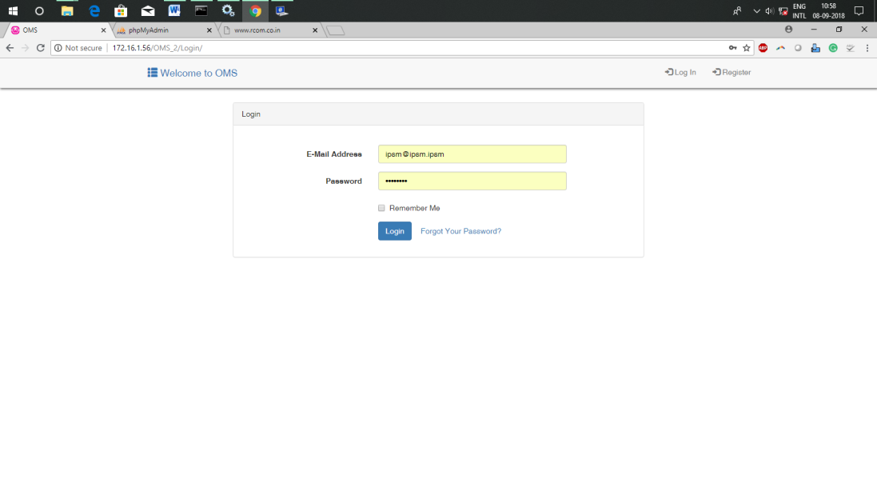

Figure (Log in form)

**Registration (entry module)**

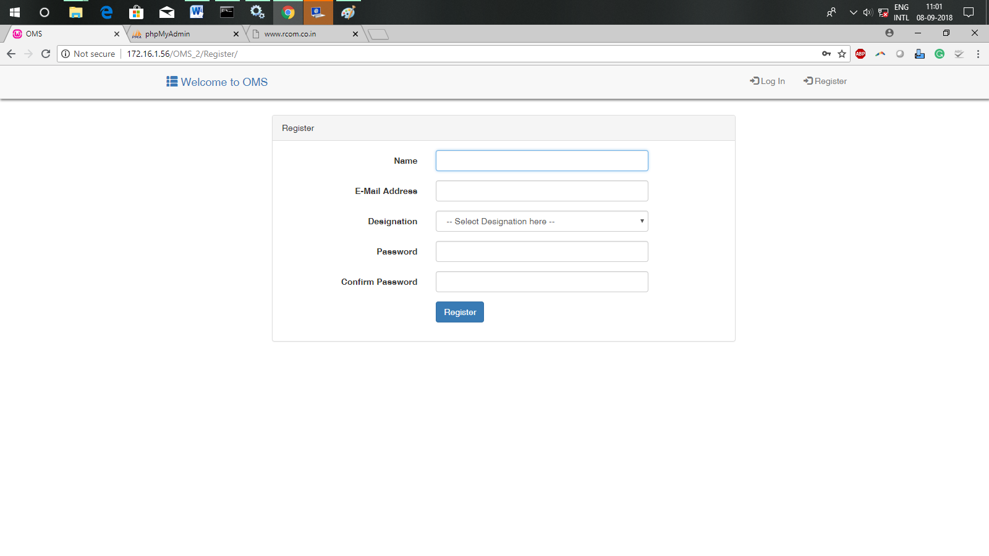

Figure (Registration module)

**Home module:**

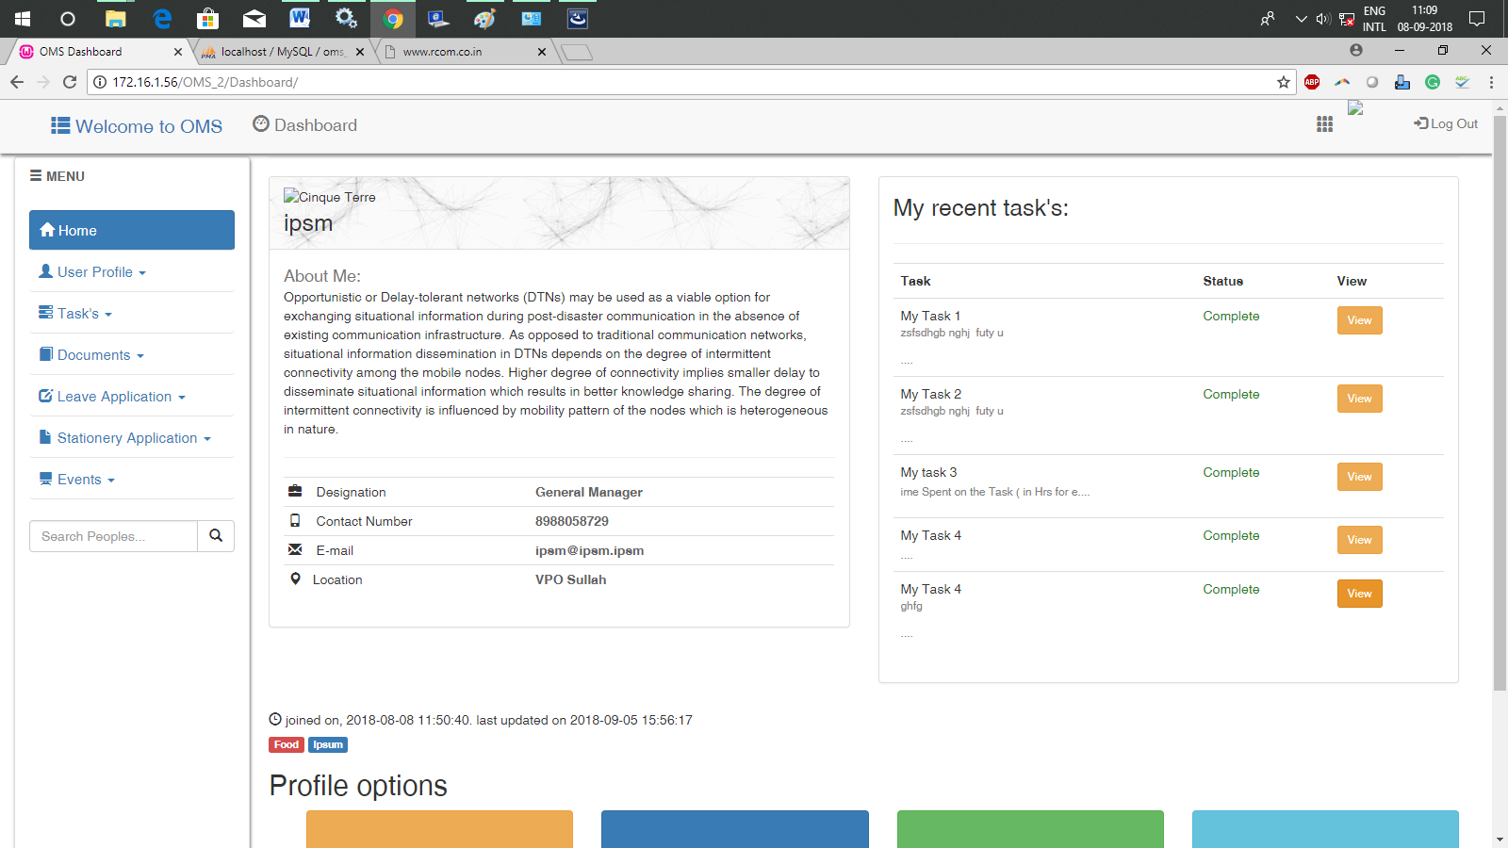

Figure (Intro page)

**Update Profile:**

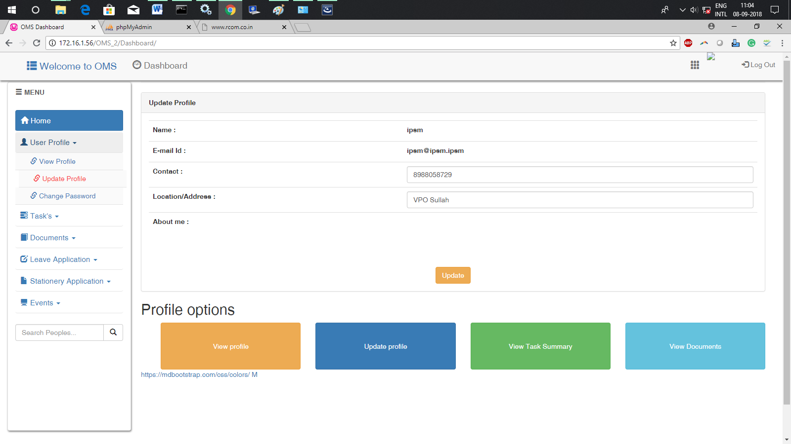

Figure (Quiz page)

**Change Password:**

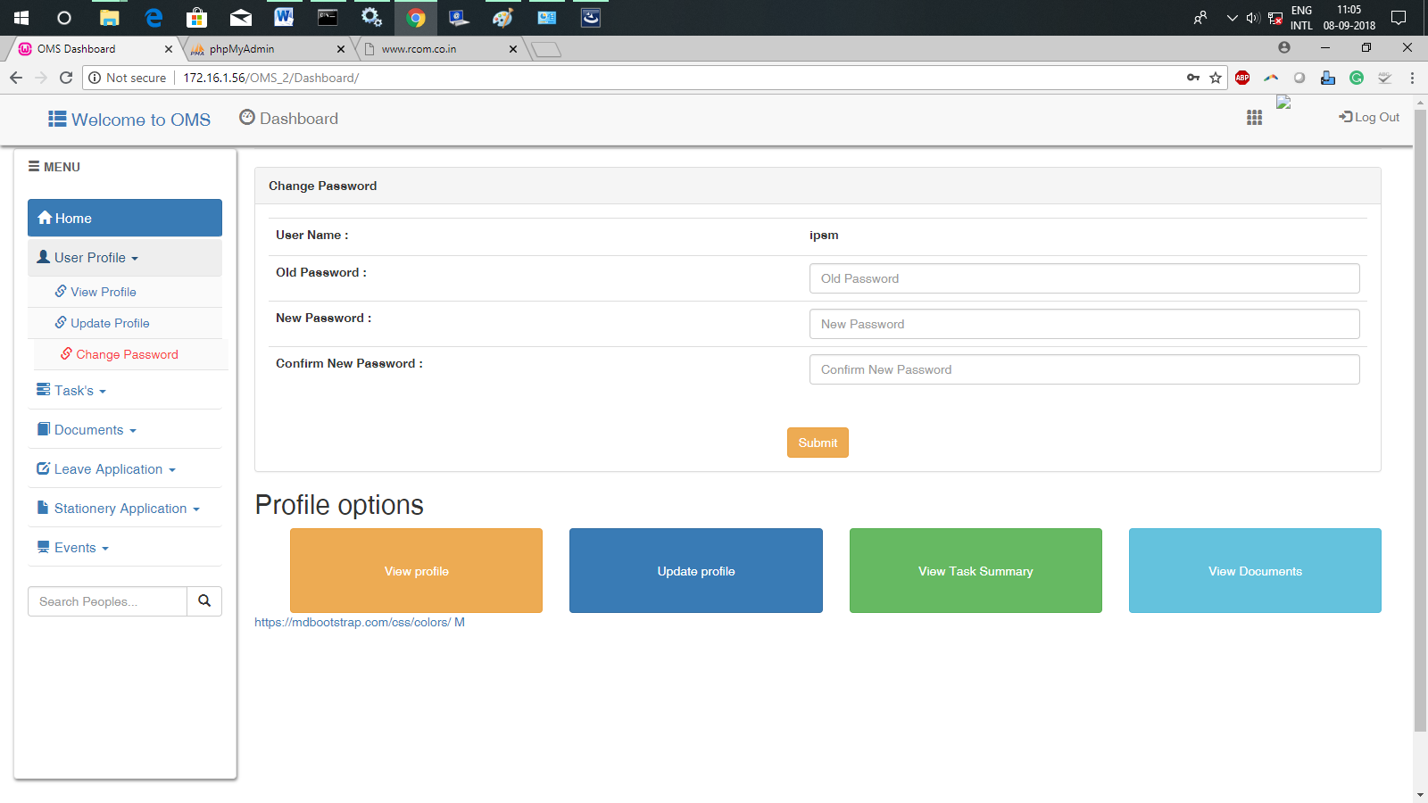

**Create Task & Sub-Task:**

## 

**Assign Task:**

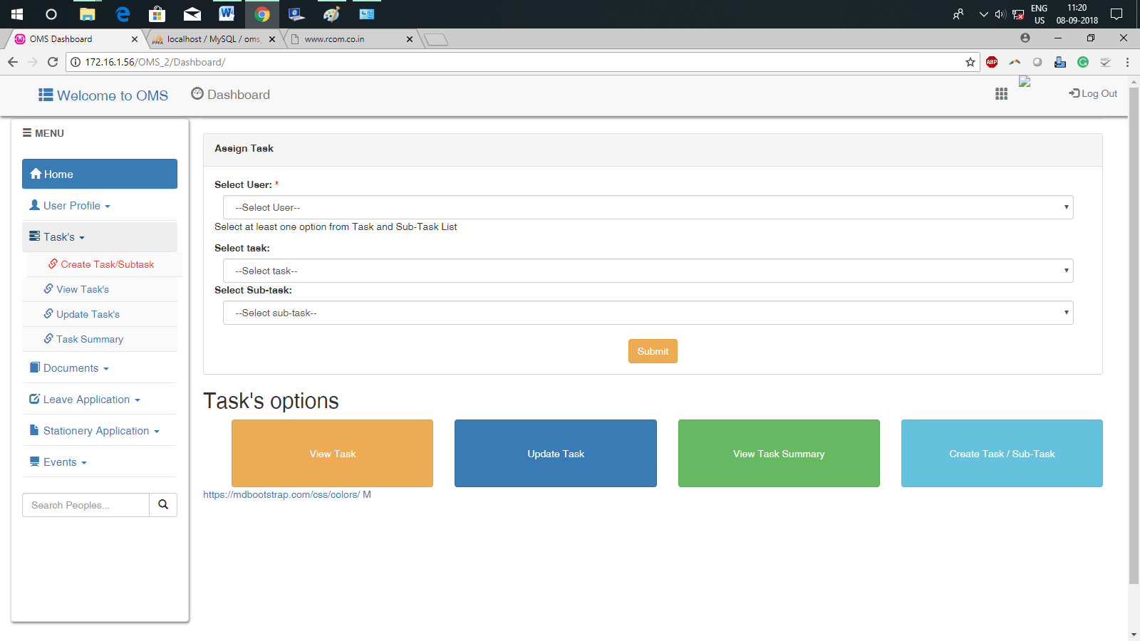

**Update Task:**

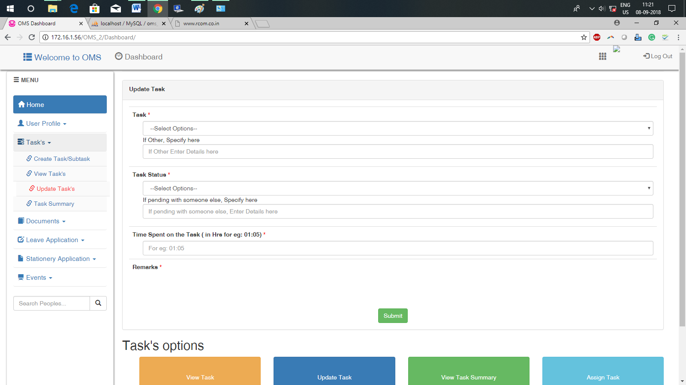

**View Task:**

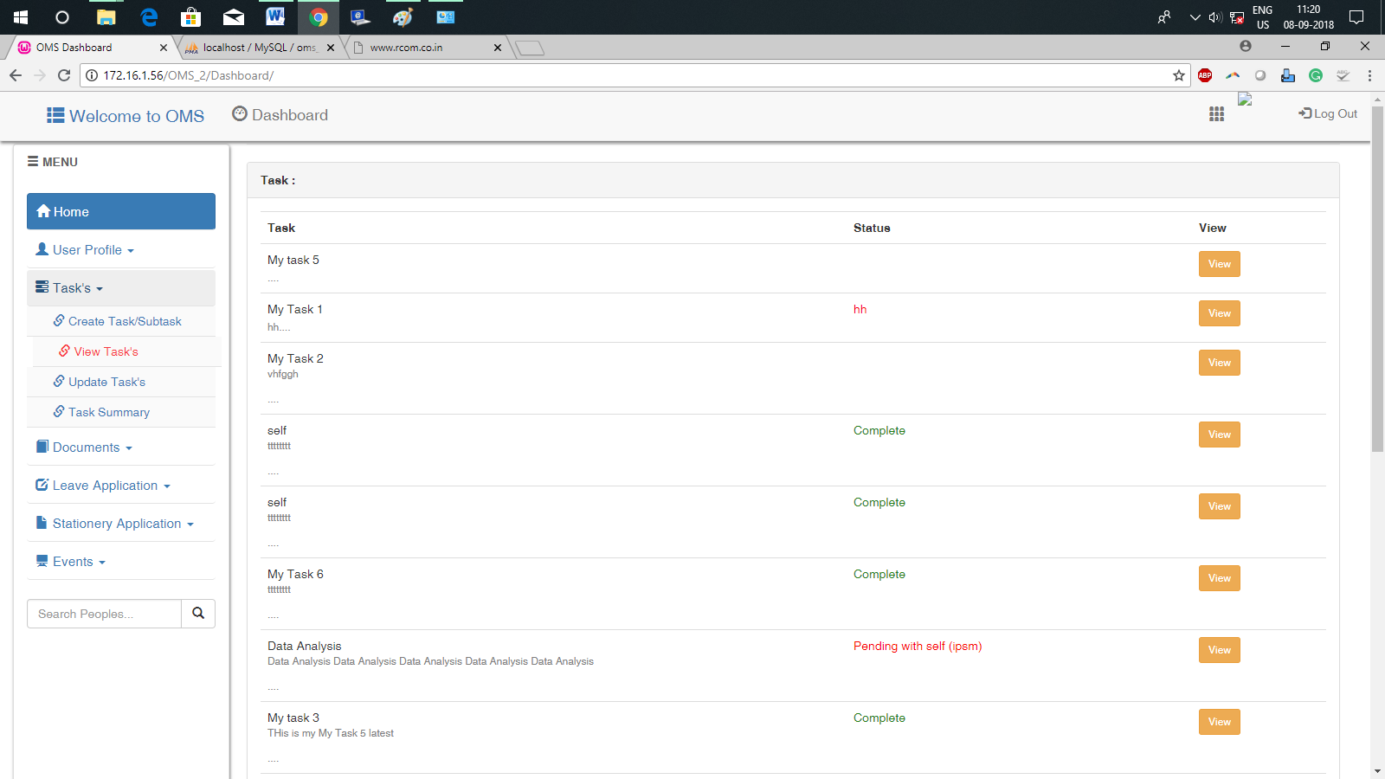

**Task Summary:**

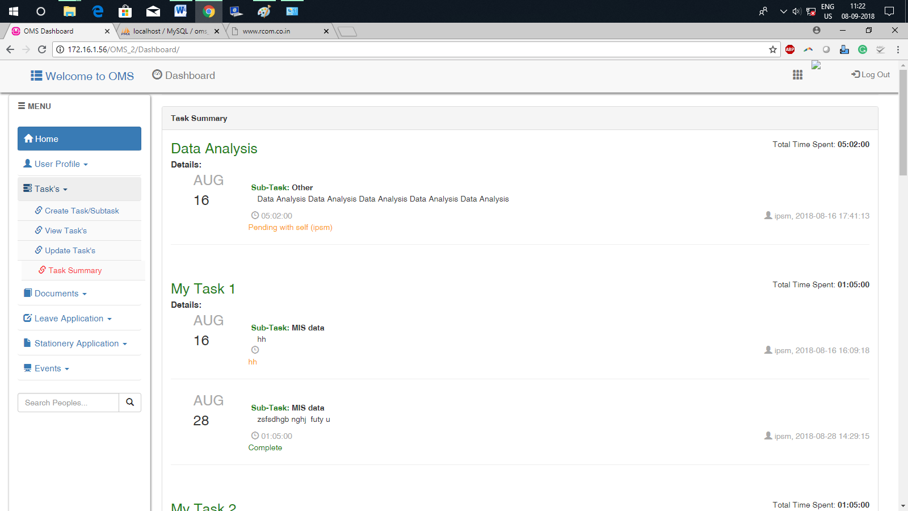

**Add Documents:**

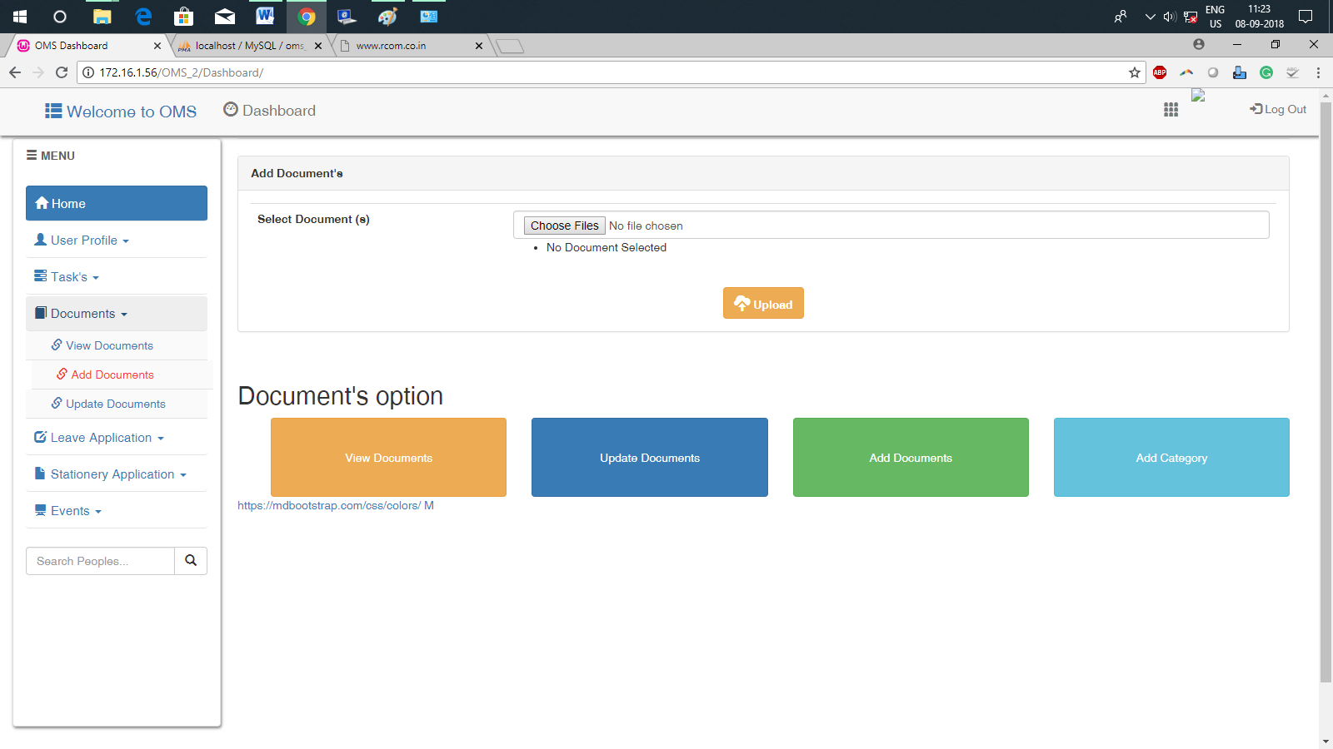

## 5.2 Sample Code

**package**com.example.aakashayurveda;

**import**android.os.Bundle;

**import**android.app.Activity;

**import**android.content.Context;

**import**android.content.Intent;

**import**android.view.Menu;

**import**android.view.View;

**import**android.view.View.OnClickListener;

**import**android.widget.ImageButton;

**publicclass**AKMainActivity**extends** Activity {

ImageButtonbutton1 ,button2;

@Override

**protectedvoid**onCreate(Bundle savedInstanceState) {

**final** Context context = **this**;

**super**.onCreate(savedInstanceState);

setContentView(R.layout.*activity_akmain*);

button1=(ImageButton)findViewById(R.id.*intro*);

button1.setOnClickListener(**new**OnClickListener()

{

@Override

**publicvoid**onClick(View arga0)

{

Intent intent = **new**Intent(context, introweb.**class**);

startActivity(intent);

}

});

button2=(ImageButton)findViewById(R.id.*quiz*);

button2.setOnClickListener(**new**OnClickListener(){

@Override

**publicvoid**onClick(View arg0) {

Intent quizintent = **new**Intent(context, quizweb.**class**);

startActivity(quizintent);

}

});

}

@Override

**publicboolean**onCreateOptionsMenu(Menu menu) {

// Inflate the menu; this adds items to the action bar if it is present.

getMenuInflater().inflate(R.menu.*activity_akmain*, menu);

**returntrue**;

}

}

**Connection String:**

<?php

$database_host = "localhost";

$username ="root";

$password = ""; // password

$database_name = "aakashaurveda"; // database name

mysql_connect("$database_host","$username","$password") or die (mysql_error());

mysql_select_db("$database_name") or die ("specified database not found");

?>

**Opening connection with database:**

<?php

include('dbConnection/akashdb.php');

if(!isset($_SESSION['array_data']))

{

$_SESSION['array_data'] = array();

$cur_row = isset($_REQUEST['rowid']) ? $_REQUEST['rowid'] : 1;

$result = mysql_query("SELECT * FROM photos WHERE id='$cur_row'");

while($row = mysql_fetch_array($result))

{

$id12 = $row['id'];

echo '<div id="div-box-left">';

echo '<div id="imagelist">';

echo '<p><b>Name :</b> '.$row['plantfamily'].' </p>';

echo '<p><b>Common Name :</b> '.$row['plantcommanname'].' </p>';

echo '<p><b>Properties :</b> '.$row['caption'].' </p>';

echo '</div>';

echo '</div>';

echo '<div id="div-box-right">';

echo '<p><imgsrc="'.$row['location'].'"></p>';

echo '</div>';

}

$_SESSION['array_data'][] = $row;

}

printf("</h4><A HREF='ayurveda.php?rowid=%d'><h4>Next</a></h4>", $cur_row+1);

printf("<A HREF='ayurveda.php?rowid=%d'><h4>Previous</h4></A>", $cur_row-1);

printf("<h4><A HREF='ayurveda.php'><h4>Home</A> ");

printf("<h4><A HREF='index.html'><h2>Quiz</h2></A>");

?>

**Insertion code:**

<?php

require_once("dbConnection/akashdb.php");

if (isset($_POST['resetzero']))

{

mysql_query("TRUNCATE TABLE photos")or die(mysql_error());

header("location: ayurvedaintroadditionpage.php");

exit();

}

if (!isset($_FILES['image']['tmp_name'])) {

echo "";

}else{

$file=$_FILES['image']['tmp_name'];

$image= addslashes(file_get_contents($_FILES['image']['tmp_name']));

$image_name= addslashes($_FILES['image']['name']);

move_uploaded_file($_FILES["image"]["tmp_name"],"introphotos/" . $_FILES["image"]["name"]);

$location="introphotos/" . $_FILES["image"]["name"];

$caption=$_POST['caption'];

$question = $_POST['desc'];

//$plantname = $_POST['pname'];

$plantfamily = $_POST['fname'];

$plantcommanname = $_POST['cname'];

$save=mysql_query("INSERT INTO photos (location, caption, plantfamily, plantcommanname) VALUES ('$location','$caption','$plantfamily','$plantcommanname')");

header("location: ayurvedaintroadditionpage.php");

exit();

}

?>

## 

# 6.

# Conclusion

**6.1 Conclusion**

**6.2 Future Prospects**

## 6.1 Conclusion

In this project, we have developed AakashAyurveda an Android based application. The application is designed to enhance the knowledge base of the students and make them aware about the traditional ayurvedic plants and there medicinal properties. Due to its dynamic nature, the application provides the facility to update and alter the data.

The conclusions can be summed up into the following points:

* Web based android application make easy flow of information.
* Data is organized in a database and is secured in computer system.
* The information overload problems (redundancy) are minimized.
* Database security with the help of security provided by MySQL.
* No replication of data.

## 6.2 Future prospects

In future, we can upgrade this application to a paid application that can help users’ to seek answers to their queries with the help of field experts.

# 7.

# Bibliography

**7.1 Bibliography**

## 7.1 Bibliography

http://www.androidhive.info/2012/05/how-to-connect-android-with-php-mysql/

http://developer.android.com

http://www.worldofwebcraft.com

[1]MELLOULI Rapport.pdf

[2]http://www.java-samples.com/showtutorial.php?tutorialid=1144

[3]http://www.tutorialspoint.com/php/php_introduction.htm

[4]http://softwarefeasibilitystudy.blogspot.in/2009/07/feasibility-study-software- engineering.html

[5]Software Engineering by pressman (book)