Step1: Download Visual Studio Code from

[**https://code.visualstudio.com/**](https://code.visualstudio.com/)

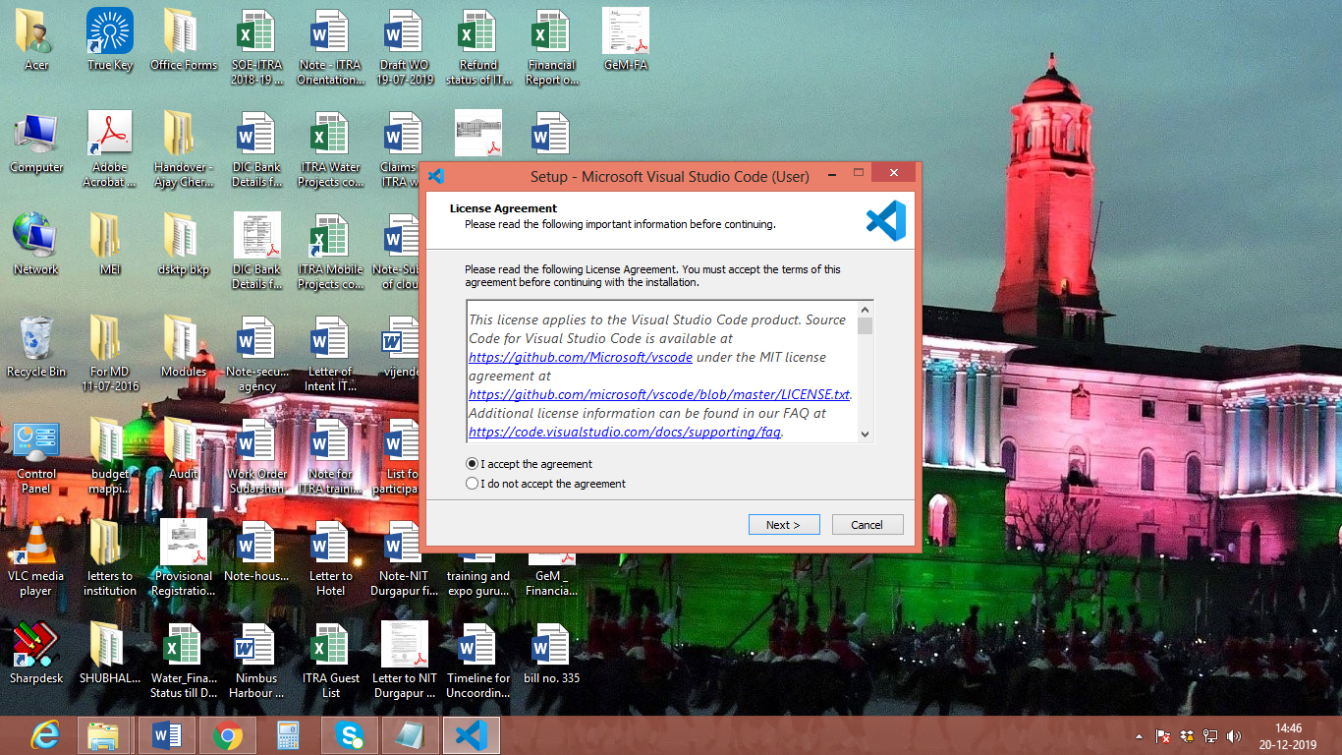

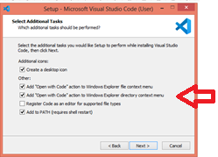

Open Visual code studio:

Then open terminal:

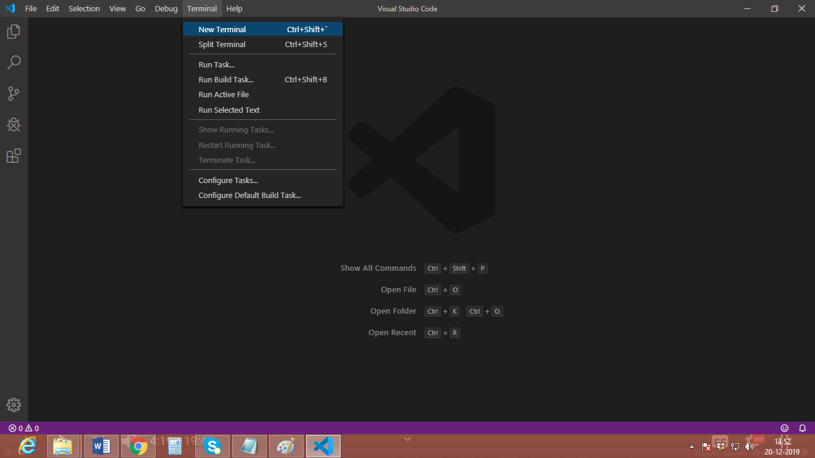

Current terminal support only windows cmd commands

Install Git from **https://git-scm.com/download/win.**

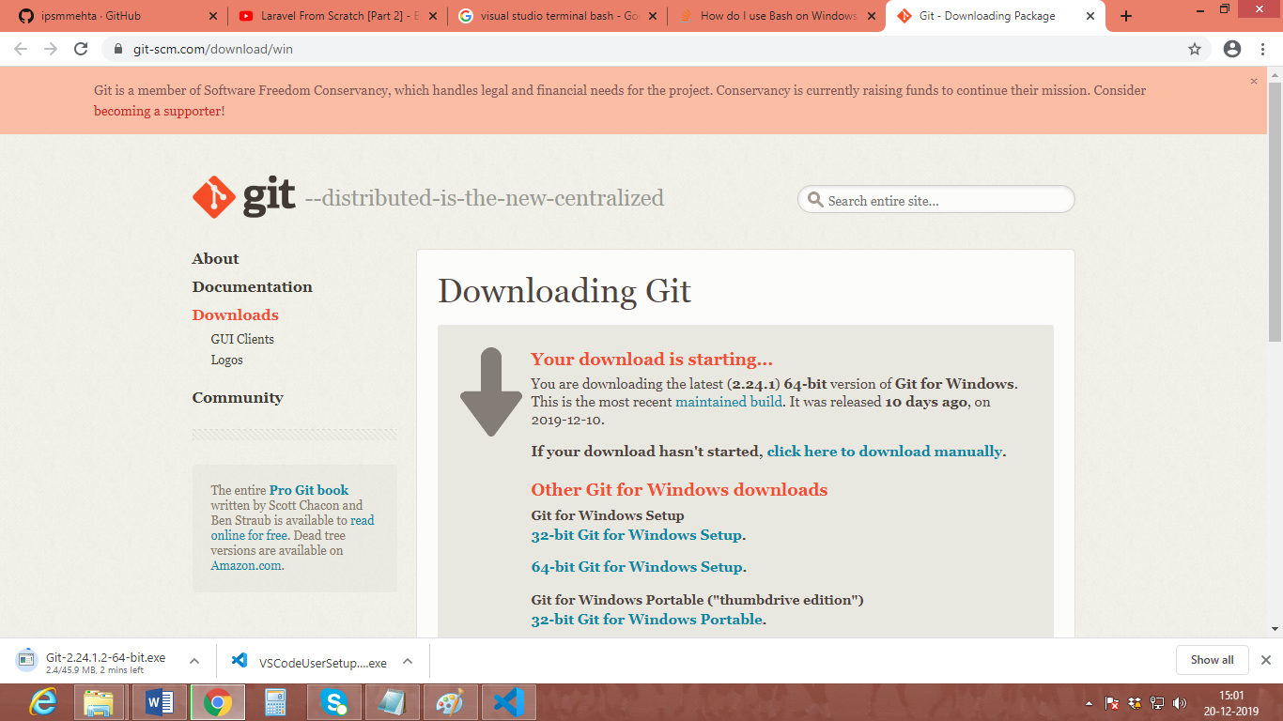

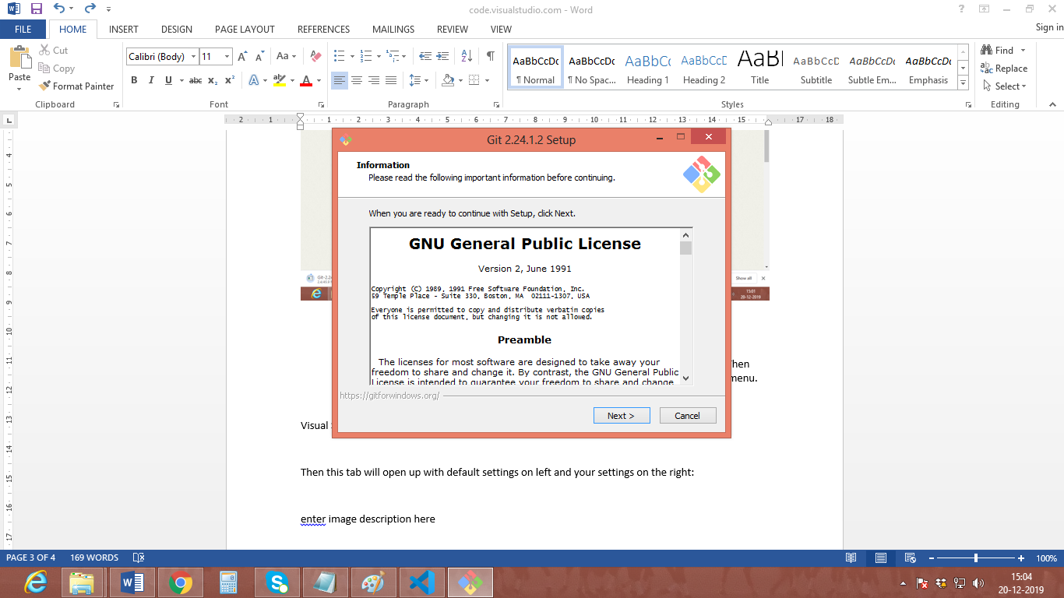

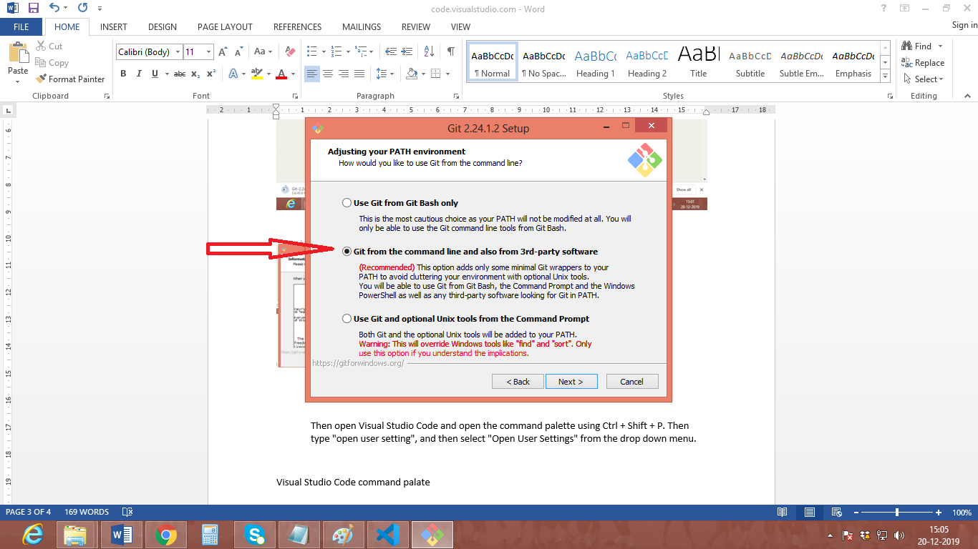

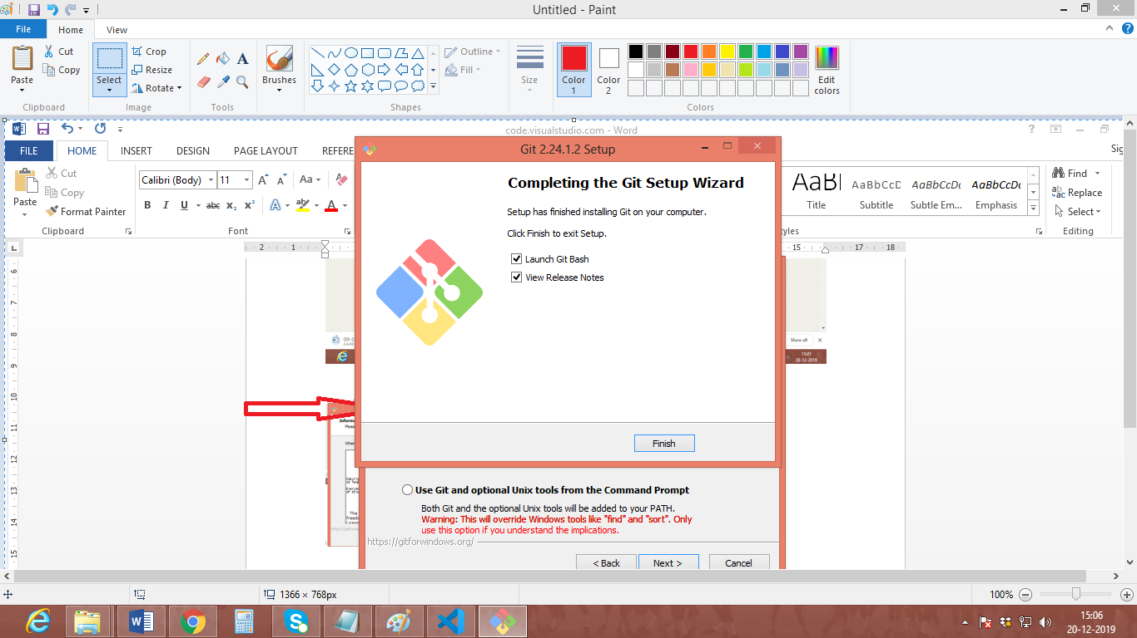

Step2: Go to file **Preference->setting**

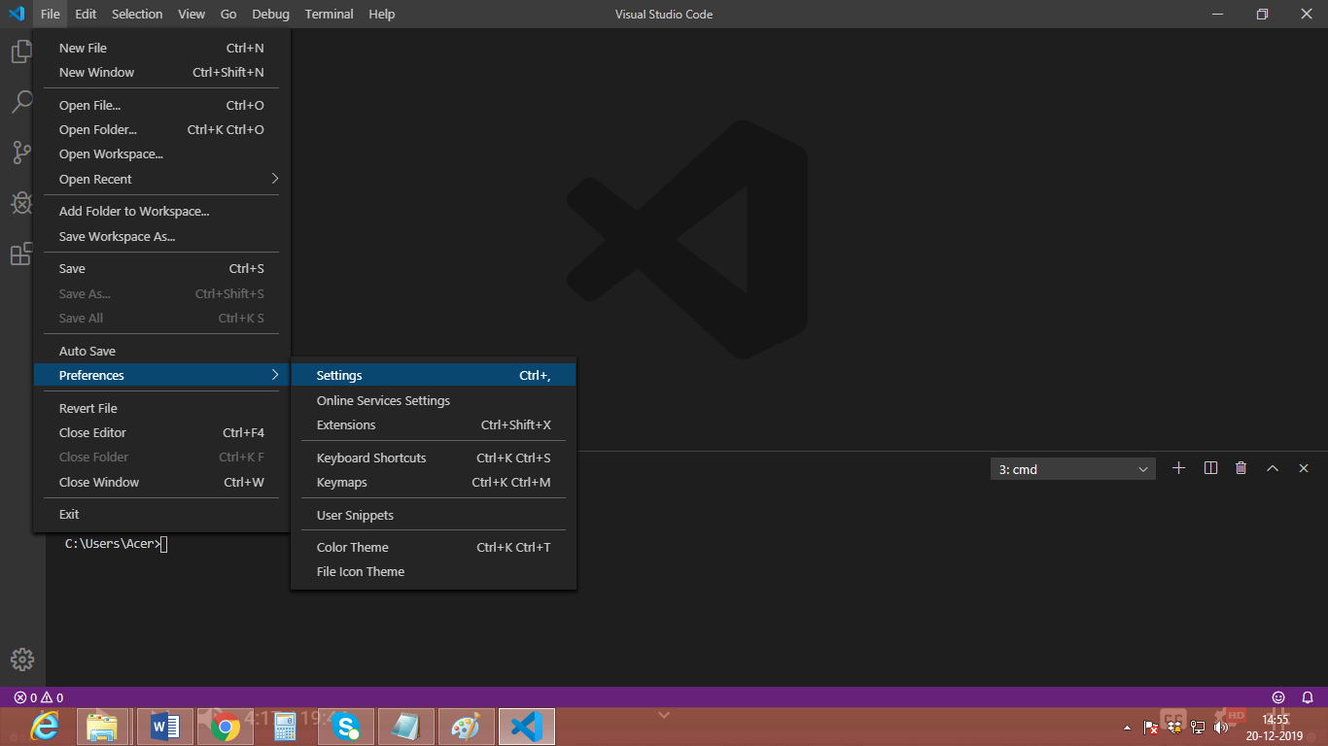

Search: **terminal.integrated.shell.windows**

Then click on **edit in setting.json**

* 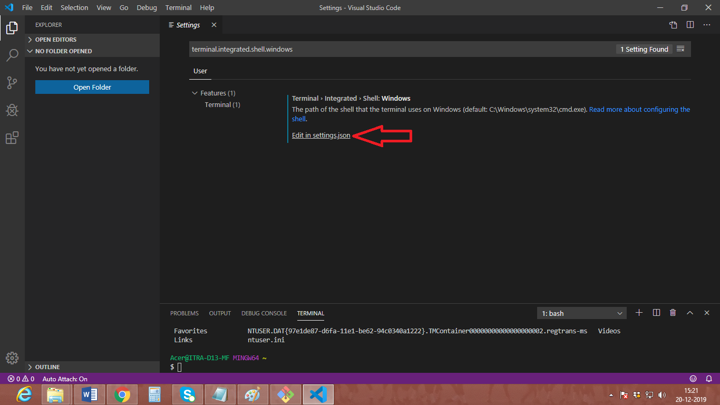

Write down:

**"terminal.integrated.shell.windows": "C:\\Program Files\\Git\\bin\\bash.exe"**

* 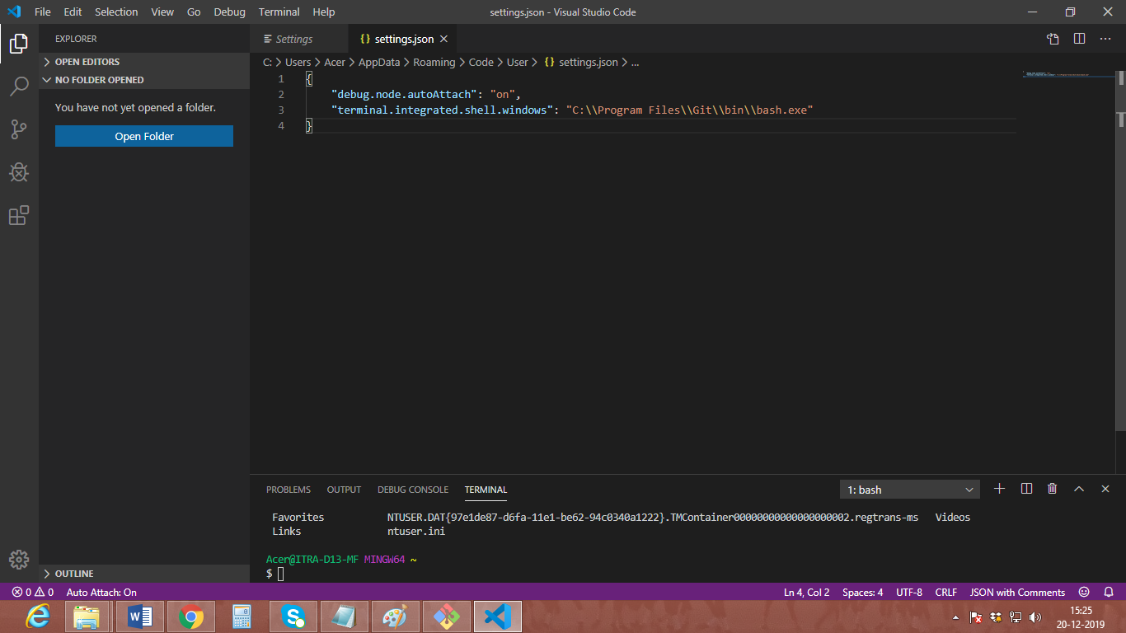

Save it and close the visuals Studio After that restart the visual studio & select bash in terminal

* 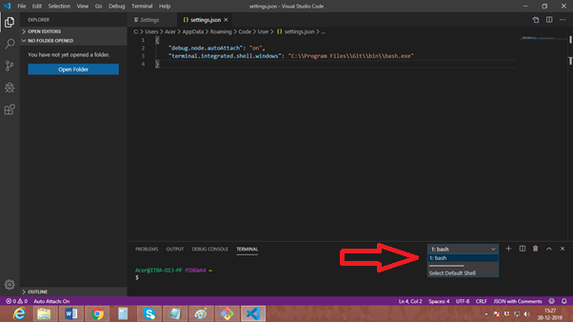

Download composer if needed: (for php project)

<https://getcomposer.org>

