Laboratory assignment №2

Topic: : Development with ASP.NET MVC. Project configuration. Displaying data from DB on web-pages.

Goal: Get acquainted with the MVC architecture, acquire skills in creating the main components of the MVC architecture, learn how to configure database connections and execute data reading queries, and acquire skills in working with views.

Workflow:

Task 1. Project creation and configuration
Create a project based on the MVC architecture following the instructions below
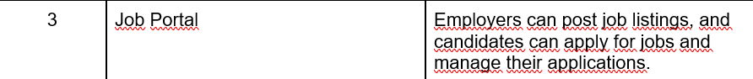
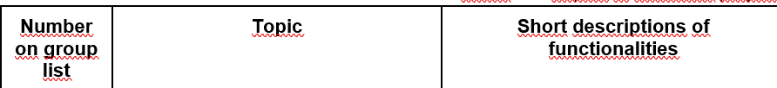

Fig. 1 – My task

I wrote
dotnet new globaljson --sdk-version 8.0 --output JobPortalSln/JobPortal
and created a global json file for possible future connections
Then I wrote in the console:
dotnet new web --no-https --output JobPortalSln/JobPortal --framework net8.0
and created the project

And made solution:
dotnet new sln -o JobPortalSln
The next one is:

dotnet sln JobPortalSln add JobPortalSln/JobPortal

This command adds the JobPortal project to the JobPortalSln solution file.

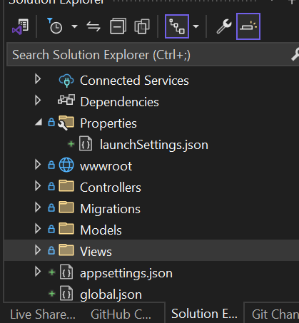
Fig. 2 – My solution explorer

Then I changed my launchsettings.json
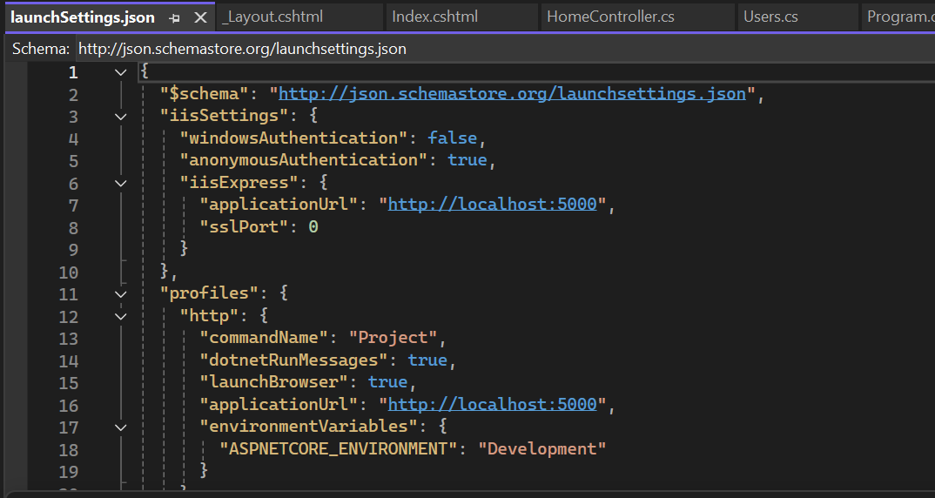
Fig. 3 – Wrote “channels” for host
Next I created the project structure with MVC principle (Models, Views, Controllers)
And also I wrote it in Program.cs:
var builder = WebApplication.CreateBuilder(args);

builder.Services.AddControllersWithViews();

var app = builder.Build();

app.UseStaticFiles();

app.MapDefaultControllerRoute();

app.Run();
It`s important, because we connected all configurations.

Added a Razor View file called _ViewStart.cshtml to the Views folder with the following content:

@{
Layout = "_Layout";
}

The Razor View Start file tells Razor to use the layout file in the HTML it generates, reducing the number of duplicate views.

I added a class file called HomeController.cs to the /Controllers folder and implemented the class in it:

public class HomeController : Controller
{
public IActionResult Index() => View();
}

To create the view, I added a Razor View file called Index.cshtml to the Views/Home folder with the content shown in the listing:
<h4>Welcome to JobPortal</h4>

Create a file with the appropriate name in the Models folder
using System.ComponentModel.DataAnnotations;
using System.ComponentModel.DataAnnotations.Schema;

namespace JobPortal.Models
{
public class Users
{
public long? UsersID { get; set; }
public string Name { get; set; }

public int Password { get; set; }
public string Login { get; set; }
public string PhoneNumber { get; set; }
public string Description { get; set; } = String.Empty;
public string City { get; set; } = string.Empty;

public string Type_access { get; set; }
public int? CompanyID { get; set; }

}
}
After completing all the previous steps, I converted an empty WebAPI project into a project that implements the MVC pattern and returns ready-made HTML pages in response to requests.

Task 2. ORM setup
Configure the database using the instructions below
I already had the SQL Server Express 2019 LocalDB packages installed

Added the Entity Framework Core package to the project:
dotnet add package Microsoft.EntityFrameworkCore.Design
dotnet add package Microsoft.EntityFrameworkCore.SqlServer

Also added the necessary packages for working with migrations
dotnet tool install --global dotnet-ef

I added the connection string to my appsettings.json
{
"Logging": {
"LogLevel": {
"Default": "Information",
"Microsoft.AspNetCore": "Warning"
}
},
"AllowedHosts": "*",
"ConnectionStrings": {
"JobPortalConnection": "Server=(localdb)\\MSSQLLocalDB;Database=JobPortalDB;MultipleActiveResultSets=true"
}
}

Conclusions: During the laboratory work, I Get acquainted with the MVC architecture, acquire skills in creating the main components of the MVC architecture, learn how to configure database connections and execute data reading queries, and acquire skills in working with views.

