Laboratory assignment №7

Topic: : Building real-time web applications with SignalR

Goal: to gain hands-on experience integrating SignalR into a web application to enable real-time data exchange using SignalR.

Workflow:

Task.
Add SignalR to your MVC project developed in the previous labs. Implement real-time functionality according to the topic of your project (Table 1).

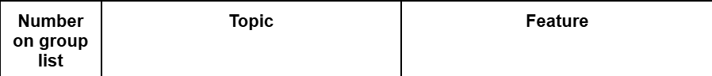
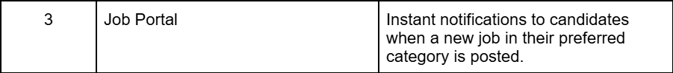

Fig 1 – My topic
What functionality did I add and the general algorithm of work:
The candidate selects categories
when a new vacancy is created then:
1) A vacancy record is created
2) we get a list of user IDs who are subscribed to this category (a special service for such interactions)
3) Notifications are created in the database
4) A message is sent to these users in real time via SignalR.

On the client:
_Layout has JS that connects to the SignalR hub.

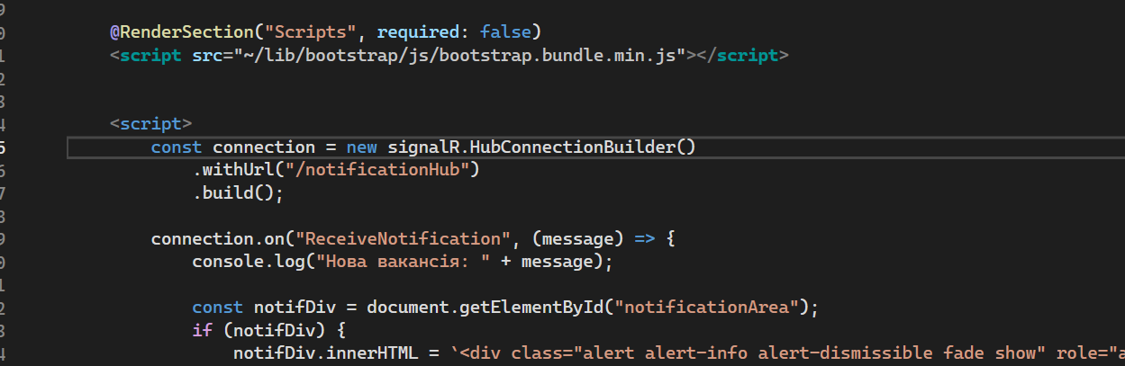
Fig 2 – On the client

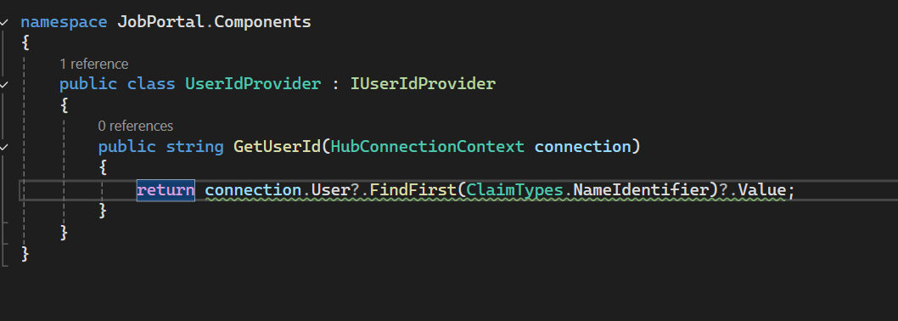
Fig 3 - UserIdProvider

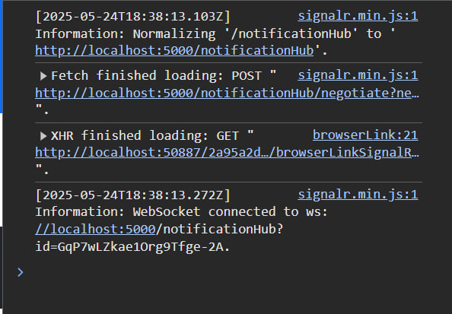
Fig 4 – SignalR connect

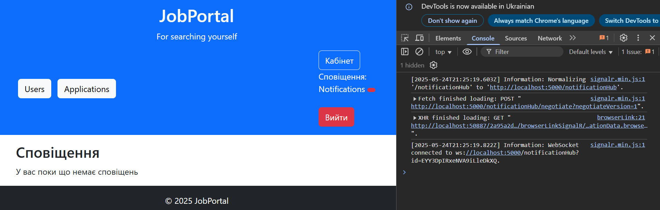
Fig 5 – Notification counter in frontend

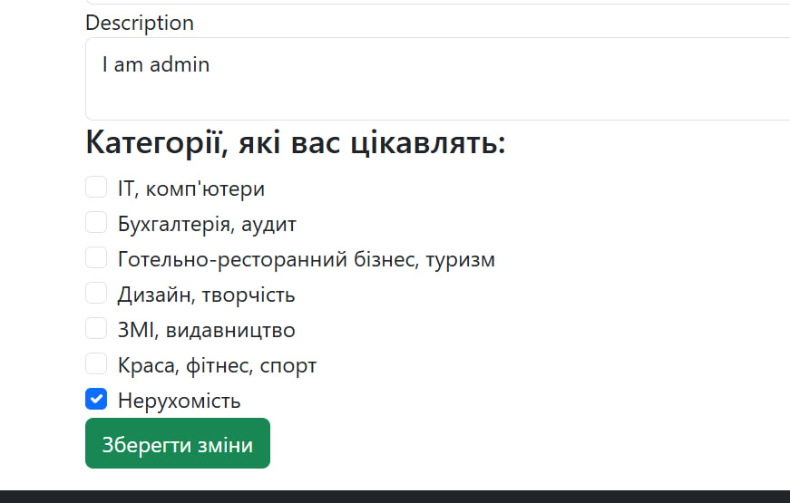
Fig 6 – Selected categories in profile

Conclusions: During the laboratory work, I gained hands-on experience integrating SignalR into a web application to enable real-time data exchange using SignalR.

