Buyer Account

As we have talked and discussed about the things. As much as time that took for seller account for buyer account as well going to take exactly same time which is Minimum 1 and half months to 2 months

Please view the why for time allocation that what can be done

Time Allocation

Access the Information Users Require through the App 15 business days days

Combine the Information Gathered and Transform It business 15 days

Give the Information Back to the User: 10 days

Writing APIs: 10 days

Scalability, Security, Robustness, Final Recommendations to Ensure App Strength 10 days

Total Days required to create buyer account is 60 business days

What buyer account will contain.

Only the things will be done which is described on this document. If possible then others things as well done.

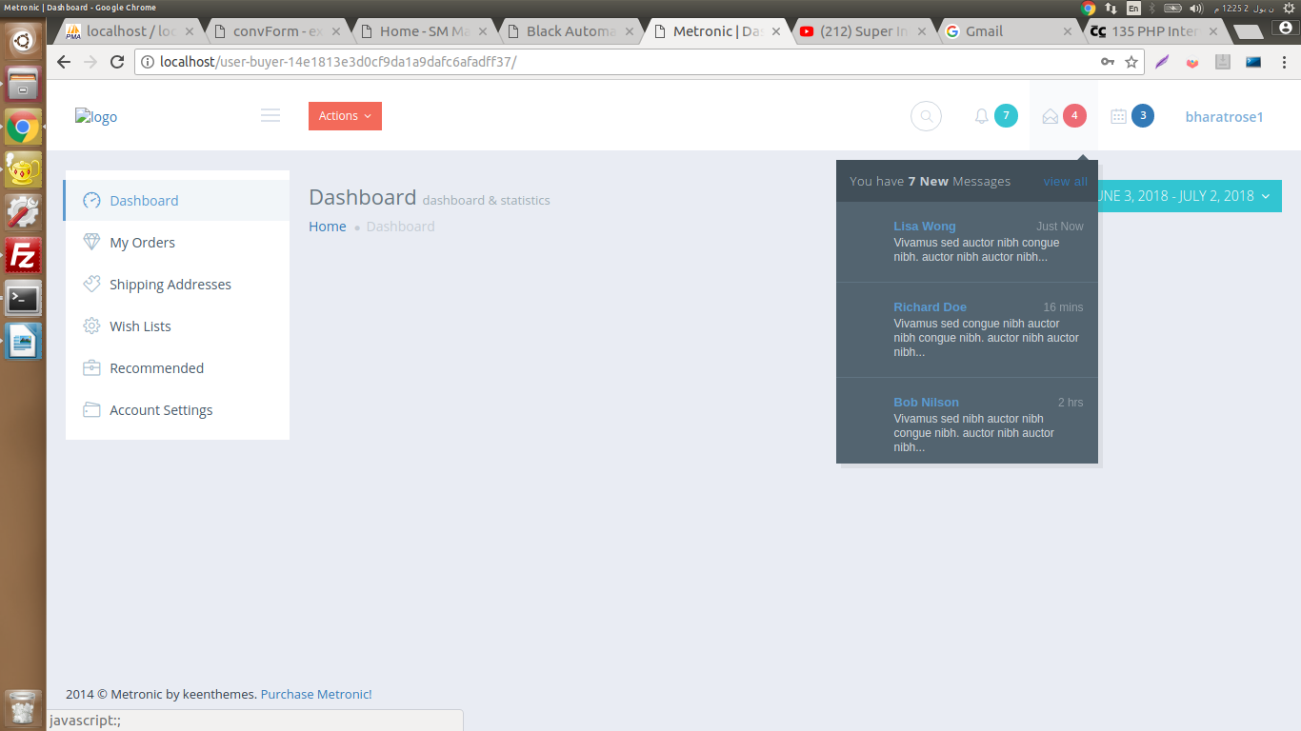
Buyer account will have dashboard for buyer account and then if buyer is logged in then buyer can send the message about the product to the seller and seller can receive the message about what buyer want to know about the seller in seller dashboard. I am striving to make like chatting system like if buyer logged in to their dashboard then buyer can send message to the seller and seller as well can send the message to the buyer. Message will comes as notification to the buyer visa versa. Let me illustrate the following with the map

As you can see there I am talking the message the buyer will as well receive about the if the seller will send to the buyer.

As I would like to explain again that UI/UX there will be different type of functionality will be available but it will not work as Backend because Front End design is complete design and Backend design is in the process.

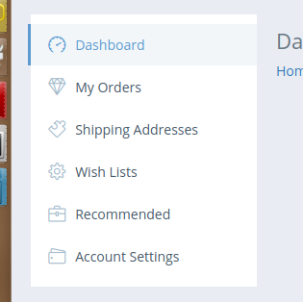
I am trying to make things best and here is explain that how the user and the deadline for the project is From July 1 buy adding 2 months it will be September 1st will be deadline of the project and there is many thing will be remain while developing the application.

If in the given time any other's jobs take place then the deadline will be increased an accounting to the the scope of the job and how long that jobs take to finish. Science from the date, July first together not all function will be available due to the scope of the work and human resource that you have provided.

As you can see there is alots of functions is out there such as left side of the picture
this development will be done in future development process. Because everything is enter connected with each others

Remember
This is not full function of buyer account because we will need to add many things in this account therefore we required to add letter on and function can not be completed at one.

