

Pre-Documentation of Multi Vendor E-Commerce Development

Author : BK Shah

Full Stack PHP Developer Leads

United Arab Emirates, Abu Dhabi

**1. PREFACE**

1.0 Purpose of this Document

Documentation is a fundamental part of any Large Web Application documentation is fundamental part of any Web Development Project, we will also learned through our experience that production something without planing can leads to wards the place where we do not want to go, but do much documentations as well can leads to wards human resources to prevent to become flexibly because time and technologies is very chronological it's has been changing very preparedly but what we will focuses that how by become very flexible we can deliver that project and together how we can maintain that. Development is infinitive process it's never get over and this document does not descriptor when Project will be 100% complete but on the other side it's describe that the functionality that most of the modern era using and what providing to the client. Purpose of this documentation is as well to minimize waste and achieve learn, best way to find the process of development and production. Science this is Pre- development it's really not providing 100% surety for the project therefore in real field implementation can be different then the described in this documentation or can be identical to the document.

Without human resource and without experiences and certain qualification/ education it's is not possible to achievable any goal the fore in this document I am explaining about the key, skill, qualification and experiences that is required for this project

Machine is very implementor part of development because only human resources is not enough the fore I am explaining what kind of machine we are using so team members can be more united rather then distributed team.

In this document I have explained the application on graphical information about the project about how the front end section is look like and their functionality and what we can use the best for back end section which supporting modern updated programming languages.

2.0 Human Resources that is required for the project

* Backed Developer (PHP Base).
* Front End Specialist/ UI/UX Designer
* Digital Marketing with SEO Specialist for future On line Marketing
* Project Manager who handle the project-specific
* Graphic Designer
* If more things required as our progress in future

2. Machine and programming language they we are using

* Ubuntu 16.04/ Linux Distribution can use other's operating system as well but Production Environmental will be Linux/ Ubuntu / CentOs etc
* HTML, CSS, JavaScript, Jquery, Ajax, JSON, XML for front end development
* In future we will be required MEAN Stack Developer (Full Stack JavaScript Developer )
* For Backed PHP 7.0 Lates version, Good to go With new version, Minimum because When we will work with team it's help to become more united and more. For for info **Reference** [**http://www.php.net/**](http://www.php.net/)**,** understanding ability to each others codes . For Caching Re dish Server (<https://github.com/clue/php-redis-server>) will be used. Front end Cache for Increase Speed such as HTML5 Front End Native Cacheing
* Database Mys 5.6/ Updated Version. Reference https://www.mysql.com/
* SSL Certified Domain (Secure Socket Layer) Reference https://www.linkedin.com/pulse/importance-advantages-ssl-certificates-jay-jones
* Amazing Looking Front End Design Which we have disguised
* Grillwork will be using for Version Control System and All team members will work on GitWorkflow Methods. Reference (<https://github.com/>)
* More things we will be adding here in future. ETC.

We have been disguising since long. As you have described customer need to advertise on our home page with banner, right side we will show the product after right side of the banner, When we click on the each product link then it's supposed to show product description and right side contact details of the suppliers to gather if user is logged in then then they can be able to send message regarding to the product and in the admin panel they supposed to receive message from the client about what they are saying all tings will come in the next phase of development not because I can not do in the first phase because we are skipping fundamental steps. Such as you can not build 3rd floor unless you built first floor therefore I would like to explain what will be done in the first phase of the development with just one person. Therefore you might find here explaining something else then what we have talk. Because those things is really obvious things and will be done in the next phase of the because like I said built first floor then second floor.

Just would like to give you some graphical introduction how actually front end of all process will work.

We have been talking about temporary and permanent there is no temporary and permanent things in we application there is first, second, third or version in development. Because what we are making toady is part of future development.

1.0 Front End for User

Picture No. 101 Illustrate how front end would look like

In the front end section will section we will have following functions.

1. Join with use link above the header side of the website with sign in link to and sell with us link, but initially only seller account registration will be working but user can register on both way either buyer or seller. I would like to illustrate through the image .



1. We will be having our own logo to header and link to ward our own website Sindbad.
2. Language will be shown in drop down menu on the right side of the website and two language will be shown Arabic and English but only English version of website will have been working for temp period. Let's illustrate through the image.

Logo will be changed for the flag letter on.

1. We are not building interface for short time. Because interface need to complete most of the things but system can be develop gradually.
2. In the category menu we will be have most of the category that we had in our previous page which will be shown to the user on hover to that menu. Let's illustrate by the images.



We are changing all the category as we had in our previous website and doing research that If we can add more things which can make more user friendly. This is design preview for the category menu.

1. After having the large category menu we will be having another category menu which is 2nd array dimension for the future purpose for the product searching but that will be in future version of development, but so far as I have explained front-end even though system does not work we need to create front end which just demonstrate our new feature in the future as well. Let's illustrate with the image.



1. Tough we will have many for front end but may things will not work it's will be for demonstration because if we do not put that website will not looks good. For example search bar will not work but we will still need to show through the fron-end side. Such as currency as well it's will show and will be developed in future version. In the banner we need to have <https://www.shutterstock.com/> account where we can get nice picture and will advertise some pictures from the brand in UAE when they click to the banner for a while we will redirect to their website.
2. On the the left side of the front page banner if we will have product uploaded then we can show some product on the random basis on to the website but first we need to upload the product then and then only we can have those product on to the right side of the website.
3. After banner side we will be having some icon row where we will show why they buy with use such as FREE SHIPPING, MONEY BACK GURANTEE, SAFE SHOPPING GURANTEE, ONLINE SUPPORT 8 HOURS ETC.



1. After completion of this block we will be having product rows where we will show to this section, just some category such as Machinery, Cloths etc. and right side of the row there will be arrow moving where we can move the product to see more it's if it is available there. Each product will be show as column with product primary image and name their price below and add to cart button but add to cart button will just work for demonstration. Just would like to give an example.
2. Important part of our website that we are company all physical address



1. In another block block will will be showing another category of the product with the same information as we have mentioned above.
2. Page that wee will create is home, category, login, registration, user verification, description, page not found, category page. Add to cart button will be static

But this we will have static design for this row or else we can upload at least 10 product in same category and show that category product in this line such as Fashion, Electronic etc. when user click to the page then we will show very basic product description page and will show product details on that product description page.

When user will click on the category on the basis of that category we will fetch the product on the category page using category_parameter and same things will happened when they click on individual page.

Just An Example Page

1.0.0 Home, Sign In, Sell With Us, My Account, My Wish List, Checkout, Cart, Checkout, Search Result,

**User Registration Interface**



Customer Ad-min Panel after login they will get following user administrator panel where they will manage their inventories. This is just an example because not everything will be same as mentioned in the picture. While user register with use now we are handling only the user who is uploading the product to our website therefore seller radio button will be activated and buyer will be deactivated and letter on it will be activated in second phase of development.

When user registered with us then registration link will be sent to their email for verification. Unless they verify there they can not be able to login to their account.

1.0.2 General Customer Log in panel

As I have explained that for Main administrator form will be different and we redirect to our admin panel and if this is general account then different form will be provided to the user and if user is seller then different form which will to different queries to our database and will provide if authenticated by the database. Below for general user how it's really looks like I would like to illustrate about that.

As you can see these picture how really user can get log in and manage their ordering such as what they have order, their shipping address, wish lists, On the basis of their purchase what we can recommend them to purchase and Account setting



**Contact Part of the website**

How we want to build multi vendor website in MEA and we do not have proper contact address so they can contact that



**BACKEND SIDE MOST IMPORTANT PART OF THE WEBSITE**

This part is most important which we have not been talking at all as I have explained in the previous chapters that when without backend you will not be able to run you fronend section the fore this part I would like to focus more.

When user get register as seller then he/she must need to verify their account which is sent to their email address. After verification they can login and there will be may option as UI/UX or Fronend side but only some of them will have been working for example they can upload the product with the following details. On the right side we will show who is logged in and like we spoke this place where they will get message regarding the product but not now it's will be in next phase of development. I would like to illustrate the example below. 

As you can see above we will just show now front end such as message icon but in server side it will work in next phase of development not in temporary it's not temporary

There will be page will the following filed where user can upload the product. I just would like to illustrate by the image

As you can see some of the filed that Is required for the uploading the product to the server 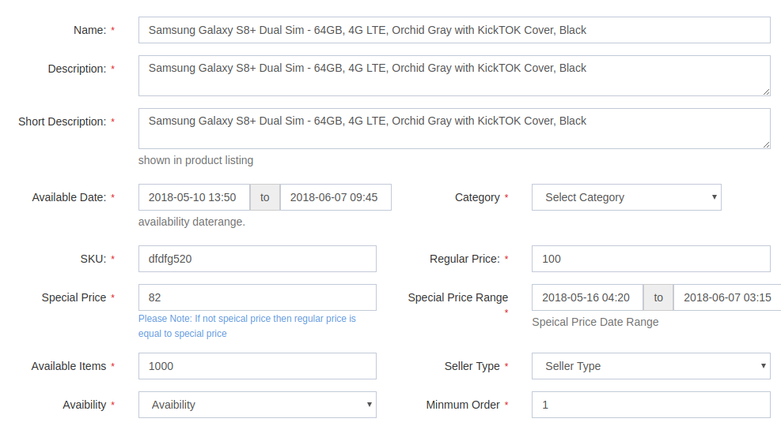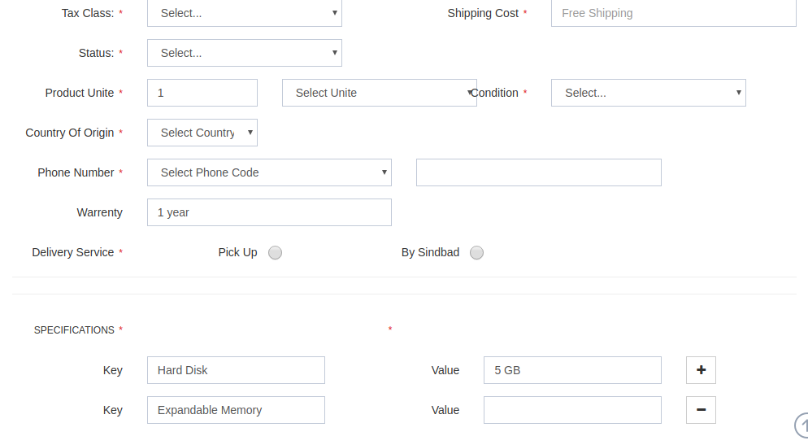

As you can see how these articles will work from the backend side the filed that wil be presented with theirs name and descriptions.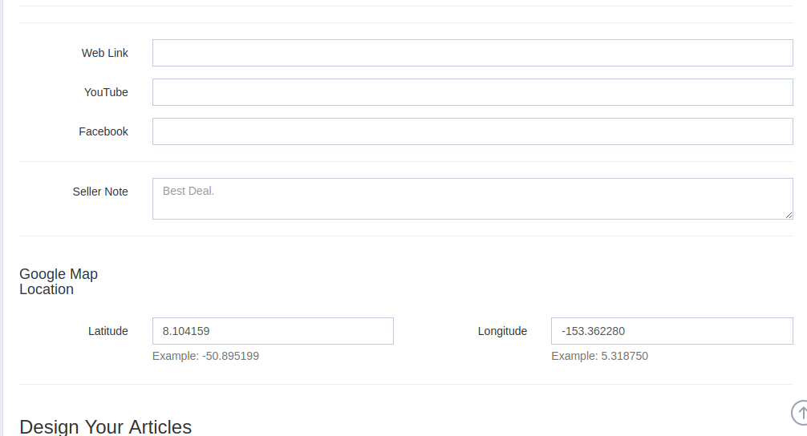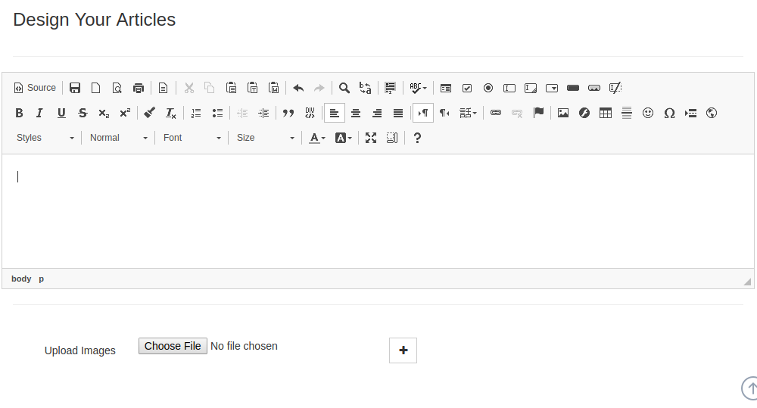

1. Name → where user will put product name and it's must be a-zA-Z0-9
2. Description → product description and it's must be /^[a-zA-Z0-9\-,+:\/ ]{2,150}
3. Short Description → Short description for the product
4. Available Date → Date available from to to.
5. Category → Product category
6. SKU → Stock Keeping Unite
7. Regular Price → Regular price of the product must be 0-9
8. Special Price → Special price of the product must be integer
9. Availability → where product in stock of out of stock
10. Min mm order → How many they can order minimum Integer
11. Tax Class → Where product is taxable of not select element
12. Shipping Cost → Weather shipping is free or cost, string and integer
13. Status → Whether product is published or not published
14. Condition → Product is new, old, used etc select string element
15. Country of origin → Where the product is located
16. Phone Number → Phone number for the product where they can contact integer
17. Warranty → Product have any warranty or not
18. Delivery Service - > Radio button either pick up or by Sindbad
19. Specification -> On the basis of dynamic field Key and their value
20. Web Link → A valid link of web address where user can find product details
21. YouTube → Link of the you tube to show in future in product description page
22. Facebook → If the product have face book profile then link
23. Seller Note → Anything that seller would like to tell about the product
24. Latitude → Latitude of the product to show Google map(Future version Not now )
25. Longitude → Longitude of the product for future version (Not Now )
26. Designing Articles → Whole HTML page for the seller for the specific product will display in future version of the development.
27. File → Maximum only 5 number for file, file type jog, png, bmp, gif not more then 2 MB file size only images
28. Submit → After submitting it will send the request to the server and another script will execute on the basis of request

Note: Many things perhaps has not written in this articles hope can do something more in this specific time.

Deadline for the first phase is July 3 because of 2 days holiday of Eid.

Best Regards

Mr. Shah