

Pre-Documentation of Multi Vendor E-Commerce Development

Author : BK Shah

Full Stack PHP Developer Leads

United Arab Emirates, Abu Dabi

**1. PREFACE**

**1.0 Purpose of this Document**

Documentation is a fundamental part of any Large Web Application documentation is fundamental part of any Web Development Project, we will also learned through our experience that production something without planing can leads to wards the place where we do not want to go, but do much documentations as well can leads to wards human resources to prevent to become flexible because time and technologies is very chronological it's has been changing very preparedly but what we will focus that how by become very flexible we can deliver that project and together how we can maintain that. Development is infinitive process it's never get over and this document does not descriptor when Project will be 100% complete but on the other side it's describe that the functionality that most of the morden era using and what providing to the client. Purpose of this documentation is as well to minimize waste and achieve learn, best way to find the process of development and production. Science this is Pre- development it's really not providing 100% surety for the project the for in real field implementation can be different then the described in this documentation or can be identical to the document.

Without human resource and without experiences and certain qualification/ education it's is not possible to achievable any goal the fore in this document I am explaining about the key, skill, qualification and experiences that is required for this project

Machine is very implementor part of development because only human resources is not enough the fore I am explaining what kind of machine we are using so team members can be more united rather then distrusted team.

In this document I have explained the application on graphical information about the project about how the front end section is look like and their functionality and what we can use the best for back-end section which supporting modern updated programming languages.

2.0 Huamn Resources that is required for the project

* Backend Developer (PHP Base).
* Front End Specialist/ UI/UX Designer
* Digital Marketing with SEO Specialist for future Online Marketing
* Project Manager who handle the project-specific
* Grahic Designer
* If more things required as our progress in future

2. Machine and programming language tha we are using

* Ubuntu 16.04/ Linux Destribution can use other's operating system as well but Production Environmental will be linux/ Ubuntu / CentOs etc
* HTML, CSS, JavaScript, Jquery, Ajax, JSON, XML for front end development
* In future we will be required MEAN Stack Developer (Full Stack Javascript Developer )
* For Backend PHP 7.0 Lates version, Good to go With Laravel 5.0 Minimun because When we will work with team it's help to become more united and more. For for info **Reference** [**http://www.php.net/**](http://www.php.net/)**,** understanding ability to each others codes . For Caching Redish Server (<https://github.com/clue/php-redis-server>) will be used. Front end Cache for Increase Speed such as HTML5 Front End Native Cacheing
* Database Mysql 5.7 Updated Version. Reference https://www.mysql.com/
* SSL Certifited Domain (Secure Socket Layer) Reference https://www.linkedin.com/pulse/importance-advantages-ssl-certificates-jay-jones
* Amazing Looking Front End Design Whic we have disgussed
* GitWorkFlow will be using for Version Control System and All team members will work on GitWorkflow Methods. Reference (<https://github.com/>)
* More things we will be adding here in future. ETC.

3.0 Time that will take to reach towards the completions of the project

As I have described the web development is infitive process but we can not say event that is uncertain. As we have started with 2 Members if 1 team menbers does front end and another backend development then minimum 6 Months .

4.0 Sites mapes

Just would like to give you some graphical introduction how actually front end of all process will work.

1.0 Front End for User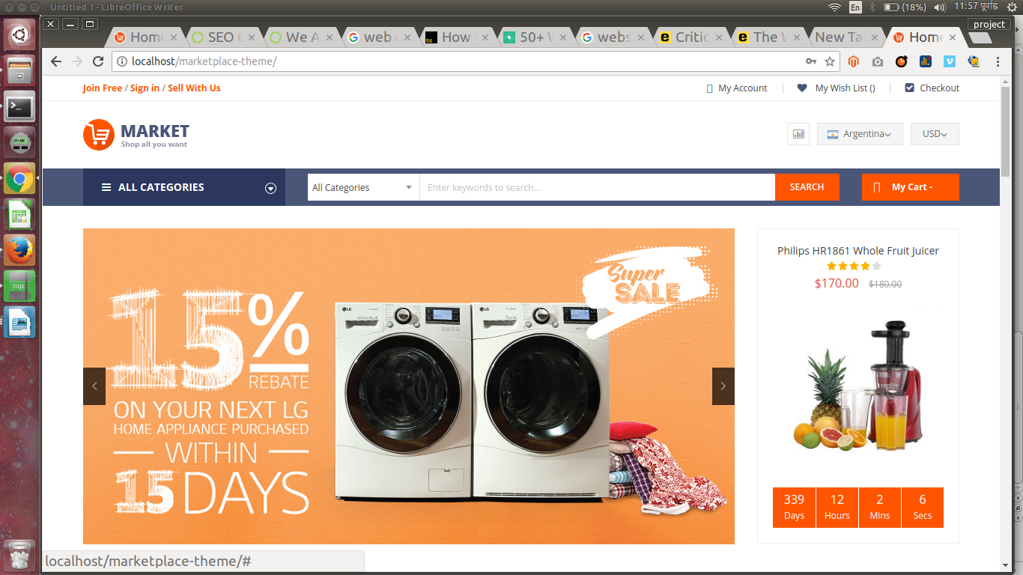

Picuture No. 101 Illustrate how front end would look like

Picture No. 102 Illustrate how Sller Accoun would look like. The most important things is seller account is seller either is Individual or Shop and if they are individual then they must need to provide Emirate ID or Whic is equivalent to that if seller is shop then they need to provide their Shop id and image of certificates show validation can be done in right way otherwise everybody can do anythings with application.

Just An Example Page

1.0.0 Home, Sign In, Sell With Us, My Account, My WishList, Checkout, Cart, Checkout, Search Result,

1.0.1 Customer Admin Panel after login they will get following admin panel where they will manage their inventories. This is just an example because not everything will be same as mentioned in the picture below

As you can see in Picture No 101 When user register and user must need to verify their email address as you can see in the bleow picuture there need to have Inventory, Order, Post Delivery, Financials, Performances Sponsored Products, Promotion these elemnent will be gradually develop each section have theire own function for example from Invertory Section user can Creat, Read, Delete, and Update the product that they have . I would like to I would like to illustrate from the following way.

1.0.2 General Customer Log in panel

As I have explained that for Main administrator form will be different and we redirect to our admin panel and if this is general account then different form will be provided to the user and if user is seller then different form which will to different queries to our database and will provide if athendicated by the database. Below for general user how it's really looks like I would like to illustrate about that.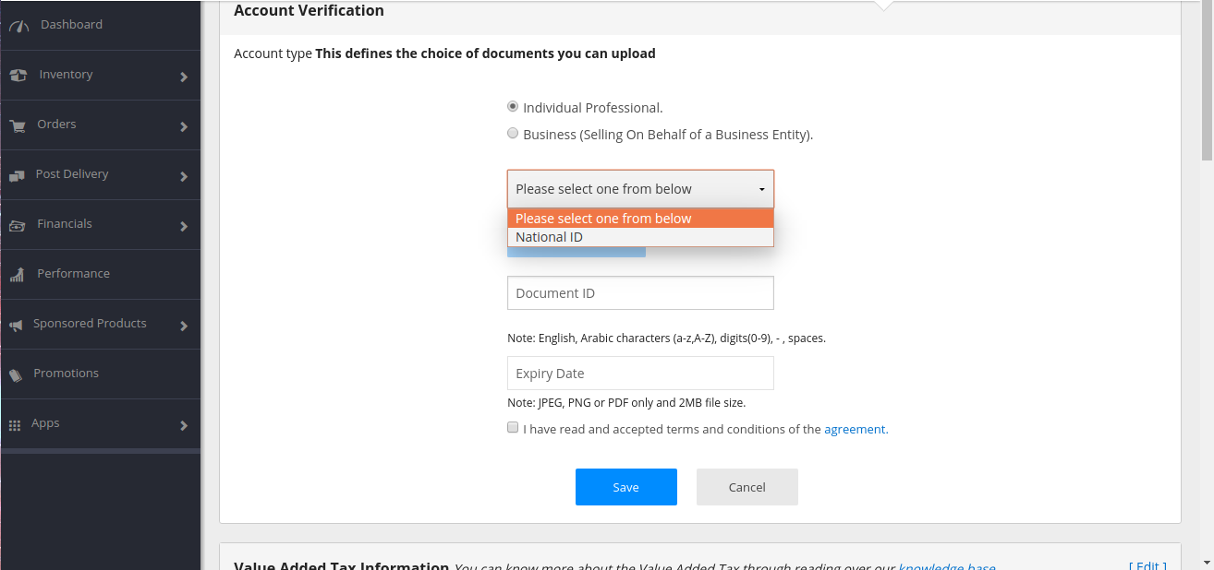

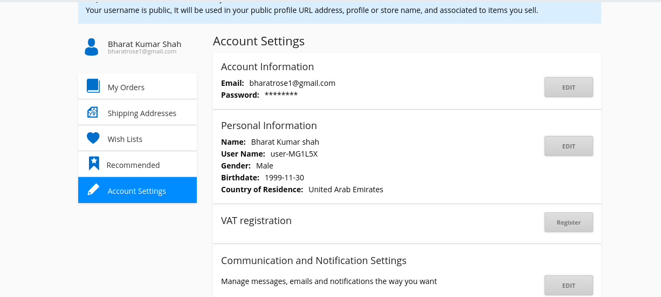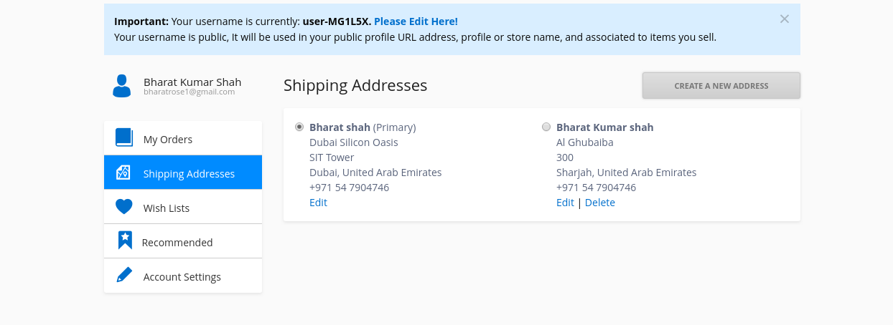

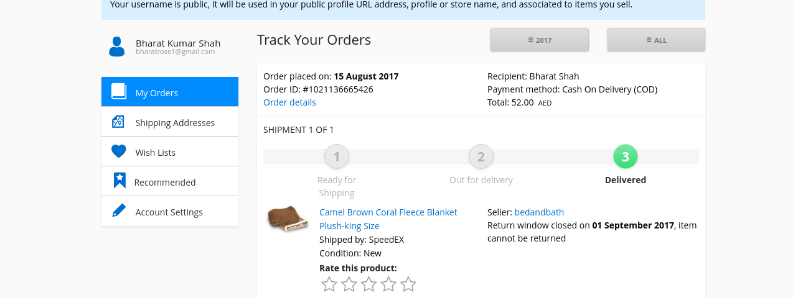

As you can see these picture how really user can get log in and manage theire orderring such as what they have order, their shipping address, wish lists, On the basis of their purchas what we can recommand them to purchase and Account setting

**As We Have Made The Theme**

This is amazing theme which will be used to General User Backend, Seller User Backend, Administrator Backend Togarther. This metronic theme is used by 50, 000 Developer all over the glob it's amazing

Seller can come in different basis Aggregator, Brand, Distributor, Importer/Exporter, Individual, Manufacturer, Retailer, Wholesaler, Others

Documentation will be continue