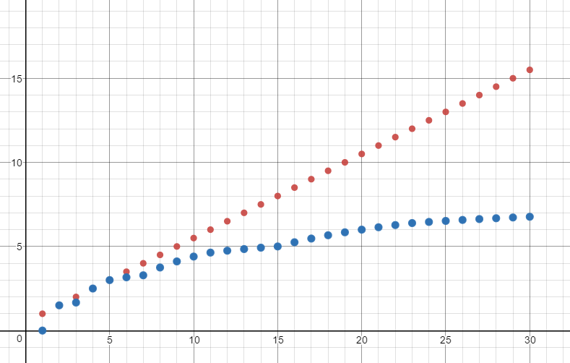

Blue = binary, red = linear

**Based on your graph, for what array sizes is linear search more efficient than binary search?**

Linear search (may) be more efficient for smaller arrays (and of course, arrays where the elements are already sorted).

**Based on your graph, for what array sizes is binary search more efficient than linear search?**

Under almost all other conditions, binary search will be more efficient than linear search because it can locate the specified element in O(log(n)) time.