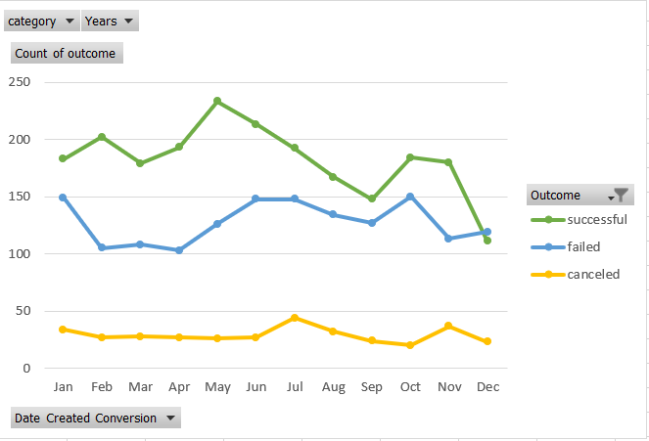

What are three conclusions we can make about Kickstarter campaigns given the provided data?

* The successful kickstarter campaign is peaking high in the month of May and trending downward towards the end of the year.
* When the goal is becoming costly, the successful project rate is becoming lower and the failed projects are increasing.
* The canceled projects are also trending up when the goal is becoming costly.

What are some of the limitations of this dataset?

The graph representation does not cover beyond a year.

What are some other possible tables/graphs that we could create?

Graph against backers count and state of the project.