

List Name of students and Academic numbers

1. Nora Hamdan Al johni 441006182
2. Rawan Mohammed Al Blowi 431009485
3. Maram Musa Al Attawi 441000611
4. Atheer Mohammed Al Huwaiti 441003533

Name of the supervisor

Dr. Monia Youssef OUEDER

Date of submission

9/05/2024

**Graduation Project**

**ACCS 1298**

**Design and Implementation of "My Trip Bus" Website**

**Kingdom of Saudi Arabia**

**Ministry of Education**

**University of Tabuk**

**Applied College**

**Programming and Computer Science**

## إهــــداء

إلى عائلتي الغالية وصديقاتي الأعزاء، ولمشرفتي الرائعة على مشروعي التخرج، أهديكم أجمل التحيـات والامتنـان أعلم تمامُا أن الكلمات لن تكفي لتعبير مدى حبي وامتناني لكم، لكنني أرغب في مشاركة بعض العبارات القليلة التي تحمل دفئ قلبي وتعبيري وعن مدى أهميتكم في حياتي.

لعائلتي الحبيبة، أنتم سندي ودعمي الأبدي. بفضل حبكم اللا متناهي وتشجيعكم الدائم، استطعت تحقيق حلمي في إكمال دراستي وإتمام مشروع التخرج. فشكرًا لكم على وقوفكم إلى جانبي، وعلى كل الدعم والثقة التي وضعتموها فيٌ. أحبكم جميعًا من القلب. لأبي العزيز، أنت الركيزة القوية التي تسندنا وتقودنا في هذه الحياة.

بحكمتك وصبرك وحبك العميق، تجسدت فيك صفات الرجولة والعطاء. أنت الأب الحنون والصديق المخلص، ومن دون دعمك وتشجيعك، لم أكن سأصل إلى هنا. فشكرًا لك وأحبك بجنون. لأمي الغالية، أنت أميرة حياتي ونجمة ساطعة في سماء عائلتنا. بحنانك اللامحدود وعطفك العميق، تحولت حياتنا إلى بستان من الأمل والسعادة. أنتِ المصدر الأبدي للحنان والعناية، وأشكر الله على نعمة وجودك بجانبي. أنتِ الملاك الحافظ وأمي الغالية، وأحبك للأبد. ولأخوتي وأخواتي الأعزاء، أنتم رفاق الدروب شركاء المغامرات. من الضحكات العفوية إلى المشاعر العميقة، قضيتم معي أجمل اللحظات. أنتم الأصدقاء الحقيقيون والأخوة والأخوات الأعزاء، وأشكركم على دعمكم الدائم وحبكم الصادق. دمتم أبدًا في قلبي.

وإلى صديقاتي الرائعات، لقد كنتن رفيقاتي المخلصات وصديقاتي الحميمات على مدى سنوات الدراسة. من مشاركة الضحكات والأفراح إلى تجاوز التحديات والمشاكل، لقد كنتن جزءًا لا يتجزأ من رحلتي الأكاديمية. أشكركم على الدعم والتشجيع والمحبة التي أظهرتنها لي، وأتمنى أن نستمر في بناء ذكرياتنا الجميلة سويًا. وأخيرًا، للدكتورة المشرفة الرائعة، أنتِ لم تكن مجرد مشرفة، بل كنتِ مرشدة وملهمة. بفضل خبرتك ومعرفتك العميقة، ساعدتني في توجيه مشروعي بأفضل الطرق. شكرًا لك على صبرك واهتمامك ودعمك اللامحدود. لقد كنتِ نموذجًا ملهمًا للعمل الجاد والتفاني، وسأحمل ذلك معي طوال حياتي المهنية.

## ABSTRACT

Our project is about developing, designing, and implementing of a website called "My trip bus". "My Trip Bus" is a specialized website that allows students, parents, and bus drivers to get a real-time information about school bus movements. It goes beyond tracking buses, providing a safe and effective solution that enhances students' comfort and safety, keeping them effectively under the watchful eyes of their parents. In the increasing focus on personal safety, this website achieves a perfect balance between technology and personal care. By providing an advanced and user-friendly interface for students, "My Trip Bus" enables parents to track the bus route and know the departure and return times of their children with ease and safety. It allows parents to communicate with drivers and ensure their children's safe arrival at their destination.

TABLE OF CONTENTS

Acknowledgements II

ABSTRACT III

TABLE OF CONTENTS IV

LIST OF TABLES V

LIST OF FIGURES VI

Chapter I Introduction 1

1.1 Introduction 1

1.2 Motivation 1

1.3 Problem statement 1

1.4 Objectives 2

1.5 The structure of the report 2

Chapter II Literature Review 4

2.1 Related work 4

Chapter III Design and Implementation 6

3.1 Methodology 6

3.2 Tools and Software 6

3.3 System Design and Implementation 9

Chapter IV Results and Discussion 14

4.1 User Testing 14

4.2 Results and Discussion 15

4.3 Limitation and Future Work 15

4.4 Conclusion 16

References  17

## LIST OF TABLES

|  |  |  |
| --- | --- | --- |
| **Table** |  | **Page** |

Table 3.1: Tools and Software used. 8

Table 4.1: User Testing opinions.  14

## LIST OF FIGURES

|  |  |  |
| --- | --- | --- |
| **Figure** |  | **Page** |

Figure 3.1: Home page 9

## Figure 3.2: Login page 9

## Figure 3.3: Account Creation page 10

## Figure 3.4: Student page 10

## Figure 3.5: Driver page 11

## Figure 3.6: Parents page 11

## Figure 3.7: Home page Code 12

## Figure 3.8: Login page Code 12

## Figure 3.9: Account Creation page Code 13

## Figure 3.10: Style Code 13

1. **Introduction**
   1. **Introduction**

In this chapter, we will introduce an introduction about our website. "My Trip Bus" website revolutionizes school transportation, offering a secure web platform that goes beyond tracking buses. It prioritizes student safety and parent communication. It is a sustainable initiative, addressing challenges in education, improving daily life. In this chapter, first we present our motivation to develop this website, then we will state the problem statement that we are face with, finally we will present the website 'objectives and we will detail the structure of the report.

* 1. **Motivation**

The development of our website "My Trip Bus" was motivated by the challenges 4solution. The focus is on enhancing the overall experience for students and parents while optimizing daily operations for bus drivers. The initiative reflects a commitment to innovative solutions and aligns with environmental sustainability, contributing to improved daily lives.

* 1. **Problem statement**

The existing challenge in tracking school buses poses difficulties for students and parents who struggle to determine bus locations and schedules. University students also face issues in timely attendance for lectures. This lack of a reliable tracking system creates inconvenience and safety concerns for all stakeholders. In response to this problem, "My Trip Bus" emerged as an innovative solution to provide real-time information and enhance the safety, efficiency, and overall experience of school transportation.

* 1. **Objectives**

The objectives of "My Trip Bus" are multiple. Among these objectives, we find:

* **Enhance Student and Parent Experience:** Improve the overall experience for students and parents by providing a reliable and efficient school bus tracking system.
* **Ensure Student Safety:** Prioritize the safety of students during transportation by offering real-time tracking and effective communication channels between parents, students, and bus drivers.
* **Optimize Daily Operations:** Enhance the daily operations of bus drivers by providing them with tools to streamline routes, manage timings, and promptly address any issues that may arise during transportation.
* **Efficient Communication:** Facilitate effective communication between parents and bus drivers, enabling parents to track the bus route, departure, and return times effortlessly.
* **Comprehensive Solution:** Go beyond basic bus tracking to offer a comprehensive solution that addresses the challenges faced by students, parents, and bus drivers, ensuring a safer and more efficient transportation system.
  1. **The structure of the report**

The report structure for "My Trip Bus" is as follows:

The first chapter is an introduction where we give an overview of "My Trip Bus" as an innovative solution for challenges faced by students, parents, and bus drivers during the school transportation experience.In the second chapter, we give somesimilar works related with our website. Then in chapter three, we detail the different tools, software and languages used to implement our project and we present the different pages of our website and the different codes that allow us to obtain these pages. The chapter four is dedicated to give the different results that we collect from the users who have tested our website, and we present the different future works to improve our site. Finally, a conclusion concludes our work.

1. **Literature Review**

In the upcoming chapter, we will present some existed websites and application that are similar to our website. By examining the disadvantage of these websites, we obtain the idea of our site to adjust these lacks.

**Related work**

There exist multiple websites and applications that deal with tracking cars and others that deal with the student needs. From these websites, we find:

* **Uber:**

Uber is a popular transportation service that uses digital.

technology to connect passengers with private drivers using.

their own cars. The Uber application allows users to simply request an

Uber cars via their smartphones. It is a delivery application for all places, so we inspired the idea of delivery from it [1]. But the Uber application has the disadvantage that it does not provide delivery services such as buses and others for educational groups [1].

* **Google Maps:**

the Google Maps application is used to get turn-by-turn directions.

to easily reach different places. It shows us routes and uses real-time insight into the best route for our route. The advantage of this application is that it shows us the idea of maps, the idea of live location points, and real-time traffic information [2]. But it suffers from a major drawback which is that if the Internet is not available, the page will not exit, the accuracy is limited, and the information provided may contain some errors [2]

* 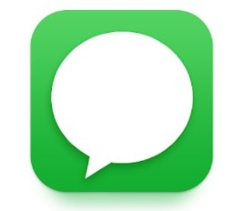**Messages:**

A messaging application is electronic.

program used for exchanging text messages and

multimedia content via smartphones, tablets, and computers, the advantage of the Application Users can send and receive text messages instantly, enabling quick communication. Instant notifications ensure no message is missed [3]. But it Uses messaging apps consumes the smartphone's battery power, which can be problematic, especially if charging is not readily available [3]

1. **Design and Implementation**

Our website design and implementation process has passed by different stages, and we have utilized many tools and languages. In this chapter, we will describe the methodology that we have deal with, and we will outline the software tools and languages utilized for the implementation of our website. Finally, we will present some developed pages of the website with some codes to obtain them.

* 1. **Methodology**

To achieve the ''trip bus'' website, we have, in the first, proposed a design for the website using the canvas software. Then, we begin the implementation of the website utilizing advanced programming languages such as HTML and CSS. Additionally, employing JavaScript techniques has enabled us to provide high interactivity and enhance site performance. To present all our work, we utilize the word software to form the document of the project and we use the power point software to present the different stages of our work.

* 1. **Tools and Software**

The programs, software, and languages that we were used to create and design the website are presented in the following table:

|  |  |  |  |
| --- | --- | --- | --- |
| **Project Phase** | **Software Icon** | **Software Name** | **The Description** |
| **Site Creation** |  | **HTML** | HTML stands for Hypertext Markup Language. It is a markup language used for creating and designing web pages and websites. HTML is one of the oldest and most widely used languages for web page design. It is responsible for defining the structure and layout of the content on the page.  We used html to create the webpage.   * Example: the tag for inserting the img   <div>  <img src="bus-stop.png" alt="logo">  </div> |
| **Site Implementation** |  | **CSS** | CSS stands for Cascading Style Sheets.  It is a styling language for web pages that focuses on the design and appearance of websites. CSS is specifically designed to separate the formatting from the content of the written document, including colors, fonts, images, and backgrounds used on the pages. It helps make the website visually appealing, organized, and distinct from others. We used css in our website for formatting the web page like fonts, color, movement, etc   * Example: the tag for the header img   header img{  width:110px.  float: left |
| **Site Implementation** |  | **Javascript** | Javascript is a scripting or programming language that allows us to implement complex features on web pages displaying timely content updates, interactive maps, animated 2D/3D graphics, scrolling video jukeboxes, etc.  We used Javascript in our website to add a chat to communicate.   * Example: Variable to store the user's message.   let userMessage = null; |
| **Site Design** |  | **CANVA** | Canva is an online design and publishing tool that empowers people around the world to design and publish.  anything, anywhere. It is a fundamental program for graphic design online, enabling you to create invitations, flyers, logos, and various other designs easily. Its function is to provide a graphic design tool that offers ready-made templates online for creating your designs. We used this program to design our website. |
| **Website Presentation** |  | **Power Point** | PowerPoint is used for creating presentations from scratch or using templates. It allows us to add text, images, drawings, and videos, and customize a professional design. Its function is to create slide show presentations that contain various information and notes. We used this program to present the main ideas of our work. |
| **Document Site steps** |  | **Word** | Microsoft Word is a word processing program designed to assist in creating professional-quality documents. Its function is to help organize and efficiently write documents. We used this program to write the document of our project. |

Table 3.1. Tools and software used.

* 1. **System Design and Implementation**

● System Design

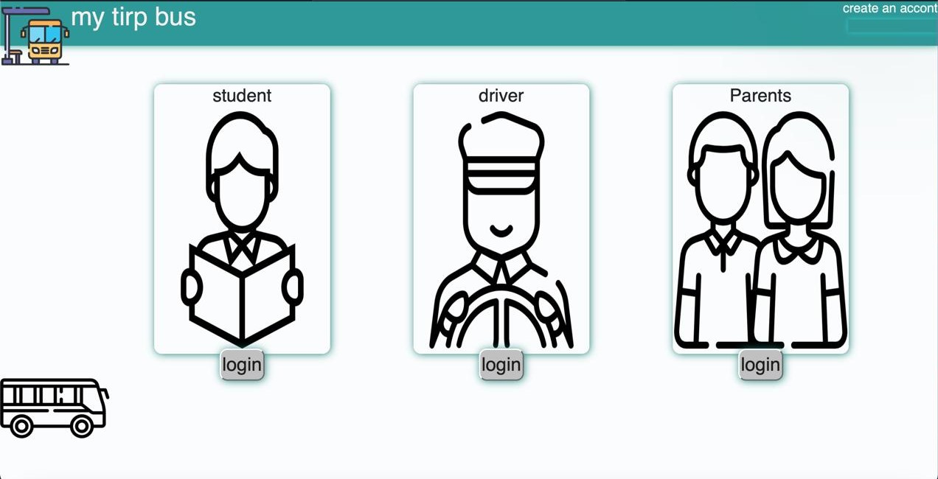The first page of our website is presented in figure 3.1 and it is the section page. The user chooses which section he wants to log in to.

Figure 3.1: Home page

After choosing the nature of the user if he is student or driver or parent, the second page presented in figure 3.2 is shown. This page is the login page where the user enters his registration data.

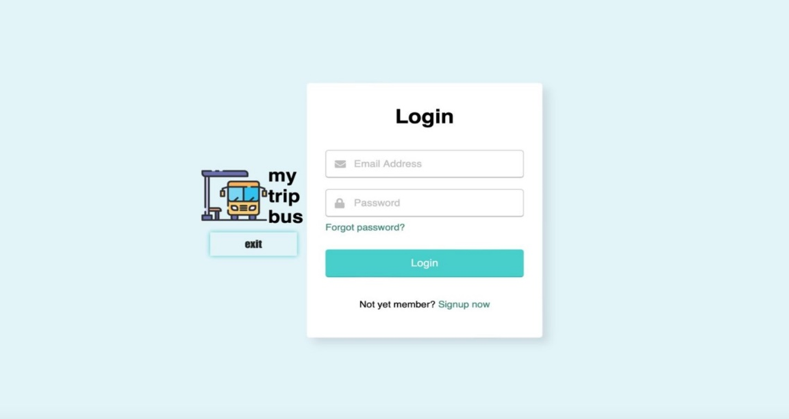

Figure 3.2: Login page

If the user is a new user, the page presented in the figure 3.3 allows the user to create a new account of his own.

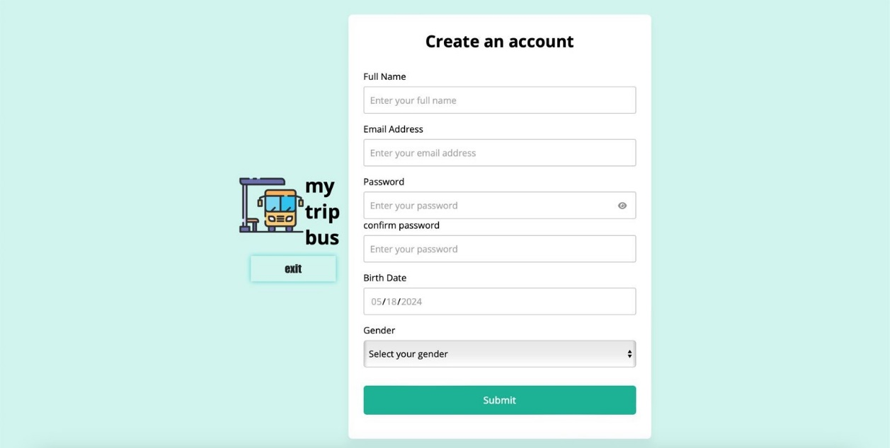

Figure 3.3: Account Creation page.

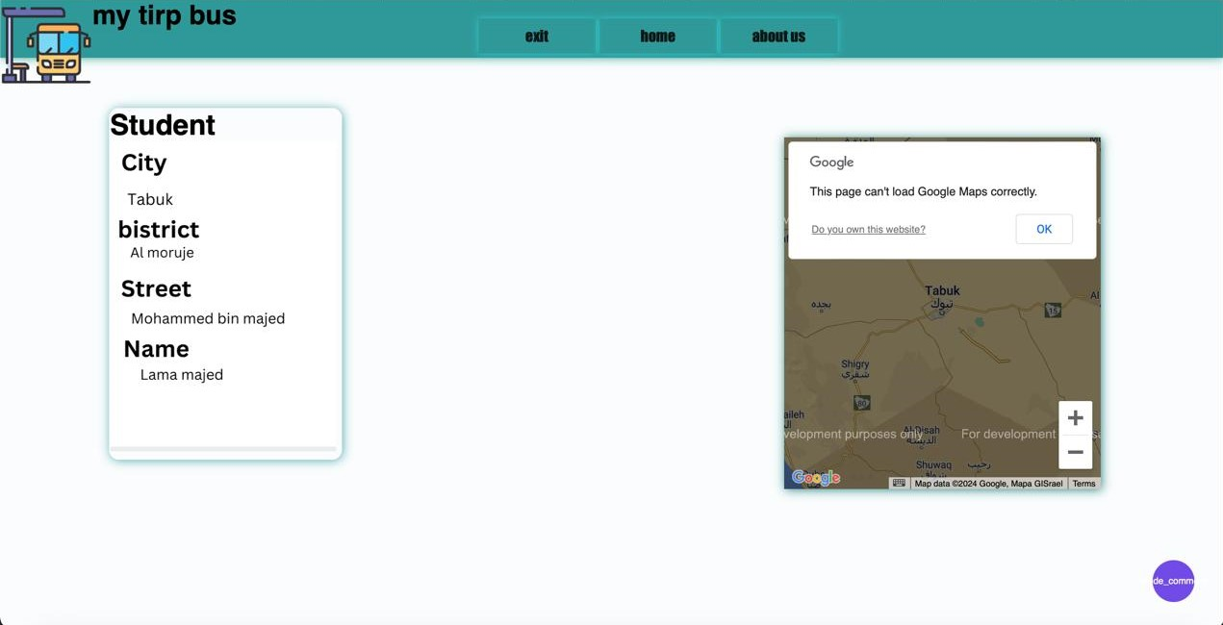If the user is identified as a student, then the page presented in figure 3.4 is shown which is the student's page and contains his personal information. There are fields that allow him to know the location of the bus and chat with the bus driver.

Figure 3.4: Student page

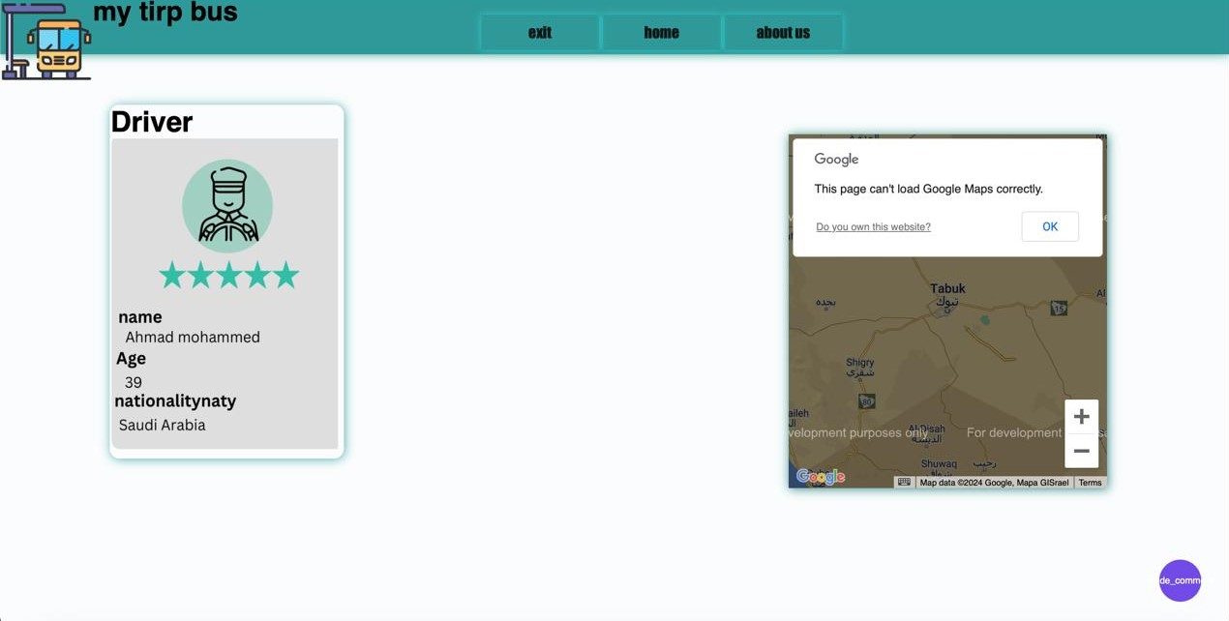If the user is a bus driver, then the page presented in figure 3.5 is shown which is the driver's page. This page contains his information and a map showing him the locations of the students' homes, and there is also a chatting part.

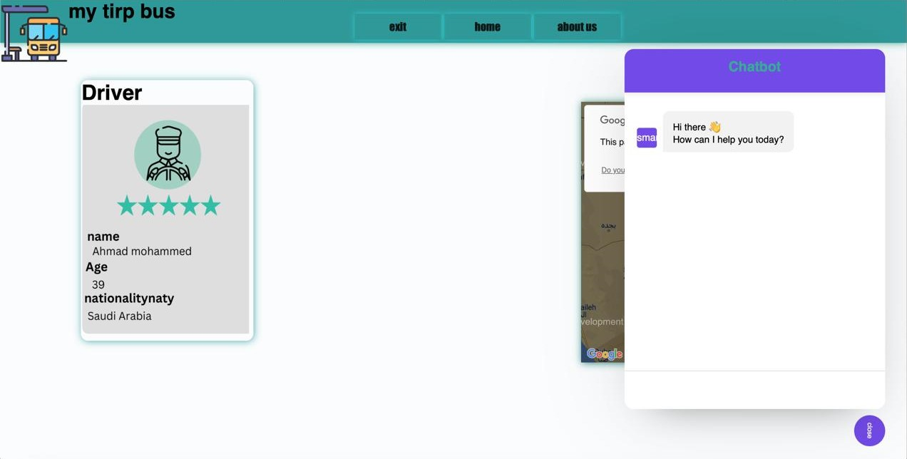

Figure 3.5: Driver page

If the user is a student parent, then the page presented in the figure 3.6 is shown. This page is the home page where student information, bus driver information, location and chat are located.

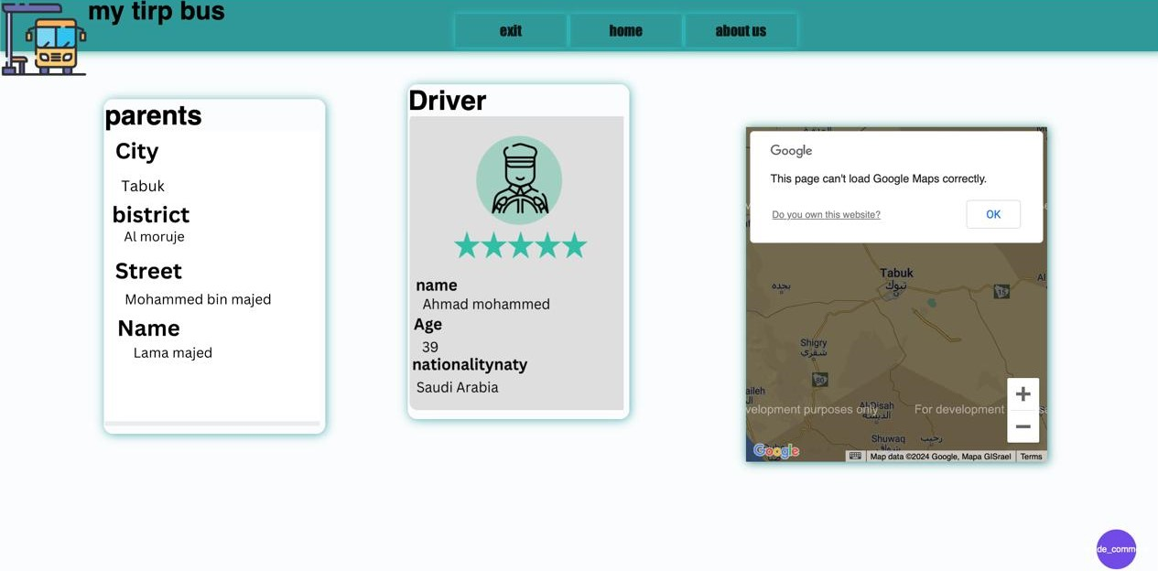

Figure 3.6: Parents page

* System Implementation

Now, we will detail the implementation of the different pages of our website. To obtain the Home page of the website which is presented in figure 3.1, we implement the code shown in figure 3.7 which includes the student, driver, and parent's fields.

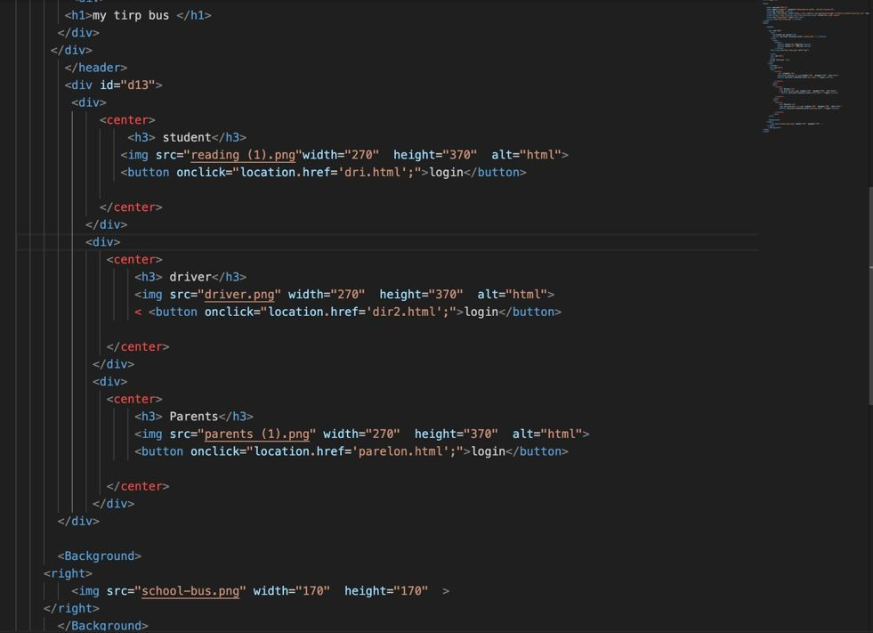

Figure 3.7 Home page Code

The Login page presented in figure 3.2 has the code presented in figure 3.8. This code is for logging into the account, such as name, password, and email, and also includes forgetting the password.

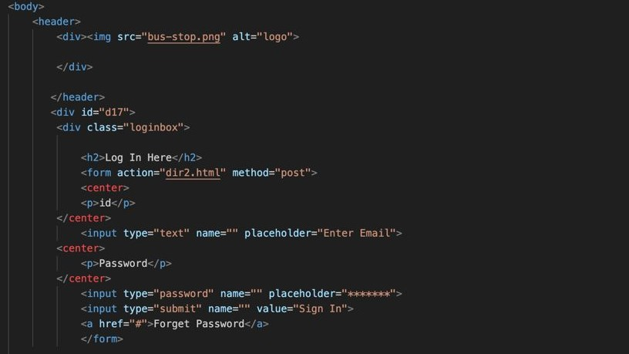

Figure 3.8: Login page Code

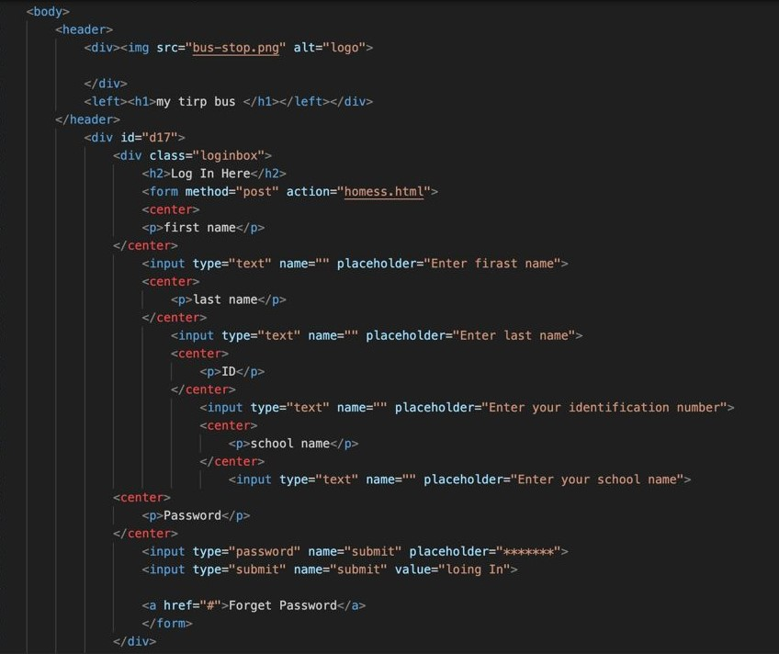To add a new user, we use the code presented in figure 3.9 which allows to the new user to create an account and add his own data to it, such as full name, password, email, etc.

## 

## Figure 3.9: Account Creation page Code

## This is the code for the style sheet shown in Figure 3.10. It contains the colors, formats, fonts, and images found on the website.

Figure 3.10: Style Code

-

1. **Results and Discussion**

In this chapter, we will describe the results of testing conducted by users on our site, as well as document features and improvements that are planned but not yet implemented. This testing is designed to better understand user experience and needs and improve site design and performance based on the feedback collected.

* 1. **User Testing**

To collect the ideas of the users, we have asked some users about our site after trying it out, and the table here after resumes their different answers.

|  |  |  |  |  |
| --- | --- | --- | --- | --- |
| **Q - N** | **The Question** | **First user** | **Second user** | **Third user** |
| **1** | **Did you find the user interface easy to use and well organized?** | **Yes** | **Yes** | **Yes** |
| **2** | **Was the registration or login process easy and smooth?** | **Yes** | **Yes** | **Yes** |
| **3** | **Did you encounter any problems navigating the site or accessing different pages?** | **NO** | **NO** | **NO** |
| **4** | **Did you benefit from any additional features such as tracking buses through the website?** | **Yes** | **Yes** | **Yes** |
| **5** | **Did you find that the service provided through the site adequately meets your needs?** | **Yes** | **Yes** | **Yes** |

Table 4.1. User testing opinions

* 1. **Results and Discussion**

After conducting user tests on the ''My Trip Bus'' website, we came up with several concrete findings and discussions. We have concluded that users expressed their general satisfaction with the site’s interface and ease of navigation. They said that the website is simple, and it has a clear design that make it easier to use for everyone, including students, parents and drivers. By asking the users about performance and speed of the website, they claim that the site was characterized by fast performance and effective response to user actions and there were no technical problems or delays in loading pages, which added to the overall smoothness of the experience. When we demand the users about the functions and features of the website, they confirm that the website's functionality has been very well received, especially those related to tracking buses and providing accurate information about schedules.

IV.3 **Limitation and Future Work**

Nevertheless, there are some improvements that we were hoping to add to the site but have not been able to at this time. We look forward to including some sections and buttons in the future to further improve the user experience.

Some of these sections and buttons are:

* **Time remaining** for bus arrival.
* **Surveillance Camera** allows parents to monitor the bus to ensure the safety of their child.
* **Bus speed monitoring** enables parents to easily monitor the bus speed and ensure their safe arrival. If a parent notices that the speed is high, they can provide an alert to technical support.
* **Emergency** This section allows the driver to immediately notify the relevant authorities in case of a bus malfunction.

IV.4. **Conclusion**

As we conclude our work with My Trip Bus, we are proud of the achievements that we have achieved so far and look forward to the future. Despite the challenges we faced in improving the student transportation experience, we are determined to continue developing the site and adding more features and improvements that better meet the needs of our users. We eagerly look forward to a bright future that combines technology and innovation to improve the student transportation experience and make it smoother and safer. Thank you to everyone who contributed to this project, and we are excited for more successes in the future. We pray to God to accept our efforts and make them sincere for His honorable face, and to bless our project and make it of lasting benefit and success for everyone.

**References**

[1] [Uber - Request a ride - Ratings and Reviews (apple.com)](https://apps.apple.com/us/app/uber-request-a-ride/id368677368?see-all=reviews)

[2]<https://apps.apple.com/us/app/google-maps/id585027354?see-all=reviews>

[3] <https://apps.apple.com/us/app/messages/id1146560473?see-all=reviews>