SEMESTER PROJECT PROPOSAL
Smart Career & Job Portal System
Student Name | Arham Imran
Roll No. | F-24-BSSE-025
Program | BS Software Engineering
Project Type | Individual Project
1. Introduction
Smart Career & Job Portal System is a web-based platform designed to connect job seekers with employers through a centralized system. The proposed system will provide job posting, job searching, job application, CV verification, CV recommendation, and resume-building features in one platform. The aim is to make the recruitment and job-search process more organized and efficient.
2. Problem Statement
Existing job platforms provide several useful recruitment services, but users may need different platforms for job searching, CV creation, CV verification, and recommendations. This can make the process time-consuming and less convenient. The proposed system addresses this problem by integrating these major functions into a single platform.
3. Current Situation and Opportunity Statement
Current Situation: Job seekers may use different platforms for job searching, CV preparation, CV verification, and career-related services. Employers also need tools to post jobs and manage applications.
Opportunity: There is an opportunity to provide a single integrated platform that combines job posting, job application, CV verification, resume creation, and personalized job recommendations.
4. Project Objectives
- Provide a centralized platform for job seekers and employers.
- Allow employers to create and manage job postings.
- Allow job seekers to search and apply for jobs.
- Provide CV upload and verification functionality.
- Recommend suitable jobs according to candidate skills and job requirements.
- Provide a resume/CV maker for users.
- Provide an admin module for managing users, jobs, and applications.
5. Preliminary / Functional Requirements
The following preliminary functional requirements are written as specific and testable system requirements.
ID | Functional Requirement
FR-01 | The system shall allow a registered job seeker to create and update a profile containing education, skills, and experience.
FR-02 | The system shall allow employers to create, edit, and delete job postings.
FR-03 | The system shall allow registered job seekers to search available jobs.
FR-04 | The system shall allow job seekers to apply for available jobs.
FR-05 | The system shall allow users to upload their CVs.
FR-06 | The system shall provide CV verification functionality.
FR-07 | The system shall compare candidate skills with job requirements and display suitable job recommendations.
FR-08 | The system shall allow users to create and update a resume using the resume maker.
FR-09 | The system shall allow employers to view and manage received applications.
FR-10 | The system shall allow administrators to manage users, jobs, applications, and reported content.
6. Non-Functional Requirements
Requirement | Description
NFR-01 Security | Only authenticated users shall access their protected accounts and functions.
NFR-02 Performance | The system should return job-search results within a reasonable response time.
NFR-03 Usability | The user interface should be simple, clear, and user-friendly.
NFR-04 Reliability | User, job, CV, and application data shall be stored consistently.
NFR-05 Maintainability | The system shall use modular components so individual modules can be updated with minimal effect on other modules.
NFR-06 Availability | The system should remain available during normal operating periods.
7. Benchmarking with Existing Systems
The following benchmarking table follows the job-platform benchmarking example provided with the project instructions.
Feature / Aspect | Rozee.pk | LinkedIn | Jobs.pk | Indeed | AcquireJobs.pk | Proposed System
Posting Job | Yes | Yes | Yes | Yes | Yes | Yes
Applying for Job | Yes | No | No | No | Yes | Yes
CV Verification | No | No | No | No | Yes | Yes
CV Recommendation | Yes | Yes | Yes | Yes | Yes | Yes
Resume Maker | Yes | Yes | Yes | Yes | Yes | Yes
Benchmarking Gap: The comparison shows that the existing systems provide different combinations of job posting, applications, CV-related services, recommendations, and resume creation. The proposed system focuses on integrating these functions into one platform so that users do not need to move between separate services for major career and recruitment tasks.
8. Options and Recommendation
Option | Solution | Evaluation
Option 1 | Use existing job platforms | Low development effort, but the project would not provide a new integrated system.
Option 2 | Develop separate systems for job searching, CV services, and recommendations | Provides dedicated functions but increases duplication, maintenance, and integration effort.
Option 3 | Develop one integrated Smart Career & Job Portal | Combines major functions in one platform and directly addresses the identified problem.
Recommended Option: Option 3 is recommended because it integrates job posting, job applications, CV verification, CV recommendation, and resume creation into a single platform.
9. Proposed System Features
Job Seeker Module
- User registration and login
- Profile management
- Job searching
- Job application
- CV upload
- Personalized job recommendations
Employer Module
- Employer registration and login
- Job posting
- Application management
- Candidate shortlisting
CV Module
- CV upload
- CV verification
- CV analysis
- Resume maker
Recommendation Module
- Analyze candidate skills
- Compare skills with job requirements
- Recommend suitable jobs
Admin Module
- Manage users
- Manage jobs
- Monitor applications
- Manage reported content
10. Proposed System Architecture
The proposed system will follow a modular web application structure. Users will interact with the web interface, which communicates with backend services. The backend handles authentication, job management, applications, CV processing, and recommendations, while the database stores user, job, CV, and application information.
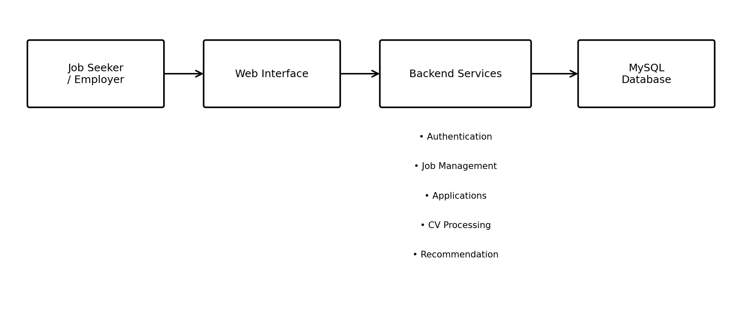
Main modules: Job Module | CV Module | Recommendation Module | Application Module | Admin Module
11. CCP Justification
Complex Analysis: The system requires analysis of candidate skills and job requirements to provide suitable job recommendations.
Conflicting Requirements: Employers and candidates have different requirements, preferences, and expectations that the system must accommodate.
Stakeholder Involvement: Candidates, employers, and administrators interact with the system and have different needs.
Interdependence: Job posting, applications, CV processing, verification, and recommendation modules are interconnected.
Significant Impact: The system aims to improve the efficiency and convenience of job searching and recruitment.
Depth of Knowledge / Technical Complexity: The project requires knowledge of web development, database management, authentication, CV processing, and recommendation techniques.
12. Tools and Technologies
- Frontend: HTML, CSS, JavaScript, Bootstrap
- Backend: Java / Spring Boot
- Database: MySQL
- Development Tools: IntelliJ IDEA or NetBeans, MySQL Workbench
- Version Control: Git / GitHub
- Documentation: Microsoft Word and PowerPoint
13. Project Schedule
Timeline | Task
Week 1 | Requirements gathering and research
Week 2 | System design and database design
Week 3 | Frontend development
Week 4 | Backend development
Week 5 | CV and recommendation modules
Week 6 | System integration
Week 7 | Testing and debugging
Week 8 | Final documentation and presentation
14. Potential Risks and Mitigation
Risk | Mitigation
Incorrect CV analysis | Test the CV module with different CV formats and sample data.
Data security issues | Use authentication, authorization, and secure data handling.
Recommendation errors | Improve matching rules and test recommendations with different profiles.
System errors | Perform regular testing and debugging throughout development.
Time shortage | Follow the planned weekly development schedule.
15. Conclusion
The Smart Career & Job Portal System will provide an integrated platform for job seekers and employers. By combining job posting, job application, CV verification, recommendation, and resume creation features, the proposed system aims to make the recruitment process more efficient and user-friendly. The project addresses multiple CCP characteristics through complex analysis, stakeholder involvement, interdependent modules, conflicting requirements, significant impact, and technical depth.

