January 9, 2018

PROG2370 Section 2

Object Oriented Game Programming

Made by: Ibrahim Qadhmani 7688823

For: Sabbir Ahmed

Shadow of Animus is a side scrolling game. The playing character is a knight who can move forward (to the right) and backward (to the left). Also, he can attack with his sword. He’s in a forest between skeletons and a huge rock. His objective is to kill all of the three enemies to clear the path (triggers end game). If the knight dies before that, then it is a game over.

Parallax scrolling and a decent amount of animation has been used. The skeleton has a basic Artificial Intelligence that is triggered by its own health and how far it is from the knight.

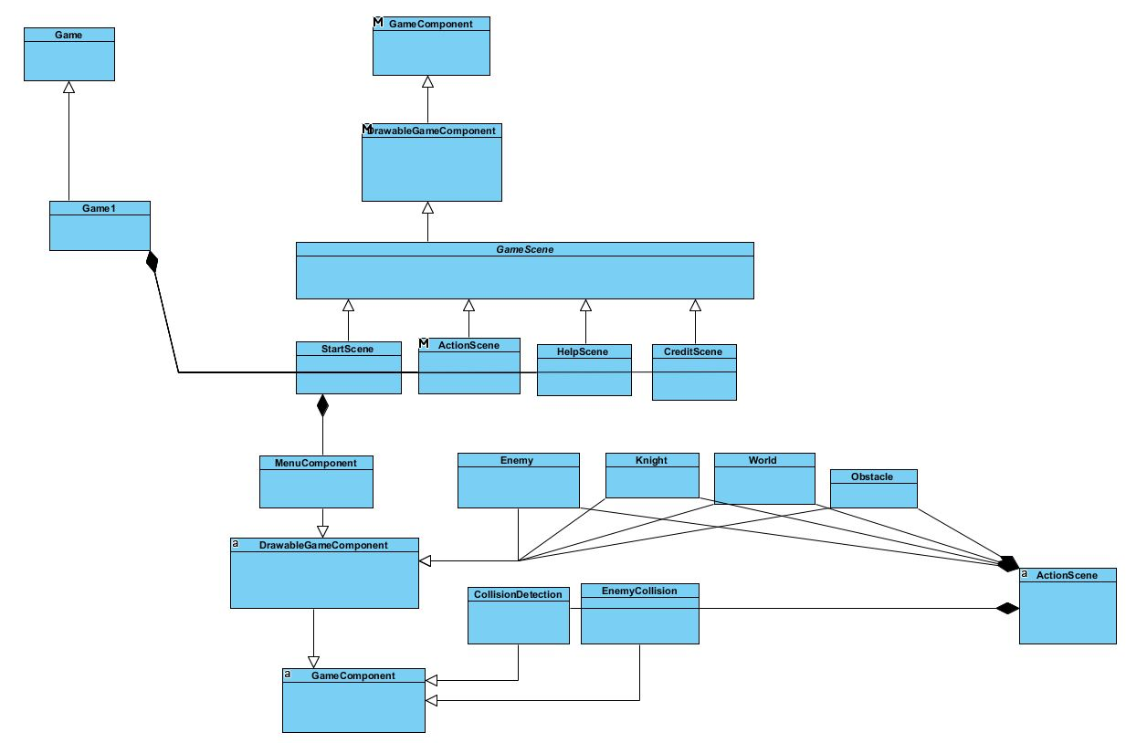

Figure 1: Shadow of Animus Class Diagram

# References

Images

Action_Background (parallax scrolling): <https://edermunizz.itch.io/free-pixel-art-forest>

Knight: <https://lionheart963.itch.io/knight-sprite>

Skeleton: <https://jesse-m.itch.io/skeleton-pack>

Main_Menu_Background: <http://rwby.wikia.com/wiki/File:Bonfire.gif>

Rock: <http://dontstarve.wikia.com/wiki/File:Render_Limpet_Rock.png>

Original Soundtrack

Sono_Chi_no_Sadame: <https://www.youtube.com/watch?v=EWCEBSmZbG0>

Light_of_Nibel: <https://downloads.khinsider.com/game-soundtracks/album/ori-and-the-blind-forest-original-soundtrack>

Sound Effects

axe_swing: <http://www.soundsboom.com>

CURSOL_SELECT: <https://www.reddit.com/r/darksouls/comments/4930vd/request_a_sound_ii/>

footsteps: <http://www.soundsboom.com>

skeleton_walk: <http://www.soundsboom.com>

sword_swing: <http://www.soundsboom.com>