CSE350: Project Demo 1

Group Member 1: | Jubayer Iqbal [24101512]
Group Member 2: | Mehedi Hasan Somoy [24101093]
Group Member 3: | Yeasin Arafat Rabby [24101120]
Table No: | 05
Section: | 4B
Faculty: | - Purbayan Das [PDS]  - Abu Musa Al Ashary [MHY]
Folder | Project

Project Title

4-bit Password Encryption & Verification

Components
Component Name | Quantity
D Flip-Flop (SN74LS74N) | 2x
XNOR (CD4077BE) | 2x
AND (SN74HC08N) | 1x
NOT (SN74HC04N) | 1x
Push Button | 2x
DIP Switch | 1x
Resistors | 6x
LED (Red) | 6x
LED (Green) | 1x

Summary
The 4-Bit Password Encryption and Verification System is a digital logic project designed to securely store and verify a 4-bit password using sequential and combinational logic circuits.

The password is first set through input switches and stored 4 bit in D flip-flops by pressing a STORE push button. During verification, the same input switch is used to enter a password, which is then compared with the stored password using XNOR logic gates. The outputs of the XNOR gates are combined through AND gates to determine whether all four bits match.

If every bit matches, the system activates the Correct LED(GREEN); otherwise, the Wrong LED(RED). The project demonstrates the practical application of digital memory elements, logic gates, and password verification techniques in digital electronic systems.

Circuit Diagram
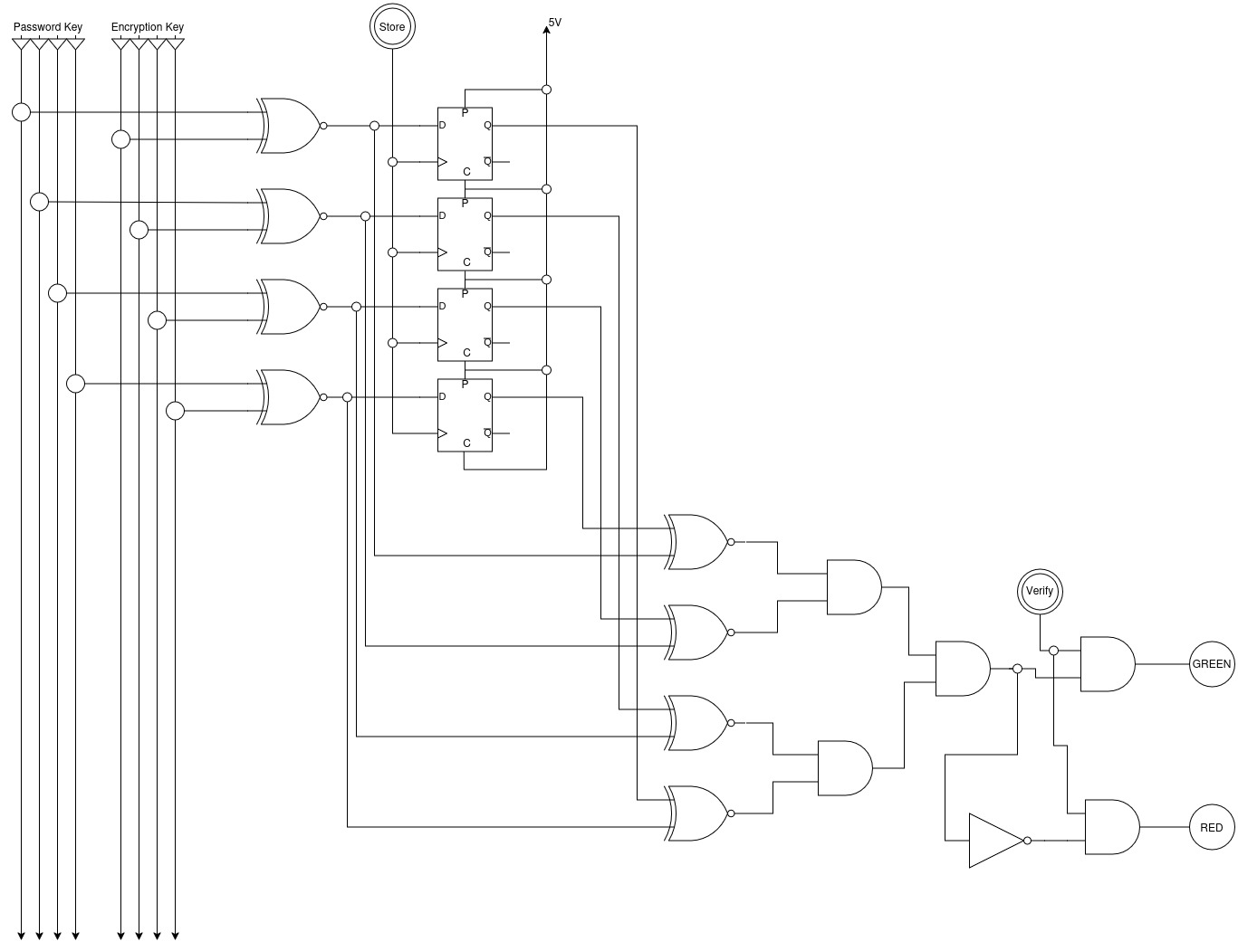

Receipt of ordered components
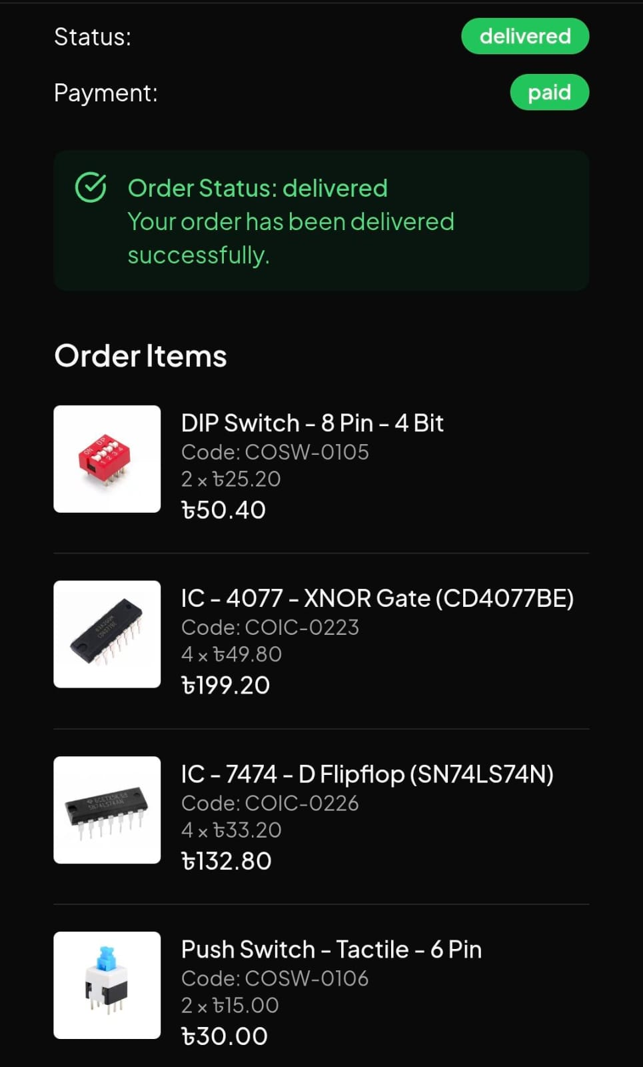

Flow chart
