CSE422: Artificial Intelligence Lab

Project Report
Machine Learning-Based Tree Sterility Classification and Model

Submitted By,

Jubayer Iqbal
ID: 24101512
Section: 16

&

Muhammad Saif Altaf
ID: 24101410
Section: 16

Table of Contents
- Introduction…………………………………………………………………………………….02
- Dataset Description………………………………………………………………………….…02
- Exploratory Data Analysis (EDA) …………………………………………………….………06
- Dataset Cleaning & Preprocessing………………………………………………………....…..10
- Data Splitting…………………………………………………………………………………...11
- Model Training……………………………………………………………..…………………..12
- Model Comparison Analysis………………………………………………….………….……..13
- Conclusion………………………………………………………………………...…………….17

1. Introduction
This project aims to develop machine learning models to classify trees into Sterile and Non-Sterile classes based on their ecological and biological characteristics. The main objective is to investigate whether machine learning can identify patterns in the available features that are associated with tree sterility.

The motivation behind this project is to explore how data-driven techniques can assist in understanding ecological conditions and predicting sterility. Since the dataset contains multiple environmental, biological, and plant-related features, different classification algorithms are applied and compared to determine which model can most effectively distinguish between Sterile and Non-Sterile instances. The project also evaluates the models using metrics such as accuracy, precision, recall, F1-score, AUC, and confusion matrices to obtain a more comprehensive assessment of their performance.

Dataset Description

Overview
Attribute | Value
Total Data Samples | 2783
Total Features | 24
Target Variable | Sterile (Sterile / Non-Sterile)
Problem Type | Binary Classification

We have a tree sterility dataset consisting of a total 2783 data samples and 24 features. Among the target variables “Sterile” seems to be the perfect candidate for being a target variable. And thus, the problem type is a binary classification problem.

Feature Description
Feature | Type | Description / Range
No | Integer (Identifier) | Unique tree identification number (DROPPED)
Plot | Integer | Plot number | Range: 1 - 18
Subplot | Categorical | Subplot under each plot | Labels: A, B, C, D, E
Species | Categorical | Tree Species: Acer saccharum, Quercus alba ,Quercus rubra, Prunus serotina
Light_ISF | Numerical | Light-related environmental measurement: Continuous Values
Light_Cat | Categorical | Light Category: High, Med, Low (DROPPED)
Core | Integer | When the core is collected
Soil | Categorical | Soil Type: Prunus serotina, Quercus rubra, Acer rubrum, Populus grandidentata, Sterile, Acer saccharum, Quercus alba (DROPPED)
Adult | Categorical | Adult tree indicator (DROPPED)
Sterile | Categorical  (Target Variable) | Sterility: Sterile / Non-Sterile
Conspecific | Categorical | Conspecific Relationship (DROPPED)
Myco | Categorical | Mycorrhiza Type: AMF / EMF
SoilMyco | Categorical | Soil Mycorrhiza Type: AMF / EMF / Sterile (DROPPED)
PlantDate | Date | PlantDate (DROPPED)
AMF | Numerical | Arbuscular Mycorrhizal Fungi
EMF | Numerical | Ectomycorrhizal Fungi (DROPPED)
Phenolics | Numerical | Phenolic Compounds Concentration
Lignin | Numerical | Soil Lignin Concentration
NSC | Numerical | Non-Structural Carbohydrates Concentration
Census | Integer | Census Number (DROPPED)
Time | Numerical | Time: Number of days elapsed since the tree was planted.
Event | Binary | Event Indicator (0 / 1)
Harvest | Categorical | Harvest Flag (DROPPED)
Alive | Categorical | Alive Flag (DROPPED)

In the dataset we have 24 features among which 10 features are qualitative and 24 features are quantitative. Later 11 features will be dropped from the dataset during the cleaning process based on exploratory data analysis.

Problem Type
The problem is a binary classification problem. The target variable, Sterile, has exactly two classes: Sterile and Non-Sterile. The goal is to classify whether a tree is sterile or non-sterile based on the given input features.

Encoding Categorical Variables
The categorical variables must be encoded because ML models require numerical inputs. The categorical features will be encoded into numerical representations using Scikit-learn. Label encoding will be used for categorical variables where the categories can be represented appropriately by integer values. One hot encoding and ordinal encoding will be used for categorical variables where the categories are nominal and ordinal encoding.

Class Imbalance
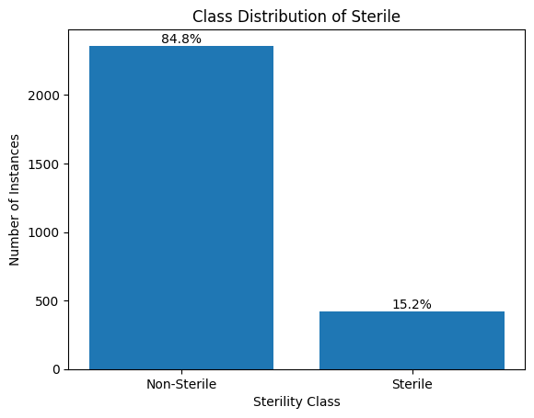
The dataset is actually highly imbalanced (84.8% Non-Sterile and 15.2% Sterile). To address this problem we will be using—
- Stratified splitting to maintain the splitting ratio
- class_weight=balanced during model training if applicable

Correlation Analysis
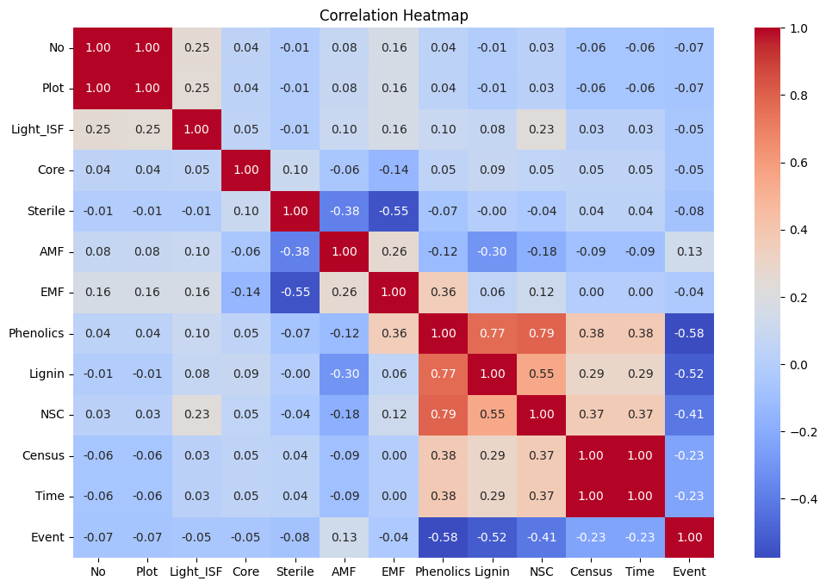
Pearson Correlation Heatmap
From the heatmap above we can see that some important relationships that should be examined—
- Census and Time have a perfect positive correlation, which should be investigated to see if both census and time represents the same thing.
- Phenolics has a high correlation with both Lignin and Phenolics
- NSC has a moderate positive correlation with Lignin
- Event has moderate negative correlation with Phenolics, Lignin, NSC
- Sterile, our target variable, has no linear correlation with lignin. But it could have a non-linear relationship.
- Sterile has a moderate negative correlation with EMF and AMF.

Exploratory Data Analysis (EDA)

Inspecting Missing Values
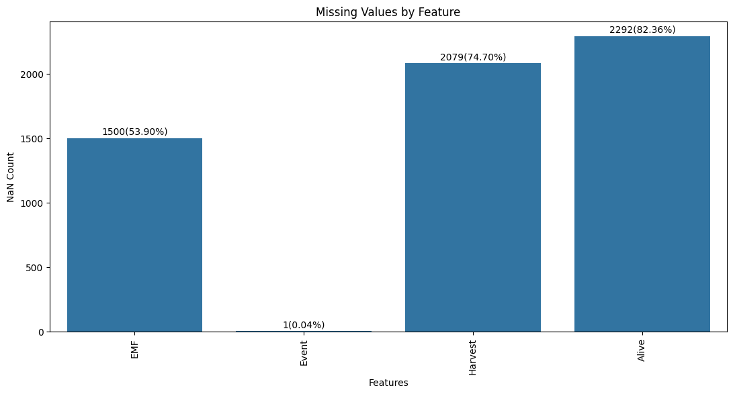
Number of Missing Value vs Features

Investigating Time vs Census
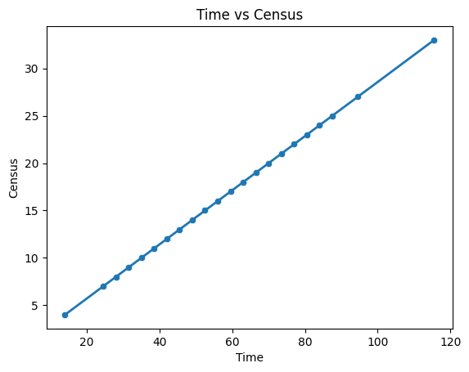
Census vs Time
Census and Time showed a perfect positive correlation (r = 1.00). Further investigation using a scatter plot revealed a perfect linear relationship between the two features. An additional check confirmed that Time is exactly 3.5 times Census for every observation, indicating a deterministic relationship. Therefore, Census was removed as a redundant feature, while Time was retained because it provides a more interpretable representation of elapsed time.

Inspecting Outlier
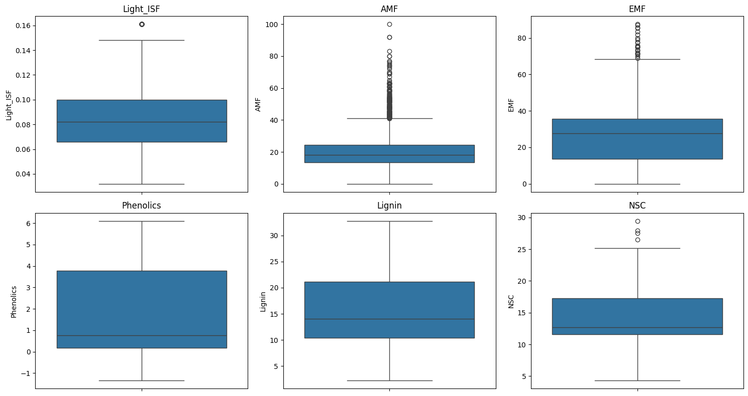
BoxPlot for Numerical Features

Feature | Outliers
Light_ISF | 44
AMF | 180
EMF | 25
NSC | 4

The outliers results are summarized in the table above, which shows the number of potential outliers identified for each affected numerical feature. Among these features, AMF contained the highest number of potential outliers. After some further investigation, no clear evidence of data-entry or measurement errors was found. Therefore, the potential outliers were retained to avoid removing potentially meaningful observations from the dataset.

Unique Value Analysis of Categorical Features

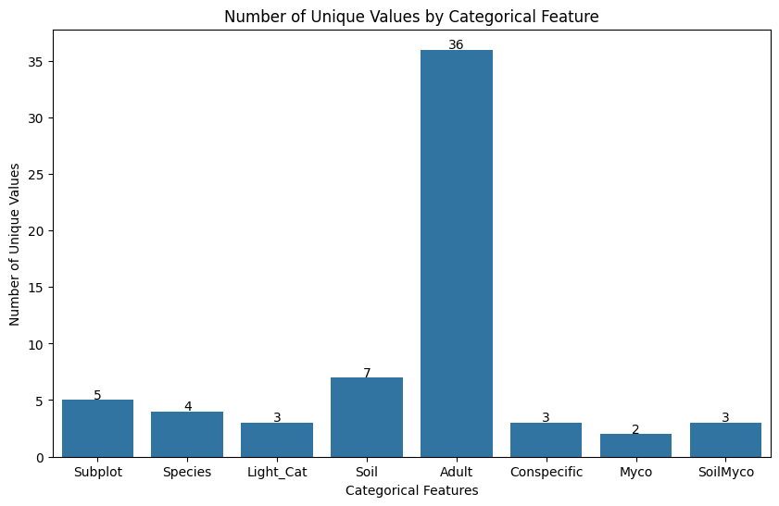
Number of Unique Values by Categorical Feature

The number of unique values was examined for each categorical feature to identify features with potentially high cardinality or unusual value representations. The Adult feature contained 36 unique values, including numeric-looking codes and alphabetic codes such as G, H, I, and J. These values appear to represent identifiers or codes rather than meaningful categorical measurements. Encoding such values as ordinary categories would introduce many additional features without providing clear predictive meaning.

Relationship between Sterility and Soil, Conspecific, and SoilMyco
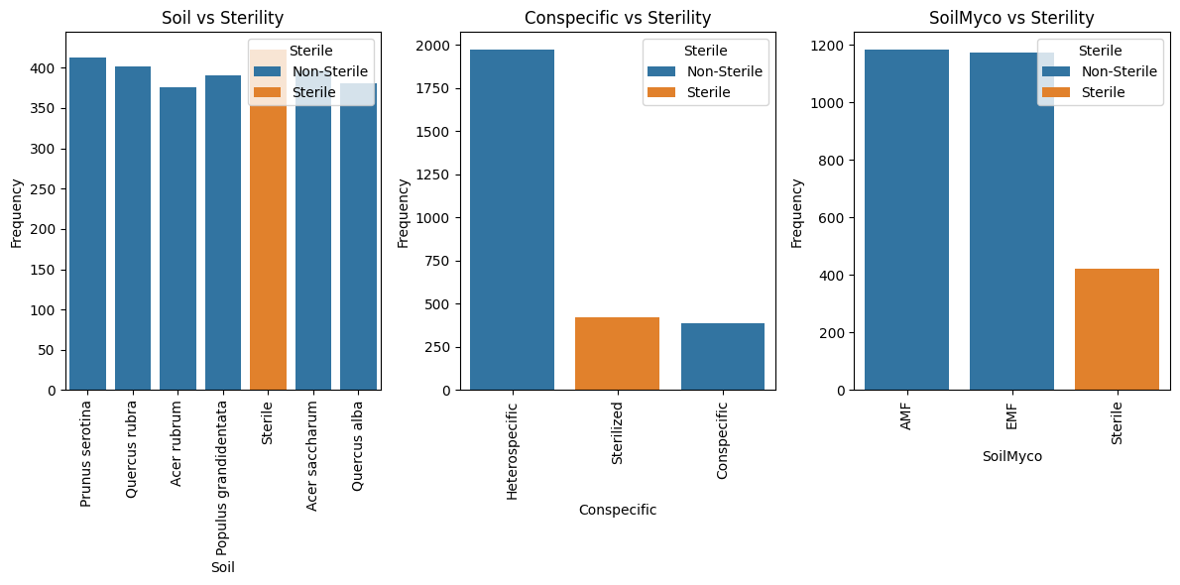
Soil, Conspecific, and SoilMyco are potentially leaking data. These features contain information that is closely associated with the target variable and may provide the model with information that would not be available at prediction time.

Relationship between Light_Cat and Light_ISF
 | Light_ISF
Light_Cat | count | mean | std | min | 25% | 50% | 75% | max
High | 304.0 | 0.137507 | 0.011996 | 0.122 | 0.133 | 0.138 | 0.141 | 0.161
Low | 1005.0 | 0.060985 | 0.010094 | 0.032 | 0.055 | 0.061 | 0.068 | 0.075
Med | 1474.0 | 0.091879 | 0.011553 | 0.076 | 0.082 | 0.087 | 0.103 | 0.118

The descriptive statistics showed a strong relationship between Light_ISF and Light_Cat, as the categories generally corresponded to distinct ranges of Light_ISF. However, the exact categorization thresholds could not be established from the available data.

Dataset Cleaning & Preprocessing

Handling null / missing values
Feature | Missing values | Decision | Reason
Alive | 84% | Dropped | Very high missing value makes reliable imputation difficult
Harvest | 75% | Dropped | Very high missing value makes reliable imputation difficult
EMF | 54% | Dropped | Large proportion of missing values; although related to Myco and Sterile, there was insufficient information for reliable imputation.
Event | 1 value | Mode Imputed | Missingness is negligible, so mode imputation is appropriate.

Handling Irrelevant / High-Cardinality values
Feature | Decision | Reason
No | Dropped | Irrelevant identifier; it does not provide meaningful predictive information.
Adult | Dropped | High cardinality and inconsistent representation, making it unsuitable as a categorical feature.
PlantDate | Dropped | Stored as a date string and not directly suitable for encoding
Census | Dropped | Redundant with Time because it has a perfect linear relationship with Time. The same information can therefore be represented using Time alone.

Handling Data Leakage
Feature | Decision | Reason
Soil | Dropped | Strongly associated with the target variable; the value “Sterile” can directly reveal the Sterile class, creating potential target leakage.
SoilMyco | Dropped | Strongly associated with the target variable; the value “Sterile” can directly reveal the Sterile class, creating potential target leakage.
Conspecific | Dropped | Strongly associated with the target variable; the value “Sterilized” can directly reveal the Sterile class, creating potential target leakage.

Encoding Categorical Variables
Feature | Type | Encoding Type
Subplot | Nominal | One Hot Encoding
Species | Nominal | One Hot Encoding
Sterile (Target) | Binary | Binary Encoding
Myco | Nominal / Binary | One Hot Encoding
Light_Cat | Ordinal | Ordinal Encoding

Feature Scaling
Feature scaling was applied to numerical features to ensure that variables with larger numerical ranges did not disproportionately influence the machine learning models. This was particularly important for KNN as they are sensitive to feature magnitudes and distances.
StandardScaler was used for feature scaling after performing the train-test split. The scaler was fitted only on the training data to learn the mean and standard deviation of each feature. These learned parameters were then used to transform both the training and testing data. After standardization, each feature in the training data has a mean approximately equal to 0 and a standard deviation approximately equal to 1.

Data Splitting
Since the target variable, Sterile, was highly imbalanced, stratified splitting was used to divide the dataset into training and testing sets. The dataset contained approximately 84.8% Non-Sterile and 15.2% Sterile observations. Stratification ensured that both the training and testing sets maintained approximately the same class distribution as the original dataset. This provides a more representative test set and helps produce a more reliable evaluation of the classification models.

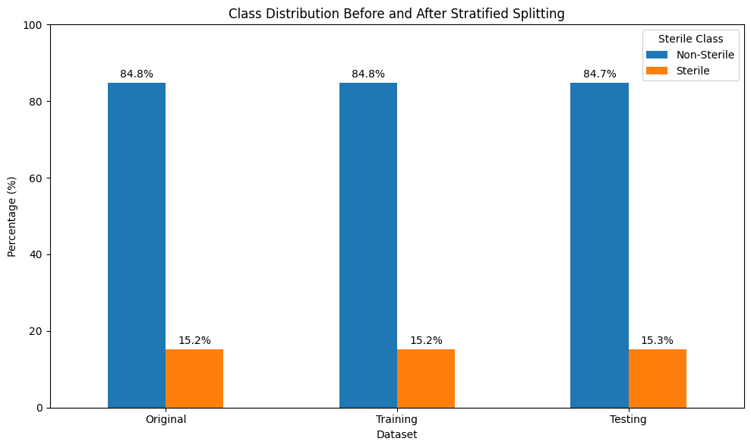

Model Training
Model Name | Type | Hyper Parameter
Logistic Regression | Supervised | max_iter=1000  class_weight="balanced"  random_state=42
KNN | Supervised | n_neighbors=5
Naive Bayes | Supervised | None
Neural Network | Supervised | hidden_layer_sizes=(32, 16)  max_iter=1000  random_state=42  early_stopping=True  alpha=0.001
K-means | Unsupervised | n_clusters=2  random_state=42  n_init=10

Unsupervised Learning — K-Means
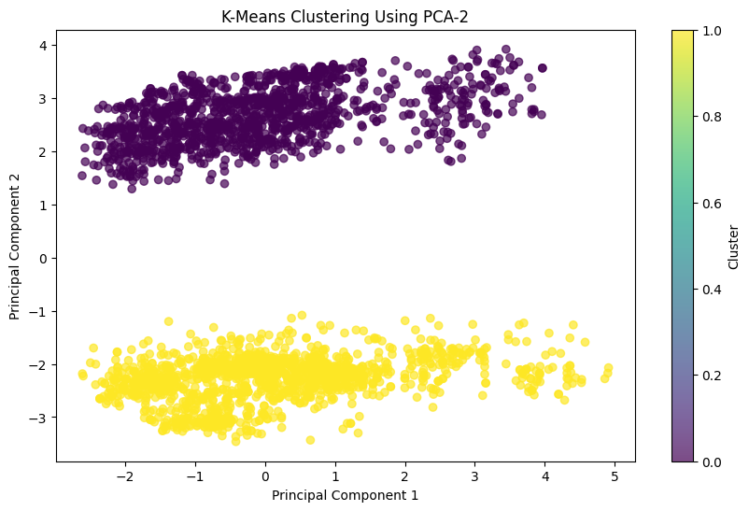
K-Means identified two distinct clusters in the PCA-reduced feature space. However, comparison with the actual Sterile labels showed that both clusters contained similar proportions of sterile and non-sterile samples. Therefore, the discovered clusters do not strongly correspond to the target variable.

Model Comparison Analysis

Model | Accuracy | Precision | Recall | F1 Score
Logistic Regression | 0.910233 | 0.64 | 0.941176 | 0.761905
KNN | 0.859964 | 0.620690 | 0.211765 | 0.315789
Naive Bayes | 0.868941 | 0.676471 | 0.270588 | 0.386555
Neural Network | 0.915619 | 0.839286 | 0.552941 | 0.666667

Accuracy Bar Chart and Precision - Recall Comparison
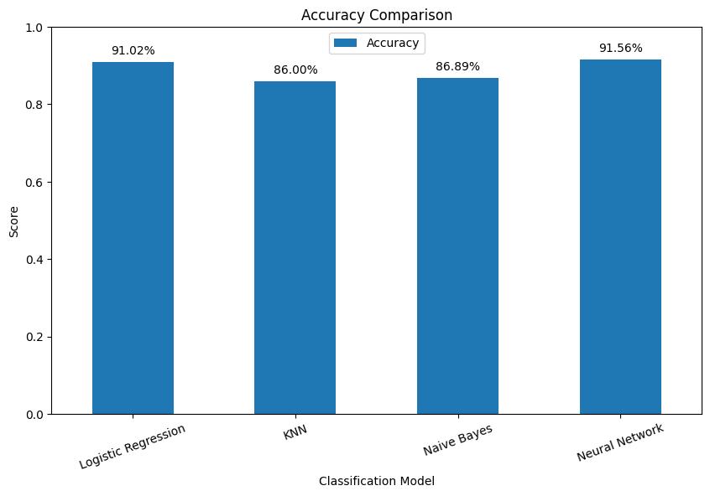
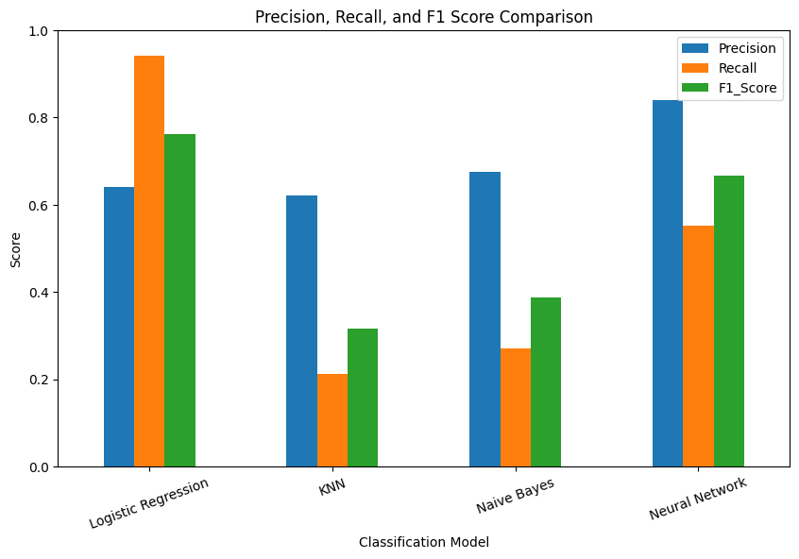
From the accuracy comparison bar chart, it can be observed that the Neural Network achieved the highest accuracy of 91.56%, followed by Logistic Regression with an accuracy of 91.02%. Naive Bayes and KNN achieved lower accuracy compared with the other models. However, since the dataset is highly imbalanced, with 84.8% Non-Sterile and only 15.2% Sterile instances, accuracy alone is not a reliable metric for selecting the best model.

From the above results, we can observe that the Neural Network achieved the highest precision of 88%. This means that, among all the instances predicted as Sterile by the Neural Network, approximately 88% were actually Sterile. On the other hand, Logistic Regression achieved the highest recall of 94%, meaning that among all the actual Sterile instances in the test set, the Logistic Regression model correctly identified approximately 94% of them. Since the dataset is highly imbalanced, both precision and recall are important. Overall, the Neural Network provides a better balance between precision and recall, while Logistic Regression is preferable when minimizing missed sterile instances is the primary objective.
From the F1-score comparison, Logistic Regression achieved the highest F1-score of 76.19%, followed by the Neural Network with an F1-score of 66.67%. This indicates that Logistic Regression provides the best balance between precision and recall among the evaluated models. Although the Neural Network achieved higher precision (83.93%) than Logistic Regression (64.00%), its lower recall (55.29%) resulted in a lower F1-score.
KNN and Naive Bayes achieved considerably lower F1-scores of 31.58% and 38.66%, respectively, indicating weaker performance in identifying the Sterile class.
Therefore, based on the F1-score, Logistic Regression is the best-performing model for balancing the identification of Sterile instances with the accuracy of its Sterile predictions.

Confusion Matrix
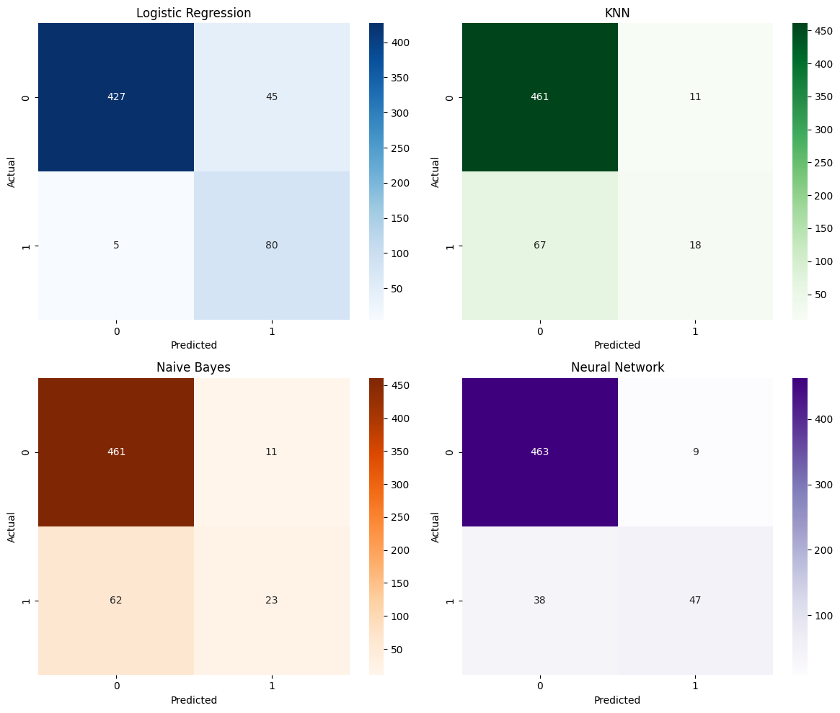
For Logistic Regression, the model correctly classified 427 Non-Sterile instances and 80 Sterile instances. It incorrectly classified 45 Non-Sterile instances as Sterile and only 5 Sterile instances as Non-Sterile. The small number of false negatives indicates that Logistic Regression was highly effective at detecting Sterile instances, resulting in a recall of 94.12% for the Sterile class.
In contrast, the Neural Network correctly classified 463 Non-Sterile instances and 47 Sterile instances. It produced only 9 false positives, but incorrectly classified 38 Sterile instances as Non-Sterile. Therefore, although the Neural Network made fewer false-positive predictions than Logistic Regression, it missed considerably more actual Sterile instances, resulting in a lower recall of 55.29%.
Overall, Logistic Regression is better at detecting Sterile instances, as demonstrated by its much higher number of true positives and substantially fewer false negatives. The Neural Network is more conservative in predicting the Sterile class, leading to fewer false positives but also more missed Sterile cases. This difference is consistent with their precision-recall results: the Neural Network has higher precision (83.93%), whereas Logistic Regression has substantially higher recall (94.12%).

ROC Curve and AUC Comparison

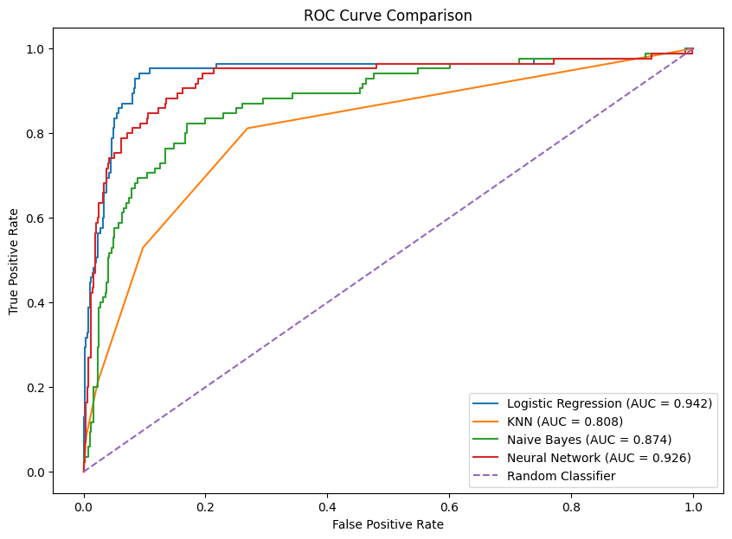

Model | AUC
Logistic Regression | 0.941974
KNN | 0.807665
Naive Bayes | 0.873554
Neural Network | 0.925523
From the AUC comparison, Logistic Regression achieved the highest AUC of 0.942, followed by the Neural Network with 0.926, Naive Bayes with 0.874, and KNN with 0.808. A higher AUC indicates a stronger ability to distinguish between the Sterile and Non-Sterile classes across different classification thresholds. Therefore, Logistic Regression demonstrates the best overall class-discrimination ability among the evaluated models.
Although the Neural Network achieved competitive accuracy and higher precision, its lower AUC and lower recall indicate that it is less effective than Logistic Regression at identifying sterile instances across classification thresholds.

Conclusion
From the experimental results, it can be concluded that the evaluated classification models performed differently in identifying Sterile and Non-Sterile instances. Since the dataset is highly imbalanced, with Non-Sterile instances forming the majority class, accuracy alone was not sufficient to determine the best model. Therefore, precision, recall, F1-score, AUC, and confusion matrices were also considered.

Among the models, Logistic Regression performed best for detecting the Sterile class, achieving 91.02% accuracy, 94.12% recall, 76.19% F1-score, and 0.942 AUC. It correctly identified 80 Sterile instances with only 5 false negatives, although it produced 45 false positives. The Neural Network achieved slightly higher accuracy (91.56%) and precision (83.93%), but its recall was lower (55.29%), with 38 Sterile instances missed. Its AUC was 0.926. KNN and Naive Bayes performed less effectively, particularly in recall, with 21.18% and 27.06%, respectively. Overall, Logistic Regression was the most effective model for identifying Sterile instances.
The observed results can be explained partly by the class imbalance in the dataset. Because Non-Sterile instances are much more common than Sterile instances, models can achieve relatively high accuracy while still failing to identify many Sterile cases. The use of class_weight="balanced" in Logistic Regression helped give greater importance to the minority class, which likely contributed to its high recall. Feature scaling was also important, particularly for distance-based methods such as KNN and for the Neural Network, because the original features were measured on different scales.

Several challenges were encountered during the project. Firstly, the dataset was highly imbalanced between Sterile and Non-Sterile classes, which made accurate classification of the minority class more difficult. Secondly, the dataset contained a substantial amount of missing data. The Alive and Harvest features had more than 70% missing values, while EMF had approximately 53% missing values. Although EMF showed a moderate negative correlation with the target variable, the high proportion of missing values made reliable imputation difficult without sufficient information. Moreover, Soil, SoilMyco, and Conspecific were identified as potential data leakage features, as they could provide information strongly associated with the target and artificially improve model performance. Therefore, these features were removed to obtain a more reliable evaluation.

Overall, based on the evaluated metrics, Logistic Regression is the most suitable model for this dataset when the primary objective is to identify Sterile instances, because it achieved the highest recall, F1-score, and AUC while producing very few false negatives. The Neural Network is also a strong model, particularly when precision is more important. However, model selection should ultimately depend on the practical objective: if missing a Sterile instance is more costly than incorrectly flagging a Non-Sterile instance, Logistic Regression would be the preferable choice.

