5 files:
Computer.jpg
Dog.jpg
Ocean.jpg
Rubiks.jpg
Solitaire.exe

File name | Tools | Commnd | Picture | Description
computer.jpg | Hexeditor | Hexeditor. Computer.jpg | 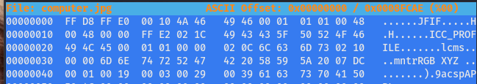 | ICC_PROFILE
dog.jpg | Binwalk | binwalk dog.jpg  Binwalk -e dog.jpg | 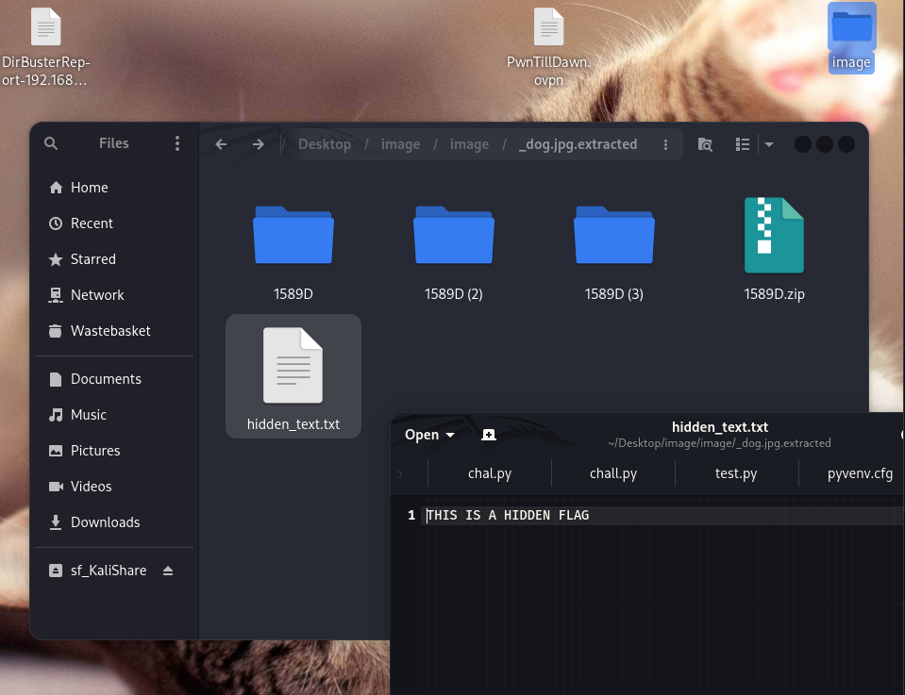 | Run the command in Terminal. Then, open the extracted file and we can see the flag file there
ocean.jpg | Exiftool | exiftool ocean.jpg | 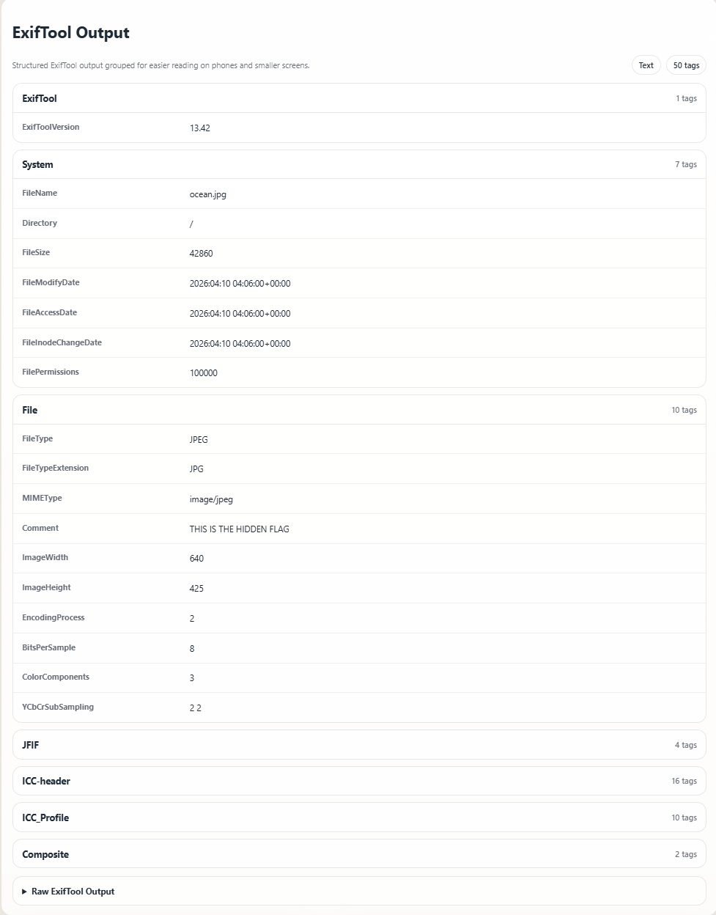 | THIS IS HIDDEN FLAG
rubiks.jpg | File | file rubiks.jpg | 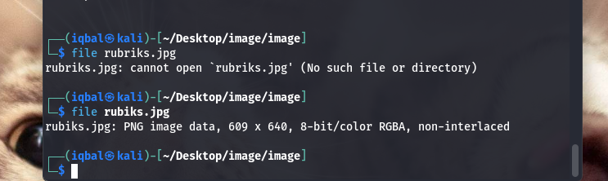 | This file is not a jpg file, it is png
solitaire.exe | File | File solitaire.exe | 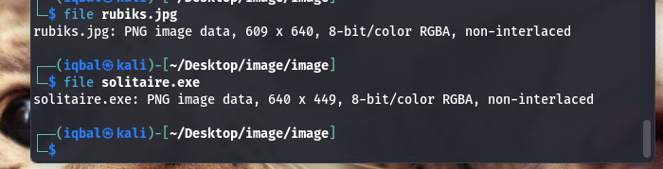 | This .exe file is actually a png

