WEEK 3 TASK REPORT
Advanced Data Analysis and Visualization in Logistics
Yuva Intern — Logistics Data Analytics Internship
Prepared by: Intern | Dataset: Hypothetical, 120 shipments | Tools: Python, pandas, NumPy, Matplotlib

1. Executive Summary
This report demonstrates an end-to-end exploratory analysis of a simulated logistics dataset containing 120 shipments. The dataset records region, transport mode, distance, shipment volume, delivery time, transport cost, and delivery status. The average delivery time is 2.77 days (median 2.80 days), while average transport cost is ₹1,718.26 per shipment. 45.0% of shipments are classified as on time and 19.2% are classified as delayed. Visualizations are used to examine distributions, compare transport modes, and explore relationships between distance, volume, delivery time, and cost. The results are illustrative because the data is synthetic; they should not be treated as actual company performance.

2. Objectives and Scope
- Define a hypothetical logistics dataset and document its variables.
- Perform exploratory data analysis (EDA) using Python.
- Calculate central tendency, distribution summaries, and correlations.
- Create multiple visualizations to show trends, distributions, and relationships.
- Explain why each chart type is suitable and interpret what it shows.
- Identify potential operational bottlenecks, cost drivers, and practical recommendations.
- Document the methodology, code examples, findings, and limitations in a Word document.

3. Dataset Design and Data Dictionary
A reproducible hypothetical dataset of 120 shipment records was generated for this exercise. It is designed to resemble a small logistics operation, not to represent real transactions. Each row represents one shipment.
Variable | Description | Type / Unit
Shipment_ID | Unique shipment reference, e.g., SH001 | Text
Region | Destination/operating region: North, South, East, or West | Category
Transport_Mode | Road, Rail, or Air | Category
Distance_km | Approximate shipment distance | Kilometres
Shipment_Volume_units | Number of units in the shipment | Units
Delivery_Time_days | Elapsed time from dispatch to delivery | Days
Transport_Cost_INR | Estimated transportation cost per shipment | INR (₹)
Delivery_Status | On time, Slight delay, or Delayed, derived from delivery time | Category

4. Methodology and Data Quality Checks
- Generated the dataset with a fixed random seed so the analysis can be reproduced.
- Checked row count, column names, data types, missing values, and duplicate shipment IDs.
- Confirmed numeric variables are stored as numbers and categorical variables use consistent labels.
- Calculated descriptive statistics using pandas, with sample standard deviation for delivery time.
- Used Pearson correlation to measure linear association between numeric variables.
- Created charts using Matplotlib and interpreted the visual patterns alongside summary statistics.
Data-quality check result: 120 rows and 8 columns; 0 missing cells; 0 duplicate shipment IDs. Delivery status is derived from delivery time for this exercise: On time ≤ 2.5 days; Slight delay > 2.5 and ≤ 4 days; Delayed > 4 days.

5. Exploratory Data Analysis (EDA)

5.1 Key descriptive statistics
Metric | Result
Number of shipments | 120
Average distance | 423.8 km
Average shipment volume | 133.8 units
Average delivery time | 2.77 days
Median delivery time | 2.80 days
Delivery-time standard deviation | 1.53 days
Average transport cost | ₹1,718.26
Median transport cost | ₹1,730.23
Total simulated transport cost | ₹206,190.85
On-time share | 45.0%
Delayed share | 19.2%

5.2 Delivery status distribution
Status counts are: 54 on time, 43 slightly delayed, and 23 delayed. This breakdown helps operations teams distinguish routine variation from more serious delays. The thresholds are defined for this simulation and would need to be replaced by the organization's service-level agreement (SLA) in a real project.
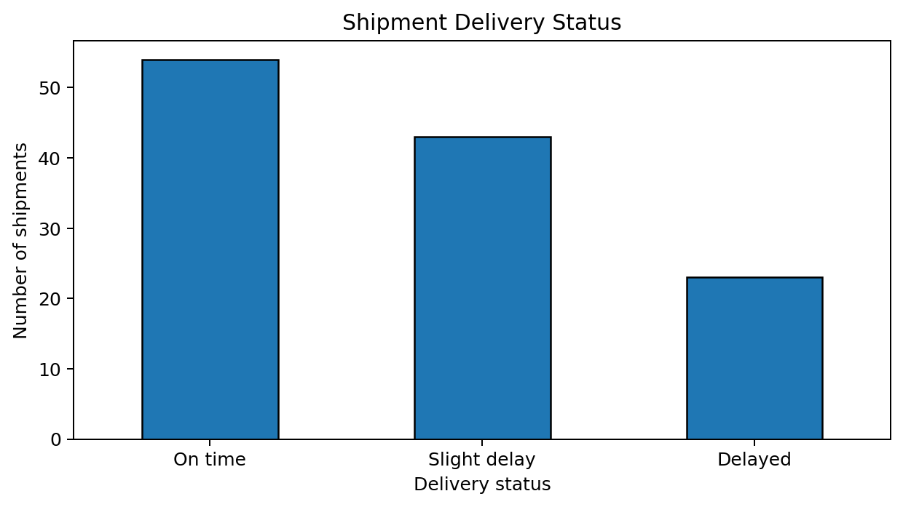
Figure 1. Shipment counts by delivery status.

5.3 Delivery-time distribution
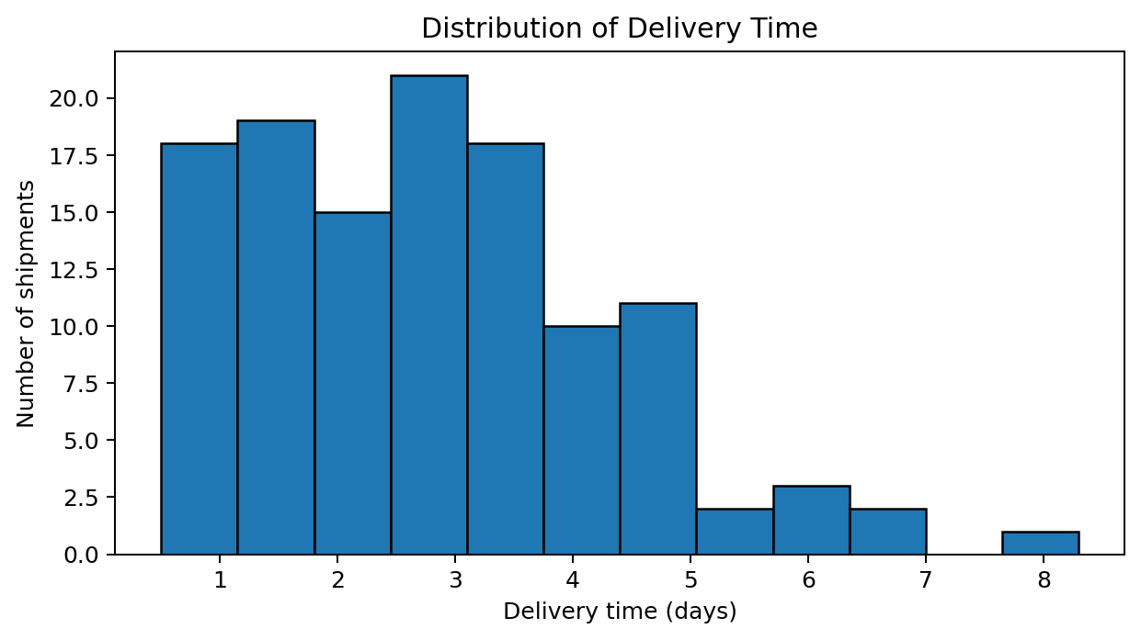
The histogram shows how delivery times are spread across shipments. The mean (2.77 days) and median (2.80 days) can be compared to judge whether a small number of long deliveries pull the average upward. Wide spread or a long right tail would signal inconsistent service and justify investigating individual delayed shipments.

5.4 Performance by transport mode
Mode | Shipments | Avg. delivery (days) | Avg. cost (₹) | Avg. distance (km)
Road | 84 | 2.79 | ₹1,651.44 | 415.1
Rail | 22 | 3.70 | ₹1,620.52 | 479.7
Air | 14 | 1.21 | ₹2,272.75 | 388.0
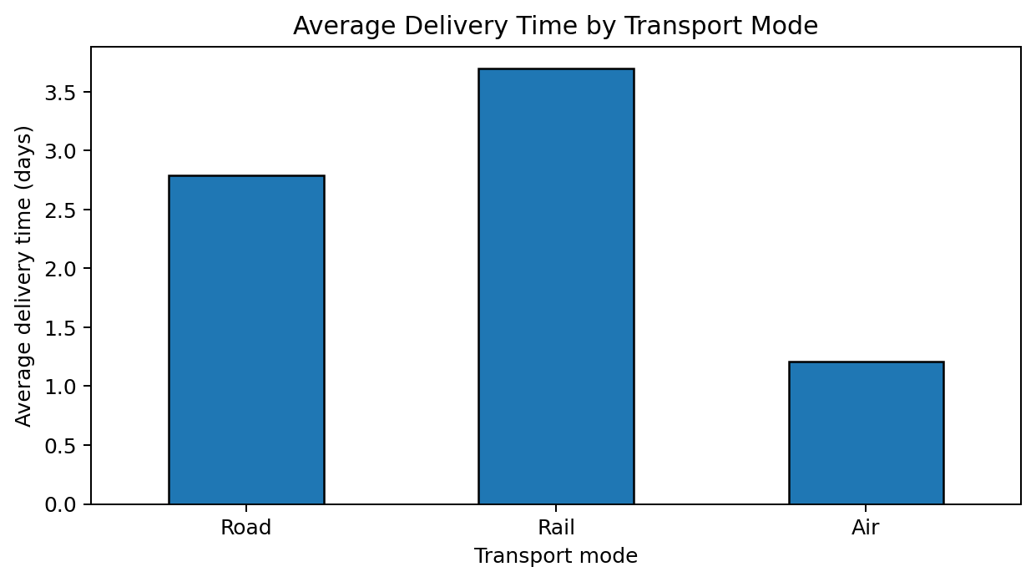
The bar chart compares mean delivery time across modes. The quickest mode is not automatically the best choice: mode-level averages should be considered alongside cost, distance, shipment type, and service requirements. Because mode assignment was simulated rather than randomized under controlled conditions, the chart describes this sample and does not prove that mode alone caused the difference.

5.5 Cost drivers and correlations
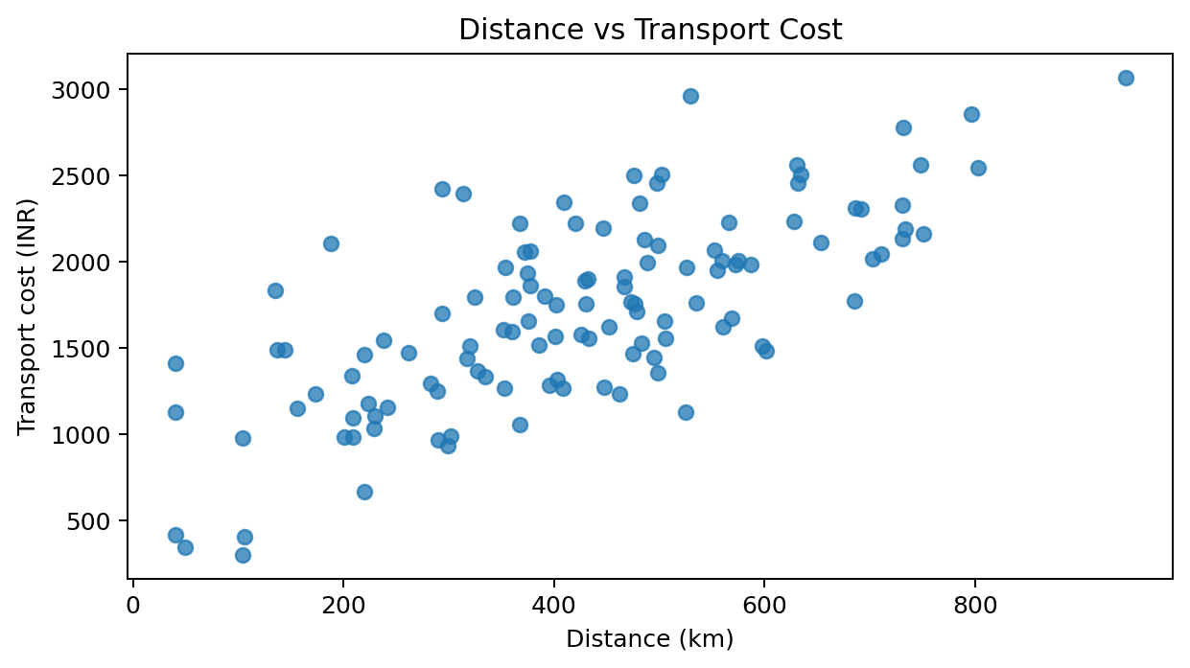
The distance-versus-cost scatter plot helps assess whether longer shipments tend to cost more. The Pearson correlation between distance and cost is 0.72. A positive value indicates that greater distance is associated with higher cost in this simulated dataset, though volume and transport mode also affect cost.
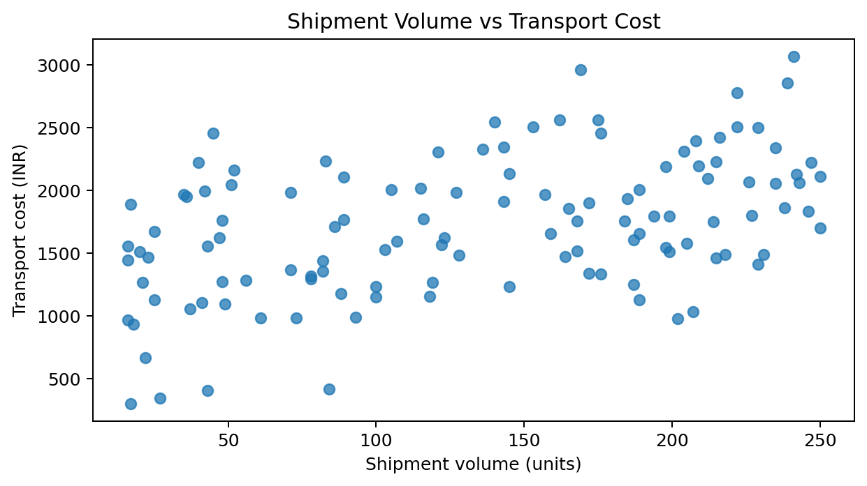
The volume-versus-cost scatter plot explores whether larger shipments are associated with higher costs. The correlation between volume and cost is 0.46. If a relationship is weak or points are widely scattered, other variables—such as distance or mode—may explain much of the variation.
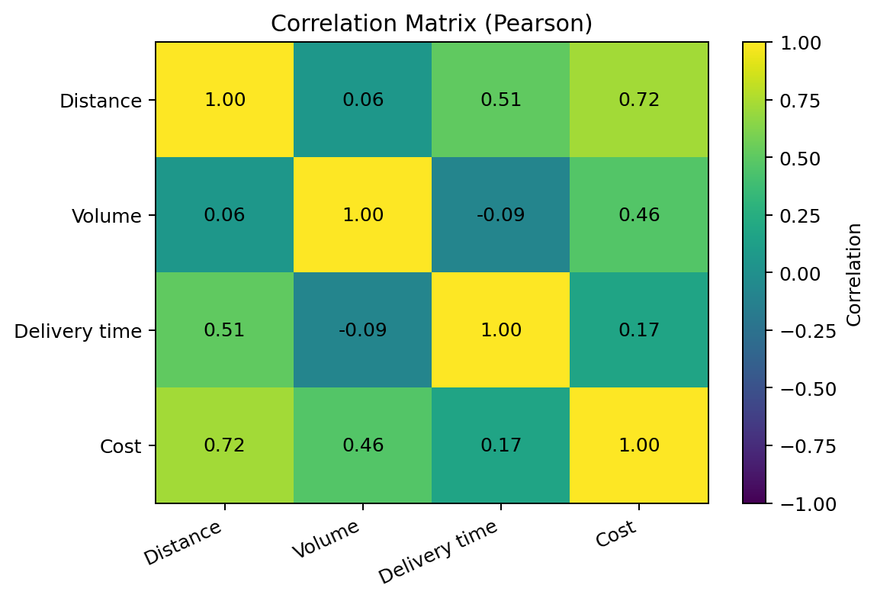
The correlation matrix summarizes pairwise linear associations. Distance and cost correlation = 0.72; distance and delivery-time correlation = 0.51; volume and cost correlation = 0.46. Correlation does not establish causation, and Pearson correlation can miss non-linear relationships.

5.6 Regional comparison
Region | Shipments | Avg. delivery (days) | Avg. cost (₹)
North | 31 | 2.46 | ₹1,586.45
South | 32 | 2.91 | ₹1,736.64
East | 28 | 3.10 | ₹1,754.76
West | 29 | 2.64 | ₹1,803.63
Regional averages can reveal where to investigate service variability or unusually high costs. However, regions may have different distances, volumes, and mode mixes. A fair comparison should control for these factors before concluding that one region is inherently less efficient.

6. Why These Visualization Methods Were Chosen
Visualization | Reason for use
Histogram | Shows the distribution and spread of delivery times; useful for spotting skew and unusually long deliveries.
Bar chart | Compares discrete delivery-status counts and average delivery time by transport mode.
Scatter plot: distance vs cost | Shows whether cost changes with distance and makes outliers visible.
Scatter plot: volume vs cost | Explores the relationship between shipment size and cost.
Correlation heatmap | Provides a compact view of the direction and strength of linear relationships among numeric variables.

7. Analytical Insights and Recommendations
- Delivery reliability: 45.0% of shipments are on time in the simulated sample. Track on-time delivery as a primary KPI and review delayed shipments by route, region, carrier, and dispatch day. Use agreed SLA thresholds for real operations.
- Delay exposure: 19.2% of shipments fall into the Delayed category under the exercise's >4-day rule. Create an exception dashboard with shipment ID, planned arrival, actual arrival, delay duration, cause, and owner. Escalate shipments likely to miss commitments.
- Distance-cost relationship: Pearson r = 0.72. Use distance bands and route-level cost per kilometre to identify expensive lanes. Compare like-for-like routes before negotiating rates.
- Volume-cost relationship: Pearson r = 0.46. Test shipment consolidation for compatible low-urgency consignments where it lowers cost without breaching delivery commitments.
- Mode and region averages may differ because of route mix and simulated assignments. Evaluate total landed cost and service together; do not choose a transport mode from speed or cost alone. Investigate regional outliers after adjusting for distance and volume.
- Synthetic data limits the certainty of operational conclusions. Before implementing changes, repeat the analysis with validated real shipment data, documented SLA definitions, actual carrier invoices, and delay reason codes.

8. Python Tools and Code Excerpts
pandas was used for tabular data handling and group summaries; NumPy for reproducible simulation and numerical operations; Matplotlib for charts. The following excerpts illustrate the main analysis steps.
# Inspect structure and data quality
print(df.shape)
print(df.dtypes)
print(df.isna().sum())
print(df['Shipment_ID'].duplicated().sum())
# Descriptive statistics
print(df[['Distance_km', 'Shipment_Volume_units',
'Delivery_Time_days', 'Transport_Cost_INR']].describe())
# Group performance by transport mode
mode_summary = df.groupby('Transport_Mode').agg(
Shipments=('Shipment_ID', 'count'),
Avg_Delivery_Days=('Delivery_Time_days', 'mean'),
Avg_Cost_INR=('Transport_Cost_INR', 'mean')
)
# Correlations
corr = df[['Distance_km', 'Shipment_Volume_units',
'Delivery_Time_days', 'Transport_Cost_INR']].corr()
print(corr)
# Example visualization
import matplotlib.pyplot as plt
plt.figure(figsize=(7, 4))
plt.scatter(df['Distance_km'], df['Transport_Cost_INR'], alpha=0.75)
plt.xlabel('Distance (km)')
plt.ylabel('Transport cost (INR)')
plt.title('Distance vs Transport Cost')
plt.tight_layout()
plt.show()

9. Limitations
- All records are simulated; the results do not describe a real company or real carrier performance.
- The sample has 120 shipments, which is adequate for demonstrating methods but not for broad operational generalization.
- Delivery status is derived from a simple time threshold rather than a contractual delivery promise.
- Correlation measures linear association only and does not demonstrate causation.
- The analysis does not include fuel prices, weather, failed delivery attempts, warehouse dwell time, carrier identity, or detailed route identifiers.

10. Conclusion
This project demonstrates how Python can turn structured logistics records into descriptive statistics, visual evidence, and actionable questions for operations teams. The combination of distribution analysis, group comparisons, scatter plots, and correlation analysis helps identify where delays and costs may deserve further investigation. The most important next step is to apply the same workflow to verified operational data, validate definitions with stakeholders, and monitor improvements using consistent KPIs.

Appendix A. Reproducibility Notes
The dataset used in this report is generated synthetically with NumPy's random generator seed set to 42. The report includes the resulting charts and selected code excerpts. For a production analysis, save the full script and source dataset alongside the report and document the Python/package versions.

