WEEK 4 TASK REPORT
Predictive Modeling and Optimization in Logistics Systems
Yuva Intern — Logistics Data Analytics Internship
240 simulated shipments | Target: delivery time in days | Python, pandas, NumPy, scikit-learn, Matplotlib

1. Executive Summary
This project builds and evaluates predictive models to estimate shipment delivery time from simulated logistics attributes. The dataset contains 240 hypothetical shipments with distance, volume, transport mode, region, weather condition, congestion level, and transportation cost. Three regression models were compared on a held-out test set. The best model by RMSE is Linear Regression, with MAE 0.48 days, RMSE 0.62 days, and R-squared 0.658. These results demonstrate a reproducible workflow on synthetic data and are not evidence of real-world predictive performance.

2. Problem Definition and Objectives
Prediction problem: estimate delivery time in days from information about shipment distance, volume, transport mode, region, weather, and congestion. The aim is to support planning and identify shipments that may need attention.
- Create and describe a hypothetical logistics dataset with a clear target variable.
- Prepare features and split data into training and testing subsets.
- Train and compare appropriate regression models.
- Evaluate models using MAE, RMSE, and R-squared.
- Use cross-validation to assess stability and discuss tuning.
- Propose operational optimization strategies informed by predictive insights.

3. Dataset and Variables
The simulated dataset contains 240 rows and 9 columns. Each row represents one shipment. A fixed random seed was used for reproducibility.
Variable | Description | Type / Unit
Shipment_ID | Unique shipment identifier | ID
Distance_km | Shipment distance | km
Shipment_Volume_units | Number of units | units
Transport_Mode | Road, Rail, or Air | category
Region | North, South, East, or West | category
Weather_Condition | Normal or Adverse | category
Congestion_Level_1_to_5 | Simulated congestion score | ordinal 1–5
Delivery_Time_days | Elapsed delivery time; prediction target | days
Transport_Cost_INR | Simulated transport cost | INR
Data preparation: no missing values were intentionally introduced. Categorical variables were one-hot encoded. Shipment_ID was excluded from predictors because it is only an identifier.

4. Methodology and Data Preparation
- Generated the hypothetical dataset with a fixed NumPy random seed.
- Selected delivery time as the continuous target variable.
- Used distance, shipment volume, transport mode, region, weather, and congestion as predictors.
- Applied one-hot encoding to categorical variables, dropping the first category to avoid redundant dummy columns.
- Split the data into 80% training and 20% testing using random_state=42.
- Trained Linear Regression, Ridge Regression, and Random Forest Regressor models.
- Compared test predictions using MAE, RMSE, and R-squared. Lower MAE/RMSE indicate smaller errors; higher R-squared indicates more variance explained.

5. Model Selection and Results
Linear Regression is an interpretable baseline. Ridge Regression adds regularization to reduce coefficient instability. Random Forest can capture nonlinear patterns and interactions but is less directly interpretable. All models were evaluated on the same held-out test set.
Model | MAE (days) | RMSE (days) | R-squared
Linear Regression | 0.479 | 0.622 | 0.658
Ridge Regression | 0.480 | 0.624 | 0.655
Random Forest | 0.642 | 0.767 | 0.479
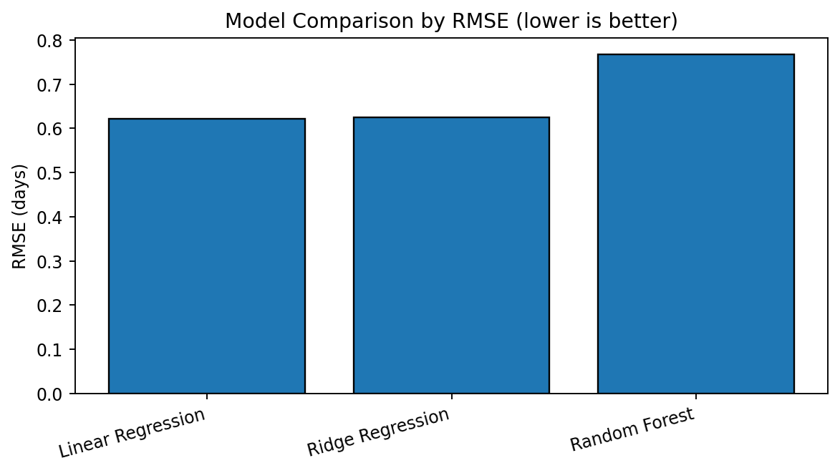
Figure 1. Test-set RMSE by model; lower values indicate smaller typical error with extra penalty for large errors.

6. Evaluation and Validation
The selected model (Linear Regression) achieved MAE 0.479 days, RMSE 0.622 days, and R-squared 0.658 on the held-out test data.
As a stability check, five-fold shuffled cross-validation for the Linear Regression baseline produced mean MAE 0.476 days. This score applies to the linear baseline, not necessarily to the selected model.
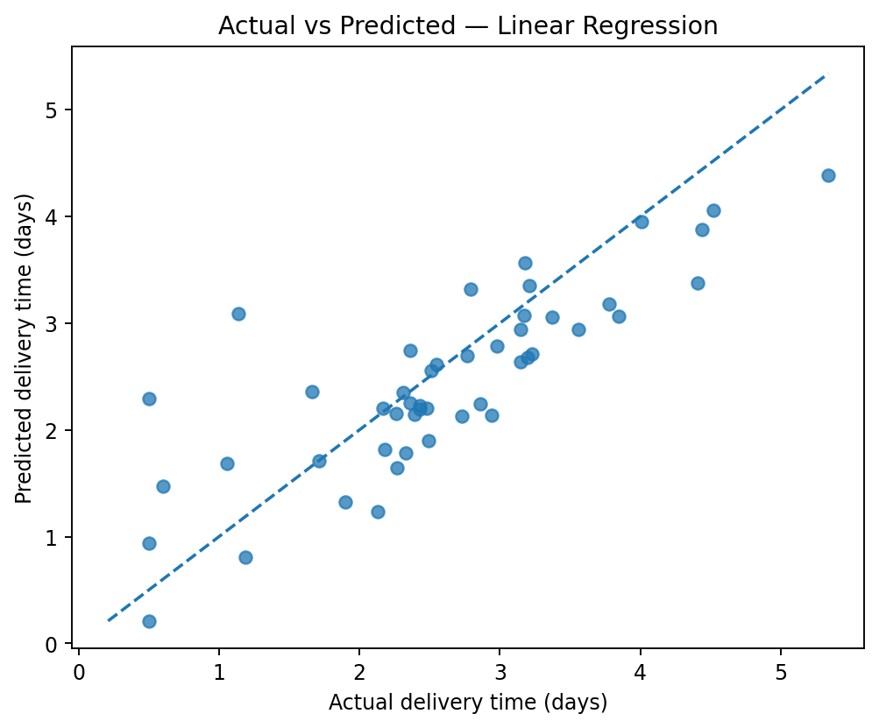
Figure 2. Actual versus predicted delivery time for the selected model. Points nearer the dashed diagonal indicate more accurate predictions.

7. Feature Interpretation
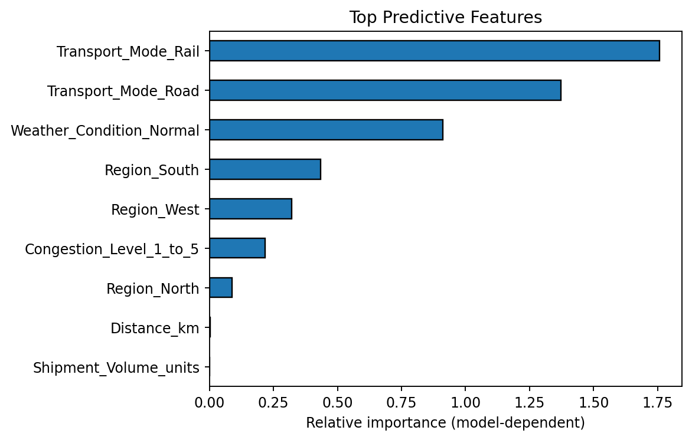
Figure 3. Top predictive features. For Random Forest, the chart uses impurity-based feature importance; for linear models, absolute coefficients are shown. These measures are model-dependent and do not establish causation.

8. Optimization Strategies
- Proactive exception management: flag shipments whose predicted delivery time exceeds the service target and investigate them early.
- Route planning: compare route alternatives using predicted time, distance, congestion, and cost while respecting operational constraints.
- Resource allocation: schedule vehicles, loading staff, and warehouse capacity around expected demand and delivery windows.
- Transport-mode selection: evaluate road, rail, and air using both cost and service requirements.
- Weather and congestion contingency: consider alternate dispatch windows or routes during adverse conditions.
- Model monitoring: compare predictions with actual deliveries, track error metrics, and retrain when operating conditions change.

9. Python Code Example
import pandas as pd
from sklearn.model_selection import train_test_split
from sklearn.ensemble import RandomForestRegressor
from sklearn.metrics import mean_absolute_error, mean_squared_error, r2_score
df = pd.read_csv("week4_hypothetical_logistics_dataset.csv")
y = df["Delivery_Time_days"]
X = pd.get_dummies(df[[
"Distance_km", "Shipment_Volume_units", "Transport_Mode",
"Region", "Weather_Condition", "Congestion_Level_1_to_5"
]], drop_first=True, dtype=float)
X_train, X_test, y_train, y_test = train_test_split(
X, y, test_size=0.20, random_state=42
)
model = RandomForestRegressor(
n_estimators=250, max_depth=8, min_samples_leaf=3, random_state=42
)
model.fit(X_train, y_train)
pred = model.predict(X_test)
print("MAE:", mean_absolute_error(y_test, pred))
print("RMSE:", mean_squared_error(y_test, pred) ** 0.5)
print("R-squared:", r2_score(y_test, pred))

10. Limitations and Responsible Use
- The data is synthetic and does not represent actual logistics operations.
- Random train/test splitting demonstrates model evaluation; time-ordered validation is preferable for future forecasting from historical time series.
- Metrics may change with a different sample or split.
- Predictions should support, not replace, operational judgment and must be validated before real dispatch use.
- The dataset omits real-world factors such as carrier reliability, warehouse dwell time, hourly traffic, holidays, and delivery-window constraints.

11. Conclusion
This task demonstrates a predictive modeling workflow: defining a target, preparing data, training candidate regressors, comparing performance, and translating findings into operational recommendations. The best model in this synthetic test run was Linear Regression. Real deployment would require verified historical records, leakage checks, time-aware validation, and ongoing monitoring.

Appendix: Reproducibility
Dataset generation uses NumPy random seed 2026 and the train/test split uses random_state=42. The CSV dataset and charts are included as supporting project files.

