###### logo3

###### Faculty of Computing & IT

###### University of Sialkot

AR Based Indoor University Mapping and User Satisfaction Evolution.

Session: BS-SE Fall 2019-2023

**Project Advisor:Ma’am Mehak Tanweer**

Submitted By

Ayeza Chauhdry 19101001-020

Hassan Iqbal 19101001-021

Amina Arshad 19101001-025

|  |  |
| --- | --- |
|  |  |
|  |  |

Faculty of Computing & IT

University of Sialkot

STATEMENT OF SUBMISSION

This is certify that Ayeza Chaudhry Roll No.19101001-020 and Iqbal Hassan Roll No.19101001-021,Amina Arshad Roll No.19101001-025 have successfully completed the final year project named as­­­­­­­­­­­­­­­­­­­­­­­­­­­­­­­­­­­­­ AR Based Indoor University Mapping and User Satisfaction Evolution at the Department of Software Engineering, University of Sialkot, to fulfill the requirement of the degree of BS in Software Engineering **in Software Engineering**.

______________________ ______________________

Ma’am Mahek Tanwer Project Management

Department of Software Engineering

Faculty of Computing & Information Technology

University of Sialkot, Sialkot main-campus, Punjab, Pakistan.

Email: mahek.tanweer@uskt.edu.pk Project Management Office

______________________

Head of the Department

Assistance Professor Sabeen Javaid

Department of software Engineering & Information Technology

University of Sialkot, Sialkot main-campus, Punjab, Pakistan.

Email:sabeen.javaid@uskt.edu.pk

Acknowledgement

We truly acknowledge the cooperation and help make by our supervisor, Ma’am Mehak Tanveer, from Department of Information Technology, University of Sialkot. She has been a constant source of guidance throughout the course of this projectWe are also thankful to our friends and families whose silent support led us to complete our project.

1- Ayeza Chaudhry

2- Iqbal Hassan

3-Amina Arshad

Date: December 21, 2022

**Abstract**

This project is about to advice directions to the destination in the users mobile screen. This is an Android based application to locate a directions through navigation by using Augmented reality (AR) to their required floor, room, offices our any other place that is placed in the university. Google AR Core takes live feed from the user's camera and does simultaneous locating and mapping to update the user’s location. Shortest path to the chosen destination is found using algorithm and the directions to the destination are shown in the user's mobile screen to showing modal using Augmented Reality .The visitor can easily find the location based on their needs. Visitors faces difficulties during visit to university for the first time admissions our other purposes this app will guide them properly through navigation about their work place. This will resolve the affair of wandering here and there without any knowledge about their landing place. That will also overcome the matter of freshers for finding their lectures room number. In order to resolve the issue is being developed for the visitors to visit university departments easily and save time. We aim at developing the front end in the simplest way possible so that the users can easily reach their destination by just opening the camera where the directions are shown as 2D and 3D model of the building made in blender. And user satisfaction at departmental level.

Table of Contents

Chapter 1: Project Feasibility Report 1

1

1.1. Introduction 2

1.2. Problem Statement 2

1.3. Objectives 3

1.4. Project Motivation 3

1.5. Project/Product Feasibility Report 3

1.5.1. Technical Feasibility 3

1.5.2. Operational Feasibility 4

1.5.3. Economic Feasibility 4

1.5.4. Schedule Feasibility 4

1.5.5. Specification Feasibility 4

1.5.6. Market Analysis/Preliminary Record 4

1.5.7. Motivational Feasibility 4

1.5.8. Legal & Ethical Feasibility 5

1.5. Project/Product Scope 5

1.6. Project/Product Costing 5

1.9. CPM - Critical Path Method 12

1.10. Gantt chart 16

1.11. Introduction to Team member and their skill set 17

1.12. Task and Member Assignment Table 17

1.13. Tools and Technology with reasoning 19

1.14. Vision Document 20

1.15 Risk List 21

1.16. Product Features/ Product Decomposition 21

Chapter 2: Software Requirement Specification 22

2.1 Introduction 23

2.1.1 Systems Specifications 23

2.1.2. Identifying External Entities 24

2.1.3. Context Level Data Flow Diagram: 25

2.1.4. Capture "shall" Statements 25

System Shall Requirements 25

2.1.5. Allocate Requirements: 26

2.1.6. Prioritize Requirements 27

2.2. Example: 29

2.2.1. Introduction 29

2.2.2. Existing System 30

2.2.3. Scope of the System 31

2.2.5. Summary of Requirements :( Initial Requirements) 31

2.2.6. Identifying External Entities: 32

2.2.7. Capture "shall" Statements: 34

2.2.8. Allocate Requirements: 34

2.2.9. Priorities Requirements: 36

2.2.10. Requirements Traceability Matrix: 38

2.2.11. High Level Use case Diagram: 39

2.2.12. Analysis Level Usecase Diagram: 40

2.2.13. Usecase Description 41

Chapter 3: Software Architecture and Design 43

43

3.1. Introduction 44

3.2. Domain Model 44

3.3. Architecture/Design Pattern 45

3.4. Algorithm Flow Chart 46

3.6. Sequence Diagram 48

3.7. Collaboration Diagram 49

3.8. Operation Contracts 50

3.8. Design Class Diagram 54

3.9. State chart diagram 55

3.10. Database Model 56

**List of tables**

Table 1: Scope of project 5

Table 2: Project/ product costing 7

Table 3: Complexity weighting factor 7

Table 4: Complexity Factor Matrix 10

Table 5: Activity Based Costing 11

Table 6: Task Dependency TABLE 11

Table 7: CPM Table 15

Table 8: CPM Parameters and Slack Time 16

Table 9: Allocation of people 19

Table 10: Shall Statements 25

Table 11:Requirement allocation 26

Table 12: Prioritization of requirements 27

Table 13: Requirement Traceability matrix 28

Table 14: Shall statements 34

Table 15: Allocated Requirememnts 34

Table 16: Priorities Requirements 36

Table 17: Requirement Traceability Matrix 38

**List of Figures**

Figure 1:Critical Path Method 13

Figure 2 : CPM Network Diagram 15

Figure 3 : Gantt Chart 17

Figure 4: Task and Member Assignment 18

Figure 5: Task Durations and Dependencies 18

Figure 6: Staff Allocation 19

Figure 7: Context Level Data Flow Diagram 25

Figure 8: Business Organization Chart 30

Figure 9: High Level Use Case Diagram 40

Figure 10: Level Use Case Diagram 41

Figure 11: Domain Model 45

Figure 12: Architecture/Design Pattern 46

Figure 13: Algorithm Flow Chart 47

Figure 14: System Sequence Diagram 48

Figure 15: Sequence Diagram 49

Figure 16: Collaboration Diagram 50

Figure 17: Design Class Diagram 54

Figure 18: State Chart Diagram 55

Figure 19: System Database Model 56

Figure 20: Rough ERD 57

Figure 21: Key-Based ERD 58

Figure 22: Fully Attributed ERD 59

# Chapter 1: Project Feasibility Report

## Introduction

A Mobile Augmented Reality indoor navigation framework composed of several modules to reduce human cognitive workload and save time by blending the digital and physical worlds seamlessly through aligning the appropriate 3D path with features in the real world through ground detection. This framework helps in better understanding the surrounding especially unfamiliar buildings such as offices, and libraries etc. The results proved that the system provides a good platform to show the location information without requiring hardware installation and a strong wireless connection.

Mobile augmented reality, indoor navigation, annotated maps, global positioning system (GPS), WiFi, sensors, mobile computing. Indoor navigation is the idea of navigating the user in an indoor environment. The rapid evolution of technology in recent years offered a variety of techniques to facilitate indoor navigation such as Wi-Fi, Bluetooth Beacons and annotated maps. WiFi-based positioning technology is a good alternative solution as WiFi are commonly installed in buildings and it can act as access points.

Its data can be used to calculate the current position. In addition, it uses an interactive Augmented Reality to support the navigation process, reducing cognitive burdens and engage the user in a more interesting way. We are developing the Indoor augmented reality map of our university. Now-a-days, visitors have to face a problem the he/she cannot find the specific place in the university because he/she is visiting the university for the first time and he/she have no idea about the departments ,offices, lecture rooms etc. this app will solve this problem and save time of visitor about wandering here and there in the search of their place .Visitor just have to simply open the map app insert their destination and arrow heads will navigate about their destination. Firstly, customers have to login themselves. By logging in the application, you will be shown a 3D and 2D model of the university with map of university then you have to insert your destination in search bar that will locate to the destination Visitor can easily get the details of the place where to go. The Admin can a lot the room name but developer add more rooms to the 3D,2D model of the university and add navigation to it. can also provide. Only developer can update the model and fulfill other needs according to the requirements. User of the application will find is user friendly and easy to use but application should be provided by the proper internet to work.

## Problem Statement

Visitors, fresher faces difficulties during visit to university for admissions our other purposes this app will guide them properly through navigation about their work place. This will resolve the issue of wandering here and there without any knowledge about their work place. That will also overcome the issue of freshers for finding their lectures room number. In order to resolve the issue is being developed for the visitors to visit university departments easily and save time.

## Objectives

The objectives of the project are.

1. Easy to find desired place.
2. Easy navigation system.
3. Notify updates about the changes in university model.
4. Notify about the changes made by admin.
5. User satisfaction departmental vise (Rating APP)

## Project Motivation

Visitors can motivate from project in a sense that he/she can easily locate their destination without wasting time in search of their place and wandering here and there our ask to other about that. That will be proven very helpful to them.

## 1.5. Project/Product Feasibility Report

The idea of project is feasible for visitors in university or any other student who are visiting the university for the first time and he/she have no idea about the departments ,offices ,lectures room etc . The application will indicate them the path. This idea was approved by University of Sialkot Main Campus and also appreciated by our supervisor. We developing this project for freshers and visitors to easily find their path direction to their destination without wasting time.

There are many types of feasibilities:

* Technical
* Operational
* Economic
* Schedule
* Specification
* Information
* Motivational
* Legal and Ethical

### 

### 1.5.1. Technical Feasibility

“**Indicating the path**: An Android Application” that will be developed in Android Studio IDE and other platforms and tools because android is one of the mostly useable phone in the world. This application requires minimum android version (5.0 lollipop or higher). User can easily download their application to Play Store. Customers can login easily in user-friendly interface and easy to use.

.

### 1.5.2. Operational Feasibility

The proposed application has a very user friendly interface and fault-prone application and user can easily use this application without any technical fault. We will fully try our best to produce good quality product for user. We hope when user will interact for the first time he/she will find it interest and love while using this application. We will provide help tutorial for customer who will use application for first time. Our team has a capability to fight with every type of technical issues in application. If user face any technical issue while using application he/she will report issue. We will provide quick response.

### 1.5.3. Economic Feasibility

In this version of our application there is no need of money. We need proper application such as good system with higher navigation capabilities as well as the updated Android device version to develop the application. This will cost money to every individual the proposed system is the final year project so, there is no further cost to pay unless in this case of buying any service from an external organization .External help cost depend upon the type of favor we have required according to the complexity.

### 1.5.4. Schedule Feasibility

The Project is schedule and reasonable. Our team have already prepared a chart named Gantt chart and has been divided into different activities according to their time taken limit . Our team have a capabilities to accomplish tasks in divided time limits with low risk margins. We hope our all activities will go as scheduled time according to Gantt chart and will conduct our project on time.

### 1.5.5. Specification Feasibility

Great concentration will be placed on the requirement phase. Considering that this phase will contribute more for the project success. Requirement stage will receive a lot of attention and will be carried out repeatedly for engineering good product for university . We will compile all necessary requirements, both Functional and Non-Functional. After determining that they are compelling and applicable to the project, all requirements will be fulfilled.

### 

### 1.5.6. Market Analysis/Preliminary Record

This is made for sure that our product will be very useful in market. Visitors will get more advantages from our product. Basically it is mostly engaged in university map and results in reduction of time during visit to university for the first time (unfamiliar to places) by using this application they will save their time as some time shy.

### 1.5.7. Motivational Feasibility

All member of the team are responsive and self-assured. All team members will corporate with each other in supportive setting. Daily task reports and discussions will be conducted. Similar businesses will be used to complete the compilations. Every member will share their work with other member. All members will take care of needs of there group members.,

### 1.5.8. Legal & Ethical Feasibility

This *project will only be created for quick navigation and giving visitor a solution that makes traveling easy and less time consuming. Although there are other applications to accomplish this, none of them offers the service that "University MAP" does. This project is feasible legitimately and ethically. We will not give other organizations access to our application data. We are not worried about the kind of data that consumers are producing.*

## Project/Product Scope

The document only covers the required specification for the AR Based University Indoor mapping and user satisfaction.

Table : Scope of project

|  |  |
| --- | --- |
| For | Visitors that are visiting the university for the first time. |
| What | Prevent wasting time wondering human recourses for the easiness of the visitor. |
| The | AR Based University Mapping and user satisfaction. |
| Is | Android mobile application |
| That | Easily helping to locate the path and user satisfaction at departmental level. |

## Project/Product Costing

This section gives the overall project costing. We will evaluate cost by using different formulas estimating all inputs and finding out required output. Simply said, project costing makes it possible to measure expected profits against predicted costs to determine how well a project is profitable. Moreover, project costing acts as a check to see if there are sufficient resources to finish the project.

A functional point analysis is a way of attempting to analyze the complexity and effort required to develop software base on function points. The idea is to characterized a software application in teem of function point and attempt to develop an estimated effort required based on the number of function point required.

Function points are the measure of the size of computer application and the projects that build them .The size is measured from a functional our user, point of view. Function Point Analysis can provide a mechanism to track and monitor scope creep. Function Point counts at the end of requirements; analysis, design, code, testing and implementation can be compared. The function point count at the end of requirements and/or designs can be compared to function points actually delivered. If the project has grown, there has been scope creep. The amount of growth is an indication of how well requirements were gathered by and/or communicated to the project team. If the amount of growth of projects declines over time it is a natural assumption that communication with the user has improved.

Function points are computed by completing the table shown in the figure below. Five information domain characteristics are determined and counts are provided in the appropriate table location.

Information domain values are defined in the following manner:

**Number of user inputs:**

Number of users input is listed following;

* Users current location
* Destination point
* Name
* CNIC
* Phone no.
* City
* University Referred by

**Number of user outputs:**

Number of users output is listed as following.

* Map screen
* Visitor feedback
* Request page
* Movements
* Path location
* In location

**Number of user inquiries:**

Number of user’s inquiries is listed as following.

* Feedback check list (Admin)
* Destination
* Model
* Request check (developer)

**Number of files:**

Number of files are listed below.

* Visitor(details)
* Admin(details)
* Developer (details)

**Number of external interfaces:**

Numbers of external interfaces are listed below.

* Location
* Database
* Internet location
* Motion
* Camera access

Table : Project/ product costing

|  |  |  |  |
| --- | --- | --- | --- |
| **Types of component** | **Average** | **Count** | **Total** |
| External inputs | 4* | 13 | 52 |
| External outputs | 5* | 6 | 30 |
| External inquires | 4* | 4 | 16 |
| Internal logical files | 10* | 3 | 30 |
| External interface files | 7* | 5 | 35 |
| **163** | | | |

Table : Complex Adjustment

* 0=Not present or influence
* 1=incidental influence
* 2=moderate influence
* 4=average influence
* 5=strong influence

Table : Complexity weighting factor

|  |  |  |
| --- | --- | --- |
| **Sr#** | **Complexity weighting factor** | **values** |
| 1 | Backup and recovery | 3 |
| 2 | Data communication | 4 |
| 3 | Distributed processing | 5 |
| 4 | Performance critical | 2 |
| 5 | Existing operating environment | 3 |
| 6 | On-line data entry | 4 |
| 7 | Input transaction over multiple screens | 4 |
| 8 | Master files updated online | 2 |
| 9 | Information domain values complex | 3 |
| 10 | Internal processing complex | 3 |
| 11 | Code designed for reuse | 4 |
| 12 | Conversation installation in design | 3 |
| 13 | Multiple installation | 1 |
| 14 | Application design for change | 1 |
|  | **Total complexity design for change** | **39** |

**Calculate the source lines of code (SLOC) and the formula’s used**

Total Unadjusted function point =28

**Product complexity Adjustment(PC)=0.65*(0.01*39)=0.2535**

**FP est.** =count total*CAF

**FP est.**=163*0.2535 =41.27

For our project

Average productivity =26FP/PM

Labor rate =36,400RS/month

**Total estimated Effort =FP est. /productivity**

=41.27/26 =1.587 pm

**Cost/FP=Labor Rate/productivity**

=36400/26 =1400Rs/FP

**Total project cost=FP est.*(cost/FP)**

=41.27*1400 =57,7778Rs

**1.7.2. Project Cost Estimation by using COCOMO’81 (Constructive Cost Model)**

Boehm's COCOMO model is one of the mostly used models commercially. The first version of the model delivered in 1981 and COCOMO II is available now. COCOMO 81 is a model that allows one to estimate the cost, effort, and schedule when planning a new software development activity, according to software development practices that were commonly used in the 1970s through the 1980s. It exists in three forms, each one offering greater detail and accuracy the further along one is in the project planning and design process. Listed by increasing fidelity, these forms are called Basic, Intermediate, and Detailed COCOMO. However, only the Intermediate form has been implemented by USC in a calibrated software tool.

Three levels:

**Basic:** Is used mostly for rough, early estimates.

**Intermediate:** Is the most commonly used version, includes 15 different factors to account for the influence of various project attributes such as personnel capability, use of modern tools, hardware constraints, and so forth.

**Detailed:** Accounts for the influence of the different factors on individual project phases: design, coding/testing, and integration/testing. Detailed COCOMO is not used very often.

Each level includes three software development types:

1. **Organic:** Relatively small software teams develop familiar types of software in an in-house environment. Most of the personnel have experience working with related systems.
2. **Embedded:** The project may require new technology, unfamiliar algorithms, or an innovative new method
3. **Semi-detached:** Is an intermediate stage between organic and embedded types.

**Basic COCOMO**

|  |  |  |
| --- | --- | --- |
| **Types** | **Efforts** | **Schedule** |
| Organic | PM=2.4(KLOC).1.05 | TD=2.5(PM)0.38 |
| Semi-Detached | PM=3.0(KLOC)1.12 | TD=2.5(PM)O.35 |
| Embedded | PM=2.4(KLOC)1.20 | TD=2.5(PM)0.32 |

PM= person-month (effort)

KLOC= lines of code, in thousands

TD= number of months estimated for software development (duration)

**Intermediate COCOMO**

|  |  |
| --- | --- |
| **Types** | **Efforts** |
| organic | PM=2.4(KLOC)1.05 x M |
| Semi-Detached | PM=3.O(KLOC)1.12 x M |
| Embedded | PM=2.4(KLOC)1.20 x M |

**Modes of COCOMO model.**

|  |  |  |  |
| --- | --- | --- | --- |
| **Parameters** | **organic** | **Semi-Detached** | **Embed** |
| Size | 2-50LOC | 50-300KLOC | 300KLOC or above |
| Team | small | Medium | Large |
| Developer experience | Experience Dev | Average | Changed |
| Experiment | Familiar | Less familiar | major innovation |
| Innovation | little | Medium | Tight deadline |
| deadline | flexible | Medium |  |

**Parameters of different modes.**

|  |  |  |  |  |
| --- | --- | --- | --- | --- |
| **mode** | **A** | **B** | **C** | **D** |
| **organic** | 2.41.05 | 2.5 | 2.5 | 0.38 |
| **Semi Detached** | 3.0 | 1.12 | 2.5 | 0.35 |
| **Embed** | 3.6 | 1.20 | 2.5 | 0.32 |

**Effort:**

E=A(KLOC)^B person/Month

E=2.4*75^1.05 person/Month

**Development Time:**

Dev Time =C(Effort)^D Months

Dev Time=2.5(10.28)^0.38 Month

Dev Time=6.06

**Average Staff Size:**

=Effort/Dev Time

=10.28/6.06

=1.67

**Productivity :**

=KLOC/Effort

=75/10.28

=7.29

**COCOMO 2**

**Complexity Factor Matrix**

**No. of Screens =** 23

**No. of Reports =** 2

**No. of Components:** 18

Table : Complexity Factor Matrix

|  |  |  |  |  |
| --- | --- | --- | --- | --- |
| **Object Type** | **Complexity Weight** | | | |
|  |  | **Simple** | **Average** | **Complex** |
| **No. of Screens** | **\*** | 1 | 2 | 3 |
| **Reports** | **\*** | 2 | 5 | 8 |
| **No. of Components** | **\*** | 1 | 1 | 10 |

**OP =** 23*2 + 2*5 + 18*1 = 74

**Reuse of component =** 70% = 0.7

**NOP =** 74 [(100-0.7)/100]

= 73.482

**Effort = NOP / Productivity**

**=** 73.482 / 13 = 5.652 person month.

**Labor Rate =** 30000 RS/month

**Productivity =** 13 person month

**Cost/NOP = Labor rate / productivity**

**=** 30000/13

**=** 2307.7

**Cost =** 2307.7 * 73.482 = **169574.**

**1.7.3. Activity Based Costing**

In that we measure the cost and performance of Activities, Resouces,and Cost objects.

Table : Activity Based Costing

|  |  |  |  |  |
| --- | --- | --- | --- | --- |
| **No.** | **Activities** | **Resources** | **cost** | **duration** |
| 1 | User interface | Android studio, laptop | Free | 3weeks |
| 2 | Database | Android studio ,firebase laptop | Free | 3weeks |
| 3 | Sign-up /login | Android studio ,laptop | Free | 3Weeks |
| 4 | Model making | Blender ,laptop | Free | 5weeks |
| 5 | location | Android studio, laptop | Free | 6weeks |
| 6 | Search bar | Android studio, laptop | Free | 2weeks |
| 7 | Recommended system | Android studio, laptop | Free | 1weeks |
| 8 | Verification and testing | Android studio, laptop | Free | 17weeks |

**Task Dependency Table**

Table : Task Dependency TABLE

|  |  |  |  |
| --- | --- | --- | --- |
| **Activity** | **Task** | **Dependency** | **Duration** |
| **A** | User interface | - | 3weeks |
| **B** | Database | A | 3weeks |
| **C** | Sign-up /login | A,B | 3weeks |
| **D** | Model making | - | 5weeks |
| **E** | location | C,D | 6weeks |
| **F** | Search bar | E | 2weeks |
| **G** | Recommended system | E,F | 1weeks |
| **H** | Verification and testing | A,C,E,F | 17weeks |

## 1.9. CPM - Critical Path Method

In 1957, DuPont developed a project management method designed to address the challenge of shutting down chemical plants for maintenance and then restarting the plants once the maintenance had been completed. Given the complexity of the process, they developed the Critical Path Method (CPM) for managing such projects.

CPM provides the following benefits:

* Provides a graphical view of the project.
* Predicts the time required to complete the project.
* Shows which activities are critical to maintaining the schedule and which are not.

CPM models the activities and events of a project as a network. Activities are depicted as nodes on the network and events that signify the beginning or ending of activities are depicted as arcs or lines between the nodes. The following is an example of a CPM network diagram:

Steps in CPM Project Planning

1. Specify the individual activities.

2. Determine the sequence of those activities.

3. Draw a network diagram.

4. Estimate the completion time for each activity.

5. Identify the critical path (longest path through the network)

6. Update the CPM diagram as the project progresses.

**1. Specify the Individual Activities**

A critical path is the sequence of the project network activities , which add up to the longest overall duration, Regardless if that longest duration has a float or not. This determines the shortest time possible to complete the project.

* Feasibility study
* Software Requirement Specification (SRS)
* Interface Design
* Backend Development
* Application Development
* Testing
* Database

**2. Determine the Sequence of the Activities**

Some activities are dependent on the completion of others. A listing of the immediate predecessors of each activity is useful for constructing the CPM network diagram.

**3. Draw the Network Diagram**

Once the activities and their sequencing have been defined, the CPM diagram can be drawn. CPM originally was developed as an activity on node (AON) network, but some project planners prefer to specify the activities on the arcs

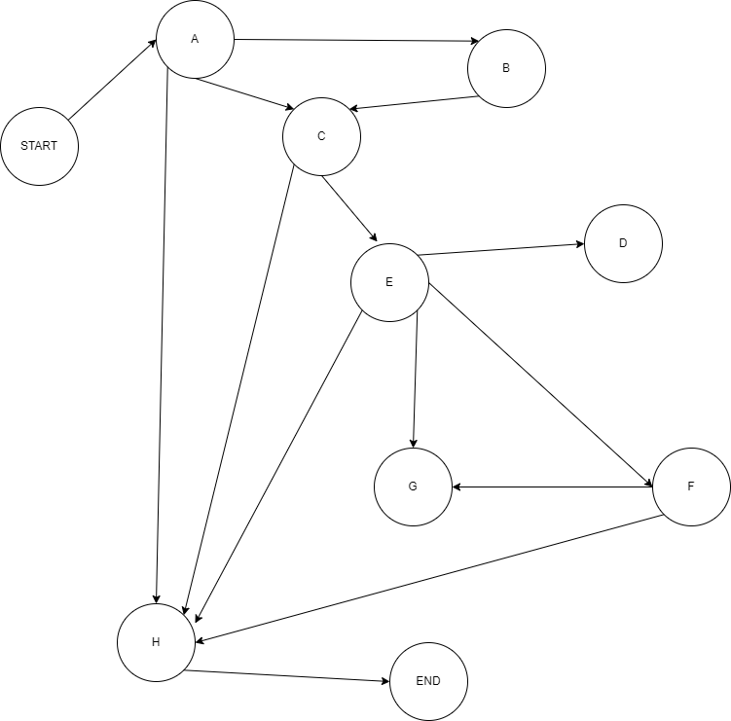

Figure :Critical Path Method

**4. Estimate Activity Completion Time**

The time required to complete each activity can be estimated using past experience or the estimates of knowledgeable persons. CPM is a deterministic model that does not take into account variation in the completion time, so only one number is used for an activity's time estimate.

**5. Identify the Critical Path**

The critical path is the longest-duration path through the network. The significance of the critical path is that the activities that lie on it cannot be delayed without delaying the project. Because of its impact on the entire project, critical path analysis is an important aspect of project planning.

Determining the following six parameters for each activity which can identify the critical path:

**ES:** earliest start time: the earliest time at which the activity can start given that its precedent activities must be completed first.

ES (K)= max [EF(J) : J is an immediate predecessor of K]

**EF:** earliest finish time: equal to the earliest start time for the activity plus the time required to complete the activity.

EF (K)= ES (K) + Dur (K)

**LF:** latest finish time: the latest time at which the activity can be completed without delaying the project.

LF (K)= min [LS(J) : J is a successor of K]

**LS:** latest start time: equal to the latest finish time minus the time required to complete the activity.

LS (K)= LF(K) – Dur (K)

**TS:** Total Slack: the time that the completion of an activity can be delayed without delaying the end of the project

TS (K)= LS(K) – ES(K)

**FS:** Free Slack: the time that an activity can be delayed without delaying both the start of any succeeding activity and the end of the project.

FS (K)= min [ES(J) : J is successor of K] – EF(K)

The slack time for an activity is the time between its earliest and latest start time, or between its earliest and latest finish time. Slack is the amount of time that an activity can be delayed past its earliest start or earliest finish without delaying the project.

The critical path is the path through the project network in which none of the activities have slack, that is, the path for which ES=LS and EF=LF for all activities in the path. A delay in the critical path delays the project. Similarly, to accelerate the project it is necessary to reduce the total time required for the activities in the critical path.

**6. Update CPM Diagram**

As the project progresses, the actual task completion times will be known and the network diagram can be updated to include this information. A new critical path may emerge, and structural changes may be made in the network if project requirements change.As shown as this table

**Example:**

Table : CPM Table

|  |  |  |
| --- | --- | --- |
| Activity | Predecessor | Duration(Weeks) |
| A |  | 3 |
| B | A | 3 |
| C | A,B | 3 |
| D |  | 5 |
| E | C,D | 6 |
| F | E | 2 |
| G | E,F | 1 |
| H | A,C,E,F | 17 |

That is the Activities table that will be performed . there duration and dependencies on each other .All that are mention in the above table. Total 8 activities will execute that start from A-H.

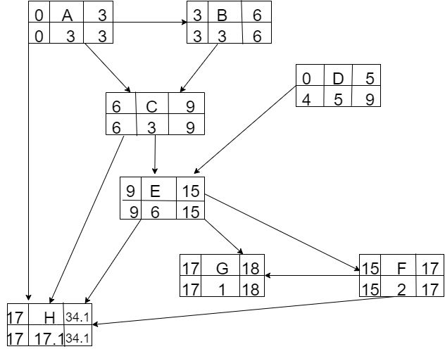

Figure : CPM Network Diagram

The parameters and slacks are calculated as follows:

Table : CPM Parameters and Slack Time

|  |  |  |  |  |  |  |  |
| --- | --- | --- | --- | --- | --- | --- | --- |
| **Activity** | **Duration** | **ES** | **EF** | **LS** | **LF** | **TS** | **FS** |
| A | 3 | 0 | 0 | 0 | 3 | 0 | 0 |
| B | 3 | 3 | 3 | 3 | 6 | 3 | 2 |
| C | 3 | 6 | 6 | 6 | 9 | 0 | 0 |
| D | 5 | 0 | 0 | 4 | 9 | 4 | 4 |
| E | 6 | 9 | 9 | 9 | 15 | 0 | 0 |
| F | 2 | 15 | 17 | 15 | 17 | 0 | 0 |
| G | 1 | 17 | 18 | 17 | 18 | 0 | 0 |
| H | 17 | 17 | 34 | 17 | 34 | 0 | 0 |

**The critical path is:**

A,C,E,F,H

## 1.10. Gantt chart

The Gantt chart enumerates the activities to be performed on the vertical axis and their corresponding duration on the horizontal axis. It is possible to schedule activities by either early start or late start logic. In the early start approach, each activity is initiated as early as possible without violating the precedence relations. In the late start approach, each activity is delayed as much as possible as long as the earliest finish time of the project is not compromised.

Based on the Work Breakdown Structure (WBS), a timeline or Gantt chart showing the allocation of time to the project phases or iterations should be developed. This Gantt chart would identify major milestones with their achievement criteria. It must contain duration estimation of all the necessary activities to be carried out during the project development along with the human resources responsible for the respective tasks. Activity dependencies are also required to be mentioned in it. As Shown as this Figure

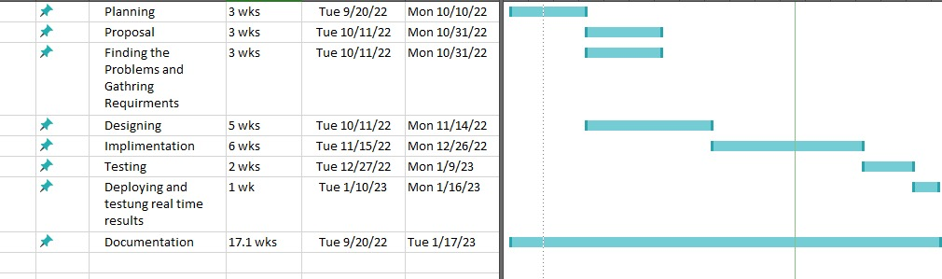

Figure : Gantt Chart

## 1.11. Introduction to Team member and their skill set

**a) Ayeza Chaudhry**

Ayeza Chaudhry is performing the following activities in the project.

1. Feasibility study
2. Test documentation
3. SRS and design Document
4. Design document

**B) Iqbal Hassan**

Iqbal Hassan is performing the following activities in the project.

1. Feasibility study
2. Database handling
3. User interface design
4. Application development

**c) Amina Arshad**

Amina Arshad is performing the following activities in the project.

1. Use interface design
2. Feasibility study
3. Test document.

## 1.12. Task and Member Assignment Table

A table should be formed which consists of a list of tasks and correspondingly allocation of members to that task. The basic aim of this table would be an indication of the amount of work the members would be performing.

Example for Task Durations and Dependencies, Activity Network Diagram, Gantt chart, and Allocation of People to Activities. As Shown as this Figure

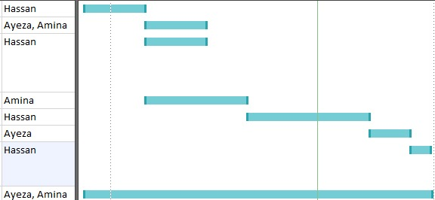

Figure : Task and Member Assignment

Consider the set of activities shown in figure. This table shows activities, their duration, and activity interdependencies. From figure, you can see that Task T3 is dependent on Task T1. This means that T1 must be completed before T3 starts. For example, T1 might be the preparation of a component design and T3, the implementation of that design. Before implementation starts, the design should be complete

Task durations and dependencies

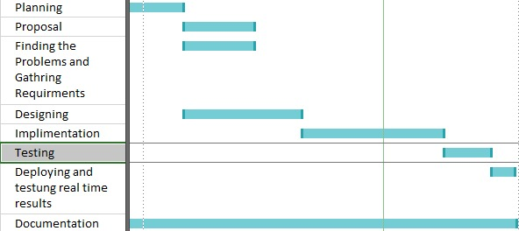

Figure : Task Durations and Dependencies

**Activity Bar Chart**

Figure with the Gantt chart is an alternative way of representing project schedule information. It is a bar chart (sometimes called a Gantt chart, after its inventor) showing a project calendar and the start and finish dates of activities.

**Allocation of People to Activities**

As Shown as this Table to allocate the task of team members.

Table : Allocation of people

|  |  |
| --- | --- |
| Task | Engineer |
| T1 | Hassan |
| T2 | Ayeza ,Amina |
| T3 | Hassan |
| T4 | Amina |
| T5 | Hassan |
| T6 | Ayeza |
| T7 | Hassan |
| T8 | Ayeza,  Amina |

**Staff Allocation:**

As Shown as this Figure



Figure : Staff Allocation

## 1.13. Tools and Technology with reasoning

The application tools, which are to be used on front and back end of the system to be developed, should be listed. The reasons for these tools should also be described.

Identify what the needs for tool support are, and what the constraints are, by looking at the following:

**Languages**

1. **Java**

We are using Java language for backend because its android base application and machine learning activities are developed in java.

1. **XML**

As we ha discuses it that our application is android base so , we use XML for front end for user interface .Which is used to design the front end of the application where the user have to interact.

1. **Augmented reality**

This will be used to create the virtual model of the university . All the things will created as they are real one.

**Tools**

* **Draw.io**

We are using draw.io in our project for documentation purposes to draw

different diagrams.

* **Blender**

It is used in our project for the creation of 2D and 3Dmodel of the university building.

* **Google model-viewer**

It is used to view the model of the building.

* **OpenGL**

## 1.14. Vision Document

The Vision defines the stockholder’s view of the product to be developed, specified in terms of the stockholder’s key needs and features. Containing an outline of the envisioned core requirements, it provides the contractual basis for the more detailed technical requirements.

A Vision Document is the starting point for most software projects. It is the primary deliverable and is therefore the first document produced in the planning process. The main purpose of this document is to move the project forward into detailed project planning and ultimately into development.

The Vision Document is designed to make sure that key decision makers on both sides have a clear, shared vision of the objectives and scope of the project. It identifies alternatives and risks associated with the project. Finally, it presents a budget for the detailed planning phase for the stakeholders to approve.

The Vision document provides a high-level for the more detailed technical requirements. There can also be a formal requirements specification. The Vision captures very high-level requirements and design constraints to give the reader an understanding of the system to be developed. It provides input to the project-approval process and is, therefore, intimately related to the Business Case. It communicates the fundamental "whys and what's" related to the project and is a gauge against which all future decisions should be validated.

A project vision is meant to be changeable as the understanding of requirements, architecture, plans, and technology evolves. However, it should be changing slowly and normally throughout the earlier portion of the lifecycle.

It is important to express the vision in terms of its use cases and primary scenarios as these are developed, so that you can see how the vision is realized by the use cases. The use cases also provide an effective basis for evolving a test case suite.

Another name used for this document is the Product Requirement Document. There are certain checkpoints that help to verify that the vision document is fulfilled.

Checkpoints:

Some agreed features of the software are listed below.

* Log in for the users
* Admin that can change the rooms number etc.
* Developer modifies the building model.
* Search option of there specific destination
* Will show 2D 3D model of the building .
* Guide about the shortest path
* Navigation of the path through arrow head .
* User satisfactions (ratting app)at departmental level.

## 1.15 Risk List

The risk list is designed to capture risk to the success of the project. It identifies, in decreasing order of priority, the events that could lead to a significantly negative outcomes. It serves as a focal point for the project activities and is the basic around which iterations are organized.

Following could be the risk of our project.

1. Google service may slow down the application.
2. The online server may slow down some times.
3. Without having map it is very difficult to develop and run our application.
4. If app fails to load properly the visitor will be unable to see the model.
5. If the visitor does not see the admin request the model /map will not be updated.
6. If the database is not working properly the admin and developer portal will contain no dates por false data to show.

## 1.16. Product Features/ Product Decomposition

Functional requirements capture the intended behavior of the system. This behavior may be expressed as services, tasks or functions the system is required to perform.

1. Login and registration
2. Admin that can change the rooms number etc.
3. Developer modifies the building model.
4. Search option.
5. Will show 2D 3D model of the building.
6. Guide about the shortest path.
7. Navigation.

# 

# Chapter 2: Software Requirement Specification

## 2.1 Introduction

This clause should contain brief “Introduction” of the system under discussion domain knowledge. It can also contain company, its location, its historical background and its current status in the market. The most important part of this clause is to give an overview of the major business areas of the company. This overview must be very brief so that one can get a bird’s eye view of the organization under study.

Navigation refers to the method of determining aspects such as position, speed, and direction during travel. In the modern sense, navigation is mechanical devices equipped in such as artificial satellites. In this project we are using indoor navigation maps that have improved immensely over the year. Application like Google Indoor Maps have helped people navigate inside any infrastructure with the help of technology. In fact some of the best indoor navigation ,send notification, and provide effective way finding.

**Existing System**

Problems and weaknesses in the system were found based on earlier research AR Based Indoor mapping and user satisfactions evolution. There are many system that are using this indoor mapping systems to locate the desired place for example, indoor maps are used in big shopping malls to navigate the shops path. Following are the existing systems that are in working form.

* Shopping malls
* Business filed

But in our proposed system we are using augmented reality in 3D model of the university

### 2.1.1 Systems Specifications

The following are the clauses that must be included while describing the system specifications(AR Based Indoor University Mapping and User Satisfaction Evolution)

**Organizational Chart**

Organizational chart will be very much supportive to get a better overview of the organization’s business areas and their decomposition into different departments.

**Scope of the System**

Requirements of the project are as following.

* Display all the available categories.
* Display all Sub Categories on a homepage that are associated with any particular modal.
* Allow User to display Navigation Map on the activity after understanding requirement of the application.
* Allow Admin to modify/ add/ delete the product.
* Allow Admin to change location of room, offices etc.
* Allow developer to modification in the model of building.
* Permission Admin to view User’s details
* Display user satisfaction(ratting app)departmental level and average of it .
* Allow visitor to send the request.

**Summary of Requirements:**

A System shall be able to provide a good environment of navigation panel with a responsive behavior such as showing arrows towards location, voice output towards location, floor number, room number, office etc. Indoor mapping system provide searching option, that will show first off all model of the building that will be 3D model that will show after filling the formalities of the application then user can search about their desired destination that will help them to locate with arrow heads. Allow user to give feedback on the departmental level.

### 2.1.2. Identifying External Entities

According to their access, external entities have been identified in the area of USKT indoor mapping system. The Identification of External Entities is done in two phases.

The Identification of External Entities is done in two phases.

**a. Over Specify Entities from Abstract:**

* Admin
* Developer
* Visitor/user

**b. Perform Refinement:**

* **Admin**
  + Admin can update the room numbers, offices ,floor ,numbers etc.
  + Admin have access to check any login entity detail.
* **Visitor**
  + Visitor can make Experience application.
  + Visitor can search about their place.
* **Developer**
  + Developer can modify the model of the building.
  + Developer can update the model.

**a. Over Specify Entities from Abstract:**

On the basis of the Abstract, one might identify the entities from the problem.

**b. Perform Refinement:**

After over specifying the entities, you have to refine them on the basis of your business logic. Now after refinement ,our entities will be

* Admin
* visitors

### 2.1.3. Context Level Data Flow Diagram:

Context level data flow diagram contains only one process, representing the entire system. The process is given the number zero and all external entities are shown on the context diagram as well as major data flow to and from them. The diagram does not contain any data stores as shown in figure

Figure : Context Level Data Flow Diagram

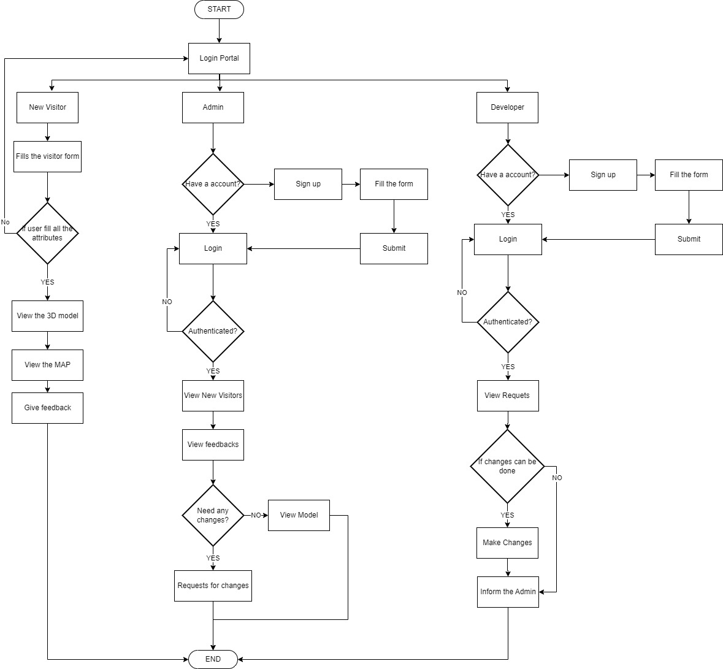

### 2.1.4. Capture "shall" Statements

### System Shall Requirements

Table : Shall Statements

|  |  |
| --- | --- |
| **Para#** | **Initial statements** |
| 1.1 | The system” shall” allow the admin to login. |
| 1.2 | The system” shall” allow the admin to log out. |
| 1.3 | The system” shall” allow the admin to edit the room numbers . |
| 1.4 | The system” shall” allow the admin to delete the room number . |
| 1.5 | The system” shall” allow the admin to change the alert status. |
| 1.6 | The system” shall” allow the visitor to search the destination . |
| 1.7 | The system” shall” allow the visitor to login . |
| 1.8 | The system” shall” allow the visitor to logout. |
| 1.9 | The system” shall” allow the admin to notify concerned authorities. |
| 1.10 | System shall allow to Shopkeeper to give feedback about behavior of Shopper |
| 1.11 | The system “shall” allow the average rating of the every department. |
| 1.12 | The system “shall” navigate the path. |
| 1.13 | The system “shall” allow user to give feedback about the department behavior. |

### 2.1.5. Allocate Requirements:

Table :Requirement allocation

|  |  |  |
| --- | --- | --- |
| **Para#** | **Initial Requirements** | **Use Case Name** |
| 1.1 | The system” shall” allow the admin to login. | UC_login |
| 1.2 | The system” shall” allow the admin to log out. | UC_Login |
| 1.3 | The system” shall” allow the admin to edit the room numbers . | UC_Update room Number |
| 1.5 | The system” shall” allow the admin to change the alert status. | UC_ News&Updates |
| 1.6 | The system” shall” allow the visitor to search the destination . | UC_pathDetails |
| 1.7 | The system” shall” allow the visitor to login . | UC_ Login |
| 1.8 | The system” shall” allow the admin to notify concerned authorities | UC_News&Updates |
| 1.10 | System” shall” allow to Shopkeeper to give feedback about behavior of Shopper | UC_FeedBack |
| 1.11 | The system “shall” allow the average rating of the every department. | UC_Ratting |
| 1.12 | The system “shall” navigate the path. | UC_NavigationPanel |
| 1.13 | The system “shall” allow user to give feedback about the department behavior. | UC_DepartmentBehaviourFeedback |

### 2.1.6. Prioritize Requirements

Table : Prioritization of requirements

|  |  |  |  |  |
| --- | --- | --- | --- | --- |
| Para# | Rank | Initial Requirements | UseCase ID | Use case name |
| 1.1 | medium | The system” shall” allow the admin to login. | UC-1 | UC_login |
| 1.2 | medium | The system” shall” allow the admin to log out. | UC-2 | UC_Login |
| 1.3 | Highest | The system” shall” allow the admin to edit the room numbers . | UC-3 | UC_UpdateroomNumber |
| 1.5 | High | The system” shall” allow the admin to change the alert status. | UC-4 | UC_ News&Updates |
| 1.6 | Highest | The system” shall” allow the visitor to search the destination . | UC-5 | UC_pathDetails |
| c | Medium | The system” shall” allow the visitor to login . | UC-6 | UC_login |
| 1.9 | Medium | The system” shall” allow the admin to notify concerned authorities | UC-7 | UC_login |
| 1.11 | Low | The system “shall” allow the average rating of the every department. | UC-8 | UC_Ratting |
| 1.12 | High | The system “shall” navigate the path. | UC-9 | UC_NavigationPanel |
| 1.13 | Low | The system “shall” allow user to give feedback about the department behavior. | UC-10 | UC_DepartmentBehaviourFeedback |

### 2.1.7.Requirements Trace-ability Matrix:

The requirements trace-ability matrix is a table used to trace project life cycle activities and work products to the project requirements. The matrix establishes a thread that traces requirements from identification through implementation.

Table : Requirement Traceability matrix

|  |  |  |  |  |  |
| --- | --- | --- | --- | --- | --- |
| **Sr#** | **Para#** | **System Specification Text** | **Build** | **Use case Name** | **Category** |
| 1 | 1.1 | The system” shall” allow the admin to login. |  | UC_login | Business |
| 2 | 1.2 | The system” shall” allow the admin to log out. |  | UC_Login | Business |
| 3 | 1.3 | The system” shall” allow the admin to edit the room numbers . |  | UC_UpdateroomNumber | Business |
| 4 | 1.5 | The system” shall” allow the admin to change the alert status. |  | UC_ News&Updates | Business |
| 5 | 1.6 | The system” shall” allow the visitor to search the destination . |  | UC_pathDetails | Business |
| 6 | 1.7 | The system” shall” allow the visitor to login . |  | UC_login | Business |
| 7 | 1.9 | The system” shall” allow the admin to notify concerned authorities. |  | UC_Updates | Business |
| 8 | 1.10 | The system “shall” allow the average rating of the every department. |  | UC_Ratting | Business |
| 9 | 1.11 | The system “shall” navigate the path. |  | UC_NavigationPanel | Business |
| 10 | 1,12 | The system “shall” allow user to give feedback about the department behavior. |  | UC_DepartmentBehaviourFeedback | Business |

## 2.2. Example:

Here is an example to explain all the above. We are taking the system of AR Based Indoor mapping and User satisfaction.

### 2.2.1. Introduction

This clause should contain brief “Introduction” of the system under discussion domain knowledge. It can also contain company, its location, its historical background and its current status in the market. The most important part of this clause is to give an overview of the major business areas of the company. This overview must be very brief so that one can get a bird’s eye view of the organization under study.

Navigation refers to the method of determining aspects such as position, speed, and direction during travel. In the modern sense ,navigation is mechanical devices equipped in such as artificial satellities. In this project we are using indoor navigation maps that have improved immensely over the year. Application like Google Indoor Maps have helped people navigate inside any infrastructure with the help of technology. In fact some of the best indoor navigation ,send notification, and provide effective way finding.

### 2.2.2. Existing System

Problems and weaknesses in the system were found based on earlier research AR Based Indoor mapping and user satisfactions evolution.

There are many system that are using this indoor mapping systems to locate the desired place for example, indoor maps are used in big shopping malls to navigate the shops path.

Following are the existing systems that are in working form.

* Shopping malls
* Business filed

But in our proposed system we are using augmented reality in 3D model of the university

Problems and weaknesses in the system were found based on earlier research .USKT indoor map there are many system that are using this indoor mapping systems to locate the desired place for example, indoor maps are used in big shopping malls to navigate the shops path.

**Business Organization Chart**

Figure : Business Organization Chart

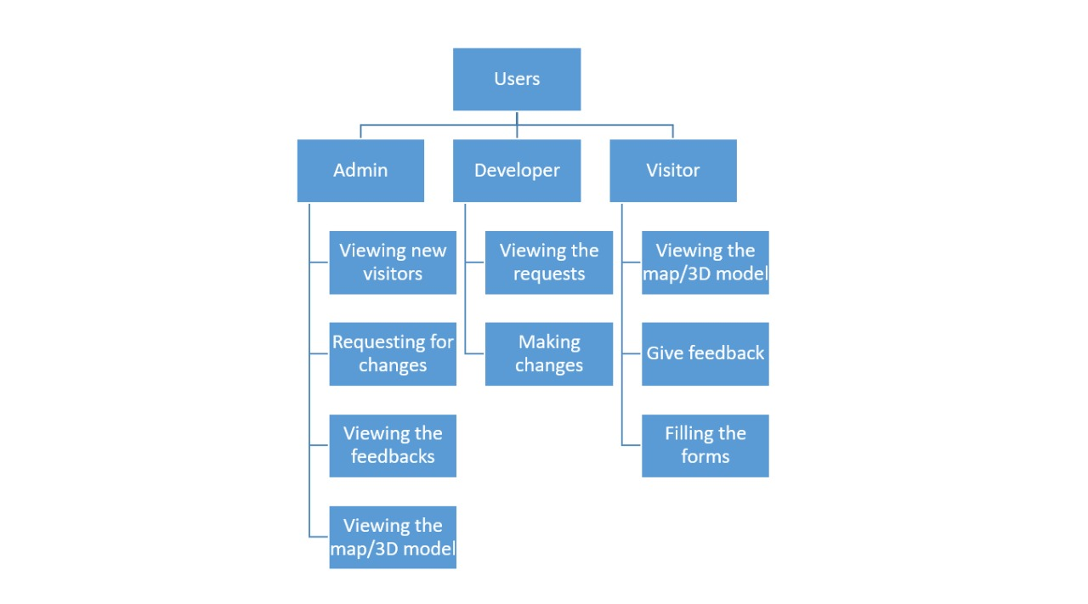

### 

### 2.2.3. Scope of the System

The AR Based Indoor mapping and user satisfaction System is divided in to three phases.

#### Phase I

Phase I includes following business areas:

* User Account
* Request process

#### Phase II

Phase II involves complete automation of the system. Phase II includes following business areas:

* Accounts and Administration
* Feedback

#### Phase III

Phase III covers a complete solution for AR Based Indoor mapping and user satisfaction. Phase III includes remaining business areas which are not developed in previous phases.

### 2.2.5. Summary of Requirements :( Initial Requirements)

The purposed system must fulfill following requirements as follow:

* **Customer Account**

The system shall allow the user to manage the account on the display screen, so the user easily manages .

* **Request process**

The system shall allow user to send the request to process .

* **Feedback department wise**

The syatem shall allow user to give feedback on the bases of behavior of the department workers.

**2.2.5.1. Supplier Department Requirements**

**Oder Management(visitor)**

1. Only registered users could place request for the path navigation . So a user must be able to register himself to the system by requesting for registration. There should have to be two types of registration process, normal and new visitor .User should provide his personal, organizational, authorizer details in the registration request process. All the requests are to be viewed by the user account administrator (CA). CA could accept, reject and temporarily waive the requests. If admin accept the registration request, a login information (Password, Id & role) should be assigned. He could request for the path of Indoor university. User could also view his details for verification purposes and similarly CA could search any user detail and could also view the whole list of currently registered customers.

2. Both registered and new visitors user could request for goods. User places an order by providing his ID and other order related details A complete order must contain personal details of the user. User could also view the status that has been updated by the admin related to the changing to the building . New visitors could also place the request for path navigation after fulfilling the requirements . After that the model of the building will be visible to the user.

3.Action List mechanism should be adopted for better notification/messaging services, business interaction and control. An action event should be generated for a corresponding administrator when a request is placed for path navigation. These actions could be generated by the Admin Operator or through the updating process. Similarly on the other hand corresponding administrator could view his Action List containing different actions, and correspondingly process these pending actions. Similarly when the action processing is completed or if the action is just a notification message then administrator could delete these actions from the action list. Actions List configuration should be done by System Admin, who could add new action events and delete any current event from the system.

### 2.2.6. Identifying External Entities:

The identification of the external entities will be based on the information contained in your Abstract. This identification is done after two phases. We will map the “Fast Shopping” case study to make things more comprehensible.

**Over Specify Entities from Abstract:**

On the basis of the Abstract, one might identify the following entities from the AR Based university mapping and user satisfaction case study.

* Visitor
* Request
* Register
* Model
* Search path
* navigation
* notification
* departmental level
* Feedback
* motion
* navigation
* map screen

### 2.2.7. Capture "shall" Statements:

Table : Shall statements

|  |  |
| --- | --- |
| **Para #** | **Initial Requirements** |
| 1.1 | A user “shall” place oder for path destination. |
| 1.2 | A user “shall” register himself to the system |
| 1.3 | The system “shall” provide two types of registration process, normal and new vistor. |
| 1.4 | CA “shall” accept, reject and temporarily waive the requests on the basis of requirements. |
| 1.5 | A customer “shall” login to the system and can change his password |
| 1.6 | System “shall” update the user Request |
| 1.7 | System “shall” process different types of updating e.g. updating of his personal details, or upgrading of his status from registered to privileged customer. |
| 1.8 | A user “shall” view his details for verification purposes |
| 1.9 | CA “shall”accept, reject and temporarily waive the requests on the basis of credentials provided. |
| 1.10 | System “shall” search any user details |
| 2.1 | Both registered and privileged customers “will ”request for path navigation. . |
| 2.2 | Privileged customer “shall” place the request for the cancellation of the order. But all these updating and cancellation requests are to be viewed by the Order Administrator in order to accept, reject, or waive them. |
| 3.1 | An action event "shall" be generated for a corresponding administrator when a request is placed for updating of orders or user details etc |

### 2.2.8. Allocate Requirements:

Table : Allocated Requirememnts

|  |  |  |
| --- | --- | --- |
| **Para #** | **Initial Requirements** | **Use Case Name** |
| 1.1 | A user “shall” place request for path destination | UC_Place_request |
| 1.2 | A user “shall” register request himself to the system | UC_Registration_Request |
| 1.3 | The system “shall” provide two types of registration process, normal and new vistor. | UC_Place_Registration |
| 1.4 | CA “shall” accept, reject and temporarily waive the requests on the basis of requirements. | UC_Process_Customer_Request |
| 1.1 | A customer “shall” login to the system and can change his password | UC_Login |
| 1.2 | System “shall” update the user Request | UC_Update_Request |
| 1.3 | System “shall” process different types of updating e.g. updating of his personal details, or upgrading of his status from registered to privileged customer. | UC_Change_Status |
| 1.4 | A user “shall” view his details for verification purposes | UC_View_user_Details |
| 1.5 | CA “shall”accept, reject and temporarily waive the requests on the basis of credentials provided. | UC_Accept_user_Request |
| 1.6 | System “shall” search any user details | UC_Search |
| 1.7 | Both registered and privileged customers “will ”request for path navigation | UC_Path_Navigation |
| 2.1 | Privileged customer “shall” place the request for the cancellation of the order. But all these updating and cancellation requests are to be viewed by the Order Administrator in order to accept, reject, or waive them. | UC_Place_Order_Privleged |

### 

### 2.2.9. Priorities Requirements:

Table : Priorities Requirements

|  |  |  |  |  |
| --- | --- | --- | --- | --- |
| Para # | **Rank** | **Initial Requirements** | **Use Case ID** | **Use Case Name** |
| 1.1 | Highest | A user “shall” place request for path destination |  | UC_Place_request |
| 1.2 | High | A user “shall” register request himself to the system |  | UC_Registration_Request |
| 1.3 | High | The system “shall” provide two types of registration process, normal and new vistor. |  | UC_Place_Registration |
| 1.4 | High | CA “shall” accept, reject and temporarily waive the requests on the basis of requirements. |  | UC_Process_Customer_Request |
| 1.5 | Medium | A customer “shall” login to the system and can change his password |  | UC_Login |
| 1.6 | Medium | System “shall” update the user Request |  | UC_Update_Request |
| 3.1 | Medium | System “shall” process different types of updating e.g. updating of his personal details, or upgrading of his status from registered to privileged customer. |  | UC_Update_status |
| 1.1 | Medium | A user “shall” view his details for verification purposes |  | UC_Verification |
| 1.1 | Medium | CA “shall”accept, reject and temporarily waive the requests on the basis of credentials provided. |  | UC_Accept _Request  UC_Reject_Request |
| 1.2 | Medium | System “shall” search any user details |  | UC_Search |
| 1.3 | Medium | Privileged customer “shall” place the request for the cancellation of the order. But all these updating and cancellation requests are to be viewed by the Order Administrator in order to accept, reject, or waive them. | UC_15 | UC_View_Customer_Details |
| 1.4 | Medium | Both registered and privileged customers “will ”request for path navigation | UC_16 | UC_Search_Customer |

### 2.2.10. Requirements Traceability Matrix:

Table : Requirement Traceability Matrix

|  |  |  |  |  |  |
| --- | --- | --- | --- | --- | --- |
| **Sr#** | **Para #** | **System Specification Text** | **Build** | **Use Case Name** | **Category** |
| 1 | 1.1 | The system” shall” allow the admin to login. | B1 | UC_login | Business |
| 2 | 1.2 | The system” shall” allow the admin to log out. | B1 | UC_Login | Business |
| 3 | 1.3 | The system” shall” allow the admin to edit the room numbers . | B1 | UC_UpdateroomNumber | Business |
| 4 | 1.4 | The system” shall” allow the admin to change the alert status. | B1 | UC_ News&Updates | Business |
| 5 | 1.5 | The system” shall” allow the visitor to search the destination . | B1 | UC_pathDetails | Business |
| 6 | 1.6 | The system” shall” allow the visitor to login . | B1 | UC_login | Business |
| 7 | 1.7 | The system” shall” allow the admin to change the alert status. | B1 | UC_ News&Updates | Business. |
| 8 | 1.8 | The system” shall” allow the visitor to search the destination . | B1 | UC_pathDetails | Business. |
| 9 | 1.9 | The system” shall” allow the visitor to login . | B1 | UC_login | Business. |
| 10 | 2.1 | The system” shall” allow the admin to notify concerned authorities. | B1 | UC_Updates | Business. |
| 11 | 2.2 | The system “shall” allow the average rating of the every department. | B1 | UC_Ratting | Business. |
| 12 | 2.3 | The system “shall” navigate the path. | B1 | UC_NavigationPanel | Business. |

### 2.2.11. High Level Use case Diagram:

A use case scenario is a visual description, typically written in structured English or point form, of a potential business situation that a system may or may not be able to handle.

A use case defines a goal-oriented set of interactions between external actors and the system under consideration.

A use case is initiated by a user with a particular goal in mind, and completes successfully when that goal is satisfied. It describes the sequence of interactions between actors and the system necessary to deliver the service that satisfies the goal. It also includes possible variants of this sequence, e.g., alternative sequences that may also satisfy the goal, as well as sequences that may lead to failure to complete the service because of exceptional behavior, error handling, etc. The system is treated as a “black box”, and the interactions with system, including system responses, are as perceived from outside the system.

Thus, use cases capture who (actor) does what (interaction) with the system, for what purpose (goal), without dealing with system internals. A complete set of use cases specifies all the different ways to use the system, and therefore defines all behavior required of the system, bounding the scope of the system.

Generally, use case steps are written in an easy-to-understand structured narrative using the vocabulary of the domain. This is engaging for users who can easily follow and validate the use cases, and the accessibility encourages users to be actively involved in defining the requirements.

**Example:**

Figure : High Level Use Case Diagram

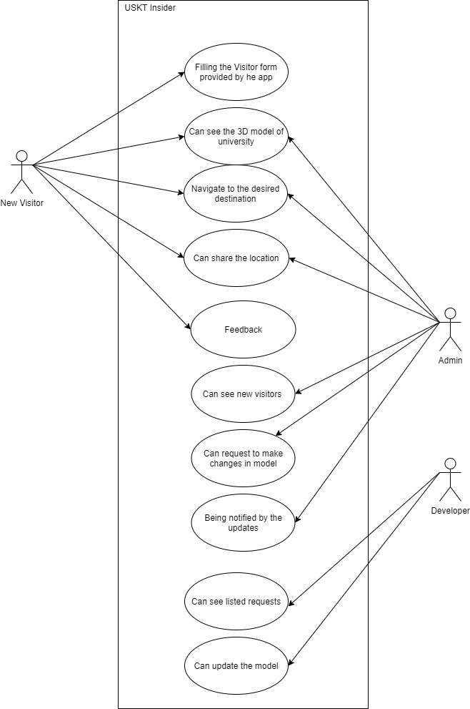

### 

### 2.2.12. Analysis Level Usecase Diagram:

Analysis level usecase diagram is actually the explanation of high level usecas diagram. In this diagram high level usecases are expanded in a way that exhibit how high level usecases will reach to their functionality. Two types of relationships are used in this diagram. Which are:

* Extend
* Include

Figure : Level Use Case Diagram

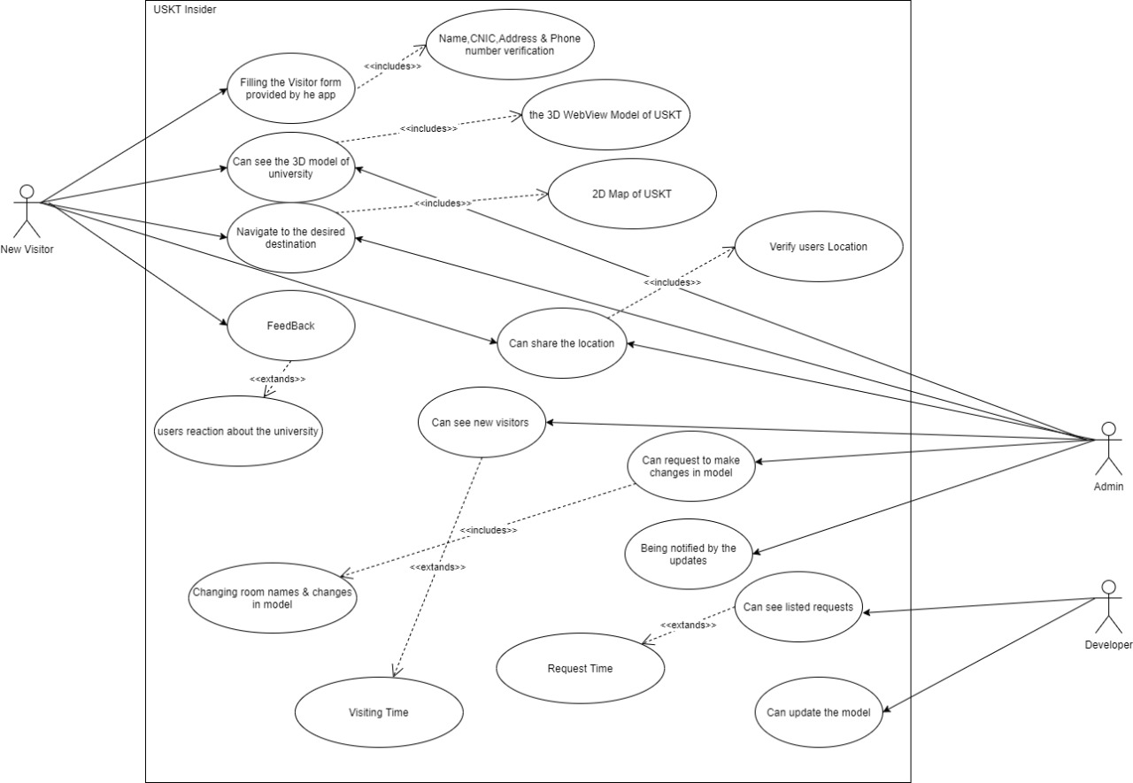

### 2.2.13. Usecase Description

While technically not part of UML, use case documents are closely related to UML use cases. A use case document is text that captures the detailed functionality of a use case. Such documents typically contain the following parts:

#### Brief description

This use case describes how the system start and show the form of app.The system admin utilize the interface to input the room data of selected map. Visitor utilizes navigation application to obtain their position information. Visitors utilizes navigation application to find a route to walk from a room to other room. system admin utilizes

Calibration tool to browse floor plan and related calibration data.

#### Preconditions

* Preconditions is Smartphone is connected to internet.
* Filing the form provided by the app.
* Log in with valid credentials.
* Check the show password feature.
* Check the Remember Me Checkbox.
* Check the autofill.
* Check the logout button restore the password with a registered email.
* Check the Forget password email.
* Create a new password using valid data.
* The app is loaded or not the location services or allowed or not ?
* Camera allowed or not.
* The motion senser are working or not.

#### Basic flow

Basic flow of the app is fill the form and enter your name CNIC and address and phone number and then show the 3D WebView model of USKT. Call the 3D model of Uskt. And also admin show the map by 2D model. also then visitor navigate the desired location. Click the route description status bar . Click Start tracking button

#### Alternate flows

If route tracking function had been enabled, user can click Stop tracking to disable the tracking function.

#### Post conditions

The Collected information The room data is stored into database.A room-level positioning result will be obtain. In addition, if route tracking function is turned on, the non-room-level positioning result will be obtain. Then finally, the result will be displayed on the Map viewer and the Map viewer screen will auto scroll to the result position. If route has been found, the route will be displayed on Map viewer. And a route description will be shown in a status bar. Otherwise, user will be noticed the route not found. It may occur, when user has an input error. The user position will be displayed on Map viewer.

# Chapter 3: Software Architecture and Design

## 3.1. Introduction

The proposed system can be designed and developed using some techniques. The priority of this application is to assist users in unfamiliar surroundings within a complex indoor structure. Users can select their desired location within the indoor structure and the application then displays directions that can be viewed through the user’s smartphone using augmented reality. They will provide map functions and combine with positioning service to develop a mobile navigation application. In this section, the system architecture, system design and provided functions will be discussed. In addition, several diagrams will be used to help to describe the design.

1. Domain Model
2. System Sequence Diagram
3. Sequence Diagram
4. Collaboration Diagram
5. Operation Contracts
6. Design Class Diagram
7. State Transition Diagram
8. Data Model
9. Now we discuss these artifacts one by one as follows:
10. Now we discuss these artifacts one by one as follows:

## 3.2. Domain Model

In domain model we show the domain of our system in a graphical form that displays the functionalities as shown in following diagram.

Figure : Domain Model

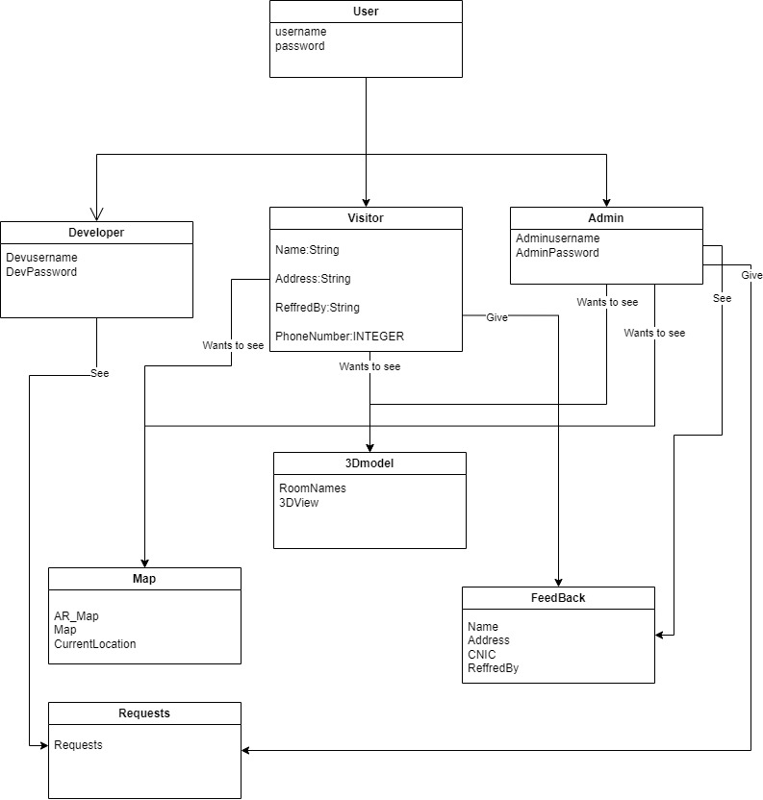

## 3.3. Architecture/Design Pattern

The DFD diagram shows the operational requires being sent to the system by all the users and possible outputs.

Figure : Architecture/Design Pattern

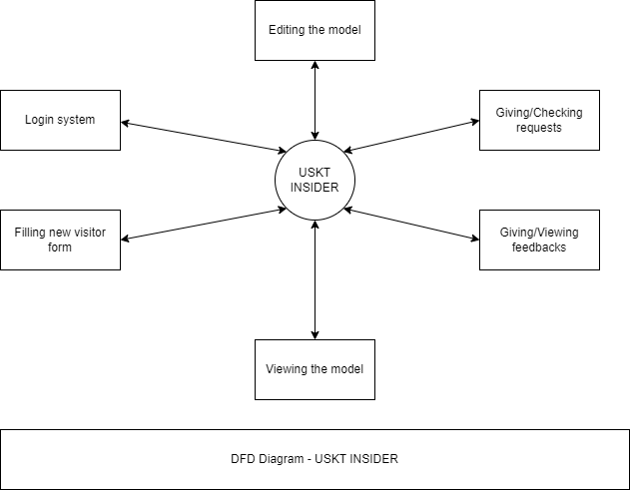

## 3.4. Algorithm Flow Chart

An flowchart an graphical representation of an flow to actions or function that are being taken in the system. The following diagram shows the flow of actions and functions of our system.

Figure : Algorithm Flow Chart



**3.5 System Sequence Diagram**

The following diagram shows the simple sequence of inputs and outputs of the system.

Figure : System Sequence Diagram

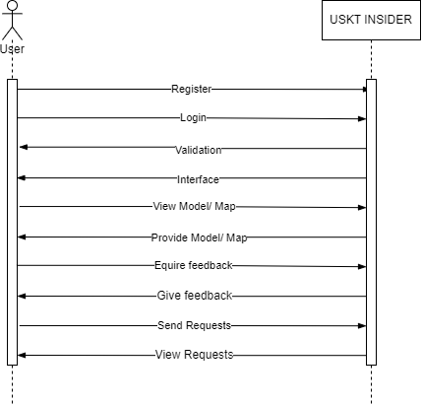

## Sequence Diagram

The sequence diagram shows the sequence of user interaction with the user as shown in the following diagram the users are interacting with the system in a proper sequence with their queries.

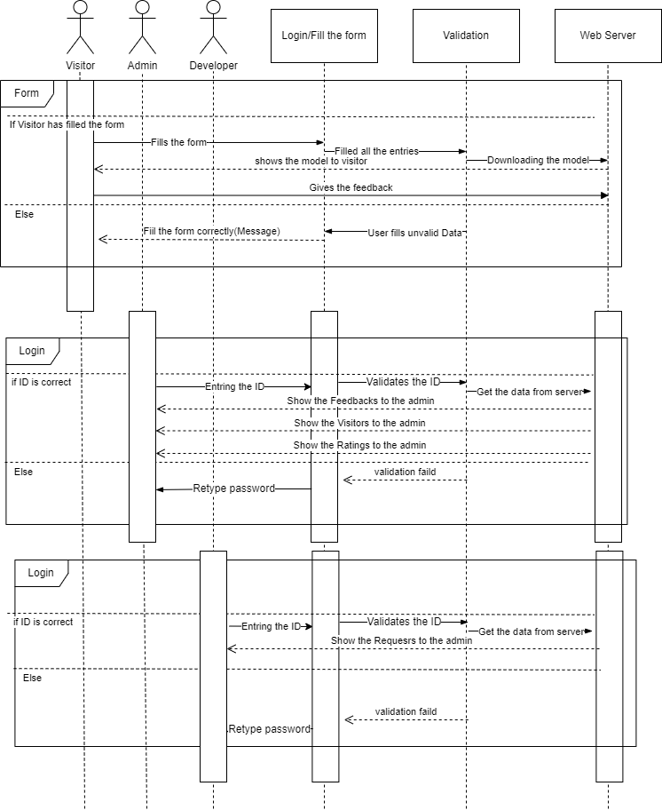

Figure : Sequence Diagram

## Collaboration Diagram

The following diagram is an illustration of the relationships and interactions among software objects in the Unified Modeling Language (UML). This diagrams can be used to portray the dynamic behavior of a particular use case and define the role of each object.

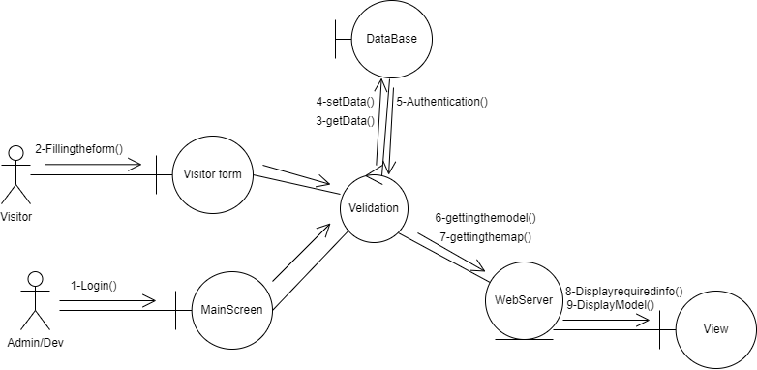

Figure : Collaboration Diagram

## 3.8. Operation Contracts

Operation Contract Syntax

**Contract C1: Registration**

|  |  |
| --- | --- |
| **Name:** | Registration (Username, Email, Phone number, Password, Confirm Password). |
| **Responsibilities:** | Enter User Registration Details into System. |
| **Cross Reference:** | Use cases: UC_SignUp. |
| **Exception:** | If Password and Confirm Password are not same, it sets an error. |
| **Preconditions:** | Application must be in Running State and Wi-Fi is on. Sign up Form visible to user. |
| **Post Conditions:** | If required information is not fulfilled correctly, do it correct and if  required information is fulfilled correctly. User got registered. |

**Contract C2: Login Page**

|  |  |
| --- | --- |
| **Name:** | Login (Email, Password). |
| **Responsibilities:** | Enter Login Credentials into System. |
| **Cross Reference:** | Use cases: UC_Login. |
| **Exception:** | If email and password not correct it sets an error. |
| **Preconditions:** | Application must be in running state and user should be registered. |
| **Post Conditions:** | If Email and Password incorrect user should stick on same activity and notified about to enter correct credentials. If Email and Password are correct. Dashboard activity will appear. |

**Contract C3: Dashboard**

|  |  |
| --- | --- |
| **Name:** | Dashboard (Main Activity visible after login includes branding, and Some Banners). |
| **Responsibilities:** | Select Brand, Slider Banners. |
| **Cross Reference:** | UC_DashBoard. |
| **Exception:** | If user not login with system dashboard not appears. |
| **Preconditions:** | If user not login with system dashboard not appears |
| **Post Conditions:** | User able to interact with UI and explore application Dashboard. |

**Contract C4: Navigate Room**

|  |  |
| --- | --- |
| **Name:** | Navigate Product (By Name). |
| **Responsibilities:** | User locate their needed product. |
| **Cross Reference:** | Use cases: UC_NavigationPanel. |
| **Exception:** | Device must have an internet connection. |
| **Preconditions:** | Wi-Fi is on, Application must be in running state and Signed up / Logged, Dashboard must appears, and brand must be selected |
| **Post Conditions:** | User able to locate their product by their brand and name. |

**Contract C5: View Model**

|  |  |
| --- | --- |
| **Name:** | View Model (3D Model of University). |
| **Responsibilities:** | User see 3D Model of mart in 3D View Model. |
| **Cross Reference:** | Use cases: UC_ViewModel. |
| **Exception:** | Device must have an internet connection. |
| **Preconditions:** | Wi-Fi is on, Application must be in running state and Signed up / Logged and Dashboard must appears. |
| **Post Conditions:** | User able to understand mart map using 3d model. |

**Contract C6: Feedback**

|  |  |
| --- | --- |
| **Name:** | Feedback(About the Behavior of Departmental level Staff). |
| **Responsibilities:** | User feedback by their experience. |
| **Cross Reference:** | Use cases: UC_Feedback. |
| **Exception:** | none |
| **Preconditions:** | Wi-Fi is on, Application must be in running state and Signed up / Logged, Dashboard must appears, and user must buy products. |
| **Post Conditions:** | User able to feedback to Staff about staff behavior or accuracy in their work. |

**Contract C7: Feedback Information to Admin**

|  |  |
| --- | --- |
| **Name:** | Feedback Information to Admin |
| **Responsibilities:** | User can check and update its personal details. |
| **Cross Reference:** | Use cases: UC_ FeedbacktoAdmin |
| **Exception:** | none |
| **Preconditions:** | User have to verify their Destination from admin. |
| **Post Conditions:** | Admin See the user Request and also Respond it. |

**Contract C8: Room Details**

|  |  |
| --- | --- |
| **Name:** | Room Details |
| **Responsibilities:** | Admin can add and modify details of product. |
| **Cross Reference:** | Use cases: UC_RoomtDetails |
| **Exception:** | Device must have an internet connection |
| **Preconditions:** | Admin have to add or modify details in database |
| **Post Conditions:** | User able to check bill details in list. |

**Contract C9: Forget Password**

|  |  |
| --- | --- |
| **Name:** | Forget Password |
| **Responsibilities:** | User can change its authentication if user can forget it. |
| **Cross Reference:** | Use cases: UC_ForgetPassword |
| **Exception:** | Device must have an internet connection and a valid email for verification and code that have sent on mail does not same it set an error. |
| **Preconditions:** | User’s id is correct but password is incorrect |
| **Post Conditions:** | User have Login. |

## Design Class Diagram

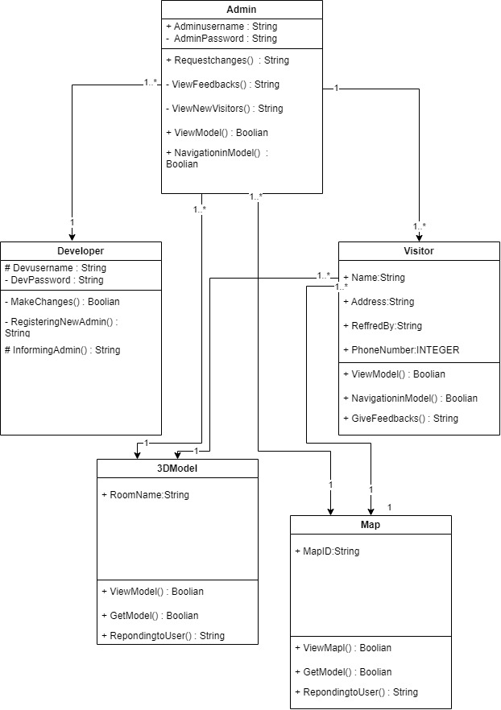

Figure : Design Class Diagram

## StateChartDiagramState chart diagram

Figure : State Chart Diagram

The state chart diagram shows the next or upcoming state of the system as we have shown in the following diagram.

## Database Model

The following diagram shows the variabes being ised in the system database.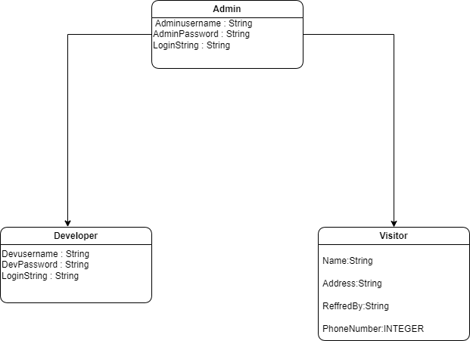

Figure : System Database Model

We construct the following Entity Relationship Matrix:

|  |  |  |  |  |
| --- | --- | --- | --- | --- |
|  | **Department** | **Employee** | **Supervisor** | **Project** |
| Department |  | is assigned | run by |  |
| Employee | belongs to |  |  | works on |
| Supervisor | runs |  |  |  |
| Project |  | uses |  |  |

* 1. ***Rough ERD***

An entity relationship diagram (ERD), also known as an entity relationship model, is a graphical representation that depicts relationships among people, objects, places, concepts or events within an information technology (IT) system. The following ERD contain basic concept of our system.

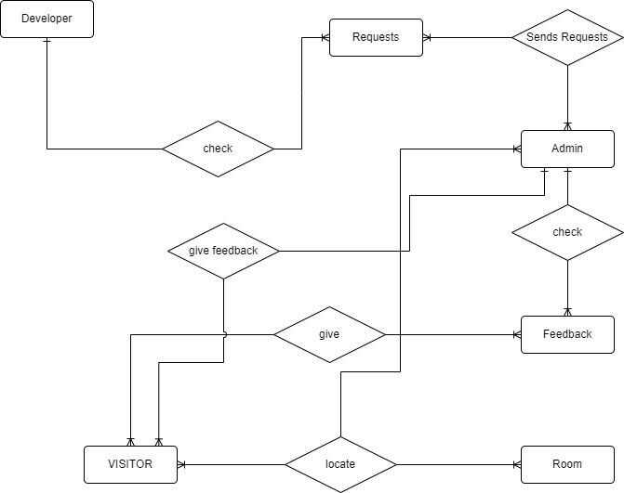

Figure : Rough ERD

**3.12.Draw Key-Based ERD**

An entity relationship diagram (ERD), also known as an entity relationship model, is a graphical representation that depicts relationships among people, objects, places, concepts or events within an information technology (IT) system. The following ERD contain basic concept of our system.

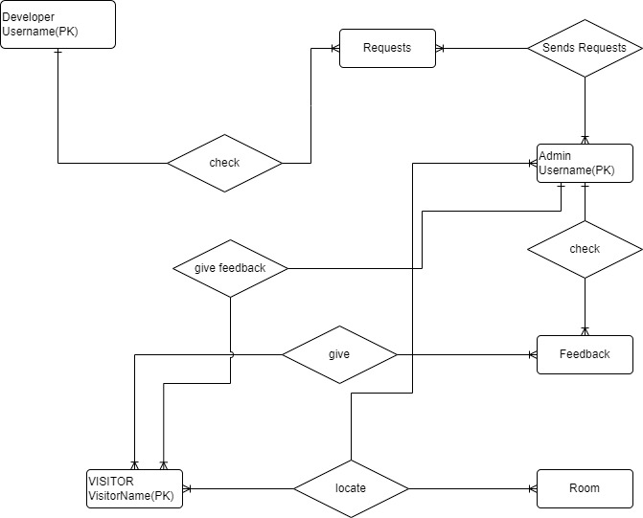

Figure : Key-Based ERD

|  |  |  |  |
| --- | --- | --- | --- |
| **Attribute** | **Entity** | **Attribute** | **Entity** |
| Department Name | Department | Supervisor Number | Supervisor |
| Employee Number | Employee | Supervisor Name | Supervisor |
| Employee Name | Employee | Project Name | Project |
|  |  | Project Number | Project |

**3.13..Draw Fully Attributed ERD**

An entity relationship diagram (ERD), also known as an entity relationship model, is a graphical representation that depicts relationships among people, objects, places, concepts or events within an information technology (IT) system. The following ERD contain Attributed concept of our system.

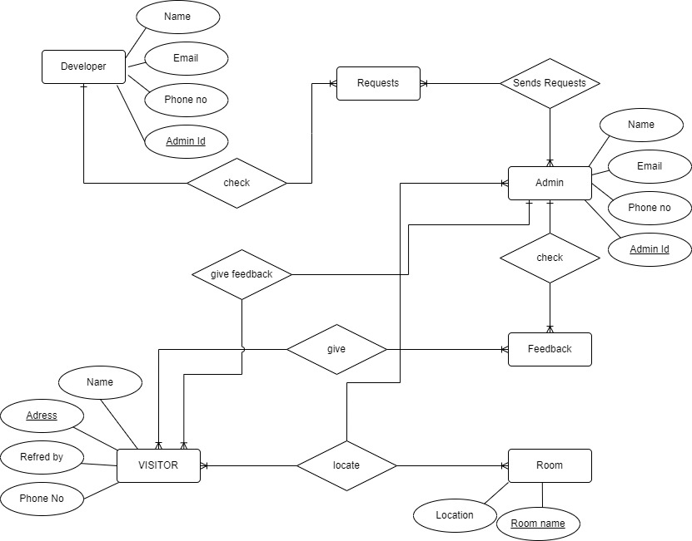

Figure : Fully Attributed ERD

**References**

[1].https://www.researchgate.net/publication/354296946_Indoor_Navigation_Using_Augmented_Reality.

[2].https://www.researchgate.net/publication/311927005_Augmented_Reality_for_Indoor_Navigation_and_Task_Guidance.

[3]. <https://www.ncbi.nlm.nih.gov/pmc/articles/PMC8401022/>.

[4]. <https://core.ac.uk/download/pdf/381812169.pdf>.

[5]. https://www.irjet.net/archives/V8/i6/IRJET-V8I6429.pdf.