**Screenshot File**

**Project Name: Set Up and Monitor a WordPress instance for your organization**

**Step-1**  Set up a live WordPress instance to publish blogs

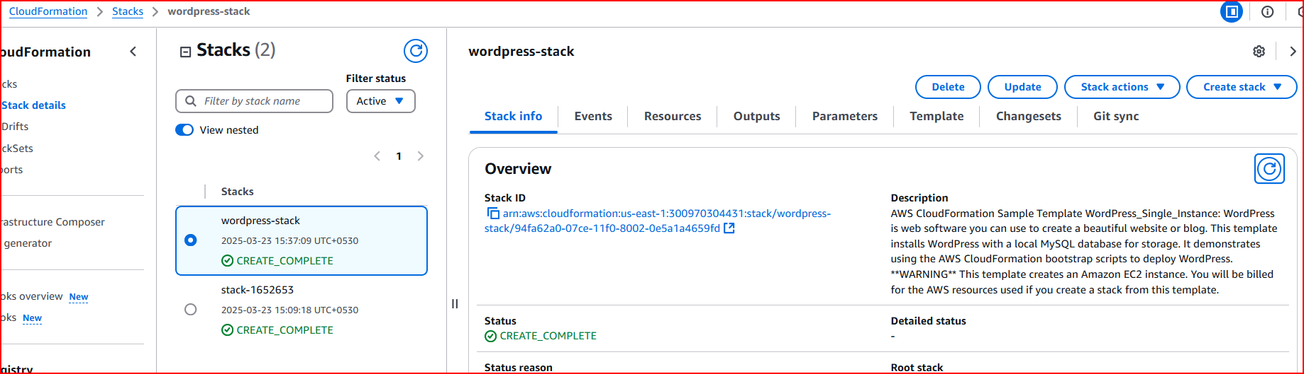

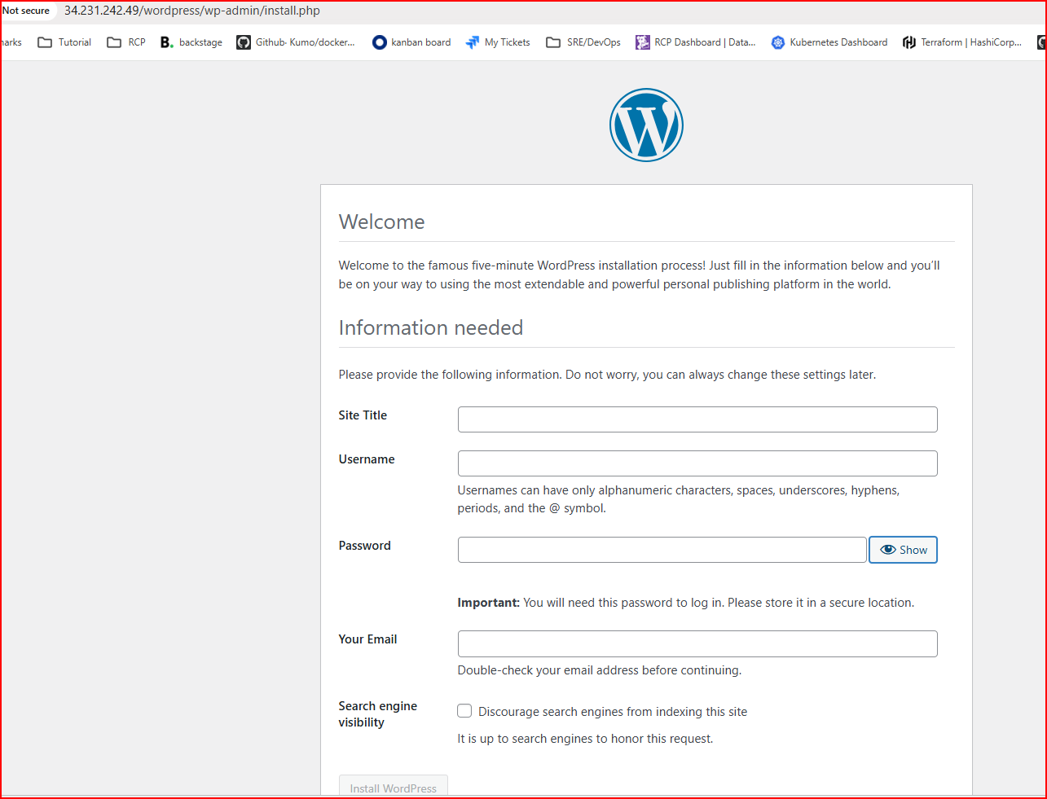

**Step-2**  Set up a WordPress instance that can be used for development and testing purposes so that any work done on this instance will not impact the live blog

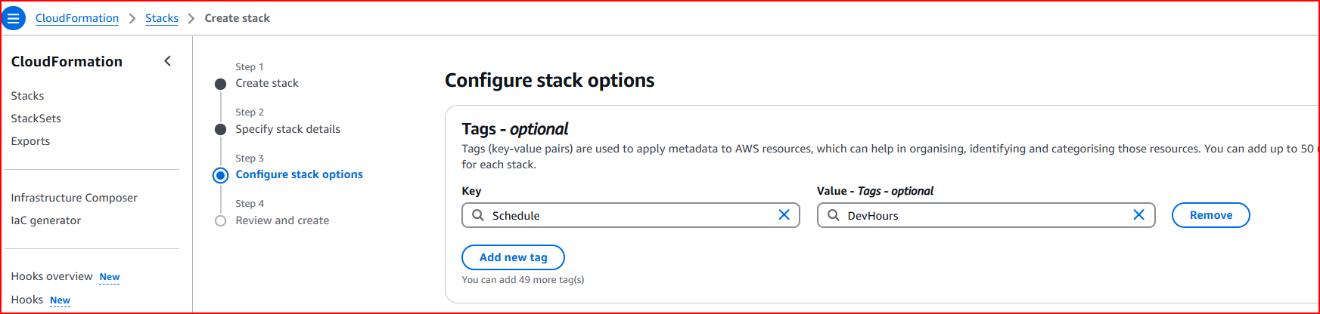

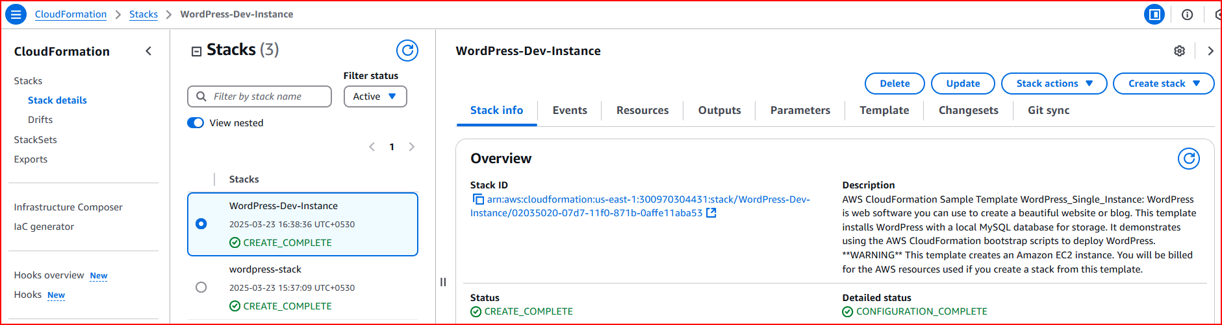

**Step-3** Configure the WordPress instance for development and testing purposes, which will be available only during the business hours (9 AM–6 PM)

These are the schedule for START-STOP EC2 Dev instance.  
**NOTE:**

(AWS uses UTC, so 9 AM IST = 3:30 AM UTC, rounded to 3 AM UTC.)  
(6 PM IST = 12:30 PM UTC, rounded to 12 PM UTC.)

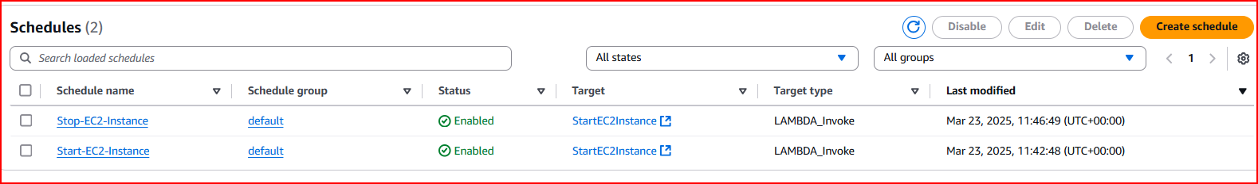

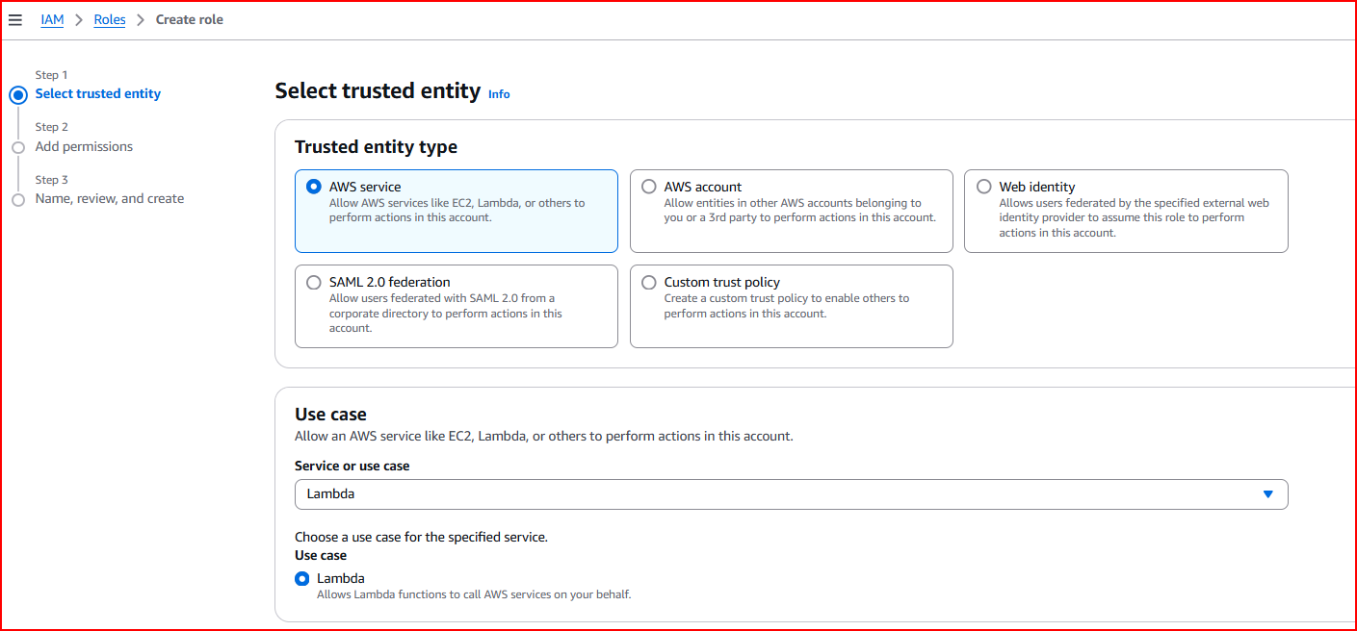

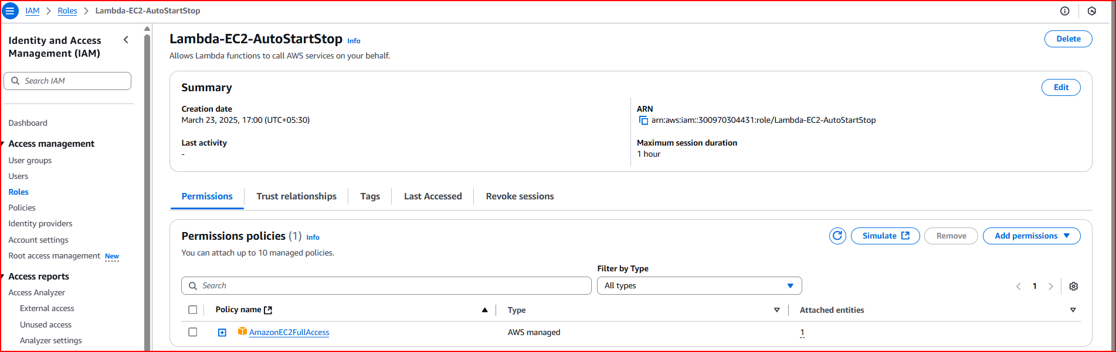

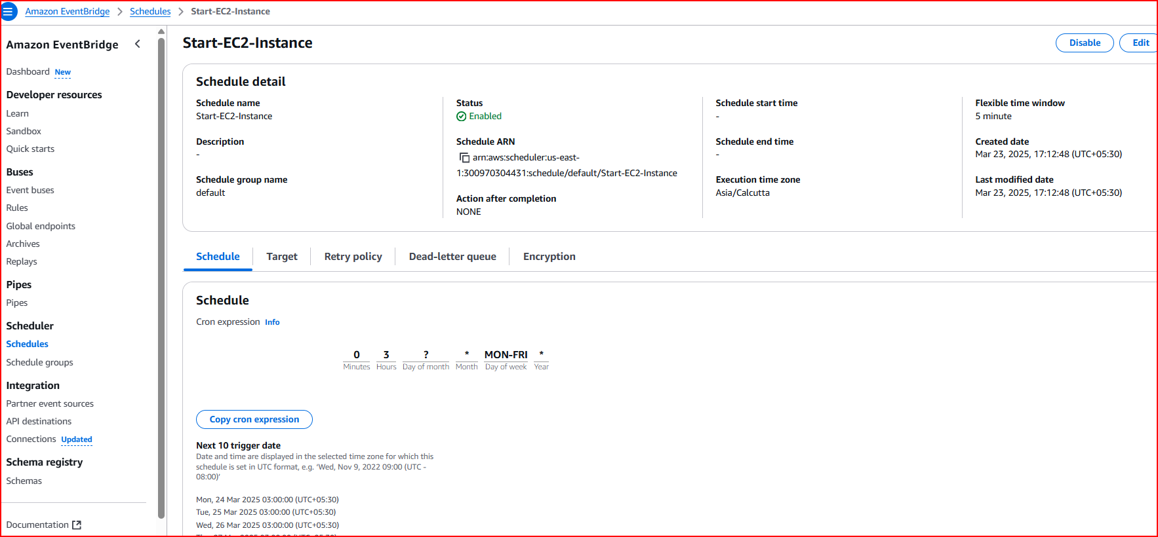

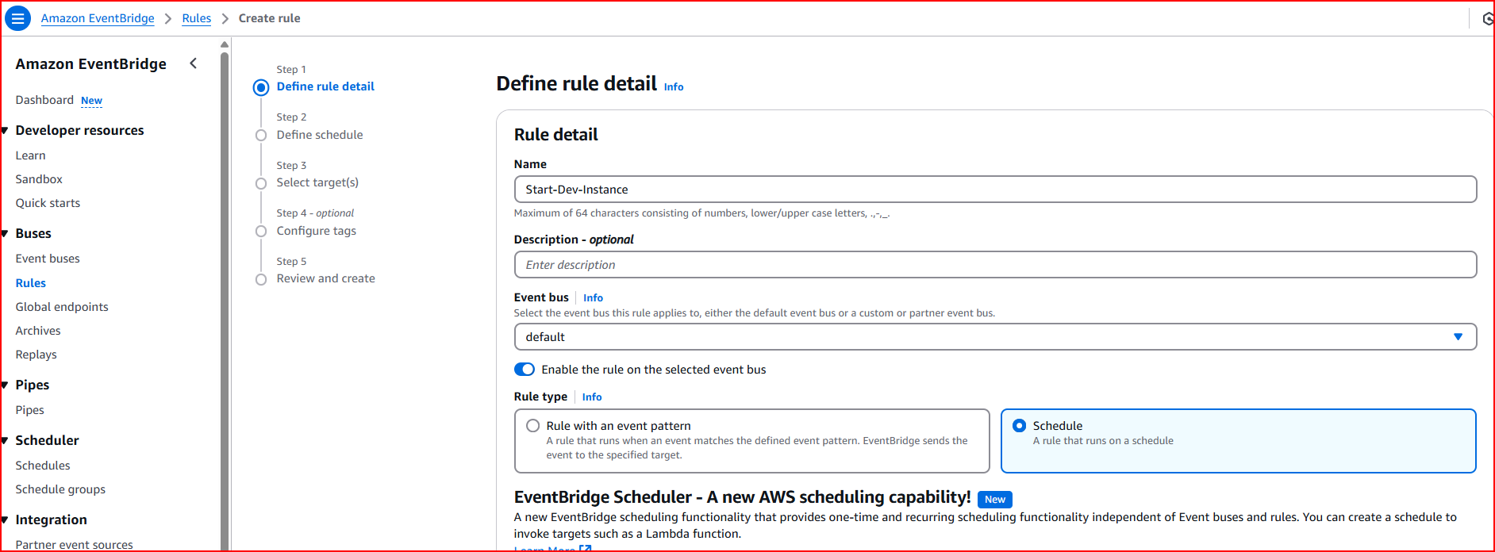

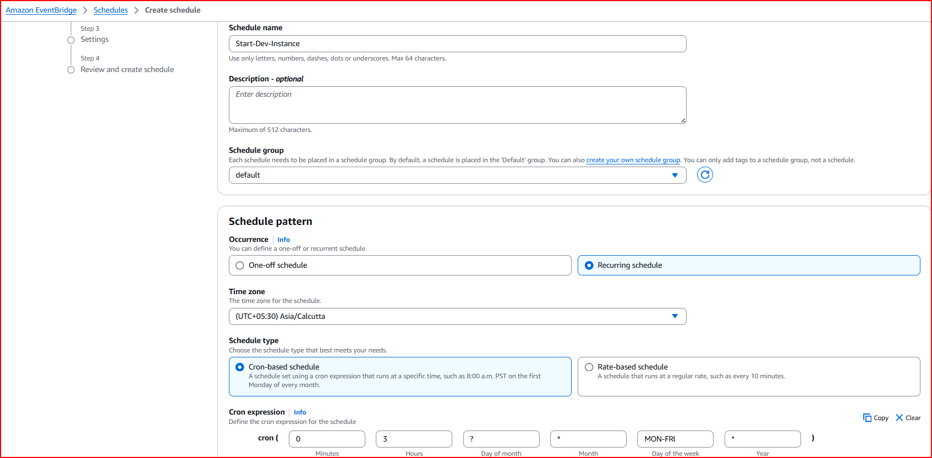

**Step-4**  Monitor the health of the WordPress instance

