**CONTACT ME**

Spg. 938-70-112-5, No. 6, Jln. Agau, Kampong Batong Parit Masin, BH1123.

iqbalmatnoor22@gmail.com +673 8668195

linkedin.com/in/iqbal-haji-matnoor

**EDUCATION**

**Bsc in Computer Science**

**Laksamana College of Business**

2017-2020

**Diploma in Information Technology**

**Maktab Teknik Sultan Saiful Rijal** 2014-2016

**SKILLS**

|  |  |  |  |  |  |
| --- | --- | --- | --- | --- | --- |
| Communication |  |  |  | 90% |  |
|  |  |  |  |
|  |  |  |  |
| Leadership |  |  | | 80% |  |
|  |  | |  |
|  |  | |  |
| Teamwork |  | | | 90% |  |
|  | |  |  |
|  | | |  |
| Office |  | | | 90% |  |
|  | |  |  |
|  | | |  |
| Management |  | | | 90% |  |
|  | |  |  |
|  | | |  |
| Problem Solving |  | | | 80% |  |
|  |  | |  |
|  | | |  |

|  |  |  |  |  |  |  |  |
| --- | --- | --- | --- | --- | --- | --- | --- |
|  | **LANGUAGES** | | | |  |  |  |
|  |  |  |  |  |  |  |  |
| English |  |  |  |  | | 80% |  |
|  |  |  | |  |
|  |  |  | |  |
| Malay |  |  | |  | | 90% |  |
|  | |  | |  |
|  | |  | |  |

**MUHAMMAD IQBAL NUR RIFQI BIN HAJI MATNOOR**

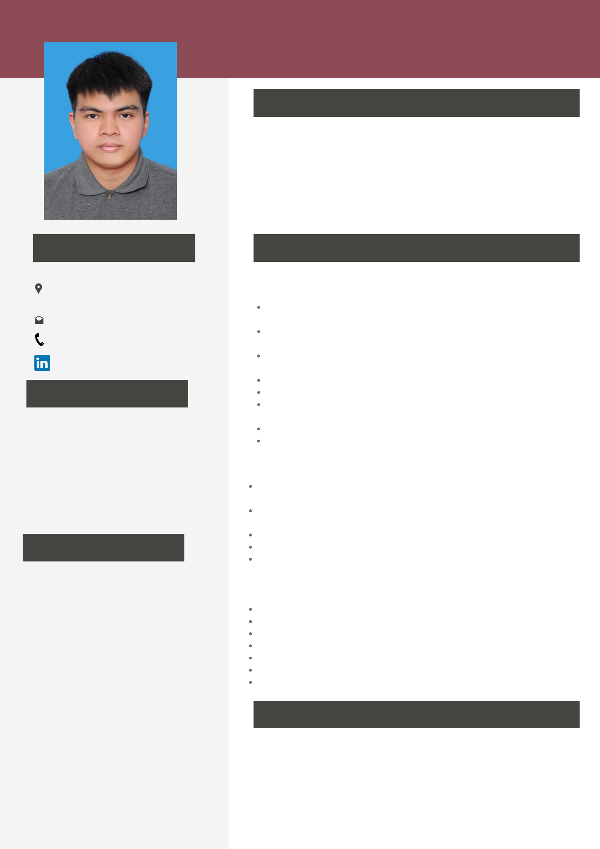

**PERSONAL INFO**

I am a hard working, honest individual and also good time management. I always willing to learn new skills. I am friendly, helpful and polite, have a good sense of humour. I am able to work independently in busy environments and also within a team setting. I am outgoing and tactful, and able to listen effectively when solving problems.

**WORK EXPERIENCE**

IT Officer (I-Ready Apprentice Program)

**Jabatan Pengajian Islam** 22 May 2021-21 November 2022

Manage track record in delivering exceptional service to end-users and company clients.

Maintain accurate, comprehensive reports of all IT-related systems including desktops and laptops and IT hardware.

Ensure proper maintenance of computers peripherals, printer, networking, internet & e-mail, security, data backup and recovery.

Assist to install software, network, internet, email, printer and update antivirus.

Train and guide user on using new software, PC maintenance and troubleshoot.

Interact with third-party service providers and vendors as needed top support core duties.

Updates user data and produces activity reports.

Manage new and existing users in Active Directory and Office365

IT Technician 1 October 2020 - 20 May 2021

**OKVY Enterprise**

Perform troubleshooting to diagnose and resolve problems (repair or replace parts, debugging etc.)

Provide orientation and guidance to users on how to operate new software and computer

equipment

Re-imaging of laptops and desktops and software deployment

Maintain records/logs of repairs and fixes and maintenance schedule

Developing positive relationships with all departments and colleagues.

IT Support 1 April 2016 - 31 July 2016

**Universiti Brunei Darussalam**

Resolving IT support requests from employees

Answering employee questions regarding computer systems

Gathering and analyzing data to diagnose problems with computer systems

Changing configurations, settings and permissions to fix computer issues

Generating sign ins for new hires during the onboarding process

Installing new software and hardware drivers and updating existing ones as needed Logging all service requests and updating tickets as needed

**REFERENCES**

**Sabri Amirul Hafiz bin Haji Yunos**

Pegawai Pelajaran, Jabatan Pengajian Islam

**Phone:** +673 881 1181

**Email :** sabri.yunos@jpi.edu.bn