Q1. List top 5 customers by total order amount.
Retrieve the top 5 customers who have spent the most across all sales orders. Show CustomerID, CustomerName, and TotalSpent.

ANSWER : select TOP 5
cust.first_name + ' ' + cust.last_name as full_name,
SUM(ordIt.list_price) as order_amount
from sales.customers as cust
inner join sales.orders as ord
on ord.customer_id = cust.customer_id
inner join sales.order_items as ordIt
on ordIt.order_id = ord.order_id
group by cust.first_name,cust.last_name
order by order_amount desc

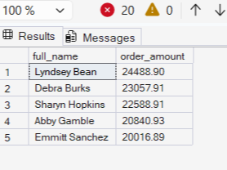

Q2. Find the number of products supplied by each supplier.
Display SupplierID, SupplierName, and ProductCount. Only include suppliers that have more than 10 products.

ANSWER : SELECT
sup.Name,
COUNT(pod.ProductID) as ProductCount
FROM
dbo.Supplier as sup
INNER JOIN dbo.PurchaseOrder as po
ON po.SupplierID = sup.SupplierID
INNER JOIN dbo.PurchaseOrderDetail as pod
ON pod.OrderID = po.OrderID
GROUP BY sup.Name
HAVING COUNT(pod.ProductID)>10

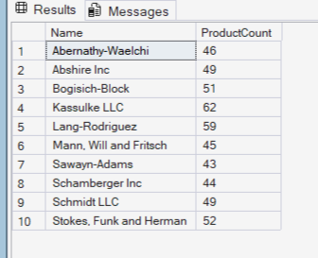

Q3. Identify products that have been ordered but never returned.
Show ProductID, ProductName, and total order quantity.

ANSWER : SELECT
pr.Name,
pr.ProductID
FROM dbo.Product as pr
WHERE pr.ProductID IN ( SELECT pod.ProductID
FROM dbo.PurchaseOrderDetail as pod)
AND pr.ProductID NOT IN ( SELECT rod.ProductID
FROM dbo.ReturnDetail as rod)
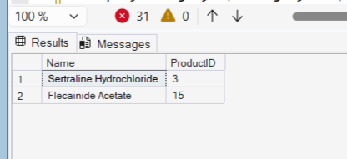
Q4. For each category, find the most expensive product.
Display CategoryID, CategoryName, ProductName, and Price. Use a subquery to get the max price per category.

ANSWER : SELECT
c.CategoryID,
c.Name as CategoryName,
p.Name AS ProductName,
p.Price
FROM dbo.Product p
INNER JOIN dbo.Category c
ON c.CategoryID = p.CategoryID
WHERE p.Price =
(
SELECT MAX(p2.Price)
FROM dbo.Product p2
WHERE p2.CategoryID = p.CategoryID
);

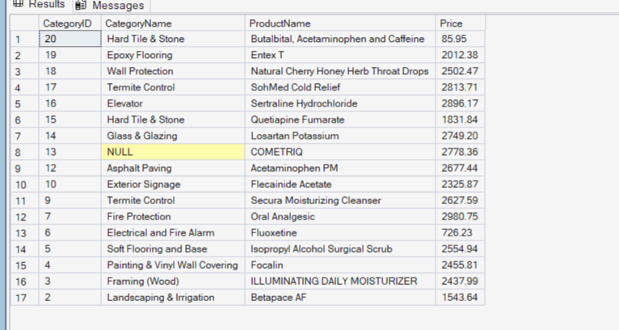
Q5. List all sales orders with customer name, product name, category, and supplier.
For each sales order, display:
OrderID, CustomerName, ProductName, CategoryName, SupplierName, and Quantity.
ANSWER : select
so.OrderID,
cust.Name as CustomerName,
pr.Name as ProductName,
cat.Name as CategoryName,
sup.Name as SupplierName,
sod.Quantity
from dbo.SalesOrder as so
inner join dbo.Customer as cust
on cust.CustomerID = so.CustomerID
inner join dbo.SalesOrderDetail as sod
on sod.OrderID = so.OrderID
inner join dbo.Product as pr
on pr.ProductID = sod.ProductID
inner join dbo.Category as cat
on cat.CategoryID = pr.CategoryID
inner join PurchaseOrderDetail as pod
on pod.ProductID = pr.ProductID
inner join PurchaseOrder as po
on po.OrderID = pod.OrderID
inner join Supplier as sup
on sup.SupplierID = po.SupplierID

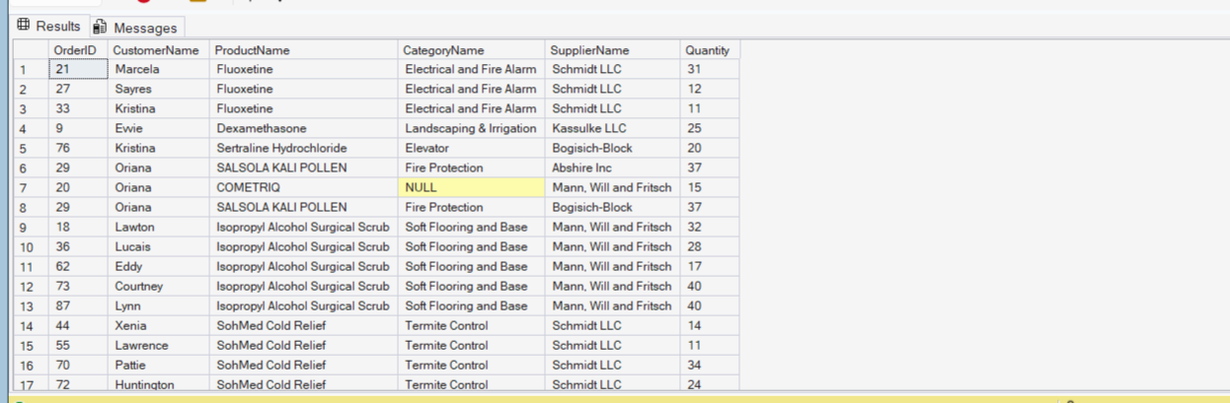
Q6. Find all shipments with details of warehouse, manager, and products shipped.
Display:
ShipmentID, WarehouseName, ManagerName, ProductName, QuantityShipped, and TrackingNumber.

ANSWER : SELECT
s.ShipmentID,
w.Capacity AS WarehouseName,
e.Name AS ManagerName,
p.Name AS ProductName,
sd.Quantity AS QuantityShipped,
s.TrackingNumber
FROM dbo.Shipment s
INNER JOIN dbo.Warehouse w
ON w.WarehouseID = s.WarehouseID
INNER JOIN dbo.Employee e
ON e.EmployeeID = w.ManagerID
INNER JOIN dbo.ShipmentDetail sd
ON sd.ShipmentID = s.ShipmentID
INNER JOIN dbo.Product p
ON p.ProductID = sd.ProductID
ORDER BY s.ShipmentID;

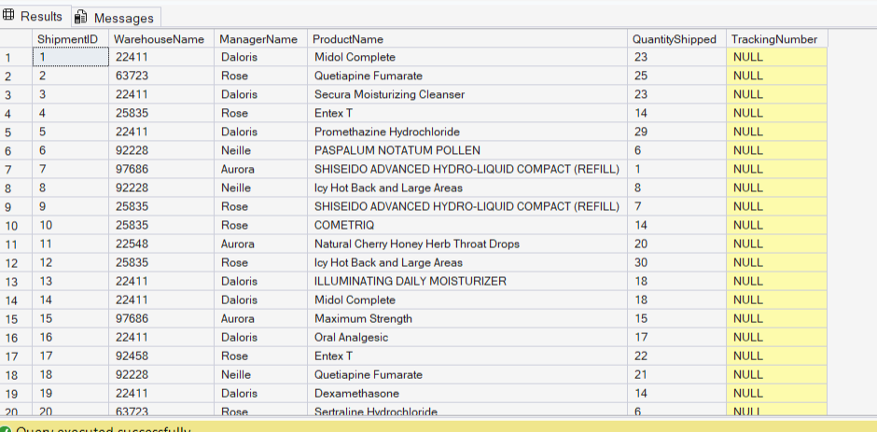

Q7. Find the top 3 highest-value orders per customer using RANK(). Display CustomerID, CustomerName, OrderID, and TotalAmount.
ANSWER : WITH CustomerOrderRank AS
(
SELECT
c.CustomerID,
c.Name AS CustomerName,
so.OrderID,
so.TotalAmount,
RANK() OVER
(
PARTITION BY c.CustomerID
ORDER BY so.TotalAmount DESC
) AS OrderRank
FROM dbo.Customer c
INNER JOIN dbo.SalesOrder so
ON so.CustomerID = c.CustomerID
)
SELECT
CustomerID,
CustomerName,
OrderID,
TotalAmount
FROM CustomerOrderRank
WHERE OrderRank <= 3
ORDER BY CustomerID, TotalAmount DESC;

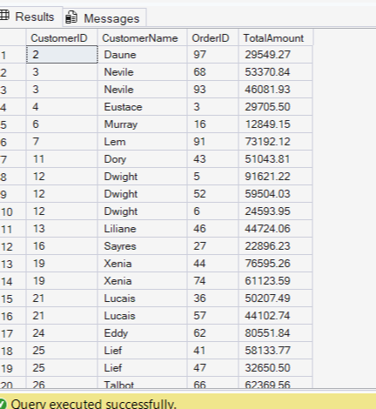

Q8. For each product, show its sales history with the previous and next sales quantities (based on order date). Display ProductID, ProductName, OrderID, OrderDate, Quantity, PrevQuantity, and NextQuantity.
ANSWER : SELECT
p.ProductID,
p.Name AS ProductName,
so.OrderID,
so.OrderDate,
sod.Quantity,

LAG(sod.Quantity) OVER
(
PARTITION BY p.ProductID
ORDER BY so.OrderDate
) AS PrevQuantity,

LEAD(sod.Quantity) OVER
(
PARTITION BY p.ProductID
ORDER BY so.OrderDate
) AS NextQuantity

FROM dbo.Product p
INNER JOIN dbo.SalesOrderDetail sod
ON sod.ProductID = p.ProductID
INNER JOIN dbo.SalesOrder so
ON so.OrderID = sod.OrderID
ORDER BY
p.ProductID,
so.OrderDate;

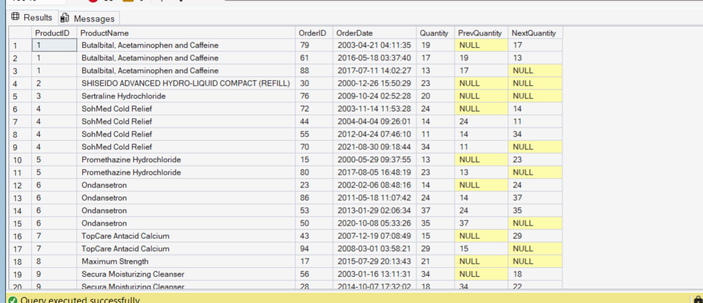

Q9. Create a view named vw_CustomerOrderSummary that shows for each customer:
CustomerID, CustomerName, TotalOrders, TotalAmountSpent, and LastOrderDate.

ANSWER : CREATE VIEW vw_CustomerOrderSummary
AS
SELECT
c.CustomerID,
c.Name AS CustomerName,
COUNT(so.OrderID) AS TotalOrders,
SUM(so.TotalAmount) AS TotalAmountSpent,
MAX(so.OrderDate) AS LastOrderDate
FROM dbo.Customer c
LEFT JOIN dbo.SalesOrder so
ON so.CustomerID = c.CustomerID
GROUP BY
c.CustomerID,
c.Name;
GO

SELECT *
FROM vw_CustomerOrderSummary;

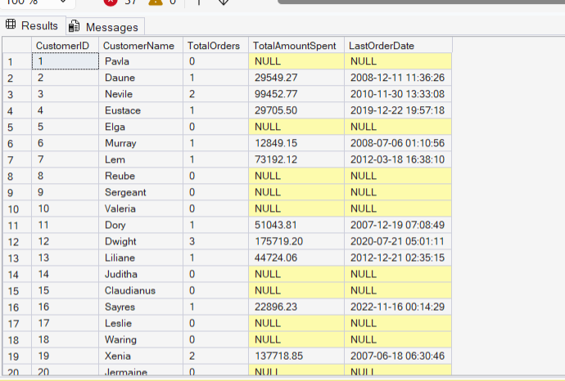

Q10. Write a stored procedure sp_GetSupplierSales that takes a SupplierID as input and returns the total sales amount for all products supplied by that supplier.

ANSWER : CREATE PROCEDURE sp_GetSupplierSales
@SupplierID INT = NULL
AS
BEGIN
SET NOCOUNT ON;

SELECT
s.SupplierID,
s.Name AS SupplierName,
ISNULL(SUM(sod.TotalAmount),0) AS TotalSalesAmount
FROM dbo.Supplier s
INNER JOIN
(
SELECT DISTINCT
po.SupplierID,
pod.ProductID
FROM dbo.PurchaseOrder po
INNER JOIN dbo.PurchaseOrderDetail pod
ON pod.OrderID = po.OrderID
) sp
ON sp.SupplierID = s.SupplierID
INNER JOIN dbo.SalesOrderDetail sod
ON sod.ProductID = sp.ProductID
WHERE (@SupplierID IS NULL OR s.SupplierID = @SupplierID)
GROUP BY
s.SupplierID,
s.Name;
END;
EXECUTE sp_GetSupplierSales;

