1. **Features of Selenium IDE**

* Record and playback
* Auto filling locators: ID, name, link, XPath, CSS, and DOM
* Dropdown selection of Selenium commands
* Features of debugging tests
* Capability to save tests as HTML and convert to WebDriver Java, Ruby, Python, and C#
* Support for Selenium user-extensions.js file
* Scheduler for scheduling your tests.

1. **Demonstrate how Selenium web driver is installed and integrated in Eclipse.**

**Installing and Integrating Selenium WebDriver in Eclipse**

**Prerequisites:**

* Java Development Kit (JDK) installed and configured.
* Eclipse IDE installed.

**Step 1**: Download Selenium WebDriver JAR

Open the official Selenium website: <https://www.selenium.dev/downloads/>

Choose the appropriate version of Selenium WebDriver for your Java version.

Click on the "Download" button for the desired "Java Client Driver" package.

Save the downloaded file (e.g., selenium-java-4.7.2.jar) to a desired location (e.g., C:\Selenium).

**Step 2**: Download WebDriver binaries

* Different browsers require specific browser drivers to interact with them.
* Choose the browser you want to automate (e.g., Chrome, Firefox).
* Visit the corresponding browser driver download page:
* Chrome: <https://chromedriver.chromium.org/downloads>
* Firefox: <https://github.com/mozilla/geckodriver/releases>
* Download the appropriate driver binary for your operating system (e.g., chromedriver.exe for Windows).
* Save the downloaded file to a desired location (e.g., C:\Selenium\chromedriver.exe).

**Step 3**: Configure Eclipse Classpath

* Open Eclipse and create a new Java project.
* Right-click on the project and navigate to Build Path > Configure Build Path.
* Go to the Libraries tab and click Add External JARs.
* Select the downloaded Selenium JAR file (e.g., selenium-java-4.7.2.jar) and click Open.
* Click OK to save the changes.

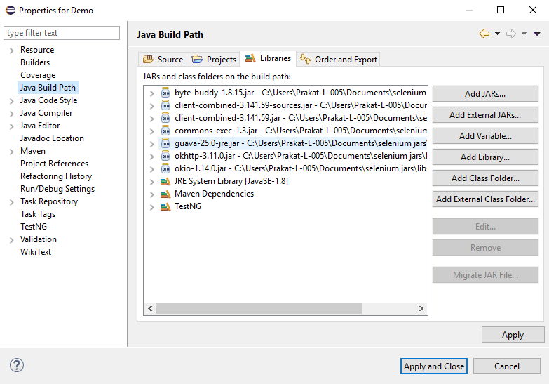

**Step 4**: Create a Selenium WebDriver script

* Right-click on the project package and select New > Class.
* Name the class appropriately (e.g., MyFirstSeleniumTest).
* Import the necessary Selenium libraries:
* Java

import org.openqa.selenium.WebDriver;

import org.openqa.selenium.chrome.ChromeDriver;

* Create a WebDriver instance:

Java

WebDriver driver = new ChromeDriver();

* Set the desired browser window size:
* Java

driver.manage().window().maximize();

* Navigate to a website:
* Java

driver.get("https://www.google.com");

* Perform any desired actions on the website using Selenium commands.
* Close the browser window after completing the script:
* Java

driver.quit();

**Step 5**: Run the script

* Right-click on the class and select Run As > Java Application.
* Eclipse will launch the Chrome browser and execute the script.
* Verification:
* If your script runs successfully, you should see the browser open and navigate to the specified website.
* This confirms that Selenium WebDriver is installed and integrated correctly in Eclipse.

1. **Demonstrate how elements are located using Selenium WebDriver.**

We can locate Elements by:

1. Using **ID** as a Locator
2. Using **class** name as a Locator.
3. Using **name** as a Locator.
4. Using **Link Text** as a Locator
5. Using **Xpath** as a Locator
6. Using **CSS Selector** as a Locator
7. Using **XPath** for handling complex and dynamic elements.

**Step 1:** Using ID as a Locator

* Open Eclipse
* Find a web element using Locator **ID**

1. Syntax: id = id of the element
2. Example: driver.findElement(By.id(“Email”));

**Step 2** Using class name as a Locator

* Find a web element using Locator **ClassName**
  1. Syntax: class = Class Name of the element
  2. Example: driver.findElement(By.class(“classname”));

**Step 3** Using Name as a Locator

* Find a web element using Locator **Name**
  1. Syntax: name = Name of the element
  2. Example: driver.findElement(By.name(“name”));

**Step 4** Using LinkText as a Locator

* Find a web element using Locator **Link Text**
  1. Syntax: link = partialLink of the element
  2. Example: driver.findElement(By.partialLinkText(“plink”));

**Step 5** Using Xpath as a Locator

* Find a web element using Locator **Xpath**
* Xpath can be created in two ways
  1. **Relative Xpath**
* Syntax: relativeXpath : //*[@class=’relativexapath’]
* Example: driver.findElement(By.xpath(“//*[@class=’relativexapath’]”));
  1. **Absolute Xpath**
* Syntax: absoluteXpath : html/body/div[1]/div[1]/div/h4[1]/b
* Example: driver.findElement(By.xpath(“html/body/div[1]/div[1]/div/h4[1]/b”));

**Step 6** Using Xpath as a **CSS Selector**

* CSS Selector have many formats, namely

1. **Tag and ID**
   * Syntax:”css = tag#id”
   * Example: driver.findElement(By.cssSelector(“input#email”));
2. **Tag and Class**
   * Syntax: “css = tag.class”
   * Example: driver.findElement(By.cssSelector(”input.inputtext”));
3. **Tag and Attribute**
   * Syntax: “css = tag[attribute=value]”
   * Example: driver.findElement(By.cssSelector(“input[name=lastName]”));
4. **Tag, Class, and Attribute**
   * Syntax: “tag.class[attribute=value]”
   * Example: driver.findElement(By.cssSelector(“input.inputtext[tabindex=1]”));
5. **Inner text**
   * Syntax: ”css = tag.contains(“innertext”)”
   * Example: driver.findElement(By.cssSelector(font:contains(“Boston”)));

**Step 7** Using Xpath for handling complex and dynamic elements

* Dynamic Xpath has many formats, namely

1. **Contains();**
   * Syntax: “xpath = //*[contains(text(),’text’)]
   * Example: driver.findElement(By.xpath(”//*[contains(text(),’sub’]”));
2. **Using OR & AND**
   * Syntax: xpath=//*[@type=’submit’ or @name=’btnReset’]
   * Example:

driver.findElement (By.xpath(”=//*[@type=’submit’ or @name=’btnReset’]”));

1. **Start-with function**
   * Syntax: xpath= //label[starts-with(@id,’message’)]
   * Example:

driver.findElement (By.xpath(”//label[starts-with(@id,’message’)]”));

1. **Text();**
   * Syntax: xpath=//td[text()=’UserID’]
   * Example: : driver.findElement (By.xpath(”=//td[text()=’UserID’]”));
2. **Following**
   * Syntax: xpath=//*[@type=’text’]//following::input
   * Example: driver.findElement(By.xpath(”=//*[@type=’text’]//following::input”));
3. **Preceding**
   * Syntax: xpath=//*[@type=’text’]//preceding::input
   * Example: driver.findElement(By.xpath(”//*[@type=’text’]//preceding::input”));
4. **Following - sibling**
   * Syntax: xpath=//*[@type=’submit’]//preceding::input
   * Example:

driver.findElement (By.xpath (”//*[@type=’text’]//following-sibling::input”));

1. **Demonstrate how elements are located through CSS and XPath.**

**Step 1:** Finding the element present on the page using CSS Selector.

* Using CSS Selectors in Selenium. As we all know, CSS stands for Cascading Style Sheets. By using CSS selectors, we can find or select HTML elements on the basis of their id, class, or other attributes. CSS is faster and simpler than XPath, particularly in case of IE browser where Path works very slowly.
* Open Eclipse
* Using Path as a CSS Selector
* CSS Selector has many formats, namely:

1. **Tag and ID**
   * Syntax: “css = tag#id”
   * Example: driver.findElement(By.cssSelector(“input#email”));
2. **Tag and Class**
   * Syntax: “css = tag.class”
   * Example: driver.findElement(By.cssSelector(”input.inputtext”));
3. **Tag and Attribute**
   * Syntax: “css = tag[attribute=value]”
   * Example: driver.findElement(By.cssSelector(“input[name=lastName]”));
4. **Tag, Class, and Attribute**
   * Syntax: “tag.class[attribute=value]”
   * Example:

driver. findElement(By.cssSelector(“input.inputtext[tabindex=1]”));

1. **Inner text**
   * Syntax: “css = tag.contains(“innertext”)”
   * Example: driver.findElement(By.cssSelector(font:contains(“Boston”)));

**Step 2:** Finding the element present on the page using Path.

* In Selenium automation, if the elements are not found by the general locators like id, class, name, etc., then XPath is used to find an element on the web page.
* XPath contains the path of the element situated at the web page. Standard syntax for creating XPath is:

XPath=//tagname[@attribute='value']

* **//:** Select current node.
* **Tagname:**Tagname of the particular node.
* **@:** Select attribute.
* **Attribute:** Attribute name of the node.
* **Value:** Value of the attribute.
* Types of XPath:

There are two types of XPath:

1. **Absolute XPath**

* It is a direct way to find the element, but the disadvantage of the absolute XPath is that if there are any changes made in the path of the element, then that XPath fails.
* The key characteristic of XPath is that it begins with the single forward slash (/), which means you can select the element from the root node.
* Syntax for absolute Path: html/body/div[1]/div[1]/div/h4[1]/b
* Example: driver.findElement(By.xpath(“html/body/div[1]/div[1]/div/h4[1]/b”));
* Writing absolute XPath on the elements which are present in the web page will be very lengthy. To reduce the length, we use relative XPath.

1. **Relative XPath**

* For relative XPath, the path starts from the middle of the HTML DOM structure. It starts with the double forward-slash (//), which means it can search the element anywhere on the web page.
* You can start from the middle of the HTML DOM structure and you don’t need to write long XPath.
* Syntax for relativeXPath: //*[@class=’relativexapath’]

Example: driver.findElement(By.xpath(“//*[@class=’relativexapath’]”))

1. **Demonstrate how web elements are handled in Selenium.**

**1: Edit box**

* Open Eclipse
* It is a basic text control that enables a user to type a small amount of text.
* Operations on Edit box
  + Enter a Value,
  + Clear the Value,
  + Check enabled status,
  + Check edit box existence,
  + Get the value

**2: Link**

* Link is more appropriately referred to as a hyperlink and connects one web page to another. It allows the user to click their way from page to page.
* Operations on Link
  + Click the link,
  + Check the link existence,
  + Check the link enabled status,
  + Return the link name

**3: Button**

* This represents a clickable button, which can be used in forms and places in the document that needs a simple, standard button functionality.
* Operations on Button
  + Click
  + Check Enabled status
  + Display status

**4: Image, image link, and image button**

* It helps in performing actions on images like clicking on the image link or the image button, etc.
* Operations Image
  + Three types of Image elements in Web Environment
  + General Image (No functionality)
  + Image Button (Submits)
  + Image Link (Redirects to another page/location)

**5: Text area**

* It is an inline element used to designate a plain-text editing control containing multiple lines.
* Return / Capture Text Area or Error message from a web page

**6: Checkbox**

* This is a selection box or a tick box which is a small interactive box that can be toggled by the user to indicate an affirmative or a negative choice.
* Operations on checkbox
  + Check if the checkbox is displayed or not
  + Check if the checkbox is enabled or not
  + Check if the checkbox is selected or not
  + Select the checkbox
  + Unselect the checkbox

**7: Radio button**

* It is an option button which is a graphical control element that allows the user to choose only one predefined set of mutually exclusive options.
* Operations on Radio Button
  + Select Radio Button
  + Verify if the Radio Button is displayed or not
  + Verify if the Radio Button is enabled or not
  + Verify if the Radio Button is selected or not
* Example:

oRadioButton.get(1).click();

**8: Drop-down list**

* It is a graphical control element, similar to the list box, which allows the user to choose one value from the list. When this drop-down list is inactive, it displays only a single value.
* Operations on drop-down list
  + Check the drop-down box’s existence
  + Check if the drop-down is enabled or not
  + Select an item
  + Get Items Count
* Example:

Select fruits = new Select(driver.findElement(By.id("fruits")));

fruits.selectByVisibleText("Banana");

fruits.selectByIndex(1);

**9: Web table/HTML table**

* Operations on Web Table/HTML Table
  + Get cell value
  + Get Rows Count
  + Get Cells Count

**10: Frame**

* Operations on Frame
  + Switch from Top window to a frame
  + Switch from a frame to Top window
* Examples:
  + driver.switchTo().frame("iframe1");
  + driver.switchTo().frame("id of the element");

**11: Switching between tabs in the same browser window**

* Open a new tab using Ctrl + t.
* Driver control automatically switches to the newly opened tab.
* Perform the required operations here.
* Next, switch back to the old tab using Ctrl + Tab. You need to keep pressing this unless you reach the desired tab.
* Once the desired tab is reached, then perform the operations in that tab.
* Example:

driver.switchTo().window(tabs2.get(1));

driver.switchTo().window(tabs2.get(0));

1. **Demonstrate how to automate calendars on the web page**

**Step 1:** Create a Selenium project

* Open Eclipse and create a new Java project.
* Add selenium jar files to the build path.
* Add browser executable files in the **resource** folder.

**Step 2:** Write code for calendar automation

* Create a Java file with the name **calendar.java** and write the code given below:

import java.util.List;

import org.openqa.selenium.By;

import org.openqa.selenium.WebElement;

import org.openqa.selenium.chrome.ChromeDriver;

public class DatePicker

{

public static void main(String[] args) throws InterruptedException

{

String dot="19/October/2020";

String date,month,year;

String caldt,calmonth,calyear;

/*

* Split the String into String Array

*/

String dateArray[]= dot.split("/");

date=dateArray[0];

month=dateArray[1];

year=dateArray[2];

ChromeDriver driver=new ChromeDriver();

driver.get("http://cleartrip.com");

driver.findElement(By.id("DepartDate")).click();

WebElement cal;

cal=driver.findElement(By.className("calendar"));

calyear=driver.findElement(By.className("ui-datepicker-year")).getText();

/**

* Select the year

*/

while (!calyear.equals(year))

{

driver.findElement(By.className("nextMonth")).click();

calyear=driver.findElement(By.className("ui-datepicker-year")).getText();

System.out.println("Displayed Year::" + calyear);

}

calmonth=driver.findElement(By.className("ui-datepicker-month")).getText();

/**

* Select the Month

*/

while (!calmonth.equalsIgnoreCase(month))

{

driver.findElement(By.className("nextMonth ")).click();

calmonth=driver.findElement(By.className("ui-datepicker-month")).getText();

}

cal=driver.findElement(By.className("calendar"));

/**Select the Date

*/

List<WebElement> rows,cols;

rows=cal.findElements(By.tagName("tr"));

for (int i = 1; i < rows.size(); i++)

{

cols=rows.get(i).findElements(By.tagName("td"));

for (int j = 0; j < cols.size(); j++)

{

caldt=cols.get(j).getText();

if (caldt.equals(date))

{

cols.get(j).click();

break;

}

}

}

}

}

* Run the project as a Java application.

1. **Using Selenium WebDriver, write a program to handle alerts.**

**Step 1:** Handling External pop-ups.

* WebDriver has the ability to interact with multiple windows, which includes alerts using the method switchTo. This method allows to switch the control to pop-up while keeping the browser open in the background.
* Syntax for handling the different types of pop ups:
* To click on the “OK” button in pop-up

Syntax: WebDrive driver = new chromeDriver();

driver.switchTo().alert().accept();

* To click on the “Cancel” button in pop-up

Syntax: WebDrive driver = new chromeDriver();

driver.switchTo().alert().dismiss();

* To Capture the alert message

Syntax: WebDrive driver = new chromeDriver()

driver.switchTo().alert().getText();

* To enter the information

Syntax: WebDrive driver = new chromeDriver()

driver.switchTo().alert().sendKeys(“text”);

* To exit from the pop-up

Syntax: WebDrive driver = new chromeDriver();

driver.switchTo().alert().close();

**Step 4.8.2:** Handling new tabs and new windows.

* Opening a new tab  
  Syntax: WebDrive driver = new chromeDriver();  
   driver.findElement(By.id(“xyz”)).sendKeys(Keys.CONTROL + “t”);
* Opening a new window

Syntax: WebDriver driver = new chromeDriver();

driver.findElements(By.id(“xyz”).sendKeys(Keys.CONTROL + “w”);

1. **Demonstrate how screenshots are captured and browser profiles are changed in Selenium**.

**Step 1:** Screenshots

* Open Eclipse
* Convert web driver object to **TakeScreenshot**
* Call getScreenshotAs method to create image file
* Copy file to desired location

**Step 1.1** Convert web driver object to TakeScreenshot

Syntax: TakesScreenshot scrShot = (TakesScreenshot)driver;

**Step 1.2** Call getScreenshotAs method to create image file

Syntax: File srcFile = scrShot.getScreenshotAs(OutType.FILE);

**Step 1.3** Copy file to desire location

Syntax: FileUtils.copyFile(source, filePath);

The script looks like this:

**Step 2:** Browser profiles**:**

* First , close the Firefox if it is open.
* Open Run (Windows+R) and type firefox.exe -p and click OK.
* A dialogue box will open named “Firefox -choose user profile.”
* Select the option “Create Profile” from the window, and a Wizard will open. Click on Next.
* Provide your profile name which you want to create, and click on the Finish button.

1. **Demonstrate installation and configuration of AutoIT**.

**Step 1:** Installing and Configuring Auto IT

* Download Auto IT from <https://www.autoitscript.com/site/autoit/downloads/> link.
* Save it in one folder.
* Double click on autoit-v3-setup.exe file and click on **Install**.
* After successful installation, open up AutoIT Editor.

C:\Program Files(x86)\AutoIt3\SciTE

1. **Handling File Uploads**

**Step 10.1:** Handling file upload by SendKeys

* Launch Eclipse and create a Java project.
* Create project: Click on file->New->Java project.
* Enter the project name as **UploadFile** and click on Finish.
* In the project explorer, expand **UploadFile.**
* Right-click on **src** and choose **New->Class.**
* In Package Name, enter **com.ecommerce** and in **Name** enter **Upload** and click on **Finish.**
* Locate the browse button using chropath/firebug.
* Set the path using SendKeys. And the code looks like below:

//Locating 'browse' button

WebElement browse =driver.findElement(By.id("uploadfile"));

//pass the path of the file to be uploaded using Sendkeys method

browse.sendKeys("D:\\SoftwareTestingMaterial\\UploadFile.txt");

**Step 10.2:** Handling file upload by AutoIT script

* Go to **Start->Autoit v3->Autoit window info.**
* Now drag the Finder toolbox to the object in which you are interested.
* Build an AutoIT script using **SciTE editor** and write the script using **ControlFocus, ControlsetText, and ControlClick** commands.
* And the script looks like below:

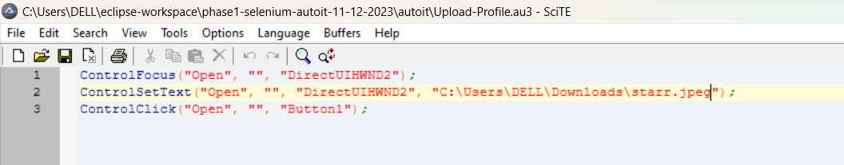

* Save the Script with **.au3** extension.
* Compile the **.au3** script which converts into **.exe** file.
* Pass the **.exe** path into selenium test script using method

**Runtime.getRuntime().exec(“C:\AutoIt\Autoitscript.exe”)**

* The complete script looks like this:

import java.io.IOException;

import java.util.concurrent.TimeUnit;

import org.openqa.selenium.By;

import org.openqa.selenium.WebDriver;

import org.openqa.selenium.firefox.FirefoxDriver;

public class AutoIt {

private static WebDriver driver = null;

public static void main(String[] args) throws IOException, InterruptedException {

driver = new FirefoxDriver();

driver.manage().timeouts().implicitlyWait(10, TimeUnit.SECONDS);

driver.get("http://toolsqa.com/automation-practice-form");

driver.findElement(By.id("photo")).click();

Runtime.getRuntime().exec("D:\AutoIt\AutoItTest.exe");

Thread.sleep(5000);

driver.close();

**11. Demonstrate how Sikuli is used for UI testing in Selenium.**

**Steps 11.1:** Integrating Sikuli with Selenium WebDriver

* Sikuli Jar files are already present in your practice labs. To learn about its directory path details, you can refer to the lab guide for Phase 1.
* Open Eclipse and create a new Java project
* Right-click on the project. Navigate through the given path: Build path->Configure build path->Add external Jars.
* Click on **Apply and OK.**

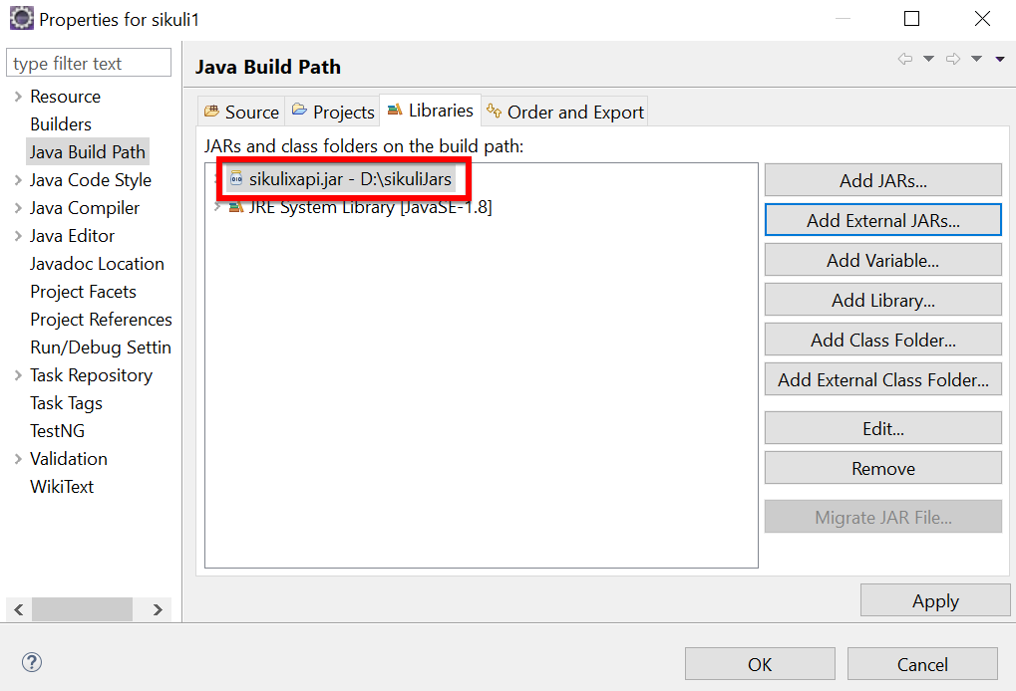

**Steps 11.2:** Screen class in Sikuli

* Screen class is a base class which contains some predefined methods to perform operations, such as click, double click, providing input to the text box and hover, etc.
* Below are the commonly used methods:
* Click

Syntax: Screen s = new Screen();

s.click()("imag.png”);

* doubleClick

Syntax: Screen s = new Screen();

s.doubleClick()("imag.png”);

* Type

Syntax: s.type(“imag.png”, “Text”);

* Hover

Syntax: s.hover(“imag.png”);

* Find

Syntax: s.find(“imag.png”);

**Steps 11.3:** Pattern class in Sikuli

* Pattern class is used to associate the image file to identify the element
* Pattern class takes the path of the image as a parameter
* Below are the commonly used methods:
* getFileName

Syntax: Pattern p = new Pattern(“D:\Test\imag.png”)

* Similar

Syntax: Pattern p1 = p.similar Pattern(“0.7f”);

* Exact

Syntax: Pattern p1 = p.exact();

The script looks like this:

package com.simplilearn.seleniumtest;

import org.openqa.selenium.WebDriver;

import org.openqa.selenium.firefox.FirefoxDriver;

import org.sikuli.script.FindFailed;

import org.sikuli.script.Pattern;

import org.sikuli.script.Screen;

/**

* This class demonstrate test of selenium with sikuli tools

*/

public class AmazonSikuliTest {

public static void main(String[] args) throws FindFailed, InterruptedException {

// step1: formulate a test domain url & driver path

String siteUrl = "https://www.amazon.in";

String driverPath = "drivers/windows/geckodriver.exe";

// step2: set system properties for selenium dirver

System.setProperty("webdriver.geckodriver.driver", driverPath);

// step3: instantiate selenium webdriver

WebDriver driver = new FirefoxDriver();

Screen screen = new Screen();

// make browser window full screen

driver.manage().window().maximize();

// step4: launch browser

driver.get(siteUrl);

Thread.sleep(3000);

Pattern pattern = new Pattern("C:\\DELL\\Eclipse workshop\\phase1-selenium-sikuli-12-12-2023\\sikuli-inputs\\amazon-tv.png");

Thread.sleep(3000);

screen.click(pattern);

// step6: close driver

// driver.close();

}

}

* Run the script and notice the action performed on the image (The path, which we have mentioned in the script).

**12. Demonstrate the usage of JDBC in Selenium.**

**Step 12.1:** Creating a table in Database

* Create a table and enter the data in the table in the Database.

**Step 12.2:** Writing the JDBC connection integrating with selenium

* Load the driver class

Syntax: class.forName(“Connection URL”);

com.mysql.cj.jdbc.Driver

URL -

* Create a Connection

Connection con = DriverManager.getConnection(“URL”, “UserName”, “Password”);

* Create a statement

Syntax: Statement stmt = con.createStatement();

* Execute SQL query

Syntax: ResultSet rs= stmt.executeQuery(“sql query”);

* Close the connection

Syntax: Con.close();

The code in Eclipse will look like this:

import java.sql.Connection;

import java.sql.DriverManager;

import java.sql.ResultSet;

import java.sql.SQLException;

import java.sql.Statement;

import org.openqa.selenium.By;

import org.openqa.selenium.WebDriver;

import org.openqa.selenium.WebElement;

import org.openqa.selenium.chrome.ChromeDriver;

import org.testng.annotations.AfterTest;

import org.testng.annotations.BeforeTest;

import org.testng.annotations.Test;

public class TestDatabaseWithSelenium {

private WebDriver driver;

@BeforeTest

public void setup() {

// Set the path to the ChromeDriver executable

System.setProperty("webdriver.chrome.driver", " drivers/chromedriver-win64/chromedriver.exe");

// Create a new instance of the ChromeDriver

driver = new ChromeDriver();

}

@Test

public void testVerifyDB() throws ClassNotFoundException, SQLException {

// Step 1: Load the driver class

Class.forName("oracle.jdbc.driver.OracleDriver");

// Step 2: Create the connection object

Connection con = DriverManager.getConnection("jdbc:oracle:thin:@localhost:1521:xe", "your_username", "your_password");

// Step 3: Create the statement object

Statement stmt = con.createStatement();

// Step 4: Execute the SQL query

ResultSet rs = stmt.executeQuery("SELECT * FROM Products");

// Step 5: Iterate through the result set and perform web testing

while (rs.next()) {

int productId = rs.getInt(1);

String productName = rs.getString(2);

String productDescription = rs.getString(3);

// Perform web testing using Selenium

driver.get("https://www.seleniumhq.org");

WebElement searchInput = driver.findElement(By.id("q"));

searchInput.sendKeys(productName);

searchInput.submit();

// Print the database record and web page title

System.out.println("Product ID: " + productId);

System.out.println("Product Name: " + productName);

System.out.println("Product Description: " + productDescription);

System.out.println("Web Page Title: " + driver.getTitle());

System.out.println("--------------------------------------------");

}

// Step 6: Close the connection object

con.close();

}

@AfterTest

public void teardown() {

// Close the browser

driver.quit();

}

}