1. **Write a program in Java to perform implicit and explicit type casting**

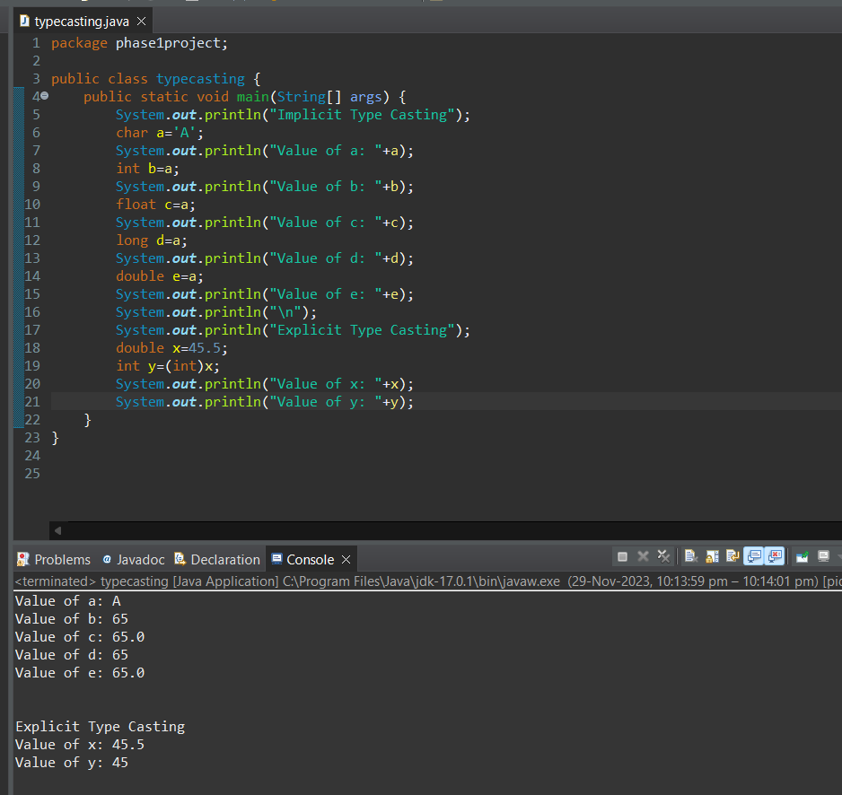

1. **Write a program in Java to verify the working of access modifiers**

**Default Access Modifier**

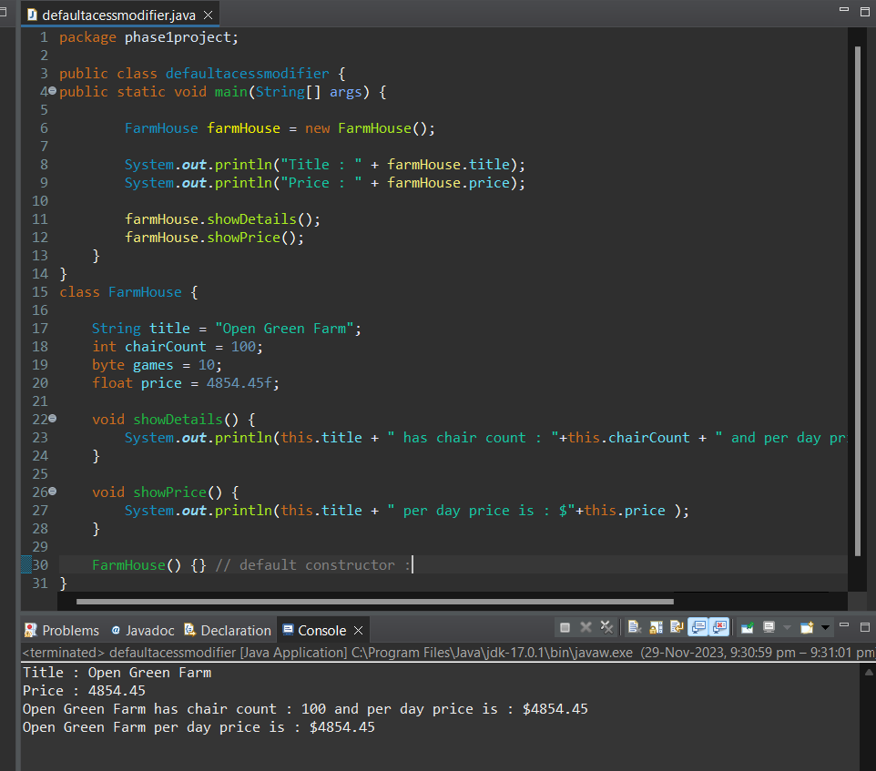

**Protected Access Modifier**

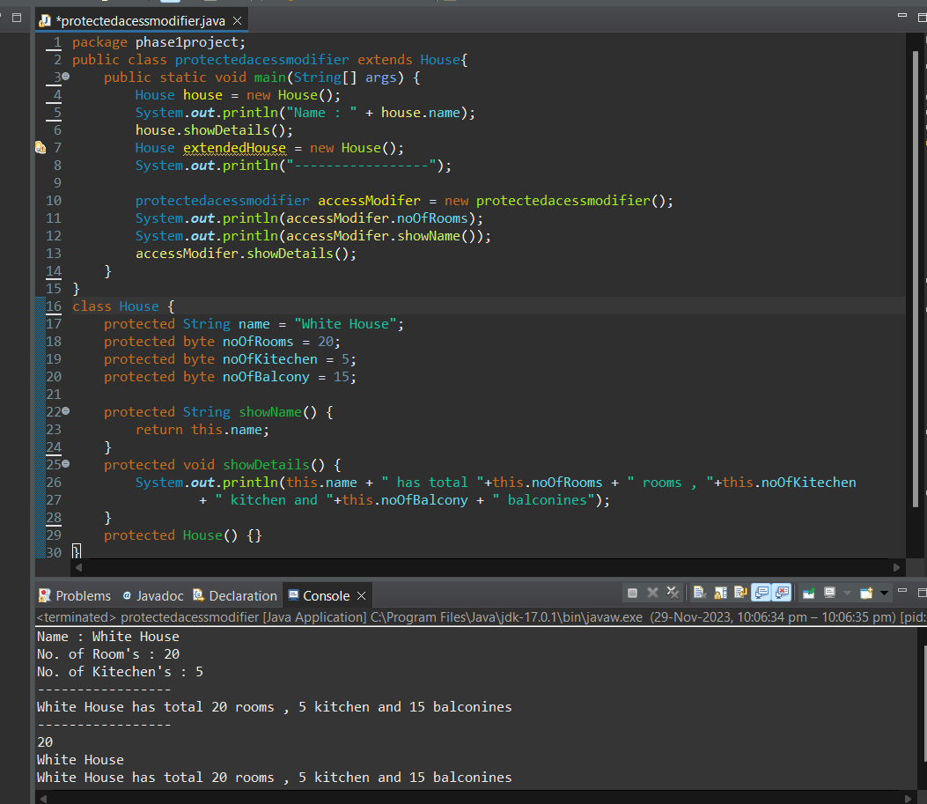

**Public Access Modifier**

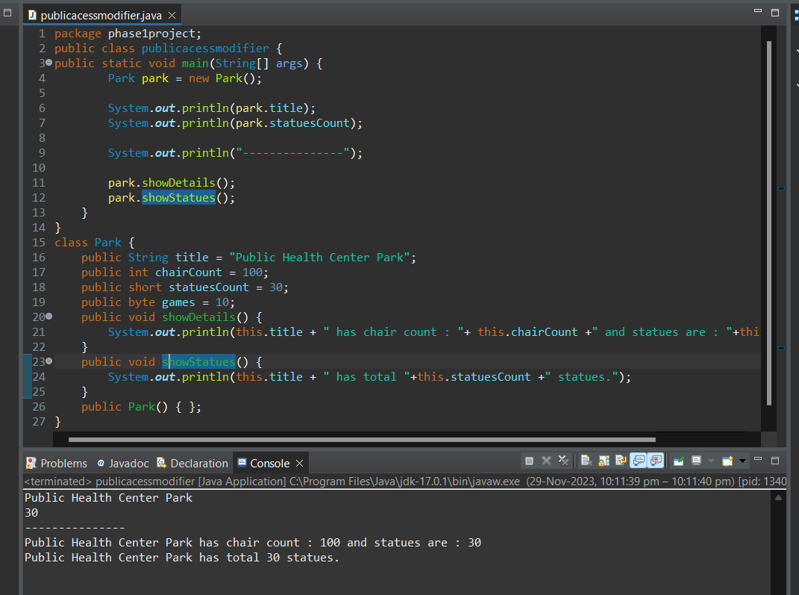

**Private Access Modifier**

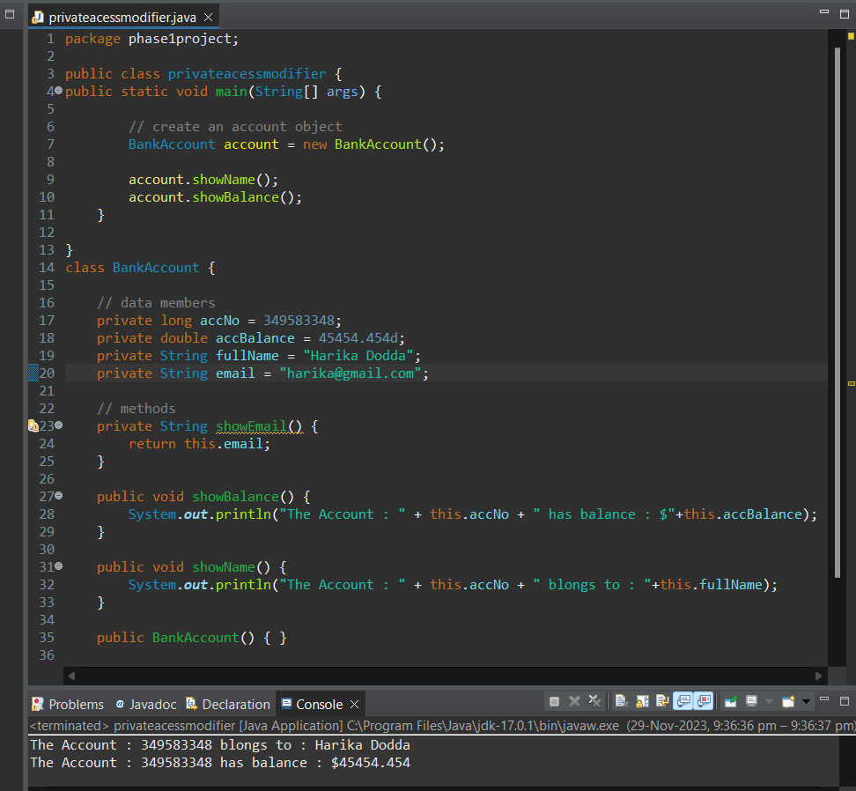

1. **Write a program to demonstrate the while loop**

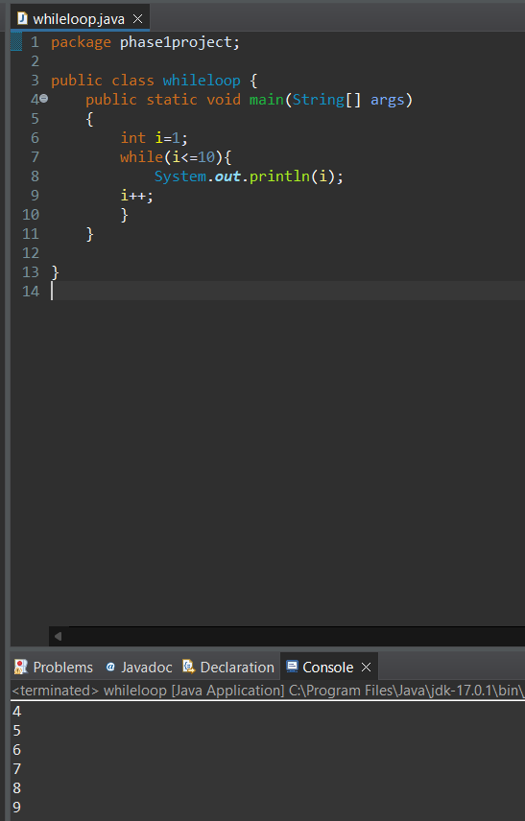

1. **Write a program to demonstrate the do while loop**

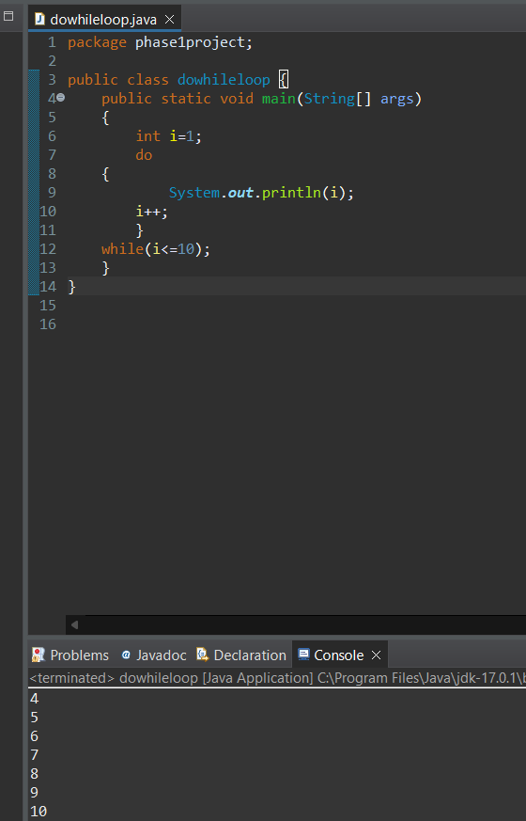

1. **Write a program to demonstrate the for loop**

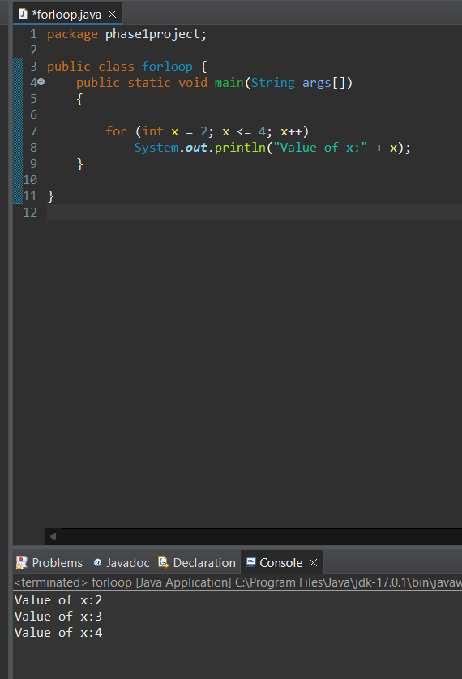

1. **Demonstrate the Classes, Objects, and Constructors**

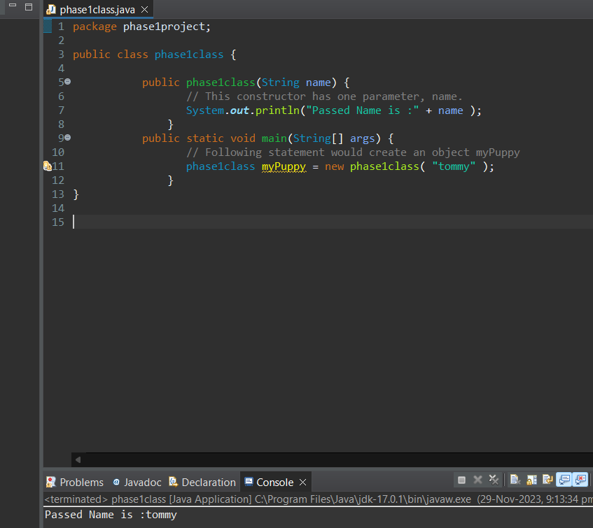

1. **Demonstrate types of inheritance**

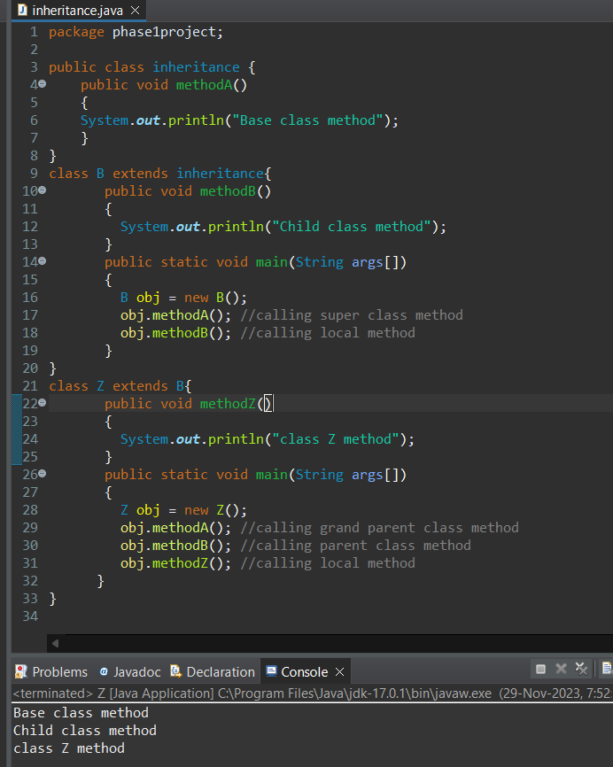

**7.2 Writing a program in Java to verify implementations of collections**

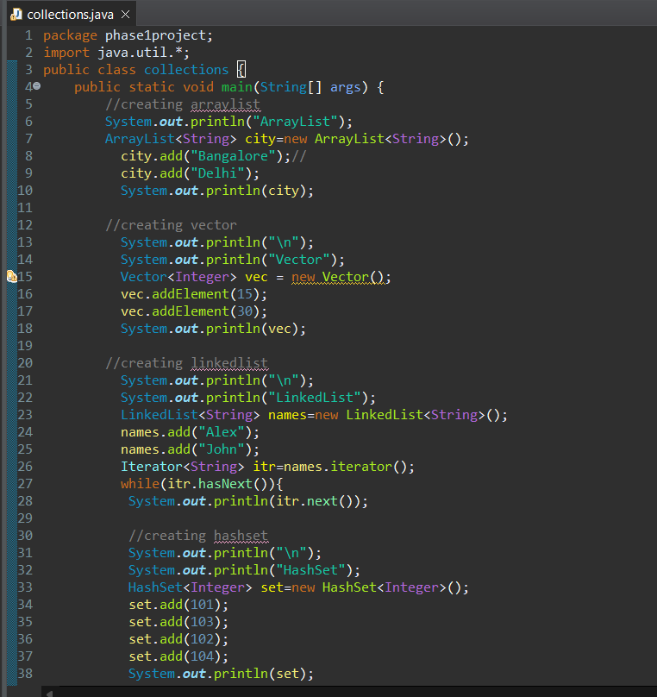

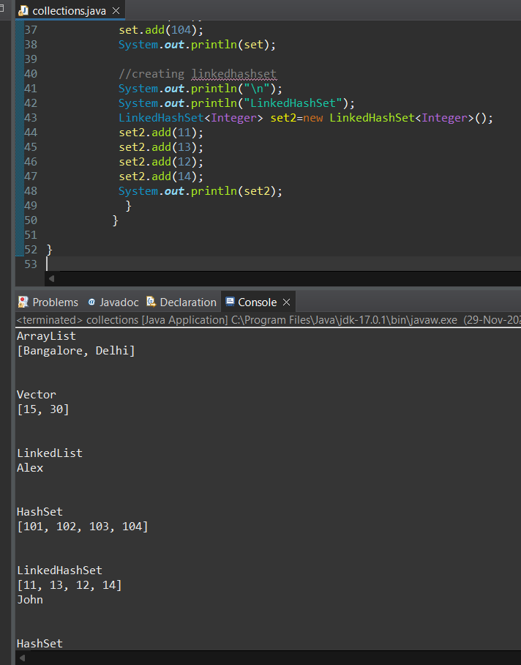

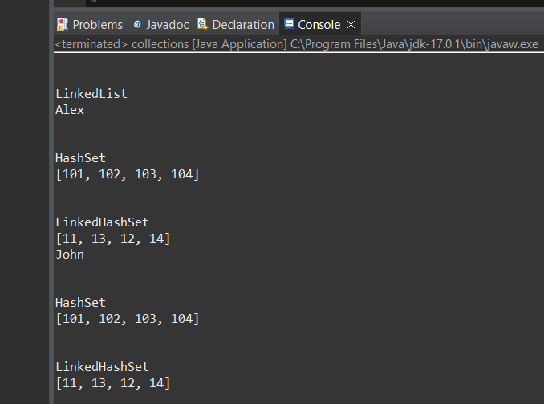

1. **Writing a program to perform try-catch block**

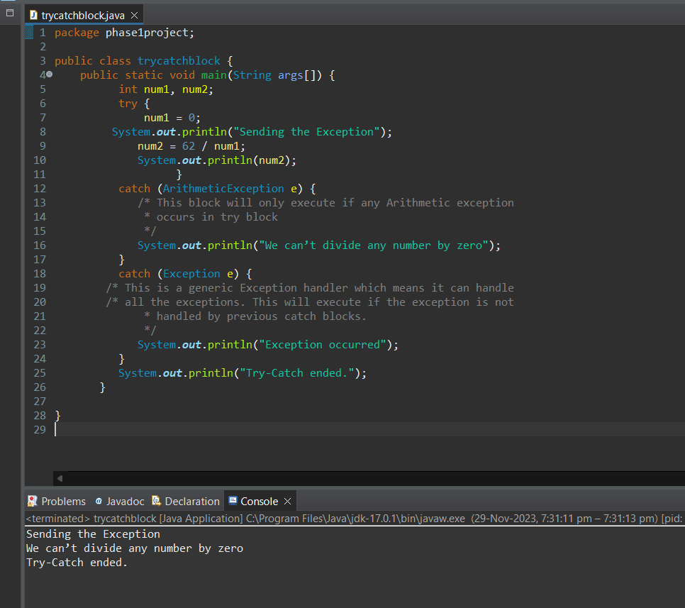

1. **Writing code for throw and throws keyword**

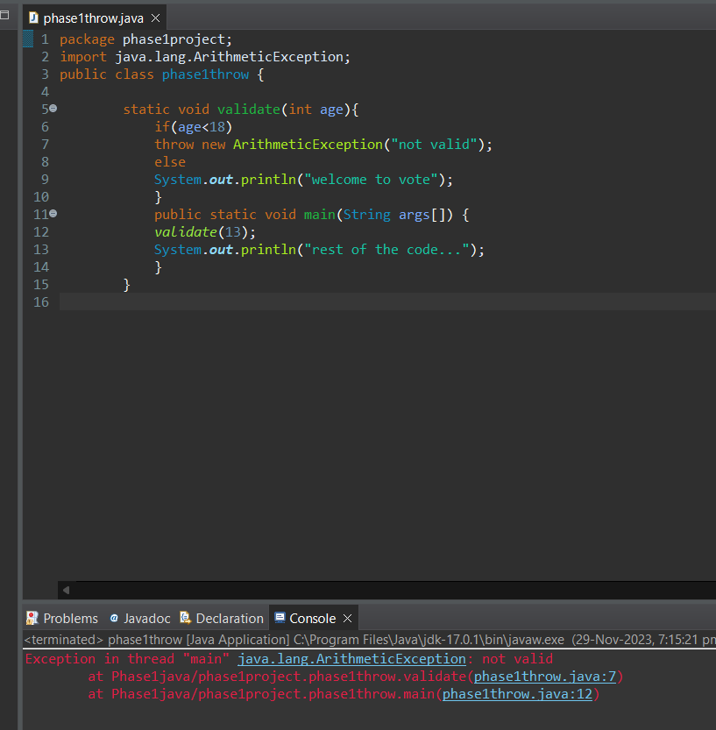

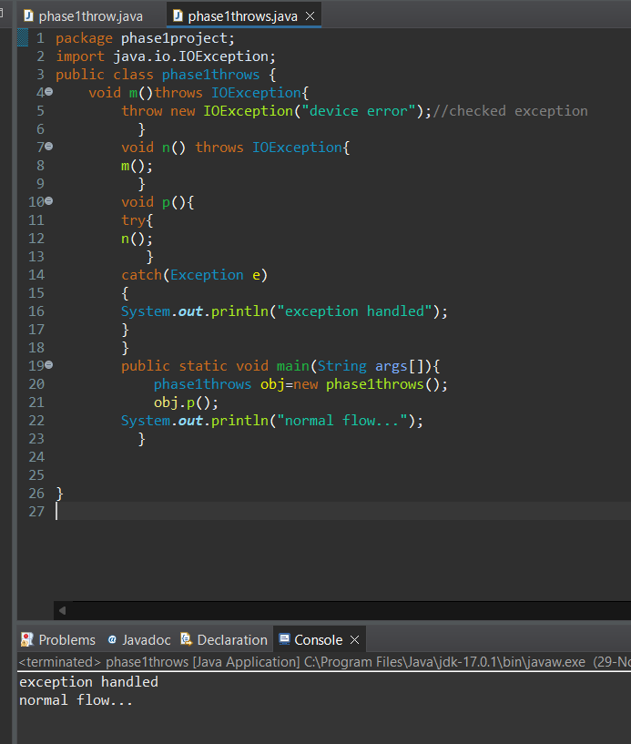

1. **Writing code for a try block with parameters**

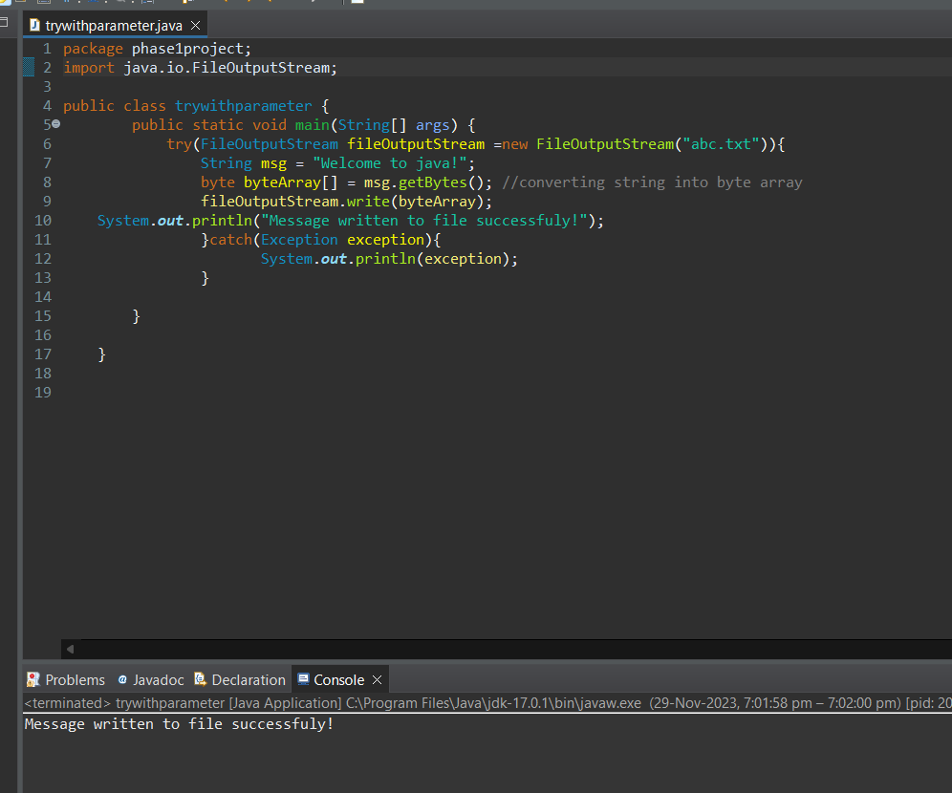

1. **Writing code for multiple catch blocks**

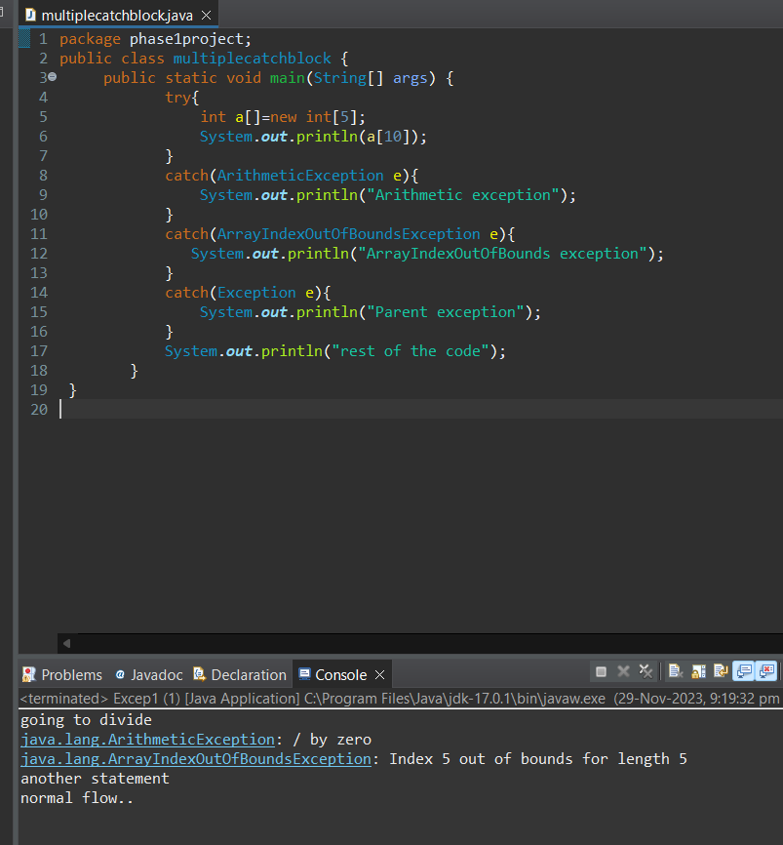

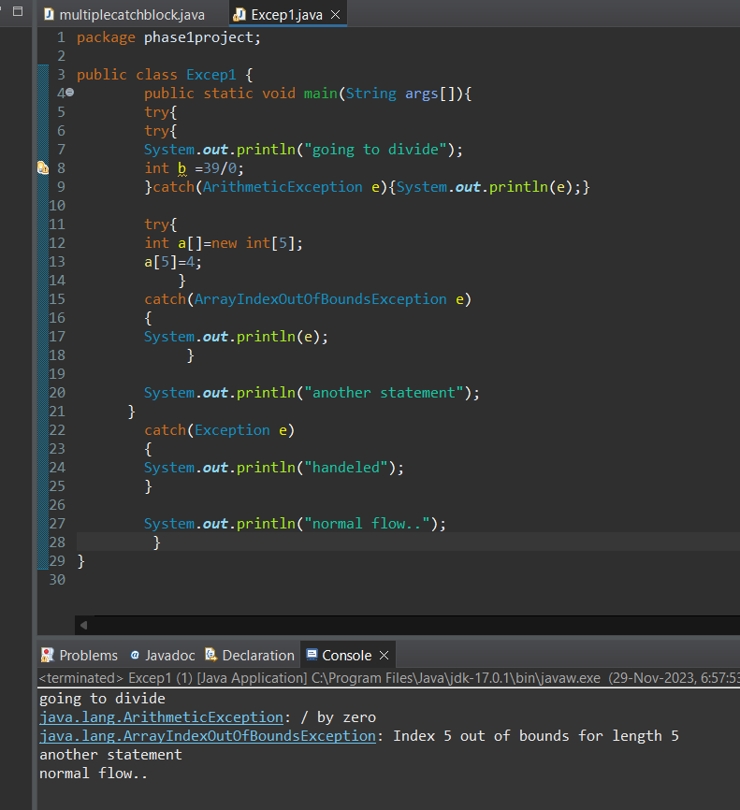

1. **Writing code for finally{} block**

