Learning Git



AI forum Of pakitsn
Class (MWF) Time 7 :00 pm to 7:30 pm

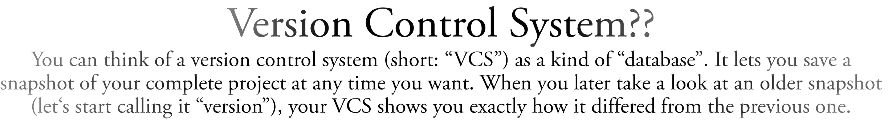


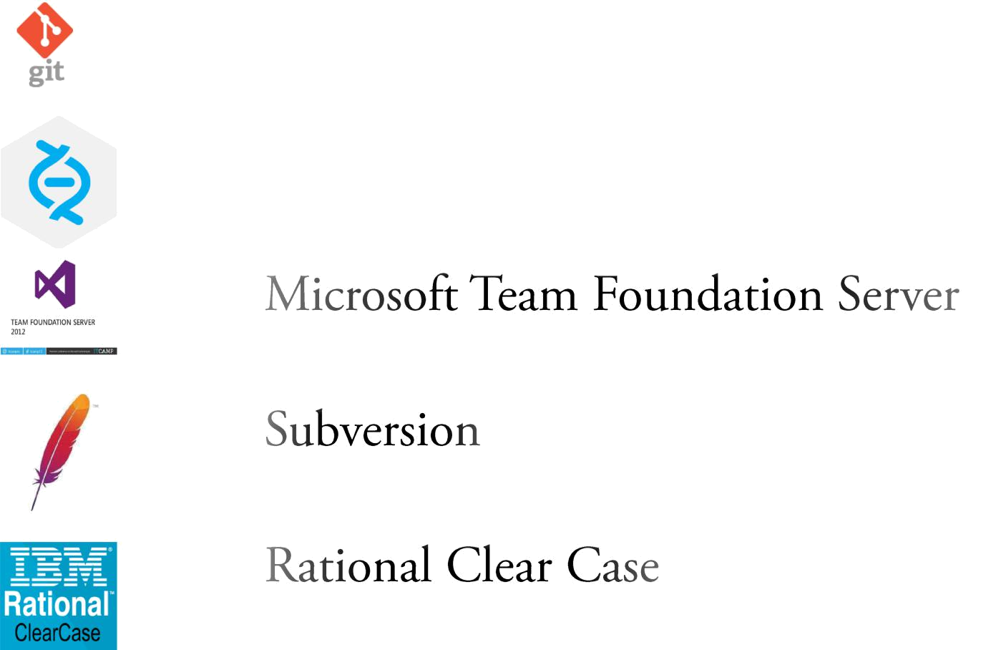

• 

• 

• 

•

• 

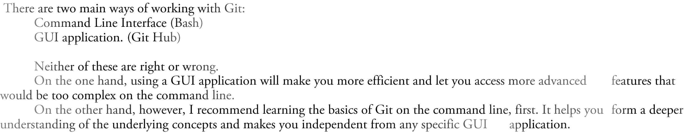


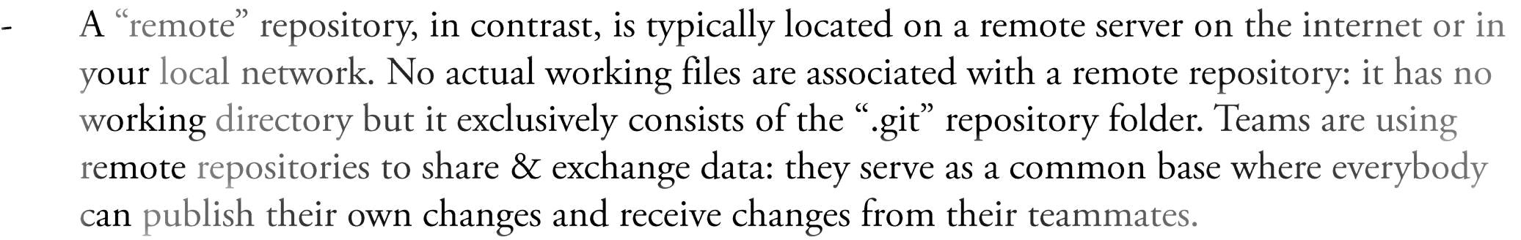

Some Very Basic Cheat Sheet

•

•
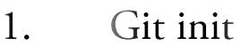
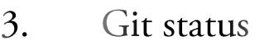



git init // a hidden folder will be created in root folder
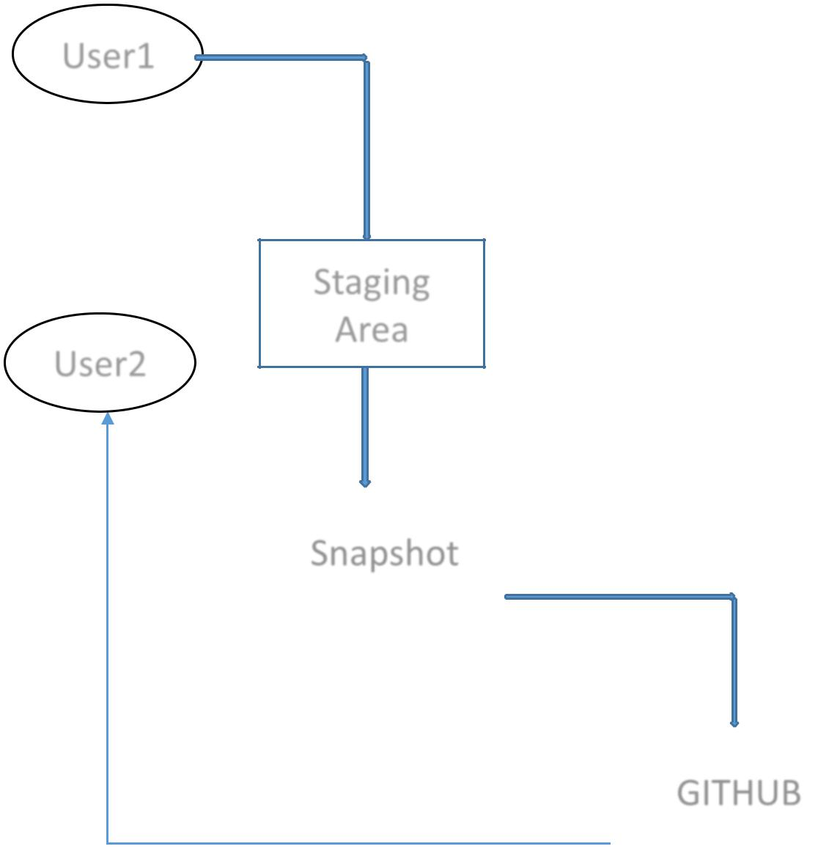

User1

User2

Git pull origin master // pull the changes

git status // untracked or tracked file will be displayed

git add[filename.txt] // to add file one by one
Staging
git add -A // to add all files together
Area

 | git commit –m “your message” // a snapshot of your commit will be created at
Snapshot | your local repository

Git remote add origin [repoName // creates a link between local and cloud repository]

GITHUB | git push origin master // push the changes to cloud

Git clone [repo name]
// will clone the repo in same directory

File1 |  | Snapshot1 | Git commit –m “file1 added”
File1 |  | Snapshot2 | Git commit –m “file2 added”
File2

File1
_{File1 Snapshot3} Git commit –m “file3 added” File1
Branching & Merging

•

•
User1 _{User2}
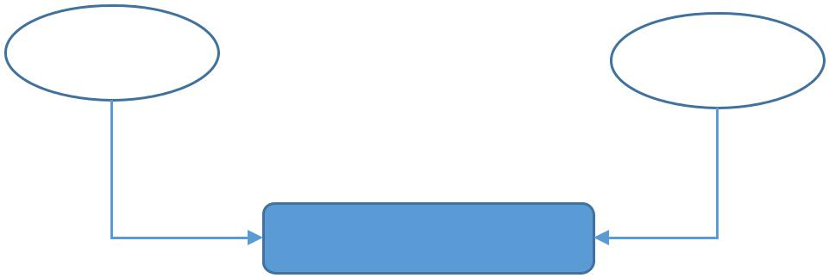

Repo | Master repo

User1 _{User2}
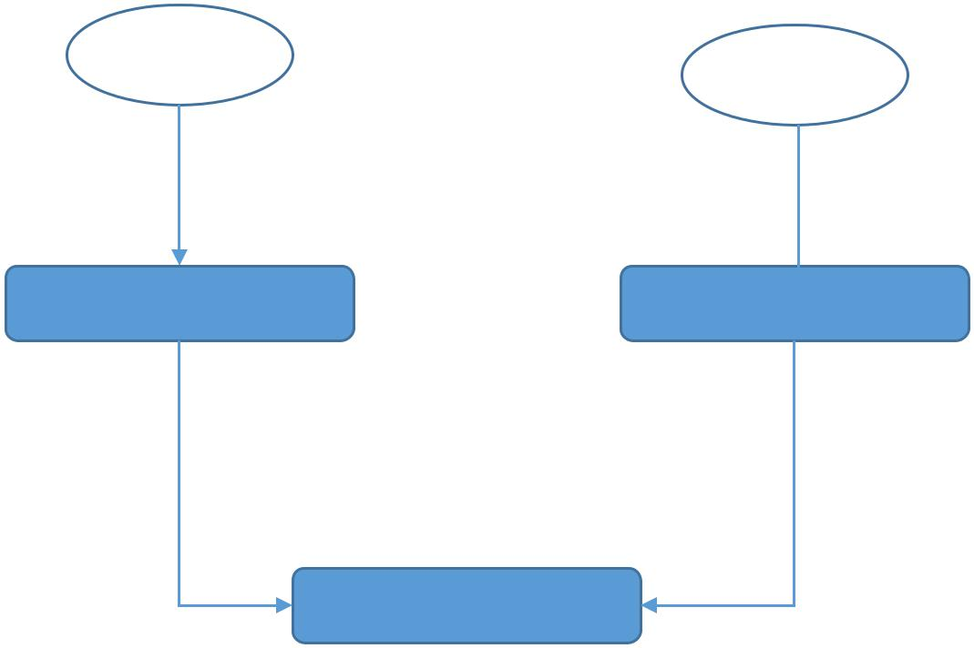

Clone Repo Clone Repo

Repo

To check list of branch:

>>>git branch

Creating a new branch:
- git branch newBranch

Switch between branches:

- git checkout newBranch

Merging branches:
Load master branch first then
>>> git merge newBranch

Deleting braches:
>>>git branch –d newBranch

