Project Assignment #3

1. **Design Patterns**
2. Singleton Design Pattern used in EventDB.java to ensure that there is only one instance of the database.

Code screenshot:

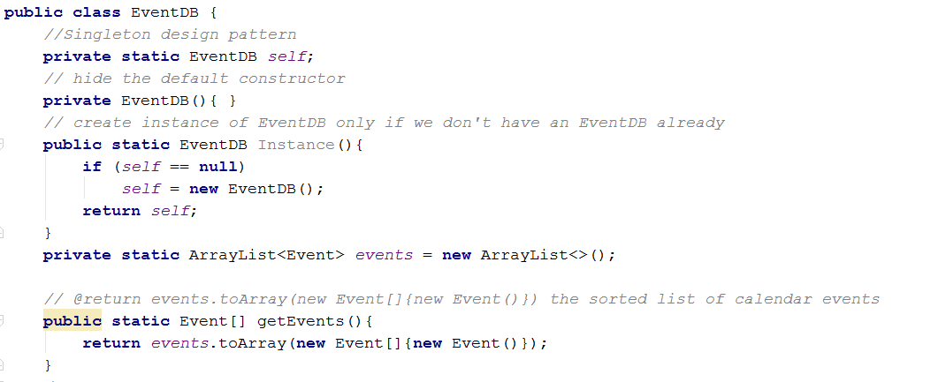

1. Navigation Pattern (Fragment Navigation Pattern) used for all the views to make navigation between views much easier

The base activity is the only activity in the app. Everything else is built as a fragment.

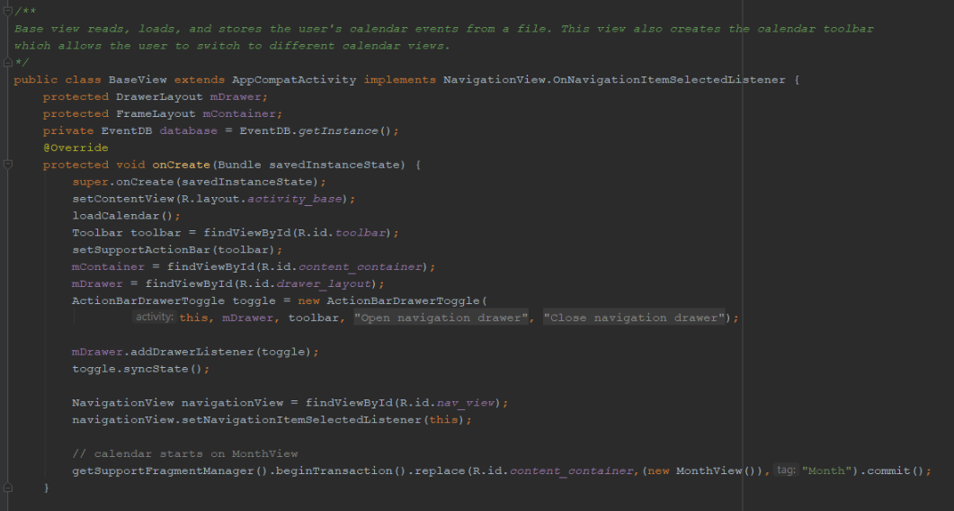

Most of the view fragments are called in the code below. This allows for the views to share common controls such as the toolbar and layout container.

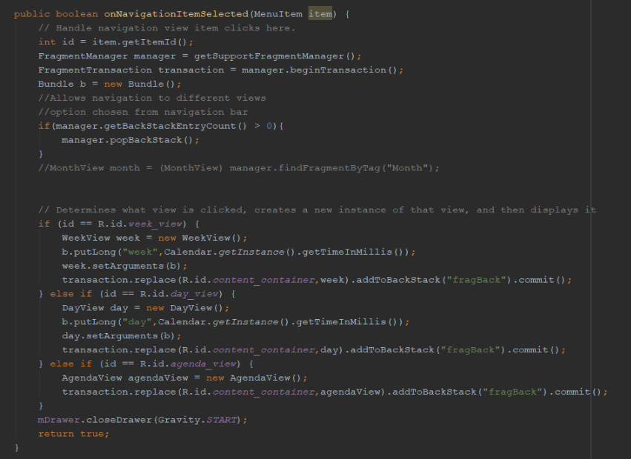

1. **Testing**

The test classes are located in the following directories:

Nothing to show

[3354-team2--](https://github.com/iqbalyarkhan/3354-team2--)/[src](https://github.com/iqbalyarkhan/3354-team2--/tree/master/src)/[CalendarApp](https://github.com/iqbalyarkhan/3354-team2--/tree/master/src/CalendarApp)/[app](https://github.com/iqbalyarkhan/3354-team2--/tree/master/src/CalendarApp/app)/src/[test/java/team2/calendarapp](https://github.com/iqbalyarkhan/3354-team2--/tree/master/src/CalendarApp/app/src/test/java/team2/calendarapp)

AND

[3354-team2--](https://github.com/iqbalyarkhan/3354-team2--)/[src](https://github.com/iqbalyarkhan/3354-team2--/tree/master/src)/[CalendarApp](https://github.com/iqbalyarkhan/3354-team2--/tree/master/src/CalendarApp)/[app](https://github.com/iqbalyarkhan/3354-team2--/tree/master/src/CalendarApp/app)/src/android[Test/java/team2/calendarapp](https://github.com/iqbalyarkhan/3354-team2--/tree/master/src/CalendarApp/app/src/test/java/team2/calendarapp)

The following test classes were developed by each member:

* GetEventsInRange.java developed by Daryl Vogel
* [AddEventToEventDBTest.java](https://github.com/iqbalyarkhan/3354-team2--/blob/master/src/CalendarApp/app/src/test/java/team2/calendarapp/AddEventToEventDBTest.java) developed by Anmol Agarwal
* CheckExpectedFlowOfMonthAndDay developed by Andrew Le
* TestDeleteEventFromDB by Iqbal Khan

1. **Instructions to Build and Run the Software:**

Steps to build the software:

* simply clone this repository
* load the following project in Android Studio
  + CalendarApp located in the folder: 3354-team2-- / src/CalendarApp
* And then build the project in Android Studio

Steps to run the software:

* Make sure the text field next to the green triangle button in the Android Studio toolbar says app
* Click the Run button in Android Studio (the green triangle button)
* Choose the emulator you would like the software to run on
  + If you do not have an available virtual device, connect a new device by following Android Studio’s prompts
* Click ok

1. **How to add event:** 
   1. With the app open, click on the ‘+’ button in the top right corner of the screen
   2. Fill out the details present on the form
   3. Click save event.
   4. Saved event will be shown in the month view with a red background as shown below:

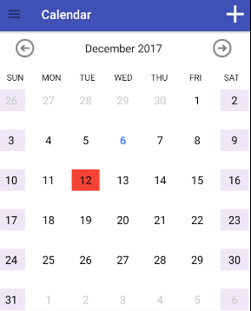

1. **How to switch from Month view to Week or Day view:**
   1. The specific view can be chosen from drop down menu in the top left corner of month view.
   2. Using gestures, day view can be accessed by double clicking on the day the user wants.
   3. Using gestures, week view can be accessed by a long press on the week the user wishes to see.
   4. The back button will take you back to the month view
2. **To switch to agenda view, follow these steps:**
3. simply open the toolbar on the left side of the emulator screen
4. select the field labeled agenda view.
5. Agenda view will display all events in a list.

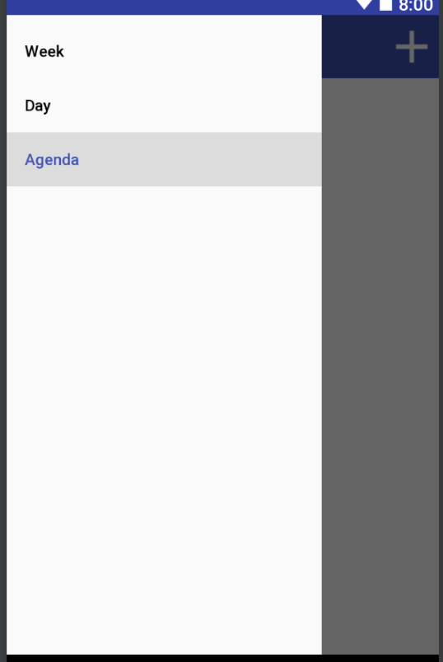

1. **How to add a category to an event**
   1. When creating an event, you can also specify a category by
      1. Creating a new category by clicking on the button add new category.

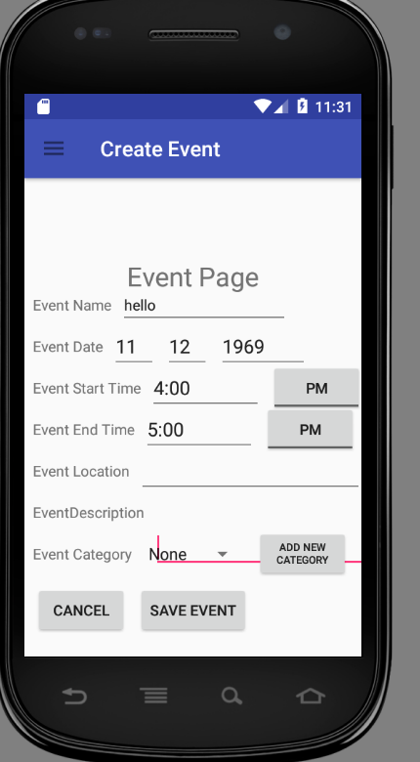

Once this is done, a new page will pop up allowing you to specify what you want your category to be. You can do so by:

* typing in a string in the category field labeled category
* You can also add a color to the category

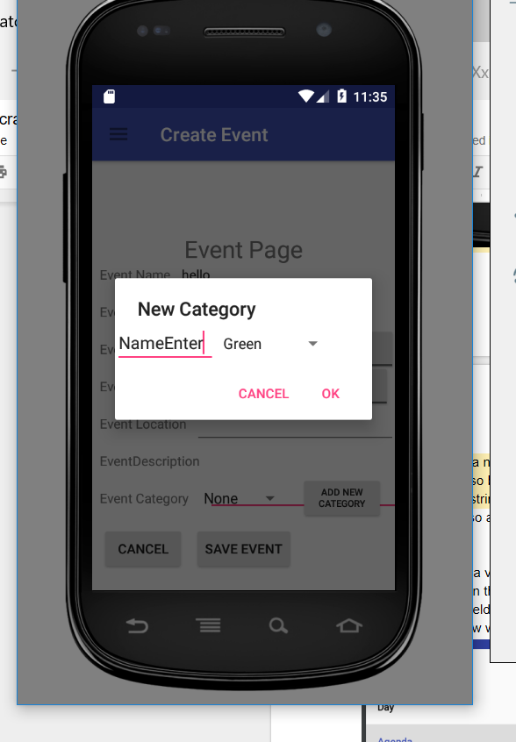

1. **How to Edit an Event**

To edit an event, follow these steps:

1. Click on the event in the calendar view, such as on Month view, week view, agenda view or daily view.
2. Once you click on the event, the event page for that event will pop up
3. you can now edit the fields you wish by deleting the current entry and typing in new values.
4. Click on the Save Event button to save your changes
5. **How to Delete an Event**

To delete an event, follow these steps:

1. click on an event within day view, week view, or agenda view.
2. This will bring up an edit event page.
3. On the bottom right corner, press the delete event to remove the event from the database.
4. On app close, the database file will be written over and the event will be removed permanently.

