**Data Mining (CSE542)**

**Homework 03**

**ID: ____ Name: ___조원석_____ Date:__2023-04-03__**

**Task-1**

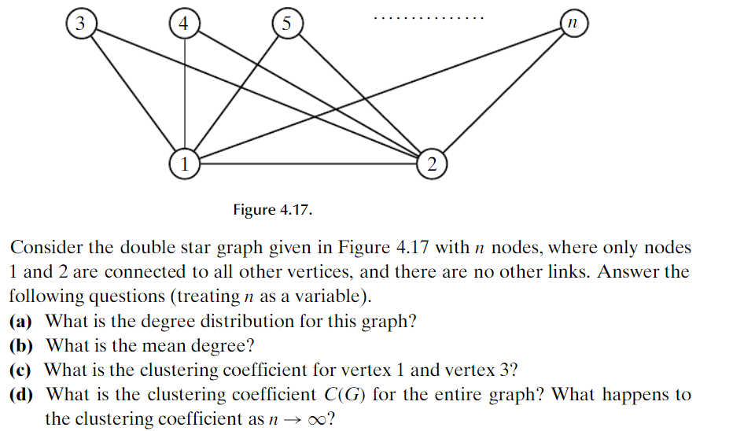

**(a) degree distribution**

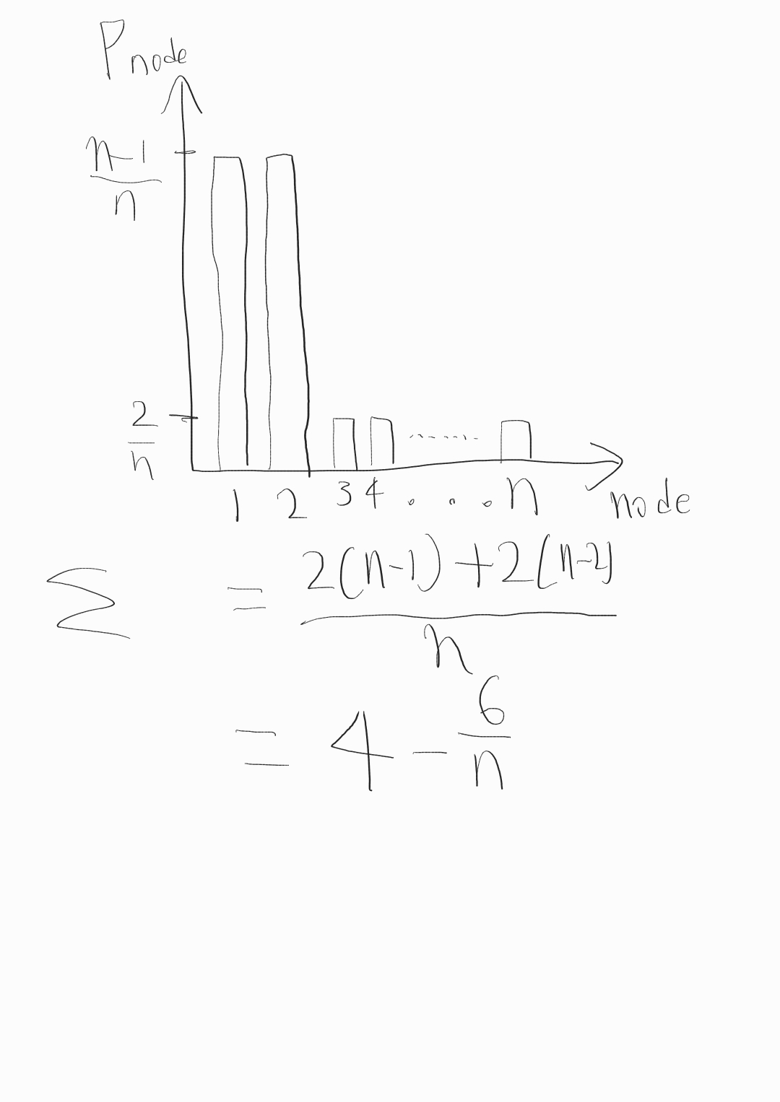

|  |  |
| --- | --- |
| **P** | **Pnode** |
| **2** | $$\frac{n-2}{n}$$ |
| **n-1** | $$\frac{2}{n}$$ |

**(b) mean degree = $\frac{1}{n}*\sum_{node=1}^{n}{P_{node}}=4-\frac{6}{n}$**

**(c) clustering coefficient for**

**- vertex 1 : C(1) = $\frac{n-2}{\left(\begin{aligned}n-1 \\ 2\end{aligned}\right)}=2*\frac{\left(n-2\right)}{\left(n-1\right)*\left(n-2\right)}=\frac{2}{n-1}$**

**- vertex 3 : C(3) = 1**

**(d)**

**- clustrering coefficient C(G) for the entire graph**

**C(G) = $\left((n-2\right)*1+2*2/(n-1))/n=\frac{n^{2}-3n+6}{n^{2}-n}$**

**- clustering coefficient as n -> ∞**

**C(G) -> $\lim_{n -> ∞}{C\left(G\right)=}\lim_{n -> ∞}{\frac{n^{2}-3n+6}{n^{2}-n}=1}$**

**Task-2**

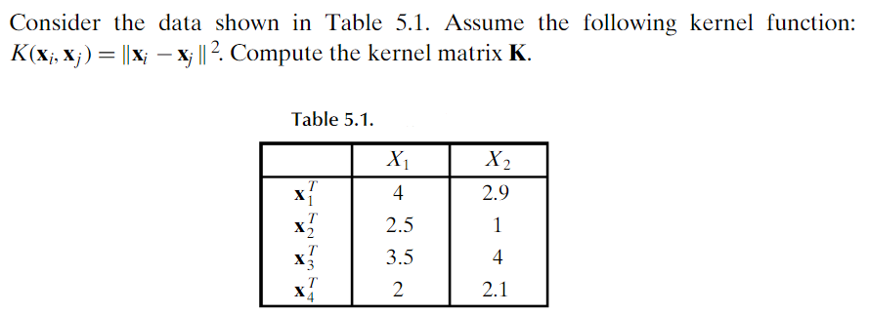

$K\left(X_{1}, X_{2}\right)={\left|\left|X_{1}- X_{2}\right|\right|}^{2}=1.5^{2}+1.9^{2}=5.86$

$K\left(X_{1}, X_{3}\right)={\left|\left|X_{1}- X_{3}\right|\right|}^{2}=0.5^{2}+1.1^{2}=1.46$

$K\left(X_{1}, X_{4}\right)={\left|\left|X_{1}- X_{4}\right|\right|}^{2}={2.0}^{2}+0.8^{2}=4.64$

$K\left(X_{2}, X_{3}\right)={\left|\left|X_{2}- X_{3}\right|\right|}^{2}=1.0^{2}+3.0^{2}=10.0$ $K\left(X_{2}, X_{4}\right)={\left|\left|X_{2}- X_{4}\right|\right|}^{2}=0.5^{2}+1.1^{2}=1.46$

$K\left(X_{3}, X_{4}\right)={\left|\left|X_{3}- X_{4}\right|\right|}^{2}=1.5^{2}+1.9^{2}=5.86$

**- Kernel matrix K**

$$K=\begin{matrix}0 & 5.86 & 1.46 & 4.64 \\ 5.86 & 0 & 10 & 1.46 \\ 1.46 & 10 & 0 & 5.86 \\ 4.64 & 1.46 & 5.86 & 0\end{matrix}$$

**Task-3:**

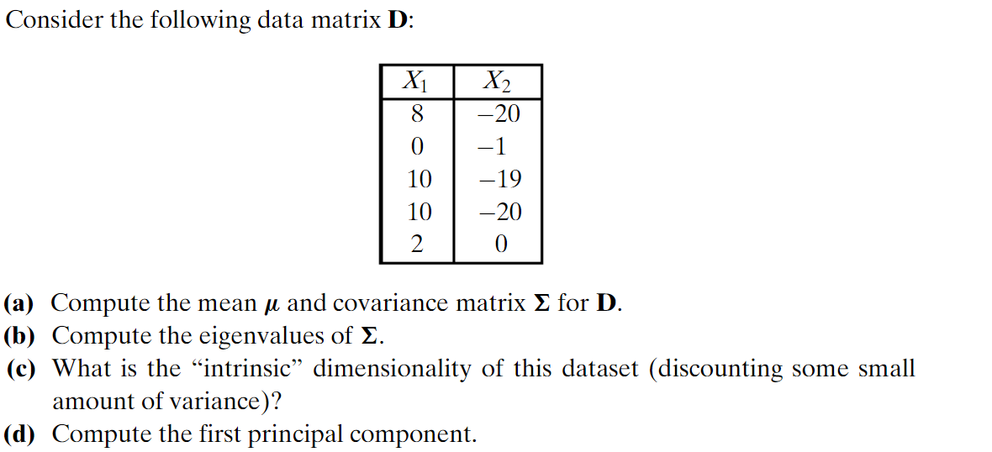

**(a) Compute the mean µ and convariance matrix ∑ for D**

**µ = [ $\frac{8+0+10+10+2}{5}{, \frac{-20,-1,-19,-20,0}{5}}$] = [6.0, -12.0]**

|  |  |  |  |  |
| --- | --- | --- | --- | --- |
| **X1** | **X2** | **X1^2** | **X2^2** | **X1 × X2** |
| **8- (6.0)=2** | **-20 - (-12.0)=-8** | **4** | **64** | **-16** |
| **0- (6.0)=-6** | **-1- (-12.0)=11** | **36** | **121** | **-66** |
| **10- (6.0)=4** | **-19- (-12.0)=-7** | **16** | **49** | **-28** |
| **10- (6.0)=4** | **-20- (-12.0)=-8** | **16** | **64** | **-32** |
| **2- (6.0)=-4** | **0- (-12.0)=12** | **16** | **144** | **-48** |
| **SUM** | | **88** | **442** | **-190** |
| **SUM / 5** | | **17.6** | **88.4** | **-38** |

**∑ for D = $\frac{1}{5}(\begin{matrix}X1^{2} & X1 X2 \\ X2 X1 & X2^{2}\end{matrix})$**

**= ( $\begin{matrix}17.6 & -38 \\ -38 & 88.4\end{matrix}$)**

**(b) Compute the eigenvalues of ∑  
 solving eigenvalues by det( ∑ - λI ),**

$\left(17.6-λ\right)\left(88.4-λ\right)-38^{2}$

$= λ^{2}-106λ+1555.84-1444$

$=λ^{2}-106λ+111.84= 0$

$λ=\frac{106±\sqrt{{106}^{2}-4*111.84}}{2}=\frac{106±\sqrt{10788.64}}{2}$

${ λ}_{1}=\frac{106+\sqrt{10788.64}}{2}≒$ 104.9342 $λ_{2}=\frac{106-\sqrt{10788.64}}{2}$ ≒ $1.0658$

**(c) What is the “intrinsic” dimensionality of this dataset( discounting some small amount of variance)?**

$$\frac{104.9342}{104.9342+1.0658}≒0.9899$$

=> first principal component is 105.

**(d) Compute the first principal component.**

**=> ∑ ui=λiui, ${ λ}_{1}≒$** 104.9342

Solving eigenvector)

$\left(\begin{matrix}17.6-104.9342 & -38 \\ -38 & 88.4-104.9342\end{matrix}\right)\left(\begin{matrix}x \\ y\end{matrix}\right)=\left(\begin{matrix}0 \\ 0\end{matrix}\right)$

$$\left(\begin{matrix}-87.3342 & -38 \\ -38 & -16.5342\end{matrix}\right)\left(\begin{matrix}x \\ y\end{matrix}\right)=\left(\begin{matrix}0 \\ 0\end{matrix}\right)$$

$-87.3342x-38y=0$ $x= -\frac{38}{87.3342}y ≒-0.4351y$**,**

**If y = 1, x $≒$ 0.4351**

$\frac{1}{1.09}(\begin{matrix}-0.4351 \\ 1\end{matrix}$**) =( $\begin{matrix}-0.3992 \\ 0.9173\end{matrix}$)**