**Data Mining (CSE542)**

**Homework 04**

**ID: ___ Name: __조원석___ Date:__2023-04-04 __**

**Task-1**

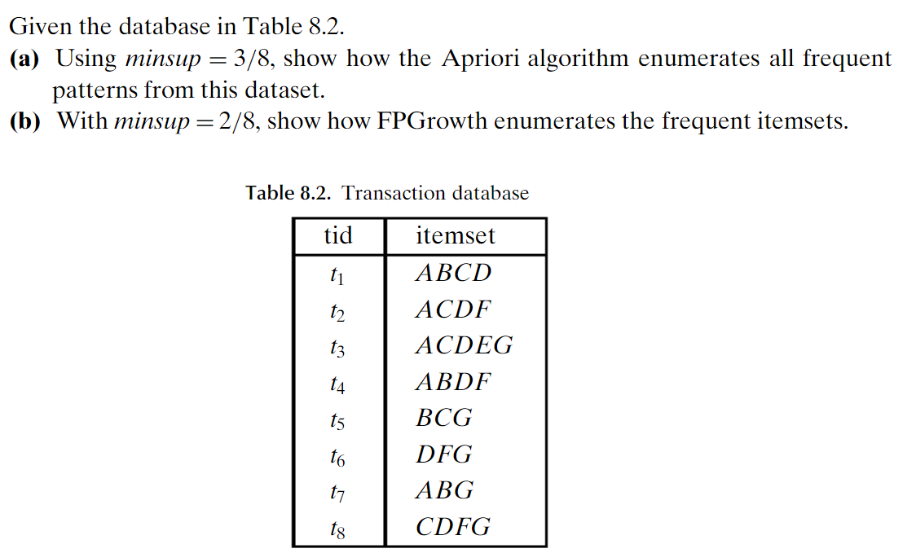

1. **Using minsup = 3/8, show how the Apriori algorithm enumerates all frequent patterns from this dataset.**

**Level one’s Frequent pattern**

**A : 5, B : 4, C : 5, D: 6, F : 4, G : 5**

* **A, B, C, D, F, G**

**-------------------------------------------------------------------------------------------------------------------**

**Level two’s Frequent pattern**

**AB : 3, AC : 3, AD : 4, AF : 2, AG : 2, BC : 2, BD : 2, BG : 2, CD : 4, CF : 3, CG: 3, DF : 4, DG : 3, FG: 3**

* **AB, AC, AD, CD, CF, CG, DF, DG, FG**

**--------------------------------------------------------------------------------------------------------------------**

**Level three’s Frequent pattern**

**ABC: 1, ABD: 2, ACD: 3, CDF: 3, CDG: 2, CFG: 2, DFG: 3**

* **ACD, CDF, DFG**

**Level four’s and five’s Frequent pattern**

**ABCD: 1, ABDF: 1, ACDE: 1, ACDF: 1, ACDG: 1, ADEG: 1, CDEG: 1, CDFG: 1, ACDEG: 1**

1. **With minsup = 2/8, show how FPGrowth enumerates the frequent itemsets.k**

**{D:6}, {A:5}, {C:5}, {G:5}, {B:4}, {F:4}**

**F : {DF: 4}, {AF: 2}, {GF: 2}, {CF: 2}, {DAF: 2}, {DGF: 2}, {DCF: 2}**

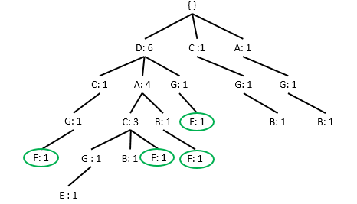

**B : {AB: 3}, {BC: 2}, {BD: 2}, { BG: 2 }, {ABD: 2}**

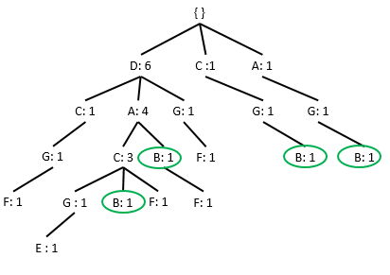

**G : {CG: 3}, {DCG: 2}, {AG: 2}, {DG: 3}**

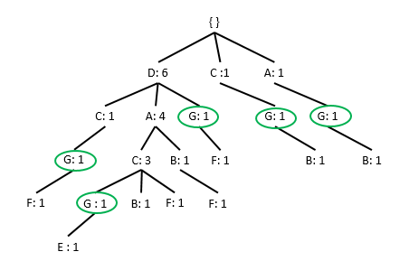

**C : {AC: 3}, {DAC: 3}, {DC: 4}**

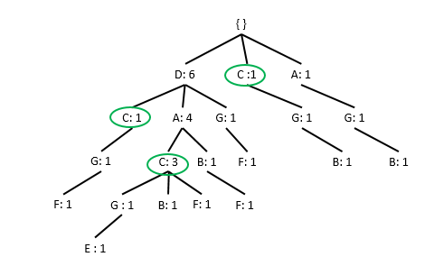

**A: {DA: 4}**

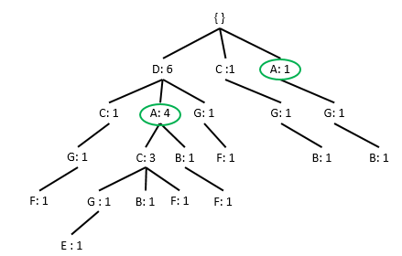

**T1 = DACB => X**

**T2 = DACF => X**

**T3 = DACGE => X**

**T4 = DABF => X**

**T5 = CGB => X**

**T6 = AGB => X**

**T7 = AGB => X**

**T8 = DCGF => X**

An example is solved for Apriori and FPGrowth Algorithms

Dataset D

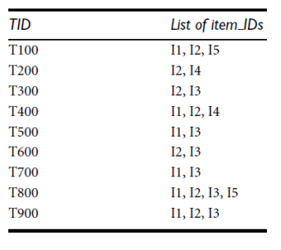

Frequent Itemsets through Apriori Algorithm

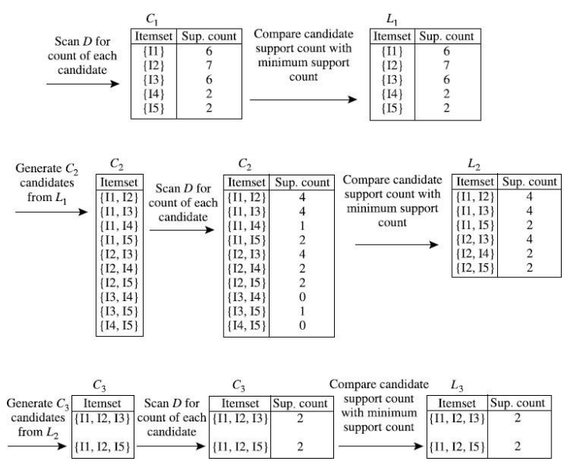

Frequent Itemsets through FPgrowth Algorithm

