Language Support:
English
Spanish
French
Arabic
Turkish
Malay
Bangla
Urdu

Categories:
Qur’an
* 114 Surahs
Invocations Morning & Evening
* Du’a Asaasi (After Obligatory Prayer)
* Pre/Post Fajr Du’a
* Pre/Post Dhuhr Du’a
* Pre/Post Asr Du’a
* Pre/Post Maghrib Du’a
* Pre/Post Isha Du’a
Salawat
* Salawat Nariyah
* Salawat Azeemiya
* Salawat Tunjina
Awrad & Litanies
* Sayyidi Awrad
* Dala'il Al Khayrat
* Hizb al-Bahr
* Hizb al-Nasr
* Wird al-Latif
Teachings
* Aqidah/Creed
* Fiqh
* Tasawwuf
Divine Names
* Asma ul-Husna
Poems & Qasa’id
* Dhikr Ashiq

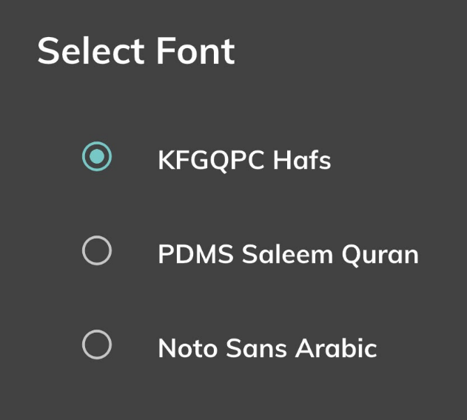
Arabic Typefaces only these 2, the user can choose between this:
Uthman Font
Indopak Font

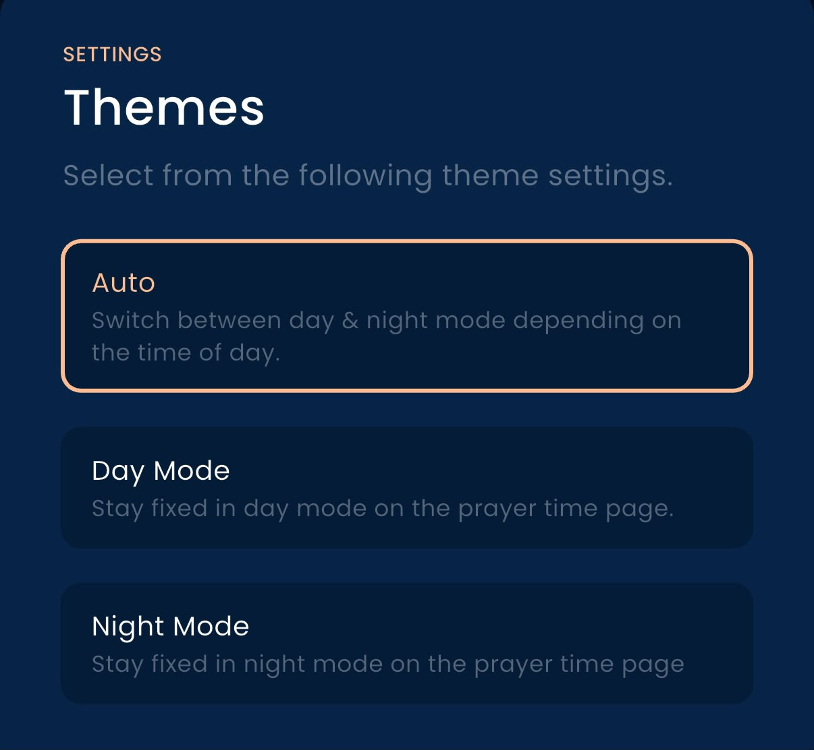
Themes:
Auto, Day and Night modes (Light & Dark)
Auto mode based on actual sunrise and Maghrib rather than a fixed clock time.
Following the phone's system theme, as an additional option.

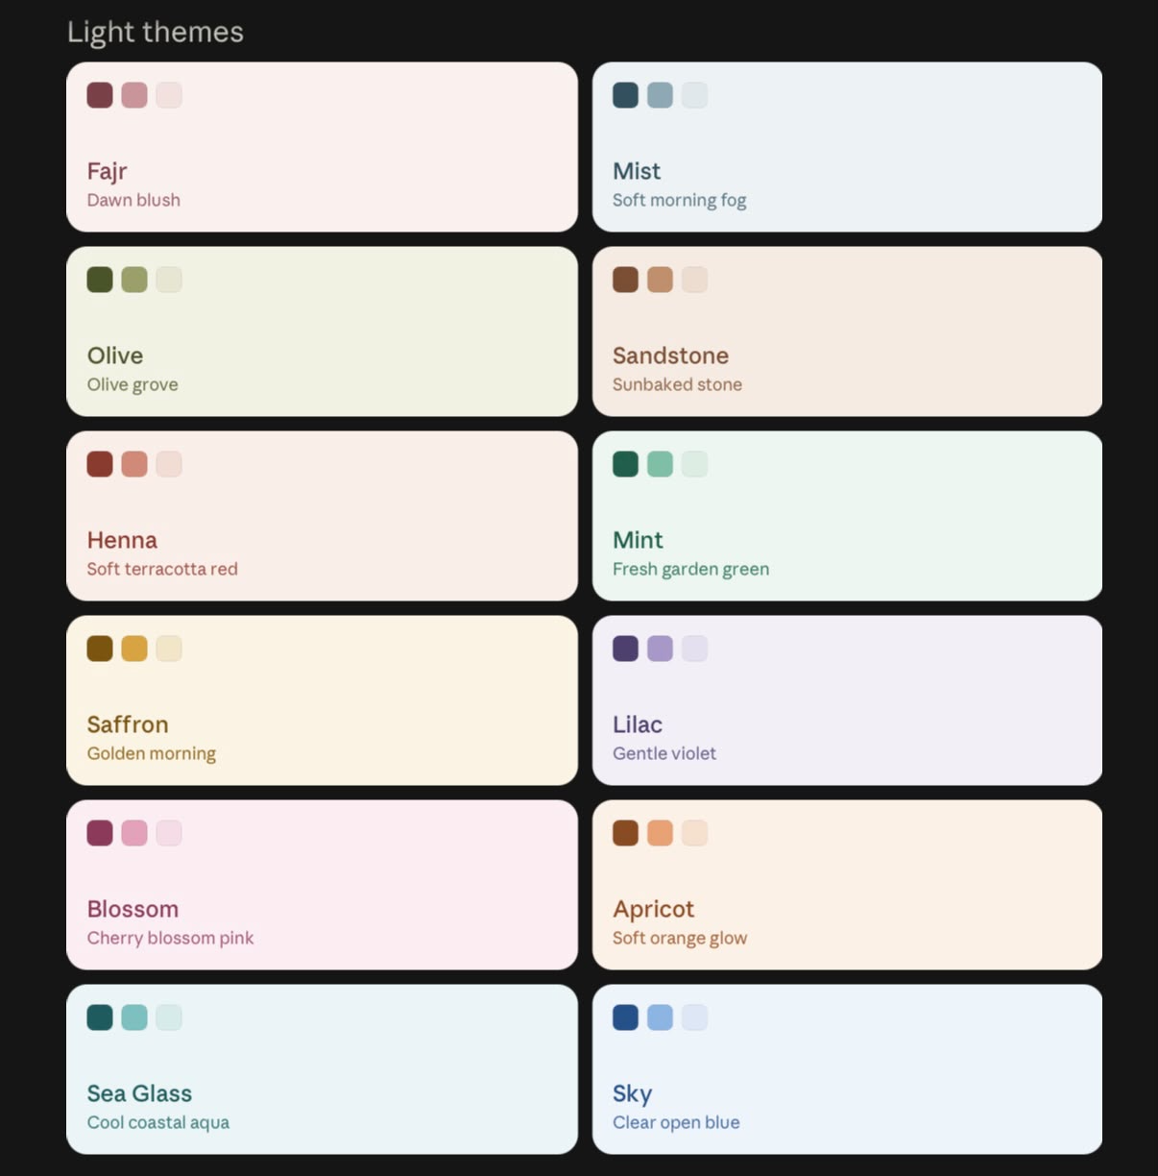
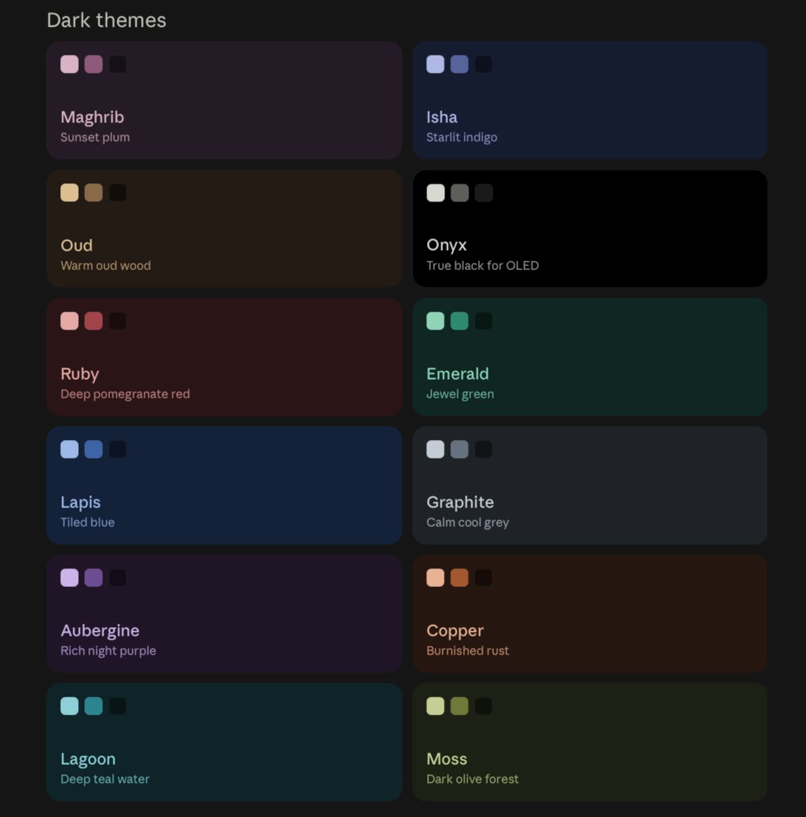

More Theme Options.
More colour way theme options here some ideas below as an example.

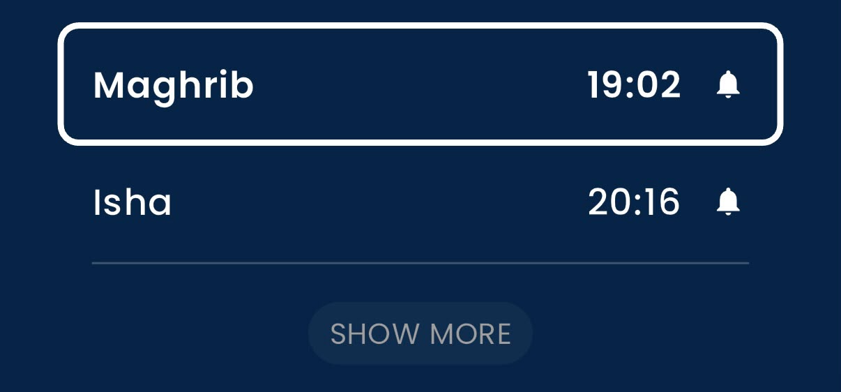
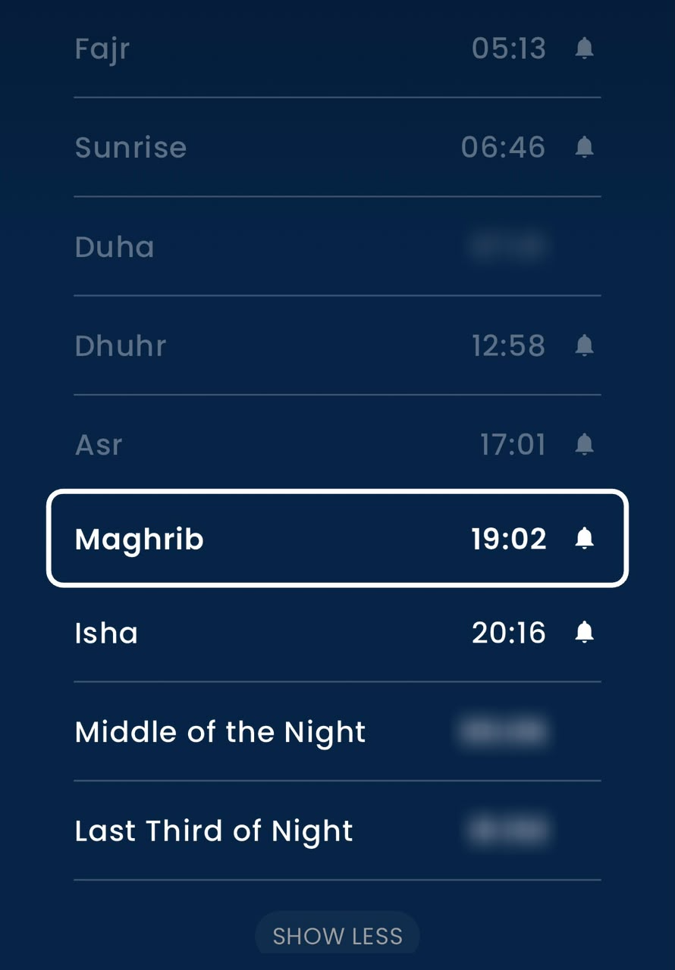
Prayer Time Settings:
Show more
Collapsed: shows the current and next prayer, with a "Show more" button
Expanded: shows the full list, with a "Show less" button
Extra times:
Duha
Middle of the night
Last third of the night

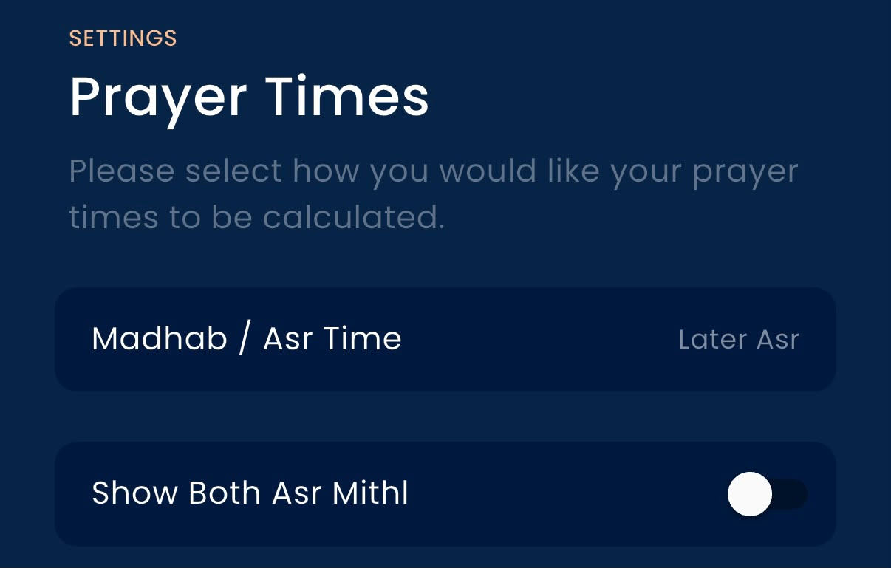
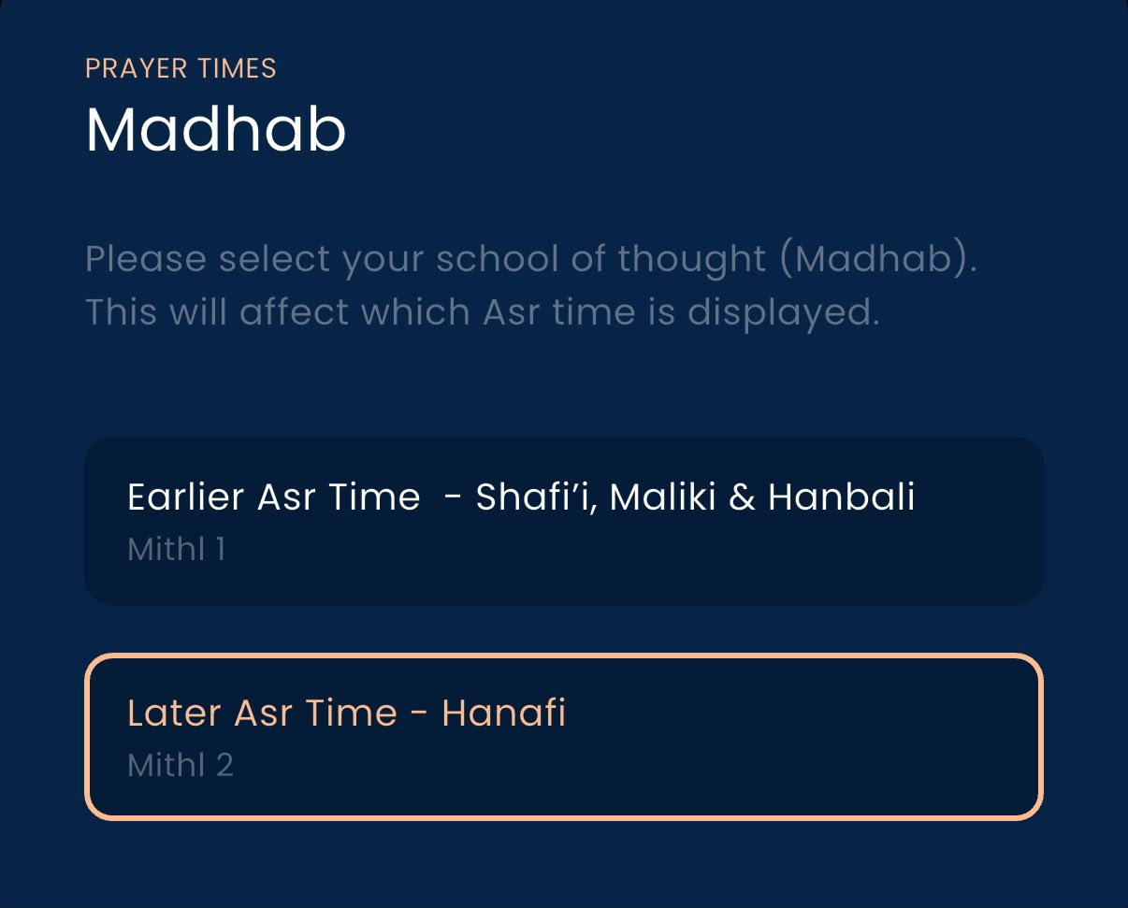
Madhab / Asr Calculation:
Let users choose Mithl 1 (Shafi'i, Maliki, Hanbali) or Mithl 2 (Hanafi), with labels like "Earlier Asr" and "Later Asr".
Show both Asr times: an optional toggle for users who want to see both times.

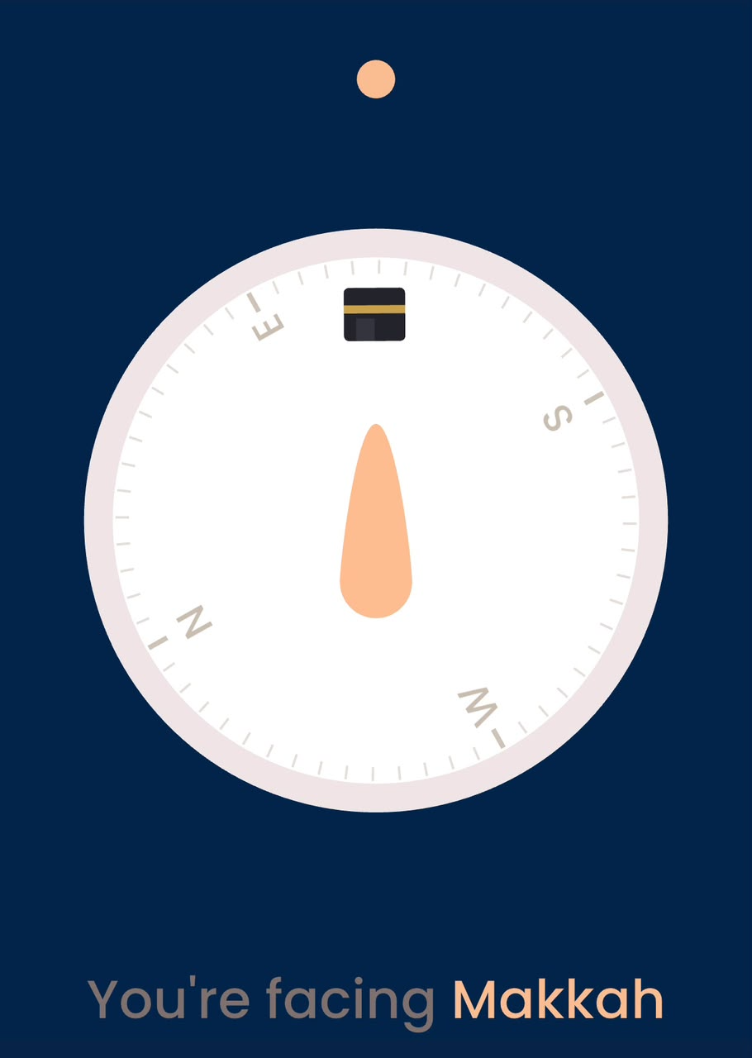
Qibla Direction:
Qibla compass showing the direction of the Kaaba in Makkah.
Use device location and compass sensors for accurate direction.
Distance to Makkah could also be displayed.

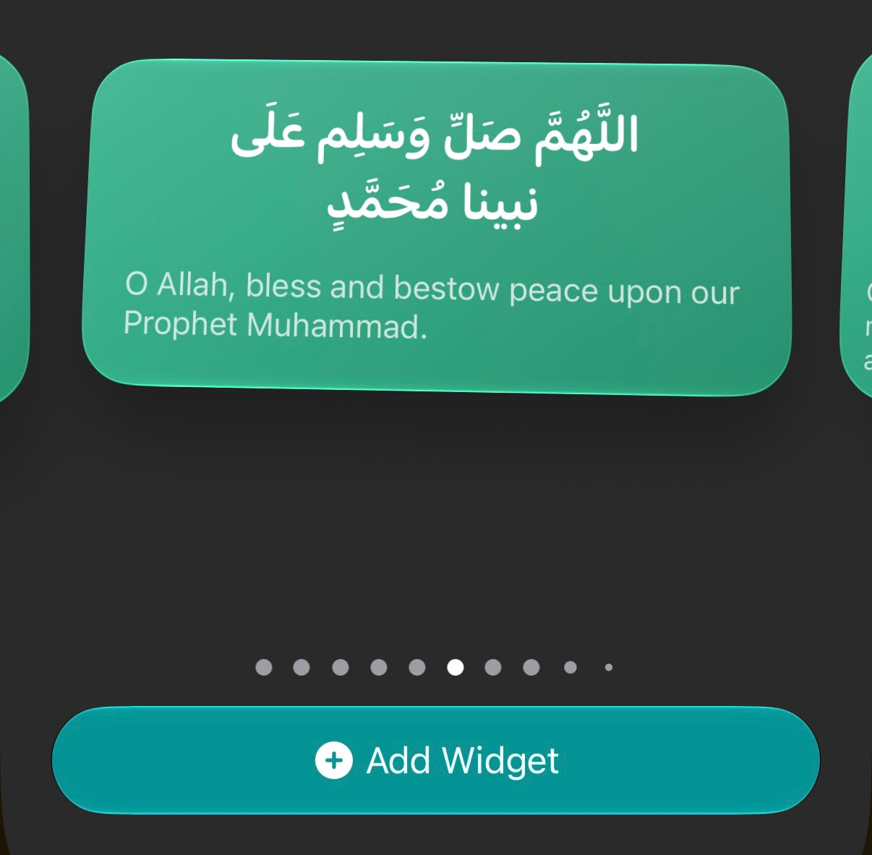
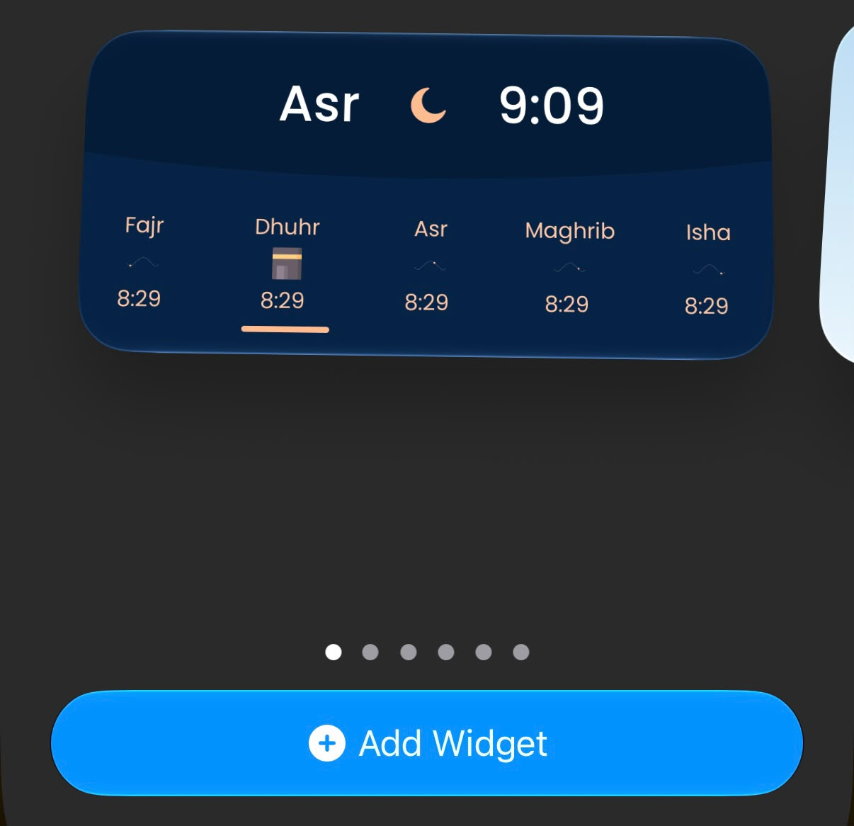
App Widgets:
Phone’s Home Screen & Lockscreen
Prayer Times
Adkhar
Lessons

