## C:\Users\HPPAVILION23KPTM\Desktop\Logo KUPTM dan Color Code.jpg

FKLT/12-00

Assignment Cover– be sure to keep a copy of all work submitted

##### To be completed by student – PLEASE PRINT CLEARLY

|  |  |  |  |
| --- | --- | --- | --- |
| Name:  IQMAL HAZZEQ BIN ABDUL AZIZ | | | |
| ID Number:  AM1709003076 | | | |
| Lecturer  Nor Azura Salleh @ Omar / Mohamed Ghazali bin Khairuzzaman | | Lab group / Tutorial group / Tutor (if applicable) |
| Course and Course Code  CSC406–Web API | | Submission Date:  **5/4/2019** |
| Assignment No. / Title  Report AdamHawa.com | | Extension & Late submission:  Allowed / Disallowed |
| Assignment type:  Group | % of Assignment Mark | Returning Date: | |
| Penalties:   1. 10% of the original mark will be deducted for every one week period after the submission date 2. No work will be accepted after two weeks of the deadline 3. If you were unable to submit the coursework on time due to extenuating circumstances you may be eligible for an extension 4. Extension will not exceed one week | | |
| Declaration: I/we the undersigned confirm that I/we have read and agree to abide by these regulations on plagiarism and cheating. I/we confirm that this piece of work is my/our own. I/we consent to appropriate storage of our work for checking to ensure that there is no plagiarism/ academic cheating.  Signature:  IQMAL HAZZEQ  Full Name: | | |

Table of Contents

1.0 Introduction 3

2.0 Services 4

3.0 Competitive Advantage 5

4.0 Process of Luvforyou 6

4.1 Flow Chart of Luvforyou 6

4.2 Work Breakdown Structure (WBS) 7

4.3 Business Process Model and Notation (BPMN) 7

4.4 Entity Relationship Diagram (ERD) 9

4.5 Wireframe 10

5.0 References 12

6.0 Appendix 13

1. **Introduction**

Online dating (or Internet dating) is a system that enables people to find and introduce themselves to new personal connections over the Internet, usually with the goal of developing personal, romantic, or sexual relationships. An online dating service is a company that provides specific mechanisms (generally websites or applications) for online dating through the use of Internet-connected personal computers or mobile devices. Such companies offer a wide variety of unmoderated matchmaking services, most of which are profile-based.

At Luvforyou, we’re dedicated to helping people find love and happiness through meaningful connections. Our one-of-a-kind algorithm matches you on what actually matters. We create romantic opportunities so singles are more likely to find someone special. Over the years, we've learned more and more about what people want and the tools they need to help take the lottery out of love. The internet have become a common tool used to seek friends, romantic and sexual partners (Baker,2003).

Luvforyou provide the platform and tools for members to get in touch. Like any dating opportunity, it all starts by creating a profile with a photo and sharing personal details. The next step is to search through the membership database and quickly see other people who have joined. All activity takes place on a secure, reliable and safe network that guarantees the privacy and safety of every member.

Our friendly customer care team is committed to your success and making sure your online dating experience is smooth, safe, and stress free. The profitability comes from users that upgrade to premium to increase their percentage to find their new partners. Luvforyou also have its unique feautures from the others dating to attract people.

1. **Service**

These days, you should consider online dating as one of the best and most effective ways to meet a romantic companion, find a meaningful relationship and live happily ever after with someone you could marry. Though the data surrounding the success of online dating is still new and ever-changing, some studies indicate meeting online paves the way for a happier relationship.

Luvforyou has a great platform with a clean design that makes it really easy to use. Luvforyou dating website promises ease of use and practicality in the singles world. Instead of filling out long and tedious questionnaires about yourself and your ideal match, it simply takes the online profiles from the social media accounts you've already created and seamlessly integrates your information into your Luvforyou account.

If you want to do anything, you’re going to have to pay for a membership. With a basic account, you can only browse and like other users. If you want to read or send any messages, you’re going to have to pay for it. But there are some benefits to becoming a member. The price points are on par with other dating sites and it’s a little bit easier to navigate. You also know that if you receive a legit message from a real user, then you can also send a reply back to them.

We help our members connect to each other based on their mutual interests and similarities and not their location. That way the users can find more specific criteria their partner. It can help the users connect more easily if there have same interest and the conversation could be more interesting.

1. **Competitive Advantage**

* Features

Our website offers features that are not available on other websites. The advantages we offer to premium users is quite intreseting that can attract users used our website such as they can view who liked, they will always be inform of suggested profiles and get unlimited like.

* Price

We offers low price than other dating websites for upgrading to premium account. Users more attract to a dating website that cost them low price to get maximum privellage.

* Focus on Readability

Readability is one of the signs that shows the usability of the website. If our site has readability issues, then it is likely that your visitors will be angry and leave it. Therefore, we must take the necessary steps to ensure that your site does not have any problem reading. Ample amount of white space, proper paragraph formatting and displaying lists using bullet points will also contribute towards making our website content more readable. In addition, we put our design elements like sidebars, banners and text boxes on website with the way they do not distract the user when they go through this site.

* Engaging customers

While observing some of the marketing, the Internet portal can reinforce your current product offerings. The ways that can improve the product's website are to offer a lot, ranging from offering new web-related products to creating affiliate programs that come out. Providing better customer service that enhances core product appeal is the best way to effectively link products to customer needs.

* No boundaries

Our platform connects free members with paid members of both sexes across the world. This enables more people to benefit from our service, and gives paid members higher response rates and more attention.

1. **Process of Luvforyou website**

No

Yes

Register

Find Match

Login page

Login

Setup profile

Homepage

4.1 Flowchart

First of all, open the website the user will see the homepage then if the user are new he/she need to register first than fill the user information and set the password also email than it will go to home or menu. If the user already registers, the system will detect and give alert that user already been registered. Next, users have to login with the email and password that have been registered to enter the website and proceed to another steps. Users have to setup their own profile where users have to fill out their names, gender, interest and also picture. Finally users can find their match and start their moves.

4.2 Work Breakdown Structure (WBS)

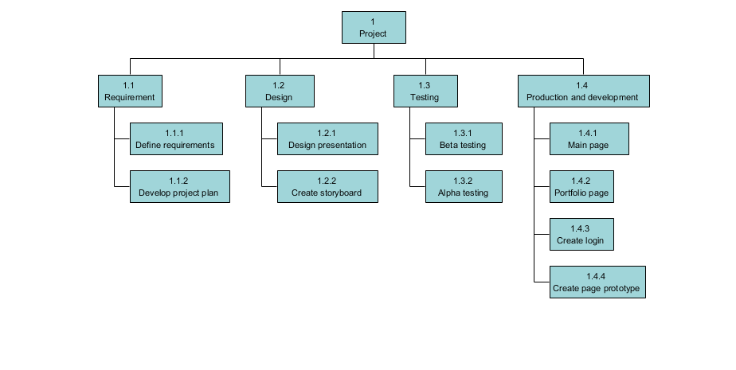

4.3 Business Process Model and Notation (BPMN)

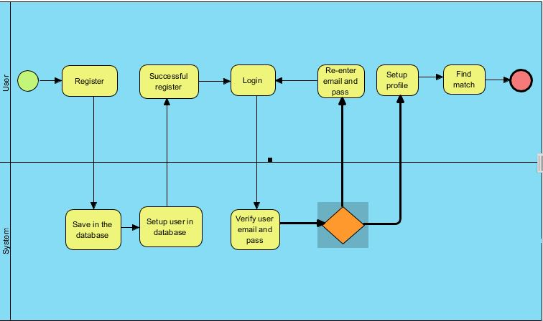

No

Yes

4.3.1 Register BPMN

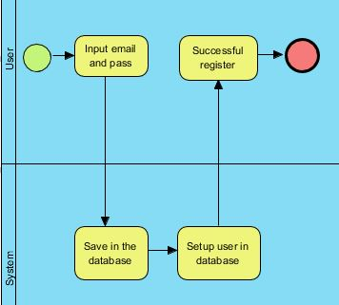

The picture above shows the process of user to register new account in Luvforyou website. First, users have to input their email and password to create their account. The system will save the email and password in the database and setup the users. The system can detect whether the email have been registered or not and send the alert. If the users successful register their account, the system will notify them.

4.3.2 Find Match BPMN

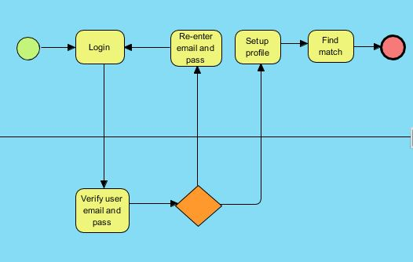

After login, users need to login with the email and password that have been registered. System will verify the user email and password. If the email is verify, the user will proceed to setup their account by adding their name, gender, interest and also picture. If not, the user need to re-enter password and email that their been registered. After all steps is complete, the users can find their match.

In searching, users specify exactly what characteristics they are looking for. They can search the set of profiles based on constrained descriptors such as age, gender, and interest, and sometimes by keywords in the free-response descriptors.

* 1. Entity Relationship Diagram (ERD)

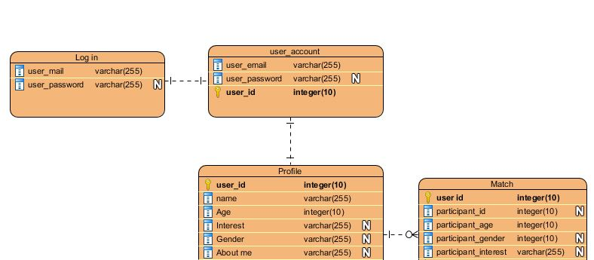

* 1. Wireframe

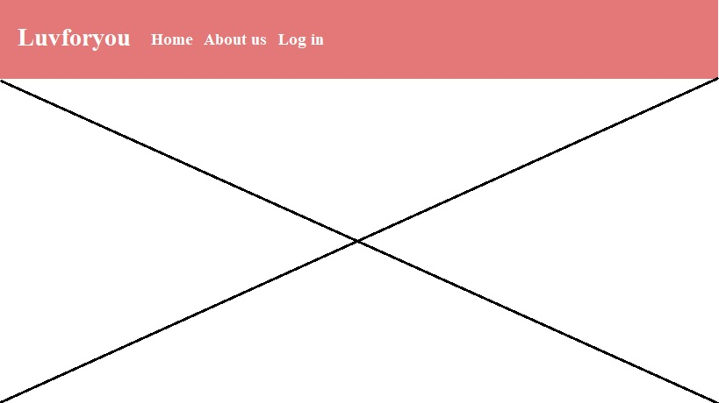

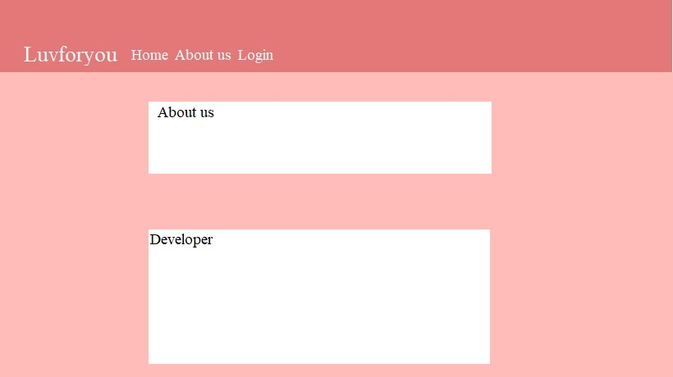

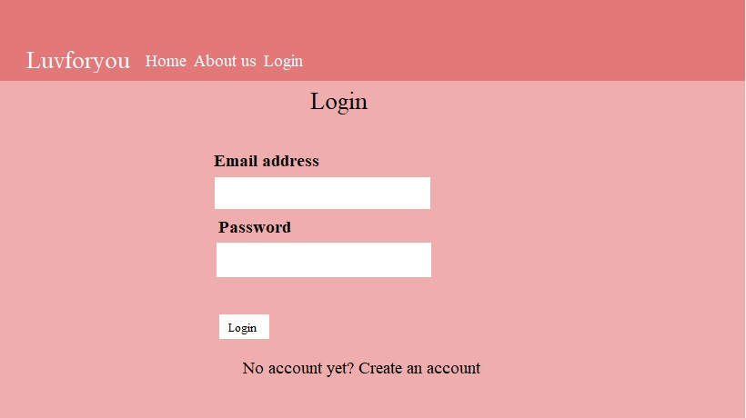

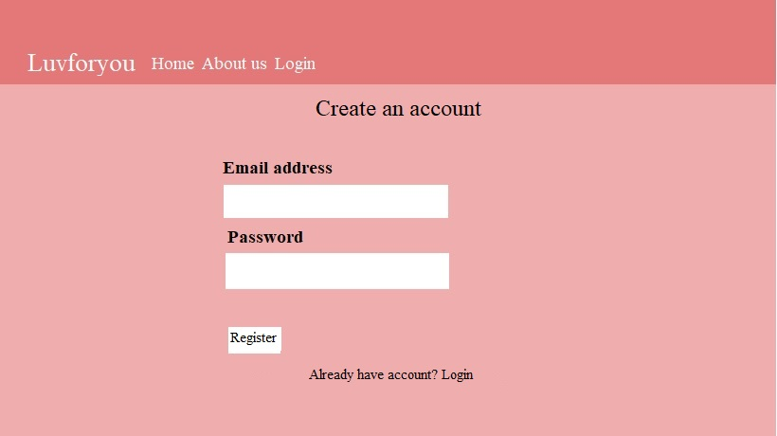

1. **Reference**

* Recker, J. (2010). Opportunities and constraints: The current struggle with BPMN. Business Process Management Journal, 16(1), 181-201. doi: <http://dx.doi.org/10.1108/14637151011018001>
* Baker, A. J. (2005). Double click: Romance and commitment among online couples. Cresskill, NJ: Hampton Press.
* Frost, J.H., et al., People are Experience Goods: Improving Online Dating with Virtual Dates. Journal of Interactive Marketing, 2008. 22(1): p. 51-61
* W Hall (Jan,1993) .Scope management through a WBS' PM Network

Hall, W 'Scope management through a WBS' PM Network Vol 7 No 5 (1993)

Ipsos-Reid Poll (2002) ‘Online Dating’ September 30, 2002. Available http://www.ipsos-na.com/news/pressrelease.cfm?id=1635

1. **Appendix**

Link github: <https://github.com/iqmlhzzq/LuvforyouNew>



