Oldsmar Cyberattack: A Defense-in-Depth Simulation for SCADA Systems

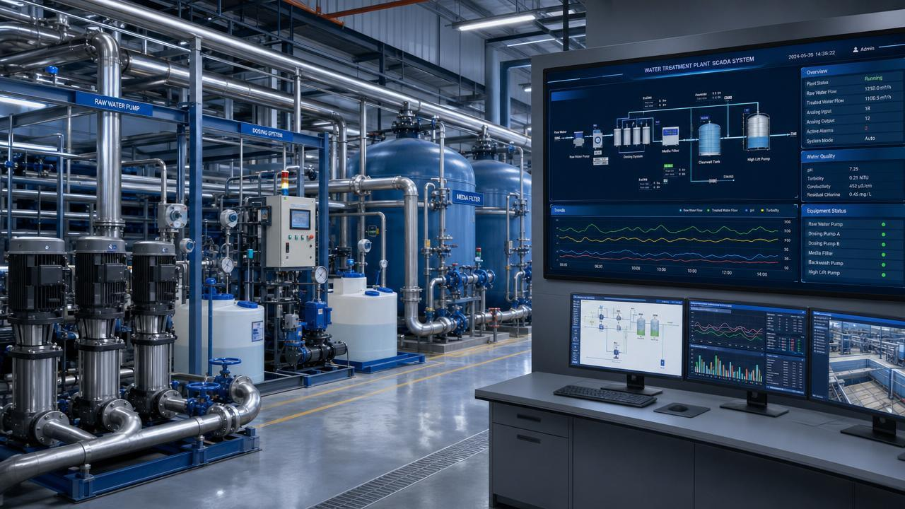

Technical Project Report & Implementation Documentation
Prepared by: Ameer Ahmed & Noran Hamid
Course Instructor: Dr. Rabei Raad Ali
Field: Cybersecurity Engineering
Project Type: Defensive Security Simulation

1. Historical Background: The Reported Oldsmar Incident
On February 5, 2021, an unauthorized attempt to manipulate the control system of a water treatment facility in Oldsmar, Florida, USA, was reported. According to the historical cybersecurity advisory published by the Cybersecurity and Infrastructure Security Agency (CISA), the sodium hydroxide (NaOH) setpoint was changed from 100 parts per million (ppm) to 11,100 ppm. The operator noticed the change and restored the setpoint to 100 ppm. The advisory stated that there was no significant increase in the amount of sodium hydroxide added to the treated water.
It is important to distinguish between three concepts:
- Setpoint: The target value that the control system is instructed to maintain or achieve.
- Measured Process Variable: The actual value measured by a sensor or obtained from the physical process.
- Actual Physical Outcome: The real-world result of the process, such as the actual chemical concentration in the treated water.
Changing a setpoint does not automatically mean that the physical process has reached the requested value. The process may require time to respond, and its actual behavior depends on the physical system and its operating conditions. This distinction is fundamental to the project because it separates a potentially dangerous control command from its actual physical consequences.
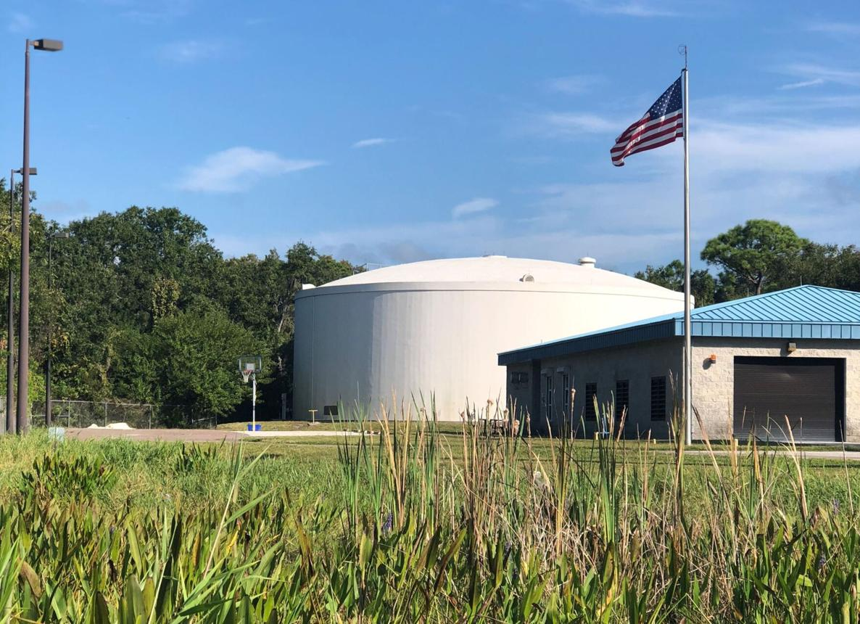
Figure 1. Oldsmar City Water Treatment Plant.
Source: City of Oldsmar, as credited by WUSF.
Later Developments and Investigative Uncertainty
In April 2023, WUSF reported that the former Oldsmar city manager questioned the original interpretation of the incident. The report also stated that the FBI had been unable to confirm that the incident was initiated by a targeted cyber intrusion. Therefore, the reported 2021 incident should be presented with this subsequent uncertainty in mind, rather than treated as a conclusively established cyberattack.
This project uses the reported setpoint-change scenario as the basis for an educational defensive simulation. It does not attempt to establish what actually caused the 2021 event.
2. Security Problem and Motivation
The security problem addressed by this project concerns the possibility of unauthorized or unsafe changes to process setpoints in industrial control systems. If an unauthorized user or session can submit a setpoint-change request, or if legitimate credentials are misused, the system may be exposed to potentially dangerous control actions.
This project focuses on three defensive concerns:
1. Unauthorized Access
Is the user or session authorized to modify the process setpoint?
2. Abnormal or Dangerous Requests
Even if the user is authorized, is the requested value or the magnitude of the change reasonable and safe according to the rules defined for the simulation?
3. Alarm Timing
Does the original SCADA alarm system alert the operator in a timely manner, or could the alarm remain inactive when a suspicious setpoint-change request occurs?
The project investigates these concerns within an educational simulation. It does not claim that each of these conditions was a confirmed vulnerability in the actual Oldsmar water treatment facility. Identifying a specific historical vulnerability would require supporting evidence.
3. Research Question and Proposed Solution
Research Question Can an additional defensive layer detect and prevent unauthorized process-setpoint changes even when the original SCADA system does not generate a timely alarm?
Proposed Solution
This project implements an educational simulation of an additional defensive layer for industrial control systems. The simulated system evaluates process-setpoint change requests using authorization checks, anomaly detection, and safety interlocks. It also models the state of the native SCADA alarm system to examine whether the defensive layer can identify and reject suspicious or unsafe requests while the simulated native alarm remains inactive.
The implementation records the request details, detection results, alarm state, and final decision in an audit log. This enables the project to demonstrate how multiple defensive controls can work together to reduce the risk associated with unauthorized or unsafe setpoint changes.
The proposed solution is evaluated using predefined simulation scenarios and automated software tests. The results demonstrate the behavior of the implemented controls under the tested conditions; they do not establish the effectiveness of the system in a real industrial environment.
4. System Architecture and Design The proposed system is organized into several software components that evaluate process-setpoint change requests and determine whether they should be accepted or rejected. The simulation combines authorization checks, anomaly detection, safety interlocks, native SCADA alarm modeling, and audit logging.
The main components are:
1. SCADA System Simulation Represents the simplified industrial control environment in which process-setpoint change requests are received and evaluated.
2. Authorization Policy Checks whether the requesting user or session is authorized to modify the process setpoint.
3. Anomaly Detector Evaluates requests for suspicious characteristics, such as an unauthorized change or an unusually large setpoint modification, according to the implemented detection rules.
4. Safety Interlock Applies the safety constraints defined for the simulation and prevents requests that violate the configured limits.
5. Native SCADA Alarm Simulation Models the state of the original SCADA alarm system to examine whether an alarm is clear, pending, or active during a simulated event.
6. Audit Logger Records relevant event details, including the request, authorization result, safety decision, alarm state, detection result, and final system decision.
Together, these components demonstrate a defense-in-depth approach in which multiple defensive checks contribute to the decision-making process. The implementation is a local educational simulation and is not connected to a real industrial control system.
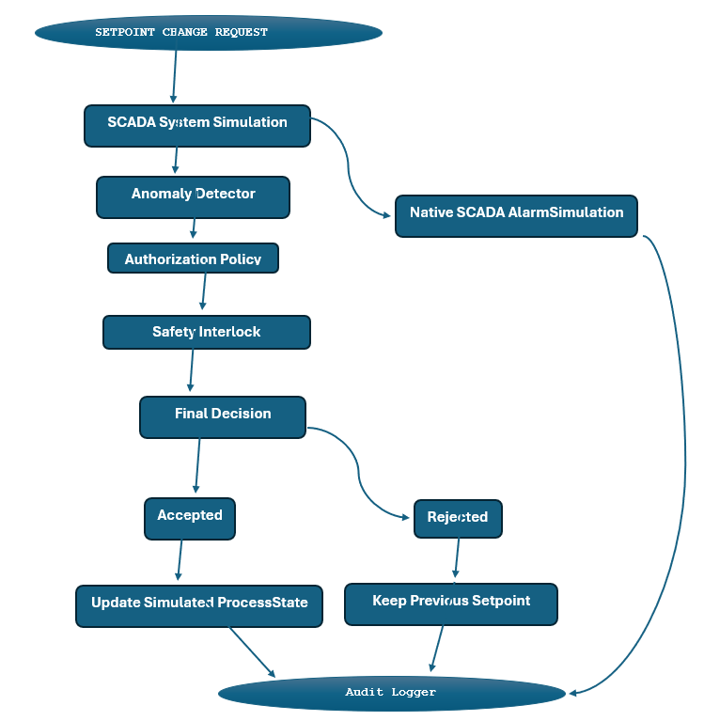

Figure 2. System Architecture of the Defensive SCADA Simulation.
The diagram presents the main components of the simulation, showing the setpoint-change request, defensive checks, simulated SCADA alarm state, final decision, and audit logging.
5. Implementation and Software Components
5.1. Project Structure
The project is implemented in Python and organized into separate directories to improve modularity, readability, and maintainability. The source code is stored in the src/ directory, simulation scenarios are located in scenarios/, automated tests are organized in tests/, and supporting documentation is maintained in docs/.
The main project components are summarized below:
File or Directory | Description
src/config.py | Defines configuration values, reference values from the historical incident, and illustrative laboratory safety limits.
src/process.py | Simulates the simplified water-treatment process, including concentration changes, dosing behavior, and an approximate pH response.
src/safety.py | Implements authorization policies and safety interlocks for evaluating setpoint-change requests.
src/audit.py | Implements anomaly detection and records security events and decisions in an audit log.
src/scada_alarm.py | Simulates the native SCADA alarm subsystem and its possible alarm states.
src/scada_system.py | Coordinates the main components and manages request evaluation, process-state updates, and audit logging.
scenarios/run_simulation.py | Executes the demonstration scenarios and displays their results.
tests/ | Contains automated tests for normal operation, security checks, safety interlocks, audit logging, and alarm behavior.
docs/ | Contains supporting project documentation and incident analysis.
This modular structure separates process simulation, security validation, alarm modeling, and event logging. It also makes individual components easier to test and maintain. The implementation operates as a local educational simulation and is not connected to a real industrial control system.
5.2. Core Security Components
The core security logic is implemented through several cooperating Python components. Each component has a specific responsibility in evaluating process-setpoint change requests.
Anomaly Detection — src/audit.py
The anomaly detector evaluates requests for suspicious characteristics, including unusually large setpoint changes and critical requested values. Its detection result contributes to the system's assessment of the request.
Authorization Policy — src/safety.py
The authorization policy checks whether the requesting user or session is permitted to perform the requested setpoint modification. Unauthorized requests are rejected before the safety interlock is evaluated.
Safety Interlock — src/safety.py
The safety interlock evaluates the requested setpoint against the safety limits configured for the educational simulation. Requests that violate these limits are rejected, and the previous process state is preserved.
SCADA System Coordinator — src/scada_system.py
The SCADA system coordinates anomaly detection, authorization checks, safety evaluation, process-state updates, and audit logging. It determines the outcome of each simulated request based on the implemented control logic.

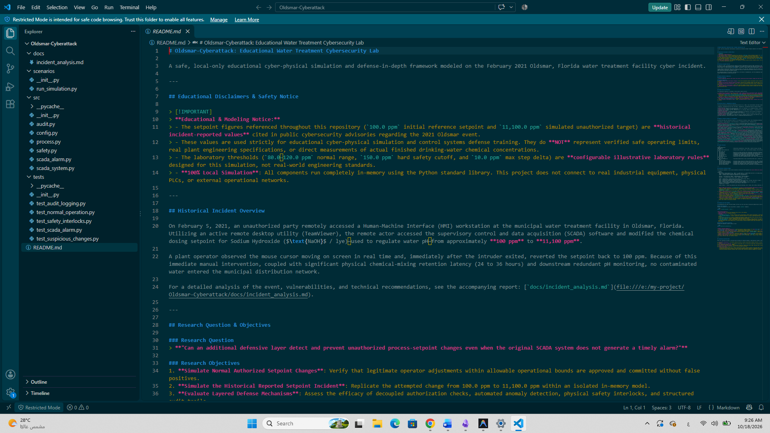
Figure 3. Directory Structure of the Oldsmar-Cyberattack Project.
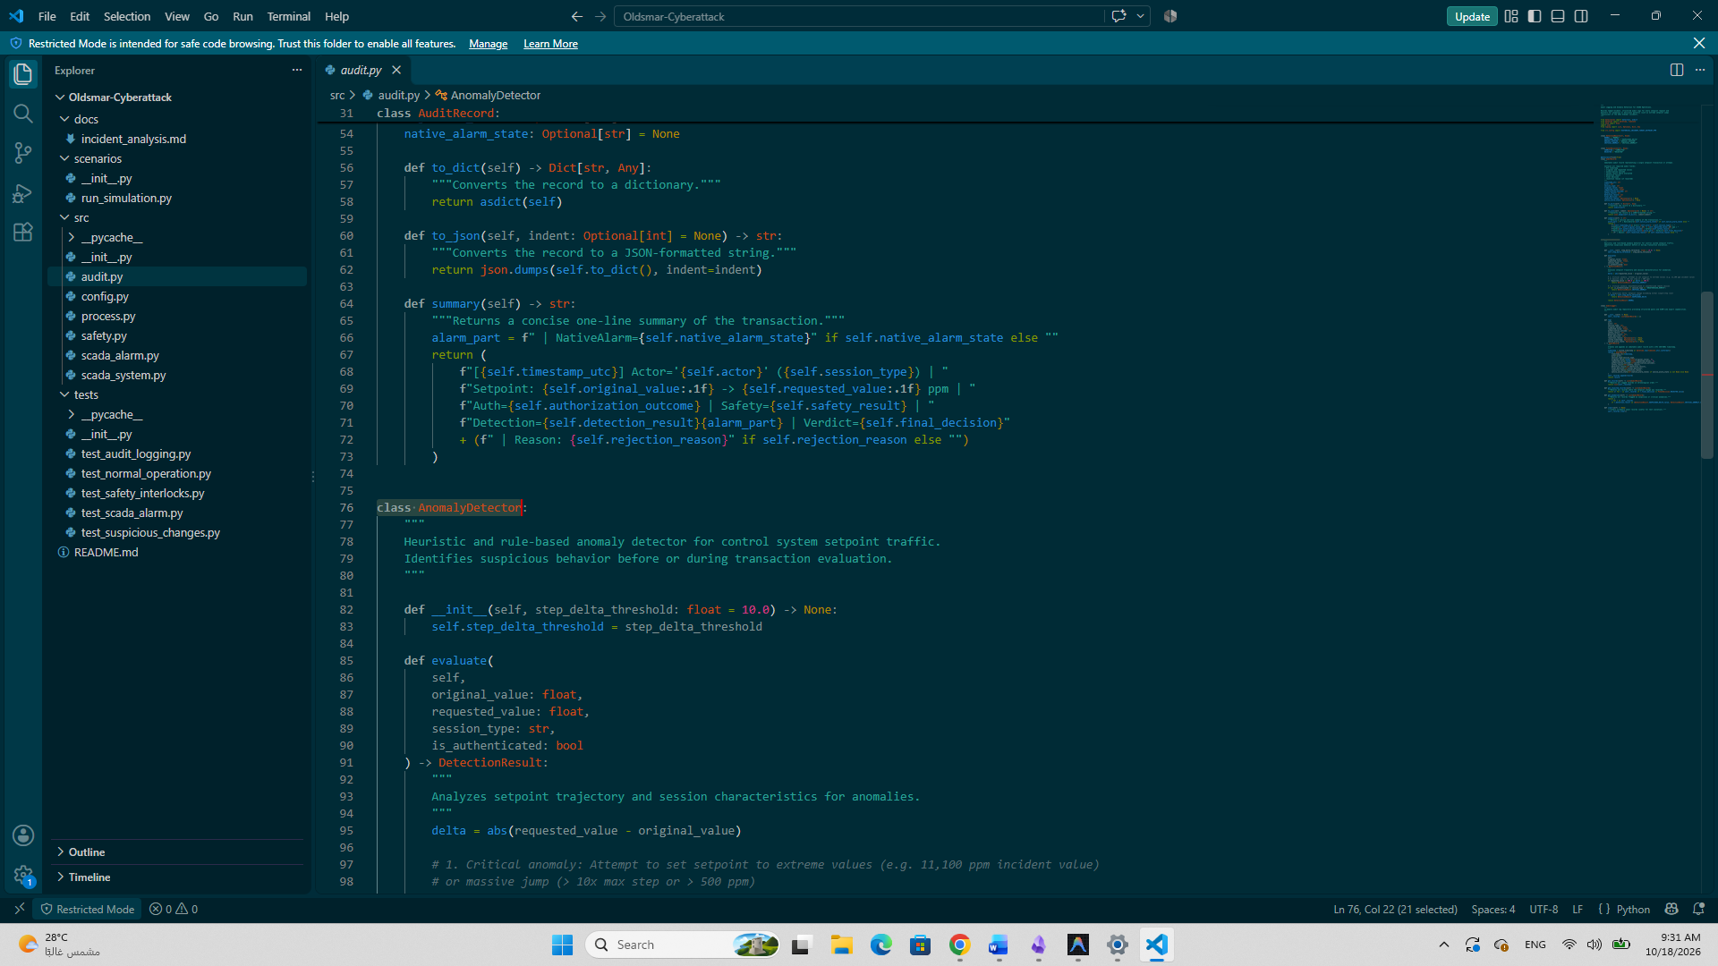
5.2.1. Anomaly Detection and Audit Logging
The src/audit.py module implements anomaly detection and structured audit logging for the simulated SCADA environment.
The module defines detection categories, including NORMAL, SUSPICIOUS_DELTA, UNUSUAL_SESSION, and CRITICAL_ANOMALY, to represent different outcomes of the detection process.
It also defines an AuditRecord data structure for recording information about each setpoint-change request. The recorded fields include the timestamp, actor, session information, original and requested values, authorization outcome, safety evaluation result, detection result, final decision, and rejection reason when applicable. These capabilities support traceability by preserving a structured record of simulated security events and the decisions made by the system.
Anomaly Detection Logic
The AnomalyDetector.evaluate() method in src/audit.py evaluates setpoint-change requests using predefined heuristic rules. It first calculates the absolute difference between the original and requested setpoints.
The method returns CRITICAL_ANOMALY if the requested setpoint is at least 500 ppm, if the absolute change is at least 500 ppm, or if the request is unauthenticated or originates from a session classified as UNAUTHORIZED_REMOTE. If none of these critical conditions is met, the method checks whether the absolute change exceeds the configured step-delta threshold, which defaults to 10.0 ppm. If it does, the result is SUSPICIOUS_DELTA. Otherwise, the request is classified as NORMAL. These classifications support the system's security assessment. They do not, by themselves, determine the final acceptance or rejection decision.
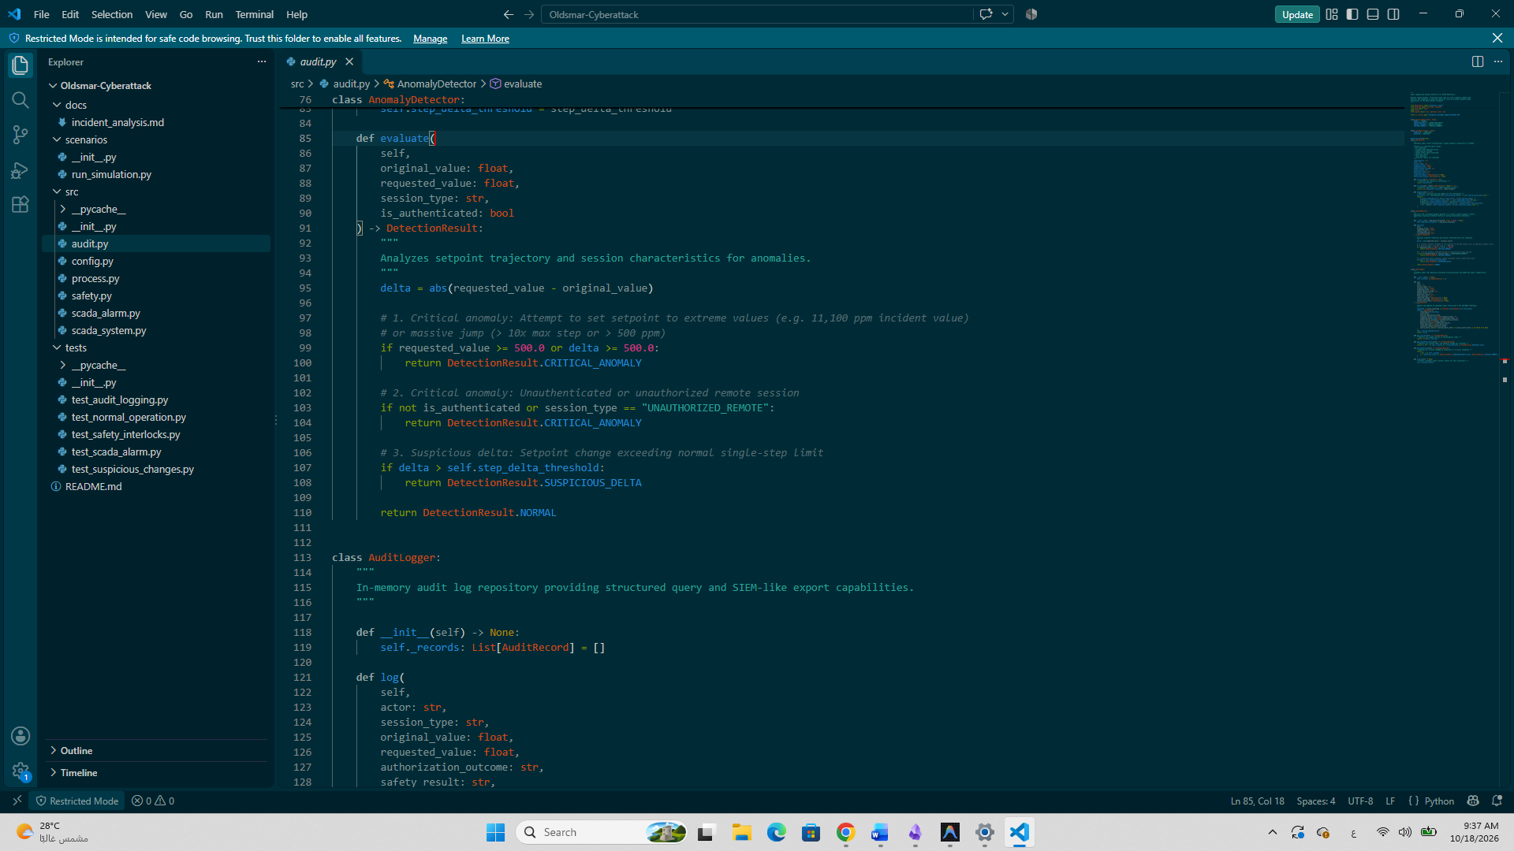Figure 4. Rule-Based Anomaly Detection Logic in src/audit.py
5.2.2. Audit Logging
Audit Logging
The AuditLogger class in src/audit.py records structured information about simulated setpoint-change requests. Each audit record includes the request details, authorization outcome, safety evaluation, anomaly detection result, native SCADA alarm state, and final system decision. These records support traceability and help explain why a request was accepted or rejected.
The audit logger stores records in memory during the simulation; it does not provide persistent log storage.
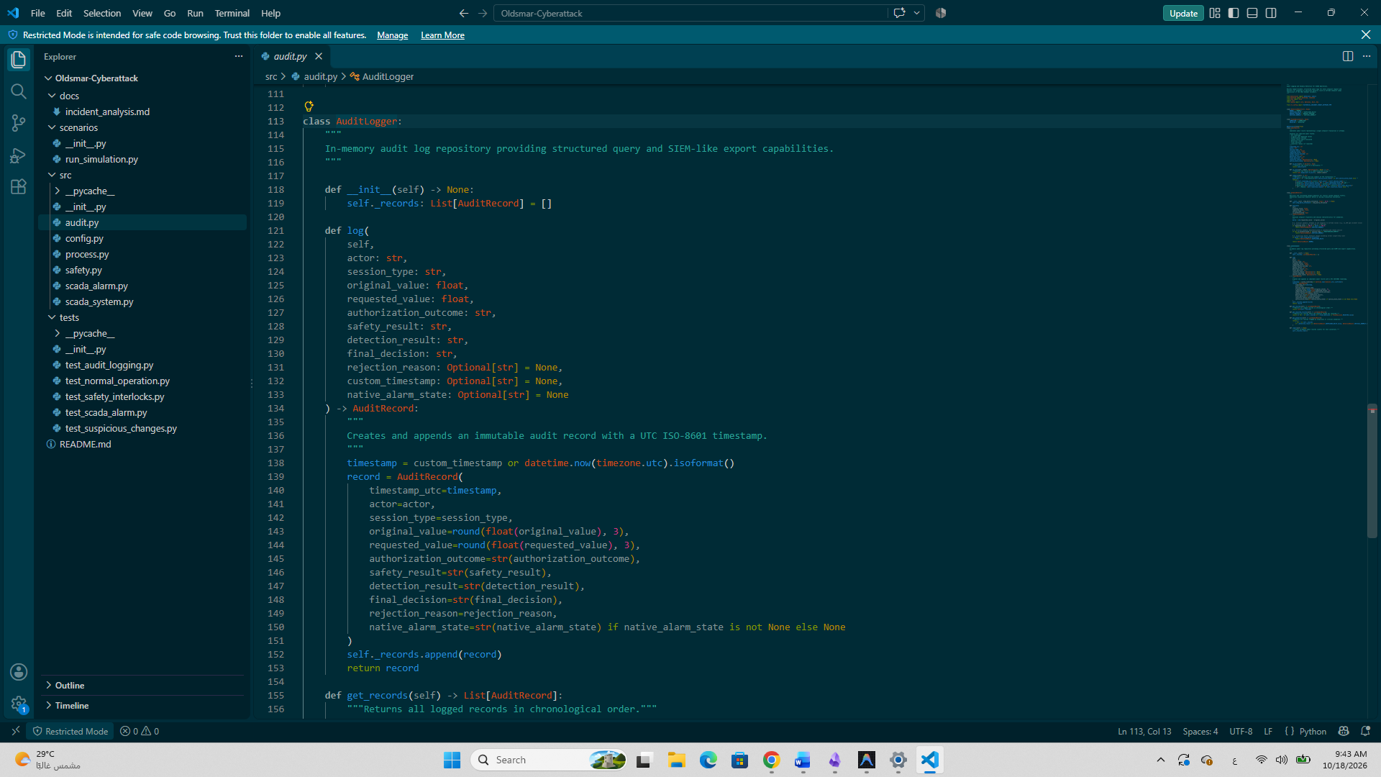Figure 5. Audit Logging Implementation in src/audit.py.
Authorization Policy and Safety Interlock
The AuthorizationPolicy and SafetyInterlock classes in src/safety.py implement two separate defensive controls. The authorization policy verifies the user's authentication status, role privileges, and session type before permitting a setpoint change. The safety interlock independently checks the requested value against the configured safety limits for the simulation and rejects requests that violate them. These controls help prevent unauthorized or unsafe modifications while preserving the previous setpoint when a request is rejected.

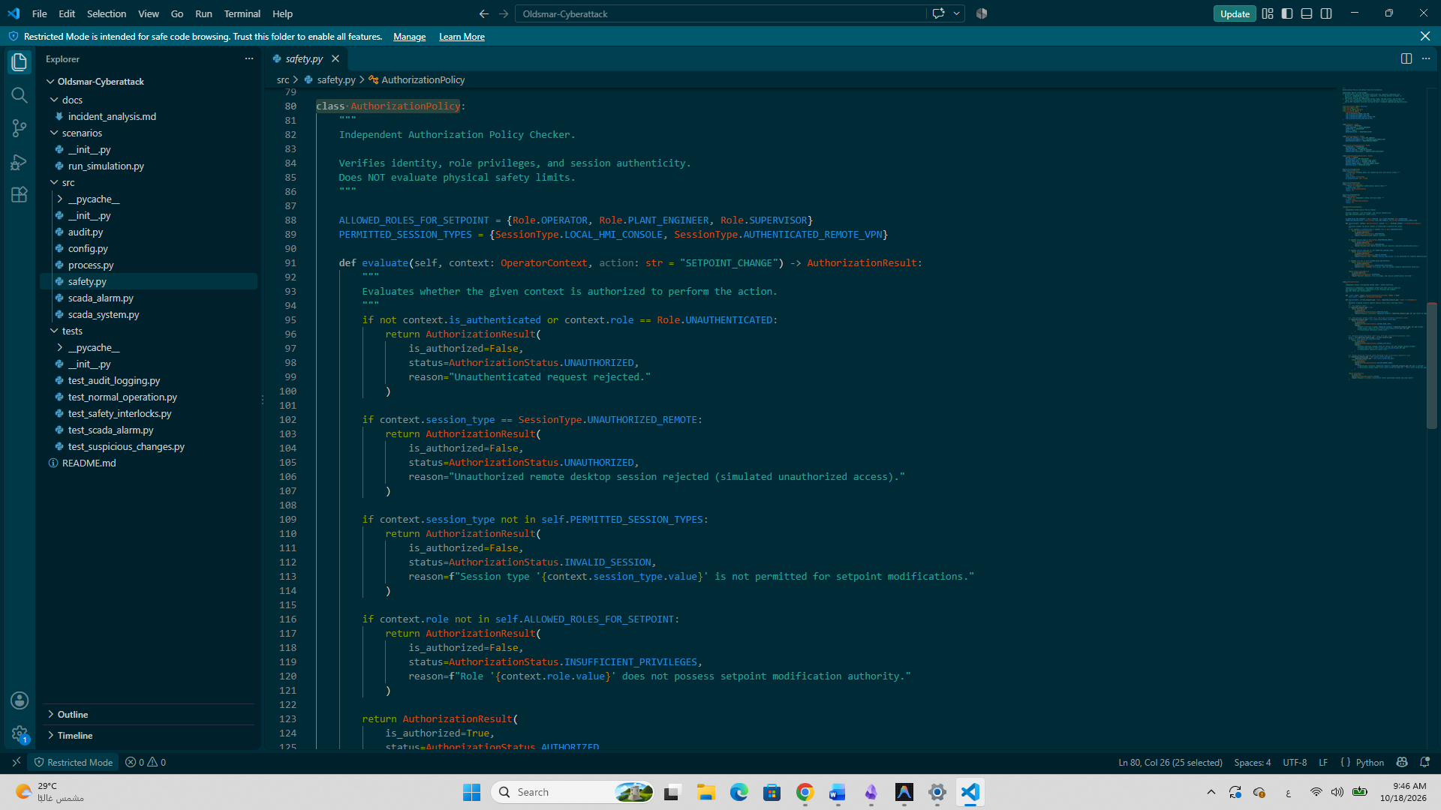Figure 6. Authorization Policy Implementation in src/safety.py.
Safety Interlock Validation
The SafetyInterlock.evaluate() method in src/safety.py validates each requested setpoint against the configured simulation limits. It rejects negative values, values exceeding the illustrative hard safety cutoff, and changes that exceed the permitted single-step limit. These checks operate independently of user authorization, providing an additional defensive layer against unsafe process modifications. The configured limits are illustrative laboratory rules and do not represent verified engineering specifications for the actual Oldsmar facility.
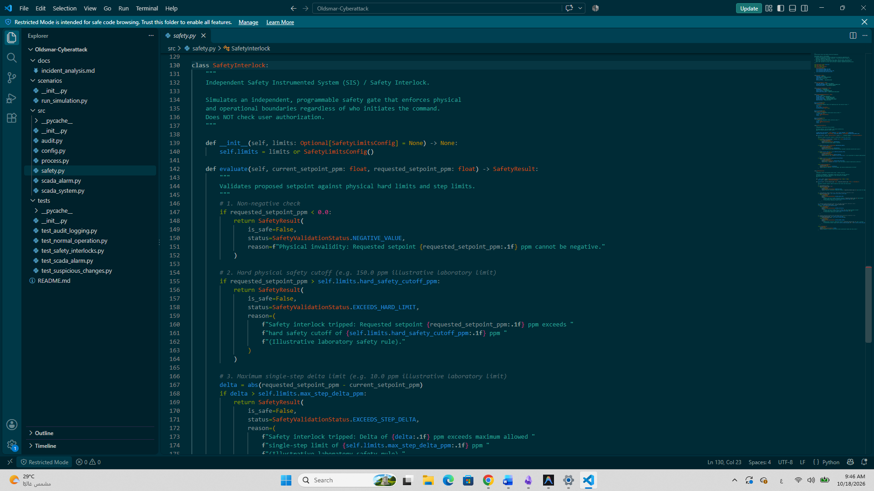Figure 7. Safety Interlock Validation Logic in src/safety.py.
SCADA System Coordinator
The request_setpoint_change() method in src/scada_system.py coordinates the evaluation of each simulated setpoint-change request. It obtains the current setpoint, evaluates the request using the anomaly detector, checks the native SCADA alarm state, and then applies the authorization policy. Unauthorized requests are rejected without modifying the process state, and the decision is recorded in the audit log. The method coordinates the defensive components to support the final decision.

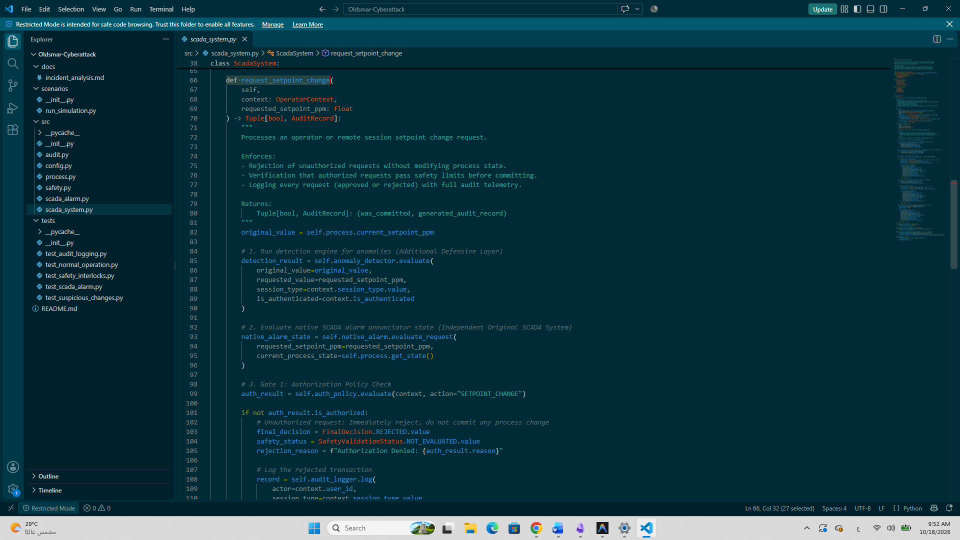Figure 8. Setpoint-Change Request Processing in src/scada_system.py.
Setpoint Validation and Final Decision
After authorization succeeds, the SCADA system evaluates the requested setpoint against the configured safety limits. If the safety interlock rejects the request, the system preserves the previous setpoint and records the rejection reason and evaluation results in the audit log. If the request passes the required checks, the system applies the requested setpoint to the simulated process and records the decision as COMMITTED. The method returns a Boolean result indicating whether the change was committed, together with the corresponding audit record.

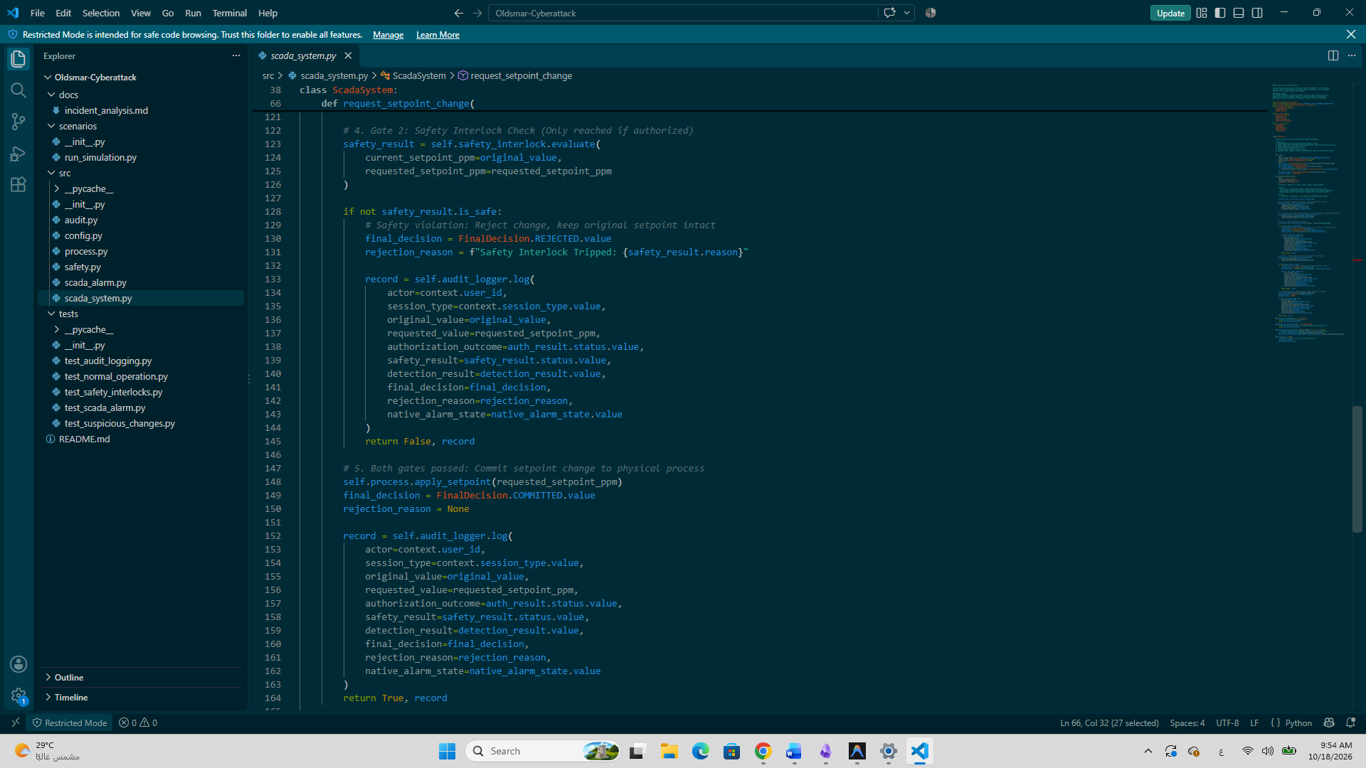Figure 9. Safety Interlock Evaluation and Final Setpoint Decision in src/scada_system.py.
Native SCADA Alarm Simulation — src/scada_alarm.py
The src/scada_alarm.py module implements an educational model of the native SCADA alarm subsystem, independently of the additional defensive layer. It defines three alarm states: CLEAR, PENDING_DELAY, and ACTIVE.
The NativeScadaAlarmSubsystem.evaluate_request() method evaluates the alarm state when a setpoint-change request is submitted. Depending on the configured alarm mode, the simulation models an unconfigured setpoint alarm, a delayed process-variable alarm, or a static setpoint-threshold alarm.
This module allows the experiment to examine whether the simulated native SCADA alarm is active when a setpoint-change request occurs. Its configuration and thresholds are illustrative laboratory assumptions and do not reproduce the verified alarm configuration of the historical Oldsmar facility.

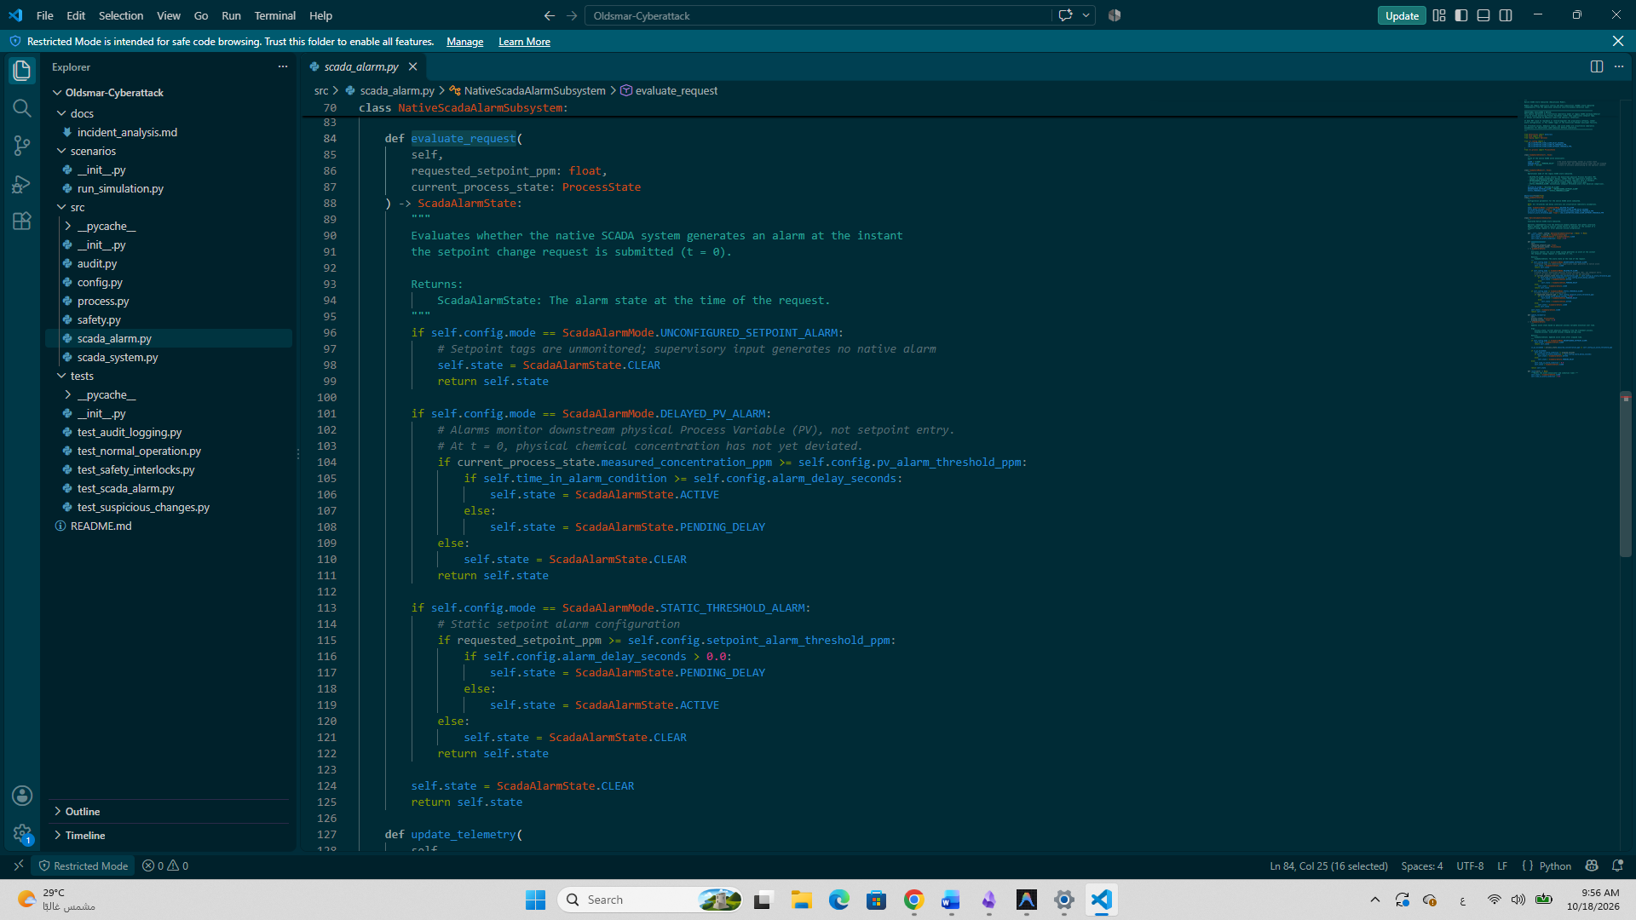Figure 10. Native SCADA Alarm Evaluation Logic in src/scada_alarm.py
6. Simulation Results and Testing
The simulation was evaluated using three scenarios representing normal operation, an unauthorized setpoint-change attempt, and an authorized but unsafe request.
- Scenario 1 — Normal Operation: An authorized change from 100 ppm to 105 ppm was accepted, and the simulated process state was updated.
- Scenario 2 — Unauthorized Request: An unauthorized request to change the setpoint from 105 ppm to 11,100 ppm was rejected by the authorization policy. The anomaly detector classified the request as CRITICAL_ANOMALY, while the simulated native SCADA alarm remained CLEAR at the time of the request.
- Scenario 3 — Unsafe Authorized Request: An authorized request to change the setpoint from 105 ppm to 11,100 ppm was rejected by the safety interlock because it exceeded the configured illustrative safety limit.
The simulation output demonstrated that the system could distinguish normal operation from suspicious or unsafe requests, reject invalid changes, preserve the previous setpoint, and record the decisions in the audit log.
The automated test suite completed successfully, with 35 tests passed. These results demonstrate the implemented behavior within the educational simulation; they do not establish the effectiveness of the system in a real industrial environment.
7. Conclusion and Limitations
This project developed a local educational SCADA cybersecurity simulation inspired by the February 2021 Oldsmar water treatment incident. It combines authorization checks, rule-based anomaly detection, a safety interlock, native SCADA alarm simulation, and structured audit logging to evaluate setpoint-change requests.
The results demonstrate how an additional defensive layer can identify suspicious requests and prevent unauthorized or unsafe setpoint changes within the simulated environment, even when the modeled native SCADA alarm is not active at the time of the request.
The main limitation is that the implementation is an in-memory software simulation. It is not connected to a real PLC, SCADA installation, or industrial network, and its laboratory thresholds and alarm configurations are illustrative rather than verified specifications of the historical facility. Future work could evaluate the approach using realistic industrial test environments and validated process data.
References
- Cybersecurity and Infrastructure Security Agency (CISA). AA21-042A: Compromise of U.S. Water Treatment Facility. https://www.cisa.gov/news-events/cybersecurity-advisories/aa21-042a
- Cervini, J., Rubin, A., & Watkins, L. (2022). Don’t Drink the Cyber: Extrapolating the Possibilities of Oldsmar’s Water Treatment Cyberattack. International Conference on Cyber Warfare and Security. https://doi.org/10.34190/iccws.17.1.29
- Oldsmar-Cyberattack Project. Source Code, Simulation Scenarios, Automated Tests, and Project Documentation. Author-developed educational simulation.

