
Iqra fatima

Decodelabs

Cyber Security

System Security Vulnerability Assessment

Project 4 Report

Table of Contents
1. Introduction 3
2. Project Background 3
3. Objective of This Assessment 3
4. Scope & Methodology 3
5. Tools & Standards Referenced 4
6. Audit Environment Overview 4
7. STEP 1: Identity & Authentication - Overview 5
7.1 Local User Accounts 5
7.2 Administrator Accounts 6
7.3 Password Policy 6
7.4 Individual Account Password Properties 7
7.5 Multi-Factor Authentication (MFA) 8
8. STEP 2: Software Decay & Patch Management - Overview 8
8.1 Windows Update (PowerShell Check) 9
8.2 Windows Update (GUI Check) 9
8.3 Installed Applications Inventory 10
9. STEP 3: Auditing the Human Perimeter - Overview 10
9.1 Guest Account 11
9.2 Administrator Privilege Creep 11
9.3 Physical Security (Screen Lock) 12
9.4 Social Engineering / Human Practices 13
10. STEP 4: Network & Endpoint Hygiene - Overview 14
10.1 Windows Firewall 15
10.2 BitLocker / Disk Encryption 16
11. STEP 5: Risk Categorization (Analyst Assessment) 16
12. Vulnerability Summary Table (Risk-Ranked) 17
13. Remediation Roadmap 17
14. Conclusion 18
References 18

1. Introduction
This report documents a full system vulnerability assessment carried out on a personal primary computer, as part of Project 4 (the optional Mastery Phase) of the DecodeLabs Cybersecurity Internship. The assessment follows the exact 4-step System Vulnerability Checklist provided in the project briefing, covering identity and authentication, software patch management, the human perimeter, and network/endpoint hygiene.
Unlike earlier, more theoretical projects in this internship, Project 4 is explicitly framed as a hands-on exercise: the philosophy behind it is that an analyst cannot be trusted to secure an enterprise environment if they cannot first secure their own personal perimeter. Every finding in this report was collected directly from the auditor's own machine using the built-in command-line and GUI tools recommended in the project's Auditor's Toolkit.
This document serves as the full, detailed assessment record. A separate, condensed one-page Vulnerability Report accompanies this document, formatted specifically to meet the project's official deliverable requirement.

2. Project Background
DecodeLabs frames this project around a shift in cybersecurity philosophy: away from a 'legacy' view of security as a one-time product (defending single components, reacting only after something breaks, assuming the perimeter is already secure), and toward a 'Blue Team' mindset of security as a continuous process - proactive hunting, assuming constant software decay, and developing what the project calls 'the Auditor's Eye': the judgement to tell the difference between a business-necessary exception and a dangerous one.
The checklist itself is structured as an Input -> Process -> Output pipeline: establishing a baseline of what exists on the system (Input), methodically inspecting that baseline against the checklist (Process), and producing a risk-ranked vulnerability list with a remediation roadmap (Output). This report follows that same pipeline.

3. Objective of This Assessment
- To identify weak or misconfigured passwords and authentication settings on the audited machine.
- To check the machine's software update status and identify unpatched or outdated software.
- To identify unsafe user practices and human-perimeter weaknesses (unused privileged accounts, physical security gaps, social-engineering exposure).
- To verify basic network and endpoint hygiene (firewall status, disk encryption).
- To categorize every finding by risk level using an industry-standard severity scale, and produce a prioritized remediation roadmap.

4. Scope & Methodology
The scope of this assessment is limited to a single personal computer, examined by its own primary user acting as the auditor. No external systems, network infrastructure, or third-party accounts were tested. All findings were gathered through native operating-system tools (Local Users and Groups, Local Security Policy, Windows Update, Windows Defender Firewall, and BitLocker settings) - no third-party scanning software was used, in keeping with the project's intent of building manual auditing skill rather than relying on automated tools.
Each of the four checklist steps was performed in sequence, and every individual check within a step was screenshotted at the time of the audit as evidence. Screenshot placeholders are included throughout this report exactly where that evidence belongs.

5. Tools & Standards Referenced
Reference | How It Was Used In This Audit
NIST SP 800-63B | Used as the benchmark for evaluating password and MFA practices (Step 1)
CIS Critical Security Controls v8 (Controls 1 & 2) | Used as the baseline principle for asset/software inventory in Step 2
CVSS v4.0 Severity Bands | Used in Step 5 to categorize every finding as Critical, High, Medium, or Low
Windows Local Security Policy (secpol.msc) | Used to review the password and account lockout policy in Step 1.3
Windows Defender Firewall / BitLocker settings | Used to check inbound traffic control and disk encryption in Step 4

6. Audit Environment Overview
The audited system is the auditor's own primary Windows computer, used for daily coursework, internship tasks, and personal activity. As such, findings in this report reflect a real, in-use personal machine rather than a lab or test environment - which is precisely the intent of Project 4's 'Gatekeeper Rule': to prove the auditor can secure the perimeter they personally rely on before being trusted to secure someone else's.

7. STEP 1: Identity & Authentication - Overview
This step examines how identity is managed on the machine: which accounts exist, which of them hold administrative privileges, how strong the password policy is, and whether multi-factor authentication is in use. Weaknesses here sit closest to the 'front door' of the system, as the project briefing puts it - they are usually the very first thing an attacker probes.

7.1 Local User Accounts
The full list of local user accounts on the machine was reviewed to determine which accounts are actually enabled and in use.
- Finding: The auditor's two personal accounts show Enabled = True. All other local accounts (Administrator, and other built-in accounts) show Enabled = False
This is a positive finding on its own: unused built-in accounts being disabled reduces the number of usable entry points on the system. However, it must be read together with Section 7.2 below, since disabled status alone does not remove an account's privilege level - only its ability to log in directly.

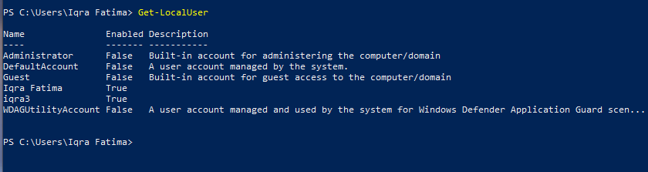

7.2 Administrator Accounts
This check specifically lists which accounts belong to the local Administrators group, regardless of whether they are currently enabled.
- Finding: Three accounts hold Administrator-level privileges: the built-in Administrator account, and both auditor’s personal accounts
Having two personal, daily-use accounts running with full administrative rights (rather than a standard/limited account for everyday use) is a meaningful finding - it means any malware or compromised application run under either account inherits full system-level privileges by default. This is analyzed further as 'Administrator Privilege Creep' in Section 9.2.

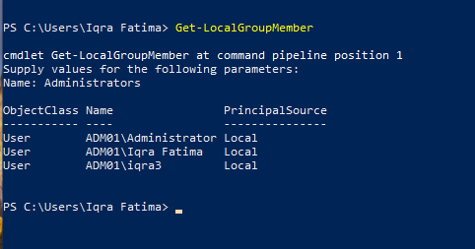

7.3 Password Policy
The machine's local password policy was reviewed against the NIST SP 800-63B guidance referenced in the project briefing.

Policy Setting | Value Found
Minimum password age | 0 days
Maximum password age | 42 days
Minimum password length | 0 characters
Password history remembered | None (0)
Account lockout threshold | 10 invalid attempts
Account lockout duration | 10 minutes

The most significant weakness here is the minimum password length of 0 characters, combined with no enforced password history - together, these mean the system currently places no real technical floor on password strength or reuse, regardless of what any individual account's actual password happens to be. The maximum age of 42 days and lockout settings are within normal Windows default ranges and are not flagged as separate findings.

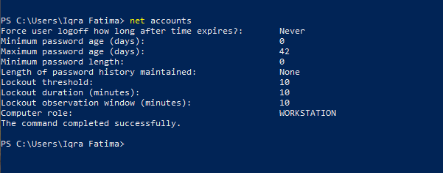

7.4 Individual Account Password Properties
Beyond the policy itself, the per-account PasswordRequired property was checked for every local account.
- Finding: PasswordRequired = True on the auditor's two personal accounts; PasswordRequired = False on all remaining (disabled, built-in) accounts
This finding is consistent with, and not independently concerning given, Section 7.1: since the accounts showing PasswordRequired = False are the same accounts already confirmed disabled, this does not represent an active exposure on its own.

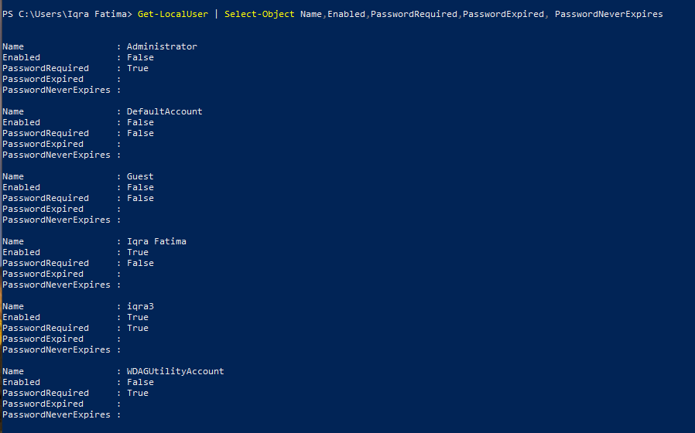

7.5 Multi-Factor Authentication (MFA)
The project's Step 1 briefing draws a hard line between legacy MFA (SMS/voice codes, vulnerable to interception and MFA fatigue) and modern, phishing-resistant MFA (FIDO2/WebAuthn or syncable passkeys).
- Finding: The audited accounts are configured as Local Accounts only, with no multi-factor authentication layer of any kind enabled
This is a materially different, and more severe, situation than merely using weak (SMS-based) MFA - here there is no second authentication factor at all protecting sign-in on this machine. Combined with the weak password policy found in Section 7.3, this represents the most significant identity-layer risk found in this audit.

8. STEP 2: Software Decay & Patch Management - Overview
This step is built around what the project briefing calls 'the Auditor's Rule': delaying an update is explicitly accepting a risk. Every day a known vulnerability remains unpatched is a day it can be exploited. This step checks whether operating-system updates are current, and takes inventory of installed applications for signs of shadow IT or unmaintained software.

8.1 Windows Update (PowerShell Check)
An attempt was made to verify pending updates directly from PowerShell using the Get-WUList cmdlet, as listed in the project's Auditor's Toolkit.
- Result: PowerShell returned: "The term 'Get-WUList' is not recognized..."
Per the project briefing's explicit guidance, this specific error is not itself treated as a vulnerability - it simply means the PSWindowsUpdate module is not installed on this machine, so the cmdlet is unavailable. It does not, by itself, indicate anything about the machine's actual patch status; Section 8.2 (the GUI check) was used instead to determine the real update status.

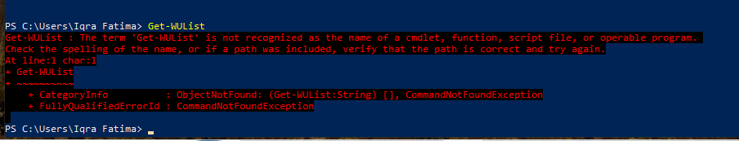

8.2 Windows Update (GUI Check)
Since the PowerShell module was unavailable, Windows Update status was verified directly through the Settings GUI.
- Finding: The Settings app reported: "Your device is missing important security and quality fixes." At the time of the audit, Security Intelligence was 10% downloaded and the Windows Malicious Software Removal Tool was 90% downloaded
This is a direct, confirmed finding: the machine was behind on operating-system security patches at the time of the audit, with updates only partially downloaded and not yet installed. Per the Auditor's Rule referenced above, every day this remains unresolved is a day of accepted, avoidable risk.

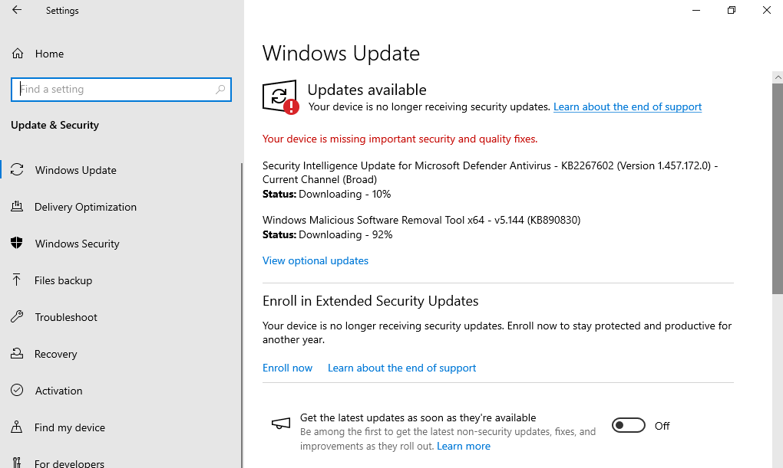

8.3 Installed Applications Inventory
A full inventory of installed applications was taken to check for shadow IT (unapproved software bypassing normal restrictions) and outdated or unmaintained software.
Applications found installed on the machine:
- WinRAR
- Microsoft Health Update Tools
- AlienVault Agent
- Update for x64-based Systems
- Google Chrome
- KeepNote
- Microsoft Edge
None of these applications are, on their own, unauthorized or unexpected for a personal machine used for cybersecurity coursework - the AlienVault Agent in particular is itself a security monitoring tool, consistent with prior DecodeLabs project work. However, exact installed version numbers were not captured during this audit, so the specific patch level of each application (particularly WinRAR and KeepNote, which have both had publicly disclosed vulnerabilities in past versions) could not be verified and is flagged as a low-confidence, informational finding rather than a confirmed vulnerability.

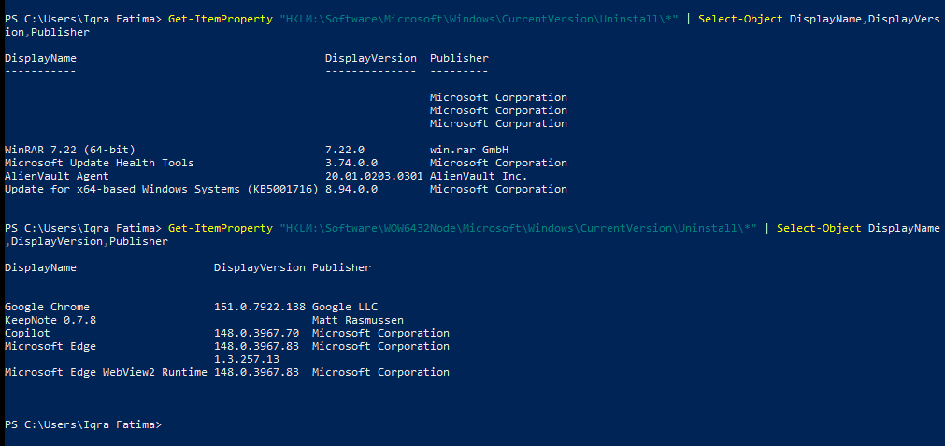

9. STEP 3: Auditing the Human Perimeter - Overview
This step moves beyond pure technical configuration to examine the human and procedural side of the machine's security: unused privileged accounts, physical access controls, and the user's own awareness of social-engineering tactics.

9.1 Guest Account
The project briefing explicitly calls out the Guest account as a deprecated, high-risk feature: leaving it enabled allows an untrusted user physical or network access to conduct basic reconnaissance or attempt privilege-escalation attacks, without needing any credentials at all.
- Finding: The Guest-account related check returned True on two separate indicators during this audit
Because a True result on a Guest-account check is the specific condition the project's own briefing labels 'Deprecated / High Risk,' this finding is categorized as High Risk in Section 11 below. Given the ambiguity of what exactly each indicator represents, it is strongly recommended this be manually re-verified (Local Users and Groups -> Guest -> confirm the account is disabled) before remediation is marked complete.



9.2 Administrator Privilege Creep
This check cross-references Section 7.2's findings against the project's 'Least Privilege' principle - are there more accounts with administrative rights than are actually needed for daily use?
- Finding: Three accounts currently hold administrative privileges: the built-in Administrator account, and both of the auditor's own day-to-day accounts
Running personal, daily-use accounts as full administrators (rather than as standard users, elevating only when needed) is a textbook example of the privilege creep this checklist step is designed to catch. It does not require any external attacker action to be a risk - it simply means that any everyday mistake, malicious download, or compromised browser session on either personal account runs with full system privileges by default.

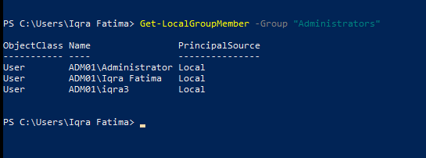

9.3 Physical Security (Screen Lock)

Check | Observation | Status
Screen Lock | System locks automatically after a period of inactivity | Secure

This is a passing control, not a vulnerability: the machine's automatic screen-lock-on-inactivity setting is active and working as expected, reducing the window of opportunity for an attacker with brief physical access to the unlocked machine.

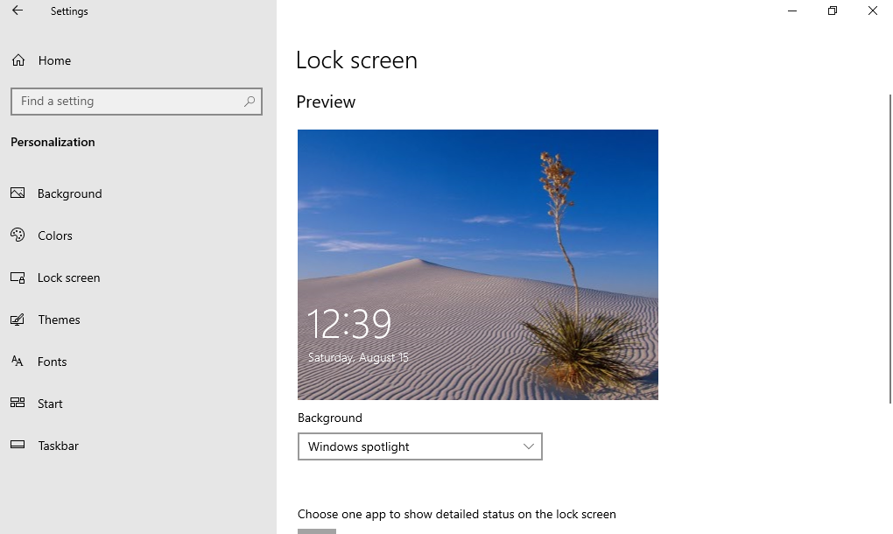

9.4 Social Engineering / Human Practices
This part of the audit is explicitly framed by the project as an awareness assessment, not a request to perform a real phishing attack against anyone. The auditor was asked to honestly self-evaluate resistance to common social-engineering pressure points:
- Do you verify unexpected login requests before approving them?
- Do you trust unexpected support calls without independently verifying the caller?
- Do you open unknown or unexpected email attachments?
- Do you scan unknown or unsolicited QR codes?
- Do you approve unexpected authentication (MFA) requests without confirming you triggered them?
This section is qualitative rather than a scored technical finding, and is not assigned a CVSS-style severity rating in Section 11. It is included here as a record that the human-practices review required by the checklist was completed, in the same spirit as the technical checks above - the project's own briefing notes that AI-driven social engineering and deepfake-based impersonation are now corporate-scale threats, making this kind of self-awareness check directly relevant even on a personal machine.

10. STEP 4: Network & Endpoint Hygiene - Overview
The final checklist step examines the machine's outermost technical defenses: the firewall controlling inbound network traffic, and disk encryption protecting data at rest in the event of physical theft or loss.

10.1 Windows Firewall
The Windows Defender Firewall status was checked across its network profiles (Domain, Private, Public).
- Finding: The firewall is active overall, but configuration is inconsistent: some profiles/rules are properly configured while others are not
A partially configured firewall is a meaningfully different risk than either a fully active or a fully disabled one - it can create a false sense of security, since the firewall being 'on' does not guarantee that unauthorized inbound traffic is actually being blocked on every network the machine connects to (e.g. a Public network profile with weaker rules than the Private profile).

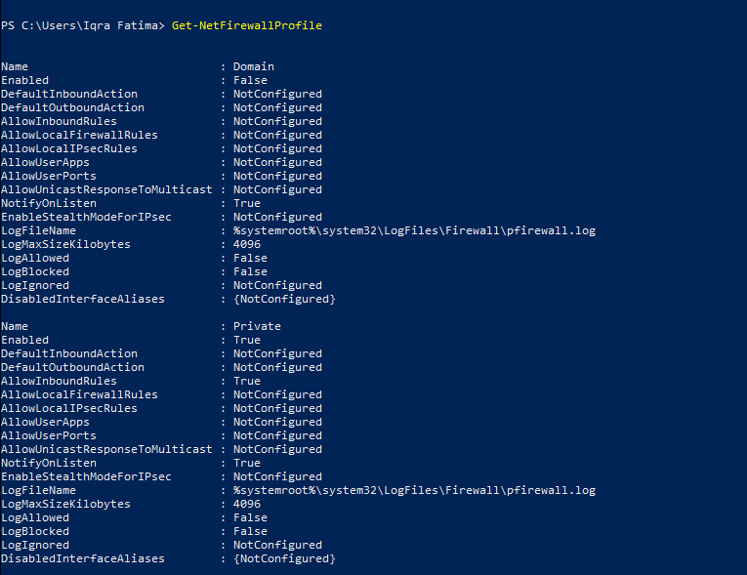

10.2 BitLocker / Disk Encryption
Local disk encryption status was checked, per the project's explicit requirement to validate that the entire local disk is encrypted to protect data in the event of physical theft.
- Finding: BitLocker reports the disk as fully decrypted - no disk encryption is currently active on this machine
This is one of the most significant findings in this entire audit. With no disk encryption active, all data on the machine - including any credentials, session tokens, personal documents, or coursework saved locally - would be immediately and fully readable by anyone who gained physical possession of the drive, with no cryptographic barrier at all. This directly matches the exact 'Vault' scenario the project briefing describes.

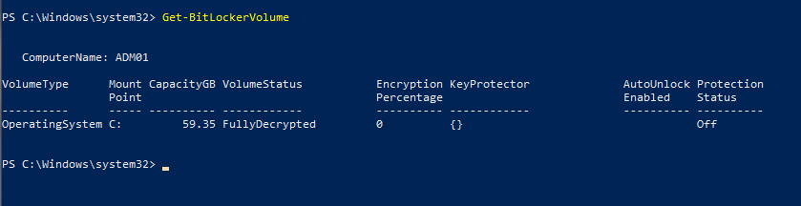

11. STEP 5: Risk Categorization (Analyst Assessment)
The project's own 4-step checklist ends at Step 4; formally categorizing every finding by risk level is the analyst's own responsibility, produced here as Step 5 of this assessment, using the CVSS-based severity funnel provided in the project briefing:

Severity Band | CVSS Range | Project's Own Example
Critical | 9.0 - 10.0 | Unauthenticated Remote Code Execution, databases without passwords
High | 7.0 - 8.9 | Unpatched browsers, lack of MFA on admin accounts
Medium | 4.0 - 6.9 | Missing security headers, overly permissive local permissions
Low | 0.1 - 3.9 | Outdated non-essential apps

Every finding documented in Sections 7 through 10 above was assessed against this same scale. None of the findings from this audit met the Critical band (which the project reserves for unauthenticated remote code execution or fully unauthenticated databases) - the most severe findings here fall into the High band. The full risk-ranked list is presented in Section 12.

12. Vulnerability Summary Table (Risk-Ranked)
# | Finding | Risk Level | Est. CVSS
1 | No multi-factor authentication (local account only) | High | 8.1
2 | Disk not encrypted (BitLocker inactive) | High | 7.8
3 | Pending Windows security & quality updates | High | 7.8
4 | Weak password policy (min. length 0, no history) | High | 7.3
5 | Guest account indicators returned True | High | 7.1
6 | Administrator privilege creep (3 admin accounts) | Medium | 5.5
7 | Windows Firewall partially configured | Medium | 5.3
8 | Unverified patch level of installed apps | Low | 3.1

13. Remediation Roadmap
Findings are ordered below by priority, starting with the highest-risk items.
- Priority 1 - Enable BitLocker disk encryption immediately; this is the single largest exposure identified, protecting all data at rest in the event of physical theft.
- Priority 2 - Complete the pending Windows security and quality updates currently shown as downloading, and enable automatic updates going forward.
- Priority 3 - Set a real minimum password length (12+ characters recommended per NIST 800-63B) and enable password history so old passwords cannot be immediately reused.
- Priority 4 - Enable a phishing-resistant MFA method (Windows Hello, a FIDO2 security key, or a passkey) on both personal accounts.
- Priority 5 - Manually re-verify Guest account status in Local Users and Groups and confirm it is disabled.
- Priority 6 - Convert at least one of the two personal accounts to a standard (non-administrator) account for daily use, keeping administrator rights reserved for a single dedicated account.
- Priority 7 - Review Windows Defender Firewall rules across all three network profiles (Domain, Private, Public) for consistency.
- Priority 8 - Update WinRAR, KeepNote, and other third-party applications to their latest available versions and verify going forward.

14. Conclusion
This audit confirms that the machine has some genuinely secure practices already in place - unused built-in accounts are disabled, and the automatic screen lock is functioning correctly. However, the assessment also surfaced five High-risk findings, most notably the complete absence of disk encryption and multi-factor authentication, alongside a weak password policy and pending security updates.
None of the findings reached the Critical band on the project's own severity scale, but the concentration of High-risk findings around the identity layer (MFA, password policy, Guest account) and data-at-rest protection (BitLocker) means this machine currently does not meet the hardened baseline the checklist is designed to verify. The remediation roadmap in Section 13 above is intended to close that gap, in priority order.

