Course Title | Secure Software Design and Development Lab
Program | BS Cyber Security
Instructor | Babar Ahmad
Student Name | Hafiza Iqra Fatima

AIR UNIVERSITY MULTAN CAMPUS
Department of Cyber Security
DevSecOps Pipeline With Jenkins
Secure Software Design and Development Lab (CY256L)

Table of Contents

1. Introduction 2
2. Objectives 2
3. Pipeline Stage Overview 3
4. Marking Rubric 4
5. Pre-Requisite Environment Setup 5
6. Install Jenkins 6
7. Jenkins Initial Configuration 8
8. Admin Account Credentials 10
9. Pipeline Creation 13
10. Writing the Basic Pipeline Script 14
11. Stage 1 — Checkout 15
12. Checkout Stage — Script and Result 16
13. Stage 2 — Build 18
14. Stage 3 — Static Application Security Testing (SAST) 20
15. SonarQube Analysis Stage — Script and Result 22
16. Stage 4 — Dependency Check 23
17. OWASP Dependency-Check UI Report 24
18. Stage 5 — Software Bill of Materials (SBOM) 26
19. Stage 6 — Secrets Detection 27
20. Stage 7 — Software Composition Analysis (SCA) 28
21. SCA Stage — Script and Result 30
22. Stage 8 — Container Security 33
23. Stage 9 — Dynamic Application Security Testing (DAST) 35
24. DAST Stage — Script and Result 36
25. Complete Pipeline 38
26. Analysis and Understanding 40
27. Challenges Faced 42
28. Conclusion 45

1. Introduction

1.1 What is DevSecOps?
DevSecOps represents the natural evolution of the DevOps philosophy, embedding security practices directly into every phase of the software delivery lifecycle rather than treating them as a final gate before release. In traditional development models, security testing is often performed late — sometimes only just before deployment — which makes vulnerabilities expensive and time-consuming to fix. DevSecOps flips this model by shifting security “left,” meaning security checks happen as early and as often as possible, ideally on every single code commit. This lab focuses on building a complete, automated CI/CD security pipeline using Jenkins, one of the most widely adopted open-source automation servers in the industry.

1.2 Purpose of This Lab
The purpose of this exercise is to step into the role of a DevSecOps Engineer and transform a standard continuous integration pipeline into a hardened, security-aware automation pipeline. Working within a virtual machine environment, an intentionally vulnerable Java application (Vulnado) is used as the target project so that the various scanning tools have real findings to report on. Across the exercise, nine distinct pipeline stages are configured: Checkout, Build, Static Application Security Testing (SAST), Dependency Checking, Software Bill of Materials (SBOM) generation, Secrets Detection, Software Composition Analysis (SCA), Container Security scanning, and Dynamic Application Security Testing (DAST).

1.3 Layers of Defense Covered
Each of these stages represents a different layer of defense. SAST inspects the raw source code without executing it, catching insecure coding patterns and code smells early. Dependency-Check and SCA scan third-party libraries for publicly disclosed vulnerabilities (CVEs), which is critical since modern applications often consist of more open-source code than original code. SBOM generation produces a transparent inventory of every component in the software supply chain, which has become a regulatory and compliance expectation following major supply-chain incidents in the industry. Secrets detection guards against accidental exposure of API keys, passwords, and tokens inside a code repository. Container security extends these protections to the deployment artifact itself, while DAST closes the loop by attacking the running application exactly as an external adversary would, from the outside in.

1.4 Expected Outcome
By the end of this lab, the pipeline produces a complete, auditable security report for every build: static code issues, vulnerable dependencies, a full software inventory, any exposed secrets, composition risks, container vulnerabilities, and live application flaws — all generated automatically, without any manual intervention, every time the pipeline runs. This mirrors real-world industry practice, where organizations rely on exactly this kind of automated gate to prevent insecure code from ever reaching production.

2. Objectives
- Configure Jenkins from scratch for DevSecOps pipeline automation.
- Integrate multiple security testing tools into a single CI/CD pipeline.
- Perform SAST, Dependency Analysis, SBOM generation, and Secrets Detection.
- Perform SCA, Container Security scanning, and DAST on a live target.
- Analyze and interpret security findings produced by each automated scan.
- Understand how a shift-left security approach embeds protection early in the pipeline.

3. Pipeline Stage Overview

Stage | Name | Purpose | Tool Used
1 | Checkout | Clone project from Git repository | Git / Git Plugin
2 | Build | Compile and package the Maven project | Apache Maven
3 | SAST | Static analysis of source code for bugs/smells | SonarQube
4 | Dependency-Check | Detect known vulnerabilities in dependencies | OWASP Dependency-Check
5 | SBOM | Generate a software bill of materials | Syft
6 | Secrets Detection | Detect hardcoded credentials/secrets | detect-secrets
7 | SCA | Composition analysis of code & dependencies | Snyk
8 | Container Security | Scan container image for vulnerabilities | Grype
9 | DAST | Dynamic scan of the running application | OWASP ZAP

4. Marking Rubric
Criteria | Marks
Jenkins setup & pipeline creation | 4
SAST + Dependency security | 4
SBOM + Secrets detection | 4
SCA / Container / DAST | 4
Analysis & understanding | 4
TOTAL | 20

5. Pre-Requisite Environment Setup
Before Jenkins can be installed or any pipeline can run, the underlying build tools must be present on the virtual machine. Jenkins itself is a Java application, and the target project (Vulnado) is built with Apache Maven, so both runtimes need to be installed first.

5.1 Install Java Development Kit (JDK)
Jenkins and the target Maven project require a Java environment to build and run. The OpenJDK 21 development kit was installed using the Debian package manager, since the development kit (not just the runtime) is required to compile the project's source code.
sudo apt update
sudo apt install openjdk-21-jdk -y
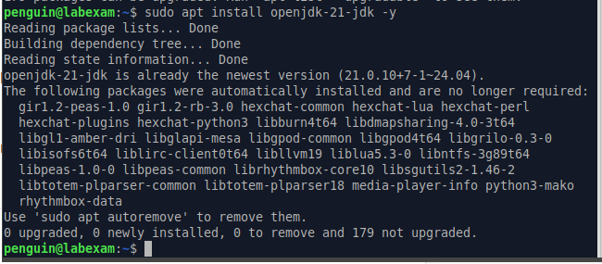

5.2 Install Apache Maven
Maven is the build automation tool used by the Vulnado project. It handles dependency resolution, compilation, and packaging, and is invoked directly inside the pipeline's Build stage.
sudo apt install maven -y

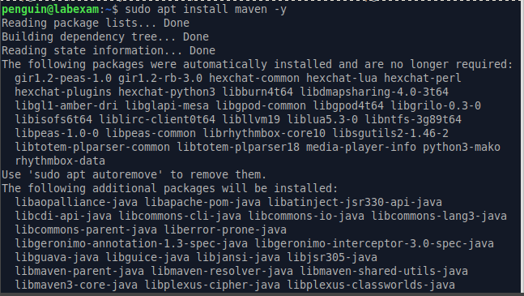

5.3 Install Jenkins
Jenkins was installed directly on the Ubuntu virtual machine (as opposed to a container) to avoid any performance or storage overhead. The official Jenkins Debian repository key was added, the repository was registered, and Jenkins was installed and started as a system daemon listening on port 8080. During installation, Jenkins automatically created a dedicated 'jenkins' service user and populated /lib/systemd/system/jenkins.service with the required configuration.
sudo wget -O /usr/share/keyrings/jenkins-keyring.asc \
https://pkg.jenkins.io/debian/jenkins.io-2023.key
echo deb [signed-by=/usr/share/keyrings/jenkins-keyring.asc] \
https://pkg.jenkins.io/debian binary/ | sudo tee \
/etc/apt/sources.list.d/jenkins.list > /dev/null
sudo apt-get update
sudo apt-get install jenkins

sudo wget -O /usr/share/keyrings/jenkins-keyring.asc \
https://pkg.jenkins.io/debian/jenkins.io-2023.key

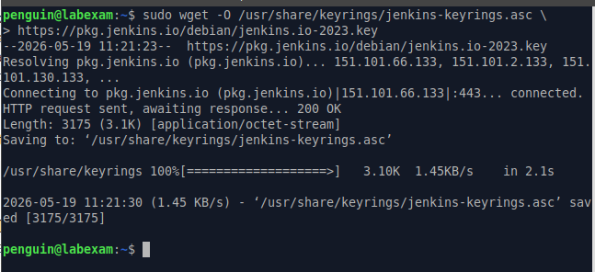

echo deb [signed-by=/usr/share/keyrings/jenkins-keyring.asc] \
https://pkg.jenkins.io/debian binary/ | sudo tee \
/etc/apt/sources.list.d/jenkins.list > /dev/null

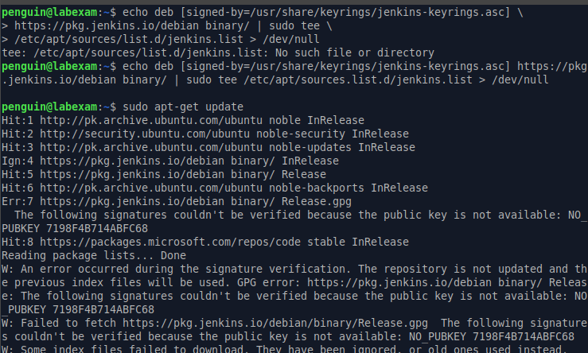

6. Jenkins Initial Configuration
Once Jenkins is installed and unlocked using the initial administrator password found at /var/lib/jenkins/secrets/initialAdminPassword, the setup wizard walks through plugin installation and admin account creation.

6.1 Installing Recommended Plugins
From Manage Jenkins → Plugins → Available Plugins, the required plugins for each pipeline stage were located using the search bar and queued for installation. The 'Restart Jenkins when installation is complete' option was checked to ensure the plugins' background paths load correctly.
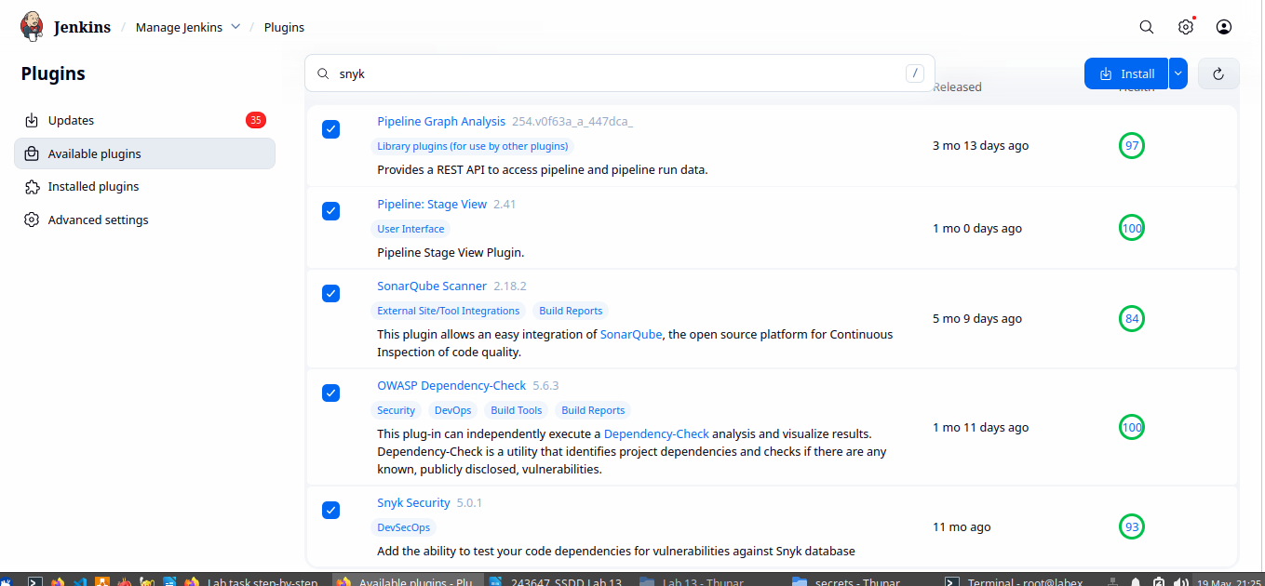

6.2 Confirming Plugin Installation
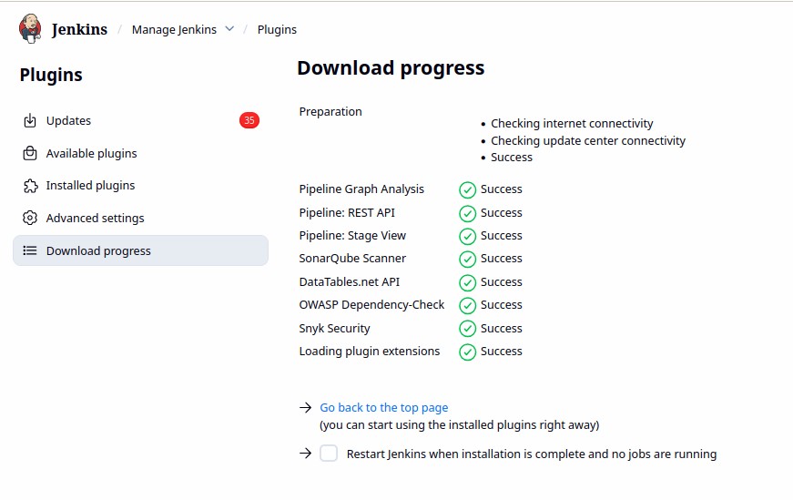
After the installation process completed, Jenkins confirmed that every selected plugin was installed successfully without errors.

6.3 Restarting Jenkins
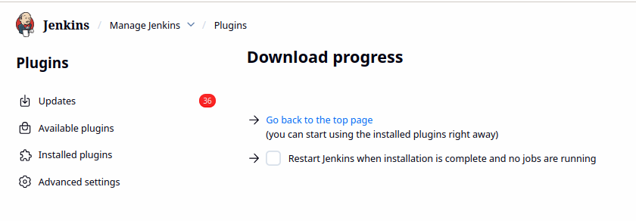
Jenkins was restarted to load the newly installed plugins' environment paths and UI components before proceeding to pipeline creation.

7. Pipeline Creation

7.1 Creating the 'vulnado' Pipeline Item
From the Jenkins dashboard, New Item → vulnado was created and the 'Pipeline' project type was selected. Pipeline (rather than Freestyle) was chosen because it allows the entire build process to be defined as code in a Jenkinsfile, which is the industry-standard approach and scales better for multi-stage security scanning.
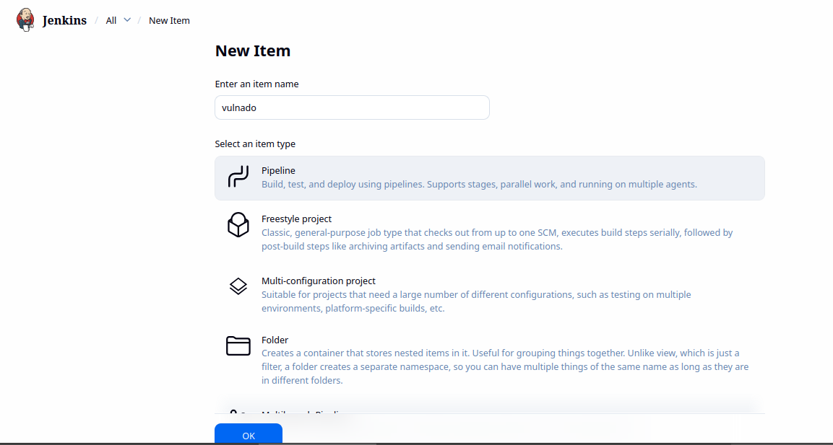

7.2 Writing the Basic Pipeline Script
A minimal single-stage 'Hello World' script was written first, in the Pipeline Script definition box, to confirm the pipeline syntax and Jenkins configuration were both working correctly before adding any security tooling.
pipeline {
agent any
stages {
stage('Hello') {
steps {
echo 'Hello World'
}
}
}
}
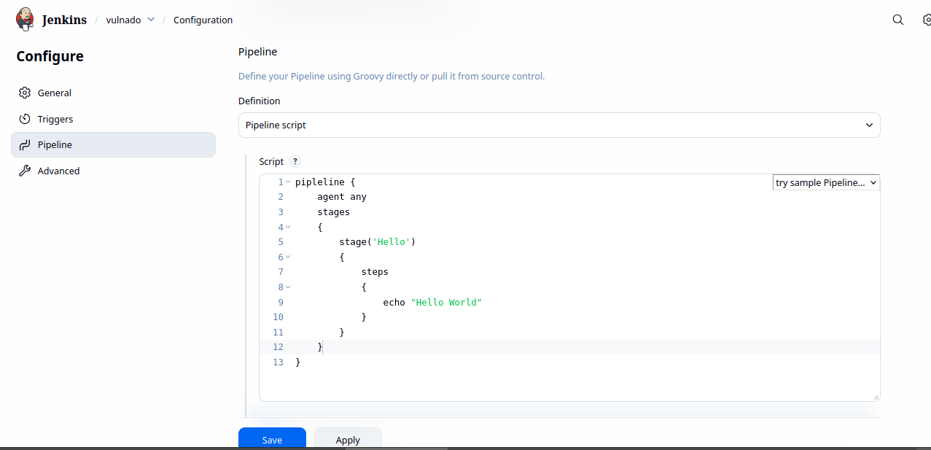

7.3 Running the First Build
The 'Build Now' option was used to trigger the pipeline manually. The stage view confirmed the pipeline executed successfully, establishing a working baseline before layering in the Checkout, Build, and security scanning stages.
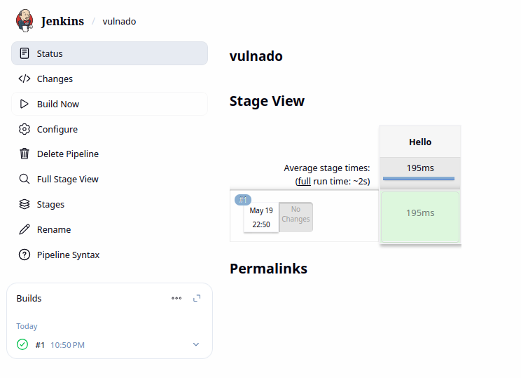

8. Stage 1 — Checkout
The Checkout stage is responsible for pulling the target project source code from its Git repository at the start of every pipeline run. The target project used throughout this lab is Vulnado, an intentionally vulnerable Java application, sourced from https://github.com/ScaleSec/vulnado.

8.1 Installing Git
Although the Jenkins Git plugin is installed by default, the underlying Git binary must still be present on the host machine for the plugin to invoke.
sudo apt-get install git -y
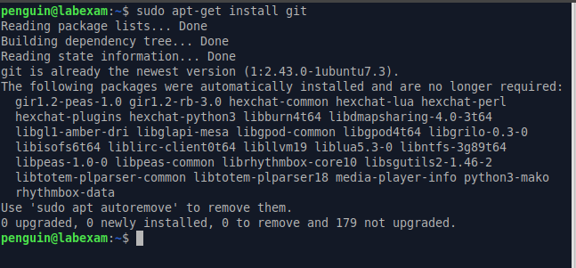

8.2 Installing Java 25 and Verifying the Version
An updated Java version was installed and verified on the command line to ensure compatibility with the newer plugin requirements used later in the pipeline (SonarQube scanner, Snyk, etc.
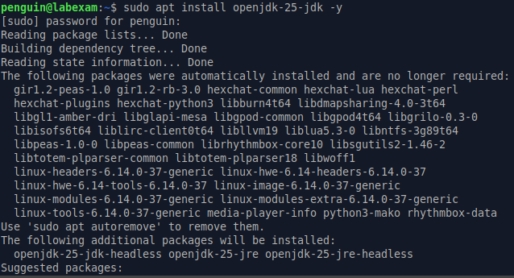

8.3 Checkout Stage — Script and Result
The Checkout stage uses the 'git' pipeline step to clone the Vulnado repository at the start of every run. The build result confirmed a successful clone.
stage('Checkout') {
steps {
git 'https://github.com/ScaleSec/vulnado.git'
}
}
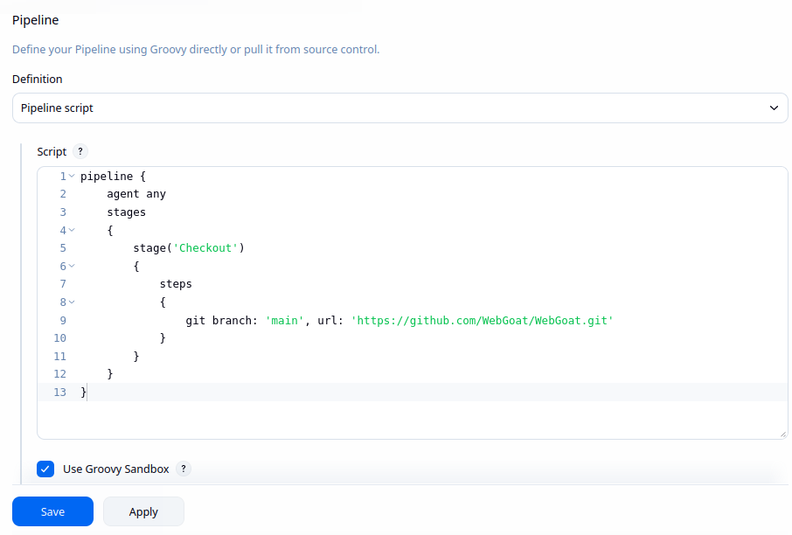

9. Stage 2 — Build
Building the project is a prerequisite for almost every downstream security tool, since SAST, SCA, and dependency scanners generally need a compiled, packaged artifact to analyze fully and accurately. As Vulnado is a Maven project, the standard 'mvn clean package' command was used.

9.1 Build Stage — Script and Result
The Build stage compiles and packages the checked-out source using Maven. A successful build confirms the code compiles cleanly before any scanning takes place.
stage('Build') {
steps {
sh 'mvn clean package'
}
}
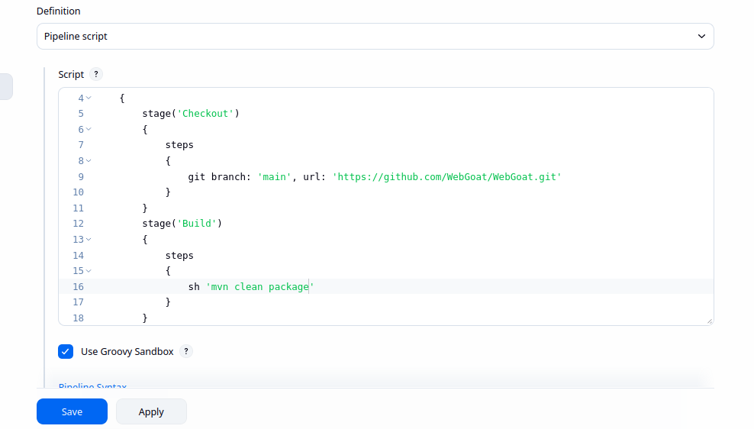

10. Stage 3 — Static Application Security Testing (SAST)
SAST inspects source code without executing it, identifying insecure coding patterns, bugs, and code smells. SonarQube was selected for this stage because of its strong Jenkins integration and multi-language support.

10.1 Installing Docker and Starting SonarQube
SonarQube was run locally as a Docker container for simplicity, avoiding the need for a separate cloud instance. Docker was installed first, and the SonarQube container was started and exposed on its default port.
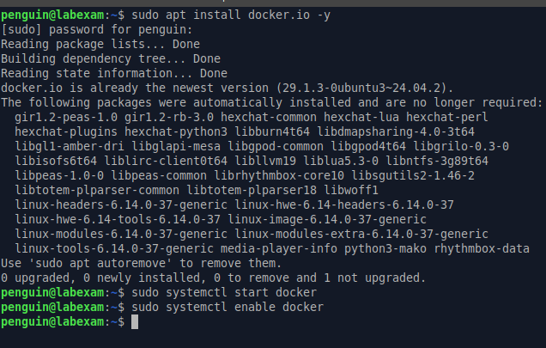

10.2 Creating a Local SonarQube Project
From the SonarQube dashboard, 'Create a local project' was selected instead of importing from a DevOps platform such as GitHub, since setting up a GitHub App was unnecessary for this local testing scope. A project key and name were assigned manually.
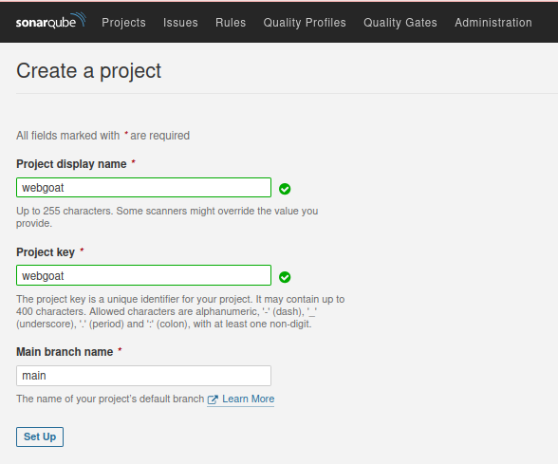

10.3 Choosing the Jenkins Analysis Method
The analysis method 'With Jenkins' was selected, followed by GitHub as the DevOps platform reference (used only to surface the relevant setup instructions), then the configuration and Maven build steps were reviewed and confirmed to continue with a manual pipeline script.
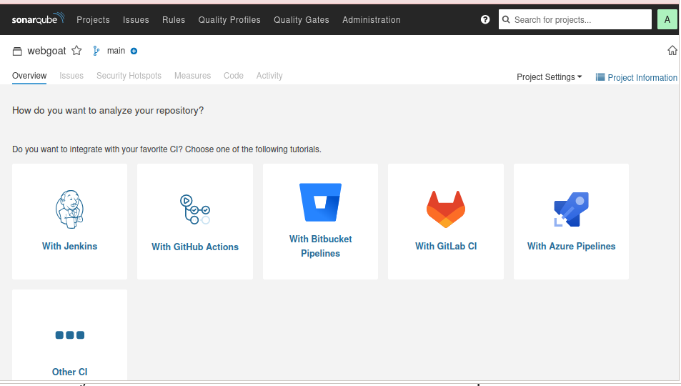

10.4 Jenkins Credentials for SonarQube
In Jenkins, Manage Jenkins → Credentials → System → Global credentials was used to add a new 'Secret Text' credential of Global scope, which holds the SonarQube authentication token.
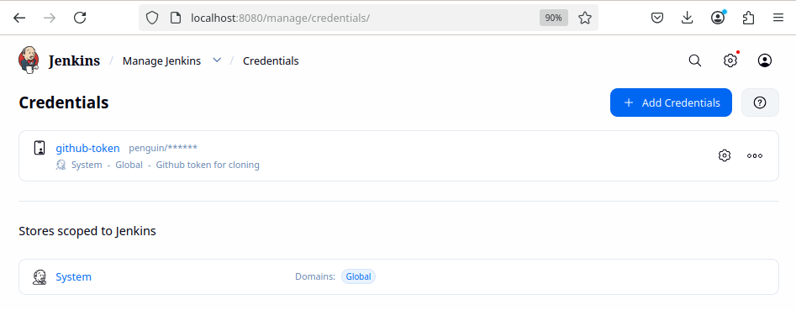

10.5 Generating a SonarQube Token via WebGoat Account
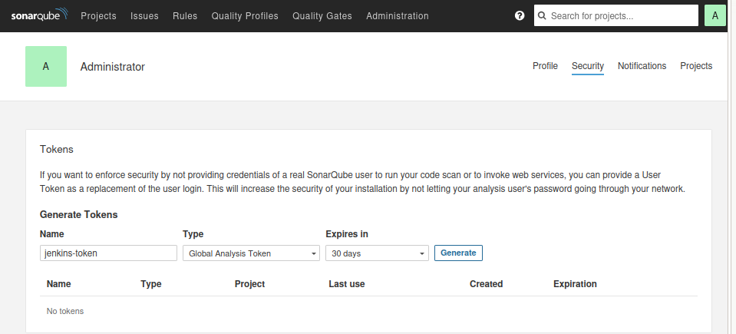
A Global Analysis Token was generated from User → My Account → Security in SonarQube, then copied directly into the Jenkins secret text credential created in the previous step.

10.6 Configuring the SonarQube Server in Jenkins
Under Manage Jenkins → System → SonarQube servers, an installation named 'sonar-local' was registered with the server URL (http://localhost:9000) and the authentication token credential created earlier.
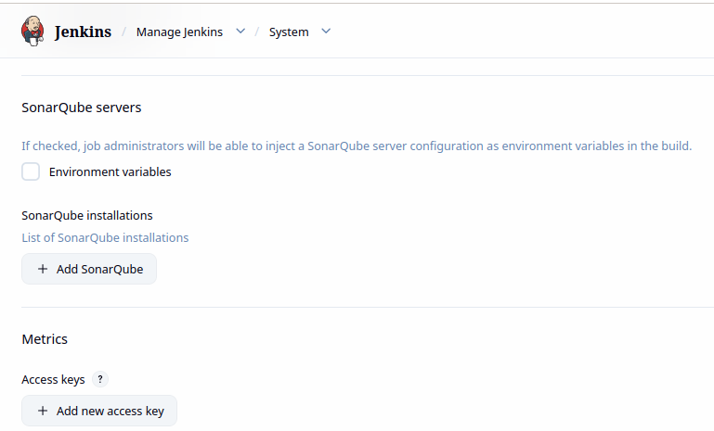

10.7 SonarQube Analysis Stage — Script and Result
The SonarQube Analysis stage uses 'withSonarQubeEnv' to inject the configured server context, then runs the Maven Sonar scanner goal. The build result confirmed a Quality Gate pass with the project's code smells, security hotspots, and coverage metrics visible on the SonarQube dashboard.
stage('SonarQube Analysis') {
steps {
withSonarQubeEnv(installationName: 'sonar-local') {
sh "mvn clean verify sonar:sonar -Dsonar.projectKey=webgoat -Dsonar.projectName='webgoat'"
}
}
}
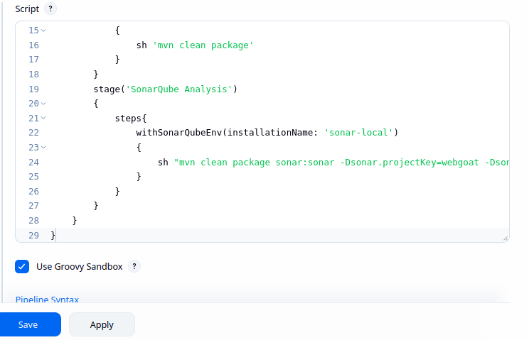

11. Stage 4 — Dependency Check
Dependency checking evaluates third-party libraries and frameworks for publicly disclosed vulnerabilities. OWASP Dependency-Check (ODC) was used, which cross-references project dependencies against the National Vulnerability Database (NVD).

11.1 Configuring the Dependency-Check Tool
After installing the OWASP Dependency-Check Jenkins plugin, an ODC installation named 'dep-check-auto' was configured under Manage Jenkins → Tools with 'Install automatically' enabled, sourced directly from GitHub releases.
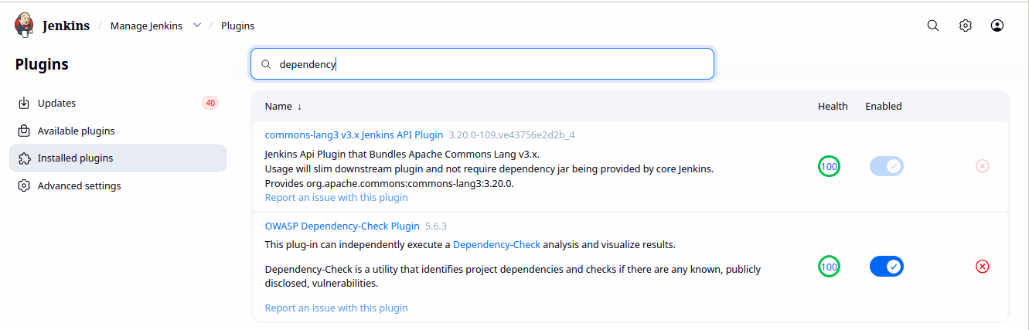

11.2 Dependency-Check Stage — Script and Initial Result
The stage runs the dependencyCheck step against the built project, publishes results with dependencyCheckPublisher, and archives the XML report as a build artifact for later review.
stage('Dependency-Check') {
steps {
dependencyCheck additionalArguments: '', odcInstallation: 'dep-check-auto'
dependencyCheckPublisher pattern: ''
archiveArtifacts allowEmptyArchive: true, artifacts: 'dependency-check-report.xml', fingerprint: true, followSymlinks: false, onlyIfSuccessful: true
sh ' rm -rf dependency-check-report.xml*'
}
}

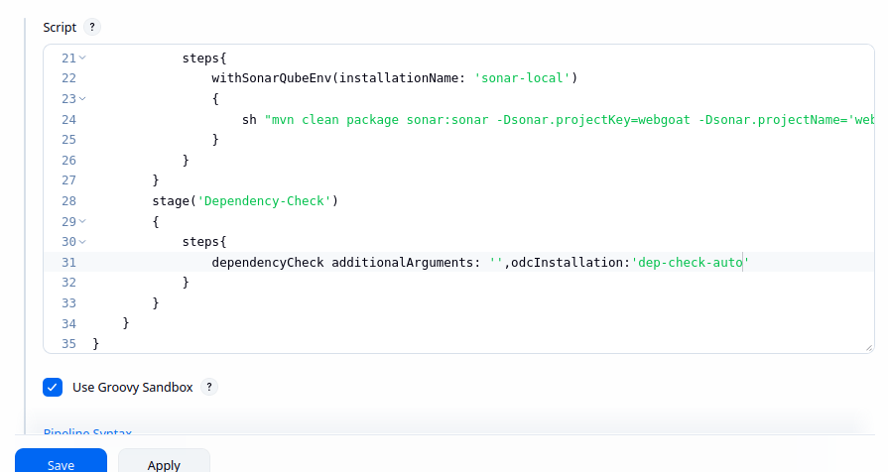

11.3 Updated Command and Re-run
The dependencyCheck arguments were revisited to refine the scan behaviour, and the pipeline was re-run to confirm the updated configuration executed cleanly.
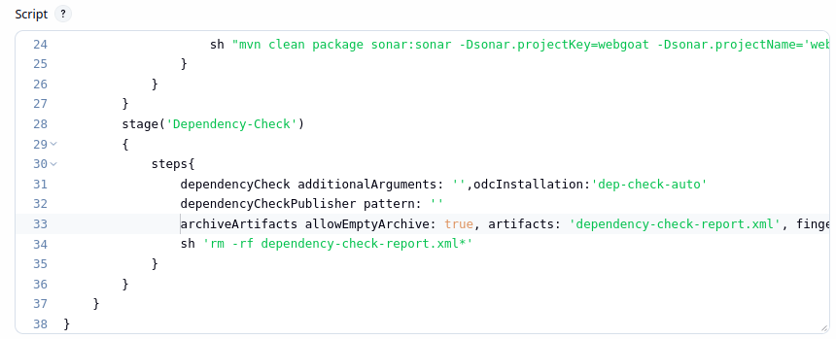

11.4 OWASP Dependency-Check UI Report
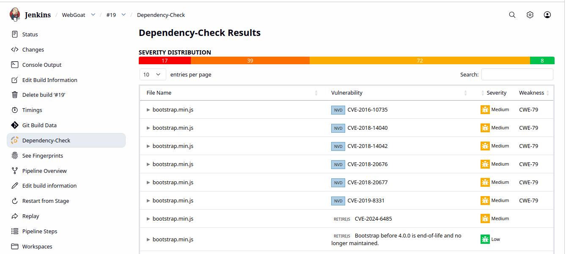
The 'Dependency-Check' link inside the build view opens a dedicated UI showing every flagged file, its associated CVE, and severity rating (Critical / High / Medium / Low), which is far easier to triage than reading the raw XML output directly.

12. Stage 5 — Software Bill of Materials (SBOM)
An SBOM is a complete inventory of every component, library, and dependency used to build a piece of software. It improves supply-chain transparency, supports vulnerability response, and is increasingly a compliance requirement. Syft was used to generate the SBOM in this lab.

12.1 Installing Syft
Syft was installed via its official install script, which places the binary at /usr/local/bin for direct use inside pipeline shell steps.
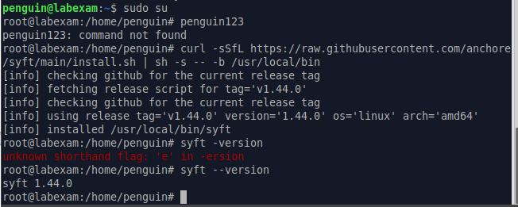
curl -sSfL https://raw.githubusercontent.com/anchore/syft/main/install.sh | sh -s -- -b /usr/local/bin

12.2 SBOM Stage — Script and Result
The stage scans the workspace directory and outputs a CycloneDX-format JSON SBOM, which is then archived as a build artifact and removed from the workspace to keep it clean for subsequent stages.
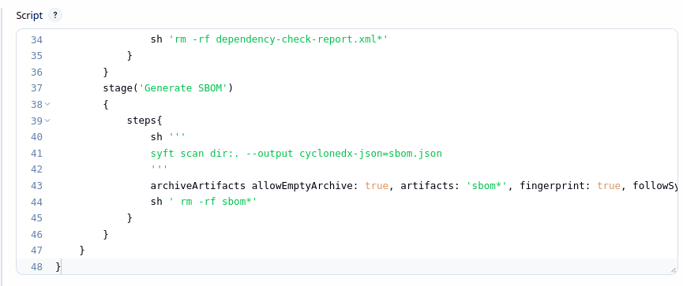
stage('Generate SBOM') {
steps {
sh '''
syft scan dir:. --output cyclonedx-json=sbom.json
'''
archiveArtifacts allowEmptyArchive: true, artifacts: 'sbom*', fingerprint: true, followSymlinks: false, onlyIfSuccessful: true
sh ' rm -rf sbom*'
}
}

13. Stage 6 — Secrets Detection
Secrets detection identifies hardcoded credentials, API keys, and tokens accidentally committed to the codebase — a common and high-impact source of real-world breaches. The Python tool detect-secrets was used for this stage.

13.1 Installing pipx and detect-secrets
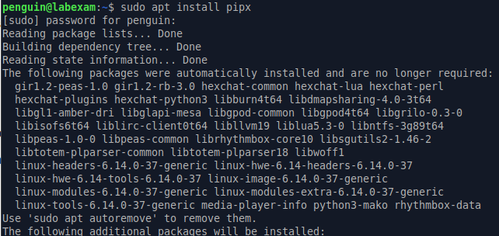
pipx was installed first to safely install detect-secrets in an isolated Python environment, avoiding conflicts with system packages.
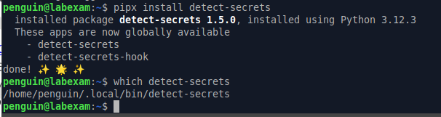

13.2 Adding the Tool Path in Jenkins
Since pip installs tools to a user-local bin directory that is not on Jenkins' default PATH, an environment variable (PATH+PYTHONTOOLS) was added under Manage Jenkins → System → Global properties, pointing to /var/lib/jenkins/.local/bin, followed by a Jenkins restart to apply the change.
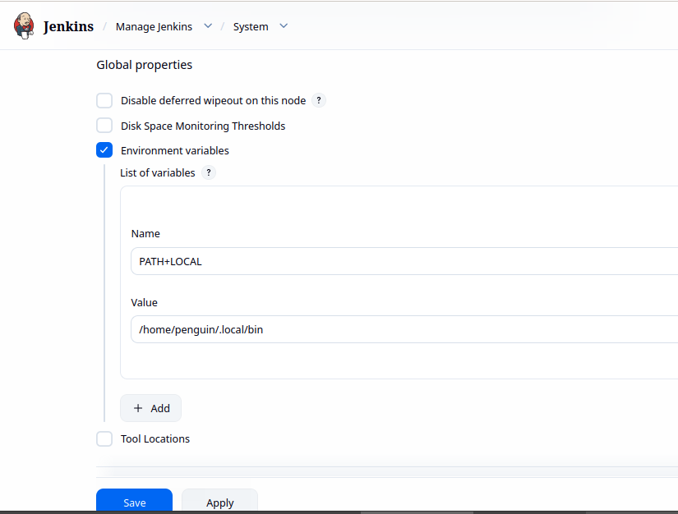

13.3 Troubleshooting: Installing detect-secrets as the Jenkins User
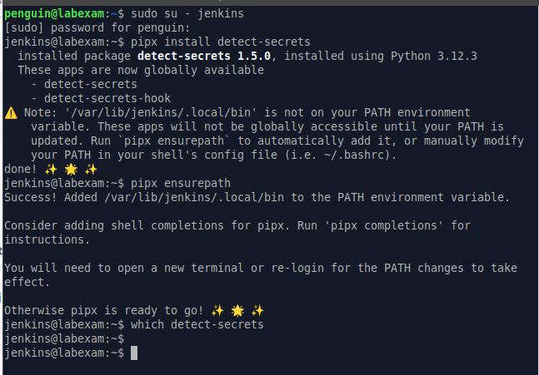
An initial run produced an error because detect-secrets was not available to the Jenkins service account. This was resolved by installing the tool directly under the 'jenkins' user and confirming the binary's path was correctly resolved.

13.4 Secrets Detection Stage — Script and Result
The stage runs a full repository scan and writes the results to a text file, which is archived as a build artifact before being removed from the workspace.
stage('Secrets Detection') {
steps {
sh 'detect-secrets scan > secrets.txt'
archiveArtifacts allowEmptyArchive: true, artifacts: 'secrets.txt', fingerprint: true, followSymlinks: false, onlyIfSuccessful: true
sh ' rm -rf secrets.txt'
}
}
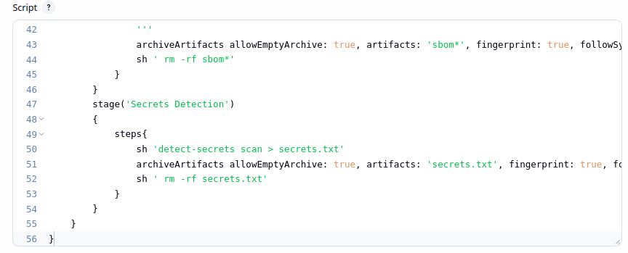

14. Stage 7 — Software Composition Analysis (SCA)
SCA tools analyze the entire software composition — all third-party libraries, frameworks, and open-source components — to provide a holistic view of dependency risk. Snyk was used for this stage, which additionally supports container and infrastructure-as-code scanning beyond what Dependency-Check alone covers.

14.1 Installing the Snyk Jenkins Plugin
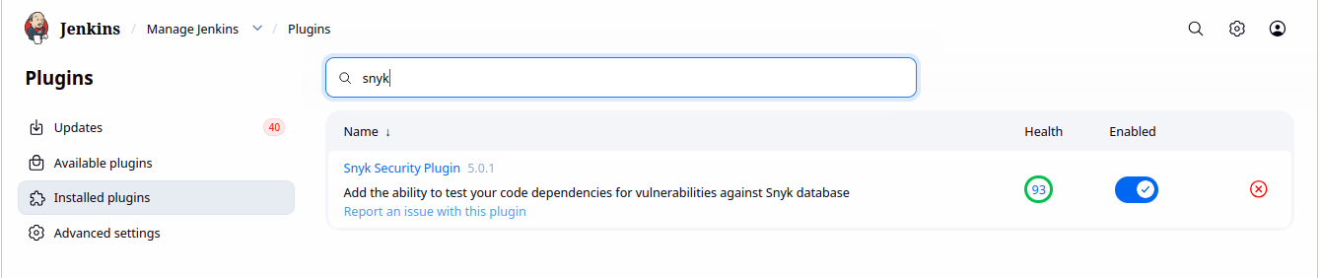
The Snyk Security plugin was located under Manage Jenkins → Plugins → Available Plugins and installed to enable the snykSecurity pipeline step.

14.2 Creating a Snyk Account and Generating an API Token
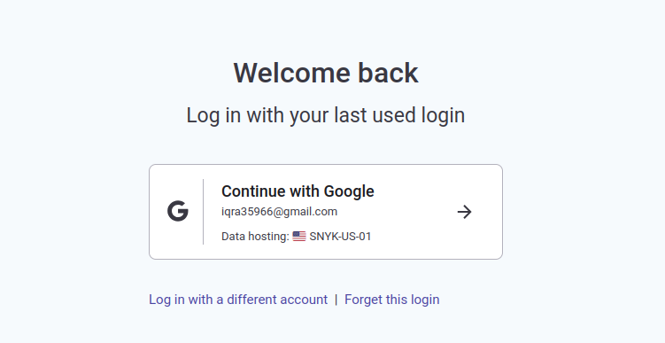
An account was created at snyk.io, and an authentication token was generated from the account settings page for use in Jenkins.

14.3 Snyk Dashboard Overview
The Snyk dashboard provides an overview of the connected organization and its scanned projects across Snyk Code, Snyk Open Source, Snyk Container, and Snyk IaC.
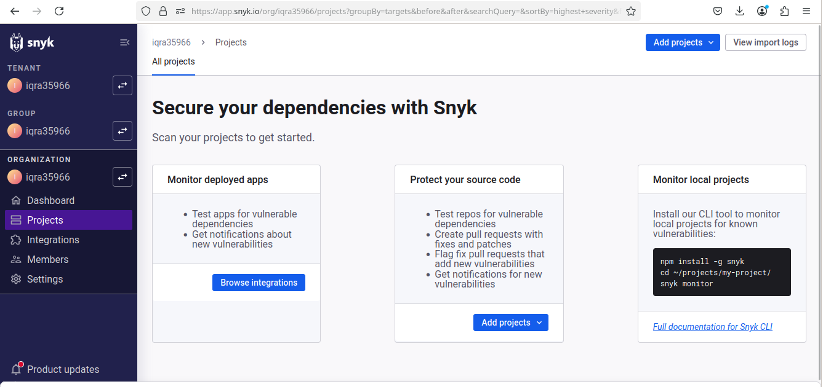

14.4 Configuring the Snyk Tool Installation in Jenkins
Under Manage Jenkins → Tools, a Snyk installation was added with 'Install automatically' enabled so the CLI stays up to date automatically.
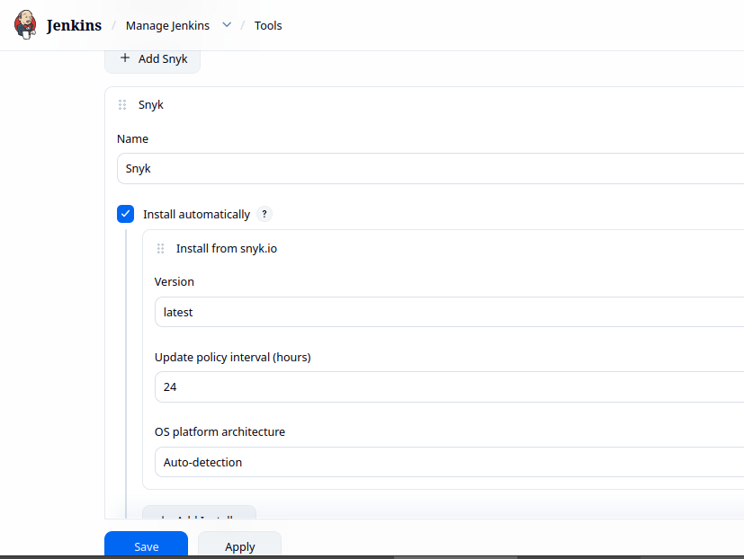

14.5 Adding the Snyk API Token as a Jenkins Credential
Under Manage Jenkins → Credentials, a new credential of kind 'Snyk API token' was created and the token from the Snyk dashboard was pasted in.
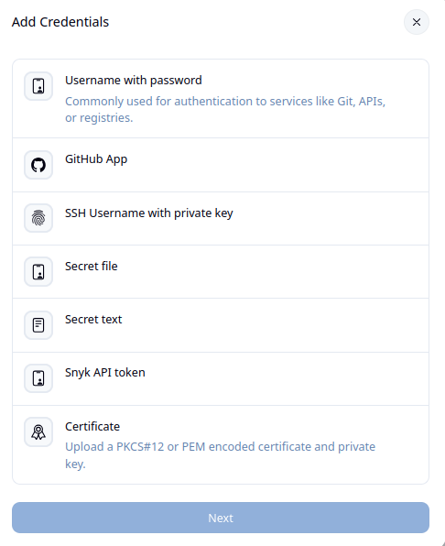

14.6 SCA Stage — Script and Result
The snykSecurity step references the configured Snyk installation and token credential, with failOnIssues set to false so the pipeline continues even when vulnerabilities are found (they are still reported).
stage('SCA') {
steps {
snykSecurity(
snykInstallation: 'Snyk',
snykTokenId: 'snyk-token',
failOnIssues: false,
)
}
}
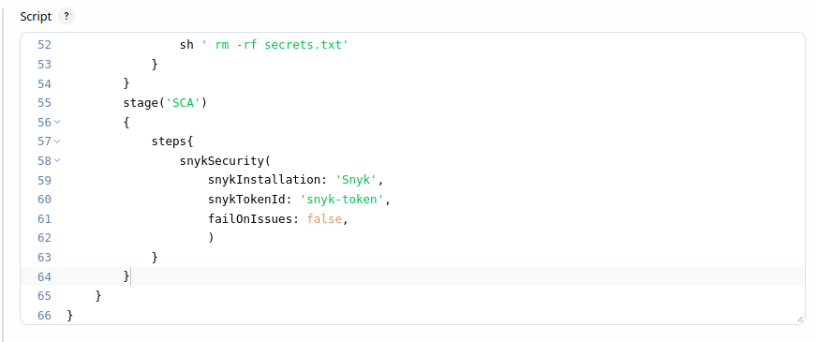

14.7 Reviewing the Snyk HTML Report
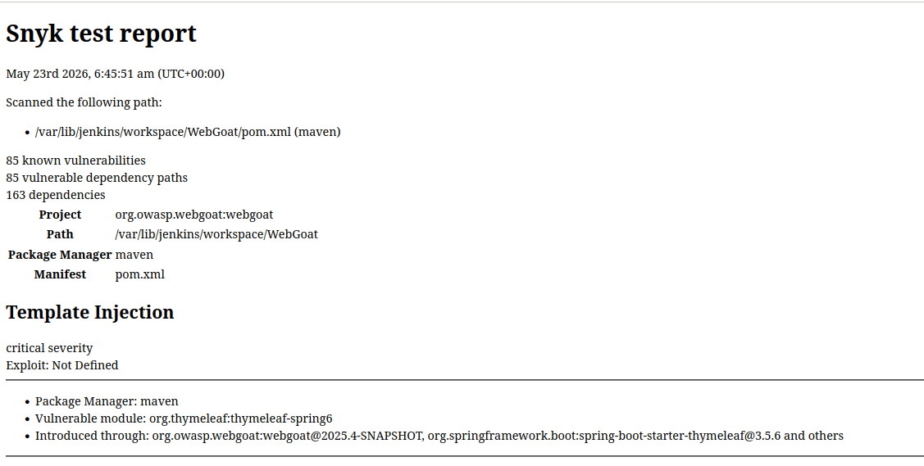
The Snyk plugin automatically archives an HTML report as a build artifact. Opening it from the build page reveals the full list of known vulnerabilities, vulnerable dependency paths, and affected packages.

15. Stage 8 — Container Security
Container security scanning protects the deployment artifact itself. Grype, a vulnerability scanner for container images and filesystems, was used to scan a containerized image for known CVEs in its OS packages and libraries.

15.1 Installing Grype
Grype was installed using its official install script, placing the binary at /usr/local/bin for direct shell invocation from the pipeline.
curl -sSfL https://raw.githubusercontent.com/anchore/grype/main/install.sh | sh -s -- -b /usr/local/bin
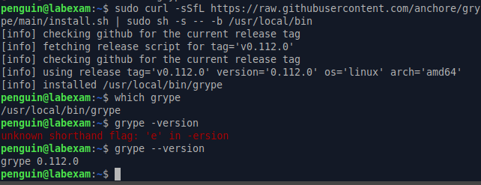

15.2 Container Security Stage — Script and Result
The stage scans the target container image and writes the findings to a text file, archived as a build artifact. The scan reported a large number of CVEs across multiple severities in the image's underlying OS packages.
stage('Container Security') {
steps {
sh 'grype docker.io/webgoat/webgoat:latest > grype.txt'
archiveArtifacts allowEmptyArchive: true, artifacts: 'grype.txt', fingerprint: true, followSymlinks: false, onlyIfSuccessful: true
sh ' rm -rf grype.txt'
}
}
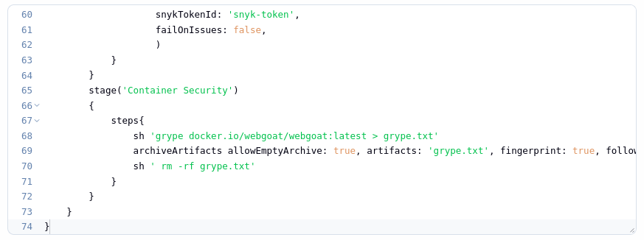

15.3 Reviewing the grype.txt Report
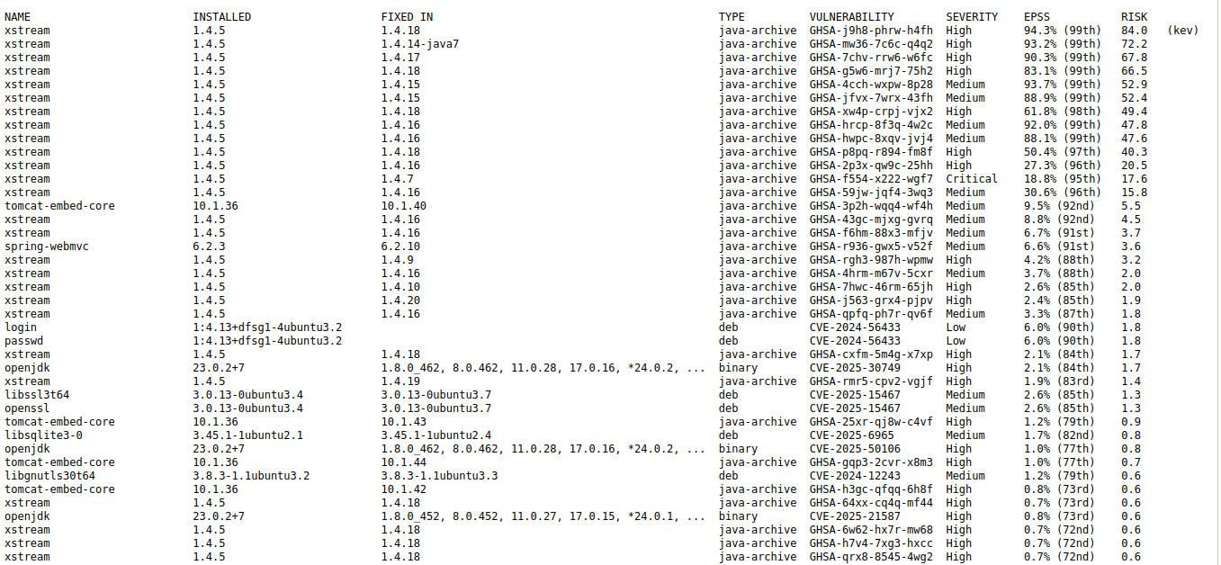
Opening the archived grype.txt artifact revealed a detailed table of installed package versions, the version each CVE is fixed in, and severity ratings ranging from Negligible to Critical.

16. Stage 9 — Dynamic Application Security Testing (DAST)
DAST evaluates a running web application from the outside in, simulating the actions of a malicious external user against the live, deployed application. OWASP ZAP was used for this stage, driven through the zap-cli command-line wrapper.

16.1 Installing OWASP ZAP and the zap-cli Tool
ZAP was installed as a native Linux package to avoid authentication complications sometimes seen with the Docker variant, and zap-cli was installed via pip to allow simple scriptable control of the ZAP daemon from the pipeline.
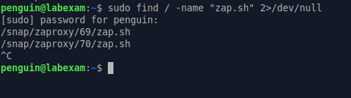

16.2 Moving ZAP Files and Launching the GUI
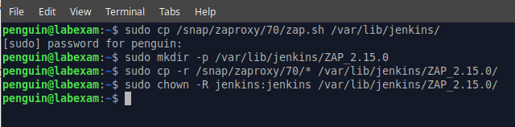
The extracted ZAP package was moved into the Jenkins home directory, and the ZAP GUI was launched once to generate and copy an API key from Tools → Options → API, which is required for zap-cli to authenticate against the daemon.

16.3 DAST Stage — Script and Result
The stage starts ZAP as a background daemon, opens the target URL, spiders the site to discover its structure, runs an active scan to probe for vulnerabilities, generates a Markdown report, and finally shuts the daemon down. The safe, intentionally vulnerable site http://testphp.vulnweb.com/ was used as the scan target.
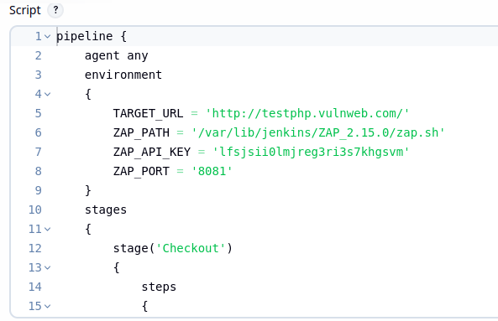
environment {
TARGET_URL = 'http://testphp.vulnweb.com/'
ZAP_PATH = '/var/lib/jenkins/ZAP_2.15.0/zap.sh'
ZAP_API_KEY = 'lfsjsii0lmjreg3ri3s7khgsvm'
ZAP_PORT = '8081'
}
stage('DAST') {
steps {
sh'''
zap-cli start --start-options -daemon
zap-cli status
zap-cli open-url ${TARGET_URL}
zap-cli spider ${TARGET_URL}
zap-cli active-scan ${TARGET_URL}
zap-cli -v report -o report-zap-cli-jenkins.md -f md
zap-cli shutdown
'''
archiveArtifacts allowEmptyArchive: true, artifacts: 'report-zap-cli-jenkins.md', fingerprint: true, followSymlinks: false, onlyIfSuccessful: true
sh ' rm -rf report-zap-cli-jenkins.md'
}
}

stage('DAST') {
steps {
sh'''
zap-cli start --start-options -daemon
zap-cli status
zap-cli open-url ${TARGET_URL}
zap-cli spider ${TARGET_URL}
zap-cli active-scan ${TARGET_URL}
zap-cli -v report -o report-zap-cli-jenkins.md -f md
zap-cli shutdown
'''
archiveArtifacts allowEmptyArchive: true, artifacts: 'report-zap-cli-jenkins.md', fingerprint: true, followSymlinks: false, onlyIfSuccessful: true
sh ' rm -rf report-zap-cli-jenkins.md'
}
}
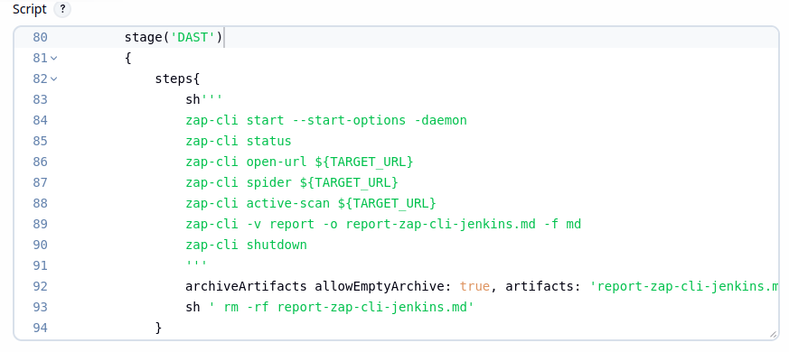

16.4 Upgrading zapcli and Final Restart
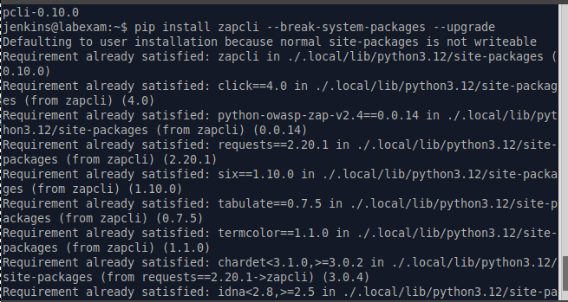
The zapcli Python package was upgraded to resolve a compatibility issue with the report command, and Jenkins was restarted once more to ensure the updated CLI was picked up cleanly by the pipeline.

17. Complete Pipeline
With all nine stages configured and individually verified, the complete Jenkinsfile below represents the final, end-to-end DevSecOps pipeline used throughout this lab.
pipeline {
agent any
environment {
TARGET_URL = 'http://testphp.vulnweb.com/'
ZAP_PATH = '/var/lib/jenkins/ZAP_2.15.0/zap.sh'
ZAP_API_KEY = 'lfsjsii0lmjreg3ri3s7khgsvm'
ZAP_PORT = '8081'
}
stages {
stage('Checkout') {
steps { git branch: 'main', url: 'https://github.com/WebGoat/WebGoat.git' }
}
stage('Build') {
steps { sh 'mvn clean package' }
}
stage('SonarQube Analysis') {
steps {
withSonarQubeEnv(installationName: 'sonar-local') {
sh "mvn clean package sonar:sonar -Dsonar.projectKey=webgoat -Dsonar.projectName='webgoat'"
}
}
}
stage('Dependency-Check') {
steps {
dependencyCheck additionalArguments: '', odcInstallation: 'dep-check-auto'
dependencyCheckPublisher pattern: ''
archiveArtifacts allowEmptyArchive: true, artifacts: 'dependency-check-report.xml', fingerprint: true, followSymlinks: false, onlyIfSuccessful: true
sh 'rm -rf dependency-check-report.xml*'
}
}
stage('Generate SBOM') {
steps {
sh 'syft scan dir:. --output cyclonedx-json=sbom.json'
archiveArtifacts allowEmptyArchive: true, artifacts: 'sbom*', fingerprint: true, followSymlinks: false, onlyIfSuccessful: true
sh ' rm -rf sbom*'
}
}
stage('Secrets Detection') {
steps {
sh 'detect-secrets scan > secrets.txt'
archiveArtifacts allowEmptyArchive: true, artifacts: 'secrets.txt', fingerprint: true, followSymlinks: false, onlyIfSuccessful: true
sh ' rm -rf secrets.txt'
}
}
stage('SCA') {
steps {
snykSecurity(snykInstallation: 'Snyk', snykTokenId: 'snyk-token', failOnIssues: false)
}
}
stage('Container Security') {
steps {
sh 'grype docker.io/webgoat/webgoat:latest > grype.txt'
archiveArtifacts allowEmptyArchive: true, artifacts: 'grype.txt', fingerprint: true, followSymlinks: false, onlyIfSuccessful: true
sh ' rm -rf grype.txt'
}
}
stage('DAST') {
steps {
sh'''
zap-cli start --start-options -daemon
sleep 30
zap-cli status
zap-cli open-url ${TARGET_URL}
zap-cli spider ${TARGET_URL}
zap-cli active-scan ${TARGET_URL}
zap-cli -v report -o report-zap-cli-jenkins.md -f md
zap-cli shutdown
'''
archiveArtifacts allowEmptyArchive: true, artifacts: 'report-zap-cli-jenkins.md', fingerprint: true, followSymlinks: false, onlyIfSuccessful: true
sh ' rm -rf report-zap-cli-jenkins.md'
}
}
}
}
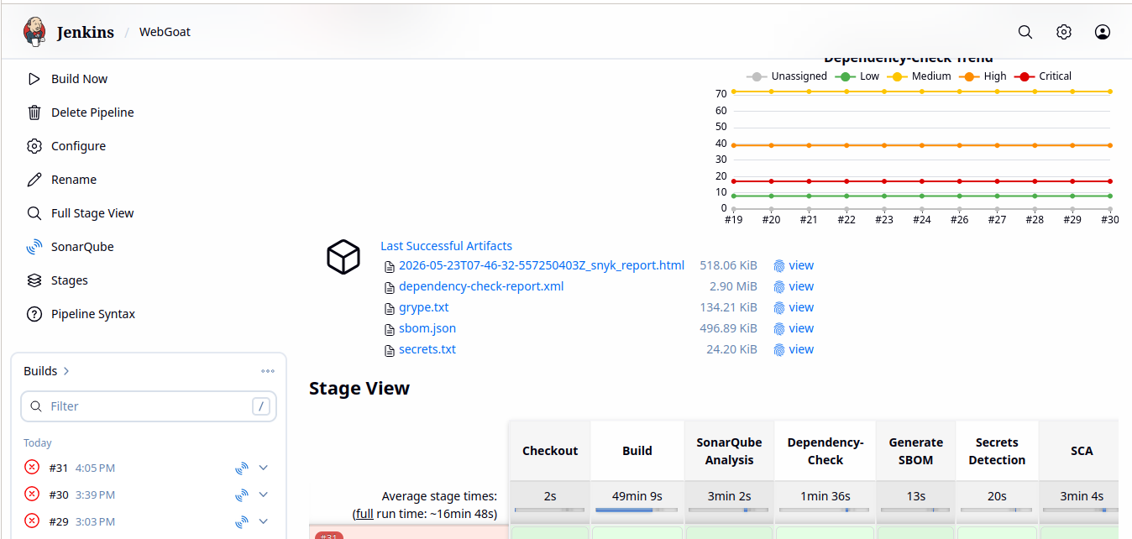

18. Analysis and Understanding

18.1 Layered Security Analysis and Defense-in-Depth
Running all nine stages together produced a layered picture of the target application's security posture that no single tool could have provided alone. SonarQube's SAST results flagged maintainability and reliability issues directly in the source code, while Dependency-Check and Snyk's SCA results cross-referenced the exact same open-source libraries but returned complementary findings, since each tool draws from a slightly different vulnerability database and detection heuristic. This overlap is a deliberate part of a defense-in-depth strategy: relying on a single scanner risks missing vulnerabilities that only appear in another tool's database.

18.2 SBOM and Secrets Detection
The SBOM generated by Syft proved to be a foundational artifact rather than a standalone report — it captures every component version precisely, which is exactly the kind of inventory an incident-response team would need if a new zero-day were disclosed in a widely used library. The Secrets Detection stage, though it found no committed secrets in this specific project, represents one of the highest-value, lowest-cost checks in the entire pipeline, since a single leaked API key or credential can lead directly to a full compromise regardless of how well the rest of the code is secured.

18.3 Container Security and Dynamic Application Testing
Grype's container scan highlighted a different category of risk entirely: vulnerabilities inherited from the base OS image rather than from the application's own code or dependencies, reinforcing that container security must be treated as a distinct concern from source-level SCA. Finally, the DAST stage's outside-in perspective validated that vulnerabilities identified statically actually manifest as exploitable behavior in the running application — closing the loop between what the code says and what the deployed system actually does.

18.4 Shift-Left Security and Continuous Security Testing
Overall, this lab demonstrated the practical value of shifting security left: every one of these nine checks now runs automatically on every build, meaning a developer receives security feedback within minutes of a code change rather than during a manual audit weeks or months later. This dramatically reduces the cost and risk associated with fixing vulnerabilities, since issues are caught and can be remediated before they ever reach a production environment.

19. Challenges Faced
- PATH configuration issues in Jenkins for Python-based tools (detect-secrets, zap-cli) required manually registering environment variables under Global properties.
- The Snippet Generator's auto-generated Dependency-Check step was incomplete and had to be manually corrected using the documented syntax.
- SonarQube's own Jenkins-integration documentation was incomplete, requiring manual configuration of the Maven command and installation name.
- An outdated zapcli package caused report generation to fail and required an upgrade before the DAST stage could complete successfully.
- Build artifacts occasionally did not appear until the build page was manually refreshed.

20. Conclusion
This lab provided hands-on experience building a production-style DevSecOps pipeline from the ground up, integrating nine distinct security tools spanning static analysis, dependency and composition scanning, supply-chain transparency, secrets detection, container security, and dynamic testing — all automated within Jenkins. Beyond the individual tool configurations, the exercise reinforced the core DevSecOps principle that security is most effective when it is continuous, automated, and embedded early in the development lifecycle rather than bolted on at the end. The resulting pipeline now serves as a reusable template: any future project pointed at this same Jenkinsfile structure would immediately benefit from the same nine layers of automated security coverage demonstrated in this lab.

