Executive Summary
Customer Engagement & Product Utilization Analytics for Retention Strategy
Prepared for: Bank Leadership & Retention Strategy Stakeholders | Prepared by: Iqra | September 2026

Why This Matters
Customers who look financially strong — high balance, high salary — are still leaving the bank. This analysis of 10,000 customer records shows that engagement (activity level and product usage), not wealth, is the real driver of retention. Inactive customers churn at nearly twice the rate of active customers, regardless of how much money they hold with the bank. Every finding below was statistically tested (chi-square tests, all p < 0.001) — these are not surface-level patterns, they are validated, reliable signals.

Headline Numbers
Metric | Value
Overall churn rate | 20.4%
Active member churn rate | 14.3%
Inactive member churn rate | 26.9%
Engagement Retention Ratio | 1.88x higher churn when inactive
Churn reduction from holding 2+ products | 53.9%
At-risk premium (high-balance, inactive) customers | 1,247 customers, 30.5% churn

Top 3 Findings
- Engagement beats wealth: Active Engaged customers churn at just 9.7%, versus 30.5% for Inactive High-Balance customers — a statistically significant 3x gap (χ² = 325.46, p < 0.001) despite similar or higher account balances.
- 2 products is the sweet spot, not more: Multi-product customers (2 products) churn far less than single-product customers, but customers pushed to 3-4 products show a sharp churn spike — a sign of cross-selling without genuine engagement.
- 1,247 high-value customers are quietly at risk: These are Premium-balance customers who are inactive, churning at 30.5% — a segment large enough, and valuable enough, to justify a dedicated retention program.
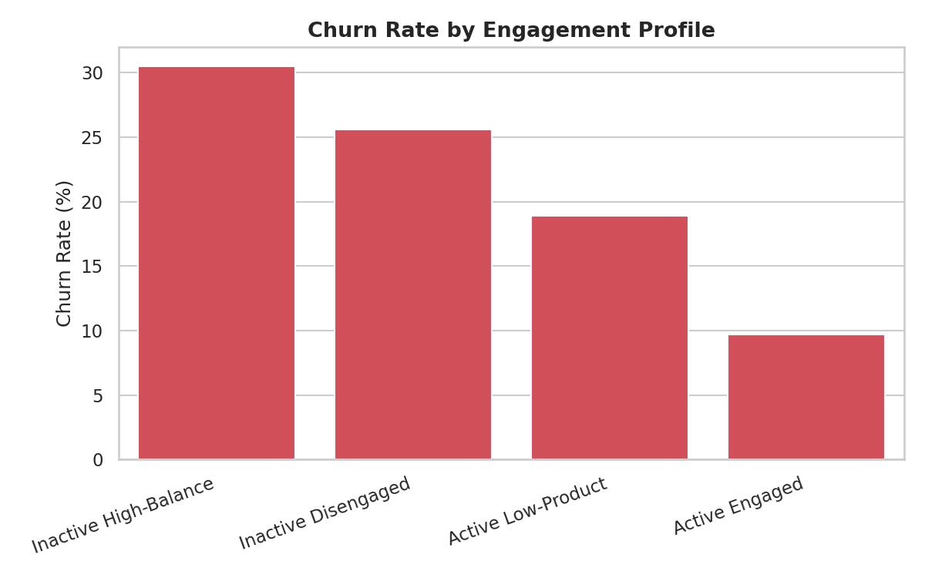

Recommended Actions
- Retarget retention campaigns around activity status, not just balance tier — the current balance-first approach misses the larger inactive-but-average-balance segment.
- Pause unmonitored cross-selling of a 3rd or 4th product; pair any such offer with a 60-day relationship check-in.
- Launch a proactive save program for the 1,247 at-risk premium customers — this is the highest-leverage, most concentrated opportunity identified.
- Track the Relationship Strength Index (RSI) monthly as a leading indicator of churn risk, alerting when a customer's score drops below 6/10.

Next Steps
The accompanying Streamlit dashboard operationalizes these findings — enabling live filtering by engagement profile, product count, and balance/salary thresholds, plus a dedicated at-risk-premium-customer detector for the retention team. The full methodology, statistical validation (chi-square tests, confidence intervals, correlation analysis), and supporting charts are available in the companion Research Paper.

