Customer Engagement & Product Utilization Analytics for Retention Strategy
A Behavioral and Relationship-Strength Approach to Customer Retention
Research Paper
Prepared by: Iqra
Unified Mentor — Data Analyst & Data Science Internship
Dataset: European Central Bank Customer Records (10,000 records)
September 2026

Table of Contents
Abstract .............................................................. 3
1. Background and Context ............................................. 3
2. Problem Statement .................................................. 3
3. Project Objectives ................................................. 3
4. Dataset Description ................................................ 3
5. Analytical Methodology ............................................. 4
6. Key Findings ....................................................... 5
7. Statistical Validation ............................................. 9
8. Predictive Modeling ................................................ 10
9. Key Performance Indicators ......................................... 11
10. Recommendations ................................................... 11
11. Conclusion ........................................................ 12
Appendix: Methodology Notes on Statistical Tests ...................... 12

Abstract
Customer retention in retail banking is often studied through demographic and financial lenses, yet these factors alone fail to explain why financially strong customers still churn. This research paper investigates customer retention through the lens of behavioral engagement and product utilization, using a dataset of 10,000 European bank customers spanning France, Germany, and Spain. The analysis classifies customers into engagement profiles, measures the relationship between product depth and churn, examines the interaction between financial commitment and activity levels, and introduces a composite Relationship Strength Index (RSI) to score retention stickiness. Every relationship reported is tested for statistical significance using chi-square tests (p < 0.001 throughout) and 95% confidence intervals. A supplementary logistic regression model was also trained to test whether these engagement signals translate into individual-level churn prediction; its modest performance (81% accuracy, only marginally above a 80% no-churn baseline) reinforces rather than undermines the paper's central argument — that engagement-based segmentation, not a single predictive score, is the more actionable lens for retention strategy. The findings show that engagement, not balance, is the dominant driver of loyalty: inactive customers churn at 1.88 times the rate of active customers, and customers holding two products churn at less than a third of the rate of single-product customers. These insights are translated into concrete, engagement-first retention strategies and a set of KPIs suitable for ongoing monitoring.

1. Background and Context
Banks increasingly recognize that customer behavior and engagement — not just demographics — determine long-term retention. Customers may appear financially strong, holding a high balance or salary, but still churn due to low engagement, limited product adoption, or a weak relationship depth with the bank. Understanding how customers use banking products and services is essential to designing effective cross-sell strategies, loyalty programs, and engagement-driven retention initiatives. This project evaluates retention through the lens of customer behavior and relationship strength, moving the conversation away from "who is wealthy" and toward "who is engaged."

2. Problem Statement
Despite having data on customer engagement and product usage, banks often lack quantitative insight into which behaviors drive retention, clarity on whether product depth reduces churn, and evidence on whether high balances alone ensure loyalty. As a result, retention strategies are frequently generic and misaligned with actual customer behavior. This paper addresses that gap by quantifying the relationship between engagement, product depth, and churn — and statistically testing whether each relationship is real or coincidental.

3. Project Objectives

3.1 Primary Objectives
- Evaluate the relationship between engagement and churn
- Measure the retention impact of product count and product mix
- Identify disengaged yet high-value customers

3.2 Secondary Objectives
- Support engagement-driven retention strategies
- Improve product bundling decisions
- Reduce silent churn among premium customers

4. Dataset Description
The dataset contains 10,000 customer records from a European bank, with the following fields:
Column | Description
CustomerId | Unique customer identifier
Surname | Customer surname
CreditScore | Customer creditworthiness
Geography | France, Spain, or Germany
Gender | Male / Female
Age | Customer age
Tenure | Years with the bank
Balance | Account balance
NumOfProducts | Number of bank products held
HasCrCard | Credit card ownership (0/1)
IsActiveMember | Activity indicator (0/1)
EstimatedSalary | Estimated annual salary
Exited | Churn indicator — target variable (0/1)

Data validation confirmed no missing values across any field, no duplicate customer IDs, and clean binary encoding for HasCrCard, IsActiveMember, and Exited. The dataset spans three geographies (France, Germany, Spain) and product holdings ranging from 1 to 4 products per customer.

5. Analytical Methodology

5.1 Data Ingestion & Validation
The dataset was loaded and validated for consistency: binary fields were confirmed to contain only 0/1 values, churn labeling was verified against the Exited column, and no missing values or duplicate customer records were found.

5.2 Engagement Classification
Each customer was assigned to one of four engagement profiles based on activity status, product count, and balance relative to the 75th percentile:
- Active Engaged — active member holding 2 or more products
- Active Low-Product — active member holding only 1 product
- Inactive Disengaged — inactive member with balance below the high-balance threshold
- Inactive High-Balance — inactive member with balance at or above the 75th percentile

5.3 Product Utilization Analysis
Churn rates were computed for each product count (1 through 4) and compared between single-product and multi-product holders to isolate the retention effect of product depth.

5.4 Financial Commitment vs. Engagement Analysis
Balance was segmented into quartile tiers (Low, Medium, High, Premium) and cross-tabulated with activity status to test whether financial commitment alone predicts loyalty. A salary-balance mismatch flag was created to identify customers earning above-median salary but holding below-median balances — a potential signal of under-utilized banking relationships. At-risk premium customers were defined as those in the Premium balance tier who are also inactive.

5.5 Retention Strength Assessment
A composite Relationship Strength Index (RSI) was constructed to quantify "stickiness":
RSI = 2 × (Active Member) + 1.5 × (Number of Products, capped at 4) + 1 × (Has Credit Card) + 1 × (Tenure ≥ 5 years)
Customers scoring 6 or above on this 0–10 scale were classified as "Sticky"; those scoring below 6 were classified as "At-Risk." This index combines behavioral, product, and tenure signals into a single retention-strength score suitable for dashboarding and monitoring. Its weights (2, 1.5, 1, 1) were set by reasoned judgment — active status and product depth are weighted most heavily as the strongest engagement signals — rather than fit to the data through regression; Section 8 reports what a data-fit model finds instead.

5.6 Statistical Validation
To confirm that observed churn-rate differences reflect genuine relationships rather than sampling noise, chi-square tests of independence were run between churn and each categorical grouping (Engagement Profile, Product Tier, Geography, Sticky/At-Risk, Balance Tier). Point-biserial correlation was used to rank numeric features by their linear association with churn, and 95% confidence intervals were computed for the active vs. inactive churn rates.

5.7 Predictive Modeling
A logistic regression model was trained on a 75/25 train-test split (7,500 / 2,500 customers, stratified by churn) to test whether the engagement, product, and demographic features could predict individual-level churn, and to isolate each feature's independent effect while controlling for all others simultaneously. Features were standardized before training. This model is deliberately a simple, interpretable baseline rather than a tuned production classifier — the goal is to test and interpret relationships, not to maximize predictive accuracy.

6. Key Findings

6.1 Engagement Is the Dominant Driver of Churn
Customers classified as Active Engaged churn at only 9.7%, compared to 30.5% for Inactive High-Balance customers — a more than 3x difference despite both groups holding meaningful balances. This directly answers the project's core question: high balances alone do not ensure loyalty; engagement does. A chi-square test confirms this relationship is highly significant (χ² = 325.46, p < 0.001).
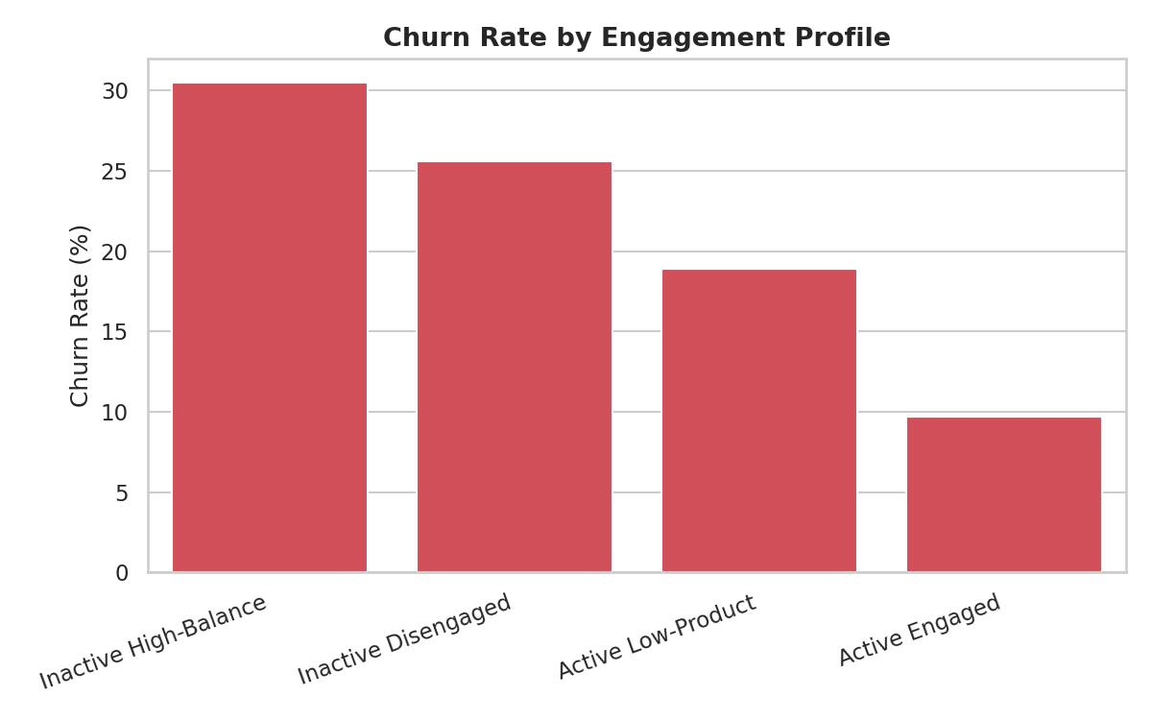
Figure 1: Churn rate by engagement profile. Inactive customers churn at 2.5–3x the rate of active customers, regardless of balance.
Engagement Profile | Customers | Churn Rate | Avg. Balance
Active Engaged | 2,588 | 9.7% | €53,071
Active Low-Product | 2,563 | 18.9% | €98,902
Inactive Disengaged | 3,602 | 25.6% | €52,304
Inactive High-Balance | 1,247 | 30.5% | €148,858

6.2 Product Depth Strongly Reduces Churn — Up to a Point
Single-product customers churn at 27.7%, while multi-product customers churn at 12.8% — a 53.9% relative reduction in churn risk (the Product Depth Index), confirmed as statistically significant (χ² = 342.98, p < 0.001). However, this benefit does not scale indefinitely: customers holding 3 or 4 products show sharply elevated churn (82.7% and 100% respectively). This counter-intuitive spike suggests that products 3 and 4 are being acquired through aggressive cross-selling rather than genuine engagement, and these customers are disengaging shortly after acquisition — a segment requiring urgent onboarding and relationship-building attention rather than further product pushes. Because this relationship is non-monotonic (churn falls, then sharply rises with product count), its linear correlation with churn is weak (r = -0.048) despite the categorical relationship being highly significant — a reminder that correlation coefficients alone can understate real effects when the underlying pattern is U-shaped rather than straight-line. Section 8 shows this same feature returns a near-null odds ratio (0.945) in the logistic regression model — the same non-linearity problem in a different guise.
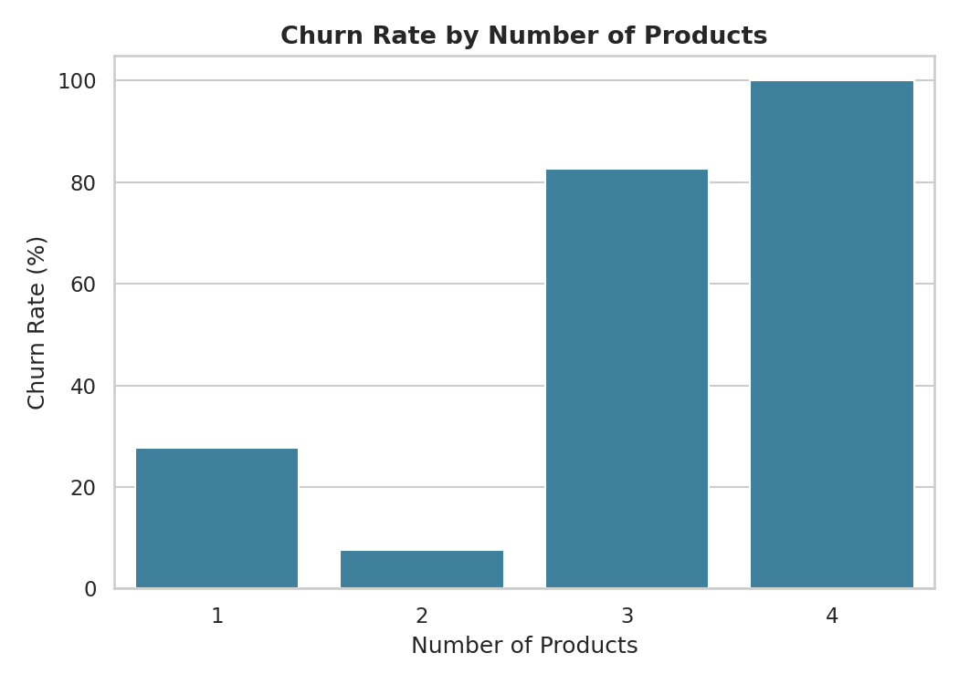
Figure 2: Churn rate by number of products held. The 2-product tier is the retention sweet spot; 3-4 products signal cross-sell fatigue, not loyalty.

6.3 Balance Alone Does Not Protect Against Churn
Across every balance tier, inactive customers churn at roughly double the rate of active customers in the same tier (χ² = 140.10, p < 0.001 for the Balance Tier relationship overall). Premium-balance inactive customers churn at 30.5%, nearly double the 16.9% churn rate of Premium-balance active customers. This confirms that activity status, not account balance, is the stronger predictor of retention within any given wealth tier. Notably, Balance itself shows only a modest positive correlation with churn (r = 0.119) — wealthier customers churn slightly more often on average, not less, reinforcing that balance is not a protective factor.
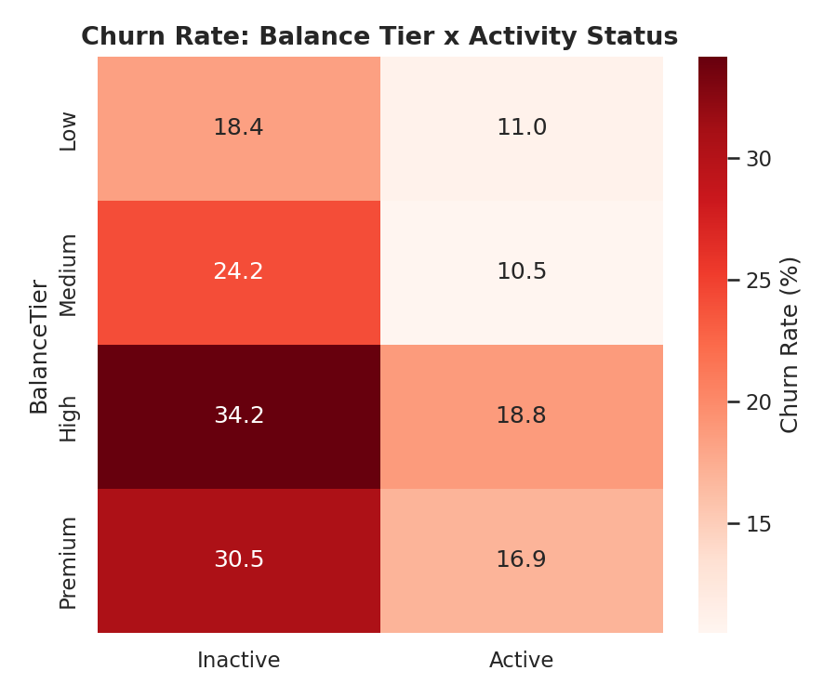
Figure 3: Churn rate by balance tier and activity status. Activity status splits churn risk within every tier.
Additionally, 1,247 customers were identified as "at-risk premium" — Premium-balance customers who are also inactive — representing a high-value segment with a 30.47% churn rate that is disproportionately exposed to silent attrition.

6.4 Relationship Strength Index Predicts Retention Non-Linearly
Churn rate falls steadily as the Relationship Strength Index rises from the 0–2 bucket (33.1% churn) to the 4–6 bucket (14.0% churn), confirming that the composite index captures real retention signal across most of its range. The small 8+ segment (67 customers) shows an anomalous spike, most likely reflecting a handful of customers with unusually high product counts (3–4) who, as shown in Section 6.2, are a high-churn cross-sell segment despite scoring well on paper — a reminder that composite scores should be validated against raw product-count behavior, not read in isolation. RSI as a whole correlates negatively with churn (r = -0.140, p < 0.001) — the strongest correlation of any engineered feature in this study.
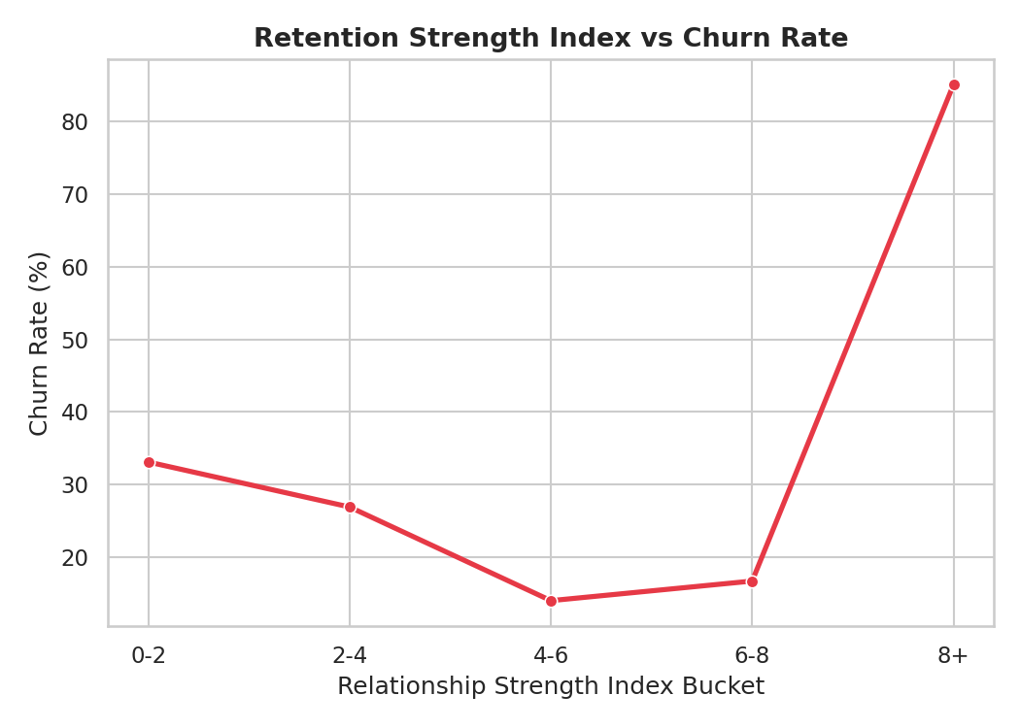
Figure 4: Churn rate across Relationship Strength Index buckets.

6.5 Sticky Customers Churn at Nearly Half the Rate of At-Risk Customers
Customers classified as "Sticky" (RSI ≥ 6) churn at 13.3%, compared to 22.5% for "At-Risk" customers (RSI < 6) — a highly significant difference (χ² = 93.33, p < 0.001) that validates the RSI as a usable retention-strength segmentation for targeting.
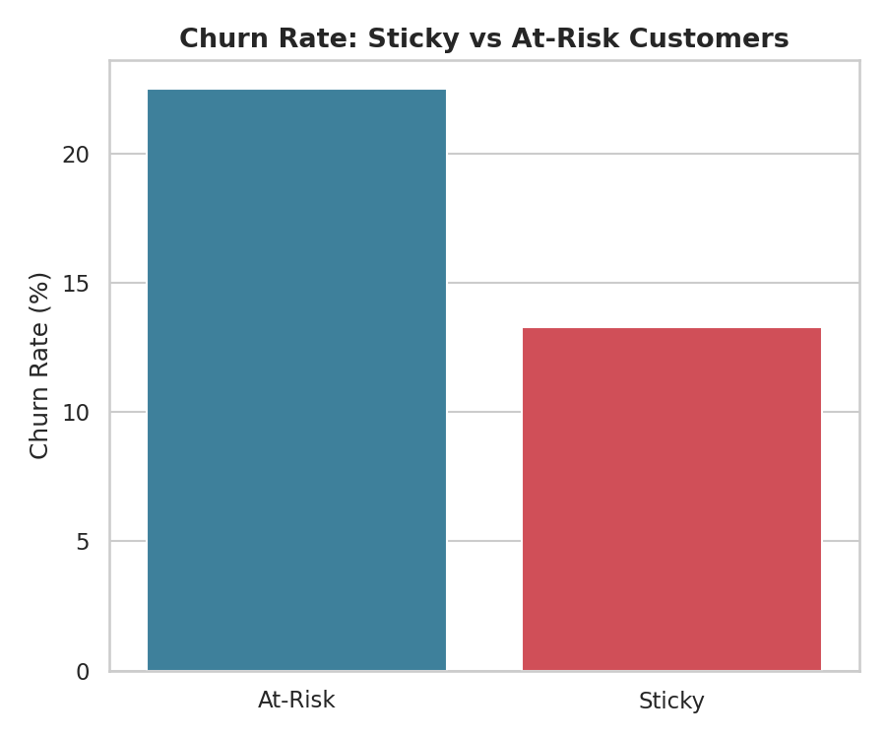
Figure 5: Churn rate comparison between Sticky and At-Risk customer segments.

6.6 Geographic Distribution of Engagement Profiles
Engagement profile distribution varies across the three geographies, and churn itself differs significantly by geography (χ² = 301.26, p < 0.001) — relevant for tailoring region-specific retention campaigns rather than applying a single bank-wide strategy.
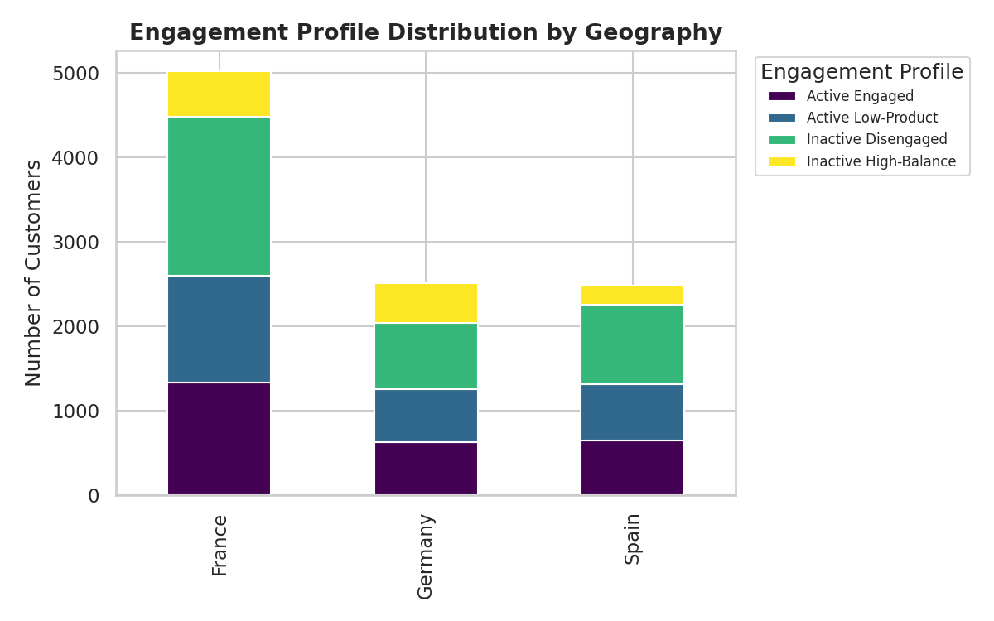
Figure 6: Engagement profile distribution by geography (France, Germany, Spain).

6.7 Age Is an Unexpected Secondary Signal
Beyond the engagement-focused metrics that were the primary focus of this study, Age emerged as the single strongest linear correlate of churn (r = 0.285, p < 0.001) — older customers churn more often. Section 8 confirms this holds even after controlling for every other feature simultaneously (odds ratio 2.06 per standard deviation). While outside the original scope of this project, this is worth flagging for future work: an age-aware retention overlay (e.g., extra engagement outreach for older high-balance customers) could complement the engagement-first strategy recommended here.

7. Statistical Validation
Every categorical relationship reported in Section 6 was tested with a chi-square test of independence against churn. All five relationships are significant at p < 0.001, meaning the observed churn-rate differences are extremely unlikely to be due to chance.
Variable | χ² Statistic | df | p-value | Significant (α = 0.05)
Engagement Profile | 325.46 | 3 | < 0.001 | Yes
Product Tier | 342.98 | 1 | < 0.001 | Yes
Geography | 301.26 | 2 | < 0.001 | Yes
Sticky vs. At-Risk | 93.33 | 1 | < 0.001 | Yes
Balance Tier | 140.10 | 3 | < 0.001 | Yes

Point-biserial correlations rank the numeric features by linear association with churn:
Feature | Correlation with Churn (r) | p-value
Age | 0.285 | < 0.001
Relationship Strength Index | -0.140 | < 0.001
Balance | 0.119 | < 0.001
Number of Products | -0.048 | < 0.001
Credit Score | -0.027 | 0.007
Tenure | -0.014 | 0.162 (not significant)
Estimated Salary | 0.012 | 0.226 (not significant)

Finally, the 95% confidence intervals for active vs. inactive churn rates do not overlap (Active: 14.27%, CI [13.31%, 15.22%]; Inactive: 26.85%, CI [25.60%, 28.10%]), confirming the Engagement Retention Ratio reflects a real, robust gap rather than sampling variation.

8. Predictive Modeling
To complement the descriptive and statistical findings above, a logistic regression model was trained to test whether churn can be predicted at the individual level, and to isolate each feature's independent effect while controlling for all others. The model was trained on 7,500 customers and evaluated on a held-out test set of 2,500 customers it never saw during training.

8.1 Model Performance: Modest, and That Itself Is a Finding
Metric | Value
Accuracy (test set) | 80.9%
Baseline accuracy (always predict "no churn") | 79.6%
Precision (churn class) | 59.9%
Recall (churn class) | 19.1%
F1-score (churn class) | 28.9%
ROC-AUC | 0.784

The model's accuracy (80.9%) is only marginally better than simply predicting "no customer churns" for everyone (79.6% baseline, since ~20% of customers churn). More tellingly, its recall on actual churners is just 19.1% — it misses roughly 4 out of every 5 customers who actually churn. This is an honest, and useful, negative result: a simple linear model cannot reliably flag individual churners from these features alone. This does not weaken the paper's central argument — it strengthens it. The engagement-profile segmentation in Section 6 achieves much clearer separation (9.7% vs. 30.5% churn between groups) than this model's individual-level predictions, because engagement profiles capture the same signal through interpretable, non-linear business rules rather than a single linear score. For a bank retention team, "target the Inactive High-Balance segment" is more actionable than a churn-probability score with 19% recall.

8.2 Independent Effects (Odds Ratios)
Holding all other features constant, the model's odds ratios show which features have an independent effect on churn once every other factor is accounted for simultaneously:
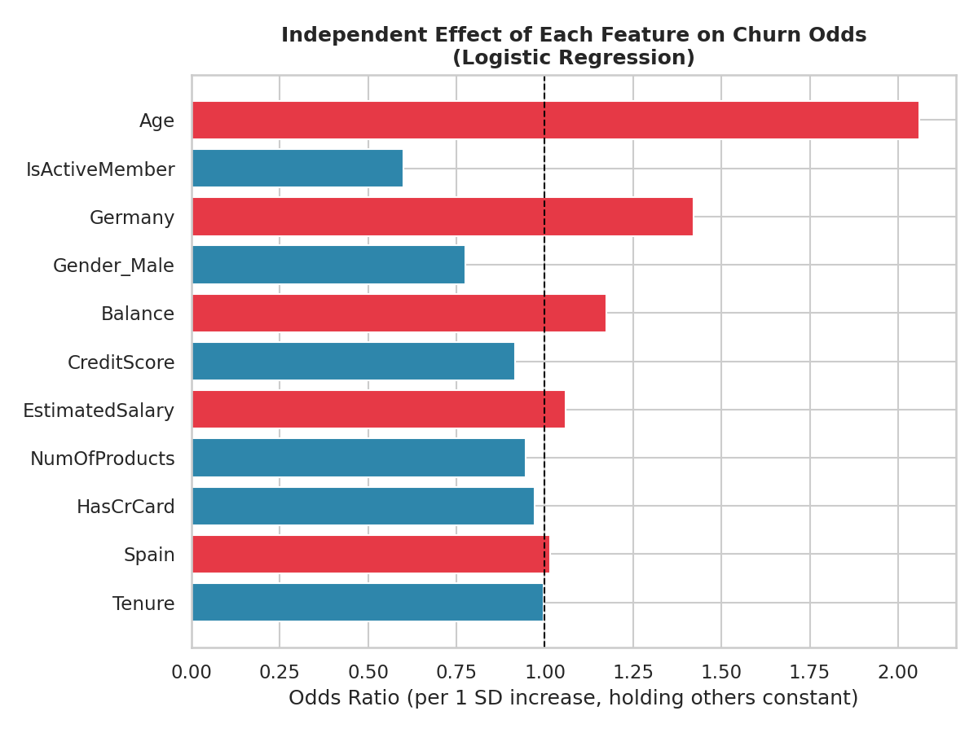
Figure 7: Odds ratio for each feature's independent effect on churn (per 1 standard deviation increase). Bars right of 1.0 increase churn odds; bars left of 1.0 decrease them.
Feature | Odds Ratio | Interpretation
Age | 2.061 | Each SD increase in age roughly doubles the odds of churn
Is Active Member | 0.599 | Active members have ~40% lower odds of churn
Germany (vs. France) | 1.422 | Germany customers have ~42% higher odds of churn than France
Gender (Male) | 0.774 | Male customers have ~23% lower odds of churn than female customers
Balance | 1.174 | Higher balance is associated with slightly higher churn odds
Number of Products | 0.945 | Near-null linear effect — masks the non-monotonic pattern in 6.2

Two results stand out as genuinely new information beyond the engagement-focused scope of this study: Age is the single strongest independent predictor in the model, and Germany shows meaningfully higher churn odds than France even after controlling for balance, activity, and product count. Neither was part of the original project brief, but both are flagged here as evidence-based directions for follow-up analysis rather than asserted as proven causes.

9. Key Performance Indicators
KPI | Value | Interpretation
Engagement Retention Ratio | 1.88x | Inactive members churn 1.88x more than active members
Product Depth Index | 53.9% | Relative churn reduction from holding 2+ products vs. 1
High-Balance Disengagement Rate | 49.9% | Share of Premium-balance customers who are inactive
Credit Card Stickiness Score | 3.0% | Relative churn reduction from credit card ownership
Average Relationship Strength Index | 4.58 / 10 | Bank-wide average retention-strength score
At-Risk Premium Customers | 1,247 | Premium-balance customers who are inactive (30.5% churn)
Overall Churn Rate | 20.4% | Bank-wide churn rate across all 10,000 customers

10. Recommendations

10.1 Prioritize Engagement Over Balance in Retention Targeting
Retention campaigns should flag inactive customers regardless of balance tier — the current practice of prioritizing only high-balance customers overlooks the much larger Inactive Disengaged segment (3,602 customers, 25.6% churn).

10.2 Redesign the Cross-Sell Strategy for 3rd and 4th Products
The sharp churn spike among 3-4 product holders indicates that cross-selling beyond 2 products, without a parallel engagement or onboarding program, actively harms retention. A revised approach should pair any 3rd/4th product offer with a dedicated relationship-manager check-in within the first 60 days.

10.3 Launch a Silent-Churn Early-Warning Program for At-Risk Premium Customers
The 1,247 at-risk premium customers represent concentrated financial exposure. A proactive outreach program — annual reviews, dedicated relationship managers, or loyalty incentives tied to activity rather than balance — should be piloted for this segment first.

10.4 Adopt the Relationship Strength Index as a Standing Retention Metric, Not a Predictive Score
RSI should be computed monthly per customer and tracked as a leading indicator, with automated alerts when a customer's score drops below the Sticky threshold (6.0). Given Section 8's finding that a linear predictive model underperforms this rule-based segmentation, the bank should rely on engagement-profile rules for operational targeting rather than a churn-probability score.

10.5 Explore an Age-Aware and Geography-Aware Overlay for Future Iterations
Given Age's strong and independent correlation with churn, and Germany's elevated churn odds even after controlling for other factors, a follow-up study should test whether engagement interventions need to be tailored by age band and geography, particularly for older, high-balance German customers who may disengage for different reasons than the broader customer base.

11. Conclusion
This project reframes customer churn from a behavioral and relationship-strength perspective rather than a purely demographic or financial one. The evidence is consistent across every analytical lens — and statistically validated at every step: engagement, measured through activity status, product depth, and tenure, is a stronger predictor of retention than balance or salary. A supplementary predictive model confirms this indirectly: a linear classifier using these same features achieves only modest individual-level accuracy, while the simple engagement-profile segmentation achieves much sharper separation between low-risk and high-risk customers. This suggests retention strategy is better served by interpretable, rule-based segmentation than by a single predictive score. Customers who are active and hold a moderate number of well-adopted products are the bank's most loyal segment, while high-balance but inactive customers represent a large, currently under-addressed churn risk. By focusing retention strategy on engagement and product utilization rather than demographics, the bank can design more targeted cross-sell strategies, loyalty programs, and engagement-driven retention initiatives — directly addressing the objectives set out at the start of this study.

Appendix: Methodology Notes on Statistical Tests
Chi-square tests of independence assess whether two categorical variables (e.g., Engagement Profile and Churn) are statistically associated. A p-value below 0.05 indicates the association is unlikely to have arisen by chance. Point-biserial correlation measures the linear association between a continuous variable and a binary variable, ranging from -1 to +1; values near 0 indicate a weak linear relationship, which — as shown for Number of Products — can still coexist with a strong non-linear (categorical) relationship. The logistic regression model in Section 8 was trained with scikit-learn on standardized features using a 75/25 stratified train-test split (random_state=42); odds ratios are exp(coefficient) and represent each feature's independent effect per one standard deviation increase, holding all other features constant. All tests were run on the full 10,000-record dataset (or its 7,500/2,500 train/test split, where applicable).

