Product Line Profitability & Margin Performance Analysis for Nassau Candy Distributor
Data Science Internship Project | Unified Mentor
Prepared for project submission

Abstract
This project analyzes 10,194 transaction-level records from Nassau Candy Distributor to determine which products, divisions and factories create the strongest financial value and which products represent margin risk. The analysis validates data quality, calculates profitability metrics, ranks products, compares divisions, performs Pareto concentration analysis, diagnoses cost-versus-sales patterns and maps product performance to factories. The company generated $141,783.63 in sales and $93,442.80 in gross profit at an overall gross margin of 65.91%. Results show strong dependence on five chocolate products, while Kazookles is a major margin-risk product with only 7.69% gross margin.

1. Business Background and Problem Statement
Sales volume alone can be misleading because high-volume products may have weak margins or excessive costs. The business therefore needs a product-level view of revenue, cost and gross profit to support pricing, sourcing, promotion and product-rationalization decisions. The project addresses the lack of visibility into high-margin products, high-sales/low-margin products, division-level financial efficiency and margin-risk products.

2. Data and Quality Validation
The source dataset contains 18 fields covering order identifiers, dates, customers, geography, product attributes and financial measures. Dates were converted to a consistent datetime format, division and product labels were standardized, duplicate records were checked, and financial values were validated.
Validation Metric | Result
Rows | 10,194
Products | 15
Divisions | 3
Order period | 2024-01-02 to 2025-12-31
Missing values | 0
Duplicate rows | 0
Zero/negative sales | 0
Invalid/zero units | 0
Gross profit formula check | Sales − Cost matched Gross Profit for all records

3. Analytical Methodology
- Data cleaning and validation: checked missing values, duplicates, dates, sales, cost, units and gross-profit consistency.
- Profitability metrics: calculated gross margin, profit per unit, revenue contribution and profit contribution.
- Product analysis: ranked products by gross profit and gross margin and flagged margin risk.
- Division analysis: compared sales, gross profit, cost and gross margin across divisions.
- Pareto analysis: calculated cumulative revenue and cumulative profit to identify concentration and dependency.
- Cost diagnostics: compared product sales and cost to identify cost-heavy, margin-poor products.
- Factory correlation: linked each product to its assigned factory and analyzed financial contribution by factory and location.

4. KPI Results
KPI | Result
Total Sales | $141,783.63
Total Cost | $48,340.83
Total Gross Profit | $93,442.80
Overall Gross Margin | 65.91%
Total Units | 38,654
Top Profit Product | Wonka Bar -Scrumdiddlyumptious ($19,357.50)
Lowest Margin Product | Kazookles (7.69%)
Highest Margin Product | Everlasting Gobstopper (80.00%)

5. Product-Level Profitability Findings
The five Wonka chocolate products dominate the portfolio. Scrumdiddlyumptious is the largest gross-profit contributor, while Nutty Crunch Surprise has the strongest gross margin among the high-volume chocolate products. Lickable Wallpaper produces a lower total profit because of lower volume, but it has a strong profit per unit. Kazookles is the most significant margin-risk product because its sales are much higher than most minor products while its gross margin is only 7.69%. At the opposite end, Everlasting Gobstopper holds the single highest gross margin in the portfolio at 80.00%, though its low sales volume means it contributes only marginally to total profit.
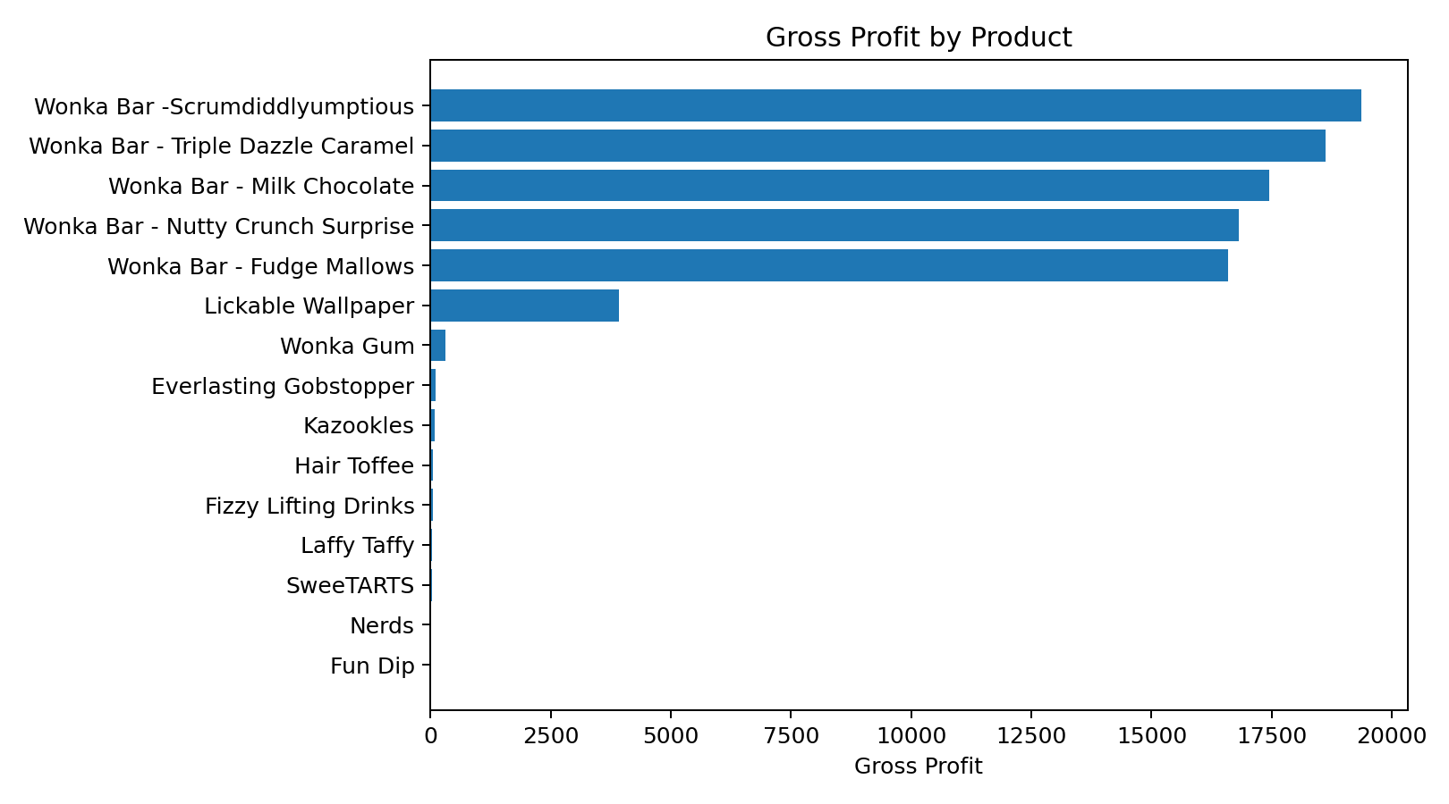
Product | Sales | Gross Profit | Margin | Profit Share
Wonka Bar -Scrumdiddlyumptious | $27,874.80 | $19,357.50 | 69.44% | 20.72%
Wonka Bar - Triple Dazzle Caramel | $28,485.00 | $18,610.20 | 65.33% | 19.92%
Wonka Bar - Milk Chocolate | $26,867.75 | $17,443.37 | 64.92% | 18.67%
Wonka Bar - Nutty Crunch Surprise | $23,574.95 | $16,819.95 | 71.35% | 18.00%
Wonka Bar - Fudge Mallows | $24,890.40 | $16,593.60 | 66.67% | 17.76%

6. Division-Level Performance
Chocolate is the financial engine of the business, contributing approximately 92.88% of revenue and 95.06% of gross profit. Other contributes meaningful revenue primarily through Lickable Wallpaper, while Sugar is very small in absolute financial contribution. Division results should therefore be interpreted using both margin and scale rather than margin alone.
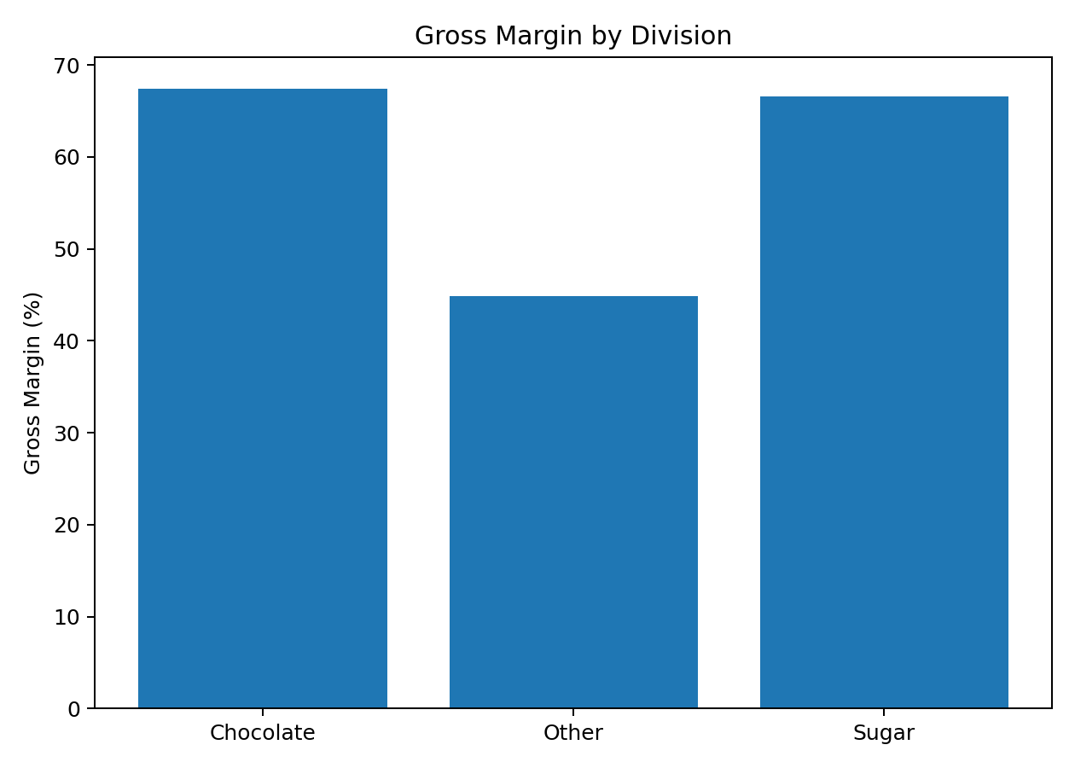
Division | Sales | Gross Profit | Margin | Profit Share
Chocolate | $131,692.90 | $88,824.62 | 67.45% | 95.06%
Other | $9,663.25 | $4,333.45 | 44.84% | 4.64%
Sugar | $427.48 | $284.73 | 66.61% | 0.30%

7. Cost Structure and Margin Risk
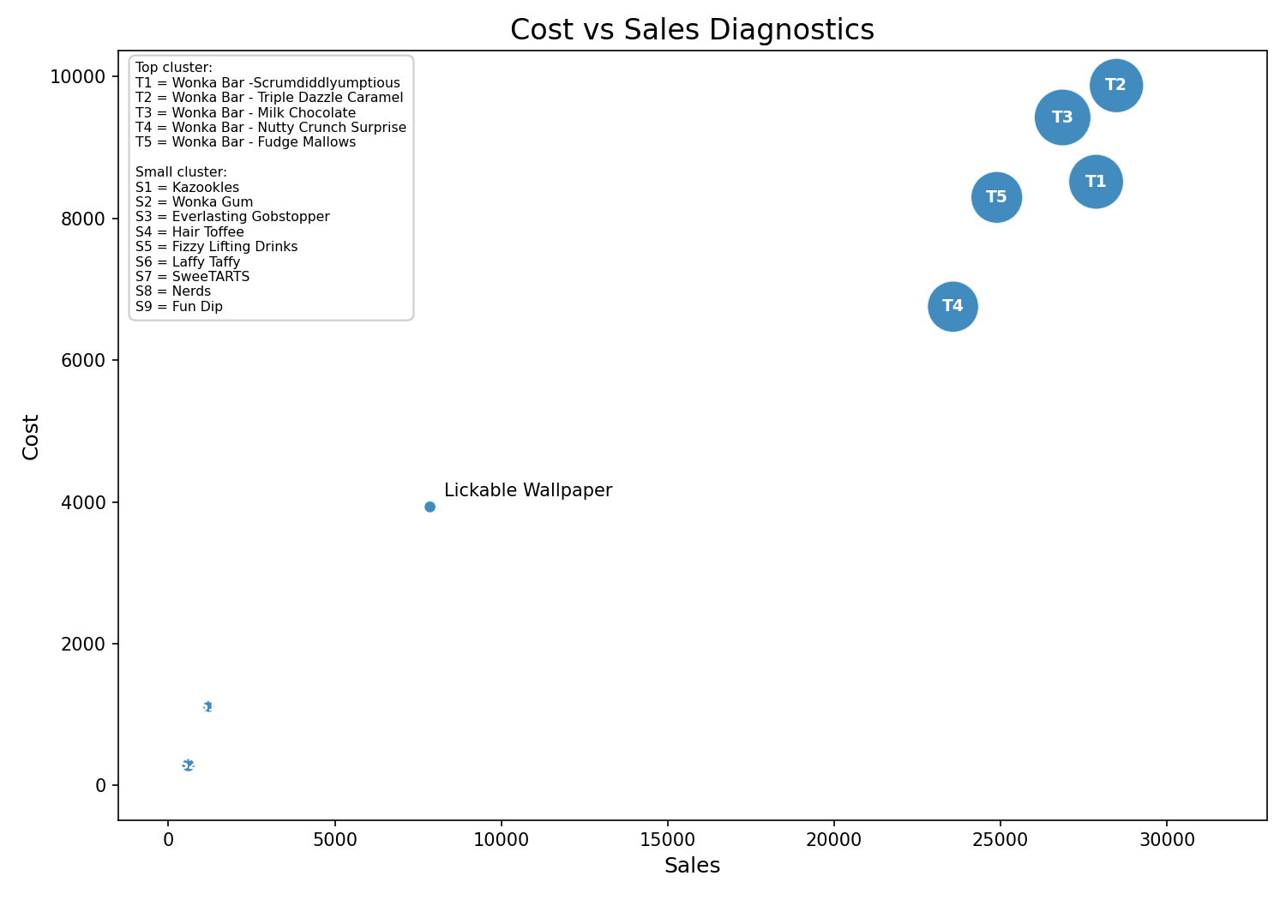
Cost diagnostics show that high sales do not automatically imply poor efficiency. The major chocolate products sustain strong margins. Kazookles is the clearest structural risk: its cost consumes most of sales, leaving only 7.69% gross margin. This product should be prioritized for repricing, supplier-cost negotiation or product-rationalization review.

8. Profit Concentration (Pareto) Analysis
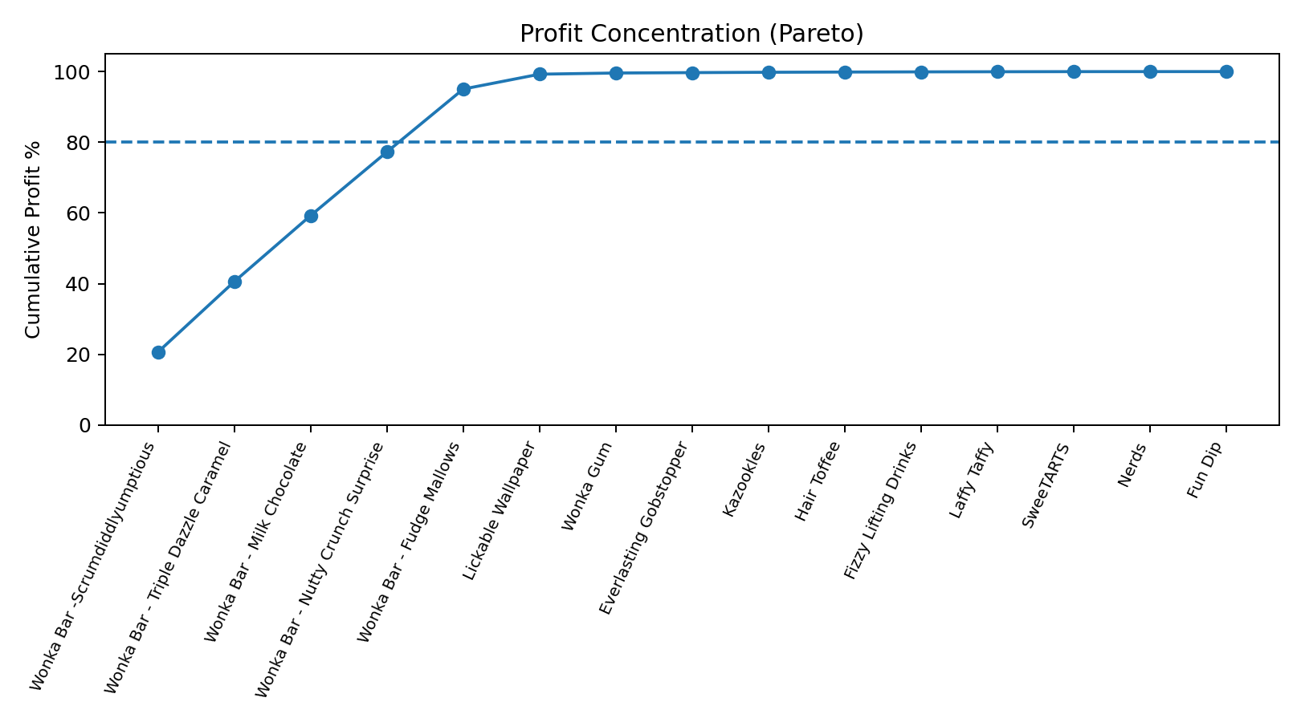
Five products are required to exceed 80% of revenue and five products are required to exceed 80% of gross profit. In fact, the five chocolate products account for approximately 92.88% of revenue and 95.06% of gross profit. This indicates substantial concentration risk: disruptions in the chocolate portfolio would have an outsized impact on company performance.

9. Factory Correlation and Geographic Intelligence
Products were mapped to five factories using the project-supplied correlation table. Lot's O' Nuts is the largest profit contributor, followed by Wicked Choccy's. The Other Factory has the weakest aggregate gross margin because its portfolio includes Kazookles, the project’s primary margin-risk product.
Factory | Products | Sales | Gross Profit | Margin
Lot's O' Nuts | 3 | $76,340.15 | $52,771.05 | 69.13%
Wicked Choccy's | 2 | $55,352.75 | $36,053.57 | 65.13%
Secret Factory | 3 | $8,587.50 | $4,344.70 | 50.59%
The Other Factory | 2 | $1,282.25 | $152.25 | 11.87%
Sugar Shack | 5 | $220.98 | $121.23 | 54.86%

10. Recommendations
- Immediately review Kazookles for repricing, sourcing-cost reduction or discontinuation because its 7.69% gross margin materially underperforms the portfolio.
- Protect the five core chocolate products because they contribute about 95% of gross profit; monitor supply, pricing and factory continuity closely.
- Use margin-based promotion rules rather than sales-volume rules so high-volume products do not receive incentives that further weaken profitability.
- Use Lickable Wallpaper as a benchmark for high profit per unit and investigate whether demand can be scaled without reducing margin.
- Create monthly margin monitoring even though current product margins are stable; future cost or price changes should trigger automated alerts.
- Add concentration-risk KPIs to executive reporting so dependency on a small product group is explicitly monitored.

11. Streamlit Application
The accompanying Streamlit application provides live filtering by date, division, margin threshold and product search. It contains product profitability, division performance, cost diagnostics, Pareto concentration and factory intelligence modules. The dashboard can be launched locally with the requirements file and app.py included in this submission.

12. Conclusion
The analysis establishes a clear, data-driven view of profitability beyond sales volume. Nassau Candy’s portfolio is highly profitable overall but strongly concentrated in five chocolate products. The most important improvement opportunity is the low-margin Kazookles product, while the core chocolate portfolio requires active protection due to its financial importance. The recommended dashboard and KPI framework enable continuous monitoring and faster pricing, sourcing and portfolio decisions.

