10 Logical Data Model (H)
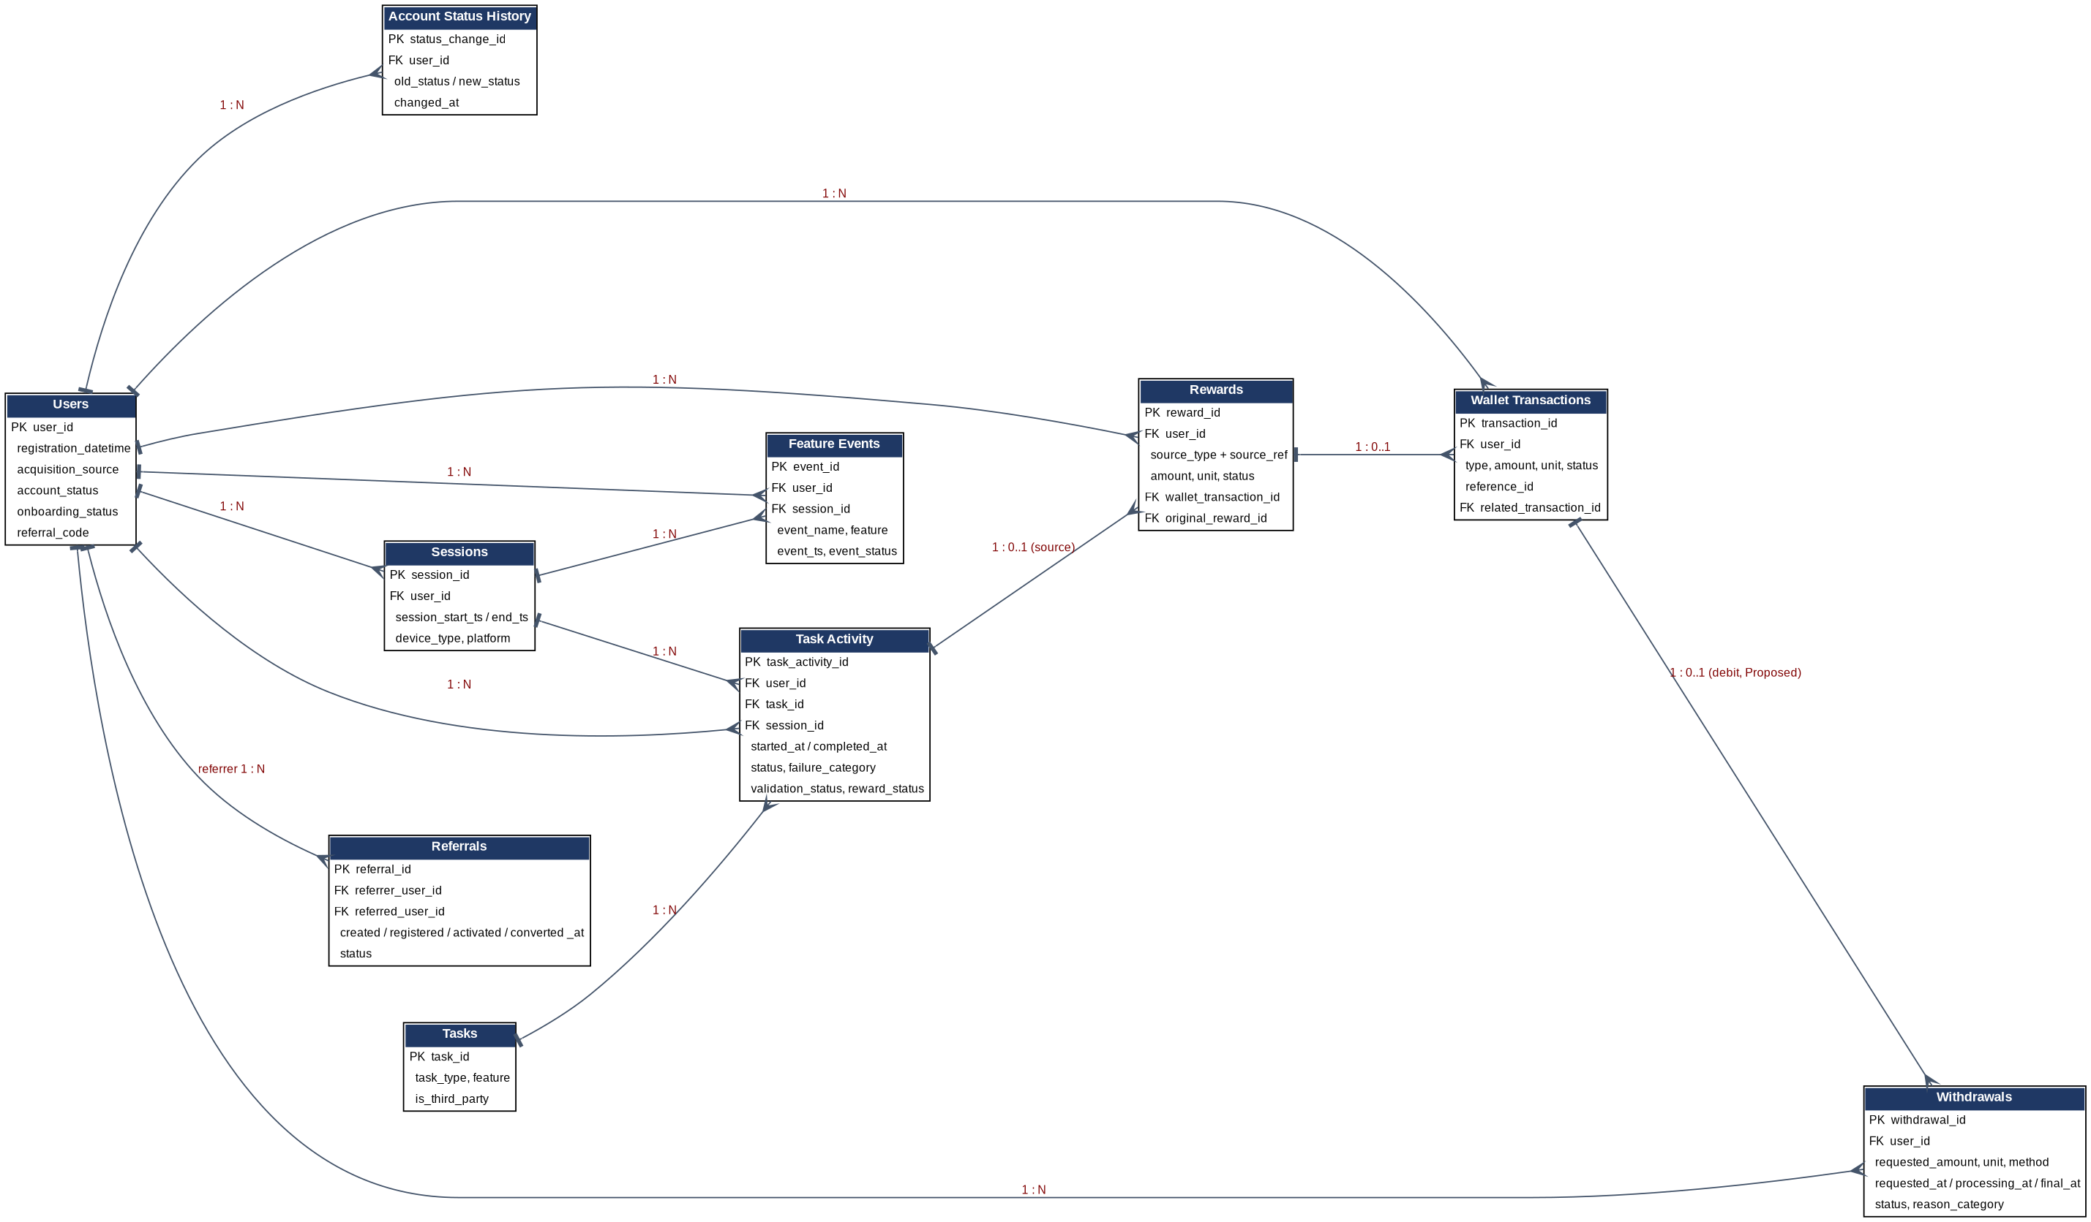
Primary keys (H1): users.user_id; account_status_history.status_change_id; sessions.session_id; tasks.task_id; task_activity.task_activity_id; rewards.reward_id; wallet_transactions.transaction_id; withdrawals.withdrawal_id; referrals.referral_id; feature_events.event_id.
Foreign keys and relationships (H2, H3):
Relationship | Cardinality | Notes
Users - Account Status History | 1 : N | Each status change is a row
Users - Sessions / Task Activity / Rewards / Wallet Transactions / Withdrawals / Feature Events | 1 : N | user_id on every child
Users - Referrals | 1 : N (referrer) and 1 : 0..1 (referred) | Two foreign keys to Users: referrer_user_id and referred_user_id; a user is referred at most once (not drawn to keep the diagram readable)
Tasks - Task Activity | 1 : N | Task catalogue entry attempted many times
Sessions - Task Activity / Feature Events | 1 : N | Optional where session_id is unavailable (A004)
Task Activity - Rewards | 1 : 0..1 | Rewards.source_type + source_ref points to the activity; other sources (daily reward, spin) use other tables
Rewards - Wallet Transactions | 1 : 0..1 | A pending reward has no ledger entry yet
Wallet Transactions - Wallet Transactions | 1 : N (self) | related_transaction_id links reversals/corrections to the original
Wallet Transactions - Withdrawals | 1 : 0..1 (Proposed) | Debit entry for a payout; depends on A009
Many-to-many | none stored directly | Users and Missions/Badges would be many-to-many through a link table if those entities are added; not included because the first release does not require them

Event relationships: every feature_event may reference task_activity, mission or spin by identifier in its properties; transaction relationships follow the ledger rules above. Missions, Badges, Levels and Support Tickets are deliberately kept out of the first model: their business value is lower and their definitions are unverified.

