14 Dashboard Blueprint (M)
Seven dashboards are specified (44 visuals). For each visual the workbook (sheet 18) records metric, calculation, source, visualization, filters, dimensions, date range, refresh frequency, business question and decision supported. Wireframes below use placeholders only; no values are shown because no production data exists.

D1 Executive Overview
Audience: Executive, Product, Operations. Filters: All filters: date range, acquisition_source, platform. Date range: Last 30 days default; 7/30/90 and custom. Refresh: Daily.
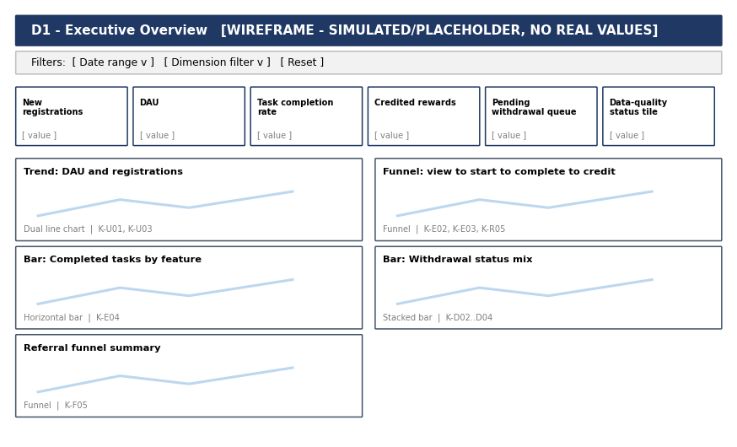
Metric | KPI | Source | Visualization | Decision supported
KPI tile: New registrations | K-U01 | Users / user_registered | KPI tile with change vs prior period | Adjust acquisition effort
KPI tile: DAU | K-U03 | Event stream | KPI tile + sparkline | Judge product traction
KPI tile: Task completion rate | K-E03 | Task Activity | KPI tile | Prioritise fixes
KPI tile: Credited rewards | K-R01 | Rewards | KPI tile by unit | Reward budget
KPI tile: Pending withdrawal queue | K-D03 | Withdrawals | KPI tile with alert colour | Staffing
Trend: DAU and registrations | K-U01, K-U03 | Users, events | Dual line chart | Campaign timing
Funnel: view to start to complete to credit | K-E02, K-E03, K-R05 | Task Activity, Rewards | Funnel | Roadmap
Bar: Completed tasks by feature | K-E04 | Task Activity | Horizontal bar | Investment
Bar: Withdrawal status mix | K-D02..D04 | Withdrawals | Stacked bar | Policy review
Referral funnel summary | K-F05 | Referrals | Funnel | Referral reward design
Data-quality status tile | Quality checks pass rate | Quality log | KPI tile | Whether to publish

D2 User Analytics
Audience: Product, Growth. Filters: Date range, source, device, state. Date range: Last 90 days; cohort by registration month. Refresh: Daily.
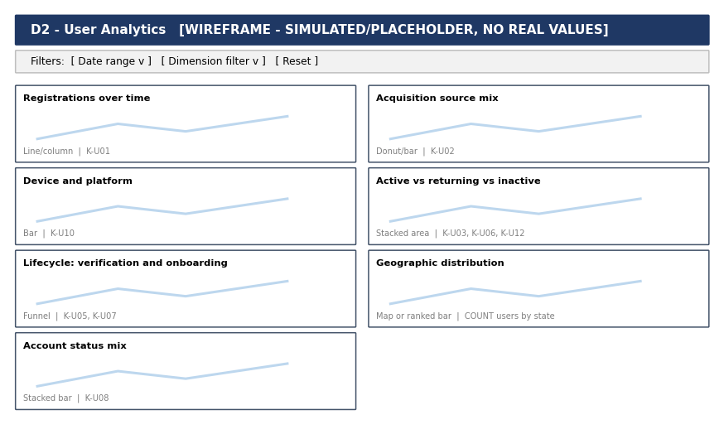
Metric | KPI | Source | Visualization | Decision supported
Registrations over time | K-U01 | Users | Line/column | Marketing
Acquisition source mix | K-U02 | Users | Donut/bar | Channel mix
Device and platform | K-U10 | Users | Bar | Engineering priority
Active vs returning vs inactive | K-U03, K-U06, K-U12 | Users, events | Stacked area | Re-engagement
Lifecycle: verification and onboarding | K-U05, K-U07 | Users | Funnel | Onboarding changes
Geographic distribution | COUNT users by state | Users | Map or ranked bar | Regional focus
Account status mix | K-U08 | Users | Stacked bar | Operations

D3 Engagement
Audience: Product. Filters: Date range, feature, task_type, device. Date range: Last 30 days. Refresh: Daily.
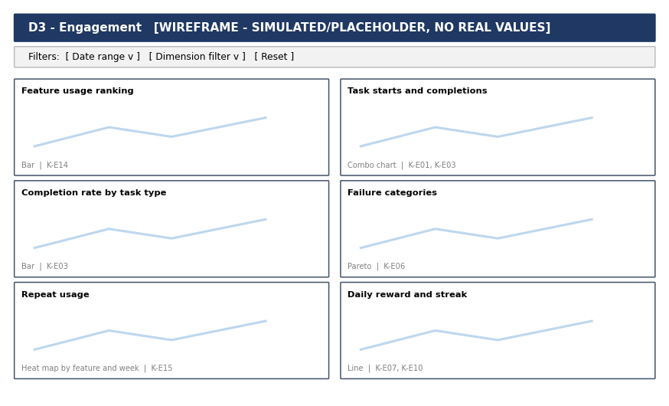
Metric | KPI | Source | Visualization | Decision supported
Feature usage ranking | K-E14 | Events | Bar | Roadmap
Task starts and completions | K-E01, K-E03 | Task Activity | Combo chart | Capacity
Completion rate by task type | K-E03 | Task Activity | Bar | Task retirement
Failure categories | K-E06 | Task Activity | Pareto | Bug priority
Repeat usage | K-E15 | Events | Heat map by feature and week | Habit design
Daily reward and streak | K-E07, K-E10 | Events | Line | Mechanic tuning

D4 Rewards
Audience: Product, Finance. Filters: Date range, source_type, unit, status. Date range: Last 30 days. Refresh: Daily.
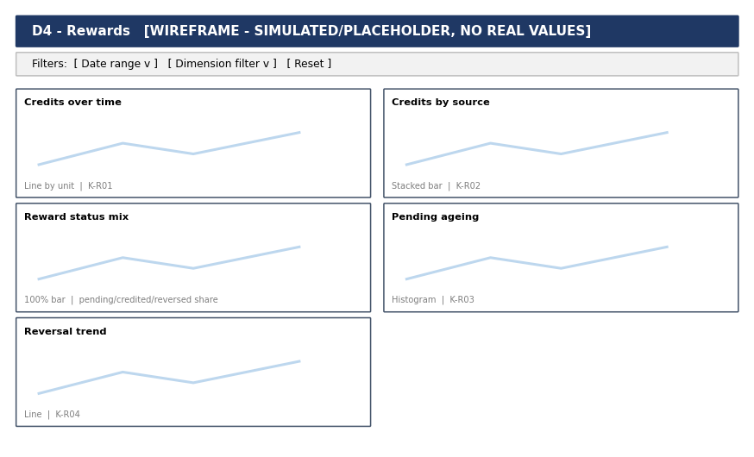
Metric | KPI | Source | Visualization | Decision supported
Credits over time | K-R01 | Rewards | Line by unit | Budget
Credits by source | K-R02 | Rewards | Stacked bar | Rebalancing
Reward status mix | pending/credited/reversed share | Rewards | 100% bar | Operations
Pending ageing | K-R03 | Rewards | Histogram | Escalation
Reversal trend | K-R04 | Rewards | Line | Provider review

D5 Wallet
Audience: Finance. Filters: Date range, transaction_type, unit, status. Date range: Last 30 days. Refresh: Daily.
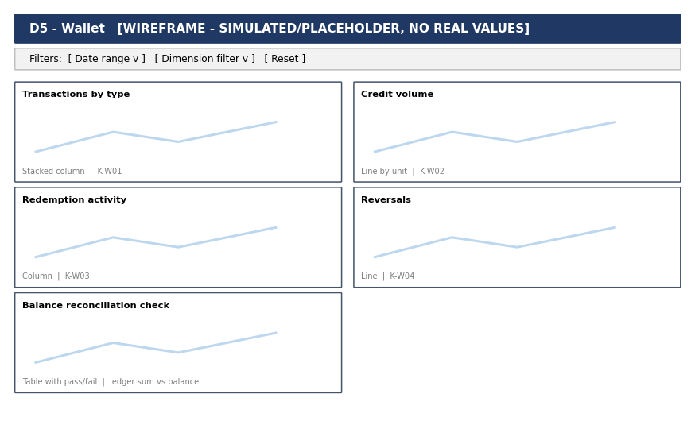
Metric | KPI | Source | Visualization | Decision supported
Transactions by type | K-W01 | Wallet Transactions | Stacked column | Ledger health
Credit volume | K-W02 | Wallet Transactions | Line by unit | Finance planning
Redemption activity | K-W03 | Wallet Transactions | Column | Redemption design
Reversals | K-W04 | Wallet Transactions | Line | Investigation
Balance reconciliation check | ledger sum vs balance | Wallet Transactions | Table with pass/fail | Release gate

D6 Withdrawals
Audience: Operations, Finance. Filters: Date range, method, status. Date range: Last 30 days. Refresh: Hourly for queue; daily for rest.
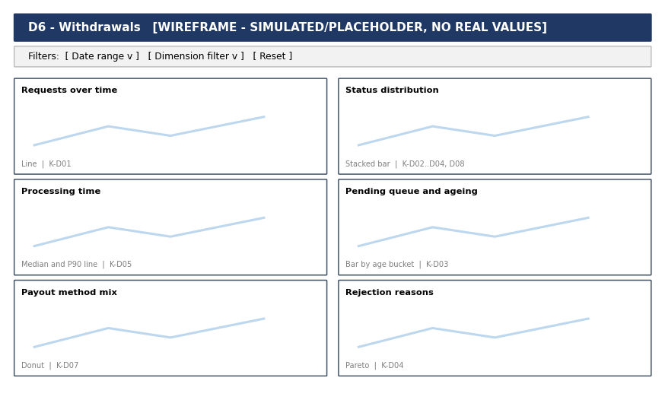
Metric | KPI | Source | Visualization | Decision supported
Requests over time | K-D01 | Withdrawals | Line | Capacity
Status distribution | K-D02..D04, D08 | Withdrawals | Stacked bar | Policy
Processing time | K-D05 | Withdrawals | Median and P90 line | SLA
Pending queue and ageing | K-D03 | Withdrawals | Bar by age bucket | Staffing
Payout method mix | K-D07 | Withdrawals | Donut | Method roadmap
Rejection reasons | K-D04 | Withdrawals | Pareto | Message and rules

D7 Referrals
Audience: Growth. Filters: Date range, channel, stage. Date range: Last 90 days. Refresh: Daily.
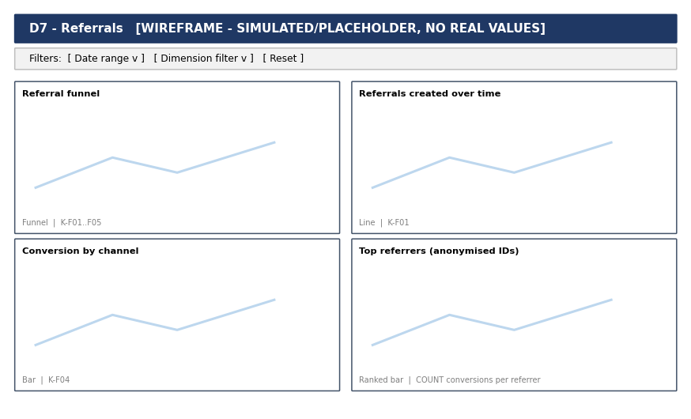
Metric | KPI | Source | Visualization | Decision supported
Referral funnel | K-F01..F05 | Referrals | Funnel | Referral design
Referrals created over time | K-F01 | Referrals | Line | Campaigns
Conversion by channel | K-F04 | Referrals | Bar | Spend
Top referrers (anonymised IDs) | COUNT conversions per referrer | Referrals | Ranked bar | Abuse review

