16 Data Pipeline and Operating Model (O)
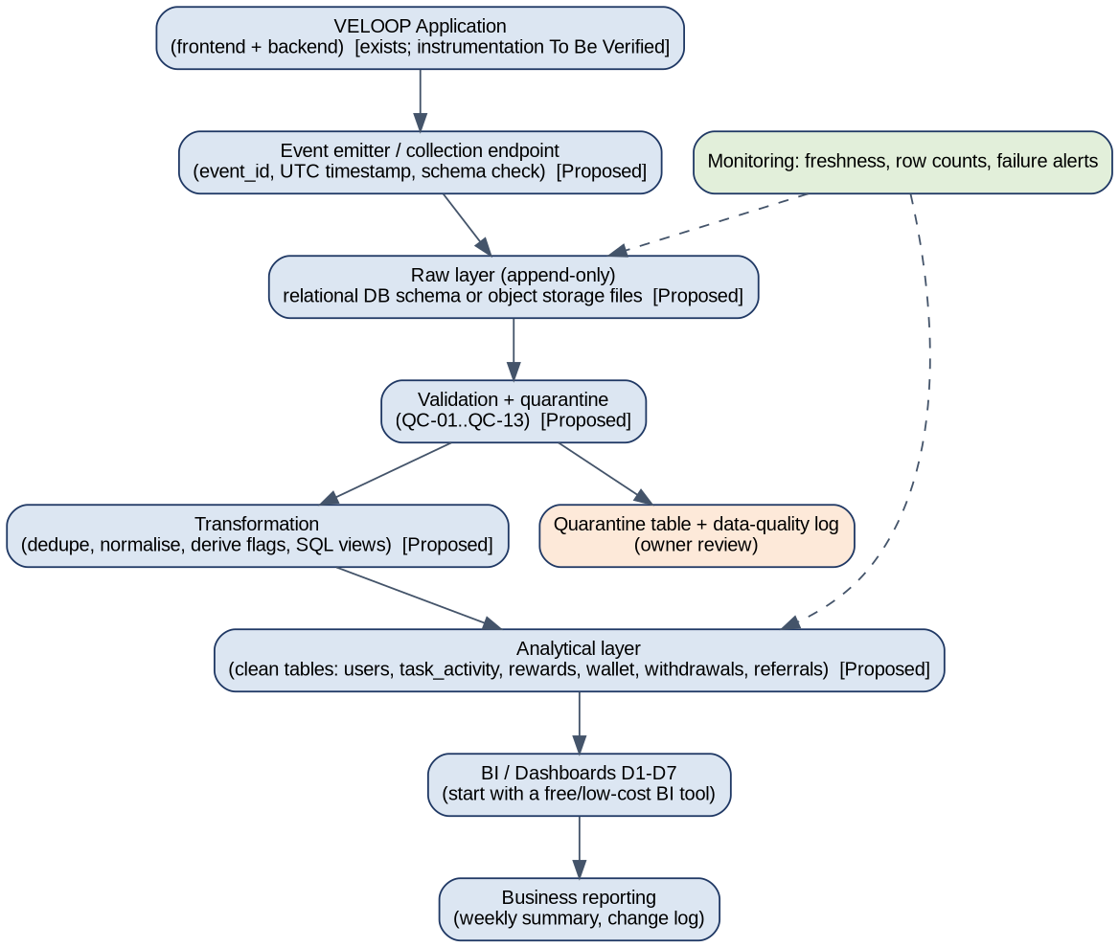
Element | Practical proposal (Proposed; fits current stack once A030 is answered)
Source systems / producers | VELOOP application frontend and backend; third-party callbacks; support tool (if any)
Collection | Single event endpoint or server-side logger; schema check; event_id and UTC timestamp assigned once
Storage and raw layer | Start with the existing relational database or file storage; raw tables append-only and never edited
Validation | Rules QC-01..QC-13 on load; failing rows go to a quarantine table
Transformation | Scheduled SQL views/jobs: deduplicate, normalise, derive flags
Analytical layer | Clean tables matching the logical model; documented KPI views
Dashboard and refresh | Free or low-cost BI tool; daily refresh, hourly for the withdrawal queue
Monitoring and failure handling | Freshness and row-count checks; alert on failed load; retry; no silent drops
Ownership | Engineering: events and raw layer. Data analyst: validation rules, KPI views, dashboards. Product/Operations: definitions and review of quarantine

Deliberately not recommended at this stage: a dedicated data warehouse, streaming platform or large orchestration stack. Scale up only when event volume or query time justifies it.

