VELOOP REWARDS
Data Analyst Internship - Task 01
Product Analytics, Data Readiness & Data Management Blueprint
Final Consolidated Report (Deliverable 21)
Prepared by: Iqra Siddiqui | Intern ID: VLRINT202601918 | Role: Data Analyst Intern (Remote)
Version 1.0 | 7 October 2026 | Companion file: VELOOP_Task01_Analytics_Workbook.xlsx
DATA AUTHENTICITY NOTICE
All datasets used are SIMULATED / FICTIONAL. No figure in this report is an actual VELOOP user, earning, withdrawal, revenue, retention, conversion or performance statistic. Events, fields and KPIs described as Proposed are not claimed to exist in production. Every simulated result is worded "In the simulated dataset...".

Contents
01 Executive Summary
02 Scope, Sources and Data Authenticity
03 Product Data Audit (A)
04 User & Account Analytics (B)
05 Earning & Reward Analytics (C)
06 Wallet & Withdrawal Analytics (D)
07 Referral & Engagement Analytics (E)
08 Event Tracking Plan and Naming Standard (F)
09 Data Dictionary (G)
10 Logical Data Model (H)
11 KPI Catalogue (I)
12 Simulated Data Profiling (J)
13 Data Quality Audit and Control Framework (K, L)
14 Dashboard Blueprint (M)
15 Developer Analytics Handoff (N)
16 Data Pipeline and Operating Model (O)
17 Privacy, Access and Governance (P)
18 Analytics Change Management (Q)
19 Analytics Readiness and Gap Assessment (R)
20 Assumption and Verification Register (S)
21 Implementation Backlog
22 Deliverables Index and Definition of Done

01 Executive Summary

What was investigated
This project builds the analytical foundation for VELOOP Rewards, a rewards and engagement product that is still under development and does not yet have enough production data for conventional performance analysis. The work covers what VELOOP should collect, how it should be structured, how to know it is trustworthy, what management should measure and what engineering should implement. Two simulated datasets were examined: the Task 01 Users workbook (1,000 clean and 1,008 audit rows, 01 Apr - 15 Sep 2026) and a supplementary behavioral workbook labelled "Task 02" (sessions, events, tasks).

What was discovered
- The supplied Task 01 workbook contains the Users entity only. The six other datasets listed in the brief (Task Activity, Rewards, Wallet, Withdrawals, Referrals, Feature Events) were not supplied, so wallet, withdrawal, reward and referral KPIs could be designed but not tested (see section 12).
- The two files cannot be joined. All 1,000 user_id values overlap, but in the simulated data none of the emails, names, registration times or referral codes match. This identifier collision is the single most serious data finding (DQ-014).
- The Users audit sheet contains 8 exact duplicate rows, 9 rows with single missing values and 1 malformed registration date ("2026-14-02 12:00"). Formats, statuses and whitespace checks found no further problems.
- The "clean" sheet still shows state conflicts: 72 users with sessions but no login, 23 users with onboarding Completed and 0 sessions, 34 users with consent Pending but marketing opt-in Yes, 9 Suspended users flagged as active in the last 7 days, 4 negative derived "days since registration" values and 4 logins after the stated period end.
- In the supplementary simulated data, referral activity exists only as events (referral_created, shared, page viewed) with no referrer-to-referred link, and wallet activity is only wallet_viewed. Referral conversion and wallet reconciliation therefore cannot be measured from either file.
- Output of the design work: 42 proposed events, 106 data-dictionary fields over 10 entities, 54 KPIs, 44 dashboard visuals, 26 logged data-quality issues, 22 quality controls, 30 registered assumptions, 14 analytics gaps and a 22-item backlog.

What is currently unknown
No production implementation could be verified. In particular: whether events, event_id, session_id and wallet transaction_id exist (A001, A004, A005, A009); how reward units relate (A008); which withdrawal methods exist (A010); what activation and conversion mean for referrals (A013); and whether status history is stored (A011). All of these are recorded as To Be Verified rather than assumed.

What VELOOP should implement first
- Stable user_id, unique event_id with idempotent writes, and a UTC timestamp standard.
- An append-only wallet ledger with a stable transaction_id and linked reversals.
- Task, reward and withdrawal lifecycle events (task_completed only after validation; reward_credited only when the ledger entry exists).
- A referral table recording referrer, referred user and stage timestamps.
- An account status history table.
- A raw layer with validation and a quarantine table before any dashboard is built.

Major risks
- Duplicate or replayed events inflating every KPI (10 duplicate events exist in the supplementary audit sheet).
- Ledger and referral data that cannot be reconciled, which would undermine user trust in payouts.
- Third-party outcomes (ads, surveys, offers) being attributed to VELOOP rather than to the external system.
- Collecting more personal data than needed (the supplied Users sheet carries name, email, age and gender that no KPI requires).
- Reading simulated results as product performance.

Major priorities
Critical: user_id, event_id, transaction_id, referral linkage, withdrawal lifecycle timestamps, task and reward events. High: status history, session_id, approved enum lists, validation layer, KPI definitions. These are detailed in sections 19 and 21. The overall readiness picture is deliberately conservative: design completeness is assessed at an average of 3.3 out of 5, while verified production readiness is 0 out of 5 because no production evidence exists yet.

02 Scope, Sources and Data Authenticity
The work follows the integrity rules of the task brief (sections 2, 30 and 34): no fabricated production data, no simulated result presented as a VELOOP result, no invented security rules, no credentials, no unnecessary personal data, and no assumption converted into a fact. Every important product fact is recorded in the Source & Verification Register below (full register in workbook sheet 1).
ID | Information | Source Type | Status
S001 | VELOOP is a developing rewards & engagement ecosystem without enough production data for conventional performance analysis | Official (task brief) | Confirmed
S002 | Relevant product areas: accounts, earning activities, VEs, XP, Gems, Tokens, Spins, daily rewards, streaks, tasks, missions, badges, levels, referrals... | Official (task brief) | Confirmed
S003 | Not every feature may be implemented or production-ready | Official (task brief) | Confirmed
S004 | Task 01 Users dataset: 1,000 clean rows, 1,008 audit rows, period 01 Apr 2026 - 15 Sep 2026, 27 columns (28 in audit incl. data_environment) | Simulated | Confirmed
S005 | Supplied Task 01 workbook contains the Users entity only; Task Activity, Rewards, Wallet, Withdrawals, Referrals and Feature Events sheets listed in b... | Simulated | Confirmed
S006 | Supplementary behavioral dataset (Users 1,000; Sessions 7,913; Feature Events 35,704; Daily Activity 6,667; Task Activity 9,846; Milestones 4,799; Eve... | Simulated | Confirmed
S007 | 15 feature names appear in the supplementary dataset: Watch Ads, Missions, Streak Rewards, CAPTCHA, Tap & Earn, Mining Rewards, Referral, Daily Reward... | Simulated | To Be Verified
S008 | Supported withdrawal methods, minimum amounts, review rules | n/a | To Be Verified
S009 | Definitions and conversion between VEs, XP, Gems, Tokens | Official (task brief) | To Be Verified
S010 | External providers behind ads, surveys, offers, games, tracking | n/a | To Be Verified
S011 | Session identifier exists in production events | Official (task brief) | To Be Verified
S012 | Definitions of derived flags is_active_7d, is_active_30d, days_since_registration and the reference timestamp used | Simulated | To Be Verified
S013 | GPT-industry competitor patterns (rewards mechanics, withdrawal trust, tracking trust) | Internal (secondary research) | Proposed
S014 | Data authenticity and integrity rules (no fabricated stats, no credentials, no unnecessary personal data) | Official (task brief) | Confirmed

Wording rule used throughout: results from simulated data are written "In the simulated dataset..."; proposed items are marked Proposed; unverified items are marked To Be Verified.

Supplementary dataset - how it was used
Because the Task 01 workbook holds only Users, the supplementary behavioral workbook was used as a clearly labelled test bed for relationship and KPI tests that would otherwise be impossible. It was never joined to the Task 01 Users sheet, and none of its results are mixed into Task 01 statistics. When the missing Task 01 sheets arrive, the tests in section 12 should be re-run on them (assumption A003).

03 Product Data Audit (A)
A1 Product area mapping and the A4 coverage matrix (31 rows) are in the workbook (sheets 3 and 4). The summary below groups them by area and priority.
Product Area | Rows | Features covered | Priorities
Account | 7 | Registration, Email verification, Login, Logout, Onboarding, Account status, Consent & marketing preference | Critical, High, Medium, Low
Tasks | 5 | Task discovery, Task open, Task start, Task completion, Task failure / abandonment | Critical, High, Medium
Ads | 1 | Watch Ads | High
Earning | 1 | Tap & Earn / Mining / CAPTCHA / Follow & Earn | Medium
Rewards | 3 | Reward credit, Reward pending, Reward reversal / correction | Critical, High
Engagement | 6 | Daily reward, Streaks, Missions, Spin the Wheel, Badges, Levels / XP, Leaderboard | High, Medium, Low
Referrals | 2 | Referral link/code, Referral registration & activation | Critical, High
Wallet | 2 | Wallet transactions, Exchange | Critical, Medium
Withdrawals | 2 | Withdrawal request, Withdrawal processing/completion/rejection/reversal | Critical
Support | 2 | Help center, Support request | Medium

Distinguishing user events, system events and business outcomes (A2, A3)
Class | Meaning | Examples (all Proposed)
User Event | Something the user does | task_started, daily_reward_claimed, withdrawal_requested, spin_started
System Event | Something the system does without a user action | reward_pending, reward_reversed, account_status_changed, wallet_transaction_created, task_failed
Business Outcome | A result with business meaning, reached after validation | task_completed, reward_credited, referral_converted, wallet_transaction_completed, withdrawal_completed

Example - task system: Task viewed > opened > started > completed > completion validated > reward credited. Measurable events: viewed, started, completed (after validation) and reward_credited. "Opened" is kept but Medium priority; "completion validated" is folded into task_completed, because emitting it earlier would count unvalidated completions.

Analytics gaps (10+ required; 14 identified)
ID | Gap | Priority | Reason
AG01 | No verified stable event_id and no idempotency design | Critical | Without a unique event_id, duplicates cannot be removed; the supplementary audit file contains 10 duplicated event rows.
AG02 | Wallet transaction_id and ledger design unverified | Critical | Without a stable transaction ID reliable deduplication and balance reconciliation cannot be guaranteed.
AG03 | No referrer-to-referred link in supplied Users data (only "Friend/Family" label and one code per user) | Critical | Referral conversion cannot be computed without referrer and referred user IDs.
AG04 | No account status-change history | High | Current status alone cannot show whether activity occurred before or after suspension (25 simulated suspended users show 30-day activity).
AG05 | Reward credited vs activity occurred not separable in Task 01 data | Critical | No Rewards sheet was supplied; reward value cannot be reconciled with completions.
AG06 | Withdrawal lifecycle timestamps not available | Critical | Processing time, pending queue and completion rate need requested/processing/final timestamps.
AG07 | Session ID not verified in production | High | Funnel steps cannot be tied to one visit without a session identifier.
AG08 | Failure classification does not exist (only proposed) | High | Failure reasons need a controlled list agreed with Engineering.
AG09 | Derived-field definitions undocumented (active flags, days since registration) | Medium | Flags could not be reproduced for 8-9 users; KPI definitions would drift.
AG10 | Timezone and timestamp standard unknown | High | Mixed zones shift day boundaries; malformed dates exist in the audit sheet.
AG11 | No event for onboarding milestones beyond three status values | Medium | Drop-off location cannot be found.
AG12 | Third-party outcome signals not defined | High | External delays and reversals would be wrongly attributed to VELOOP.
AG13 | Support/help-center tracking unknown | Medium | No source system identified.
AG14 | Consent history not stored (current flag only) | Medium | Audit of consent timing impossible.

04 User & Account Analytics (B)
Stable identifiers needed (B1):
Identifier | Why needed
user_id | Immutable, non-personal key joining every entity; must never be email or name
event_id | De-duplicates replayed events
session_id | Groups events into a visit; existence unverified (A004)
transaction_id | Reconciles and de-duplicates wallet entries; links reversals (A009)
task_activity_id / reward_id / withdrawal_id / referral_id | One id per attempt, reward, request and referral so each lifecycle can be traced

The user analytics specification (B2) lists every Users field with type, required flag, purpose, source, validation and status (workbook sheet 6). Two fields, full_name and email, are deliberately excluded from the analytics layer: no KPI needs them, and the brief asks not to request unnecessary personal information. Where de-duplication is needed, a one-way hash of the email can be used.
Lifecycle measurement: registration (user_registered), email verification (email_verified), first login and returns (user_logged_in), onboarding (started/completed; step milestones await A026) and account status changes (account_status_changed with old status, new status, reason category and actor type).

Simulated observations (Task 01 Users, 1,000 rows)
In the simulated dataset: 855 of 1,000 users (85.5%) are Verified; 722 (72.2%) completed onboarding; 77 (7.7%) are Suspended; 923 (92.3%) accepted consent; Android is the primary device for 659 users (65.9%) and platform is Web for all. These figures illustrate that the KPIs can be computed; they are not VELOOP results.

05 Earning & Reward Analytics (C)
Lifecycle measured: Discovery (task_viewed) > Start (task_started) > Completion (task_completed, only after validation) > Validation (validation_status) > Reward (reward_pending, reward_credited). Each stage has an event in section 8.

C1 Task-level fields
task_activity_id, task_id, task_type, feature, user_id, started_at, completed_at, status, reward_amount, reward_unit, validation_status, provider_ref (source information). See dictionary entities Tasks, Task Activity and Rewards.

C2 Failed activity - Proposed classification
failure_category (Proposed) | Meaning | Stage | Observed in simulated data as
tracking_failed | External or internal tracking did not register the action | tracking | -
validation_failed | Completion was rejected by validation | validation | Validation failed
task_unavailable | Task could not be performed | availability | Task unavailable
timeout | Attempt expired | system | Timeout
incomplete_action | User did not finish required steps | user | Incomplete action
user_exited | User left | user | User exited
system_error | Application error | system | -

No internal failure codes are invented: the categories are marked Proposed and must be agreed with Engineering (AG08).

C3 Reward events
Activity occurred is not the same as reward credited. task_completed records the validated activity; reward_credited records the ledger credit and carries wallet_transaction_id. reward_pending, reward_reversed and reward_corrected record the other states. Reconciliation rule QC-16 compares completed attempts with credited rewards.
In the supplementary simulated data, all 5,627 Completed attempts have reward_status Credited and no non-completed attempt is Credited; this proves nothing about wallet credits because no Rewards or Wallet table exists in either file.

C4 Third-party dependency
For ads, surveys, offers and games an external system confirms completion, may delay it, and may later reverse it. The design therefore (i) flags tasks with is_third_party, (ii) stores provider_ref and provider outcome fields as optional properties, (iii) allows reward_pending and reward_reversed with a reason category, and (iv) reports third-party reversal rates separately so they are not blamed on VELOOP. Which providers exist is To Be Verified (A012).

Supplementary simulated observation
In the supplementary simulated data, 9,846 task attempts: 5,627 Completed, 648 Pending, 3,571 Failed or Abandoned. Completion is 57.2% of all attempts (61.2% excluding Pending); the spread across eight task categories is narrow (56.1% to 58.2%).

06 Wallet & Withdrawal Analytics (D)

D1 Wallet transaction model
Field | Notes
transaction_id | Unique, immutable; Critical
user_id, transaction_ts | Owner and UTC posting time
transaction_type | reward_credit, redemption, reversal, adjustment, exchange - ALL Proposed (A009, A024)
amount, unit | Signed amount; never aggregated across units
status | created, completed, reversed, failed
source, reference_id | Origin system and triggering record (e.g. reward_id)
related_transaction_id | Links a reversal/correction to the original entry

D2 Withdrawal lifecycle
Requested > Under review / Processing > Completed, with alternatives Rejected and Reversed (Reversed only after Completed). Fields: withdrawal_id, user_id, requested_amount, unit, method, requested_at, processing_at, final_at, status, reason_category. Valid transitions are enforced by QC-11; timestamps must be ordered (QC-12). Methods are not assumed (A010).

D3 Withdrawal KPIs
KPI | Definition | Formula | Frequency | Stakeholder | Limitation
Withdrawal requests | Count of requests created | COUNT(withdrawal_id) | Daily | Operations, Finance | Table not supplied
Completed withdrawals | Requests with status completed | COUNT WHERE status = completed | Daily | Operations | Table not supplied
Pending withdrawal queue | Requests requested/processing and not final | COUNT WHERE status IN (requested, processing) | Daily | Operations | Table not supplied
Rejected withdrawals | Requests ending rejected, by reason | COUNT WHERE status = rejected GROUP BY reason_category | Weekly | Operations | Table not supplied
Processing time | Time from request to final state | AVG/MEDIAN(final_at - requested_at) for terminal requests | Daily | Operations | Open requests excluded; table not supplied
Withdrawal volume | Sum of requested/completed amounts by unit | SUM(requested_amount) GROUP BY unit, status | Daily | Finance | Table not supplied
Method distribution | Share of requests by method | requests per method / total | Weekly | Product, Finance | Methods unverified (A010)
Reversed withdrawals | Completed withdrawals later reversed | COUNT WHERE status = reversed / completed | Weekly | Finance | Table not supplied
Withdrawal completion rate | Completed share of terminal requests | completed / (completed+rejected+reversed) | Weekly | Operations | Table not supplied

Each KPI also lists data required, source and purpose in the workbook (sheet 11). None can be calculated from the supplied files because no withdrawal data exists (section 12).

07 Referral & Engagement Analytics (E)
Funnel: Referral Created > User Registered > User Activated > Referral Converted. Registration is never treated as conversion. Activation and conversion definitions are open business decisions (A013); the events carry an activation_rule / conversion_rule property so the definition used is traceable.
Stage | Event | Timestamp field | KPI
Created | referral_created | created_at | K-F01
Registered | referral_registered | registered_at | K-F02
Activated | referral_activated | activated_at | K-F03
Converted | referral_converted | converted_at | K-F04, K-F05

Finding: in the simulated Users data a referral user has only the label "Friend/Family", and every user has a referral code; there is no referrer user_id. Referral attribution is therefore impossible (DQ-021, critical gap AG03). The supplementary events contain 871 referral_created events, 834 shares and 816 page views, with no linking field.
Engagement measurement: feature adoption (K-E14), repeat usage (K-E15), task activity (K-E01..E05), daily activity and active users (K-U03, K-U04), returning users (K-U06). DAU is defined as unique users generating a qualifying activity event within a calendar day; the qualifying-event list is open (A017). In the supplementary simulated events, the average number of distinct users with any event per day is 40.7 (min 1, max 164).

08 Event Tracking Plan and Naming Standard (F)
Naming standard: object_action, snake_case, past-tense verb (e.g. user_registered, task_completed). Reasons: it matches the brief minimum events; it is short and sorts related events together; the feature is carried as a property so the name set stays small; an event is emitted only after the state is true. Properties use snake_case, enums lower case, amounts decimal with a separate unit, timestamps UTC ISO-8601; no personal data in properties. All 42 events follow it.
Event | Class | Domain | Priority | Status
user_registered | User Event | account | Critical | Proposed
email_verified | User Event | account | High | Proposed
user_logged_in | User Event | account | Critical | Proposed
user_logged_out | User Event | account | Low | Proposed
onboarding_started | User Event | account | High | Proposed
onboarding_completed | User Event | account | High | Proposed
account_status_changed | System Event | account | High | Proposed
consent_updated | System Event | account | Medium | Proposed
task_viewed | User Event | tasks | High | Proposed
task_opened | User Event | tasks | Medium | Proposed
task_started | User Event | tasks | Critical | Proposed
task_completed | Business Outcome | tasks | Critical | Proposed
task_failed | System Event | tasks | High | Proposed
task_abandoned | User Event | tasks | High | Proposed
reward_credited | Business Outcome | rewards | Critical | Proposed
reward_pending | System Event | rewards | High | Proposed
reward_reversed | System Event | rewards | High | Proposed
reward_corrected | System Event | rewards | Medium | Proposed
daily_reward_claimed | User Event | engagement | High | Proposed
streak_updated | System Event | engagement | Medium | Proposed
mission_started | User Event | engagement | Medium | Proposed
mission_completed | Business Outcome | engagement | Medium | Proposed
badge_earned | System Event | engagement | Low | Proposed
level_increased | System Event | engagement | Low | Proposed
spin_started | User Event | engagement | Medium | Proposed
spin_completed | Business Outcome | engagement | Medium | Proposed
feature_viewed | User Event | engagement | Medium | Proposed
referral_created | User Event | referrals | High | Proposed
referral_registered | System Event | referrals | High | Proposed
referral_activated | Business Outcome | referrals | High | Proposed
referral_converted | Business Outcome | referrals | Critical | Proposed
wallet_transaction_created | System Event | wallet | Critical | Proposed
wallet_transaction_completed | Business Outcome | wallet | Critical | Proposed
wallet_transaction_reversed | System Event | wallet | Critical | Proposed
exchange_completed | User Event | wallet | Medium | Proposed
withdrawal_requested | User Event | withdrawals | Critical | Proposed
withdrawal_processing | System Event | withdrawals | High | Proposed
withdrawal_completed | Business Outcome | withdrawals | Critical | Proposed
withdrawal_rejected | Business Outcome | withdrawals | High | Proposed
withdrawal_reversed | Business Outcome | withdrawals | High | Proposed
help_article_viewed | User Event | support | Medium | Proposed
support_ticket_created | User Event | support | Medium | Proposed

Full catalogue with trigger, definition, required/optional properties and types, validation, source, business purpose, KPI dependency and the name observed in simulated data: workbook sheet 7. None of the events is claimed to exist in production.

09 Data Dictionary (G)
106 fields across 10 entities - above the 75 minimum - and each is meaningful (no filler). 44 fields exist in the simulated structures (marked "Confirmed (simulated structure)"); the rest are Proposed. Every field lists entity, name, type, definition, example, required flag, allowed values, validation, source, sensitivity, analytical use and status (workbook sheet 10).
Entity | Fields
Users | 27
Account Status History | 6
Sessions | 8
Tasks | 5
Task Activity | 11
Rewards | 11
Wallet Transactions | 11
Withdrawals | 10
Referrals | 9
Feature Events | 8

Sensitivity: Restricted = name, email, age, gender and consent attributes; Internal = everything else; no Public fields. No passwords, keys or payment credentials appear anywhere.

10 Logical Data Model (H)
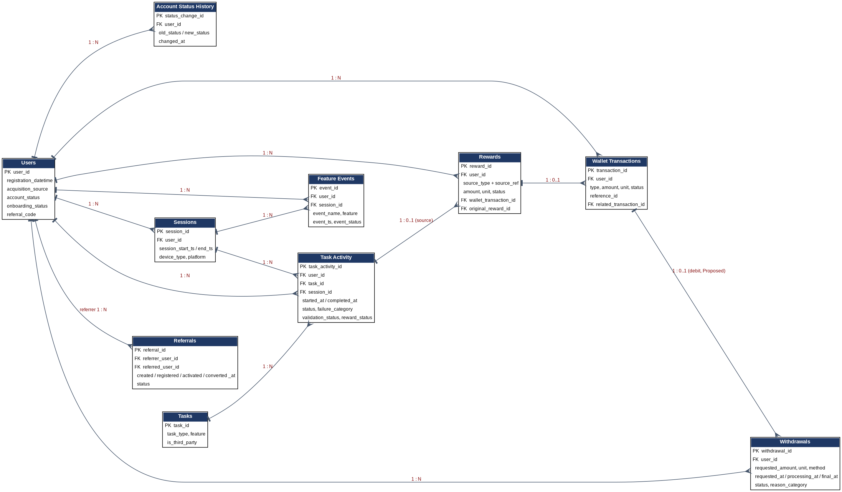
Primary keys (H1): users.user_id; account_status_history.status_change_id; sessions.session_id; tasks.task_id; task_activity.task_activity_id; rewards.reward_id; wallet_transactions.transaction_id; withdrawals.withdrawal_id; referrals.referral_id; feature_events.event_id.
Foreign keys and relationships (H2, H3):
Relationship | Cardinality | Notes
Users - Account Status History | 1 : N | Each status change is a row
Users - Sessions / Task Activity / Rewards / Wallet Transactions / Withdrawals / Feature Events | 1 : N | user_id on every child
Users - Referrals | 1 : N (referrer) and 1 : 0..1 (referred) | Two foreign keys to Users: referrer_user_id and referred_user_id; a user is referred at most once (not drawn to keep the diagram readable)
Tasks - Task Activity | 1 : N | Task catalogue entry attempted many times
Sessions - Task Activity / Feature Events | 1 : N | Optional where session_id is unavailable (A004)
Task Activity - Rewards | 1 : 0..1 | Rewards.source_type + source_ref points to the activity; other sources (daily reward, spin) use other tables
Rewards - Wallet Transactions | 1 : 0..1 | A pending reward has no ledger entry yet
Wallet Transactions - Wallet Transactions | 1 : N (self) | related_transaction_id links reversals/corrections to the original
Wallet Transactions - Withdrawals | 1 : 0..1 (Proposed) | Debit entry for a payout; depends on A009
Many-to-many | none stored directly | Users and Missions/Badges would be many-to-many through a link table if those entities are added; not included because the first release does not require them

Event relationships: every feature_event may reference task_activity, mission or spin by identifier in its properties; transaction relationships follow the ledger rules above. Missions, Badges, Levels and Support Tickets are deliberately kept out of the first model: their business value is lower and their definitions are unverified.

11 KPI Catalogue (I)
54 KPIs across User, Engagement, Reward, Wallet, Withdrawal, Referral and Support areas (minimum 30). Each has name, definition, formula, required fields, data source, frequency, stakeholder, business purpose, interpretation, limitation and status (workbook sheet 11). No fictional company targets are set: for example, DAU is defined as unique users generating a qualifying activity event within a calendar day, with no target value.
KPI ID | Area | Name | Formula | Testable?
K-U01 | User | New registrations | COUNT(DISTINCT user_id) WHERE registration_ts in period | Yes: Task 01 Users sheet
K-U02 | User | Registrations by acquisition source | registrations per source / total registrations | Yes: Task 01 Users sheet
K-U03 | User | Daily Active Users (DAU) | COUNT(DISTINCT user_id) with >=1 qualifying event on date D | Yes: supplementary dataset only
K-U04 | User | Monthly Active Users (MAU) | COUNT(DISTINCT user_id) WHERE event_ts in last 30 days | Yes: supplementary dataset only
K-U05 | User | Email verification rate | verified users / registered users | Yes: Task 01 Users sheet
K-U06 | User | Returning users | COUNT(DISTINCT user_id) active in period AND registration_ts < period start | Yes: supplementary dataset only
K-U07 | User | Onboarding completion rate | users with onboarding_status = Completed / registered users | Yes: Task 01 Users sheet
K-U08 | User | Suspended account share | Suspended / all accounts | Yes: Task 01 Users sheet
K-U09 | User | Status transitions | COUNT(*) GROUP BY old_status, new_status | No: source table not supplied
K-U10 | User | Registrations by device and platform | registrations per device / total | Yes: Task 01 Users sheet
K-U11 | User | Consent acceptance rate | Accepted / all users | Yes: Task 01 Users sheet
K-U12 | User | Inactive users | registered users - K-U04 users | Yes: Task 01 Users sheet
K-E01 | Engagement | Task starts | COUNT(task_started) | Yes: supplementary dataset only
K-E02 | Engagement | Task view-to-start rate | started attempts / viewed tasks | Yes: supplementary dataset only
K-E03 | Engagement | Task completion rate | Completed attempts / (started attempts excluding Pending) | Yes: supplementary dataset only
K-E04 | Engagement | Task completions by feature | COUNT(Completed) GROUP BY task_type | Yes: supplementary dataset only
K-E05 | Engagement | Task failure and abandonment rate | (Failed+Abandoned)/ non-pending attempts | Yes: supplementary dataset only
K-E06 | Engagement | Failures by category | COUNT(Failed) GROUP BY category | Yes: supplementary dataset only
K-E07 | Engagement | Daily reward claim rate | daily claimers / DAU | Yes: supplementary dataset only
K-E08 | Engagement | Daily claimers | COUNT(DISTINCT user_id) | Yes: supplementary dataset only
K-E09 | Engagement | Average session duration | AVG(session_end - session_start) | Yes: supplementary dataset only
K-E10 | Engagement | Streak continuation rate | extended / (extended+broken) | Yes: supplementary dataset only
K-E11 | Engagement | Mission completion rate | mission_completed / mission_started | Yes: supplementary dataset only
K-E12 | Engagement | Badge and level progression | events / DAU | Yes: supplementary dataset only
K-E13 | Engagement | Spin usage | COUNT(DISTINCT user_id) spin_started | Yes: supplementary dataset only
K-E14 | Engagement | Feature usage | COUNT(DISTINCT user_id) GROUP BY feature | Yes: supplementary dataset only
K-E15 | Engagement | Repeat usage | users with >=2 active days in feature / feature users | Yes: supplementary dataset only
K-R01 | Reward | Reward credits | COUNT/SUM(amount) WHERE status = credited, by unit | No: source table not supplied
K-R02 | Reward | Reward activity by feature | SUM(amount) GROUP BY source_type, unit | No: source table not supplied
K-R03 | Reward | Pending reward queue | COUNT pending; AVG(now - created_at) | No: source table not supplied
K-R04 | Reward | Reward reversal rate | COUNT reversed / COUNT credited | No: source table not supplied
K-R05 | Reward | Credit reconciliation | completed attempts with reward_status Credited / completed attempts | Yes: supplementary dataset only
K-W01 | Wallet | Wallet transactions | COUNT(transaction_id) GROUP BY type | No: source table not supplied
K-W02 | Wallet | Credit volume | SUM(amount) WHERE type = reward_credit AND status = completed | No: source table not supplied
K-W03 | Wallet | Redemption activity | COUNT/SUM WHERE type = redemption | No: source table not supplied
K-W04 | Wallet | Wallet reversal rate | COUNT reversed / COUNT completed | No: source table not supplied
K-W05 | Wallet | Exchange usage | COUNT(DISTINCT user_id), SUM(from_amount) | No: source table not supplied
K-D01 | Withdrawal | Withdrawal requests | COUNT(withdrawal_id) | No: source table not supplied
K-D02 | Withdrawal | Completed withdrawals | COUNT WHERE status = completed | No: source table not supplied
K-D03 | Withdrawal | Pending withdrawal queue | COUNT WHERE status IN (requested, processing) | No: source table not supplied
K-D04 | Withdrawal | Rejected withdrawals | COUNT WHERE status = rejected GROUP BY reason_category | No: source table not supplied
K-D05 | Withdrawal | Processing time | AVG/MEDIAN(final_at - requested_at) for terminal requests | No: source table not supplied
K-D06 | Withdrawal | Withdrawal volume | SUM(requested_amount) GROUP BY unit, status | No: source table not supplied
K-D07 | Withdrawal | Method distribution | requests per method / total | No: source table not supplied
K-D08 | Withdrawal | Reversed withdrawals | COUNT WHERE status = reversed / completed | No: source table not supplied
K-D09 | Withdrawal | Withdrawal completion rate | completed / (completed+rejected+reversed) | No: source table not supplied
K-F01 | Referral | Referrals created | COUNT(referral_id) | No: source table not supplied
K-F02 | Referral | Referral registrations | COUNT WHERE registered_at IS NOT NULL | No: source table not supplied
K-F03 | Referral | Referral activations | COUNT WHERE activated_at IS NOT NULL | No: source table not supplied
K-F04 | Referral | Referral conversions | COUNT WHERE converted_at IS NOT NULL | No: source table not supplied
K-F05 | Referral | Referral stage conversion | stage n+1 count / stage n count | No: source table not supplied
K-S01 | Support | Support requests | COUNT(ticket_id) | No: source table not supplied
K-S02 | Support | Help-center engagement | help_article_viewed / DAU | No: source table not supplied
K-S03 | Support | Issue categories | COUNT GROUP BY category | No: source table not supplied

12 Simulated Data Profiling (J)
All results below are from SIMULATED data. T01 = Task 01 workbook; SUP = supplementary workbook.
J1 Dataset profiles (full column-level profile in workbook sheets 12-13):
Dataset | Records | Cols | Date range | Unique IDs / dup IDs | Missing cells
T01 Users_1000_Clean | 1,000 | 27 | 2026-04-01 to 2026-09-15 | 1,000 / 0 | 953 (referral_source_detail 881, last_login 72)
T01 Users_Messy_Audit | 1,008 | 28 | 2026-04-01 to 2026-09-15 | 1,000 / 8 repeated rows | 966 incl. injected defects
SUP Users | 1,000 | 16 | 2026-04-01 to 2026-09-15 | 1,000 / 0 | 846 (referral detail)
SUP Sessions | 7,913 | 12 | 2026-04-02 to 2026-09-15 | 7,913 / 0 | 466
SUP Feature Events | 35,704 | 13 | 2026-04-02 to 2026-09-15 | 35,704 / 0 | 0
SUP Daily Activity | 6,667 | 17 | 2026-04-02 to 2026-09-15 | 6,667 (user+date) / 0 | 0
SUP Task Activity | 9,846 | 12 | 2026-04-02 to 2026-09-15 | 9,846 / 0 | 10,494 (structural nulls)
SUP Milestones | 4,799 | 6 | 2026-04-02 to 2026-09-15 | n/a | 40
SUP Event audit sheet | 35,714 | 13 | 2026-04-02 to 2026-09-15 | 35,704 / 10 | 0

Status distributions (T01 Users): account_status Active 568, Inactive 283, Suspended 77, Pending Verification 72; onboarding Completed 722, Started 146, Not Started 132; acquisition Organic Search 244, Direct 217, Social Media 160, Referral 119, WhatsApp 103, Other 102, Telegram 55. Numeric ranges: age 18-38; lifetime_sessions 0-81; active_days 0-32; xp_balance 5-1,156.
J2 Relationship tests (full list: workbook sheet 14):
Test | Result
T01 Users keys (user_id, email, referral_code) unique | Pass
T01 Users to Task Activity / Rewards / Wallet / Withdrawals / Referrals | Not testable - sheets not supplied
T01 Audit user_ids exist in Clean | Pass (8 repeated rows)
SUP Users to Sessions, Events, Tasks, Daily, Milestones | Pass - 0 orphans in all five
SUP: 16 users have no sessions and no tasks | Observation
T01 Users vs SUP Users on user_id | FAIL - same IDs, 0 matching emails/names/registration times: do not join (DQ-014)

J3 KPI test - can the KPI actually be calculated?
KPI | Calculable? | Missing data if not
K-U01, U02, U05, U07, U08, U10, U11 (user KPIs) | Yes - T01 Users | Timestamps for verification, consent, status changes
K-U03 DAU | Yes - SUP events only | Qualifying-event list; T01 has no events
K-E01, E03, E05 (task KPIs) | Yes - SUP only | Verified events and failure categories
K-R05 Credit reconciliation | Partly - SUP only | Rewards and Wallet tables
K-R01..R04, K-W01..W05 | No | Rewards and Wallet Transactions tables
K-D01..D09 | No | Withdrawals with lifecycle timestamps
K-F01..F05 | No | Referrals with referrer and referred IDs
K-S01..S03 | No | Support source

Selected simulated results: in the simulated dataset (T01) 855 of 1,000 are verified and 722 completed onboarding; in the supplementary simulated data 61.2% of non-pending task attempts completed. These show the KPIs are computable; they are not performance claims.

13 Data Quality Audit and Control Framework (K, L)

K - Data quality report (26 issues; excerpt, full table in workbook sheet 16)
ID | Dataset / field | Issue | Records | Sev. | Status
DQ-001 | Users_Messy_Audit / user_id (also email, referral_code) | Duplicate records | 8 rows (8 user_ids appear twice; exact duplicates) | High | Proposed
DQ-002 | Users_Messy_Audit / city | Missing value | 1 (VLUSR000001) | Medium | Proposed
DQ-003 | Users_Messy_Audit / acquisition_source | Missing value | 1 (VLUSR000002) | High | Proposed
DQ-004 | Users_Messy_Audit / primary_device | Missing value | 1 (VLUSR000003) | Medium | Proposed
DQ-005 | Users_Messy_Audit / onboarding_status | Missing value | 1 (VLUSR000004) | Medium | Proposed
DQ-006 | Users_Messy_Audit / email_verification_status | Missing value | 1 (VLUSR000006) | Medium | Proposed
DQ-007 | Users_Messy_Audit / age | Missing value | 1 (VLUSR000007) | Low | Proposed
DQ-008 | Users_Messy_Audit / gender | Missing value | 1 (VLUSR000008) | Low | Proposed
DQ-009 | Users_Messy_Audit / registration_datetime | Missing timestamp | 1 (VLUSR000023) | High | Proposed
DQ-010 | Users_Messy_Audit / registration_datetime | Malformed date | 1 (VLUSR000024: "2026-14-02 12:00") | High | Proposed
DQ-011 | Users_1000_Clean / days_since_registration | Invalid derived value (negative) | 4 (VLUSR000128, 000684, 000686, 000703) | Medium | Proposed
DQ-012 | Users_1000_Clean / is_active_7d / is_active_30d | Derived flag not reproducible | 8 (7d) and 9 (30d) users differ from login-based rule at reference 15 Sep 2026 | Medium | Proposed
DQ-013 | Users_1000_Clean / last_login_datetime | Date outside stated period | 4 logins after 15 Sep 2026 (up to 17 Sep): VLUSR000128, 000665, 000686, 000703 | Medium | Proposed
DQ-014 | Users (Data_01) vs Users (Task 02 file) / user_id | Identifier collision across files | 1,000 shared IDs; 0 matching emails/names/registration times | Critical | Open
DQ-015 | Users_1000_Clean / last_login_datetime vs lifetime_sessions | Conflicting state | 72 users with sessions > 0 and no login (all Pending Verification) | Medium | Open
DQ-016 | Users_1000_Clean / onboarding_status vs lifetime_sessions | Impossible/unclear state | 23 users Completed onboarding with 0 sessions | Medium | Open
DQ-017 | Users_1000_Clean / account_status vs activity flags | Unexplained activity after suspension? | 9 Suspended users flagged active 7d; 25 active 30d | High | Open
DQ-018 | Users_1000_Clean / consent_status vs marketing_opt_in | Rule conflict | 34 users consent Pending but marketing_opt_in = Yes | High | Open
DQ-019 | Users_1000_Clean / email_verification_status vs account_created_via | Inconsistency to verify | 40 Google Sign-In users with Pending verification | Low | Open
DQ-020 | Users_1000_Clean / full_name | Non-unique attribute | 596 repeated names | Low | Proposed
DQ-021 | Users_1000_Clean / referral_source_detail | Design gap | Only value is "Friend/Family" for 119 referral users; no referrer user_id | High | Open
DQ-022 | 10_Event_Data_Quality_Audit (Task 02 file) / event_id | Duplicate events | 10 duplicated event rows | High | Proposed
DQ-023 | 10_Event_Data_Quality_Audit / event_status | Trailing space and capitalization | 4 rows ("success ") | Medium | Proposed
DQ-024 | 10_Event_Data_Quality_Audit / feature_name | Inconsistent naming/capitalization | 5 rows (missions, leaderboard, wallet, daily reward, watch ads) | Medium | Proposed
DQ-025 | 02_Sessions vs 03_Feature_Events (Task 02 file) / events_in_session | Aggregate not matching detail | 7,537 of 7,913 sessions differ from event row count | Medium | Open
DQ-026 | 05_Task_Activity (Task 02 file) / user_id vs account_status | Business-rule question | 855 attempts by Pending Verification users; 601 by Suspended users | High | Open

Checks performed with no issue found:
- Missing user_id: 0 records (Users_Messy_Audit)
- Invalid status values (Users): 0 values outside controlled lists
- Trailing spaces (Users): 0 fields
- Inconsistent capitalization (Users): 0 fields
- Invalid numeric values / negatives (Users source fields): 0 (only the derived field in DQ-011)
- Orphan records (Task 02 child tables): 0 in sessions, events, tasks, daily, milestones
- Impossible task transitions (Task 02): 0 (completed without completion time; credited but not completed; completion before start)
- Invalid emails / user_id / referral_code format (Users): 0
Where the checklist in the brief found nothing (for example trailing spaces, invalid statuses and orphan records in Users) the result is reported as zero rather than inflated. Detection logic, likely cause, correction, prevention and owner for each issue are in the workbook.

L - Quality control framework
Controls are placed at the layer where each defect is cheapest to stop: Application > Data Collection > Raw Data > Transformation > Analytics Layer > Dashboard.
Rule | Quality rule | Layer | Action on failure
QC-01 | Required fields present | Application | Reject with error; do not write
QC-02 | ISO-8601 UTC timestamps | Data Collection | Quarantine event
QC-03 | Approved status and enum values | Data Collection | Reject or map to Unknown and alert
QC-04 | Unique event_id (idempotency key) | Data Collection | Drop duplicate; count it
QC-05 | Unique transaction_id | Data Collection | Reject write
QC-06 | Preserve raw data unchanged | Raw Data | Corrections in transformation only
QC-07 | Schema drift detection | Raw Data | Alert; hold load
QC-08 | Duplicate detection | Transformation | Keep first; log removed
QC-09 | Trim and normalise text | Transformation | Apply mapping; log changes
QC-10 | Referential integrity | Transformation | Move orphans to quarantine table
QC-11 | Valid state transitions | Transformation | Flag record
QC-12 | Timestamp order | Transformation | Flag record
QC-13 | Derived-field recomputation | Transformation | Replace supplied derived values
QC-14 | No cross-unit totals | Analytics Layer | Block metric
QC-15 | Ledger reconciliation | Analytics Layer | Alert Finance
QC-16 | Reward-activity reconciliation | Analytics Layer | Report gap
QC-17 | Consent-marketing rule | Analytics Layer | Treat as No
QC-18 | Dataset labelling | Analytics Layer | Block load
QC-19 | Freshness | Dashboard | Show stale banner
QC-20 | Row-count anomaly | Dashboard | Annotate dashboard; alert
QC-21 | Quality tile | Dashboard | Warn viewers
QC-22 | Suspended/pending account activity report | Analytics Layer | Report to Operations

14 Dashboard Blueprint (M)
Seven dashboards are specified (44 visuals). For each visual the workbook (sheet 18) records metric, calculation, source, visualization, filters, dimensions, date range, refresh frequency, business question and decision supported. Wireframes below use placeholders only; no values are shown because no production data exists.

D1 Executive Overview
Audience: Executive, Product, Operations. Filters: All filters: date range, acquisition_source, platform. Date range: Last 30 days default; 7/30/90 and custom. Refresh: Daily.
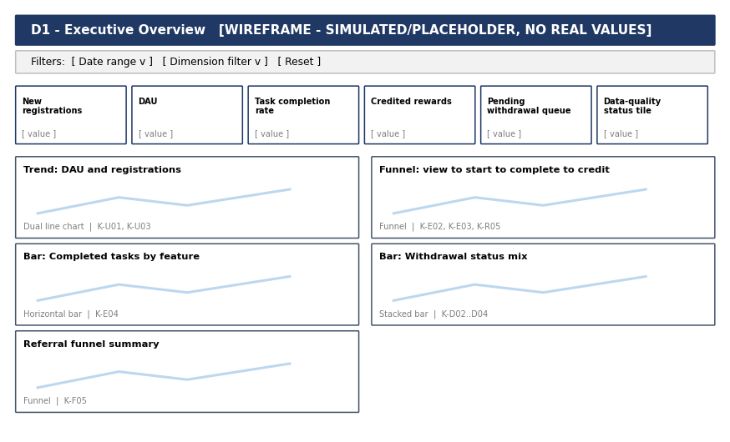
Metric | KPI | Source | Visualization | Decision supported
KPI tile: New registrations | K-U01 | Users / user_registered | KPI tile with change vs prior period | Adjust acquisition effort
KPI tile: DAU | K-U03 | Event stream | KPI tile + sparkline | Judge product traction
KPI tile: Task completion rate | K-E03 | Task Activity | KPI tile | Prioritise fixes
KPI tile: Credited rewards | K-R01 | Rewards | KPI tile by unit | Reward budget
KPI tile: Pending withdrawal queue | K-D03 | Withdrawals | KPI tile with alert colour | Staffing
Trend: DAU and registrations | K-U01, K-U03 | Users, events | Dual line chart | Campaign timing
Funnel: view to start to complete to credit | K-E02, K-E03, K-R05 | Task Activity, Rewards | Funnel | Roadmap
Bar: Completed tasks by feature | K-E04 | Task Activity | Horizontal bar | Investment
Bar: Withdrawal status mix | K-D02..D04 | Withdrawals | Stacked bar | Policy review
Referral funnel summary | K-F05 | Referrals | Funnel | Referral reward design
Data-quality status tile | Quality checks pass rate | Quality log | KPI tile | Whether to publish

D2 User Analytics
Audience: Product, Growth. Filters: Date range, source, device, state. Date range: Last 90 days; cohort by registration month. Refresh: Daily.
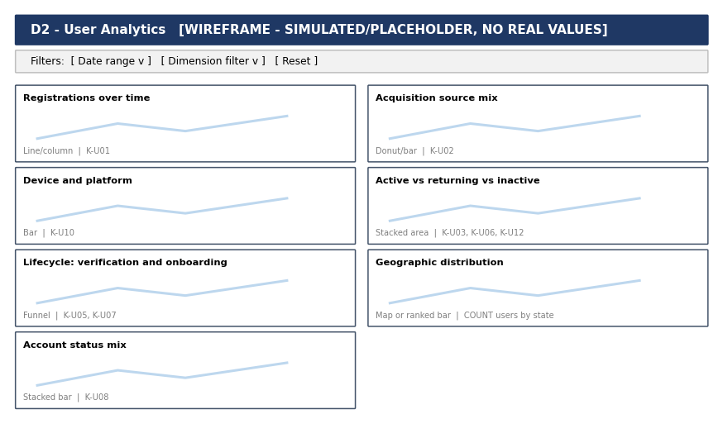
Metric | KPI | Source | Visualization | Decision supported
Registrations over time | K-U01 | Users | Line/column | Marketing
Acquisition source mix | K-U02 | Users | Donut/bar | Channel mix
Device and platform | K-U10 | Users | Bar | Engineering priority
Active vs returning vs inactive | K-U03, K-U06, K-U12 | Users, events | Stacked area | Re-engagement
Lifecycle: verification and onboarding | K-U05, K-U07 | Users | Funnel | Onboarding changes
Geographic distribution | COUNT users by state | Users | Map or ranked bar | Regional focus
Account status mix | K-U08 | Users | Stacked bar | Operations

D3 Engagement
Audience: Product. Filters: Date range, feature, task_type, device. Date range: Last 30 days. Refresh: Daily.
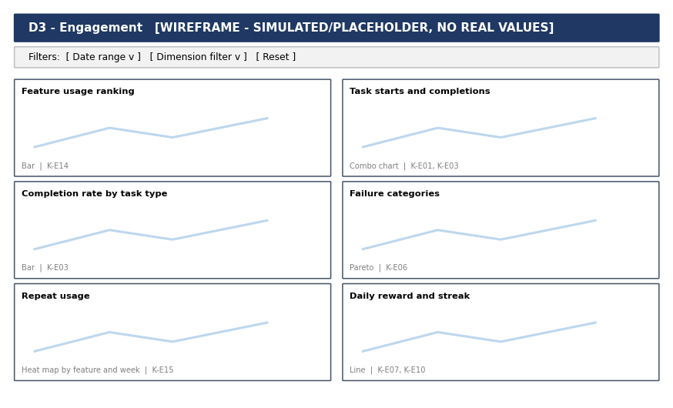
Metric | KPI | Source | Visualization | Decision supported
Feature usage ranking | K-E14 | Events | Bar | Roadmap
Task starts and completions | K-E01, K-E03 | Task Activity | Combo chart | Capacity
Completion rate by task type | K-E03 | Task Activity | Bar | Task retirement
Failure categories | K-E06 | Task Activity | Pareto | Bug priority
Repeat usage | K-E15 | Events | Heat map by feature and week | Habit design
Daily reward and streak | K-E07, K-E10 | Events | Line | Mechanic tuning

D4 Rewards
Audience: Product, Finance. Filters: Date range, source_type, unit, status. Date range: Last 30 days. Refresh: Daily.
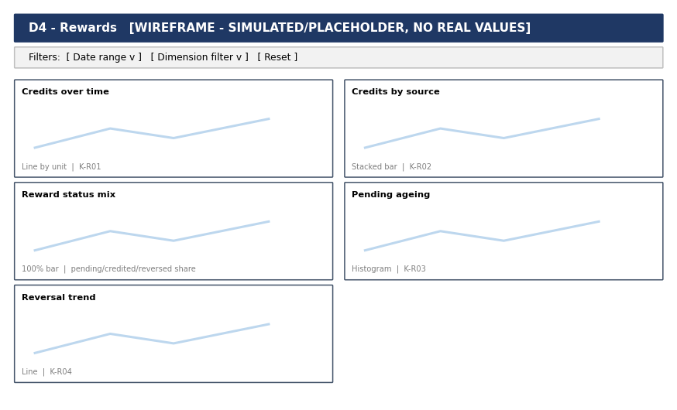
Metric | KPI | Source | Visualization | Decision supported
Credits over time | K-R01 | Rewards | Line by unit | Budget
Credits by source | K-R02 | Rewards | Stacked bar | Rebalancing
Reward status mix | pending/credited/reversed share | Rewards | 100% bar | Operations
Pending ageing | K-R03 | Rewards | Histogram | Escalation
Reversal trend | K-R04 | Rewards | Line | Provider review

D5 Wallet
Audience: Finance. Filters: Date range, transaction_type, unit, status. Date range: Last 30 days. Refresh: Daily.
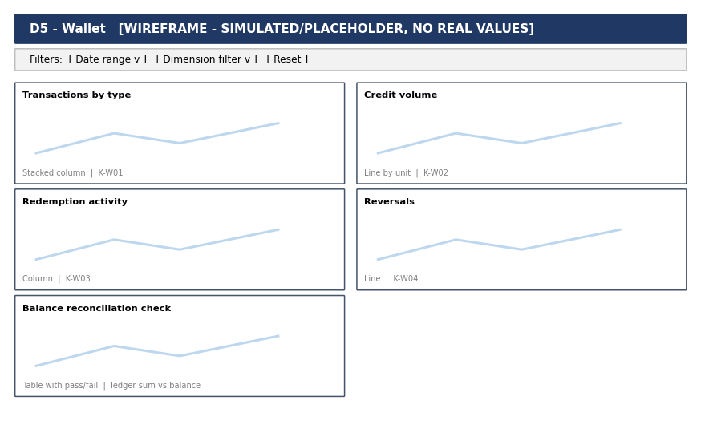
Metric | KPI | Source | Visualization | Decision supported
Transactions by type | K-W01 | Wallet Transactions | Stacked column | Ledger health
Credit volume | K-W02 | Wallet Transactions | Line by unit | Finance planning
Redemption activity | K-W03 | Wallet Transactions | Column | Redemption design
Reversals | K-W04 | Wallet Transactions | Line | Investigation
Balance reconciliation check | ledger sum vs balance | Wallet Transactions | Table with pass/fail | Release gate

D6 Withdrawals
Audience: Operations, Finance. Filters: Date range, method, status. Date range: Last 30 days. Refresh: Hourly for queue; daily for rest.
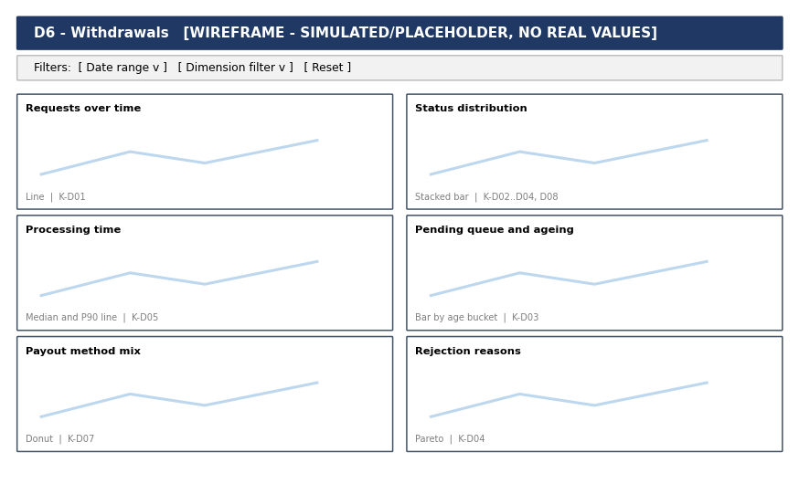
Metric | KPI | Source | Visualization | Decision supported
Requests over time | K-D01 | Withdrawals | Line | Capacity
Status distribution | K-D02..D04, D08 | Withdrawals | Stacked bar | Policy
Processing time | K-D05 | Withdrawals | Median and P90 line | SLA
Pending queue and ageing | K-D03 | Withdrawals | Bar by age bucket | Staffing
Payout method mix | K-D07 | Withdrawals | Donut | Method roadmap
Rejection reasons | K-D04 | Withdrawals | Pareto | Message and rules

D7 Referrals
Audience: Growth. Filters: Date range, channel, stage. Date range: Last 90 days. Refresh: Daily.
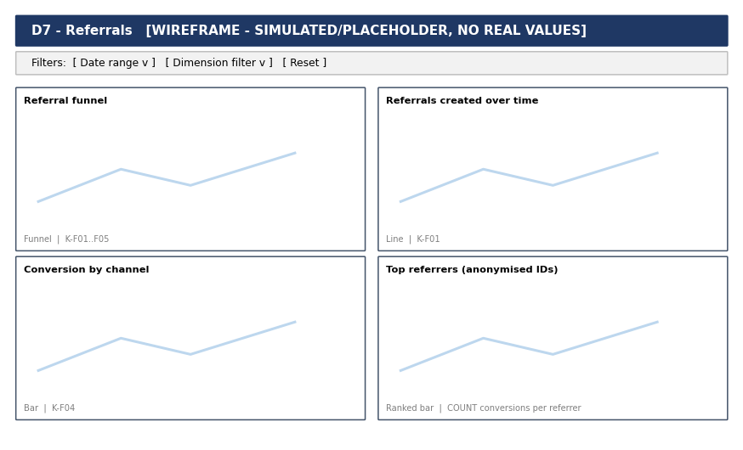
Metric | KPI | Source | Visualization | Decision supported
Referral funnel | K-F01..F05 | Referrals | Funnel | Referral design
Referrals created over time | K-F01 | Referrals | Line | Campaigns
Conversion by channel | K-F04 | Referrals | Bar | Spend
Top referrers (anonymised IDs) | COUNT conversions per referrer | Referrals | Ranked bar | Abuse review

15 Developer Analytics Handoff (N)
Fourteen critical events are specified with requirement ID, trigger, payload (field, type, required, validation), deduplication rule, timestamp rule, source, reason needed, KPI dependency, acceptance test and priority. The complete one-row-per-field table (108 rows) is in workbook sheet 9. Implementation is subject to final engineering design and idempotency decisions.

REQ-001 user_registered
Item | Specification
Trigger | Account record is successfully created
Payload (required) | user_id (string); event_id (UUID); event_ts (UTC ISO-8601); registration_method (enum: web_form, google_sign_in), acquisition_source (enum), device_type (enum), platform (enum)
Optional | referral_code_used (string), campaign_ref (string)
Validation | user_id unique; registration_method in list; one event per user_id
Deduplication | unique on user_id
Timestamp | UTC, server-generated when the state is committed
Source / Priority | Backend / Critical
Why needed | Count new users and acquisition mix
KPI dependency | K-U01, K-U02, K-U10
Acceptance test | When a new account is created, exactly one user_registered event with a new user_id is recorded; repeat submission of the same form creates no second event.

REQ-002 user_logged_in
Item | Specification
Trigger | Authenticated session is created
Payload (required) | user_id (string); event_id (UUID); event_ts (UTC ISO-8601); session_id (string), device_type (enum), platform (enum)
Optional | login_method (enum)
Validation | session_id unique per login; user must exist
Deduplication | unique on (user_id, session_id)
Timestamp | UTC, server-generated when the state is committed
Source / Priority | Backend / Critical
Why needed | Returning-user and active-user KPIs
KPI dependency | K-U03, K-U04, K-U06
Acceptance test | Each successful authentication produces one event carrying a session_id; a refresh without re-authentication produces none.

REQ-003 task_started
Item | Specification
Trigger | Task attempt created
Payload (required) | user_id (string); event_id (UUID); event_ts (UTC ISO-8601); task_activity_id (string), task_id (string), task_type (enum), feature (enum), session_id (string)
Optional | provider_ref (string)
Validation | one task_activity_id per attempt
Deduplication | unique on task_activity_id
Timestamp | UTC, server-generated when the state is committed
Source / Priority | Backend / Critical
Why needed | Starts and completion rate denominator
KPI dependency | K-E01, K-E03
Acceptance test | Starting an attempt records one event with a unique task_activity_id before any completion event exists for it.

REQ-004 task_completed
Item | Specification
Trigger | Completion has passed the applicable validation process
Payload (required) | user_id (string); event_id (UUID); event_ts (UTC ISO-8601); task_activity_id (string), task_id (string), task_type (enum), feature (enum), status (enum: completed), validation_status (enum), reward_amount (decimal), reward_unit (enum)
Optional | provider_ref (string), duration_seconds (int)
Validation | exactly one event per task_activity_id; completion_ts >= start_ts; reward fields present when reward applies
Deduplication | unique on task_activity_id (idempotency key); replays ignored
Timestamp | UTC, server-generated when the state is committed
Source / Priority | Backend / Critical
Why needed | Primary earning outcome
KPI dependency | K-E03, K-E04, K-R01
Acceptance test | When a valid task completion occurs, exactly one analytically usable completion event is recorded for the relevant task/user attempt, subject to the final engineering implementation and idempotency design.

REQ-005 task_failed
Item | Specification
Trigger | Attempt ends with an error or rejected validation
Payload (required) | user_id (string); event_id (UUID); event_ts (UTC ISO-8601); task_activity_id (string), task_id (string), failure_category (enum, Proposed list), failure_stage (enum: tracking, validation, availability, system)
Optional | failure_detail (string, no PII)
Validation | failure_category in approved list; one terminal event per attempt
Deduplication | unique on (task_activity_id, terminal state)
Timestamp | UTC, server-generated when the state is committed
Source / Priority | Backend / High
Why needed | Failure analysis
KPI dependency | K-E05, K-E06
Acceptance test | A failed attempt records one failure event with a failure_category from the approved list; no completion event exists for that task_activity_id.

REQ-006 reward_credited
Item | Specification
Trigger | Reward is written to the wallet ledger
Payload (required) | user_id (string); event_id (UUID); event_ts (UTC ISO-8601); reward_id (string), source_type (enum), source_ref (string), amount (decimal >0), unit (enum), wallet_transaction_id (string)
Optional | task_activity_id (string)
Validation | amount>0; wallet_transaction_id exists; one per reward_id
Deduplication | unique on reward_id
Timestamp | UTC, server-generated when the state is committed
Source / Priority | Backend / Critical
Why needed | Value delivered; reconciliation
KPI dependency | K-R01, K-R02, K-R05
Acceptance test | Every wallet credit from a reward has one reward_credited event whose amount equals the wallet ledger entry; no event is emitted for rewards still pending.

REQ-007 reward_reversed
Item | Specification
Trigger | Previously credited or pending reward is cancelled
Payload (required) | user_id (string); event_id (UUID); event_ts (UTC ISO-8601); reward_id (string), original_reward_id (string), amount (decimal), unit (enum), reason_category (enum), actor_type (enum)
Optional | case_ref (string)
Validation | original_reward_id must exist and be credited
Deduplication | unique on (reward_id, original_reward_id)
Timestamp | UTC, server-generated when the state is committed
Source / Priority | Backend / High
Why needed | Integrity and third-party reversal rate
KPI dependency | K-R04
Acceptance test | Reversing a reward produces one event referencing the original reward_id and a matching reversal ledger entry.

REQ-008 referral_converted
Item | Specification
Trigger | Referral meets conversion definition (A013)
Payload (required) | user_id (string); event_id (UUID); event_ts (UTC ISO-8601); referral_id (string), referrer_user_id (string), referred_user_id (string), conversion_rule (string)
Optional | reward_id (string)
Validation | after referral_activated; at most one per referral_id
Deduplication | unique on referral_id
Timestamp | UTC, server-generated when the state is committed
Source / Priority | Backend / Critical
Why needed | Conversion KPI
KPI dependency | K-F04
Acceptance test | A referral meeting the agreed conversion definition produces exactly one event; registration alone never produces it.

REQ-009 wallet_transaction_created
Item | Specification
Trigger | Ledger entry is created
Payload (required) | user_id (string); event_id (UUID); event_ts (UTC ISO-8601); transaction_id (string), transaction_type (enum), amount (decimal), unit (enum), status (enum), reference_id (string)
Optional | related_transaction_id (string)
Validation | transaction_id unique; amount != 0
Deduplication | unique on transaction_id
Timestamp | UTC, server-generated when the state is committed
Source / Priority | Backend / Critical
Why needed | Ledger completeness
KPI dependency | K-W01
Acceptance test | Each ledger write creates one event with a unique transaction_id; retries do not create new IDs.

REQ-010 wallet_transaction_completed
Item | Specification
Trigger | Ledger entry becomes final
Payload (required) | user_id (string); event_id (UUID); event_ts (UTC ISO-8601); transaction_id (string), transaction_type (enum), amount (decimal), unit (enum), balance_after (decimal)
Optional | -
Validation | transaction_id exists with status created
Deduplication | unique on transaction_id + status
Timestamp | UTC, server-generated when the state is committed
Source / Priority | Backend / Critical
Why needed | Credit volume, redemptions
KPI dependency | K-W02, K-W03
Acceptance test | A settled transaction records one completed event; the sum of completed credits less reversals equals the balance change for a test user.

REQ-011 wallet_transaction_reversed
Item | Specification
Trigger | Ledger entry is reversed
Payload (required) | user_id (string); event_id (UUID); event_ts (UTC ISO-8601); transaction_id (string), related_transaction_id (string), amount (decimal), unit (enum), reason_category (enum)
Optional | -
Validation | related_transaction_id must exist and be completed
Deduplication | unique on transaction_id
Timestamp | UTC, server-generated when the state is committed
Source / Priority | Backend / Critical
Why needed | Reversal rate
KPI dependency | K-W04
Acceptance test | A reversal references an existing completed transaction through related_transaction_id.

REQ-012 withdrawal_requested
Item | Specification
Trigger | Request is submitted and recorded
Payload (required) | user_id (string); event_id (UUID); event_ts (UTC ISO-8601); withdrawal_id (string), amount (decimal), unit (enum), method (enum, list pending A010)
Optional | -
Validation | amount>0; one per withdrawal_id
Deduplication | unique on withdrawal_id
Timestamp | UTC, server-generated when the state is committed
Source / Priority | Backend / Critical
Why needed | Request volume
KPI dependency | K-D01, K-D07
Acceptance test | Submitting a payout request records one event with a unique withdrawal_id and amount>0.

REQ-013 withdrawal_completed
Item | Specification
Trigger | Payout confirmed
Payload (required) | user_id (string); event_id (UUID); event_ts (UTC ISO-8601); withdrawal_id (string), amount (decimal), unit (enum), method (enum)
Optional | payout_reference (string, tokenised)
Validation | terminal; exclusive with rejected
Deduplication | unique on withdrawal_id + terminal status
Timestamp | UTC, server-generated when the state is committed
Source / Priority | Backend / Critical
Why needed | Completion rate, volume
KPI dependency | K-D02, K-D04, K-D06
Acceptance test | Completion appears once per withdrawal_id and never together with a rejected event.

REQ-014 withdrawal_rejected
Item | Specification
Trigger | Request refused
Payload (required) | user_id (string); event_id (UUID); event_ts (UTC ISO-8601); withdrawal_id (string), reason_category (enum)
Optional | -
Validation | terminal; exclusive with completed
Deduplication | unique on withdrawal_id + terminal status
Timestamp | UTC, server-generated when the state is committed
Source / Priority | Backend / High
Why needed | Rejection reasons
KPI dependency | K-D04
Acceptance test | Rejection records one event with a reason_category from the approved list and no completion event.

16 Data Pipeline and Operating Model (O)
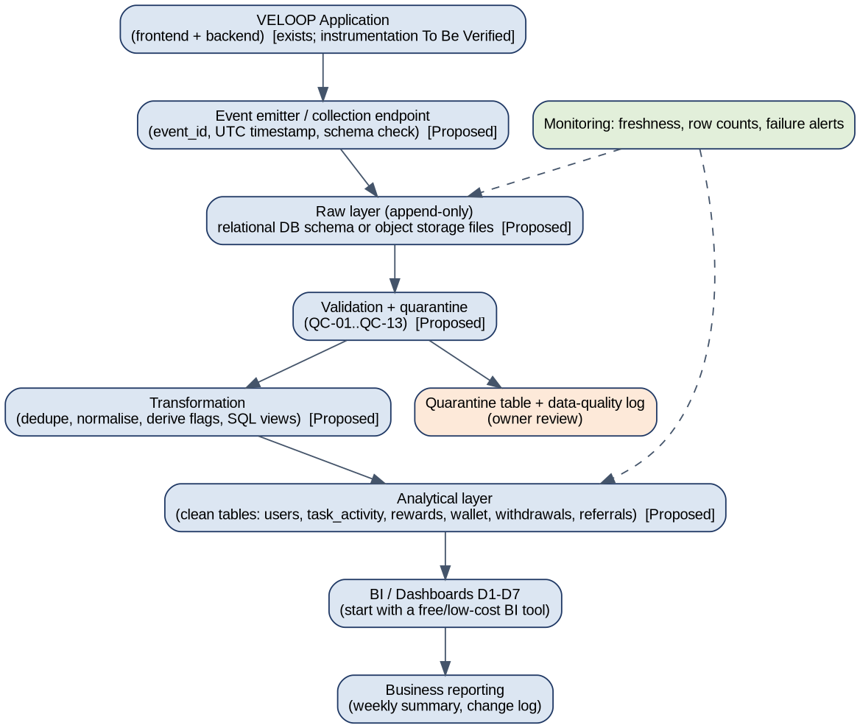
Element | Practical proposal (Proposed; fits current stack once A030 is answered)
Source systems / producers | VELOOP application frontend and backend; third-party callbacks; support tool (if any)
Collection | Single event endpoint or server-side logger; schema check; event_id and UTC timestamp assigned once
Storage and raw layer | Start with the existing relational database or file storage; raw tables append-only and never edited
Validation | Rules QC-01..QC-13 on load; failing rows go to a quarantine table
Transformation | Scheduled SQL views/jobs: deduplicate, normalise, derive flags
Analytical layer | Clean tables matching the logical model; documented KPI views
Dashboard and refresh | Free or low-cost BI tool; daily refresh, hourly for the withdrawal queue
Monitoring and failure handling | Freshness and row-count checks; alert on failed load; retry; no silent drops
Ownership | Engineering: events and raw layer. Data analyst: validation rules, KPI views, dashboards. Product/Operations: definitions and review of quarantine

Deliberately not recommended at this stage: a dedicated data warehouse, streaming platform or large orchestration stack. Scale up only when event volume or query time justifies it.

17 Privacy, Access and Governance (P)
Role | Access (Proposed)
Engineering | Technical event implementation and raw-layer troubleshooting; no routine access to business reports needing personal data
Data Analyst | Approved analytical datasets with pseudonymous IDs; hashed email only if required
Product / Operations | Aggregated business reporting and dashboards; row-level views only for operational cases
Content Team | Aggregated content/help performance only
Finance | Wallet and withdrawal aggregates and reconciliation reports
Intern | Only approved, sanitised, clearly labelled datasets

Information that must not be unnecessarily exposed or stored in analytics: passwords, authentication secrets, API keys, payment credentials, private credentials, sensitive security controls and fraud thresholds. Other principles: data minimisation (full_name and email excluded from the analytics layer), role-based access, simulated and production data never mixed, consent respected (marketing opt-in only with consent Accepted, QC-17), retention period to be decided (A025).

18 Analytics Change Management (Q)
Change type | Process
Feature changes | Update coverage matrix and event plan; version bump; notify KPI owners
Event changes | Never rename silently: add new event, deprecate old for a defined overlap period, log in change log
Reward mechanic changes | Record effective date; add reward_rule_version; split trend charts at the change
Withdrawal method changes | Add to approved method list; keep history; annotate dashboards
Field renames | Keep mapping old to new in dictionary; transformation layer exposes both until retired
KPI definition changes | New version; restate history or mark break; list affected dashboards
Dashboard changes | Version the spec; record visuals added/removed; owner sign-off

The Metric/Event Change Log (workbook sheet 19) records date, change, old and new definition, reason, affected KPIs, dashboards and reports, owner and version. Baseline entries for v1.0 are included.

19 Analytics Readiness and Gap Assessment (R)
Dimension | Design (0-5) | Verified (0-5) | Gap priority | Reason
Event coverage | 4 | 0 | Critical | Without verified events no production KPI can be produced.
Data model | 4 | 0 | Critical | Wallet transaction_id and referral linkage unverified.
Data dictionary | 4 | 0 | High | Dictionary must be reconciled with the real schema.
KPI definitions | 4 | 0 | High | Many KPIs depend on tables not supplied (J3).
Data quality | 3 | 0 | High | Duplicates and malformed dates exist in sample.
Dashboard readiness | 3 | 0 | Medium | Cannot be built until data layer exists.
Engineering instrumentation | 2 | 0 | Critical | Instrumentation determines everything else.
Access control | 3 | 0 | Medium | Minimise personal data in analytics layer.
Documentation | 4 | 0 | Medium | Needs ownership and review cadence.
Reporting | 2 | 0 | Medium | Depends on pipeline.

Scoring note: "Design" rates how complete this project's specifications are (average 3.3). "Verified" rates what is confirmed in production (0, because no production evidence was supplied). Priorities are justified, for example: Critical - without a stable transaction ID, reliable wallet transaction deduplication cannot be guaranteed.

20 Assumption and Verification Register (S)
ID | Unknown | Why it matters | Risk | Owner | Status
A001 | Does the backend currently emit task completion events? | Required for all task analytics and reward reconciliation | High | Engineering | To Be Verified
A002 | Is there a stable, immutable user_id issued at registration (independent of email)? | Cross-event joins and de-duplication depend on it | Critical | Engineering | To Be Verified
A003 | Will the program team supply the missing Task Activity, Rewards, Wallet, Withdrawals, Referrals, Feature Events sheets? | Needed to test relationships and KPIs required by J2/J3 on the intended dataset | High | Program team / Admin | To Be Verified
A004 | Does production generate a session_id and where is a session closed? | Session-level KPIs and funnels need it | High | Engineering | To Be Verified
A005 | Is event_id generated client-side or server-side, and is it idempotent on retry? | Duplicate events inflate KPIs | Critical | Engineering | To Be Verified
A006 | Which of the 15 feature names actually exist in production today? | Event plan and dashboards must not cover non-existent features | Medium | Product | To Be Verified
A007 | Is reward crediting synchronous with task completion or delayed by validation? | Determines whether reward_pending is a real state | High | Product / Engineering | To Be Verified
A008 | What are the exact reward units (VE, XP, Gem, Token) and are there conversion rules? | Amount fields need a unit; cross-unit totals are invalid without rules | High | Product | To Be Verified
A009 | Is there a single wallet ledger or one balance per currency? | Defines the transaction model and balance reconciliation | Critical | Engineering | To Be Verified
A010 | Which withdrawal methods, minimums and review steps exist? | Method distribution, processing-time and rejection KPIs depend on it | High | Product / Operations | To Be Verified
A011 | Is a status-change history stored for accounts (e.g. Active to Suspended)? | Without history, activity before/after suspension cannot be separated | High | Engineering | To Be Verified
A012 | Which external providers return completion/validation signals and with what delay? | Third-party delay and reversals affect reward timing and KPIs | High | Product / Engineering | To Be Verified
A013 | How is a referral defined as "activated" and "converted"? | Referral funnel stages cannot be computed without a business definition | High | Product | To Be Verified
A014 | Does the referral record capture the referring user (referrer user_id)? | Simulated Users only holds referral_source_detail = Friend/Family and a code per user | Critical | Engineering | To Be Verified
A015 | What time zone are timestamps stored in? | Day-level KPIs shift if UTC vs IST is mixed | High | Engineering | To Be Verified
A016 | What is the reference timestamp for days_since_registration and the active flags? | Derived fields could not be reproduced for a few users | Medium | Data owner of the dataset | To Be Verified
A017 | Is is_active based on login, any event, or a qualifying activity event? | KPI definition of DAU/WAU/MAU | High | Product / Analytics | To Be Verified
A018 | Is "platform" = Web a delivery channel while primary_device = OS family? | Both fields exist; platform has a single value in the sample | Low | Engineering | To Be Verified
A019 | Can a Pending Verification account earn rewards? | Task02 sample shows tasks for such accounts | High | Product | To Be Verified
A020 | Can a Suspended account keep earning/withdrawing? | Same, affects reversal and fraud-review reporting | High | Product / Operations | To Be Verified
A021 | Is consent captured as a timestamped event or a current flag only? | Privacy audit needs history | Medium | Legal / Engineering | To Be Verified
A022 | Which user fields are legally necessary (name, email, age, gender, city)? | Data minimisation for the analytics layer | High | Product / Legal | To Be Verified
A023 | Will support tickets / help-center content be tracked in-product or in an external tool? | Support KPIs source system | Medium | Operations | To Be Verified
A024 | Is an exchange (VE to Gem/Token) a wallet transaction type? | Transaction-type list in D1 | Medium | Product | To Be Verified
A025 | How long are raw events retained? | Storage cost and reprocessing capability | Low | Engineering | To Be Verified
A026 | Does onboarding have defined milestones? | onboarding_milestone_reached cannot be specified without them | Medium | Product | To Be Verified
A027 | Are reward reversals and corrections performed manually by staff or automatically? | Determines the actor field and audit needs | Medium | Operations | To Be Verified
A028 | What is the intended meaning of lifetime_sessions = 0 with onboarding Completed (23 users)? | Possible data defect or onboarding completed outside a session | Medium | Dataset owner | To Be Verified
A029 | Are mobile apps planned in addition to the web platform? | platform / app_version fields | Low | Product | To Be Verified
A030 | Is there an existing analytics tool or warehouse? | Pipeline recommendation must fit current stack and cost | Medium | Engineering | To Be Verified

21 Implementation Backlog
Priority | Requirement | Reason | Dependency | Owner | Stage
Critical | Stable, immutable user_id issued at registration | Cross-event analysis (A002) | Authentication | Engineering | Prelaunch
Critical | Unique event_id with idempotent writes | Duplicate events inflate KPIs (10 duplicates in sample audit) | Event service | Engineering | Prelaunch
Critical | Wallet transaction_id and append-only ledger | Reconciliation and deduplication | Wallet | Engineering | Prelaunch
Critical | Referral table with referrer and referred IDs and stage timestamps | Referral conversion cannot be computed otherwise | Registration, Referral | Engineering | Prelaunch
Critical | Withdrawal lifecycle with requested, processing, final timestamps | Processing-time and queue KPIs | Withdrawals | Engineering | Prelaunch
Critical | Emit task_started / task_completed / task_failed events | Core earning analytics | Tasks | Engineering | Prelaunch
Critical | Emit reward_credited linked to ledger entry | Separate activity from credit | Rewards, Wallet | Engineering | Prelaunch
High | Account Status History table | Separate pre/post suspension activity | Accounts | Engineering | Prelaunch
High | Session identifier and session end rule | Funnels and session KPIs | Frontend/Backend | Engineering | Prelaunch
High | Approved enum lists (failure_category, reason_category, unit, method) | Prevents free-text drift | Product decisions | Product | Prelaunch
High | Timezone standard (UTC storage, IST reporting if needed) | Day-boundary KPIs | Event service | Engineering | Prelaunch
High | Confirm eligibility rules for pending and suspended accounts | Resolves DQ-017, DQ-026 | Policy | Product / Operations | Prelaunch
High | Raw layer + validation job + quarantine table | Quality controls | Storage | Data / Engineering | Prelaunch
High | Publish KPI definitions and DAU qualifying-event list | Reproducible metrics | Product | Analytics | Prelaunch
High | Obtain missing Task 01 simulated sheets (A003) | Complete J2/J3 testing | Program team | Admin | Immediate
Medium | Consent history capture | Compliance audit | Legal | Engineering | Prelaunch
Medium | Third-party outcome fields (provider_ref, provider_status) | Attribute external effects | Providers | Engineering | Postlaunch
Medium | Data-quality dashboard tile and alerts | Operational trust | Pipeline | Data | Postlaunch
Medium | Role-based access and hashed identifiers in analytics layer | Privacy | Governance | Data / Engineering | Prelaunch
Medium | Support ticket category tracking | Support KPIs | Operations | Operations | Postlaunch
Low | Badge/level/leaderboard analytics | Low business risk | Core events | Analytics | Postlaunch
Low | Advanced management dashboard | Needs production data | Production data | Analytics | Postlaunch

22 Deliverables Index and Definition of Done
No. | Deliverable | Where
01 | Executive Summary | Report section 01
02 | Product Data Audit | Report section 03 + workbook sheets 3-5
03 | Data Coverage Matrix | Workbook sheet 4
04 | User Analytics Specification | Workbook sheet 6, report section 04
05 | Earning & Reward Analytics Specification | Report section 05
06 | Wallet & Withdrawal Analytics Specification | Report section 06
07 | Referral & Engagement Analytics | Report section 07
08 | Event Tracking Plan | Workbook sheets 7-8
09 | Data Dictionary | Workbook sheet 10
10 | Logical Data Model | Report section 10 (ER diagram)
11 | KPI Catalogue | Workbook sheet 11
12 | Simulated Data Profiling | Workbook sheets 12-15, report section 12
13 | Data Quality Audit | Workbook sheets 16-17, report section 13
14 | Dashboard Blueprint | Report section 14, workbook sheet 18
15 | Developer Analytics Handoff | Report section 15, workbook sheet 9
16 | Data Pipeline Proposal | Report section 16
17 | Privacy & Governance Proposal | Report section 17
18 | Analytics Readiness Assessment | Report section 19, workbook sheet 20
19 | Assumption & Verification Register | Workbook sheets 1-2
20 | Implementation Backlog | Workbook sheet 21
21 | Final Consolidated Report | This document

Definition of Done - self-check
Criterion | Status | Note
Product data areas mapped | Done | 31 coverage rows
Analytical events defined | Done (Proposed) | 42 events
User, reward, wallet/withdrawal, referral analytics documented | Done | Sections 04-07
Event naming standardised | Done | object_action
Data dictionary complete | Done | 106 fields
Logical data model complete | Done | 10 entities
KPIs reproducible | Done | 54 KPIs
Simulated data profiled | Partly | Users fully; wallet/withdrawal/reward/referral sheets not supplied (A003)
Data quality problems identified | Done | 26 issues
Controls proposed | Done | 22 rules
Dashboard requirements documented | Done | 44 visuals
Engineering requirements testable | Done | Acceptance test per event
Pipeline, governance documented | Done | Sections 16-17
Unknowns recorded | Done | 30 assumptions
Gaps prioritised, backlog exists | Done | 14 gaps, 22 items
Simulated data labelled; no fictional result as VELOOP result | Done | Header, wording rule
Documents internally consistent | To be reviewed | Counts in this report are generated from the workbook content; please re-check after any edit

This report is an analytical proposal. It makes no claim about the existence, performance or success of any VELOOP feature.

