Final Project Report

<< AI-Based Smart Waste Management and Classification System >>



Project Supervisor
<< Anam Naveed >>

Submitted By

<< F25PROJECT67B54 >>

<<Iqra Jamil>> <<Bc220200221>>

Software Projects & Research Section,
Department of Computer Sciences,
Virtual University of Pakistan


CERTIFICATE

This is to certify that <<Iqra Jamil>> (<<Bc220200221>>), has worked on and completed her Software Project at Software & Research Projects Section, Department of Computer Sciences, Virtual University of Pakistan in partial fulfillment of the requirement for the degree of BS in Computer Sciences under my guidance and supervision.

In my opinion, it is satisfactory and up to the mark and therefore fulfills the requirements of BS in Computer Sciences.

Supervisor / Internal Examiner

<<Anam Naveed>>
Supervisor,
Software Projects & Research Section,
Department of Computer Sciences
Virtual University of Pakistan

___________________
(Signature)

External Examiner/Subject Specialist
<<External Supervisor Name>>

___________________
(Signature)

Accepted By:

_____________
(For office use)

EXORDIUM

In the name of Allah, the Compassionate, the Merciful.

Praise be to Allah, Lord of Creation,
The Compassionate, the Merciful,
King of Judgment-day!

You alone we worship, and to you alone we pray for help,
Guide us to the straight path

The path of those who you have favored,

Not of those who have incurred your wrath,
Nor of those who have gone astray.

DEDICATION

This project is dedicated to my beloved parents, whose endless love, prayers, encouragement, and sacrifices have always been the strongest source of motivation in my life. Their support gave me the confidence to work hard; stay focused, and completes this final year project successfully. I also dedicate this work to my respected teachers; especially those who guided me throughout my academic journey and helped me improve my knowledge and skills with their valuable advice. I am equally thankful to all my friends and well-wishers who stood by me, supported me during difficult times, and inspired me to keep moving forward. This achievement would not have been possible without the blessings, encouragement, and belief of all these special people in my life.

ACKNOWLEDGEMENT

I would like to express my sincere gratitude to Almighty Allah for granting me the strength and patience to complete this project successfully.

I am especially thankful to my supervisor, Anam Naveed, for her valuable guidance, support, and encouragement throughout the development of this project. Her advice helped me improve the quality of my work at every stage.

I also thank the faculty members of the Department of Computer Sciences, Virtual University of Pakistan, for providing me with the knowledge and academic environment needed to complete this Final Year Project.

Finally, I am deeply grateful to my parents, family, and friends for their prayers, love, and continuous support.
PREFACE

This report presents the final documentation of my Final Year Project titled AI-Based Smart Waste Management and Classification System. The project was developed to provide an intelligent and practical solution for waste classification using computer vision and machine learning.

The report includes the complete process of the project, starting from requirement analysis and system design to implementation, testing, and final evaluation. It also describes the development of both the user panel and the admin panel in the Streamlit application.

This work reflects the effort, learning, and experience gained throughout the different phases of the project, and it highlights how the system was designed to support better waste management and environmental awareness.
TABLE OF CONTENTS

CHAPTER NO. 1
gathering & Analyzing info 10

1.1 Introduction

1.2 purpose

1.3 scope

1.4 definitions, acronyms and abbreviations

1.5 Project requirements

1.5.1 Functional Requirements

1.5.2 Non-Functional Requirements

1.6 use cases and usage scenarios

1.6.1 Use Case Diagrams

1.6.2 Usage Scenarios

1.7 Development Methodology

1.7.1 Chosen Methodology

1.7.2 Reasons for Chosen Methodology
1.7.2 Work Plan (Gantt Chart)
1.7.2 Project Schedule (Submission Calendar)

CHAPTER NO. 2
designing the project 27

2.1 Introduction

2.2 purpose

2.3 scope

2.4 definitions, acronyms and abbreviations

2.5 Architectural Representation (Architecture Diagram)

2.6 Dynamic Model: Sequence Diagrams

2.7 Object Model/Logical Model: Class Diagram

2.8 Database Model (Database Diagram)

2.9 Graphical User Interfaces

Chapter no.3
DEvelopment 39
3.1 Development plan (Architecture Diagram)

<<Dear Students, you have to take special care of page numbers, which are written against each Chapter and sub headings. You have to mention your own page numbers and correct one against each document heading. Make proper table of contents. Remember that if there are any new headings or you have included more headings in your documents then you also have to write these in table of contents and modify table of contents according to your documents material>>

CHAPTER 1
Gathering & Analyzing Info

  - Introduction
Waste storing has always been a dirty problem. People throw junk into the wrong bins, Slowing recycling and making manual storing slow and even sometimes unsafe. The project attempts to address that problem by using artificial intelligence and computer vision to automatically detect what type of waste an item belongs to.
The system takes a picture or uploads an image of a waste item(images acquisition), and runs it through the pre- trained CNN model, and classifies it as plastic, organic, glass, metal, paper, or “other.” After classification, it suggests the right disposal or recycling method. The idea is to make the process easier for homes, schools, and public institutions that want a smarter way to deal with trash. It cuts down on mistakes, speeds up segregation, and encourages people to dispose of waste responsibly.

  - purpose
The goal is simple: let AI handle waste sorting so it’s fast, accurate, and easy for everyone. Right now, people spend too much time guessing where their trash goes and usually get it wrong. Recycling centers end up with all sorts of mixed-up garbage because there’s no real help when you’re actually throwing stuff away.
This system changes that. It tells you exactly what kind of waste you’ve got and what to do with it. Meanwhile, admins can update the datasets, retrain the AI, and keep an eye on system’s performance

  - scope
This project covers image-based waste classification using a trained AI model and a simple interface that allows users to upload or capture waste images. The application handles preprocessing, classification, confidence scoring, disposal recommendations, and history tracking.
On the admin side, the system offers dataset management, model retraining, and classification logs for performance monitoring.
In real-world usage, this system helps the community by reducing incorrect waste disposal, which is a major issue in homes, schools, and public places. Many people are unaware of proper waste categories, which leads to mixing recyclable and non-recyclable waste. This system provides instant guidance, allowing users to make correct decisions at the moment of disposal. As a result, it improves recycling efficiency, reduces environmental pollution, and promotes responsible waste handling behavior.
The system is especially useful in areas where awareness and proper waste management facilities are limited. It can be used as an educational tool for students and households to learn correct waste segregation practices. By simplifying the process, it encourages more people to participate in environmentally friendly actions without requiring technical knowledge.
Compared to existing solutions, this system provides a more accessible and user-friendly approach. Many current systems depend on manual sorting, expensive hardware setups, or IoT-based smart bins, which are costly and not widely available. In contrast, this project is purely software-based and works with a simple device like a mobile phone or computer. It removes the need for specialized equipment and makes smart waste classification available to a wider audience.
Out of scope, real-time hardware-based sorting machines, robotic arms, IoT bins, and full environmental analytics. The system limits itself to software-based recognition and guidance only.

  - definitions, acronyms and abbreviations

- AI — Artificial Intelligence.

- CNN — Convolutional Neural Network.

- YOLO — You Only Look Once.

- UI — User Interface.

- GUI — Graphical User Interface.

- CSV — Comma-Separated Values.

- API — Application Programming Interface.

- SRS — Software Requirement Specification.

- FYP — Final Year Project.

- VU — Virtual University.

- Streamlit — A Python framework used to build web apps.

1.5 Project requirements

1.5.1 Functional Requirements

FR-01 Upload Waste Image
The system must let users to upload an image of a waste item directly from their device storage. The file goes through a validation step to check it is an acceptable image format. This feature helps users submit waste items easily without needing external tools or complicated steps.

FR-02 Capture Image Using Camera
The system must let users take a real time photo of a waste item using a built-in camera feature. This helps user when users want quick classification without browsing files. The captured image is automatically prepared for further processing.

FR-03 Validate Image Format
The system must verify that the input file is a supported image type like JPG, PNG, or JPEG. Invalid or corrupted files should be rejected immediately. This prevents processing errors and protects the AI model from unsupported data.

FR-04 Preprocess Image
Once a valid image is received, the system must resize, clean, and normalize the image before classification. Pre-processing keeps inputs consistent and helps the to work efficiently even if user images differ in size or quality.

FR-05 Classify Waste Using CNN Model
The core function is to classify waste into one of the predefined categories: Organic, Plastic, Glass, Metal, Paper or Other. The model must provide a clear category along with a confidence level. This classification drives the recommendations shown to the user.

FR-06 Display Classification Result
After processing and classification, the system must show the final category and its confidence score on the user interface. The result should be clear and easy to understand, so users can quickly identify the type of waste.

FR-07 Provide Disposal Recommendation
The system must generate disposal or recycling guidance based on the predicted waste category. Organic waste should lead to composting advice, recyclable materials should point to correct recycling bins, and hazardous materials should trigger warnings or special handling instructions. This helps users take correct action after classification.

FR-08 View Classification History
The system must let users view their previously classified waste items. Each entry should show the image, the predicted category, and classification time. This helps users track their activity and revisit past results whenever needed.

FR-09 Prevent Invalid File Uploads
The system must block the uploading of non image files .This includes PDFs, documents, text files, videos, and any unsupported formats. Preventing invalid inputs avoids unnecessary processing and keep the system stable.

FR-10 Do Not Store Personal Data
The system must operate without saving any personal information. Only the classified images and their results may be stored, and even those remain non-sensitive. This ensures privacy and keeps system operations simple and secure.

FR-11 Admin Add Training Dataset
The system must allow the admin to upload new images to expand the training dataset. Each newly added item should be stored in its correct category folder so the model can use it in the next training cycle.

FR-12 Admin Update Dataset or Retrain Model
The system must allow the admin to retrain the classification model whenever the dataset grows or quality improvements are needed. Retraining should update the model weights and improve accuracy based on newly added images.

FR-13 Log Classification Results
The system must maintain internal logs of all classifications performed. These logs may include timestamps, predicted categories, and confidence scores. This helps with monitoring system performance and detecting potential weaknesses.

FR-14 Provide Model Evaluation Report
After retraining, the system must generate a model evaluation summary showing with metrics like accuracy, loss, precision, and recall. This report helps the admin decide whether the updated model is ready for deployment.

1.5.2 Non-Functional Requirements

NFR-01 Performance
The system should classify an image and return the result within a reasonable time. Since the model runs in inference mode, it must handle image preprocessing and prediction efficiently, ideally completing the full process in a few seconds. This ensures that users can quickly proceed with proper waste disposal.

NFR-02 Accuracy
The classification model should maintain a reliable accuracy level based on the training dataset used for training. The system must consistently identify common waste types correctly and minimize misclassification. Higher accuracy not only builds user trust but also improves the effectiveness of waste segregation in real environments.

NFR-03 Usability
The interface should be simple and intuitive so that users of any age or background can easily interact with the system. Uploading images, capturing photos, reading results, and understanding disposal recommendations should feel straightforward. The layout must avoid confusion and provide a smooth experience without requiring technical knowledge.

NFR-04 Security
The system should block unauthorized access to admin features like dataset management and retraining. User uploaded images must be validated to prevent harmful or unsupported files. Passwords or admin access mechanisms should remain protected to safeguard the integrity of the model and dataset.

NFR-05 Compatibility
The system should work reliably on commonly used browsers and devices. Whether accessed from a desktop, laptop, or mobile device, the interface and functions should remain stable. This enables the system accessible to all users groups without needing installation of specialized software.

NFR-06 Maintainability
The application and AI model should be easy to update, modify, or expand over time. Developers should be able to add new dataset images, retrain the model, or enhance modules without restructuring the system. Clean code and modular design help keep the system maintainable and future-proof.

NFR-07 Reliability
The system must perform consistently even after repeated classifications. It should not crash, corrupt data, or become unstable when handling multiple requests. Reliable operation ensures users can depend on the system for routine waste classification tasks.

NFR-08 Availability
The system should remain accessible during normal usage hours with minimal downtime. maintenance, model updates, or dataset changes should be scheduled to avoid interrupting regular users. High availability ensure smooth operation for homes, schools, and public facilities.

NFR-09 Data Integrity
All stored data , including classification history, dataset images, and model outputs must remain accurate and free from corruption. The system should ensure that updates to the dataset or model do not damage existing files or affect past records. Preserving data integrity is essential for consistent performance over time.

NFR-10 Backup and Recovery
The system should maintain regular backups of key components like dataset, model weights, and logs. In case of failure or accidental deletion, these backups allow quick recovery without major loss. This protects the model’s training progress and ensures stability of future classifications.

1.6 use cases and usage scenarios

1.6.1 Use Case Diagram

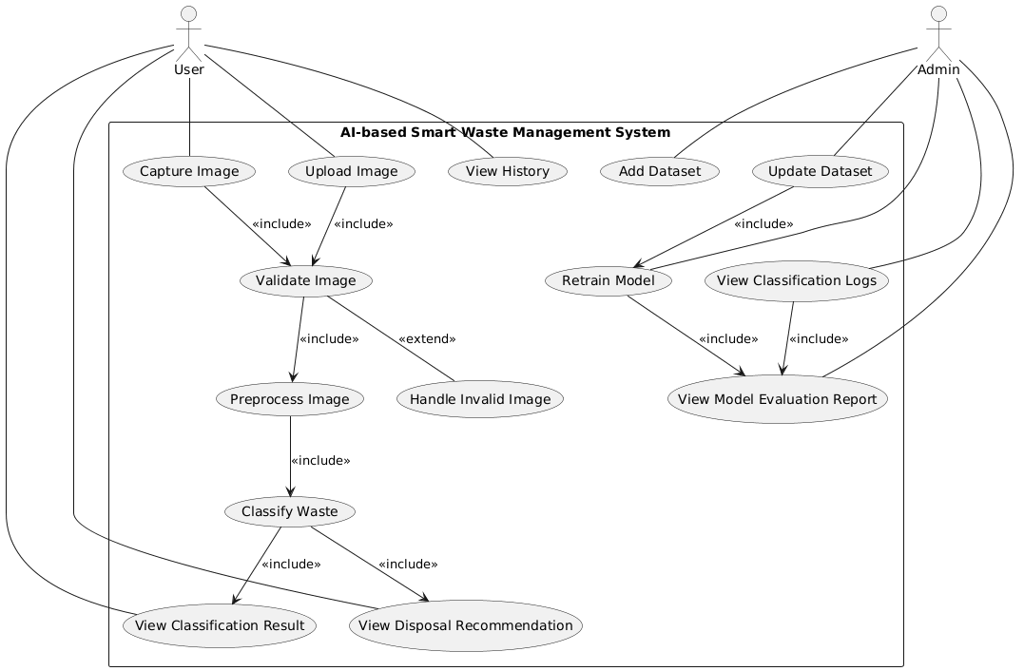

1.6.2 Usage Scenarios

Use Case ID: SWMS-CAP-01

Use Case 1: Capture Waste Image
Field | Details
Author
  BC220200221
Actor | User
Description | User captures an image of waste using device camera for classification
Precondition
  Device must have a working camera and camera permission enabled
Post condition | Image is captured and stored temporarily for processing
Main Flow | • User opens camera interface  • User captures image of waste item  • System previews captured image  • System sends image for validation and processing
Alternative Flow | A1. User cancels capture. System returns to main screen  A2. User retakes image. System replaces previous image
Exception Flow | E1. Camera not accessible. System shows error  E2. Permission denied. System requests permission  E3. Capture fails. System asks to retry
Authority | User

Modification History
Date | Version | Description
  Author
10-Dec-2025 | 1.0 | Initial creation of use case | Bc220200221

Use Case 2: Upload Image

Use Case ID: SWMS-UPL-02

Field | Details
Use Case | Upload Image
Actor | User
Precondition | User must have an image stored on the device
Main Flow | 1. User selects upload option.  2. Chooses an image from device storage.  3. System checks file type.  4. System forwards image for validation and processing.
Postcondition | Image uploaded successfully and ready for analysis

Use Case 3: View Classification Result

Use Case ID: SWMS-VAL-03
Field | Details
Use Case | View Classification Result
Actor | User
Precondition | System must have classified the waste image
Main Flow | 1. System displays waste category.  2. Shows confidence score.  3. User views result.
Postcondition | Result displayed to the user

Use Case 4: View Disposal Recommendation

Use Case ID: SWMS-PRE-04
Field | Details
Use Case | View Disposal Recommendation
Actor | User
Precondition | Classification result must be available
Main Flow | 1. System identifies waste type.  2. Shows disposal instructions (compost, recycle, etc).  3. User reads instructions.
Postcondition | User knows correct disposal method

Use Case 5: View History

Use Case ID: SWMS-CLA-05
Field | Details
Use Case | View History
Actor | User
Precondition | User must have previously classified images
Main Flow | 1. User opens history section.  2. System loads past classifications.  3. User views previous results.
Postcondition | History displayed

Use Case 6: Validate Image

Use Case ID: SWMS-RES-06
Field | Details
Use Case | Validate Image
Actor | System
Precondition | Image is captured or uploaded
Main Flow | 1. System checks file format.  2. Checks resolution/clarity.  3. Confirms it is a valid image.
Postcondition | Valid images proceed to pre-processing

Use Case 7: Pre-process Image

Use Case ID: SWMS-REC-07
Field | Details
Use Case | Pre-process Image
Actor | System
Precondition | Image is validated
Main Flow | 1. System resizes image.  2. Normalizes and cleans noise.  3. Prepares data for model input.
Postcondition | Cleaned image is ready for classification

Use Case 8: Classify Waste

Use Case ID: SWMS-HIS-08
Field | Details
Use Case | Classify Waste
Actor | System
Precondition | Image is pre-processed
Main Flow | 1. CNN model loads image.  2. Predicts waste category.  3. Generates confidence score.  4. Stores result.
Postcondition | Classification result generated

Use Case 9: Handle Invalid Image

Use Case ID: SWMS-BLK-09
Field | Details
Use Case | Handle Invalid Image
Actor | System
Precondition | Image fails validation
Main Flow | 1. System detects low-quality or wrong format.  2. Attempts automatic reprocessing.  3. If still invalid, notifies user.
Postcondition | User notified OR image reprocessed

Use Case 10: Add Dataset

Use Case ID: SWMS-PRV-10
Field | Details
Use Case | Add Dataset
Actor | Admin
Precondition | Admin must be authenticated
Main Flow | 1. Admin uploads new dataset images.  2. System stores and indexes them.
Postcondition | Dataset added to training pool

Use Case 11: Update Dataset

Use Case ID: SWMS-ADT-11
Field | Details
Use Case | Update Dataset
Actor | Admin
Precondition | Existing dataset must be available
Main Flow | 1. Admin edits or replaces dataset files.  2. System updates stored dataset.
Postcondition | Dataset refreshed

Use Case 12: Retrain Model

Use Case ID: SWMS-TRN-12
Field | Details
Use Case | Retrain Model
Actor | Admin
Precondition | Dataset must be updated or added
Main Flow | 1. Admin initiates model training.  2. System retrains CNN.  3. Generates new model.
Postcondition | Updated model ready for deployment

Use Case 13: View Classification Logs

Use Case ID: SWMS-LOG-13
Field | Details
Use Case | View Classification Logs
Actor | Admin
Precondition | System must have stored logs
Main Flow | 1. Admin opens logs panel.  2. System displays classification history.
Postcondition | Logs viewed successfully

Use Case 14: View Model Evaluation Report

Use Case ID: SWMS-EVL-14
Field | Details
Use Case | View Model Evaluation Report
Actor | Admin
Precondition | Model must be trained
Main Flow | 1. Admin requests evaluation report.  2. System generates metrics (accuracy, loss, confusion matrix).
Postcondition | Report displayed

1.7 Development Methodology

1.7.1 Chosen Methodology
The VU Process Model is selected for this project because it provides a structured development flow while still allowing controlled flexibility during development. It combines a clear phase based approach with the ability to refine complex parts of the system when required.
This model fits the project because the system has both fixed and evolving components. The application features such as image upload, camera capture, user interface, history, and admin panel follow a stable and predictable structure. These parts can be developed in a clear sequence without major changes, which aligns with the structured flow of the VU Process Model.
At the same time, the AI based classification component requires continuous improvement during development. The model performance depends on dataset quality and training adjustments, which may require refinement during implementation. The VU Process Model supports this by allowing iterative improvement within development phases while still maintaining overall project structure.
This model is better than Waterfall because Waterfall is too rigid and does not handle changes during development effectively. It is also better than purely iterative models because those can lead to lack of structure and unclear progress tracking. The VU Process Model balances both approaches by keeping a clear roadmap while still supporting necessary refinements.
Overall, it ensures proper documentation, controlled development stages, and flexibility where needed, making it suitable for an AI based system like waste classification.

1.7.2 Reasons for Chosen Methodology
Your system has specific needs:
System Requirement | Why Hybrid Model Fits
Image capture and upload | These are fixed UI functions → Waterfall handles them cleanly.
Validation, pre-processing, classification | These need improvement and tuning → Spiral handles iterative refinement.
Waste category accuracy | Accuracy is never final in one attempt → Spiral handles multiple model training loops.
Admin dataset updates | New dataset = new training loop → Spiral naturally adapts.
History, logs, UI screens | Stable modules → Waterfall builds them once without rework.
Deployment of trained model | Waterfall gives a clear final release stage.

Waterfall Model (Sequential Phases)
Overview:
Waterfall provides the project a clear top-down flow. You start by defining the requirements, then design the system, build it, test it, and finally deploy it. Each phase has a start and an end, which helps in documenting progress or reporting to supervisors.
Since the main functions, classification, UI, admin panel, dataset handling are well-defined, a sequential flow works smoothly
Advantages:
- Each stage produces clear outputs (SRS, design diagrams, trained model, UI, final system).
- Easy to track progress because everyone knows what phase they’re in.
- Works well for the non-AI parts of the project: interface, admin features, history module, logs, etc.

Waterfall Components Used
Waterfall Phase | Components Used
Requirement Analysis | Identify inputs (images), outputs (categories, confidence), admin functions, system restrictions.
System Design | Design UI, workflows, dataset storage, model integration pipeline.
Model/Data Design | Choose CNN architecture, pre-processing methods, supported waste categories.
Implementation | Build UI, history module, logs, admin dashboard, integrate trained model.
Testing | Test classification speed (≤5 sec), accuracy, UI usability, file validation.
Deployment | Host web system + trained model for real-time classification.

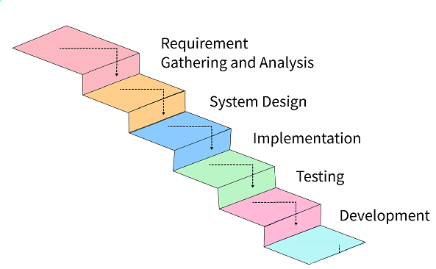

Spiral Model (Iterative Cycles)
Overview:
While Waterfall organizes the project, Spiral refines the tricky parts , especially the CNN model, dataset quality, pre-processing pipeline, and prediction accuracy.
Each Spiral loop begins with identifying risks, followed by prototyping, then testing, and then improving.
Advantages:
- You catch mistakes early instead of at the end.
- Model weaknesses (like misclassifying metal as plastic) can be fixed through multiple cycles.
- Dataset issues — imbalance, unclear images, noise — can be corrected immediately.
- Reduces wasted time because you’re improving only the areas that actually need work.

Spiral Components Used
Spiral Stage | Components
Risk Identification | Identify weak classes (plastic vs metal errors), dataset imbalance.
Risk Evaluation | Check confusion matrix, low-confidence predictions.
Prototyping | Try new pre-processing, add new dataset images, adjust CNN layers.
Testing | Evaluate accuracy, test sample images, compare models.
Iteration | Retrain model until accuracy is acceptable.
Planning Next Cycle | Plan next dataset update or pre-processing improvement.

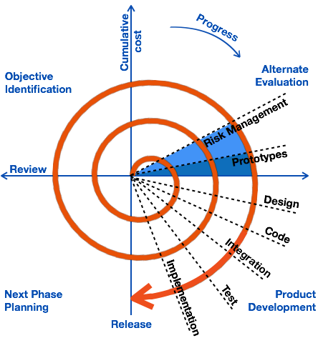
This cycle repeats until the module is complete and stable.

How the Hybrid Model Works
Waterfall (Top-Level Flow)
Used for:
- UI screens
- Upload system
- History module
- Admin panel
- System workflows
- Deployment
These modules don’t change much, so Waterfall gives a predictable roadmap.
Spiral (Inside Implementation & Testing)
Used for:
- Dataset improvement
- Pre-processing tuning
- CNN retraining
- Accuracy enhancement
- Performance optimization
Every time accuracy is low, the Spiral loop runs again.

Hybrid Approach (Waterfall + Spiral)
This system works best when Waterfall managing the overall roadmap and Spiral handling the smaller loops
inside critical modules. the hybrid structure works like this:
- The overall project moves Waterfall-style from requirements → design → implementation → testing → deployment.
- The AI parts — especially model training, dataset improvement, and pre-processing — run in Spiral loops inside the implementation and testing phases.
This keeps the project grounded but still flexible where it needs to be.
Benefits:
- Maintains clarity and structure for documentation.
- Reduces the risk of poor AI accuracy.
- Makes it easier to incorporate new dataset images.
- Helps achieve a more polished and reliable model.
- Gives room for adjustments without breaking the entire workflow.

Key Roles in the Hybrid Model
Role | Responsibility
Project Manager | Keeps development aligned with the plan and timeline
System Analyst | Defines the scope, requirements, and system flow
AI Engineer | Builds and refines the CNN model, manages dataset quality
UI/UX Designer | Designs a clean and usable interface for classification and admin tools
Developer | Implements system modules and integrates the AI model
QA / Test Engineer | Tests the UI, performance, and classification correctness
DevOps Engineer | Handles deployment and server configurations
Risk Analyst (Spiral Focus) | Tracks model performance issues, accuracy drops, dataset risks

1.7.2 Work Plan (Gantt Chart)
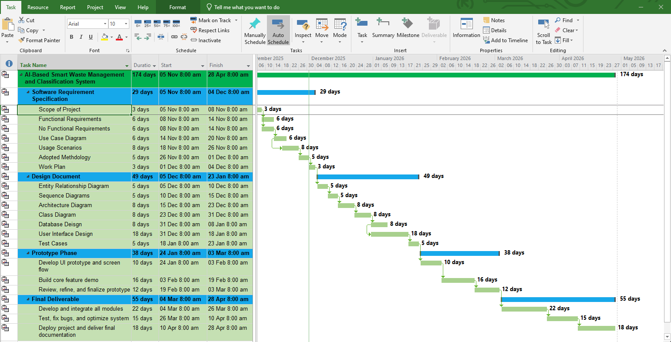

1.7.2 Project Schedule (Submission Calendar)

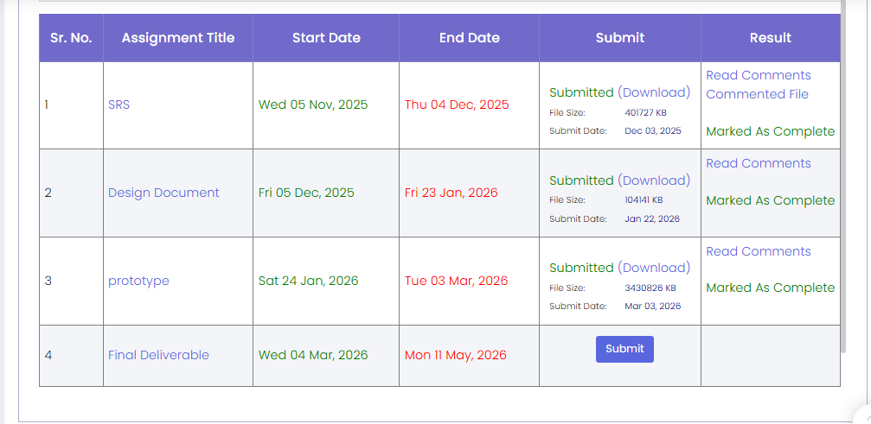

CHAPTER 2
Designing the Project

2.1 Introduction
The garbage classification project that is based on AI system needs a large amount of high-quality data to cover five categories: plastic, glass, organic matter, metal and paper. Data collection has been done with assistance of TrashNet and Mendeley Data datasets, from where images have been obtained for plastic, glass, metal,and paper as a class labels tutorial :
Here Also can be found on Ttutorial folder. The dataset incorporates different situations including lighting conditions, angles and object sizes, in addition to the background which allows the AI model to properly generalize real-world waste classification. Care was taken to keep a fair distribution of the examples in each class and images were placed in categories' folders to facilitate the pre-processing step and training.
Data Sources

1. TrashNet Dataset
• Sourced from Kaggle and GitHub.
• Categories: paper, plastic, metal, glass, cardboard, trash.
• Images were selected specifically for plastic, glass, paper, and metal.
• Dataset provides standardized, pre-labeled images with varied backgrounds.

2. Organic Waste Dataset
• Downloaded from Mendeley Data.
• Contains images of organic waste items such as food scraps and biodegradable materials.
• Images were labeled manually according to waste type.
Dataset Preparation
• Dataset covers various lighting conditions, angles, object sizes, and backgrounds to improve model robustness.
• Images were organized into category-specific folders to ensure proper labeling for automatic data loading during training.
2.2 purpose
The purpose of Chapter 2, Designing the Project, is to present the proposed system’s design in a formal and systematic manner. This chapter outlines the overall structure of the project, including its architecture, core components, workflow, and the technologies that will be used in its development. It also explains the design decisions made to ensure that the system effectively meets its intended objectives and provides a clear foundation for the implementation and testing phases that follow.

2.3 scope
The scope of this project is limited to the design and development of the proposed system, including the identification of its main features, workflow, modules, and required technologies. It focuses on defining what the project will cover and what it will not cover, so that the work remains clear, manageable, and aligned with the stated objectives. The scope also includes the major functional components that will be designed for implementation, while excluding features or technical details that are beyond the time, resources, or objectives of the study.

2.4 definitions, acronyms and abbreviations
- FYP — Final Year Project
- ML — Machine Learning
- CNN — Convolutional Neural Network
- UI — User Interface
- GUI — Graphical User Interface
- API — Application Programming Interface
- Dataset — Collection of data used for training and testing the model
- Classification — Process of assigning an input to a category based on learned patterns

2.5 Architectural Representation (Architecture Diagram)

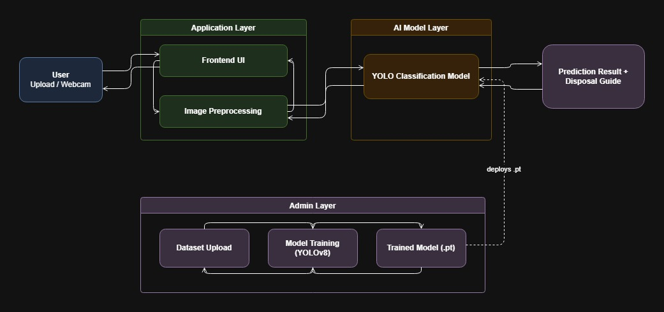

2.6 Dynamic Model: Sequence Diagrams

Figure 1: User Waste Classification Flow
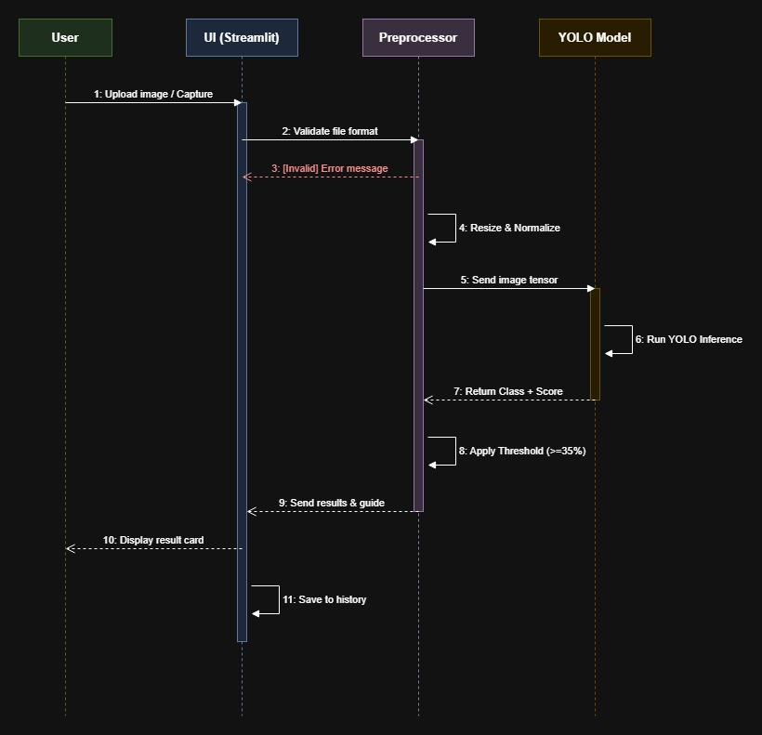

Figure 2: Admin Panel Flow
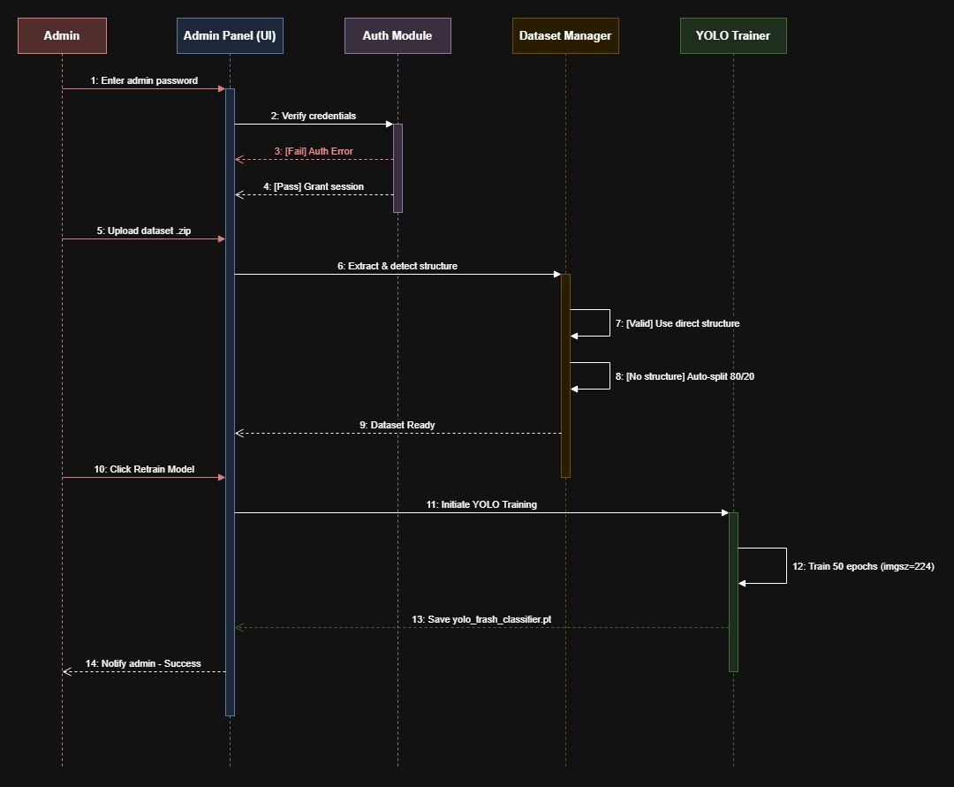

Figure 3: Model Evaluation Report Flow

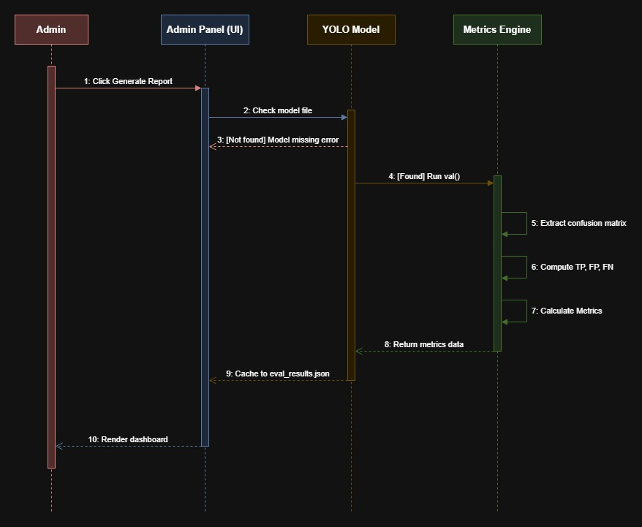

2.7 Object Model/Logical Model: Class Diagram
This project does not follow an object-oriented programming paradigm and is developed using Python and Streamlit in a procedural and functional style. Since no classes or objects are defined in the system, a conventional class diagram is not applicable. The system logic is better represented through the Sequence Diagrams and Activity Diagrams presented in this report.

2.8 Database Model (Database Diagram)

This system does not require a database. All classifications are performed at runtime by the YOLO model and results are displayed stateless to the user.

2.9 Graphical User Interfaces

Figure 4.1: User Interface, Initial Screen
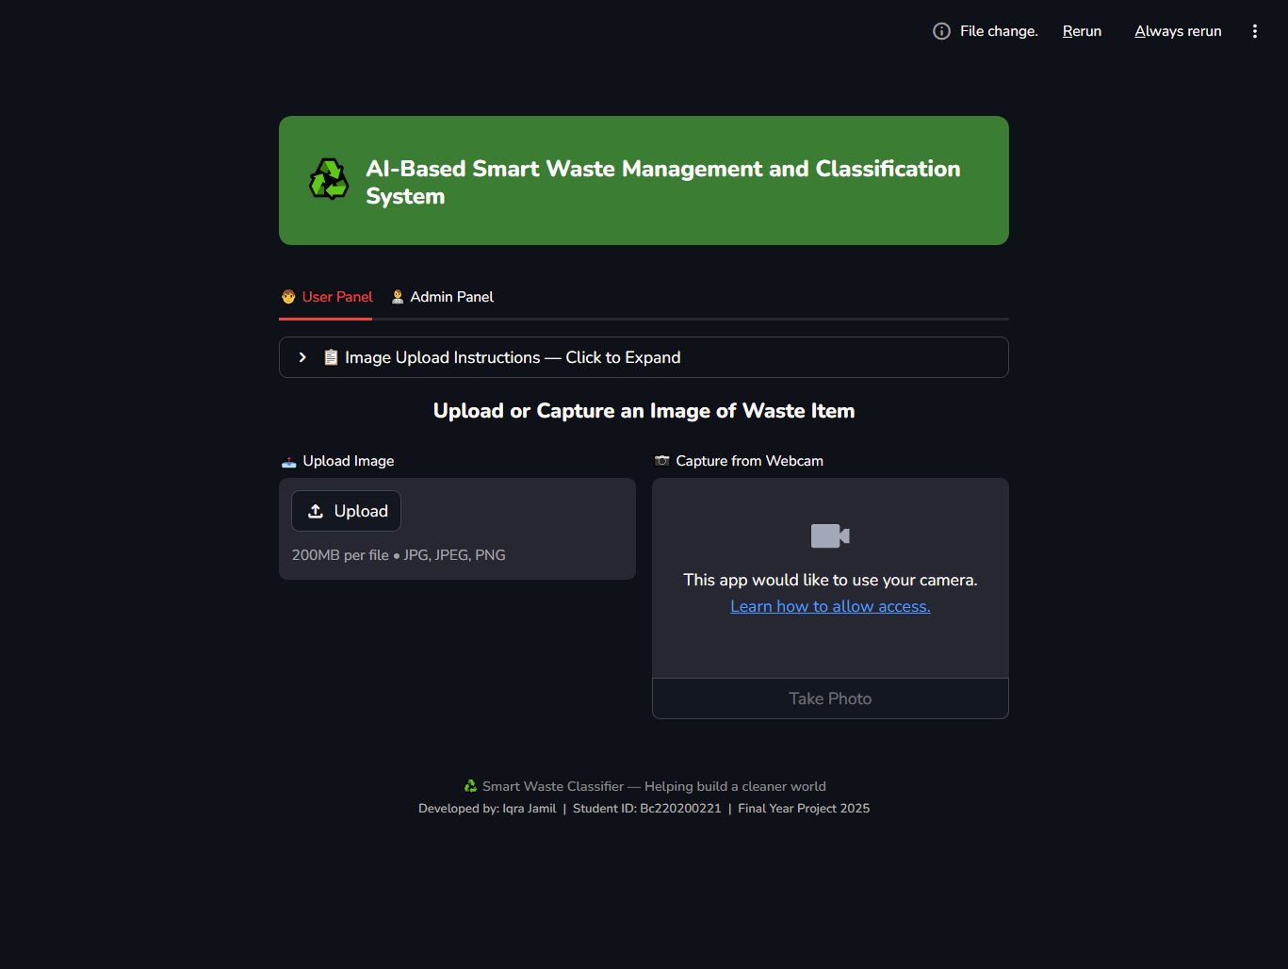

Figure 4.2: Image Upload Process

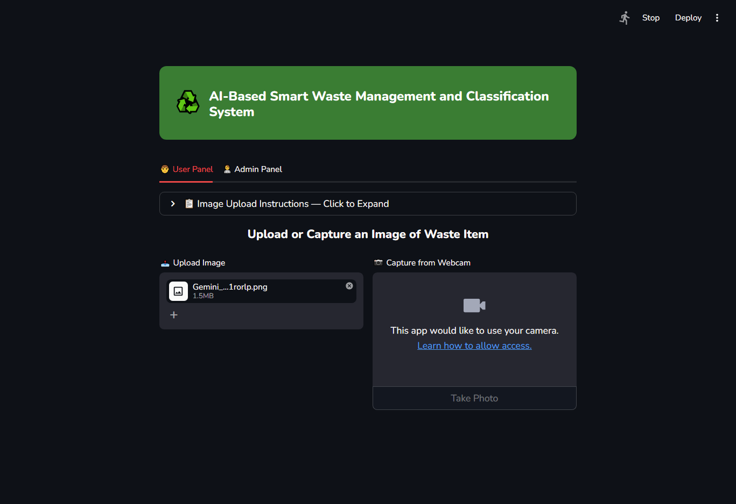

Figure 4.3: Waste Classification Result
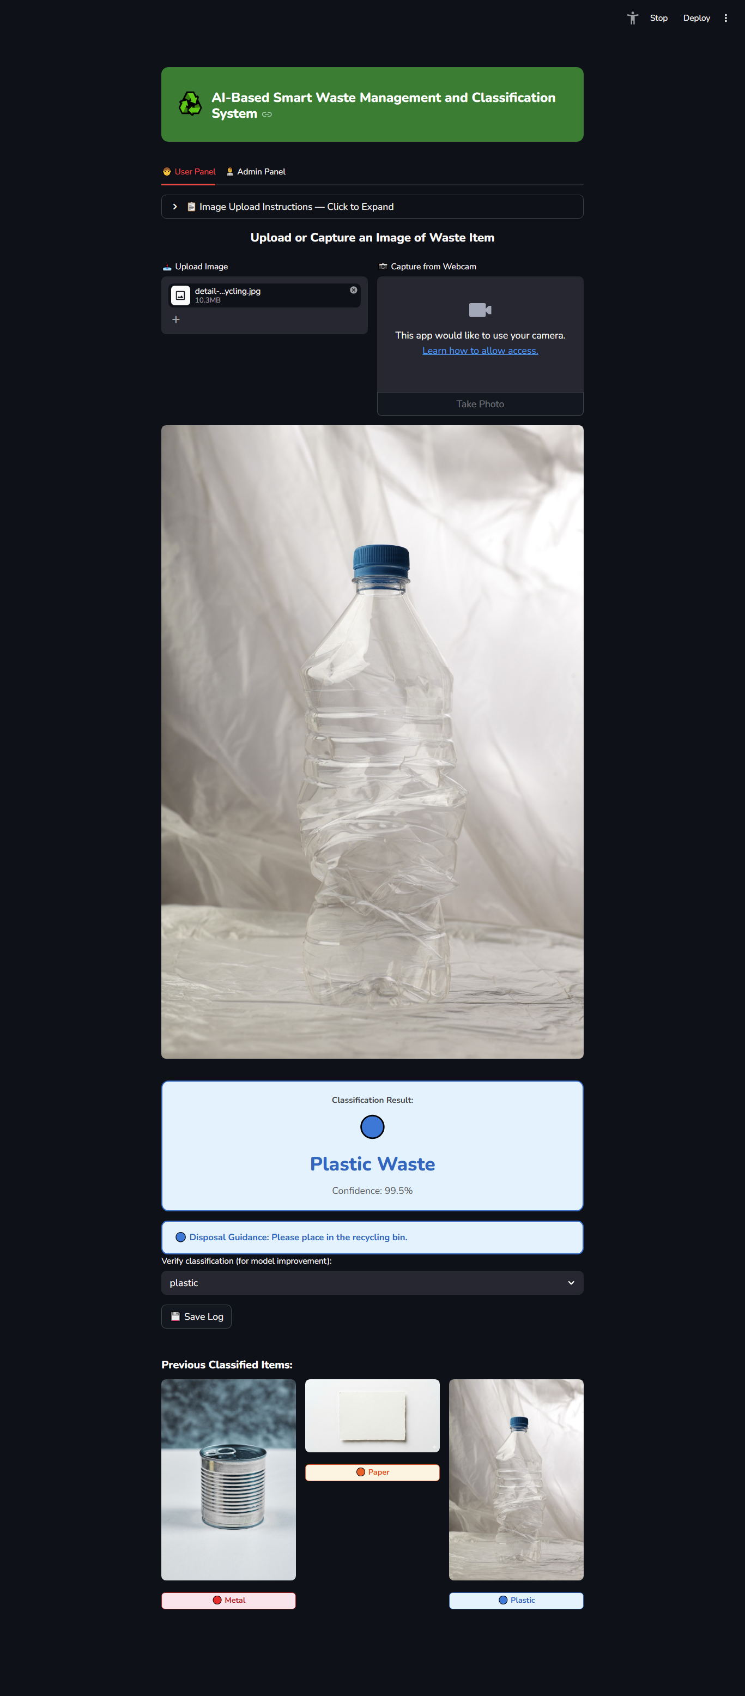
Figure 4.4: Admin Login Interface
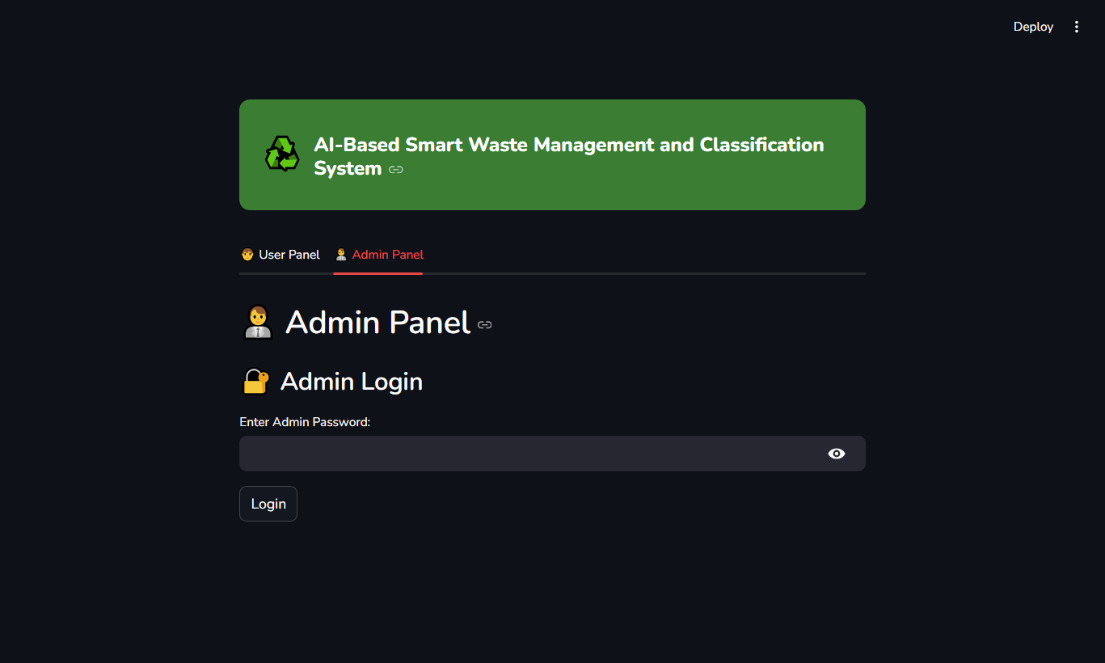

Figure 4.5: Admin Dashboard Overview
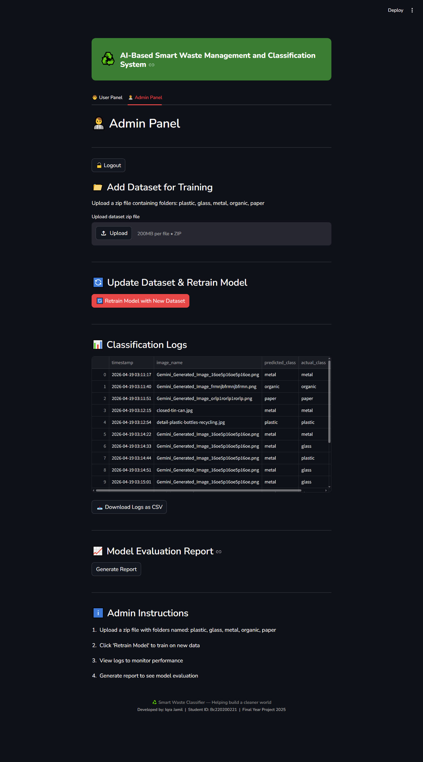

CHAPTER 3
Development

3.1 Development plan (Architecture Diagram)
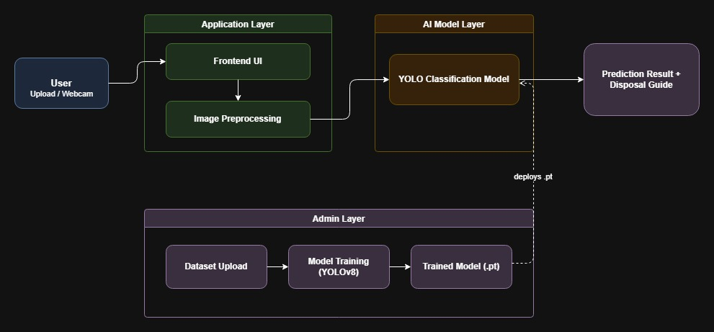

REFERENCES

- TrashNet dataset (Kaggle/GitHub)
- Youtube
- W3school
- Ultralytics YOLO documentation
- PyTorch documentation

APPENDIX

Chapter 1 | gathering & Analyzing info
Chapter 2 | designing the project
Chapter 3 | Development

