**MODELLER**

MODELLER is used for homology or comparative modelling of protein three-dimensional structures (1,2). The user provides an alignment of a sequence to be modelled with known related structures and MODELLER automatically calculates a model containing all non-hydrogen atoms.

**MODELLER vs SWISS-MODEL?**

* SWISS-MODEL is also for homology modeling.
* But MODELLER is preferred because in MODELLER we have options like can make changes to our need, unlike SWISS-MODEL.
* In SWISS-MODEL everything is selected.
* We can make changes in our scripts (specialized changes) using MODELLER.
* Modeller is advanced modeling.

**STEPS – PREPARING FOR MODELING:**

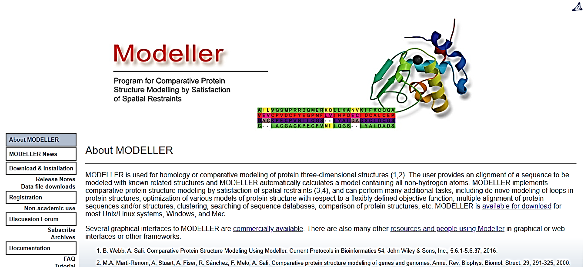

1. **Go to website**
2. **Go to tutorials (use them accordingly to the type of work you want to do)**

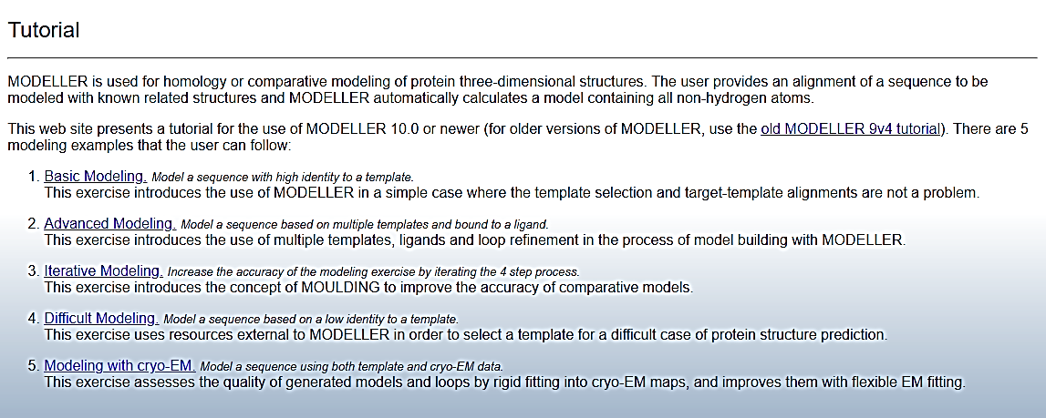

1. **Go to ‘Basic Modelling’.**
2. **Download the .zip file (Basic Examples). It file contains all kind of files that we will need in modelling our protein structure.**

1. **Extract the file and move it to desktop.**
2. **Create a new folder named ‘Modeller1’**

**--------------> Place following files in the folder**

1. **CREATING .ali FILE:**
2. Go to NCBI and obtain protein sequence.
3. Copy sequence (FASTA) and paste in a “notepad”. 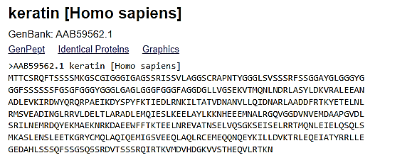

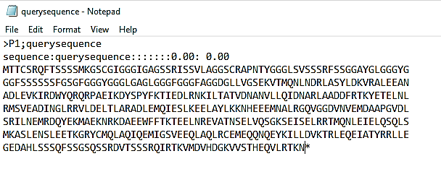



1. While saving, save as “querysequence.ali”



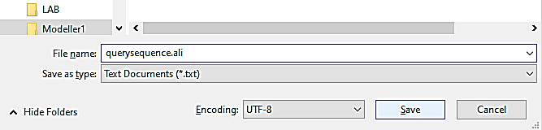



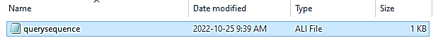



1. **CREATING .py FILE**
2. Copy the “build_profile.py” file into notepad.
3. Make changes (‘querysequence.ali’)
4. Save the file as “build_profile.py”







1. **Always place pdb_95 file in your folder (’Modeller1’)**



1. **You must have following files in the modeller1 folder**

**(NOTE: for modeller to work, we must have Python installed on our systems)**

**STEPS – PERFROMING MODELLING**

**(NOTE: your Modeller1 folder should in the directory ‘Modeller10.2’ in D)**

1. **Open Modeller**
2. **Change directory (cd)**

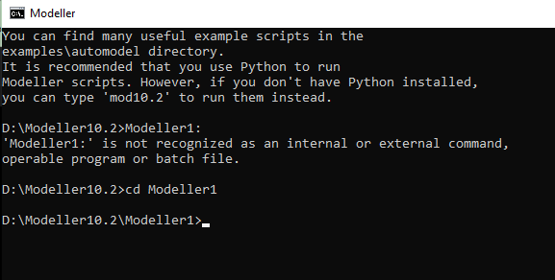



1. **Run following command**

>mod10.2 build_profile.py

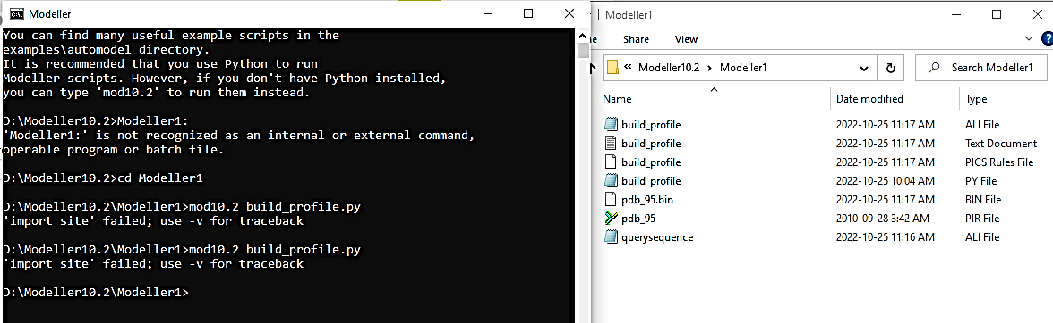



1. **SELECTING TEMPLATES**

**Paste your query sequence in BLAST to find templates or run blast from the same page.**

(note: sice couldn’t find a hit with good query coverage, had to switch on to INSULIN.

<https://www.uniprot.org/uniprotkb/P06213/entry#sequences> )

***Query Cover*** should be as close as possible (90% or above in video)

***Percentage Identity*** should be in range: 80-100, 80 is best suited.

1. **Select a template 🡪 then download its PDB structure in ‘PDB format’**

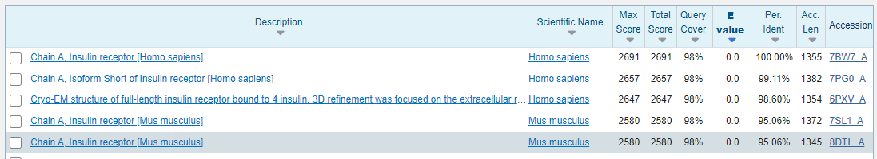

**Paste its Accession number in PDB. (without the chain element ‘_A’)**

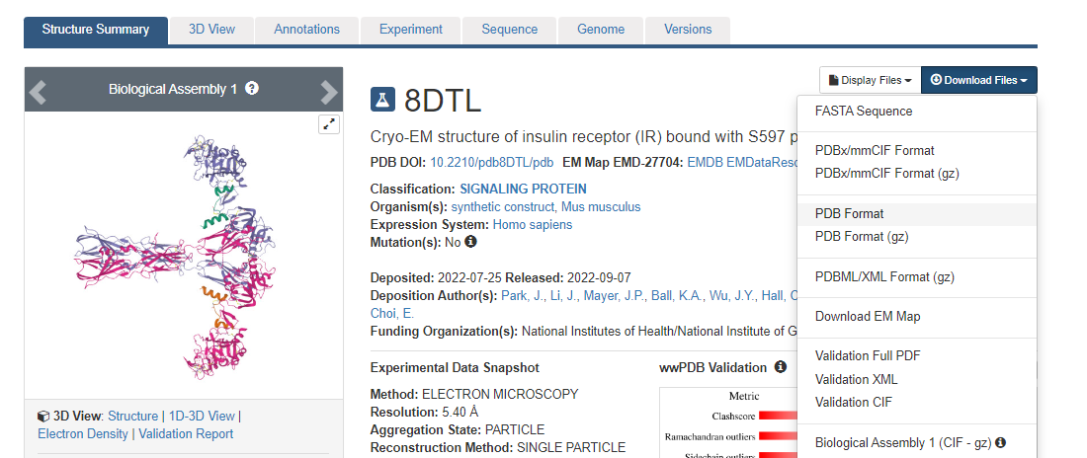



1. **Similarly download 3 more (total = 4) templates. And renames their names as t1.pdb, t2.pdb etc.**
2. **Paste them in your folder.**

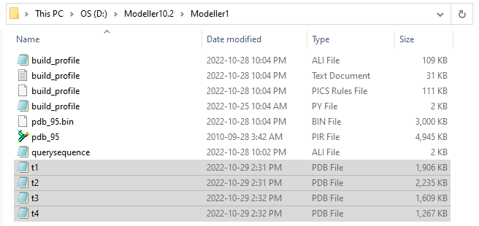

1. **Create the ‘compare.py’ file.**

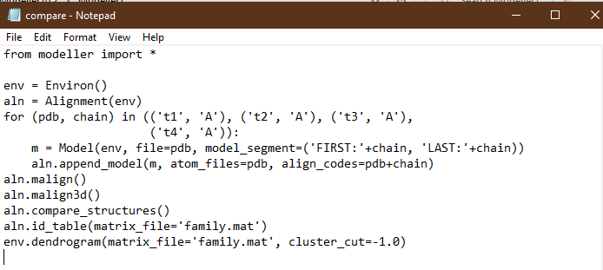



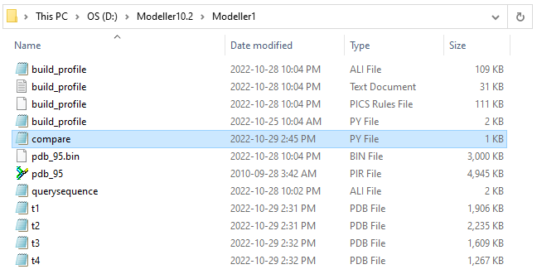



1. **Run the following command: [ following files will be made (compare log file and family]**

**mode10.2 compare.py**

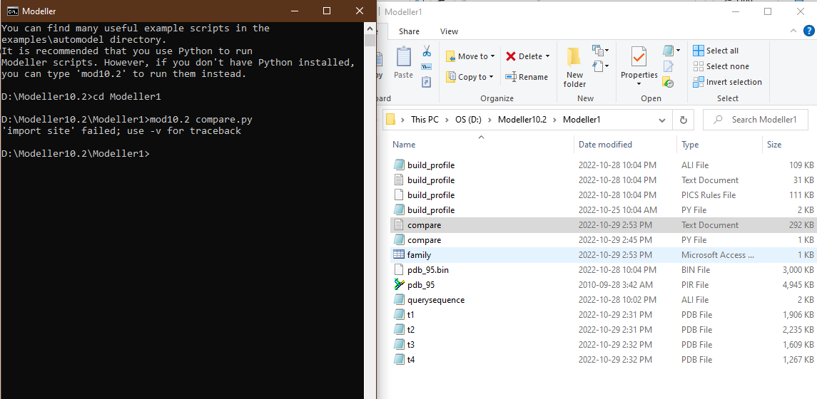**If you want to check, run following command: 🡪 dir**

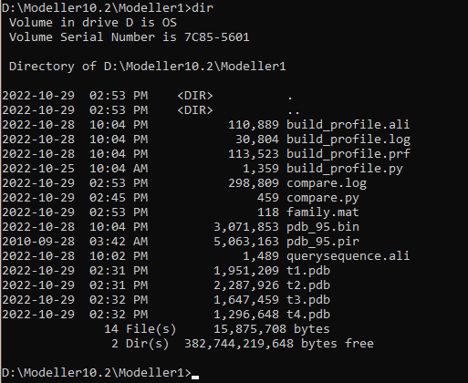



1. **Create the ‘align2d.py’ file**

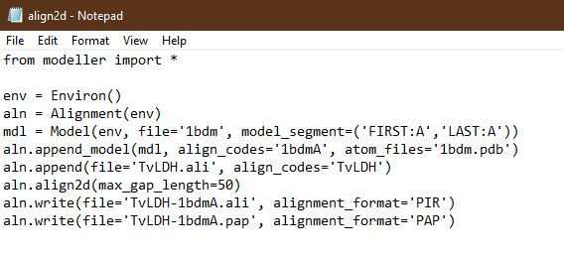

**Make following changes. 🡪 Queryseq 🡪 template**



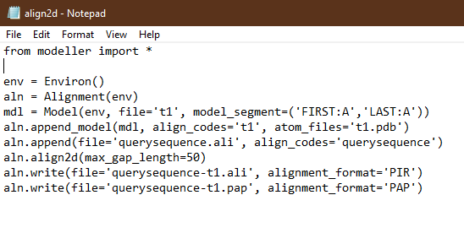



1. **Run following command on modeler. mod10.2 align2d.py**

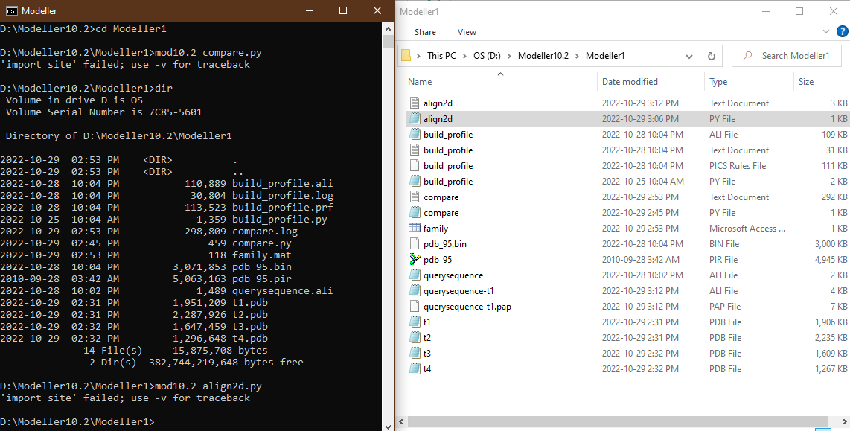



1. **Create ‘model-single.py’ file. And make following changes to the file.**

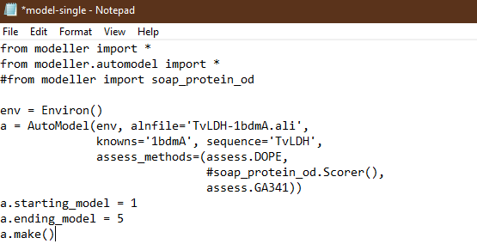

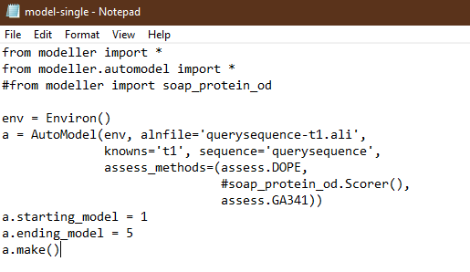



**Run following command on Modeller 🡪 mod10.2 model-single.py**

**This step takes a lot of time since at this step our protein is being modelled.**

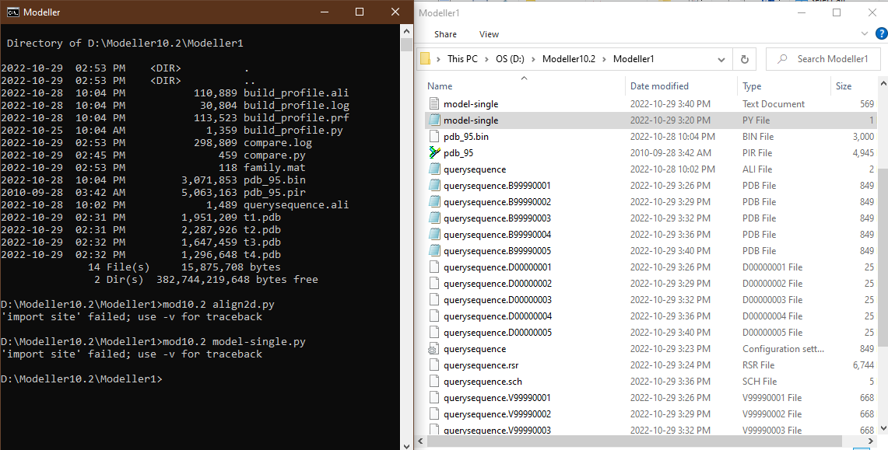



**It will generate different models (possible) that can be made using the template.**

1. **Evaluation:**

**For evaluation, DOPE Score is very important. (the more negative value, the authentic results are)**

**Select the structure that has the most negative DOPE Score.**

**From the model-single.txt file (generated as a result of the aforementioned command) we will find the best model we want.**

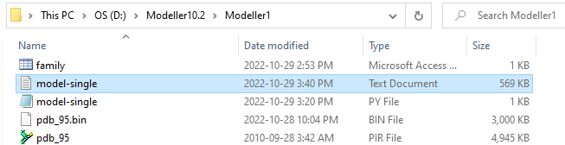

**Open the file and scroll down.**



**Highlighted model is the best one with the most negative DOPE Score.**

1. **Create ‘evaluate_model.py’ file. Now create another for ‘evaluate_template.py’**

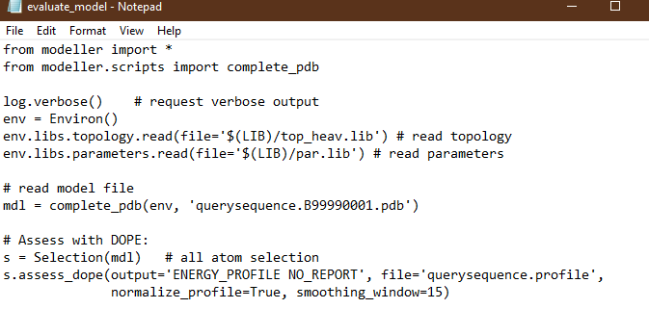



Note: evaluate_model 🡪 our model (DOPE Score) evaluate_template 🡪 our template (BLAST )

1. **Run following command on Modeller.**

**mod10.2 evaluate_*.py**



1. **The next steps require some things from google.**

**Google 🡪 install matplotlib (python)**

**“** pip install matplotlib **“**

**Google 🡪 GNUPLOT (download & Installation)**

1. **Next create the ‘plot_profiles.py’ file. And do names changes in the file.**

**(copy from basic-example folder)**



1. **Open Python IDLE and open the ‘plot_profiles.py’ file in it and run module.**

**As a result, a picture of the graph will be made.**

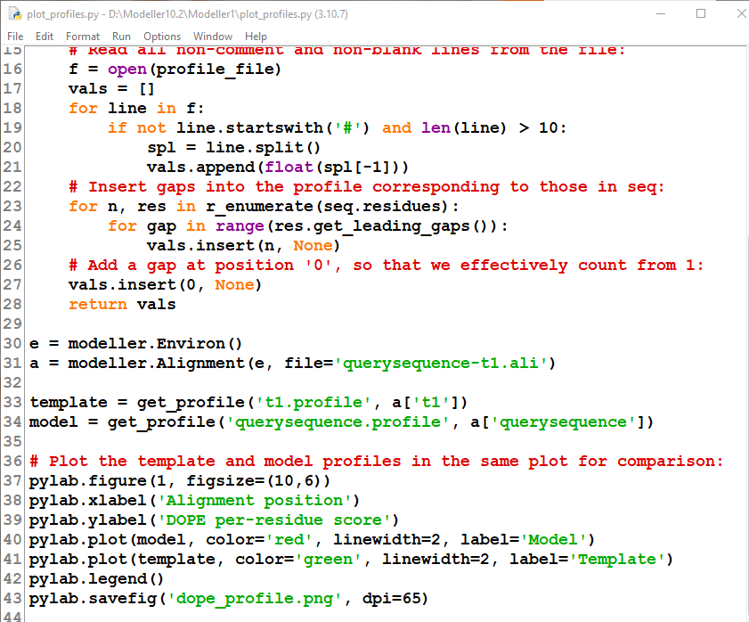

**IMAGE OBTAINED:**

