**COMSATS UNIVERSITY ISLAMABAD,**

**SAHIWAL CAMPUS**

**Assignment # 02**

**Topic: “Tertiary structure”**

**CSC462:** Structural and functional bioinformatics

**Submitted To:**

Sir Asif Imran

**Submitted From:**

**Name:** Aqsa Rafique

**Registration No:** SP20-BSI-009

**Batch:** 22

**QUES NO 1:**

**Elaborate steps of protein tertiary structural prediction.**

**Tertiary structure:**

The overall three-dimensional structure of a polypeptide is called its tertiary structure. The tertiary structure is primarily due to interactions between the R groups of the amino acids that make up the protein R group interactions that contribute to the tertiary structure include hydrogen bonding, ionic bonding, dipole-dipole interactions, and London dispersion forces – basically, the whole gamut of non-covalent bonds. For example, R groups with like charges repel one another, while those with opposite charges can form an ionic bond. Similarly, polar R groups can form hydrogen bonds and other dipole-dipole interactions. Also important to the tertiary structure are hydrophobic interaction**s**, in which amino acids with nonpolar, hydrophobic R groups cluster together on the inside of the protein, leaving hydrophilic amino acids on the outside to interact with surrounding water molecules.

Finally, there’s one special type of covalent bond that can contribute to tertiary structure: the disulfide bond. Disulfide bonds, covalent linkages between the sulfur-containing side chains of cysteines, are much stronger than the other types of bonds that contribute to tertiary structure. They act like molecular "safety pins," keeping parts of the polypeptide firmly attached to one another.

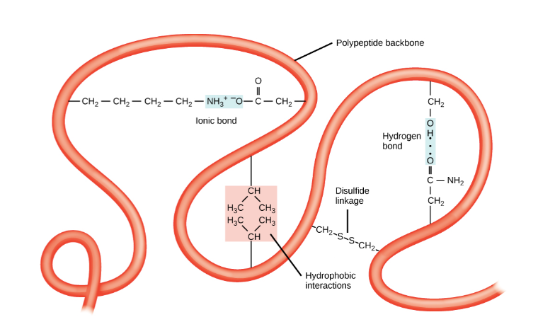

**SWISS-MODEL an automated protein homology-modeling server:**

**Steps:**

* SWISS-MODEL provides several levels of user interaction through its World Wide Web interface: in the ‘first approach mode’ only an amino acid sequence of a protein is submitted to build a 3D model. Template selection, alignment, and model building are completely automated by the server.
* In the ‘alignment mode’, the modeling process is based on a user-defined target-template alignment. Complex modeling tasks can be handled with the ‘project mode’ using Deep View (Swiss-Pdb Viewer), an integrated sequence-to-structure workbench.
* The SWISS-MODEL server is under constant development to improve the successful implementation of expert knowledge into an easy-to-use server.
* Three-dimensional (3D) protein structures provide valuable insights into the molecular basis of protein function, allowing an effective design of experiments, such as site-directed mutagenesis, studies of disease-related mutations, or the structure-based design of specific inhibitors.
* Although great progress was made in the field of experimental structure solution by X-ray crystallography and nuclear magnetic resonance spectroscopy (NMR), it is still a time-consuming process without guaranteed success.
* Currently, about 20 000 experimental protein structures are deposited in the Protein Data Bank (PDB). Nevertheless, the number of structurally characterized proteins is low compared to the number of known protein sequences: taken together, the SWISS-PROT and TrEMBL databases hold about 850 000 sequence entries which exceed the number of known different structures by about two orders of magnitude.
* Modeling of protein structures usually requires extensive expertise in structural biology and the use of highly specialized computer programs for each of the individual steps of the modeling process.

**QUES NO 2:**

**Differentiate between active site, binding site, and allosteric sites.**

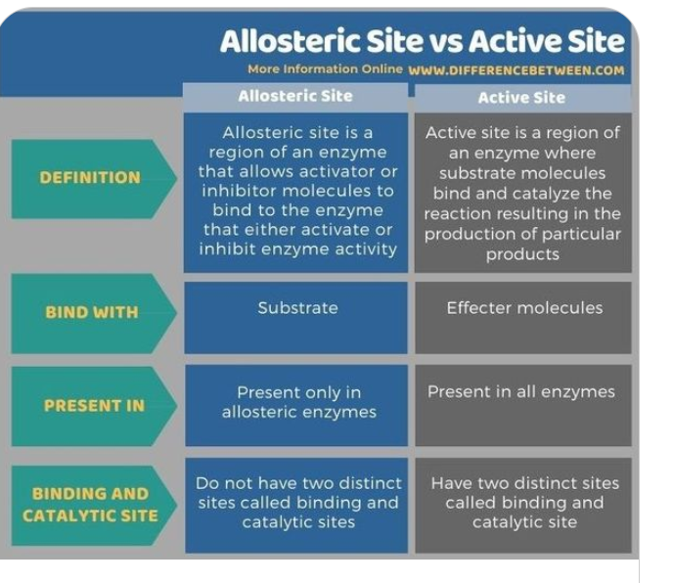

**Binding sites:**

The binding site is a region on a protein, DNA or RNA to which ligands can bind. There, the ligand can form a chemical bond with this site. These regions show specificity; a particular ligand will bind to a particular binding site. Therefore, this site is a measure of the types of ligands that can bind with a molecule.

Furthermore, we often use these regions for the functional characterization of biomolecules. For example, we can characterize the functionality of an active site through its binding site. Moreover, in the case of DNA, the specific type of binding site is the transcription factor binding site present on the DNA.