**MyDiary - Your AI-Powered Therapy Journal**

# **Problem Statement**

| **The problem of** | limited access to mental health support and self-expression |
| --- | --- |
| **affects** | individuals who struggle with their emotional well-being or need a safe space to document their thoughts. |
| **The impact of which** | is that users may feel isolated, lack proper guidance, or be unable to connect with professional therapists. |
| **A successful solution would be** | an AI-powered therapy journal web app that allows users to write daily diaries, choose to share them (with admin moderation), connect with therapists for sessions, and provide feedback, fostering a supportive and accessible mental health platform. |

# **User Stories**

##### User Story #1



##### User Story #2



##### User Story #3



##### User Story #4



##### User Story #5



##### User Story #6



##### User Story #7



##### User Story #8



##### User Story #9



##### User Story #10



##### User Story #11



##### User Story #12



##### User Story #13



##### User Story #14



##### User Story #15



##### User Story #16



##### User Story #17



.

##### User Story #18



##### User Story #19



##### User Story #20



##### User Story #21



##### User Story #22



##### User Story #23



##### User Story #24



##### User Story #25



# **Team Agreement**

## **1. Communication Guidelines**

### **Primary Communication Channels**

* **Google Docs** for sharing formal updates, documents, and reports.
* **Phone Calls** for urgent discussions that require immediate attention.
* **Discord** for team coordination, detailed discussions, and brainstorming.
* **WhatsApp (Text Messages)** for urgent notifications when other channels are unavailable.

### **Response Time Expectations**

* **Phone Calls**: If available, answer immediately; return missed calls within **2 hours**.
* **Discord (Live Chat)**: Expected to respond in real-time during discussions.
* **WhatsApp Messages**: Should be responded to as soon as possible for urgent matters.

## **2. Meeting Protocol**

### **Regular Meeting Schedule**

* **Weekdays (Monday - Thursday)**: In-person meetings at **12:30 AM**.
* **Weekends (Saturday & Sunday)**: Virtual meetings at **9:00 PM** via **Google Meet**.
* **Emergency Meetings**: Can be scheduled if a critical issue arises.

### **Attendance Expectations**

* Attendance is **mandatory** unless prior notice is provided.
* If unable to attend, the member must inform the team in advance and review meeting notes afterward.

### **Meeting Structure & Preparation**

* **Meeting Format**: Conducted in-person or on **Google Meet**.
* **Meeting Minutes**: Maintained by the **Scrum Master**.
* **Agenda**: Shared at least **2 hours before** the meeting.
* **Preparation**:
  + Review previous meeting notes.
  + Complete assigned tasks.
  + Conduct any necessary research before the discussion.

## **3. Version Control & Code Management**

### **Version Control System**

* **GitHub** will be used for managing code versions and collaboration.

### **Commit & Code Review Guidelines**

* **Commit Messages**: Must be clear and descriptive (e.g., "Added login authentication").
* **Commit Frequency**: Small, incremental commits are preferred over large changes.
* **File Management**:

1. Do **not** commit unnecessary files (e.g., .env, build artifacts).

2. Follow structured branching (e.g., feature branches merged into main or develop after review).

## **4. Task Allocation & Workflow**

### **Task Distribution**

* Work is assigned based on **expertise, availability, and team discussion**.
* The **Scrum Master/Product Owner** facilitates assignments, but all members have a say in decisions.

### **Project Management & Tracking**

* **Trello** will be used to manage tasks and track progress.
* **Stakeholders & Roles**:

1. **Development Team: Syed Muhammad Raza Moosvi**

Responsible for coding, testing, and implementation.

1. **Product Owner: Hafiza Iqra Zulfiqar**

Ensures that priorities align with project objectives.

1. **Scrum Master: Hafiza Iqra Zulfiqar**

Facilitates workflow and communication within the team.

1. **Scrum Team:**

Syed Muhammad Raza Moosvi

Hafiza Iqra Zulfiqar

## **5. Submission & Quality Assurance**

### **Submission Guidelines**

* Hafiza Iqra Zulfiqar will handle **final submission**.
* All submissions must go through a peer review process before finalization.

## **6. Contingency Planning**

### **Handling Unexpected Situations**

* **If a team member leaves the project**: Remaining tasks will be redistributed. If necessary, additional resources will be sought.
* **If a member consistently misses meetings**: A discussion will be held to understand the issue and find a resolution.
* **If academic dishonesty occurs**: The matter will be escalated to the appropriate authority, and any contributions from the involved member may be removed.

# **Trello Screenshots**

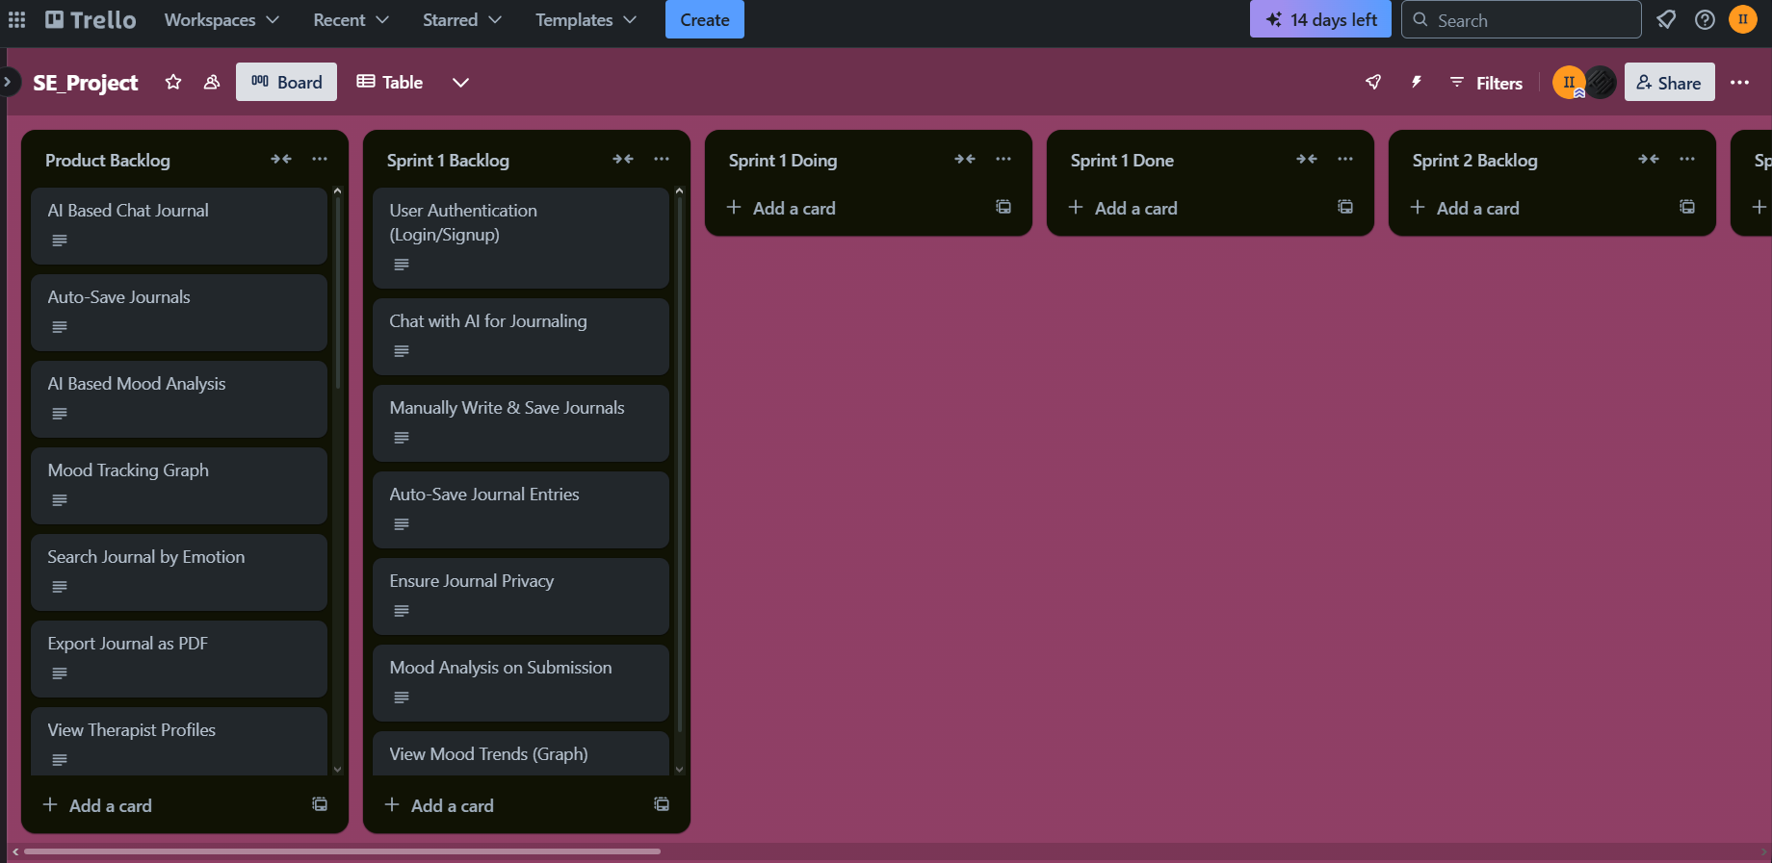

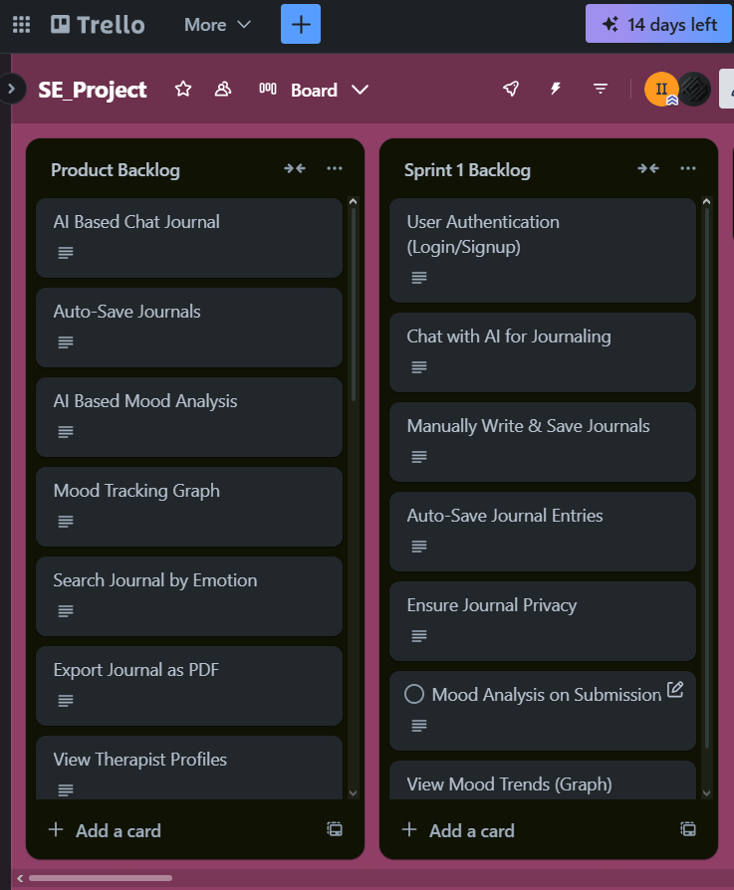

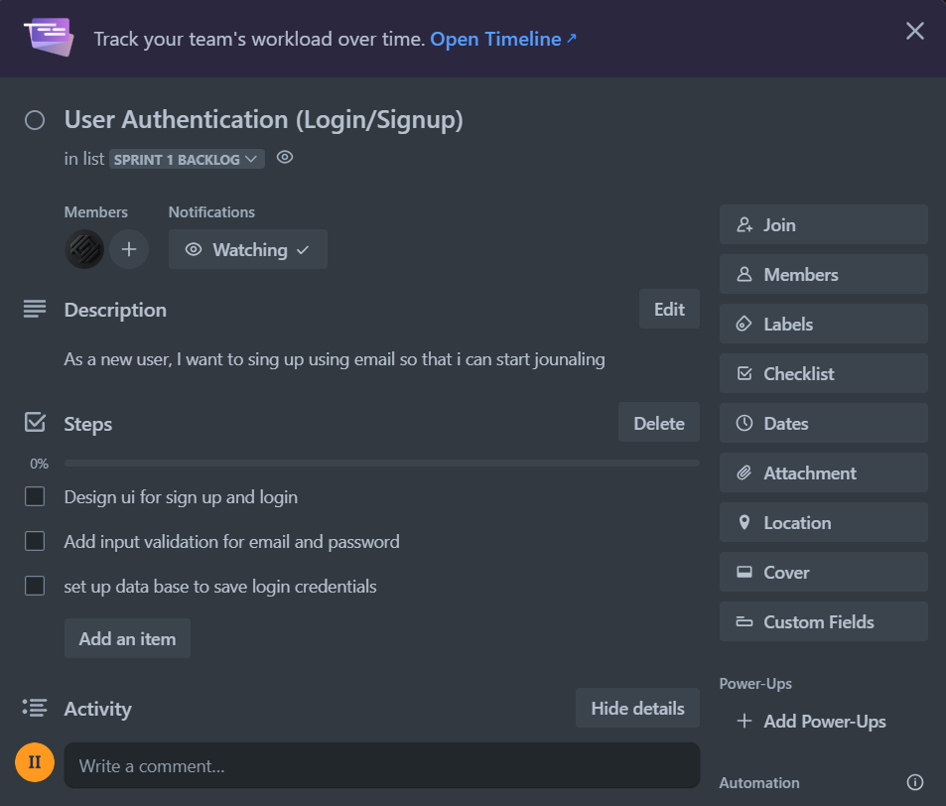

# Github Link

<https://github.com/iqra028/AI-Powered-Therapy-Journal> 